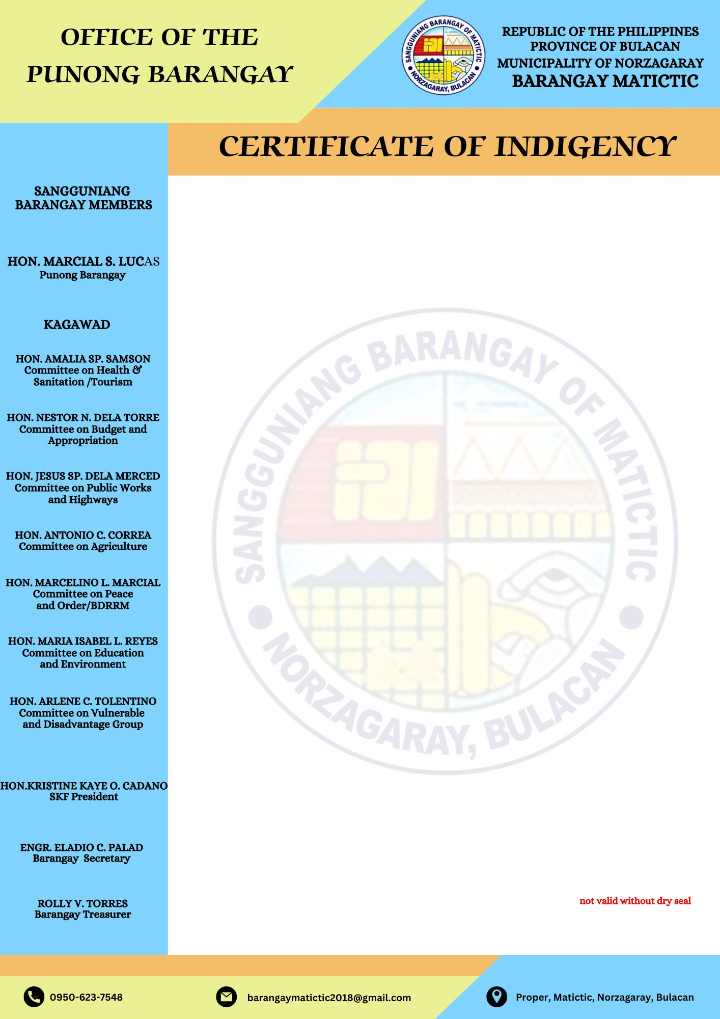


TO WHOM IT MAY CONCERN;

This is to certify that Charlene Andres, is a bonafide resident of Malaganit, Barangay Matictic, Norzagaray, Bulacan.

This further certifies that he/she belongs to INDIGENT families in our Barangay.

This certification is being issued upon the request of the above mentioned-name for EDUCATIONAL ASSISTANCE.

Issued this 1st day of October 2025 at Barangay Matictic, Norzagaray, Bulacan.

MARCIAL S. LUCAS
Punong Barangay

