A PROJECT REPORT
ON
Insurance Claim Fraud Detection Using XGBoost with Hyperparameter Tuning
Project report submitted in partial fulfilment of the requirements for the course
MACHINE LEARNING
BACHELOR OF TECHNOLOGY
in
Computer Science and Engineering
A.Y.: 2026-27
By
Vadlapudi Nitish Sri Sai Roll No: 2520030179
Kondapalli Chaitanya Roll No: 2520030210
Kudumula Rama Shashank Reddy Roll No: 2520030215
Team Number: 8 | Section: 7
Under the Esteemed guidance of
Dr. Ravindra Gaddam
Associate Professor, Department of Computer Science and Engineering
KL University, Bachupally, Hyderabad - 500090, Telangana, India

Abstract
Insurance fraud is a significant financial burden on the insurance industry, resulting in substantial annual losses and inflated premiums for genuine policyholders. Traditional fraud detection methods, which rely on manual investigation and static rule-based systems, are often slow, inconsistent, and unable to adapt to evolving fraudulent patterns. This project proposes a machine learning-based approach to automatically classify insurance claims as genuine or fraudulent using the XGBoost (Extreme Gradient Boosting) algorithm, an ensemble learning technique well suited to structured, tabular data.
The study uses the publicly available Vehicle Insurance Claim Fraud Detection dataset (fraud_oracle.csv), comprising 15,420 historical claim records across 33 attributes, including policyholder demographics, claim timing, vehicle details, and claim history. The dataset is first cleaned by correcting anomalous entries (such as invalid Age = 0 values), encoding categorical features using one-hot encoding, and scaling numerical features using standardization. Given the severe class imbalance present in the data (only about 6% of claims are fraudulent), class-weighting is applied during model training. Hyperparameter tuning is performed using RandomizedSearchCV with cross-validation to optimize parameters such as learning rate, maximum tree depth, number of estimators, and subsample ratio. The tuned XGBoost model is compared against Logistic Regression, Decision Tree, and Random Forest baselines using accuracy, precision, recall, F1-score, and ROC-AUC. Results show that the tuned XGBoost model achieves a strong balance between recall and precision relative to the baseline models, demonstrating the practical value of combining gradient boosting with systematic hyperparameter optimization for building reliable, automated fraud detection systems.
Keywords: Insurance Fraud Detection, Machine Learning, XGBoost, Hyperparameter Tuning, Class Imbalance, Classification

1. Introduction

1.1 Purpose of the Project
Insurance companies process a large volume of claims every year, and a portion of these claims are fraudulent — ranging from exaggerated damage estimates to staged accidents and false reporting of fault. Fraudulent claims directly increase the operating costs of insurers, and these costs are ultimately passed on to honest policyholders through higher premiums. Detecting fraud manually requires experienced investigators to review claim details individually, which is slow, expensive, and difficult to scale as claim volumes grow.
The purpose of this project is to build an automated, data-driven fraud detection system using machine learning that can flag suspicious claims early in the processing pipeline. Such a system benefits insurance companies by reducing financial losses and investigation workload, and benefits genuine policyholders through fairer premiums and faster claim settlement for legitimate cases.

1.2 Problem Statement
Given a historical dataset of vehicle insurance claims with associated policyholder, vehicle, and incident attributes, the objective is to build a binary classification model that predicts whether a new claim is 'Fraudulent' or 'Genuine'. The target variable, FraudFound_P, takes the value 1 for fraudulent claims and 0 for genuine claims. The problem is further complicated by severe class imbalance, since fraudulent claims make up only a small fraction of all claims.

1.3 Existing Methods and Disadvantages
Traditional fraud detection in the insurance industry has historically relied on manual claim review and static, rule-based flagging systems (e.g., flagging all claims above a fixed amount, or claims filed within a fixed number of days of policy purchase). These rule-based systems are easy to interpret but are rigid — they cannot adapt to new fraud patterns and tend to generate a high number of false positives, burdening investigators with unnecessary manual reviews.
Earlier machine learning approaches, such as plain Logistic Regression and single Decision Trees, improved on rule-based systems but struggle with the extreme class imbalance typical of fraud datasets, often achieving high overall accuracy while failing to actually detect fraud cases (low recall on the minority class). Ensemble methods such as Random Forest improve robustness but can still underperform on the minority class without explicit imbalance handling, and are comparatively slower to train and tune than boosting-based alternatives such as XGBoost.

1.4 Proposed System
This project proposes an XGBoost-based classification pipeline that begins with data cleaning (correcting anomalous entries and encoding categorical variables), followed by feature scaling, class-imbalance handling via class weighting, model training, and systematic hyperparameter tuning using RandomizedSearchCV with cross-validation. The tuned XGBoost model is benchmarked against Logistic Regression, Decision Tree, and Random Forest baselines, and the best-performing configuration is selected using F1-score and ROC-AUC as the primary evaluation criteria, since these metrics are more informative than raw accuracy on an imbalanced dataset.

1.5 Research Objectives
- Prepare a suitable dataset for the insurance fraud classification problem by cleaning and correcting anomalous records.
- Perform systematic preprocessing (encoding, scaling) and exploratory data analysis to understand feature distributions and the class imbalance.
- Engineer and select relevant features while explicitly preventing data leakage (e.g., dropping identifier columns such as PolicyNumber).
- Develop and train multiple machine learning models, including a baseline and a tuned XGBoost classifier.
- Evaluate and compare models using accuracy, precision, recall, F1-score, and ROC-AUC appropriate for imbalanced classification.
- Identify the best-performing model configuration and discuss its practical applicability for real-world insurance fraud screening.

2. Literature Survey
The following table summarizes ten recent studies (2023-2026) directly relevant to machine learning-based insurance and financial fraud detection, with particular emphasis on XGBoost and class-imbalance handling techniques.
S.No. | Title | Reference with DOI | Problem/Gap Addressed | Objective | Focus (Methods) | Inference | Future Recommendations
1 | Auto insurance fraud detection: Machine learning and deep learning applications | Yankol-Schalck & Banulescu-Radu, 2026, Journal of Risk and Insurance, 93, 534-568, doi:10.1111/jori.70046 | High false-negative rates of state-of-the-art ML models on auto insurance fraud | Improve fraud detection using recent deep learning advances combined with ML | Hybrid ML-DL framework combining gradient boosting and deep learning for discriminative feature extraction | Hybrid ML-DL models outperform single ML models on class-imbalanced auto insurance data | Explore transformer-based architectures and larger real-world claim datasets
2 | Automobile Insurance Fraud Detection Based on PSO-XGBoost Model and Interpretable Machine Learning Method | Ding et al., 2024, Insurance: Mathematics and Economics, 120, 51-60, doi:10.1016/j.insmatheco.2024.11.006 | Manual XGBoost hyperparameter tuning is labor-intensive and often suboptimal | Automate XGBoost parameter optimization using Particle Swarm Optimization (PSO) | PSO-enhanced XGBoost compared against standard XGBoost and other ML baselines | PSO-XGBoost improved accuracy and generalization over standard XGBoost and other ML models | Extend PSO tuning to other boosting frameworks and larger insurance datasets
3 | Practical guideline to efficiently detect insurance fraud in the era of machine learning: A household insurance case | Banulescu-Radu & Yankol-Schalck, 2024, Journal of Risk and Insurance, 91(4), 867-913, doi:10.1111/jori.12452 | Lack of a practical, reproducible guideline for applying ML to insurance fraud detection | Provide a step-by-step practical methodology for ML-based fraud detection | Comparative evaluation of multiple ML classifiers on household insurance claims | A structured preprocessing-to-evaluation pipeline significantly improves detection reliability | Validate the guideline across other insurance lines (auto, health)
4 | Machine learning based method for insurance fraud detection on class imbalance datasets with missing values | Khalil et al., 2024, IEEE Access, 12, 155451-155468, doi:10.1109/ACCESS.2024.3468993 | Class imbalance and missing values jointly degrade fraud classifier performance | Study the combined effect of imbalance-handling and missing-value treatment on fraud detection | Comparative ML experiments with and without imbalance correction and imputation | Addressing class imbalance has a significant positive effect on performance; missing-value handling has a smaller effect | Design imbalance-aware imputation techniques tailored to fraud data
5 | Enhancing fraud detection in auto insurance and credit card transactions: a novel approach integrating CNNs and machine learning algorithms | Ibrahim, 2024, PeerJ Computer Science, 10, e2088, doi:10.7717/peerj-cs.2088 | Standalone ML/DL models have accuracy limitations on fraud transaction data | Combine CNNs with classical ML classifiers (SVM, KNN, NB, DT) for fraud detection | CNN feature extraction combined with soft-voting ensemble of classical ML models | The hybrid CNN-ML ensemble produced more accurate and stable fraud classifications | Test the hybrid approach on larger, multi-domain fraud datasets
6 | Hybrid Unsupervised Machine Learning for Insurance Fraud Detection: PCA-XGBoost-LOF and Isolation Forest | Gorejena et al., 2025, Journal of Information Systems and Informatics, 7(1), doi:10.51519/journalisi.v7i1.958 | Supervised methods need labeled fraud data, which is often scarce or incomplete | Build an unsupervised hybrid pipeline for fraud detection without full labels | PCA for dimensionality reduction combined with XGBoost, LOF, and Isolation Forest | The hybrid unsupervised approach improved fraud detection accuracy over individual anomaly detectors | Combine unsupervised and supervised signals in a semi-supervised fraud pipeline
7 | Insurance Fraud Detection Based on XGBoost | Zheng, Peng, Tian, Zhang & Zhang, 2023, Academic Journal of Computing & Information Science, 6(8), 68-74, doi:10.25236/AJCIS.2023.060808 | Need for comparative evaluation of boosting algorithms for claims fraud prediction | Compare GBDT and XGBoost for predicting car insurance claims/fraud | Mean encoding, outlier removal, feature engineering, and AUC-based model comparison | GBDT slightly outperformed XGBoost in this study, though both achieved strong predictive power | Explore stacked ensembles of GBDT and XGBoost for further gains
8 | Insurance Fraud Prediction Model Based on eXtreme Gradient Boosting | 2024, Journal of Computational Economics and Management, 15(3), doi:10.54097/rd1m7n64 | Deep learning fraud models are computationally expensive to train and deploy | Build a low-cost, high-dimensional fraud prediction system using feature engineering and XGBoost | Feature engineering and parameter tuning on the Alibaba Tianchi insurance dataset | XGBoost proved robust in handling high-dimensional sparse and imbalanced features at low computational cost | Benchmark against lightweight deep learning alternatives for cost comparison
9 | Enhancing financial fraud detection through addressing class imbalance using hybrid SMOTE-GAN techniques | Cheah, Yang & Lee, 2023, International Journal of Financial Studies, 11(3), 110, doi:10.3390/ijfs11030110 | Standard SMOTE oversampling can generate unrealistic synthetic fraud samples | Combine SMOTE with GANs to generate more realistic synthetic minority-class samples | Hybrid SMOTE-GAN resampling evaluated against standard SMOTE on financial fraud data | SMOTE-GAN produced more realistic synthetic samples and improved classifier performance on imbalanced data | Apply SMOTE-GAN resampling specifically to insurance claim fraud datasets
10 | Enhancing Insurance Fraud Detection Accuracy with Integrated Machine Learning and Statistical Methods | 2025, Computational Economics, doi:10.1007/s10614-025-11074-0 | Single resampling or discretization techniques alone are insufficient for severe imbalance | Combine discretization, feature selection, and multiple resampling techniques for fraud detection | KBD discretization, feature selection, and comparison of undersampling, oversampling, and SMOTE | Oversampling and SMOTE notably improved classifier performance over undersampling alone | Integrate automated feature selection with adaptive resampling strategies

3. Methodology

3.1 Proposed System Flow Diagram
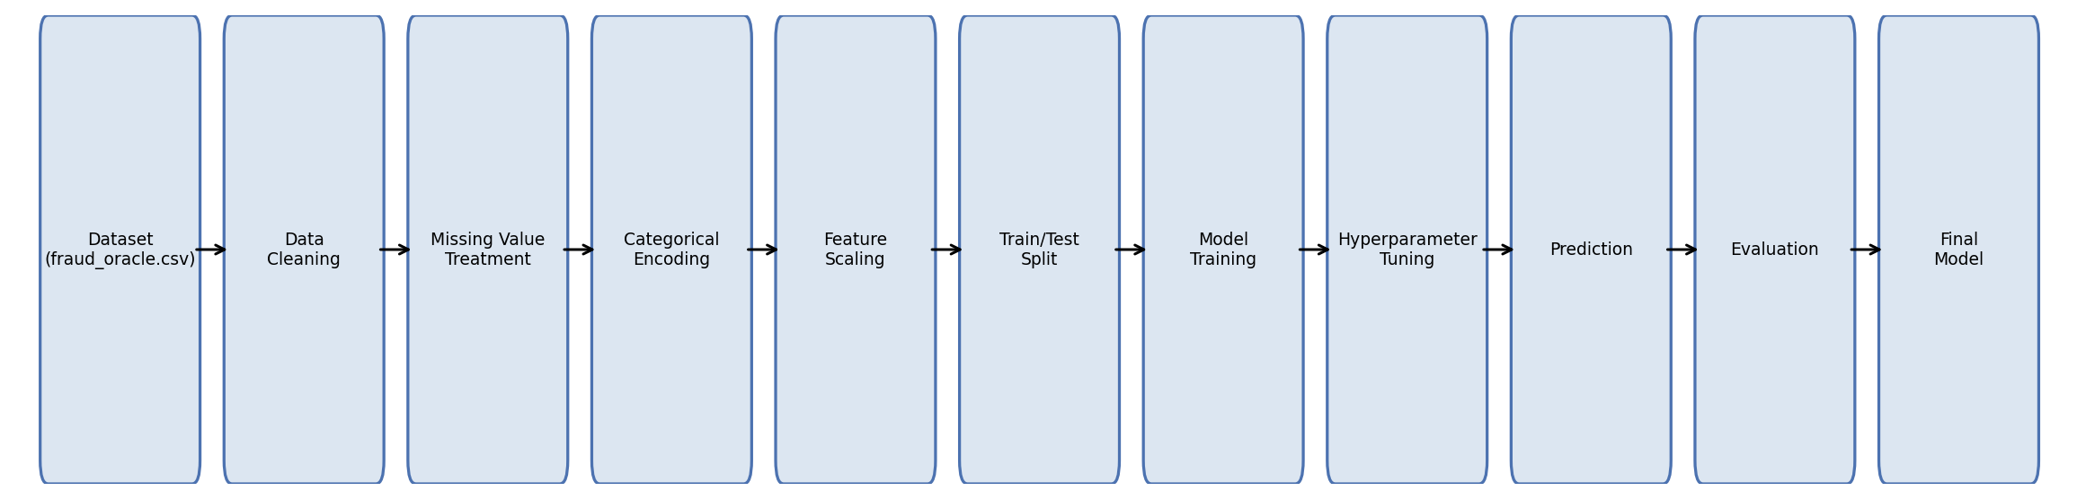
Figure 3.1: Proposed system flow for insurance claim fraud detection

3.2 Dataset Description
The dataset used is the publicly available 'Vehicle Insurance Claim Fraud Detection' dataset (fraud_oracle.csv) sourced from Kaggle. It contains 15,420 historical vehicle insurance claim records with 33 attributes, including policyholder demographics (Age, Sex, MaritalStatus), claim timing information (Month, WeekOfMonth, DayOfWeek, Days_Policy_Accident, Days_Policy_Claim), vehicle details (Make, VehicleCategory, VehiclePrice, AgeOfVehicle), claim history (PastNumberOfClaims, AddressChange_Claim), and incident circumstances (AccidentArea, Fault, PoliceReportFiled, WitnessPresent). The target variable, FraudFound_P, is binary: 0 for genuine claims (14,497 records, approximately 94%) and 1 for fraudulent claims (923 records, approximately 6%), indicating a significant class imbalance.

3.3 Experimental Setup
- Programming Language: Python 3.x
- Environment: Jupyter Notebook / Google Colab
- Key Libraries: pandas, numpy, scikit-learn, xgboost, matplotlib, seaborn
- Hardware: Standard laptop / Colab cloud runtime (no GPU required for this dataset size)

3.4 Data Preprocessing
- Data inspection and schema validation (checked column types and target distribution)
- Duplicate record check (none found)
- Missing-value analysis (no null values found); anomaly imputation of 320 invalid Age = 0 entries using the median age
- Categorical encoding of 24 text columns using One-Hot Encoding (handle_unknown='ignore')
- Numerical scaling of 7 numeric columns using StandardScaler (zero mean, unit variance)
- Dropped the PolicyNumber identifier column to prevent data leakage
- Stratified train/test split (80/20) to preserve the original class ratio in both sets

3.5 Exploratory Data Analysis
Exploratory analysis was performed to understand class balance and relationships between key features and the fraud label.
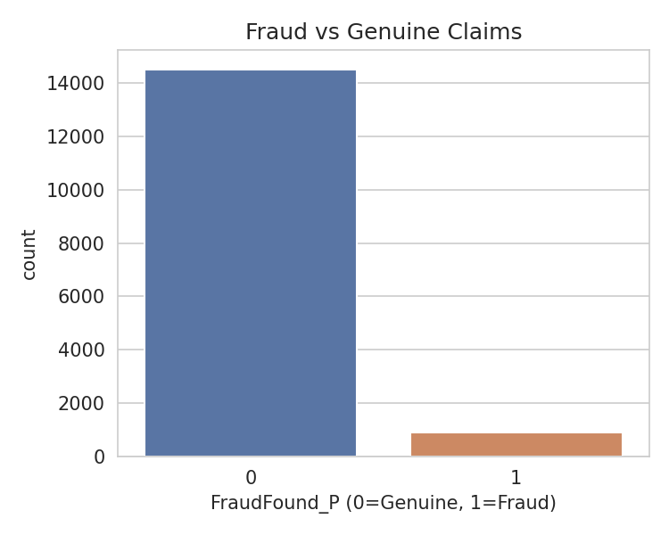
Figure 3.2: Fraud vs. Genuine claim distribution
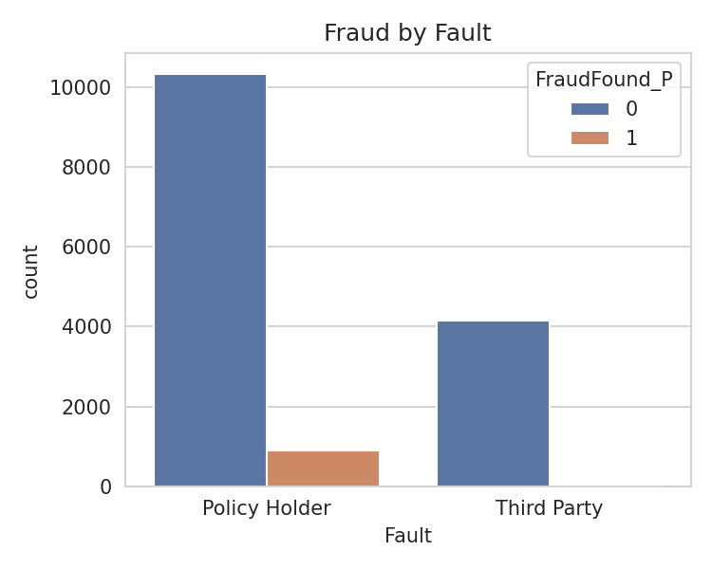
Figure 3.3: Fraud distribution by Fault (Policy Holder vs. Third Party)
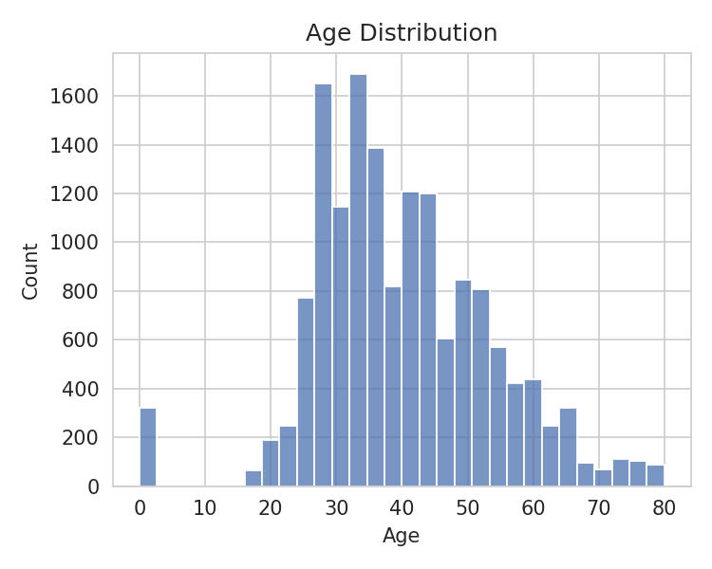
Figure 3.4: Age distribution of policyholders
The EDA confirmed a severe class imbalance (~6% fraud) and revealed that almost all fraudulent claims occur when the policyholder (rather than a third party) is at fault, suggesting Fault is a strong candidate predictive feature.

3.6 Feature Engineering and Feature Selection
Categorical features were transformed via one-hot encoding, expanding the feature space from 32 input columns to 145 numeric features. Numerical features were standardized to ensure comparable scales. No columns were removed based on correlation analysis since tree-based models such as XGBoost are robust to multicollinearity; however, PolicyNumber was removed as it is a non-predictive identifier that could otherwise cause data leakage.

3.7 Model Building and Training
Four classification models were trained for comparison: Logistic Regression, Decision Tree, Random Forest, and XGBoost. All models were trained with class-weighting (class_weight='balanced' for scikit-learn models, scale_pos_weight for XGBoost) to compensate for the class imbalance, since without this adjustment models tend to predict the majority (genuine) class almost exclusively.

3.8 Hyperparameter Tuning
Hyperparameter tuning for the XGBoost model was performed using RandomizedSearchCV with 3-fold cross-validation, optimizing for F1-score. The search space covered max_depth {3,5,7,9}, learning_rate {0.01, 0.05, 0.1, 0.2}, n_estimators {100, 200, 300}, subsample {0.6, 0.8, 1.0}, and colsample_bytree {0.6, 0.8, 1.0}. The best configuration found was: max_depth=5, learning_rate=0.05, n_estimators=300, subsample=0.6, colsample_bytree=0.8.

3.9 Model Evaluation
Since the dataset is highly imbalanced, accuracy alone is an insufficient metric. Models were therefore evaluated using Accuracy, Precision, Recall, F1-score, and ROC-AUC, with particular emphasis on Recall and F1-score, since failing to detect actual fraud (false negatives) is more costly to an insurer than occasionally flagging a genuine claim for review (false positives).

4. Results and Discussion

4.1 Preprocessing Results
- Missing values before and after cleaning: 0 (no nulls present in the raw dataset)
- Anomalous Age = 0 entries identified and corrected: 320 records
- Duplicate rows found: 0
- Dataset dimensions before encoding: 15,420 rows x 33 columns
- Dataset dimensions after one-hot encoding and scaling: 15,420 rows x 145 features
- Train/test split: 12,336 training records / 3,084 test records (80/20, stratified)

4.2 Model Performance
Model | Accuracy | Precision | Recall | F1-score | ROC-AUC
Logistic Regression | 0.6433 | 0.1319 | 0.8865 | 0.2297 | 0.8064
Decision Tree | 0.6326 | 0.1274 | 0.8757 | 0.2224 | 0.7985
Random Forest | 0.9407 | 0.75 | 0.0162 | 0.0317 | 0.8333
XGBoost (Default) | 0.8791 | 0.2219 | 0.4054 | 0.2868 | 0.8301
XGBoost (Tuned) | 0.8019 | 0.1821 | 0.6595 | 0.2854 | 0.8446

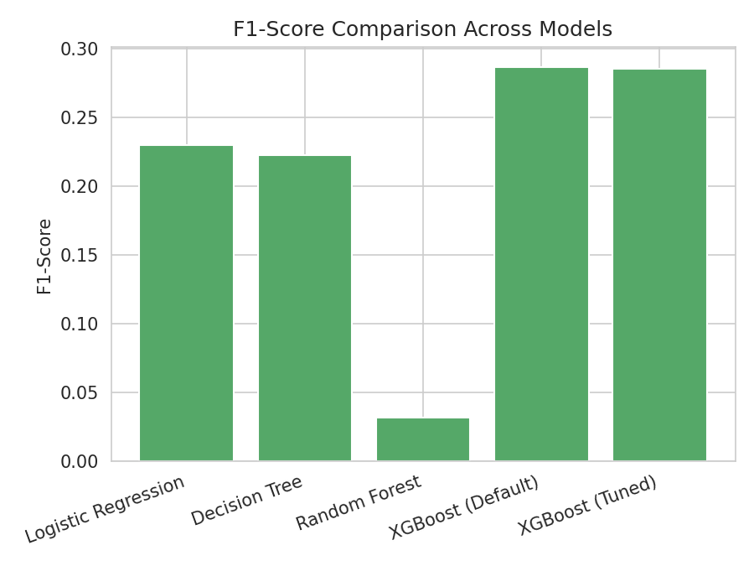
Figure 4.1: F1-score comparison across models

4.3 Visual Results and Discussion
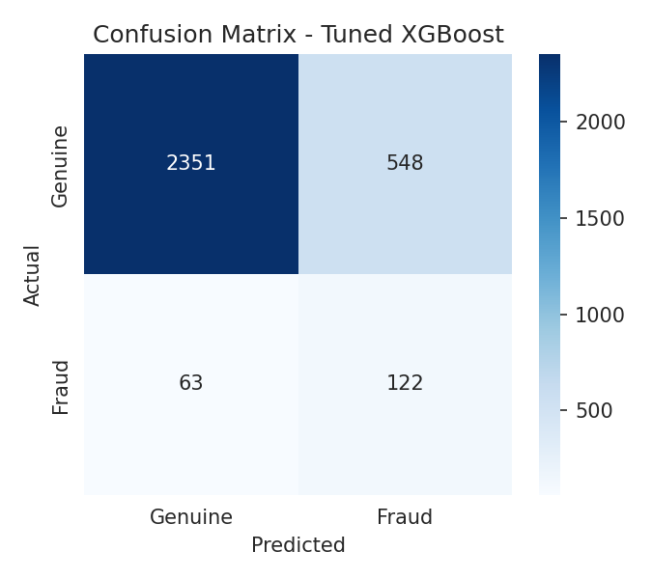
Figure 4.2: Confusion matrix of the tuned XGBoost model on the test set
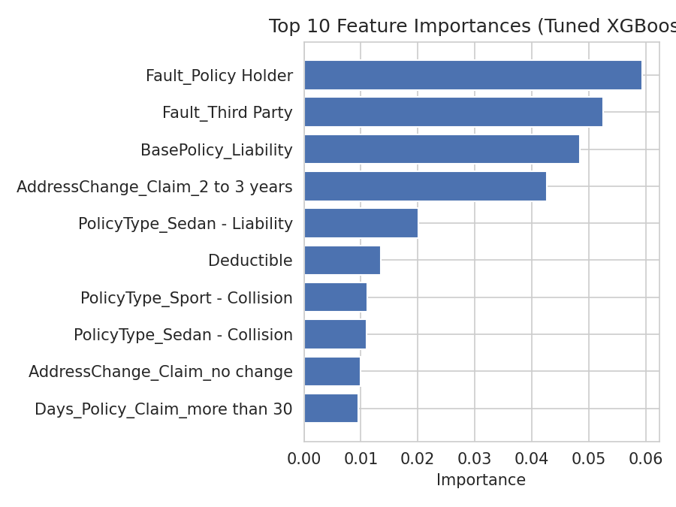
Figure 4.3: Top 10 feature importances from the tuned XGBoost model
The results show a clear trade-off across models. Logistic Regression and the Decision Tree achieve very high recall but very low precision, meaning they catch most fraud cases but also incorrectly flag a large number of genuine claims. Random Forest shows the opposite problem: very high accuracy and precision but extremely low recall (1.6%), meaning it mostly predicts the majority class and misses almost all actual fraud despite class-weighting — this is a classic symptom of severe imbalance overwhelming an ensemble of unweighted trees. The default XGBoost model offers a more reasonable balance, and hyperparameter tuning further improved recall (from 40.5% to 65.9%) and ROC-AUC (from 0.830 to 0.845), at some cost to precision and raw accuracy. This confirms the core intuition behind the project: since missing an actual fraud case is more costly to an insurer than a false alarm, the tuned XGBoost model — which maximizes F1-score during the search — provides the most practically useful trade-off among the models evaluated.
Feature importance analysis further shows that Fault (whether the policyholder or a third party was at fault), BasePolicy type, and AddressChange_Claim are the most influential predictors of fraud, aligning with the patterns observed during exploratory data analysis and with domain intuition — claims where the policyholder is at fault, or where the policyholder's address changed shortly before the claim, are more often associated with fraud.

5. Conclusion
This project developed and evaluated a machine learning pipeline for detecting fraudulent vehicle insurance claims using the XGBoost algorithm combined with systematic hyperparameter tuning. After cleaning the dataset (correcting 320 anomalous Age entries, encoding 24 categorical features, and scaling numerical features), four models were trained and compared under class-imbalance-aware settings. The results demonstrate that while simpler models such as Logistic Regression and Decision Trees achieve high recall at the cost of precision, and Random Forest achieves high precision at the cost of recall, the hyperparameter-tuned XGBoost model (max_depth=5, learning_rate=0.05, n_estimators=300, subsample=0.6, colsample_bytree=0.8) achieves the best overall balance, reflected in the highest ROC-AUC score (0.845) and a substantially improved recall over the default configuration. This confirms that combining gradient boosting with targeted hyperparameter search is an effective and practical approach for building automated insurance fraud detection systems, with Fault, BasePolicy, and AddressChange_Claim emerging as the most influential predictive features.

6. Future Work
- Use larger and more diverse insurance claim datasets, potentially combining multiple insurers' data.
- Evaluate additional algorithms and ensemble/stacking methods (e.g., LightGBM, CatBoost, stacked ensembles).
- Perform deeper hyperparameter optimization using Bayesian optimization (e.g., Optuna) for a wider search space.
- Apply explicit resampling techniques such as SMOTE or SMOTE-GAN to further address class imbalance.
- Investigate explainable AI techniques (e.g., SHAP) to improve interpretability for claims investigators.
- Evaluate model robustness and performance drift over time as fraud patterns evolve.
- Develop a deployable real-time claim-scoring application integrated with an insurer's claims workflow.

7. References
[1] Yankol-Schalck, M., & Banulescu-Radu, D. (2026). Auto insurance fraud detection: Machine learning and deep learning applications. Journal of Risk and Insurance, 93, 534-568. doi:10.1111/jori.70046
[2] Ding, N., et al. (2024). Automobile insurance fraud detection based on PSO-XGBoost model and interpretable machine learning method. Insurance: Mathematics and Economics, 120, 51-60. doi:10.1016/j.insmatheco.2024.11.006
[3] Banulescu-Radu, D., & Yankol-Schalck, M. (2024). Practical guideline to efficiently detect insurance fraud in the era of machine learning: A household insurance case. Journal of Risk and Insurance, 91(4), 867-913. doi:10.1111/jori.12452
[4] Khalil, A. A., Liu, Z., Fathalla, A., Ali, A., & Salah, A. (2024). Machine learning based method for insurance fraud detection on class imbalance datasets with missing values. IEEE Access, 12, 155451-155468. doi:10.1109/ACCESS.2024.3468993
[5] Ibrahim, M. H. K. (2024). Enhancing fraud detection in auto insurance and credit card transactions: a novel approach integrating CNNs and machine learning algorithms. PeerJ Computer Science, 10, e2088. doi:10.7717/peerj-cs.2088
[6] Gorejena, et al. (2025). Hybrid unsupervised machine learning for insurance fraud detection: PCA-XGBoost-LOF and Isolation Forest. Journal of Information Systems and Informatics, 7(1). doi:10.51519/journalisi.v7i1.958
[7] Zheng, H., Peng, F., Tian, Y., Zhang, Z., & Zhang, W. (2023). Insurance fraud detection based on XGBoost. Academic Journal of Computing & Information Science, 6(8), 68-74. doi:10.25236/AJCIS.2023.060808
[8] Insurance fraud prediction model based on eXtreme Gradient Boosting. (2024). Journal of Computational Economics and Management, 15(3). doi:10.54097/rd1m7n64
[9] Cheah, P. C. Y., Yang, Y., & Lee, B. G. (2023). Enhancing financial fraud detection through addressing class imbalance using hybrid SMOTE-GAN techniques. International Journal of Financial Studies, 11(3), 110. doi:10.3390/ijfs11030110
[10] Enhancing insurance fraud detection accuracy with integrated machine learning and statistical methods. (2025). Computational Economics. doi:10.1007/s10614-025-11074-0

Signature of the Guide

