
ACUMEN | FEASIBILITYREPORT  MVPCOURSEWORK
M V PF E A S I B I L I T YR E P O R T · 2 0 2 6
Acumen.
Practisejudgementbeforeitcounts.
Acumenhelpsemergingbusinessleaderspractiserealistic decisions, understandtheirleadershiptendencies, andconnect withpeerswhosestrengthscomplementtheirown.
PRODUCT | MODULE | GROUP47 | DATE

Acumen | MSIN0144 | DanielDutulescu | 1 May 2026
Webappprototype | GroupCoursework | MayaMunasinghe
MoritzBode

C O N T E N T S
What'sinside |  |  | 02
01 | Executivesummary
02 |  | Scopeandopportunity | 03
03 |  | Productdefinition | 04
04 |  | MVPwalkthrough | 05
05 |  | Technologyandimplementation | 07
06 |  | Businessmodel, revenueandcost | 09
07 | Marketvalidation |  | 11
08 |  | Marketattractiveness | 14
09 |  | Feasibilityandnextsteps | 17
A | Appendix · BusinessModelCanvas |  | 19
A | Appendix · ValuePropositionCanvas |  | 20
B | Appendix · Researchinstruments |  | 21
C | Appendix · Groupcharterandmeetings |  | 22
D | Bibliography |  | 24

0 1 · E X E C U T I V ES U M M A R Y
AfeasibleMVPforemergingleaders
Youngpeoplepreparingformanagementrolesaretaughtaboutleadershipbutrarelygettopractiseit. Casestudiesareabstract, internshipsarescarce, andtraditionalpsychometricsareslow, expensive, anddetachedfromtheworkitself. Acumenaddressesthisgapwithshort, scenario-drivensimulations thatsurfacehowauseractuallydecidesunderpressure.
Thebeachheadisbusinessstudents, youngprofessionals, andaspiringfounders; thepremiumlater segmentisnext-generation (NextGen) successorsinAsia-Pacificfamilybusinesseswhereleadership transitionscarrysignificanteconomicstakes[3][1]. TheMVPdemonstratesafour-steploop —Simulate, Signal, Connect, Improve — acrossthreelivewebscenarios. Themodellayersfreemium individualaccess, universitycohortpilots, andapremiumNextGenpathway; an 18-responsesurveyand
threeinterviewsgivedirectionalevidence.

Verdict.AcumenisfeasibleasanearlyMVP — thesimulation, feedback, andpeer-

discoveryloopisdemonstrated. Furtherusertestingandscoringvalidationareneeded

beforehigh-stakesuse.

Optionalquestionsaddressed: firstcustomers (§2, §7), marketsize (§2), underlyingtechnology (§5).  ACUMEN · FEASIBILITYREPORT | 02

0 2 · S C O P EA N DO P P O R T U N I T Y
Whynow, andwhothisisactuallyfor
Threeforcesconverge: agenerationofyoungleaderswholackpracticalexperience, a documentedsuccessionbottleneckinAsia-Pacificfamilybusinesses, andgrowing
acceptanceofsimulation-basedassessmentinseriousprofessionalcontexts.
WhoAcumenisbuiltfor
Acumenisbuiltforanyonedecidingearlierthanexpected — studentsrunningasocietyorcapstone, early-careerprofessionalspromotedbeforetrainingcatchesup, aspiringfoundersmakingafirsthire. Thecommonthread: theyhavereadaboutleadershipbutnotpractisedit, andthefirstpoorcallispaid inreputation. NextGensuccessorsarethehighest-willingness-to-paylatersegment, ontopofamuch
largerpoolwiththesameproblem.
SEGMENT | TRIGGERTOUSEACUMEN | WHEREWEREACHTHEM
Businessandengineering | Recruiting, societyleadership, | UCL, societypartnerships, coursetie-ins
students | capstoneprojects
Youngprofessionals (0–4 | Firstpromotion, firsthire, firstcross- | LinkedIncommunities, employerlearning & developmentprogrammes
years) | functionaldecision
Aspiringfounders | Pre-incorporation, firstco-founder | Accelerators, foundercommunities, university entrepreneurshipoffices
hire, firstinvestorpitch
NextGensuccessors | Joiningfamilybusiness, governance | Family-officenetworks, regionaladvisors
(later) | training

The "leadership-readiness" gap
Businesseducationisrichinframeworksbutpoorinpractice; internshipscompressmonthsintoweeks ofmemos, andgraduateschemesdeferdecisionauthoritytoyeartwoorthree. Seriousgames increasinglyassesssoftskills[14], andMcKinsey'sGame-BasedInnovationLabshowssimulation-basedassessmentnowsitsinsideseriousprofessionalcontexts[4].
WhyanAsia-Pacificfocus
ThepremiumsegmentisconcentratedinAsia-Pacific, wherefamilybusinessesdominateanda generationalhandoverisunderway. Between 2023 and 2030, Asia-Pacificfamiliesareexpectedto transferroughlyUSD 5.8 trilliontothenextgeneration[3]; PwCfinds43%ofIndonesianNextGenciting seniorresistancetohandover[1], andSukamdaninotesIndonesianfamilycompaniescontributeover 80% ofGDP[7]. Theanchormattersnotbecauseheirswillfunddevelopment, butbecauseitgives Acumenadefensiblereasontoexistbeyondagenericedtechpitch.
Marketsizing (top-down, 2024figures)
LAYER | DEFINITION | SIZE | SOURCE / ASSUMPTION
TAM | Globalearly-careerprofessionals + | ~50 m+ | UNESCOtertiaryenrolments; OECD 0–5 yr
business/managementstudents |  |  | graduates.
SAM | UKbusiness/managementstudents | ~250 k | HESA 2023/24 (~220 k); PwCNextGencohort
+ APACNextGenpool |  |  | [2].
SOM (Y1) | UCLbeachheadviasociety + | ~5,000 | ~200 paidusersat £9 plus 6 cohortlicences.

coursetie-ins
ACUMEN · FEASIBILITYREPORT | 03

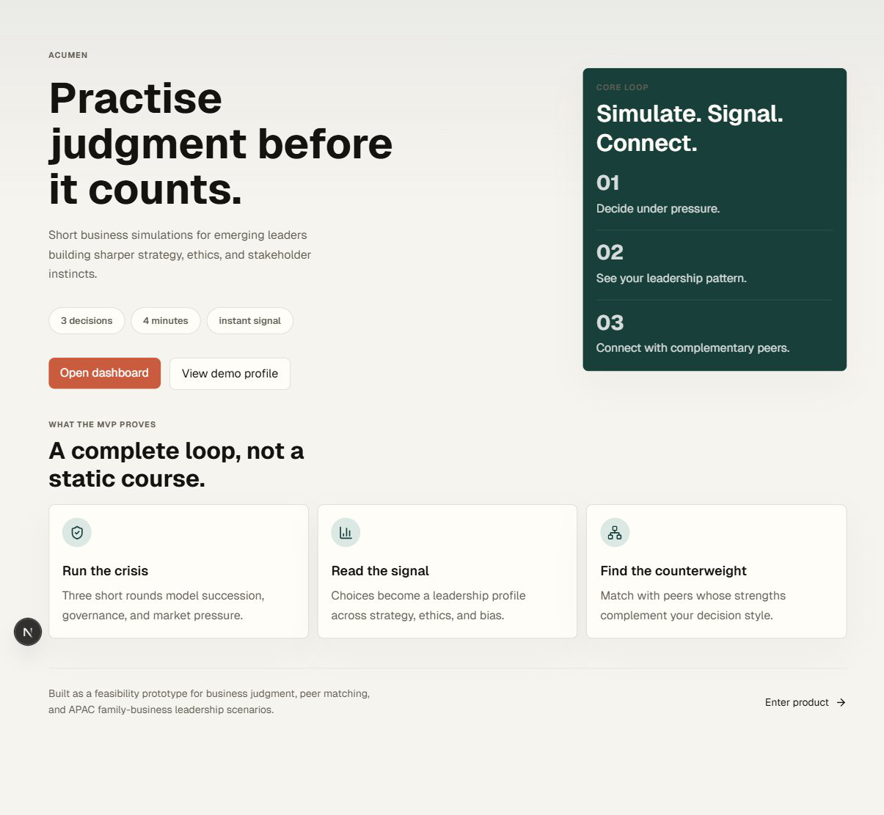
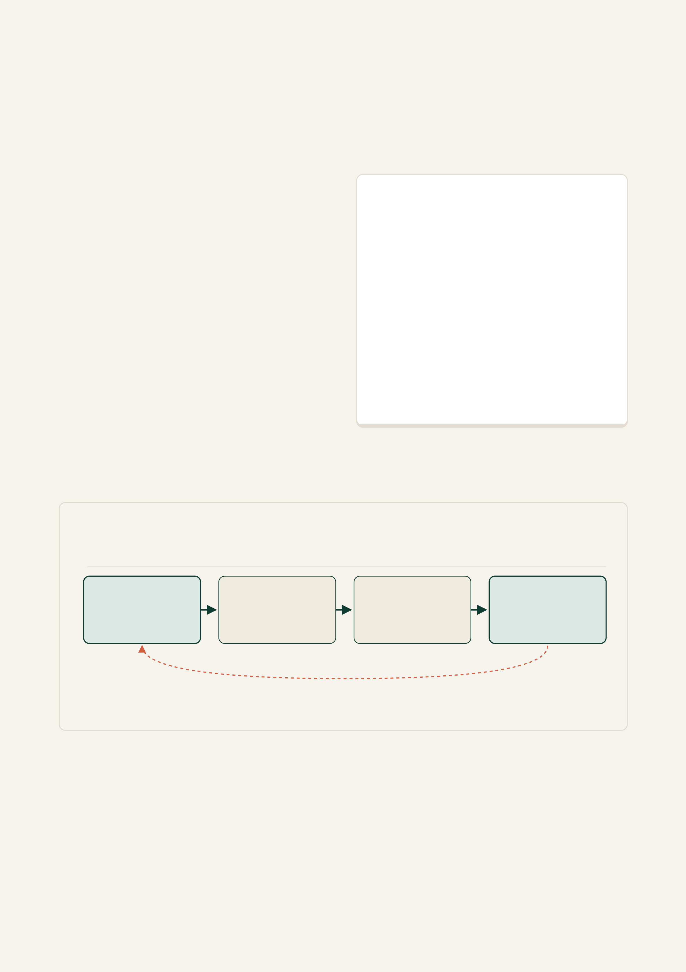
0 3 · P R O D U C TD E F I N I T I O N
WhatAcumenis
Acumenhelpsemergingbusinessleaderspractiserealisticdecisions, understandtheir leadershiptendencies, andconnectwithpeerswhosestrengthscomplementtheirown.
Theproductisonerepeatableloop. Eachsession
beginswitharealisticscenarioundertimeand
informationconstraints, thenconvertstheuser's
choicesintoaresearch-informedleadership
signal. Thesignalisdevelopmental, not
diagnostic — itpointstowardwhattopractise
nextandtowardpeerswhosestrengths
complementtheirown.
Theframingdrawsonestablishedtheory: upper-
echelons[10], Vroom-Yetton[11], Hersey-
Blanchard[12], andRest[13] — informinghow
decisions, participation, readiness, andethical
promptsarestructured.
FIG. 1Acumenintroducesasimplepromise: practise
businessjudgementbeforeitcounts.
Theproductloop
P R A C T I C E
0 1 | 0 2 | 0 3 | 0 4
SIMULATE | SIGNAL | CONNECT | IMPROVE
Realisticscenario | Leadershipprofile | Complementarypeers | Repeatandprogress
REPEA T ABLELEARNINGLOOP
FIG. 2Acumenturnsbusinesslearningintoarepeatableloop: userspractiserealisticdecisions, receivefeedback, connectwithusefulpeers, andreturntoimprove.
ACUMEN · FEASIBILITYREPORT 04

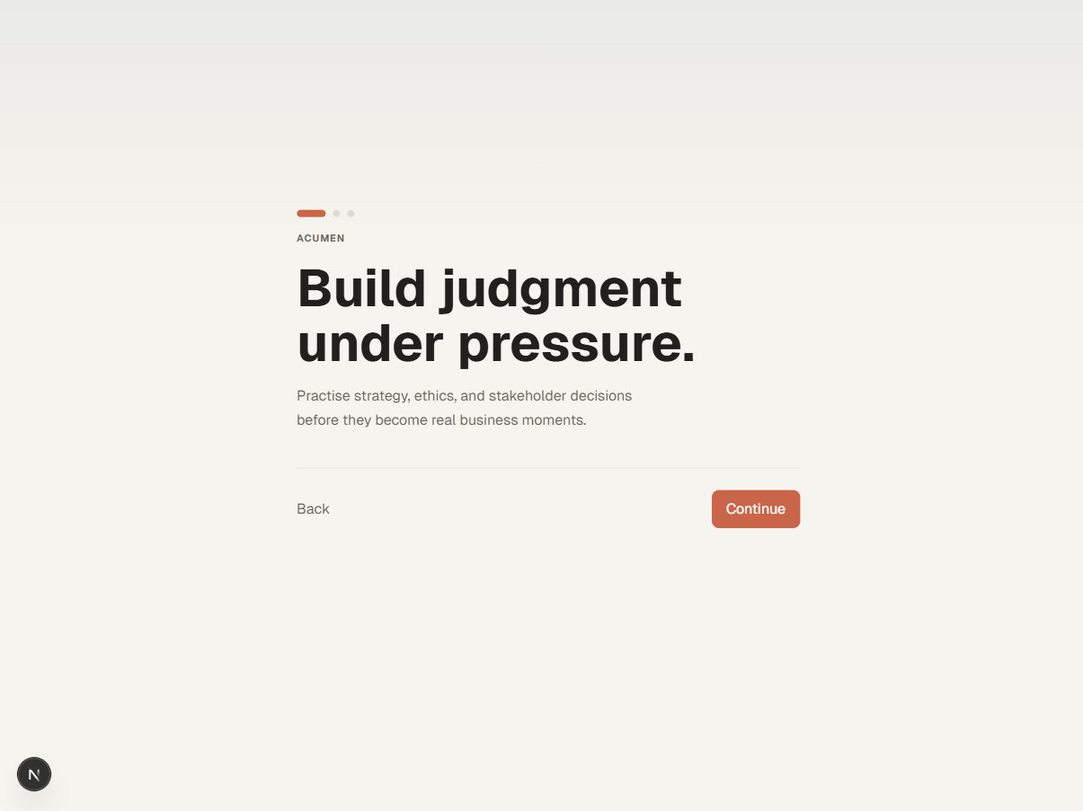
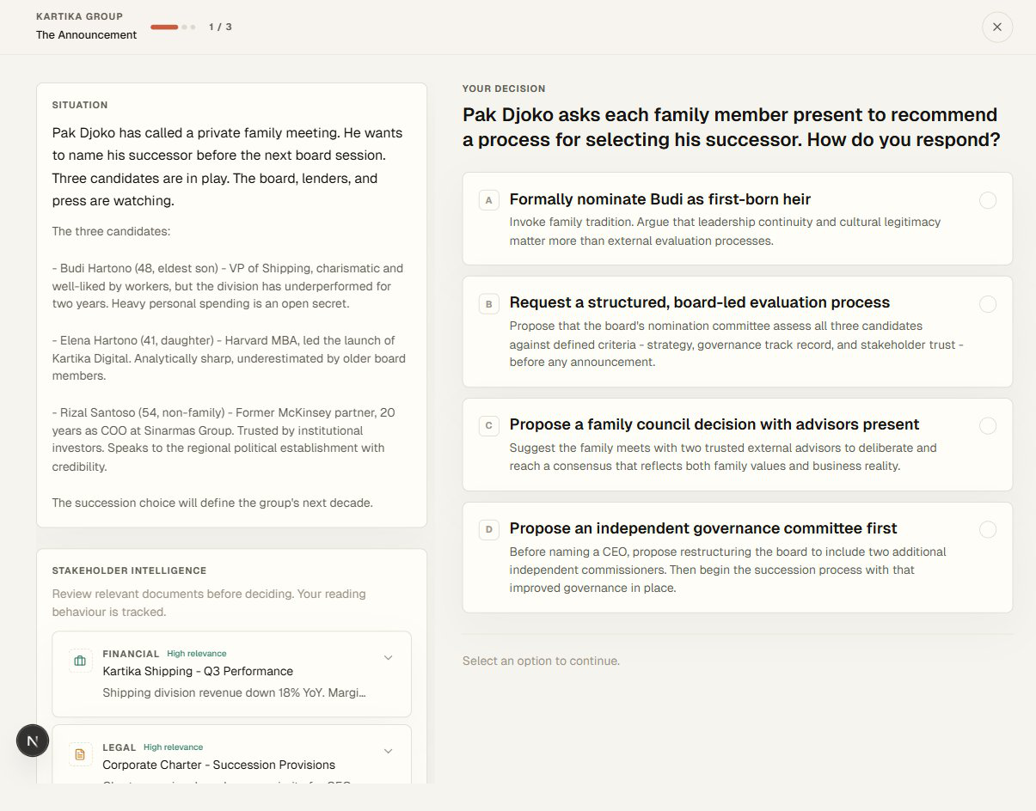

0 4 · M V PWA L K T H R O U G H
HowauseractuallyusesAcumen
ThewalkthroughshowsAcumen'scoreloop: auserentersviaasimplevalueproposition, completesasimulation, receivesaleadershipsignal, andisguidedtoward
complementarypeers.
01 | 02 | 03 | 04 | 05 | 06

L A N D I N G | O N B OA R D I N G | S I M U L AT I O N | F E E D B AC K | N E T W O R K | R E P E AT
FIG. 3TypicalAcumenusecase, shownasasequenceratherthanascreencollage.
Step1 · Onboarding
Afirst-timeuserlandsonasingle-promisehome
screenandistakenintoashortonboardingflow.
Acumenaskswhattheuserwantstodevelop:
decision-makingunderpressure, ethicaljudgement,
conflictnavigation, orstrategiccommunication.
Theseselectionsshapetheorderinwhichscenarios
appearandtheframingoffeedback.
FIG. 4Onboardingframestheexperiencearoundgoals
andskilldevelopment.
Step2 · TheSuccessionCrisis
TheuserentersTheSuccessionCrisis, ascenarioin
whichafamily-controlledmid-capbusinessmust
decidehowtohandleacontestedleadership
handover. Theuserfacessequenceddecisions
involvingapoliticallyconnectedboardmember, a
capablebutunfamiliarexternalcandidate, anda
long-servingfamilyexecutive. Eachdecisionistimed
andinformationisdeliberatelyincomplete, mirroring
realmanagementcontexts. Thescenariodrawson
successionthemesdocumentedinthePwC
Indonesiawork[1]andtheliteratureontheweightof
politicalandfamilytiesintheregion[9].
FIG. 5Thesimulationplacesusersinrealistictrade-off
decisions.
ACUMEN · FEASIBILITYREPORT 05

0 4 · M V PWA L K T H R O U G H ( C O N T. )
Fromdecisionstosignaltonetwork
Step3 · Aresearch-informedsignal  Oncethesimulationcloses, Acumenconverts  decisionpatternsintoadevelopmentalprofileacross fivedimensions: strategicjudgement, ethical  reasoning, stakeholdermanagement, decisiveness, andadaptability. Theprofileispresentedas  developmentalfeedbackratherthanahigh-stakes score. ImbellusandMcKinseypilotedandcalibrated simulation-basedassessmentwithMcKinsey  candidatesfrom 2017 [5][8]; Acumendoesnotclaim equivalentvalidationatMVPstage. | 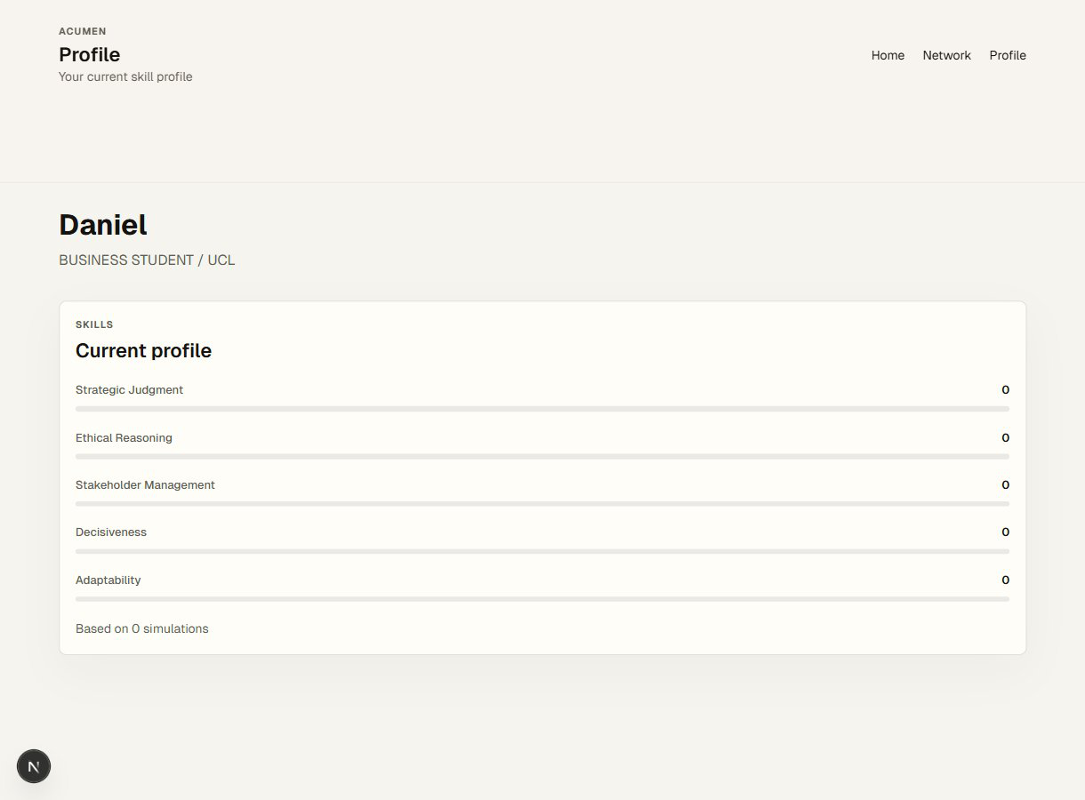
FIG. 6Feedbackconvertschoicesintoaresearch-
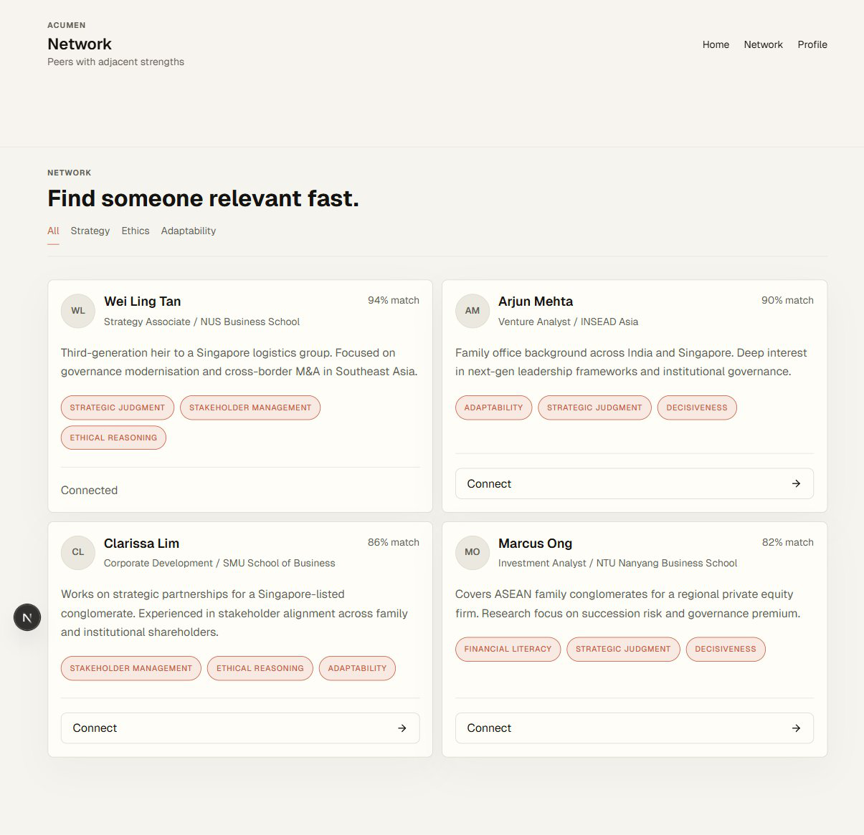 | informedleadershipsignal.  Step4 · Peermatchingassociallearning  Thesignalthensuggestspeerswithcomplementary strengths — thesamesimulatedexperience  producesacommonvocabularyforcollaboration.  MVPmatchingusesprofile-vectorsimilarityover decisiontendencies; deeperlogic, CVparsing, anda globalmapviewareroadmap.  Step5 · Repeatandtrack  Repetitionturnstheloopintolearning. Theprofile viewrecordshowauser'ssignalshiftsovertime.  TheFadingDivisionandTheAuthorityBypass broadenpracticebeyondsuccession. TheMVP demonstratesthecoresimulation–feedback–peer loop; CVparsing, maps, recruitertools, and  certificatesareroadmap, notMVP.
FIG. 7Peermatchingturnsindividualfeedbackinto
sociallearning.  ACUMEN · FEASIBILITYREPORT | 06

0 5 · T E C H N O L O G YA N DI M P L E M E N TAT I O N
Whatactuallyhastowork
Theinterfaceissimple; thecomponentsbehinditarenot. Threecarrymostofthe
productrisk — simulationengine, scoringsystem, peermatchinglayer. Everythingelseis
conventionalwebengineering.
Thethreecomponentsthatmatter
SIMULATIONENGINE | SCORINGSYSTEM | PEERMATCHING
Asmallstatemachinewith | Everychoiceistagged | Matchingsurfacespeers
fourphases (deciding, | behindthescenes. Those | withcomplementaryrather
ethical, twist, complete) | tagsrollupintofivescores | thanidenticalprofile
drivesusersthrough | describinghowtheuser | vectors. AtMVPscaleit
scenariorounds, | tendstodecide: strategic | runsagainstaseededset
stakeholderdocument | judgement, ethical | ofdemoprofiles; real
review, ethicalprompts, | reasoning, stakeholder | matchingbecomes
anddecisionselection. | management, | testableatroughlyfifty
Scenariosarestoredas | decisiveness, and | activeusers.
typeddata, nothardcoded | adaptability. Eachis
UI, sonewonescanbe | anchoredinestablished
addedwithoutrewritingthe | theory (UpperEchelons,
engine. | Rest, Vroom-Yetton,
Hersey-Blanchard, OODA).
Validationagainstexpert
ratingsisontheroadmap.

Stackandarchitecture
LAYER | CHOICE | WHY
Framework | Next.jswithReactandTypeScript | Routingacrossdistinctappviews (landing,
onboarding, simulation, feedback, profile, network);
 |  | typesmakethedatamodelself-documenting.
Styling | TailwindCSS; sharedvisualsystem | Editorialpalettestaysconsistentacrosspages
 | inglobals.css | withoutaheavydesignsystem.
Interaction | LucideReacticons; FramerMotion | Animationisrestrained; transitionspunctuatethe
 | fortransitions | loopratherthandecorateit.
State | GlobalReactcontextprovider; | Thedemojourneysurvivespagerefreshes;
 | persistedtolocalStoragewith | protectedpagesdonotredirectbeforesavedstate
 | hydrationcheck | hasloaded.
Scenariodata | Strongly-typedTypeScriptdatafiles | Newscenariosareaddedasdata, notcode. The
SuccessionCrisis, TheAuthorityBypass, andThe
 |  | FadingDivisionalreadyusethispattern.
Authanddata | Emaillogin; anonymisedprofile | Reducescompliancesurfaceandishonestwith
vectorsonly |  | usersaboutwhatiscollected.
ACUMEN · FEASIBILITYREPORT |  |  | 07

0 5 · T E C H N O L O G YA N DI M P L E M E N TAT I O N ( C O N T. )
Fromdecisiontosignal
Howadecisionbecomesasignal
Thesimulationreadsascenariofromtypeddataandpresentstheuserwithroundscontaining situations, options, andstakeholderdocuments. Thestatemachinemovestheuserthroughdeciding, optionalethicalprompts, afinaltwist, thencompletion. Oncompletion, thearrayofchosenoptionsis passedtothescoringfunction, whichmapseachdecisiontoitshiddentagsacrossthefivedimensions, appliesbiasdetection, andproducesanoverallscoreplusaVroom-Yettonstyleclassification. Theuser isredirectedtofeedback, wheretheprofileisrenderedasplain-languagesummarieswithdimension bars. Thesameprofilevectorthendrivesthenetworkview, wherepeersaresurfacedby
complementarityratherthansimilarity.
HonestlimitationsandIP
Acumenisaresearch-informedprototype, notavalidatedassessmentplatform. Scoringisframework-basedbutnotexternallyvalidatedagainstreal-worldoutcomes; matchingusesdemodata; CVparsing, globalmaps, recruitertools, andcertificatesareoutofscopeatMVP.
Whatishardtocloneisnotthecodebasebutthreethingsthatcompound: thescenariolibrary (typed datawithexpertreviewperrelease), thecalibratedfeedbackrubric (anchoredinupper-echelons, Vroom-Yetton, Hersey-Blanchard, andRest; expert-ratercalibrationisR5), andcohort-pilotnetwork density (matchingqualitygrowswithusage, soalateentrantcannotmatchdayone). Allsitwiththe
foundingteam; trade-markfilingisbudgetedinYear-1 legalcosts.  ACUMEN · FEASIBILITYREPORT | 08

0 6 · B U S I N E S SM O D E LA N DVA L U EP R O P O S I T I O N
Astagedpathtomarket
Acumen'sbusinessmodelisbuiltaroundstagedmarketentry, notasingletarget
customer. TheBusinessModelCanvasdescribesthebroadbeachhead; theValue
PropositionCanvasfocusesonthepremiumlatersegment. Therelationshipbetween
themissequential, notcontradictory.  BeachheadviatheBMC  AtMVPstageAcumenpursuesbusiness  students, youngprofessionals, andaspiring  founders. Theyarereachablethroughuniversities andsocieties. Acquisitioncostislow, willingness totestishigh, andfeedbackloopsarefast.  Revenueinthislayerisfreemium, withpaid scenariopacksandsavedprogress. | PremiumviatheVPC  TheValuePropositionCanvasfocuseson  NextGensuccessorsinAsia-Pacificfamily  businesses. Theirpainsarestructural: senior resistancetohandoverandtheabsenceofasafe spacetopractisedifficultdecisions[1]. Revenue herecomesfrominstitutionalpilots, butonlyafter theloopisprovenonthebroaderbeachhead.
Revenuestreams
Acumenrunsthreestreams: freemiumindividualconvertingtoapaidscenariopack (live), institutional
cohortlicencesforuniversitiesandsocieties (inoutreach), andapremiumNextGenprogramme
(roadmap).
STREAM | PRICEPOINT | YEAR-1 TARGET | YEAR-1 REVENUE (ILLUSTRATIVE)

 |  | VOLUME
Individualscenariopack | £9 one-off | 1,200 unlocks | £10,800
Universitycohortlicence | £1,500 persociety | 6 institutions | £9,000

 | / cohort
NextGenpilotprogramme | £8,000 percohort | 1 paidpilot | £8,000
TotalYear-1 revenue |  |  | £27,800

(target)

Conservativetarget: ~1,200 scenario-packunlocksat £9, sixcohortlicences, andoneNextGenpilot. TheSOM (§2)
leavesanorder-of-magnitudeheadroombeforesaturatingthebeachhead.
Coststructure
ThecostbaseislightatMVPstage. Dominantlinesarescenarioauthoring, serverlesshosting, anda
smallUCL-focusedmarketingbudget. Foundertimeisshadow-pricedfortransparencybutnotdrawn.
LINE | YEAR-1 | NOTES

ESTIMATE
Scenarioauthoringandexpert | £6,000 | ~20 scenariosatMVPcost; expertreviewoncontributor agreement.
review
Hostingandinfrastructure | £1,200 | Serverlessbackend; costscaleswithusage.
Marketingandacquisition | £3,500 | UCLsocietyevents, targetedLinkedIn, content.
Tooling, design, legal | £2,300 | Trade-markfiling, designtooling, contractorsupport.
TotalYear-1 cost | £13,000 | Foundertimeisshadow-priced, notdrawn.
ACUMEN · FEASIBILITYREPORT |  | 09

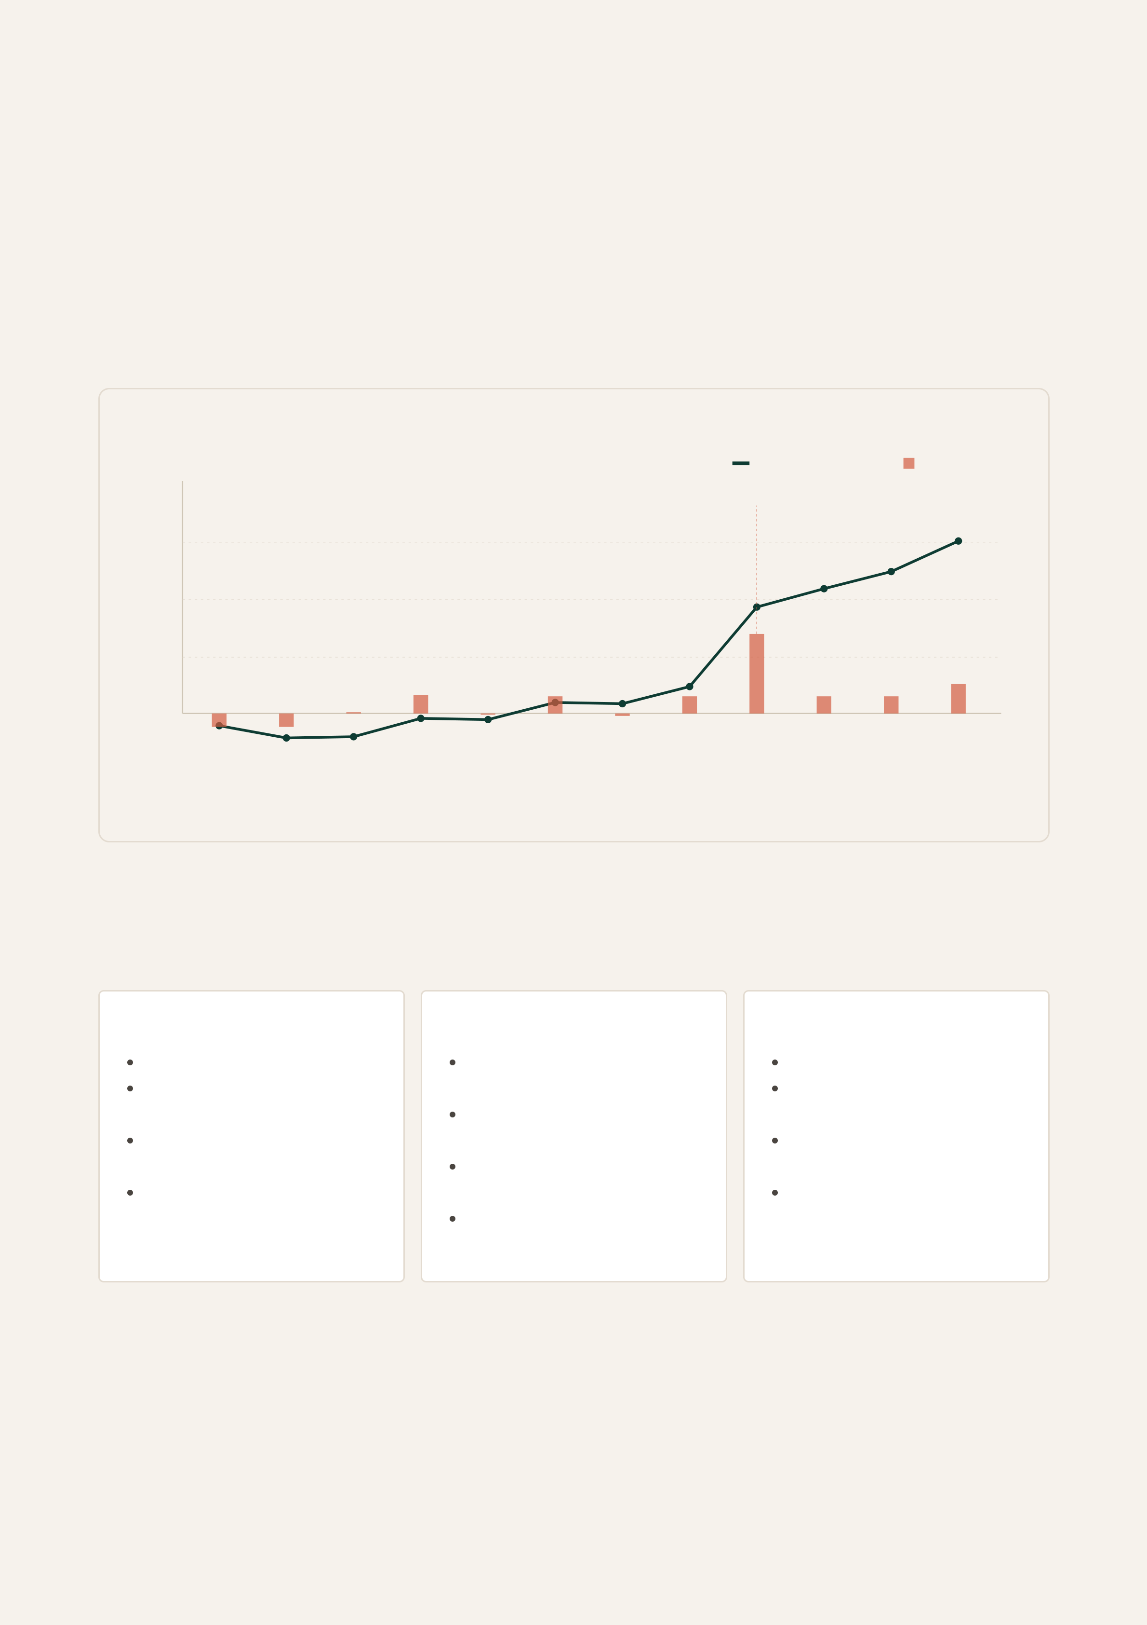
0 6 · B U S I N E S SM O D E L ( C O N T. )
First-yearcashflowandroadmap
Monthlyandcumulativecashflow
ThechartbelowtracesaconservativeYear-1 trajectoryunderthevolumetargetsabove. Themodel assumesindividualscenariorevenuerampsfrommonththree (afterthefirstcohortpilotdrivesword-of-mouth), theuniversitycohortlicenceslandinmonthsfour, six, eight, ten, andeleven, andthesingle NextGenpilotclosesinmonthnine. Costsarespreadroughlyevenlyacrosstheyear. Netmonthlycash flowturnspositiveinmonthfour; cumulativecashflowendsYear 1 atapproximately£14,800.
Cumulativecashflow Netmonthlycashflo£20k
NextGenpilotlands
£15k
£10k
£5k
£0
M1 | M2 | M3 | M4 | M5 | M6 | M7 | M8 | M9 | M10 | M11 | M12
FIG. 8Year-1 cashflowprojection. Conservativeramp; foundertimeshadow-priced. Cumulativecashflowends Year 1 atapproximately £14,800.
Now / Next / Later
NOW · MVP | NEXT · 6–12MONTHS | L ATER · 12–24MONTHS
Threelivewebscenarios | iOSandAndroidbuildfor | Institutionalpilotsatscale
Research-informed | publiclaunch | Verifiedcompletion
feedbackprofile | Additionalscenariosacross | certificates
Peerdiscoveryviaprofile | functions | NextGensuccession
similarity | UCLandsocietycohort | pathway
Freemiumpluspaid | pilots | B2Badvisoryorrecruiter
scenariopack | Firstpayinginstitutional | tools
licence
OutofscopeatMVP.CVparsing, globalmapmatching, paidcertificates, recruiterdashboards, andfully validatedscoringsitontheroadmapratherthaninthecurrentproduct.
ACUMEN · FEASIBILITYREPORT 10

0 7 · M A R K E TVA L I DAT I O N
Whatusershavetoldussofar
Threeexploratoryinterviewsandashortstudentsurveywereusedtotestearly assumptionsabouttheproblemandtheproposedsolution. Samplesizesaresmall, so findingsaredirectionalratherthanconclusive. Theyaremostusefulforsurfacing hypothesestotestinthenextcohort, notforprojectingmarketbehaviouratscale.
Howweranit
Threein-depth, semi-structured 20–25 minuteinterviews — afinal-yearUCLstudent, anearly-career professionalinafirstmanagementrole, andapre-incorporationfounder — followedathree-partguide: painpoints, conceptreactionafterprototypewalkthrough, andwillingnesstopay (fullguidein AppendixB). Aparallelfive-questionsurveythroughUCLstudentnetworksreturned18 responses (12
students, 4 early-career, 2 founders) — directional, notrepresentative.
Surveysnapshot, n = 18 |  | Voicesfrominterviews
Fewchancestopractisejudgement | 15 / 18 | "Thehardestpartisnotknowingifa
 |  | decisionwasactuallyagoodone. You
WantfeedbackonhowIdecide | 13 / 18 | makethecall, thingshappen, andyou
Networkingeventsfeeltransactional | 11 / 18 | neverreallygettoldwhyitworkedor
 |  | didnot."
Wouldtrya 15-minutesimulation | 12 / 18 | INTERVIEWEEA · FINAL-YEARSTUDENT
Wouldpayforadvancedscenarios | 5 / 18
Respondentsagreeingorstronglyagreeingona 5-pointscale. Smallsample; treatasdirectionalonly. |  | "LinkedInisfineforthephotoofyou ataconference. Itisnotwhereyou
findthepersonyouwouldactually
FIG. 9Problem-statementagreement, n = 18. | phonebeforeahardmeeting. Iwould payifatoolgenuinelygotmebetterat
decidingunderpressure, andmetme
twoorthreepeoplethroughitIwanted
toknow."
INTERVIEWEEB · EARLY-CAREER
PROFESSIONAL
"IamnotsurewhyIneedtopractise
leadershipwhenIamtryingtostart
myownbusinessbutIwillnotbe
employinganyoneanytimesoon,
therearemoreimportantskillstobe
workingon."
INTERVIEWEEC · ASPIRINGFOUNDER,
ACUMEN · FEASIBILITYREPORT | PRE-INCORPORATION | 11

0 7 · M A R K E TVA L I DAT I O N ( C O N T. )
Reactiontotheprototype
EachintervieweewaswalkedthroughtheAcumenprototypeafterthepain-pointdiscussion. The 12
surveyrespondentswhoindicatedopennessansweredthesameclosingpromptsinfreetext. Three
signalstosurface: intentiontouse, perceivedvalue, andthedissentingview.
INTENTIONTOTRY |  | REACTIONSENTIMENT |  | WILLINGNESSTOPAY
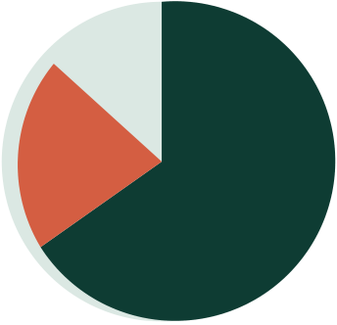 |  | 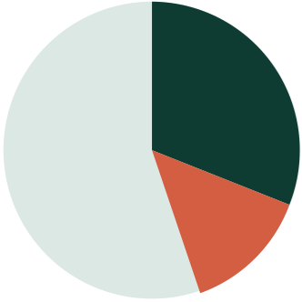 |  | 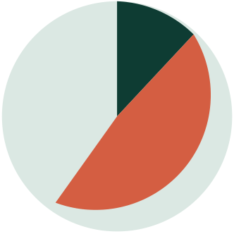
 | Wouldtry, 70% |  | Positive, 56% |  | Forskill, 26%
 | Maybe, 22% |  | Constructiveconcern, 30% |  | Conditional, 56%
 | No, 8% |  | Sceptical, 14% |  | No, 18%
n = 18 survey + 3 interviews |  | n = 18 + 3, free-textcoded |  | n = 18 + 3, free-textcoded
FIG. 10Threepiechartsofpost-prototypereactionacrosssurveyfree-text (n = 18) andinterviews (n = 3), coded
bytheteam.  Whatpeoplemostwantfromtheloop | Whythefounderconcernmatters

FeedbackIcanacton |  |  |  |  |  |  |  |  |  |  |  |  |  |  |  |  |  |  |  |  |  |  |  |  |  |  |  |  | 11 / 12 |  |  |  |  | IntervieweeC — thefounder — isthemost
 |  |  |  |  |  |  |  |  |  |  |  |  |  |  |  |  |  |  |  |  |  |  |  |  |  |  |  |  |  |  |  |  |  | strategicallyusefulvoiceofthethree. Atvery
 |  |  |  |  |  |  |  |  |  |  |  |  |  |  |  |  |  |  |  |  |  |  |  |  |  |  |  |  |  |  |  |  |  | earlyfounderstage, decisionpracticefeelsless
 |  |  |  |  |  |  |  |  |  |  |  |  |  |  |  |  |  |  |  |  |  |  |  |  |  |  |  |  |  |  |  |  |  | urgentthanproductorfundraising; thesame
Realscenarios, notabstractcases |  |  |  |  |  |  |  |  |  |  |  |  |  |  |  |  |  |  |  |  |  |  |  |  |  |  |  |  | 9 / 12
 |  |  |  |  |  |  |  |  |  |  |  |  |  |  |  |  |  |  |  |  |  |  |  |  |  |  |  |  |  |  |  |  |  | concernappearedinthreefounderfree-text
Usefulpeerconnections |  |  |  |  |  |  |  |  |  |  |  |  |  |  |  |  |  |  |  |  |  |  |  |  |  |  |  |  | 8 / 12 |  |  |  |  | responses. Theresponseisnottowiden
 |  |  |  |  |  |  |  |  |  |  |  |  |  |  |  |  |  |  |  |  |  |  |  |  |  |  |  |  |  |  |  |  |  | Acumen'sscopebuttopositionithonestly — it
Short, repeatablesessions |  |  |  |  |  |  |  |  |  |  |  |  |  |  |  |  |  |  |  |  |  |  |  |  |  |  |  |  | 7 / 12
 |  |  |  |  |  |  |  |  |  |  |  |  |  |  |  |  |  |  |  |  |  |  |  |  |  |  |  |  |  |  |  |  |  | helpsanyonedecidingearlierthanexpected, not
 |  |  |  |  |  |  |  |  |  |  |  |  |  |  |  |  |  |  |  |  |  |  |  |  |  |  |  |  |  |  |  |  |  | asareplacementforproductorcommercial
Mobile-friendly |  |  |  |  |  |  |  |  |  |  |  |  |  |  |  |  |  |  |  |  |  |  |  |  |  |  |  |  | 11 / 12
 |  |  |  |  |  |  |  |  |  |  |  |  |  |  |  |  |  |  |  |  |  |  |  |  |  |  |  |  |  |  |  |  |  | skill-building.
Verifiablecertificate |  |  |  |  |  |  |  |  |  |  |  |  |  |  |  |  |  |  |  |  |  |  |  |  |  |  |  |  | 2 / 12

Featuresmentionedunpromptedinfree-textbythe 12

surveyrespondentswhosaidtheywouldtryAcumen.

FIG. 11Featurementionsinconcept-reactionfreetext, n =

12.  ACUMEN · FEASIBILITYREPORT | 12

0 7 · M A R K E TVA L I DAT I O N ( C O N T. )
Whatweheard, andwhatchanged
Patternsacrossthethreeinterviews
Withonlythreeconversations, wereportwhatwassaidratherthanhowmanyagreed. Thematrixbelow records, perinterviewee, whethereachtopicwasraisedunprompted, raisedafterprompting, ornot
raised — arecord, notaquantitativefinding.
TOPIC | A · STUDENT | B · PRO | C · FOUNDER
Wantedfeedbackonpastdecisions | ●Unprompted | ◐Afterprompt | ○Notraised
LinkedIn-stylenetworksfeltshallow | ●Unprompted | ●Unprompted | ◐Afterprompt
Preferredinteractiveovercourse-style | ●Unprompted | ●Unprompted | ●Unprompted
Wouldprefertouseonmobile | ●Unprompted | ●Unprompted | ●Unprompted
Concernedaboutthinuserbaseat | ○Notraised | ●Unprompted | ◐Afterprompt

launch
Scepticalof "scoring" framing | ◐Afterprompt | ●Unprompted | ◐Afterprompt
Scepticalofleadershippracticeasa | ○Notraised | ○Notraised | ●Unprompted

priority
Wouldpayforskill, notcertificates | ◐Afterprompt | ●Unprompted | ◐Afterprompt

●Raisedwithoutprompting◐Raisedafterprompt○Notraisedinthisinterview
Whatchangedbecauseoftheinterviews
Fourproductdecisionsfollowed: theleadershipsignalwasreframedasdevelopmental, notdiagnostic; peermatchingmovedearlierinthejourney; themobilebuildwaspromotedfrom "later" to "launch" (all threeintervieweespreferredphoneuse); copyandonboardingwererewrittentobehonestabout scope.
Thecold-startconcern
IntervieweeBraisedthesharpestconcern: "thematchingonlyworksifthereareactuallypeopleinthere worthmeeting."Response: acohort-pilotmodel — closedUCLsocietypilotssoeveryonestartsonthe sameday, guaranteeingameaningfulnetworkatfirstcontact.
Whatstillneedstesting
ThreeopenquestionsinformR1, R2, R6: whetherusersreturn, whetherthesignalisunderstoodwithout afacilitator, andwhetherasocietysignsapayingpilot. Nextvalidation: a 40-userUCLcohortwith
telemetryoncompletion, return, andpeer-messagerates.  ACUMEN · FEASIBILITYREPORT | 13

0 8 · M A R K E TAT T R AC T I V E N E S S
SWOTandcompetitivestructure
Twoshortanalyses: SWOTforinternalposition, Porterforexternalmarketstructure.
SWOT |  | WEAKNESSES
STRENGTHS
 | Clearsimulation-basedMVP |  | Scoringisresearch-informed, notvalidated
 | Stronglinktoleadershipreadinessresearch |  | Peermatchingisstilldemodata
 | Broadstudentbeachheadwithpremium |  | Someroadmapfeaturesarenotimplemented
NextGenpathway |  |  | Needsmoreusertestingbeforestronger
 | Differentiatedblendofdecisionpracticeand | claims

networking |  | THREATS
OPPORTUNITIES
 | Universitiesandsocietiescanprovideearly |  | GenericAIcoachingtoolsmaylooklike
cohorts |  | substitutes
 | APACfamily-businesssuccessionisahigh- |  | McKinsey, LinkedIn, Coursera, orassessment
valuelatermarket |  | firmscouldmoveintosimulations
 | Simulationscanbecomemoreculturally |  | Weakvalidationcoulddamagecredibility
specificovertime |  |  | Usersmayseefeedbackasgenericifnot
 | Peernetworkcancreateretentionifenough | explainedwell

usersjoin

WhattheSWOTactuallytellsus
Strengthsclusteraroundclarityanddesign — theloopiseasytoexplain, researchgroundingis
verifiable, andthepractice + networkpropositionisdifferentiated. Weaknessesclusteraroundproof:
thefeedbackmodelisresearch-informedbutnotcalibrated, matchingusesdemodata. Opportunities
areaddressableshort-termviacohortpilots; threatsarecompetitive, sharpeningthecaseforvalidation
overfeaturebreadth. Closingtheevidencegapmattersmorethanbuildinganythingnew.  ACUMEN · FEASIBILITYREPORT | 14

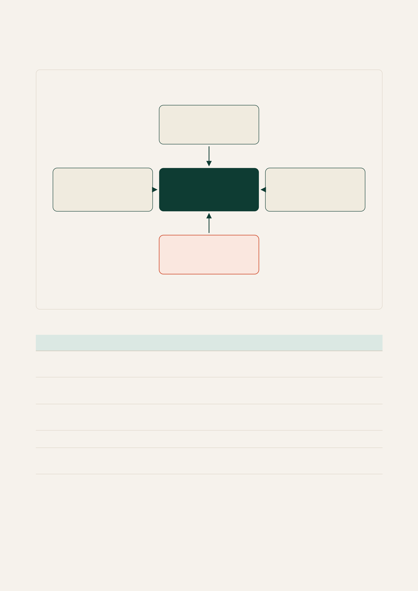
0 8 · M A R K E TAT T R AC T I V E N E S S ( C O N T. )
Porter'sFiveForces
T OP
THREATOFNEWENTRANTS
MediumtoHigh
UIiseasytocopy; trustisnot
LEFT | CENTRE | RIGHT
SUPPLIERPOWER | COMPETITIVERIVALRY | BUYERPOWER
Medium | Medium | Medium
Scenarioauthors, expertreview |  | Aggregatedviainstitutions
 | Adjacentlearningplatformsstrong
BO TT OM
THREATOFSUBSTITUTES
High
AItutors, MOOCs, mentoring, casepractice
FIG. 12Porter'sFiveForces, withAcumen'sinterpretationofpressureoneachforce.
FORCE | PRESSURE | REPORTPOINT
Competitiverivalry | Medium | Fewdirectcompetitorscombinesimulations, feedback, andpeer
matching; adjacentplatformsarestrong.
Threatofsubstitutes | High | AItutors, LinkedInLearning, Coursera, mentoring, andcase
practicesubstituteeasily.
Buyerpower | Medium | Studentsarepricesensitive; universitiesandsocietiesaggregate
demand.
Supplierpower | Medium | Scenarioqualityandcredibilitydependonexpertinput.
Threatofnew | Medium- | UIiseasytocopy; crediblescoring, contextualscenarios, and
entrants | High | networkdensityareharder.
WhereAcumenactuallycompetes
Thestrongestpressureisfromsubstitutes — AItutors, Coursera, mentors, casebooks — allcheaper.
Acumenwins, ifatall, byofferingwhattheydonot: structureddecisionsunderpressure, defensible
feedback, andapeerwhomadethesamecalldifferently. UIclonesinweeks; calibratedfeedbackand
activenetworkdensitydonot.
ACUMEN · FEASIBILITYREPORT 15

0 8 · M A R K E TAT T R AC T I V E N E S S ( C O N T. )
Fromresearchtoproductdecisions
Theevidencemapshowshoweachresearchfindingtranslatedintoaproductdecision —
Acumenisdesignedagainstaspecificbodyofresearch, notagenericedtechidea.
RESEARCHFINDING | PRODUCTDECISION
Successionandgovernancearehigh-stakesin | Usesuccessionandgovernancescenariosas
APACfamilybusinesses[1][2] | flagshipandpremiumcontent.
IndonesianfamilycompaniesarecentraltoGDP | Anchorscenariostakesinrealisticregionalbusiness
andmarketcapitalisation[7] | contexts.
Politicalandfamilytiesshapedecisionsin | Buildpoliticallyconnectedstakeholdersintoscenario
regionalcontexts[9] | decisiontrees.
Youngusersneedpracticalbusinesslearning, | Launchwithshortinteractivesimulationsratherthan
notmorecontent | longcourses.
Seriousgamescansupportsoft-skillassessment | Useinteractivedecisionsimulationsastheunitof
[14] | practice.
Game-basedassessmentisusedinserious | FrameAcumenagainstanexistingprofessional
professionalsettings[4][5] | precedentratherthanasanovelty.
Peernetworkssupportlearningandopportunity | Addcomplementarypeermatchingdirectlytothe
discovery | loop.
Assessmentvaliditytakestimeanddata[8] | Framescoringasresearch-informed, notvalidated, at

MVPstage.

Eachproductdecisionistraceabletoafinding, notintuition, andwherethefindingisweaktheframing
softensaccordingly. Scoringisdescribedasresearch-informedratherthanvalidatedbecauseImbellus andMcKinseytookyearsandalargedatasettocalibrateequivalentinstruments[5][8]. Theflagship scenarioisanchoredintheregionmoststressedbysuccession[1]; thebroaderlibraryisnotregionally
locked, keepingthebeachheadinclusiveofuserswithnofamily-businesscontext.  ACUMEN · FEASIBILITYREPORT | 16

0 9 · F E A S I B I L I T YA N DN E XTS T E P S
Abalancedverdict
Acumenisafeasibleearly-stageMVPwithacoherentbeachhead, aresearch-backed
premiumpathway, andaclearproductloop. Itsnextchallengeisnotbuildingmore
features, butvalidatingwhetheruserstrustandreturntothesimulation, feedback, and
peerloop.
WheretheMVPstandsacrossfourlenses
LENS | VERDICT | REASONING
Technical | Feasible | Scenarioengine, weighted-tagfeedbackmodel, andprofile-vectormatchingare

 |  | implementedandstable; threescenarioslive; conventional, cheapstack.
Strategic | Coherent | ReachingNextGensuccessorsviaastudent/societybeachheadisinternally

 |  | consistentandmatchestheliterature.
Commercial | Promising, | Strongontheproblem (83% agreeonlackofpractice) butsoftonwillingnessto
 | unproven | pay (34%); nopaidpilotyet — thelargestopenquestion.
Research | Backed | Leadershiptheory, successionevidence, andserious-gamesliteraturesupport
thedesign. ScoringvalidationisnotatImbellus/McKinseylevel[5][8]; wedonot
claimotherwise.

Whatwedeliberatelydonotclaim
Threecaveats: threeexploratoryinterviewsaredirectional, notproofofdemand; Acumenoffers
research-informeddevelopmentalfeedback, notvalidatedpsychometricassessment; CVparsing, global
maps, recruitertools, certificates, andfullyvalidatedscoringsitontheroadmap.
Thefivehypotheseswenowhavetotest
Listedinpriorityorder; thefirsttwocarrythemostproductrisk.
# | HYPOTHESIS |  | HOWWEWILLTESTIT | PASSTHRESHOLD
H1 | Usersreturnforasecondscenariowithin |  | CohorttrackingonaUCLpilotof | ≥ 35% returnrate.
14 daysoftheirfirst. |  |  | 40+ users.
H2 |  | Usersunderstandandtrustthe | Five-minutepost-session | ≥ 12 of 15 score 3 orabove.
leadershipsignalwithoutfacilitator |  |  | interviewswith 15 users;
explanation. |  |  | comprehensionscoringagainsta

 |  | four-pointrubric.
H3 | Auniversitysocietywillrunacohortpilot | OutreachtoUCLEntrepreneurs | Onesignedpilotagreementby
 | of 40+ members. | Society, UCLInvestmentSociety, | endofJune 2026.

H4 |  | andoneexternalsociety.
 | Usersfindpeermatchesvaluable | Telemetryonprofileviewsand | ≥ 25% ofcompletingusers
enoughtomessage. |  | outboundmessageswithinthe | sendatleastonepeer
 |  | pilotcohort. | message.
H5 | NextGensuccessorsfindscenario | Threeexploratoryinterviewswith | Qualitativeagreementonthree
realismcredible. |  | NextGencontactsviafamily- | offourscenariorealism
 |  | businessadvisors. | dimensions.
ACUMEN · FEASIBILITYREPORT |  |  | 17

0 9 · F E A S I B I L I T YA N DN E XTS T E P S ( C O N T. )
SMARTnextstepsandlimitsofthisstudy
SMARTrecommendationsforthenextsixmonths
Eachactionisspecific, measurable, achievable, realistic, andtimebound. Ownersareplaceholderstobe
filledinbytheteamatkickoff.
# | ACTION | MEASURE | DEADLINE | OWNER
R1 | Runa 40-userUCLcohortpilotofThe | 40 completed | 30 Jun | Maya
SuccessionCrisiswithtelemetryon |  | sessions; H1 and | 2026
completion, return, andpeer-message |  | H4 thresholdsmet.

 | rates.
R2 | Conduct 15 post-session | 12 of 15 score 3+ | 15 Jul 2026 | Daniel
 | comprehensioninterviewstotestthe | ontherubric.

 | feedbacksignallanguage.
R3 | Authorandshiptwonewscenarios | Bothscenarios | 31 Jul 2026 | Moritz
 | (oneoperational, oneethical) towiden | live, expert-
 | practicesurfacebeyondsuccession. | reviewedbyaUCL

 |  | facultymember.
R4 | ShipiOSandAndroidbuildsviaReact | Bothappsin | 15 Aug | Daniel
 | Native, sharingscenarioengineand | TestFlightandPlay | 2026
 | feedbackmodelwiththewebbundle. | InternalTesting;
smoketests
 |  | passing.
R5 | Calibratethefeedbackmodelagainst | Inter-rater | 31 Aug | Daniel
 | fiveexpertratersonaheld-out | agreementκ≥ 0.5 | 2026
 | scenarioset. | onthreeoffive

 |  | dimensions.
R6 | Signonepayingpilotwithasocietyor | Onesigned | 30 Sep | Maya
 | course, evenatanominalprice, totest | agreement; | 2026
 | willingnesstopay. | revenuecollected.
R7 | RunthreeexploratoryNextGen | Threecompleted | 31 Oct 2026 | Moritz
 | interviewsviafamily-business | interviewswith
 | advisorstobegintestingthepremium | notesshared
 | pathway. | internally.

Limitationsofthisstudy
Threelimitationsmattermost. Theprimaryresearchissmall (18 surveyresponses, threein-depth interviews) — figuresinSection 7 aredirectional, notrepresentative. AccesstoNextGensuccessorsis second-hand: wehavereadthePwCandMcKinseyworkbutnotinterviewedAsianfamily-business successorsdirectly. Thefeedbackmodelisnotyetcalibratedagainstexpertratings; Imbellusand McKinseyneededyearsandasubstantialdatasetforhigh-stakescalibration[5][8]. Thesearewhy scoringisframedasdevelopmentalandthecohortpilotisthemostimportantnextstep.
Theargumentinoneline
Researchshowsaleadership-readinessgap. Acumentestswhethershortsimulationscanhelp emergingleaderspractisejudgement, receiveusefulfeedback, andformvaluablepeerconnections.
TheMVPdemonstratestheloopisbuildable. Thenextsixmonths — onecohortpilot, acalibrated feedbackmodel, apayingpilot, andthreeNextGeninterviews — willtelluswhetherusersreturn, and
whethertheyreturnfortherightreasons.  ACUMEN · FEASIBILITYREPORT | 18

A P P E N D I XA
BusinessModelCanvas
ThefullAcumenBusinessModelCanvas, completedusingtheofficialStrategyzertemplate. Thecanvas describesthebroadbeachheadsegment (studentsandearly-careerprofessionals) ratherthanthe
premiumNextGentier, whichistreatedseparatelyintheValuePropositionCanvasoverleaf.

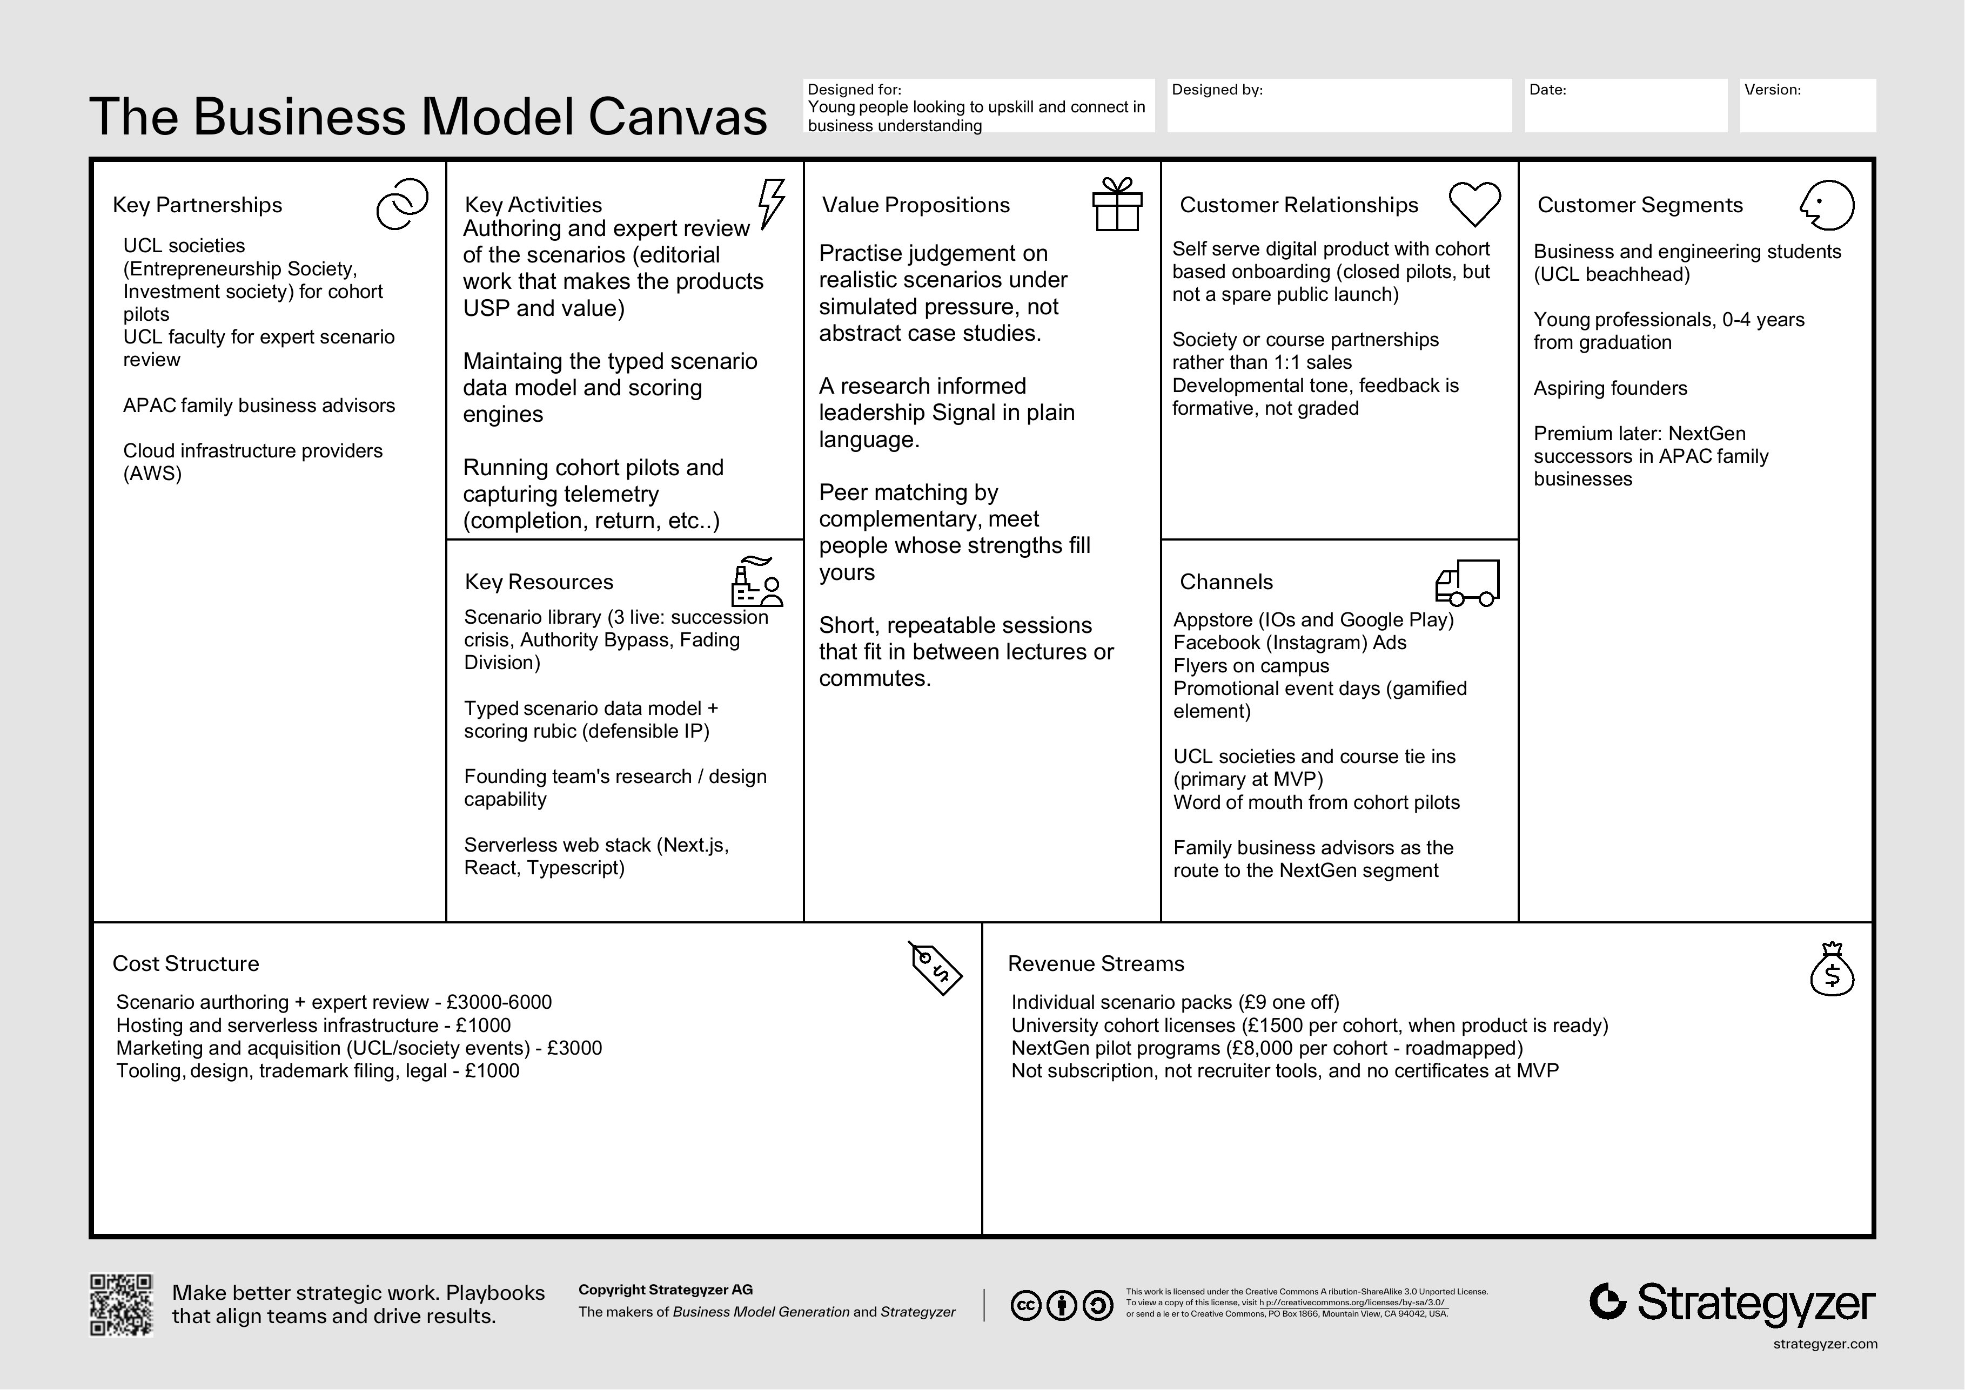

FIG. 13AcumenBusinessModelCanvas (Strategyzertemplate), beachheadview.  ACUMEN · FEASIBILITYREPORT | 19

A P P E N D I XA ( C O N T. )
ValuePropositionCanvas · NextGensegment
TheValuePropositionCanvasfocusesonthepremiumlater-stagesegment, wherewillingnesstopayis highestandthestrategicstakesmostacute: NextGensuccessorsinAsia-Pacificfamilybusinesses
preparingtotakeleadershipwithoutformaltrainingpathways.

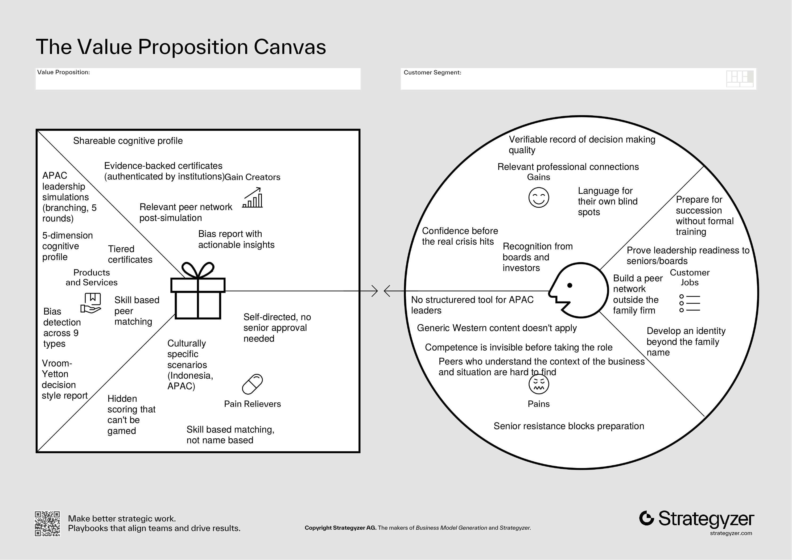

FIG. 14AcumenValuePropositionCanvas (Strategyzertemplate), NextGensuccessorsegment.  ACUMEN · FEASIBILITYREPORT | 20

A P P E N D I XB
Researchinstrumentsandarchitecture
Interviewguide · Painpointsandgaps | Interviewguide · Profitabilityandvalue
1. Whatarethekeyskillsyoubelieveleadershipand | 1. Ifthisplatformcouldgenuinelyhelpyouimprove
owningyourownbusinessrequire? | yourdecision-makingandconnectyouwiththe
2. Whatdoyoufindhardestaboutbecomingabetter | rightpeople, wouldyoupayforit?
leaderorentrepreneur? | 2. Whichofthesewouldmattermoretoyou:
3. Doyoufeellikelearningfromothers, especially | certificates, skillimprovement, networking
peoplewhoseskillsaredifferentfromyours, helps | opportunities, orcareeropportunities (iftheywere
yougrow? Ordoyouprefertoworkindependently? | good)?
4. Howeasyisitforyoutomeetpeoplewhoactually | 3. Whatwouldmakeyouactuallywanttomessageor
challengeyourthinkingorcomplementyourskills? | respondtosomeoneonaplatformlikethis?
5. Whenyouconnectwithpeopleonplatformslike | 4. Ifyoucoulddesigntheperfectplatformtobecome
LinkedIn, dothoseinteractionsactuallyleadto | abetterleader, whatwoulditlooklike?

meaningfulconversations? | Sourceauditsummary
Interviewguide · Conceptreaction
 | CLAIM | SOURCE
1. Iftherewasaplatformwhereyoucouldgothrough | USD 5.8 trillionAPACNextGenwealth | [3]
realbusinessscenariosandgetfeedbackonyour
 | transfer
decisions, howusefulwouldthatbe?
 | 43% IndonesianNextGencitingsenior | [1]
2. Haveyoueverbeeninasituationwhereyouhadto
 | resistance
makeadifficultbusinessorleadershipdecision?
Whatdidyoudo? | PwCGlobalNextGenSurvey 2024 | [2]
3. Doyoufindithardtoconnectwithpeoplethrough | sample
coldemailing, orareLinkedInandsimilarnetworks | Indonesianfamilycompanies' rolein | [7]
notveryin-depth?
 | GDPandmarketcap
4. Doyoulikesimulativecontextualgames, andwould
youwanttoseehowotherswithsimilaror | Seriousgamesandsoft-skill | [14]
contrastingsituationaljudgementresponded? | assessment
5. Wouldyouprefersomethinglikethistofeelmore | McKinseyGame-BasedInnovationLab | [4]
likeastructuredcourse, ormorelikeaninteractive
 | Imbellus / McKinseysimulation | [5][8]
experience?

calibration
PoliticalconnectionsinIndonesia | [9]
Upper-echelons / Vroom-Yetton / Hersey-Blanchard / Rest | [10][11][12] [13]

Technicalarchitecture
Acumenrunsasastaticclientpairedwithalightweight
serverlessbackendforscenariostateandprofile
storage. Scenariosareauthoredasdecisiongraphs
withweighteddimensiontags; thefeedbackmodel
aggregatestheseintoaprofilevector. Peermatching
usescosinesimilarityoverprofilevectors. No
productionuserdatabeyondanonymisedprofile
ACUMEN · FEASIBILITYREPORT | vectorsisheldatMVPstage. | 21

A P P E N D I XC
Groupcharterandmeetinglog
Requiredbythebrieftoevidenceequitablecontribution. Thechartersetsexpectations; themeetinglogrecordsprogress, allocation, andanymitigations.
Groupcharter · Group47
MEMBER | PRIMARYREMIT | SECONDARYCONTRIBUTION
DanielDutulescu | Product, scenarioengine, | Technicalarchitecture, bibliography, co-authorofthe report
feedbackmodeldesign
MayaMunasinghe | Marketresearch, surveydesign, | Businessmodel, valuepropositioncanvas, co-author ofthereport
validationinterviews
MoritzBode | Strategy, SWOTandPorter | Visualidentity, MVPwalkthrough, co-authorofthe report
analysis, sourceaudit

WORKINGAGREEMENTS
1. Decisionsaretakenbysimpleconsensus; ifconsensuscannotbereachedafteronemeeting, themember withprimaryremitdecidesandthedisagreementislogged.
2. Eachmembercommitstoanevenshareofwritingandreview.
3. Meetingshappenweekly, withafortnightlyreviewofallocationagainstdeliverables.
4. Ifamemberisunabletodeliveranallocatedtask, thegroupisinformedatleast 48 hoursbeforethenext meetingandthetaskisreallocated.
5. Themoduleleaderisinformedpromptlyifanyequityissuesarisethatthegroupcannotresolveinternally,
inlinewiththebrief.  ACUMEN · FEASIBILITYREPORT | 22

A P P E N D I XC ( C O N T. )
MeetinglogandAIuse
Meetinglog
DATE | MODE | PRESENT / ABSENT | DECISIONSAND | MITIGATIONS

 |  |  | ALLOCATION
17 Mar 2026 | Inperson | Allpresent | ConfirmedAcumenasthe | None.
venture. Allocatedinitialresearch
areasacrossleadershiptheory,
family-businesssuccession, and
 |  |  | serious-gamesliterature.
24 Mar 2026 | Inperson | Allpresent | Reviewedinitialsourceaudit. | None.
Decidedonthebroader-
beachhead, premium-NextGen
 |  |  | positioning. Draftedproductloop.
31 Mar 2026 | Online | Allpresent | Lockedthefour-stepproduct | Surveyinstrument
 |  |  | loop. Danielstartedscenario | shortenedtoseven
 |  |  | engine; Mayadraftedsurvey; | itemsafterpilotreview.
MoritzstartedSWOTandPorter
 |  |  | analysis.
07 Apr 2026 | Inperson | Allpresent | Reviewedfirstscenariodraft (The | Scenariolength
 |  |  | SuccessionCrisis). Maya | reducedfrom 12 to 8
 |  |  | conductedthefirstexploratory | decisionnodesafter
 |  |  | interview. Confirmedvisual | internalplaytest.

 |  |  | identitydirection.
14 Apr 2026 | Online | Allpresent | Secondexploratoryinterview. | None.
Reframedtheleadershipsignalas
developmentalratherthan
diagnosticfollowinginterview
feedback. Movedpeermatching
 |  |  | forwardintheloop.
21 Apr 2026 | Inperson | Allpresent | Reviewedfulldraft. Agreedon | Wordcountcontained
 |  |  | hypothesisprioritisationand | bymovingextended
 |  |  | SMARTrecommendations. | notestotheappendix.

 |  |  | Allocatedfinalreportsections.
28 Apr 2026 | Inperson | Allpresent | Finalreviewofreportlayout, | None.
citations, andsourceaudit.
Submissionpreparation.

UseofAItools
GenerativeAIwasusedinanassistiveroleconsistentwithUCLguidance: fordraftingandeditingprose,
layoutiteration, andproofreading. Allresearchclaims, citations, hypotheses, recommendations, primary
researchinstruments, andthescenariolibraryaretheteam'sownwork. TheteamreviewedeveryAI-assisted
passageforaccuracyandtonebeforeinclusion.  ACUMEN · FEASIBILITYREPORT | 23


B I B L I O G R A P H Y
References
01 PwC (2025) HowIndonesianfamilybusinessesarepreparingtheirlegacy, andhowagiletheyareamidst
uncertainty. PwCIndonesia.
02 PwC (2024) GlobalNextGenSurvey 2024: AsiaPacifichighlights. PwC.
03 McKinsey & Company (2024) Asia-Pacific'sfamilyofficeboom: Opportunityknocks. McKinsey & Company.
04 McKinsey & Company (2025) Fromapprenticeshipinspacetoselectingmicrobes: MeetMcKinsey'sgame-
basedinnovationlab. McKinsey & Company.
05 McKinsey & Company (2020) Innovatingrecruitingthroughonlinegaming. McKinsey & Company.
06 EYandUniversityofSt.Gallen (2025) Global 500 FamilyBusinessIndex. EYandUniversityofSt.Gallen.
07 Sukamdani, N.B. (2023) 'FamilyBusinessDynamicsinSoutheastAsia: AComparativeStudyofIndonesia,
Malaysia, Singapore, andThailand', JournalofASEANStudies, 11(1), pp. 197–218. DOI: 10.21512/jas.v11i1.9518.
08 Kantar, R. etal. (2018) 'ConstructingCognitiveProfilesforSimulation-BasedHiringAssessments', Educational
DataMining.
09 Fisman, R. (2001) 'EstimatingtheValueofPoliticalConnections', AmericanEconomicReview, 91(4), pp. 1095–
1102.
10 Hambrick, D.C. andMason, P.A. (1984) 'UpperEchelons: TheOrganizationasaReflectionofItsTop
Managers', AcademyofManagementReview.
11 Vroom, V.H. andYetton, P.W. (1973) LeadershipandDecision-Making. UniversityofPittsburghPress.
12 Hersey, P. andBlanchard, K.H. (1969 orlateredition) SituationalLeadership.
13 Rest, J.R. (1986) MoralDevelopment: AdvancesinResearchandTheory. Praeger.
14 JMIRSeriousGames (2023) 'GamificationandSoftSkillsAssessmentintheDevelopmentofaSeriousGame:
DesignandFeasibilityPilotStudy'.
ACUMEN
Practisejudgementbeforeitcounts. ENDOFREPORT · 1 MAY 2026
ACUMEN · FEASIBILITYREPORT 24

