Project Report 2.
Mikael Pratama Kristyawicaksono (S1241079).

What I have done?
- Aubio pitch and volume extraction.
- OpenCV face detection.
  - On computer.
  - On website.
- Reading 12 state of the art projects.

Problems.
- The process is quite heavy, take quite long, around 5 seconds for Raspberry PI to capture photo, record sound from microphone, analyzing faces, and then analyzing sound from microphone.
- I have motivation issue to start writing the paper. But, I did write a lot of documents and papers and make a lot of summarizations from it. The reason was because I want to finish reading other papers (around 8 papers) before I start making my state of the art document.

Reflections.
- Busy week.
  - Presentation.
  - Programming.
  - Reading.
- Perhaps I need to manage my priorities better and not to over promise things.

Screenshots.
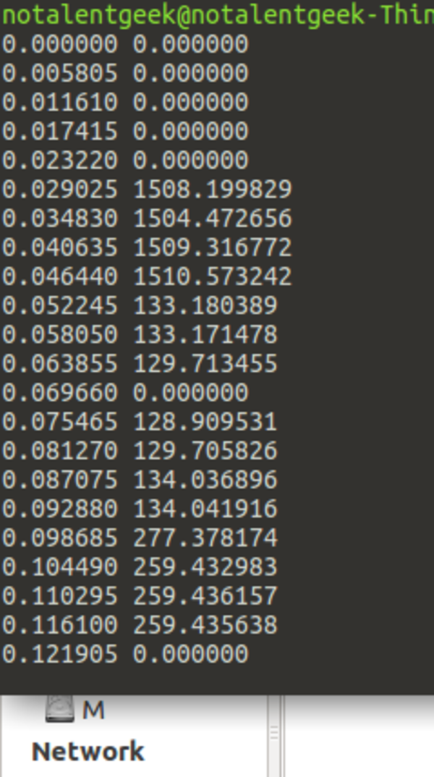
This is the example of the pitch detection. The left column is the pitch, while the right column is the volume. The input was from a .wav file. So I need to capture the audio first.
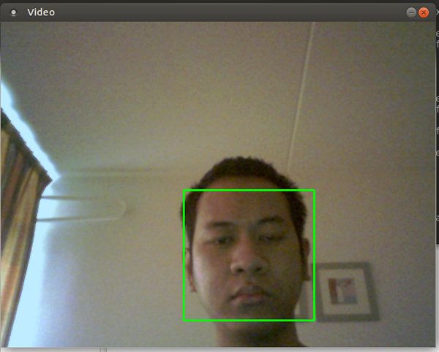
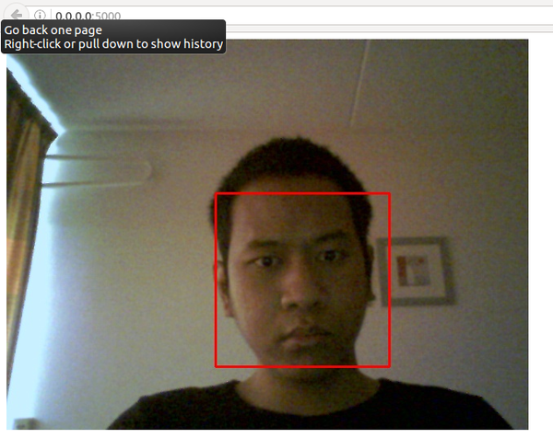
This is the example of face detection that compiled into native Linux application. The input is from webcam.
This is the example of face detection that is taken from web browser. This is currently server side. The input is from webcam.

