**M. Ali. Arslan**

**19F-0348**

**Lab-01**

**Task # 01**

#include<iostream>

using namespace std;

void swap(int size);

int main()

{

int size;

cout << "Enter the size of array: ";

cin >> size;

cout << endl;

swap(size);

system("pause");

return 0;

}

void swap(int size) {

int *arr = new int[size];

cout << "Enter values of array: ";

for (int i = 0; i < size; i++)

{

cin >> arr[i];

}

if (size % 2 == 0)

{

int temp, val = size / 2;

for (int i = 0; i < size / 2; i++)

{

temp = arr[i];

arr[i] = arr[i + val];

arr[i + val] = temp;

}

cout << "The values of array after swapping is: ";

for (int i = 0; i < size; i++)

{

cout << arr[i];

}

}

else if (size % 2 != 0)

{

int temp = 0;

int val = (size / 2) + 1;

for (int i = 0; i < size / 2; i++)

{

if (i <= val)

{

temp = arr[i];

arr[i] = arr[i + val];

arr[i + val] = temp;

}

}

cout << "The values of array after swapping is: ";

for (int i = 0; i < size; i++)

{

cout << arr[i];

}

}

cout << endl;

delete arr;

}

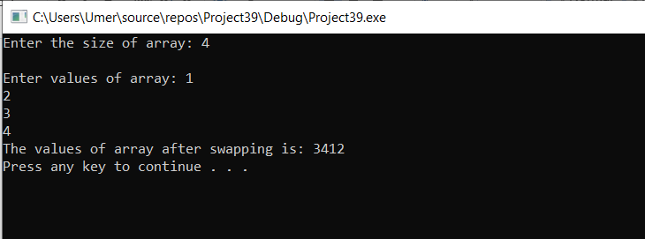

**Task # 04**

#include<iostream>

#include<string>

#include<ctime>

using namespace std;

int main()

{

int size,in;

string name, disease_name;

char choice_1;

cout << "Enter the size of the array : ";

cin >> size;

int *arr = new int[size];

for (int i = 0; i < size; i++)

{

srand(time(0));

arr[i] = rand() % 10;

}

cin.ignore();

cout << "Name: ";

getline(cin, name);

cout << "Disease: ";

getline(cin, disease_name);

cout << "Do you wish to choose your own slot[Y/N]? ";

cin >> choice_1;

if (choice_1 == 'Y')

{

cout << "Slots 1,2,3,4,7,8 are available, please choose: ";

cout << "\nInput: ";

cin >> in;

if (in == 1 || in == 2 || in == 3 || in == 4 || in == 7 || in == 8)

{

cout << "You have been alotted slot " << in << ", please visit the earliest." << endl;

}

else {

cout << "Sorry slot " << in << " is not availabe" << endl;

}

}

else if (choice_1 == 'N')

{

cout << endl;

}

system("pause");

return 0;

}

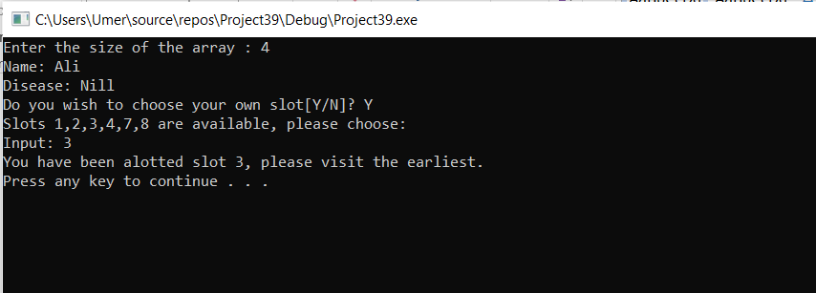

**Task # 05**

#include<iostream>

using namespace std;

int main()

{

int size;

cout << "Enter the size of array: ";

cin >> size;

int *arr = new int[size];

cout << "Enter the values of array: ";

for (int i = 0; i < size; i++)

{

cin >> arr[i];

}

cout << endl;

for (int i = 0; i < size; i++)

{

cout << arr[i] << ": ";

for (int j = 1; j < arr[i]; j++)

{

if (arr[i] % j == 0)

{

cout << j << " ";

}

}

cout << endl;

}

cout << endl;

delete arr;

system("pause");

return 0;

}

