**M. Ali. Arslan**

**19F-0348**

**Lab-07**

**Task # 01**

#include<iostream>

using namespace std;

class Node

{

public:

int data;

Node* left;

Node* right;

int height;

Node()

{

data = 0;

left = NULL;

right = NULL;

height = 0;

}

};

class AVL

{

const int s = 5;

public:

Node* root;

AVL()

{

root = NULL;

}

Node* get_root()

{

return root;

}

int height(Node* N)

{

if (N == NULL)

{

return 0;

}

return N->height;

}

int max(int a, int b)

{

return a > b ? a : b;

}

Node* newNode(int d)

{

Node* ptr = new Node; ptr->data = d;

ptr->left = NULL; ptr->right = NULL; ptr->height = 1;

return ptr;

}

Node* rightRotate(Node* y)

{

Node* x = y->left;

Node* T2 = x->right; x->right = y;

y->left = T2;

y->height = max(height(y->left),

height(y->right)) + 1; x->height =

max(height(x->left),

height(x->right)) + 1;

return x;

}

Node* leftRotate(Node* x)

{

Node* y = x->right; Node* T2 = y->left; y->left = x;

x->right = T2;

x->height = max(height(x->left),

height(x->right)) + 1;

y->height = max(height(y->left),

height(y->right)) + 1;

return y;

}

int getBalance(Node* N)

{

if (N == NULL)

{

return 0;

}

return height(N->left) - height(N->right);

}

Node* insert(Node* r, int d)

{

if (r == NULL)

{

return newNode(d);

}

if (d < r->data)

{

system("cls");

displayTree(root, s);

cout << endl;

cout << " Comparing " << d << " with " << r->data << endl;

system("pause");

r->left = insert(r->left, d);

}

else if (d > r->data)

{

system("cls");

displayTree(root, s);

cout << endl;

cout << " Comparing " << d << " with " << r->data << endl;

system("pause");

r->right = insert(r->right, d);

}

else

{

system("cls"); displayTree(root, s);

cout << endl;

cout << " Data already Exists! " << endl;

system("pause");

return r;

}

r->height = 1 + max(height(r->left), height(r->right));

int balance = getBalance(r);

if (balance > 1 && d < r->left->data)

{

return rightRotate(r);

}

if (balance < -1 && d > r->right->data)

{

return leftRotate(r);

}

if (balance > 1 && d > r->left->data)

{

r->left = leftRotate(r->left); return rightRotate(r);

}

if (balance < -1 && d < r->right->data)

{

r->right = rightRotate(r->right); return leftRotate(r);

}

return r;

}

void displayTree(Node* r, int space)

{

if (r == NULL)

{

return;

}

space = space + s; displayTree(r->right, space); cout << endl;

for (int i = s; i < space; i++)

{

cout << " ";

}

cout << r->data << endl; displayTree(r->left, space);

}

};

int main()

{

AVL a1;

int val = 0;

const int SPACE = 5;

do

{

cout << "INPUT VALUE TO INSERT IN AVL TREE (-1 to exit): ";

cin >> val;

if (val == -1)

break;

a1.root = a1.insert(a1.get_root(), val);

system("cls");

cout << val << " BALANCED " << endl;

a1.displayTree(a1.get_root(), SPACE);

cout << endl;

} while (val != -1);

cout << endl;

cout << " AVL TREE " << endl;

a1.displayTree(a1.get_root(), SPACE);

return 0;

}

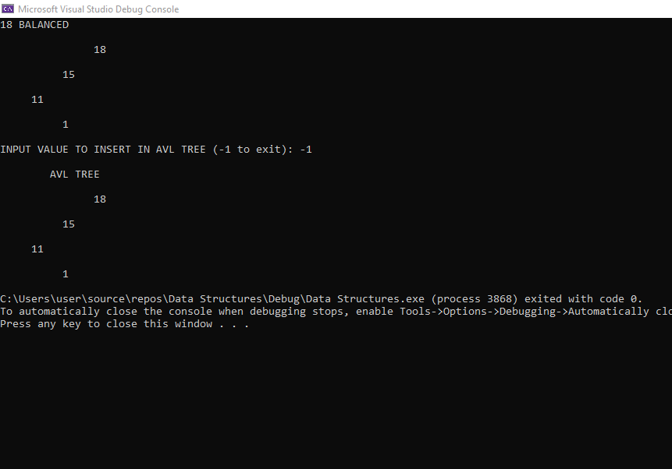

**Task # 02**

#include<iostream>

using namespace std;

class Node

{

public:

int data;

Node* left;

Node* right;

int height;

Node()

{

data = 0;

left = NULL;

right = NULL;

height = 0;

}

};

class AVL

{

const int s = 5;

int count;

public:

Node* root;

AVL()

{

root = NULL;

}

Node* get_root()

{

return root;

}

int get_count()

{

return count;

}

int height(Node* N)

{

if (N == NULL)

{

return 0;

}

return N->height;

}

int max(int a, int b)

{

return a > b ? a : b;

}

Node* newNode(int d)

{

Node* ptr = new Node; ptr->data = d;

ptr->left = NULL; ptr->right = NULL; ptr->height = 1;

return ptr;

}

Node* rightRotate(Node* y)

{

Node* x = y->left;

Node* T2 = x->right; x->right = y;

y->left = T2;

y->height = max(height(y->left),

height(y->right)) + 1; x->height =

max(height(x->left),

height(x->right)) + 1;

return x;

}

Node* leftRotate(Node* x)

{

Node* y = x->right; Node* T2 = y->left; y->left = x;

x->right = T2;

x->height = max(height(x->left),

height(x->right)) + 1;

y->height = max(height(y->left),

height(y->right)) + 1;

return y;

}

int getBalance(Node* N)

{

if (N == NULL)

{

return 0;

}

return height(N->left) - height(N->right);

}

Node* insert(Node* r, int d)

{

if (r == NULL)

{

return newNode(d);

}

if (d < r->data)

{

system("cls");

displayTree(root, s);

cout << endl;

cout << " Comparing " << d << " with " << r->data << endl;

system("pause");

r->left = insert(r->left, d);

}

else if (d > r->data)

{

system("cls");

displayTree(root, s);

cout << endl;

cout << " Comparing " << d << " with " << r->data << endl;

system("pause");

r->right = insert(r->right, d);

}

else

{

system("cls"); displayTree(root, s);

cout << endl;

cout << " Data already Exists! " << endl;

system("pause");

return r;

}

r->height = 1 + max(height(r->left), height(r->right));

int balance = getBalance(r);

if (balance > 1 && d < r->left->data)

{

return rightRotate(r);

}

if (balance < -1 && d > r->right->data)

{

return leftRotate(r);

}

if (balance > 1 && d > r->left->data)

{

r->left = leftRotate(r->left); return rightRotate(r);

}

if (balance < -1 && d < r->right->data)

{

r->right = rightRotate(r->right); return leftRotate(r);

}

return r;

}

void displayTree(Node* r, int space)

{

if (r == NULL)

{

return;

}

space = space + s; displayTree(r->right, space); cout << endl;

for (int i = s; i < space; i++)

{

cout << " ";

}

cout << r->data << endl; displayTree(r->left, space);

}

void count_nodes(Node* r)

{

if (r == NULL)

{

return;

}

count_nodes(r->left);

if (r->left == NULL && r->right == NULL)

{

count++;

}

count_nodes(r->right);

}

};

int main()

{

AVL a1;

int val = 0;

const int SPACE = 5;

do

{

cout << "INPUT VALUE TO INSERT IN AVL TREE (-1 to exit): ";

cin >> val;

if (val == -1)

break;

a1.root = a1.insert(a1.get_root(), val);

system("cls");

cout << val << " BALANCED " << endl;

a1.displayTree(a1.get_root(), SPACE);

cout << endl;

} while (val != -1);

cout << endl;

cout << " AVL TREE " << endl;

a1.displayTree(a1.get_root(), SPACE);

a1.count_nodes(a1.get_root());

cout << "\nNumber of Leaf Nodes are: " << a1.get_count() << endl;

return 0;

}

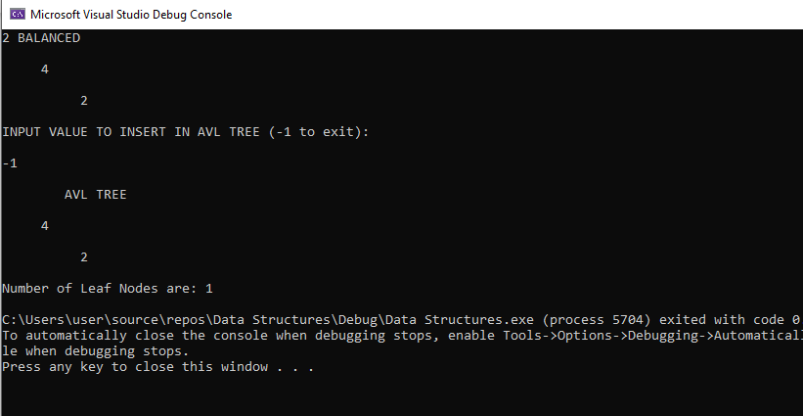

**Task # 03**

#include<iostream>

#include<cstdio>

#include<sstream>

#include<algorithm>

#define pow(n) ( << (n))

using namespace std;

struct avl_node {

int data;

struct avl_node* left;

struct avl_node* right;

}

*root;

class avlTree

{

public:

int height(avl_node*);

int diff(avl_node*);

avl_node* rr_rotation(avl_node*);

avl_node* ll_rotation(avl_node*);

avl_node* lr_rotation(avl_node*);

avl_node* rl_rotation(avl_node*);

avl_node* balance(avl_node*);

avl_node* insert(avl_node*, int);

void display(avl_node*, int);

void inorder(avl_node*);

void preorder(avl_node*);

void postorder(avl_node*);

avlTree()

{

root = NULL;

}

};

int main()

{

int choice, item;

avlTree avl;

while (1)

{

cout << "\n------------------------- " << endl;

cout << "AVL Tree Implementation" << endl;

cout << "\n--------------------------" << endl;

cout << "l. Insert Element into the tree" << endl;

cout << "2. Display Balanced AVL Tree" << endl;

cout << "3. InOrder traversal" << endl;

cout << "4. PreOrder traversal" << endl;

cout << "5. PostOrder traversal" << endl;

cout << "6. Exit" << endl;

cout << "Enter your Choice: ";

cin >> choice;

switch (choice)

{

case 1:

cout << "Enter value to be inserted: ";

cin >> item;

root = avl.insert(root, item);

break;

case 2:

if (root == NULL) {

cout << "Tree is Empty" << endl;

continue;

}

cout << "Balanced AVL Tree:" << endl;

avl.display(root, 1);

break;

case 3:

cout << "lnorder Traversal:" << endl;

avl.inorder(root);

cout << endl;

break;

case 4:

cout << "Preorder Traversal:" << endl;

avl.preorder(root);

cout << endl;

break;

case 5:

cout << "Postorder Traversal:" << endl;

avl.postorder(root);

cout << endl;

break;

case 6:

exit(1);

break;

default:

cout << "Wrong Choice" << endl;

}

}

return 0;

}

int avlTree::height(avl_node* temp)

{

int h = 0;

if (temp != NULL)

{

int l_height = height(temp->left);

int r_height = height(temp->right);

int max_height = max(l_height, r_height); h =

max_height + 1;

}

return h;

}

int avlTree::diff(avl_node* temp)

{

int l_height = height(temp->left);

int r_height = height(temp->right);

int b_factor = l_height - r_height;

return b_factor;

}

avl_node* avlTree::rr_rotation(avl_node* parent)

{

avl_node* temp;

temp = parent->right;

parent->right = temp->left;

temp->left = parent;

return temp;

}

avl_node* avlTree::ll_rotation(avl_node* parent)

{

avl_node* temp;

temp = parent->left;

parent->left = temp->right;

temp->right = parent;

return temp;

}

avl_node* avlTree::lr_rotation(avl_node* parent)

{

avl_node *temp;

temp = parent->left;

parent->left = rr_rotation(temp);

return ll_rotation(parent);

}

avl_node* avlTree::rl_rotation(avl_node* parent)

{

avl_node* temp;

temp = parent->right;

parent->right = ll_rotation(temp);

return rr_rotation(parent);

}

avl_node* avlTree::balance(avl_node* temp)

{

int bal_factor = diff(temp);

if (bal_factor > 1)

{

if (diff(temp->left) > 0)

temp = ll_rotation(temp);

else

temp = lr_rotation(temp);

}

else if (bal_factor < -1)

{

if (diff(temp->right) > 0) temp = rl_rotation(temp);

else

temp = rr_rotation(temp);

}

return temp;

}

avl_node* avlTree::insert(avl_node* root, int value)

{

if (root == NULL)

{

root = new avl_node;

root->data = value;

root->left = NULL;

root->right = NULL;

return root;

}

else if (value < root->data)

{

root->left = insert(root->left, value);

root = balance(root);

}

else if (value >= root->data)

{

root->right = insert(root->right, value); root =

balance(root);

}

return root;

}

void avlTree::display(avl_node* ptr, int level)

{

int i;

if (ptr != NULL)

{

display(ptr->right, level + 1);

printf("\n");

if (ptr == root)

cout << "Root ->";

for (i = 0; i < level && ptr != root; i++)

cout << " ";

cout << ptr->data;

display(ptr->left, level + 1);

}

}

void avlTree::inorder(avl_node* tree)

{

if (tree == NULL)

return;

inorder(tree->left);

cout << tree->data << " ";

inorder(tree->right);

}

void avlTree::preorder(avl_node* tree)

{

if (tree == NULL)

return;

cout << tree->data << " ";

preorder(tree->left);

preorder(tree->right);

}

/* * Postorder Traversal of AVL Tree */

void avlTree::postorder(avl_node* tree)

{

if (tree == NULL)

return;

postorder(tree->left);

postorder(tree->right);

cout << tree->data << " ";

}

