M. Ali. Arslan

19F-0348

**Class Activity**

**Problem # 1**

**Cube a variable using pass-by-value**

#include <iostream>

using std::cout;

using std::endl;

int cubeByValue(int); // prototype

int main()

{

int number = 5;

cout << "The original value of number is " << number;

// pass number by value to cubeByValue

number = cubeByValue(number);

cout << "\nThe new value of number is " << number << endl;

return 0; // indicates successful termination

} // end main

// calculate and return cube of integer argument

int cubeByValue(int n)

{

return n * n * n; // cube local variable n and return result

} // end function cubeByValue

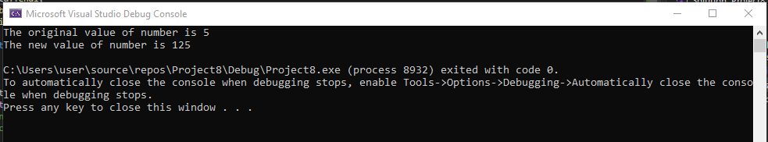

**Problem # 2**

**Cube a variable using pass-by-reference with a pointer argument**

#include <iostream>

using std::cout;

using std::endl;

void cubeByReference(int*); // prototype

int main()

{

int number = 5;

cout << "The original value of number is " << number;

// pass address of number to cubeByReference

cubeByReference(&number);

cout << "\nThe new value of number is " << number << endl;

return 0; // indicates successful termination

} // end main

// calculate cube of *nPtr; modifies variable number in main

void cubeByReference(int* nPtr)

{

* nPtr = *nPtr * *nPtr * *nPtr; // cube *nPtr

} // end function cubeByReference

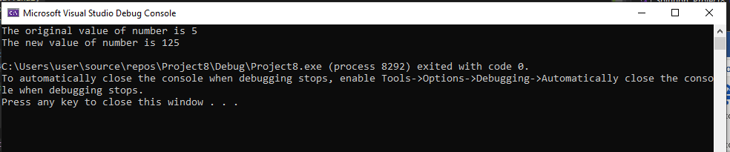

**Problem # 3**

**Using Structure to convert time into Seconds**

#include<iostream>

using namespace std;

struct time {

int hours;

int min;

int sec;

};

int toseconds(time now);

int main()

{

time t;

while (cin >> t.hours >> t.min >> t.sec)

{

cout << "Total Seconds: " << toseconds(t) << endl;

}

}

int toseconds(time now) {

return 3600 * now.hours + 60 * now.min + now.sec;

}

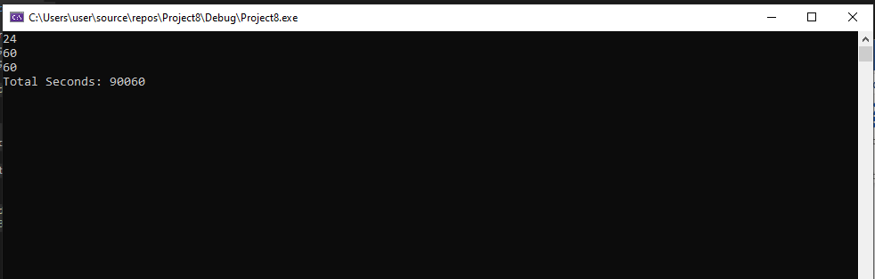

**Problem # 4**

#include<iostream>

using namespace std;

struct xamp1 {

int x;

};

int main()

{

xamp1 structure;

xamp1* ptr;

structure.x = 12;

ptr = &structure;

cout << ptr->x;

cin.get();

}

