**M. Ali. Arslan**

**19F-0348**

**Lab # 07**

**Program # 1:**

#include<iostream>

#include<string>

using namespace std;

class cart

{

private:

string cname;

float total;

float price1;

float price2;

float price3;

int cartvalue;

int no_of_book1;

int no_of_book2;

int no_of_book3;

string bookname1;

string bookname2;

string bookname3;

string choice;

public:

void info()

{

cout << "(1) Display data of books" << endl;

cout << "(2) Add to cart" << endl;

cout << "(3) Buy a book" << endl;

cout << "(4) Exit" << endl;

}

void setter()

{

cart book1, book2, book3;

book1.bookname1 = "English";

book2.bookname2 = "Urdu";

book3.bookname3 = "Math";

book1.price1 = 180.0;

book2.price2 = 150.0;

book3.price3 = 400.0;

book1.no_of_book1 = 4;

book2.no_of_book2 = 5;

book3.no_of_book3 = 10;

cout << "Book id\t Bookname \tBookprice \tNumber of books" << endl;

cout << "1\t\t" << book1.bookname1 << "\t\t" << book1.price1 << "\t\t" << book1.no_of_book1 << endl;

cout << "2\t\t" << book2.bookname2 << "\t\t" << book2.price2 << "\t\t" << book2.no_of_book2 << endl;

cout << "3\t\t" << book3.bookname3 << "\t\t" << book3.price3 << "\t\t" << book3.no_of_book3 << endl;

}

void buyitem()

{

cart buy;

buy.setter();

int choice;

cout << "Enter your choice: ";

cin >> choice;

switch (choice)

{

case 1:

{

int item;

int rupees;

cout << "Enter amount: ";

cin >> rupees;

cout << "How many books, you want to buy: ";

cin >> item;

int price1 = 180, price2 = 150, price3 = 400;

int book1 = 4, books2 = 5, books3 = 10;

int final = (4 - item);

cout << "\t\t\t\t\t< Updated items are >\n" << endl;

cout << "Book id\t\t Bookname \tBookprice \tNumber of books" << endl;

cout << "1\t\t\tEnglish\t\t" << price1 << "\t\t" << book1 << endl;

cout << "2\t\t\tUrdu\t\t" << price2 << "\t\t" << final << endl;

cout << "3\t\t\tMath\t\t" << price3 << "\t\t" << books3 << endl;

int amount = (item * 180);

cout << "Total Amount is: " << amount << endl;

cout << "You have: " << rupees << " rupees" << endl;

if (amount > 3000)

{

cout << "Amount is greater than 3000!" << endl;

}

if (rupees >= amount)

{

cout << "Your remaing amount is: ";

int rem;

rem = (rupees - amount);

cout << rem << endl;

}

else

cout << "You have insufficient money!" << endl;

break;

}

case 2:

{

int item;

int rupees;

cout << "Enter amount: ";

cin >> rupees;

cout << "How many books, you want to buy: ";

cin >> item;

int price1 = 180, price2 = 150, price3 = 400;

int book1 = 4, books2 = 5, books3 = 10;

int final = (5 - item);

cout << "\t\t\t\t\t< Updated Books are >\n" << endl;

cout << "Book id\t\t Bookname \tBookprice \tNumber of books" << endl;

cout << "1\t\t\tEnglish\t\t" << price1 << "\t\t" << book1 << endl;

cout << "2\t\t\tUrdu\t\t" << price2 << "\t\t" << final << endl;

cout << "3\t\t\tMath\t\t" << price3 << "\t\t" << books3 << endl;

int amount = (item * 150);

cout << "Total amount is: " << amount << endl;

cout << "You have: " << rupees << " rupees" << endl;

if (amount > 3000)

{

cout << "Amount is greater than 3000!" << endl;

}

if (rupees >= amount)

{

cout << "Your remaing amount is: ";

int rem;

rem = (rupees - amount);

cout << rem << endl;

}

else

cout << "You have insufficient money to buy this!" << endl;

break;

}

case 3:

{

int item;

int rupee;

cout << "Enter amount: ";

cin >> rupee;

cout << "How many books, you want to buy: ";

cin >> item;

int price1 = 180, price2 = 150, price3 = 400;

int book1 = 4, books2 = 5, books3 = 10;

int final = (10 - item);

cout << "\t\t\t\t\t< Updated Books are >\n" << endl;

cout << "Book id\t\t Bookname \tBookprice \tNumber of books" << endl;

cout << "1\t\t\tEnglish\t\t" << price1 << "\t\t" << book1 << endl;

cout << "2\t\t\tUrdu\t\t" << price2 << "\t\t" << final << endl;

cout << "3\t\t\tMath\t\t" << price3 << "\t\t" << books3 << endl;

int amount = (item * 400);

cout << "Total Amount is: " << amount << endl;

cout << "You have: " << rupee << " rupees" << endl;

if (amount > 3000)

{

cout << "Amount is greater than 3000!" << endl;

}

if (rupee >= amount)

{

cout << "Your remaing amount is: ";

int remaining;

remaining = (rupee - amount);

cout << remaining << endl;

}

else

cout << "You have insufficient money!" << endl;

break;

}

case 4:

{

exit;

break;

}

default:

{

cout << "Invalid Entry" << endl;

int main();

}

}

}

int addbooks()

{

cart add;

string name;

int id;

cout << "Enter book id: ";

cin >> id;

cout << "Enter book Name: ";

cin >> name;

cout << "Enter book Price: ";

cin >> add.price1;

cout << "Enter no of books: ";

cin >> add.no_of_book1;

cout << "\t\t\t\t\t< Updated Books are >\n" << endl;

add.setter();

cout << id << "\t\t" << name << "\t\t" << add.price1 << "\t\t" << add.no_of_book1 << endl;

return 0;

}

void conditions()

{

cart boo;

int choose;

cout << "Enter your choice: ";

cin >> choose;

switch (choose)

{

case 1:

{

boo.setter();

break;

}

case 2:

{

boo.addbooks();

break;

}

case 3:

{

boo.buyitem();

break;

}

case 4:

{

break;

}

default:

{

cout << "Invalid Entry" << endl;

int main();

}

}

}

};

int main()

{

cart s1;

s1.info();

s1.conditions();

system("pause");

return 0;

}

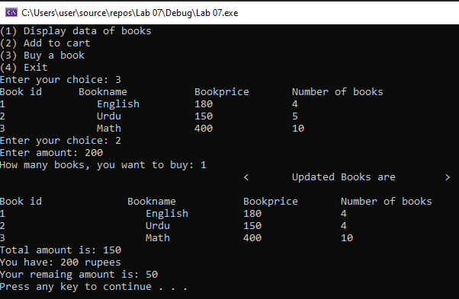

**Program # 2:**

#include<iostream>

#include<string>

using namespace std;

class student

{

int stdID;

string stdName;

string stddept;

public:

student(int f1, string f2)

{

stdID = f1;

stdName = f2;

stddept;

}

student(int a, string b, string c)

{

stdID = a;

stdName = b;

stddept = c;

}

student(string d, string e)

{

stdName = d;

stddept = e;

}

void display()

{

cout << "Default constructor:" << endl;

cout << "Student id is :" << stdID << endl;

cout << "Student name is :" << stdName << endl;

cout << "Student department is :" << stddept << endl;

}

void display1()

{

cout << "Over loaded constructor 1:" << endl;

cout << "Student ID is :" << stdID << endl;

cout << "Student department is :" << stddept << endl;

}

void display2()

{

cout << "overloaded constructor 2:" << endl;

cout << "Student id is :" << stdID << endl;

cout << "Student name is :" << stdName << endl;

cout << "Student department is :" << stddept << endl;

}

void display3()

{

cout << "Over loaded constructor 3:" << endl;

cout << "Student Name is :" << stdName << endl;

cout << "Student Deprtment is :" << stddept << endl;

}

};

int main()

{

student s(0, "", "");

s.display();

student s1(12345, "jason bourne");

s1.display1();

student s2(23456, "johnny depp", "computer science");

s2.display2();

student s3("Denzel Washington", "computer science");

s3.display3();

system("pause");

return 0;

}

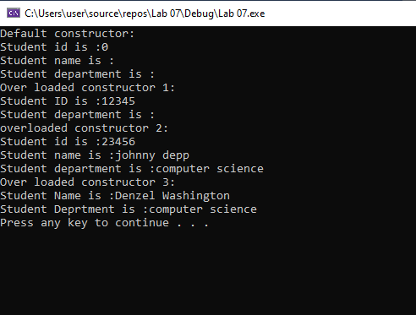

**Program # 3:**

#include<iostream>

#include<string>

using namespace std;

class Class1 {

public:

Class1() {

row = 2;

col = 2;

ptr = new int* [row];

for (int i = 0; i < row; i++)

{

for (int j = 0; j < col; j++)

{

ptr[i] = new int[col];

}

}

}

Class1(int row1, int col1)

{

row = row1;

col = col1;

ptr = new int* [row1];

for (int i = 0; i < row1; i++)

{

for (int j = 0; j < col1; j++)

ptr[i] = new int[col1];

}

}

void input(Class1 m)

{

Class1(row, col);

for (int i = 0; i < row; i++)

{

for (int j = 0; j < col; j++)

{

cin >> ptr[i][j];

}

}

}

void add(Class1 m)

{

for (int i = 0; i < row; i++)

{

for (int j = 0; j < col; j++)

{

m.ptr[i][j] = ptr[i][j] + m.ptr[i][j];

}

}

}

void subtract(Class1 m)

{

for (int i = 0; i < row; i++)

{

for (int j = 0; j < col; j++)

{

m.ptr[i][j] = ptr[i][j] - ptr[i][j];

}

}

}

void printmatrix(Class1 m)

{

for (int i = 0; i < row; i++)

{

for (int j = 0; j < col; j++)

{

cout << m.ptr[i][j] << " ";

}cout << endl;

}

}

private:

int** ptr;

int row;

int col;

};

int main()

{

int row;

int coloumn;

Class1 A(3, 3);

Class1 B(3, 3);

Class1 C(3, 3);

cout << "Enter data for matrix 1 of 3x3: " << endl;

A.input(A);

cout << "1st Matrix is: " << endl;

A.printmatrix(A);

cout << endl;

cout << "Enter data for matrix 2 of 3x3: " << endl;

B.input(B);

cout << "2nd Matrix is: " << endl;

B.printmatrix(B);

cout << endl;

A.add(B);

cout << "The Addition of two matrix is: " << endl;

A.printmatrix(B);

cout << endl;

A.subtract(B);

cout << "Subtraction of two matrices is: " << endl;

A.printmatrix(B);

cout << endl;

system("pause");

return 0;

}

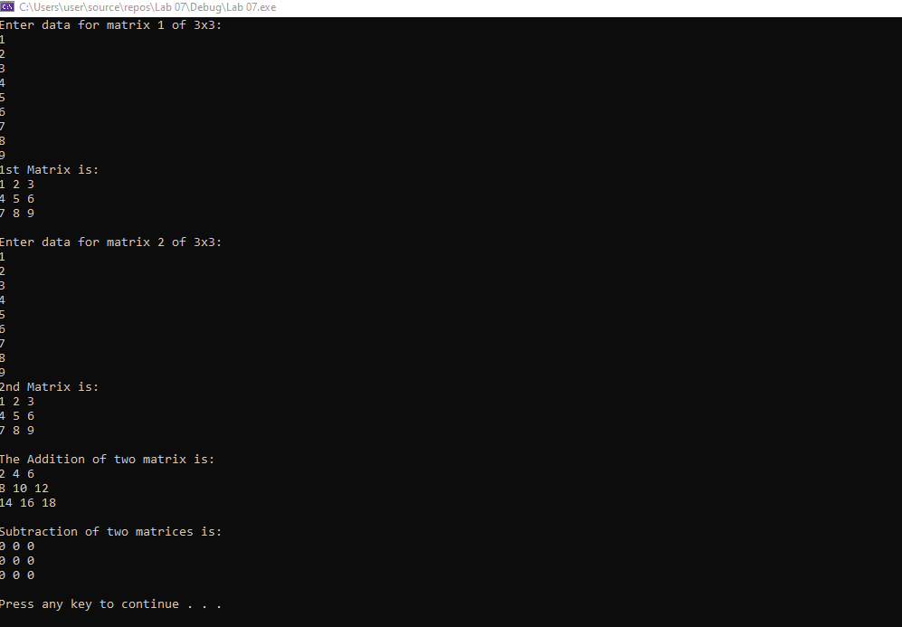

**Program # 4:**

#include<iostream>

using namespace std;

class matrix

{

int** ptr;

int rows;

int cols;

public:

void add(matrix, matrix);

void printmatrix();

void input();

matrix()

{

rows = 2;

cols = 2;

cout << "I am default constructor!";

}

matrix(int r, int c)

{

rows = r;

cols = c;

}

};

void matrix::input()

{

ptr = new int* [rows];

for (int i = 0; i < rows; i++)

{

ptr[i] = new int[cols];

}

for (int i = 0; i < rows; i++)

{

for (int j = 0; j < cols; j++)

{

cin >> ptr[i][j];

}

}

}

void matrix::printmatrix()

{

for (int i = 0; i < rows; i++)

{

for (int j = 0; j < cols; j++)

{

cout << ptr[i][j] << " ";

}

cout << endl;

}

}

void matrix::add(matrix A0, matrix A1)

{

if (rows == cols)

{

for (int i = 0; i < rows; i++)

{

for (int j = 0; j < cols; j++)

{

ptr[i][j] = A0.ptr[i][j] + A1.ptr[i][j];

}

}

}

else

cout << "Invalid Entry!" << endl;

}

int main()

{

matrix A0(3, 3);

cout << "Enter value of matrix 1: " << endl;

A0.input();

cout << "Matrix 1" << endl;

A0.printmatrix();

matrix A1(3, 3);

cout << "Enter value of matrix 2: " << endl;

A1.input();

cout << "Matrix 2" << endl;

A1.printmatrix();

matrix A2(3, 3);

cout << "After adition matrix: ";

A2.add(A0, A1);

A2.printmatrix();

system("pause");

return 0;

}

