**M. Ali. Arslan**

**19F-0348**

**Lab # 09**

**Program # 1:**

#include<iostream>

using namespace std;

class persondata

{

private:

string firstName;

string lastName;

string address;

string city;

string state;

int zip;

int phoneno;

public:

void setFirstName(string newFirstName)

{

firstName = newFirstName;

}

string getFirstName()

{

return firstName;

}

void setLastName(string newLastName)

{

lastName = newLastName;

}

string getLastName()

{

return lastName;

}

void setAddress(string newAddress)

{

address = newAddress;

}

string getAddress()

{

return address;

}

void setCity(string newCity)

{

city = newCity;

}

string getCity()

{

return city;

}

void setState(string newState)

{

state = newState;

}

string getState()

{

return state;

}

void setZip(int newZip)

{

zip = newZip;

}

int getZip()

{

return zip;

}

void setPhone(int newPhone)

{

phoneno = newPhone;

}

int getPhone()

{

return phoneno;

}

void inputcustomerdata()

{

cout << "Enter your first name: ";

cin >> firstName;

cout << "Enter your last name: ";

cin >> lastName;

cout << "Enter your address: ";

cin >> address;

cout << "Enter your city: ";

cin >> city;

cout << "Enter your state: ";

cin >> state;

cout << "Enter your zip code: ";

cin >> zip;

cout << "Enter your Phone number: ";

cin >> phoneno;

}

void displaycustomerdata()

{

cout << "Enter first name: ";

cout << firstName;

cout << endl;

cout << "Enter last name: ";

cout << lastName;

cout << endl;

cout << "Enter address: ";

cout << address;

cout << endl;

cout << "Enter city: ";

cout << city;

cout << endl;

cout << "Enter state: ";

cout << state;

cout << endl;

cout << "Enter zip code: ";

cout << zip;

cout << endl;

cout << "Enter Phone number: ";

cout << phoneno;

cout << endl;

}

};

class customerdata :public persondata

{

int customernumber;

bool mailinglist;

public:

void setcustomernumber(int newcustomernumber)

{

customernumber = newcustomernumber;

}

int getcustomernumber()

{

return customernumber;

}

void getmailinglist(int newmailinglist)

{

mailinglist = newmailinglist;

}

int setmailinglist()

{

return mailinglist;

}

void inputcustomerdata()

{

persondata::inputcustomerdata();

cout << "Enter a unique customer number: ";

cin >> customernumber;

cout << "If you wishes to be on a mailing list, Enter 1 else 0: ";

cin >> mailinglist;

}

void displaycustomerdata()

{

persondata::displaycustomerdata();

cout << "customer number : ";

cout << customernumber;

cout << endl;

cout << "mailinglist : ";

cout << mailinglist;

cout << endl;

}

};

int main()

{

customerdata d;

d.inputcustomerdata();

cout << endl;

cout << endl;

d.displaycustomerdata();

system("pause");

return 0;

}

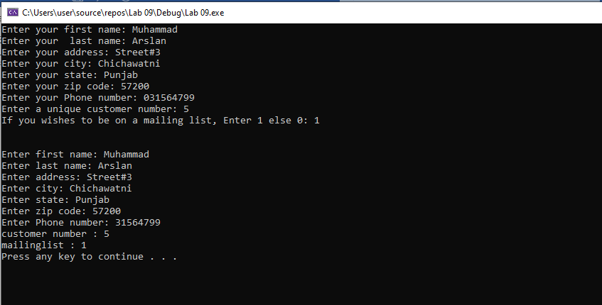

**Program # 2:**

#include<iostream>

using namespace std;

class persondata

{

private:

string firstName;

string lastName;

string address;

string city;

string state;

int zip;

int phoneno;

public:

void setFirstName(string newFirstName)

{

firstName = newFirstName;

}

string getFirstName()

{

return firstName;

}

void setLastName(string newLastName)

{

lastName = newLastName;

}

string getLastName()

{

return lastName;

}

void setAddress(string newAddress)

{

address = newAddress;

}

string getAddress()

{

return address;

}

void setCity(string newCity)

{

city = newCity;

}

string getCity()

{

return city;

}

void setState(string newState)

{

state = newState;

}

string getState()

{

return state;

}

void setZip(int newZip)

{

zip = newZip;

}

int getZip()

{

return zip;

}

void setPhone(int newPhone)

{

phoneno = newPhone;

}

int getPhone()

{

return phoneno;

}

void inputcustomerdata()

{

cout << "Enter your first name: ";

cin >> firstName;

cout << "Enter your last name: ";

cin >> lastName;

cout << "Enter your address: ";

cin >> address;

cout << "Enter your city: ";

cin >> city;

cout << "Enter your state: ";

cin >> state;

cout << "Enter your zip code: ";

cin >> zip;

cout << "Enter your Phone number: ";

cin >> phoneno;

}

void displaycustomerdata()

{

cout << "Enter first name: ";

cout << firstName;

cout << endl;

cout << "Enter last name: ";

cout << lastName;

cout << endl;

cout << "Enter address: ";

cout << address;

cout << endl;

cout << "Enter city: ";

cout << city;

cout << endl;

cout << "Enter state: ";

cout << state;

cout << endl;

cout << "Enter zip code: ";

cout << zip;

cout << endl;

cout << "Enter Phone number: ";

cout << phoneno;

cout << endl;

}

};

class customerdata : public persondata

{

int customernumber;

bool mailinglist;

public:

void setcustomernumber(int newcustomernumber)

{

customernumber = newcustomernumber;

}

int getcustomernumber()

{

return customernumber;

}

void getmailinglist(int newmailinglist)

{

mailinglist = newmailinglist;

}

int setmailinglist()

{

return mailinglist;

}

void inputcustomerdata()

{

persondata::inputcustomerdata();

cout << "Enter a unique customer number: ";

cin >> customernumber;

cout << "If you wishes to be on a mailing list, Enter 1 else 0: ";

cin >> mailinglist;

}

void displaycustomerdata()

{

persondata::displaycustomerdata();

cout << "Customer number: ";

cout << customernumber;

cout << endl;

cout << "Mailinglist: ";

cout << mailinglist;

cout << endl;

}

};

class preferredcustomer : public customerdata

{

double discountlevel;

double purchaseamount;

double purchaseamount2;

public:

void getpurchaseamount(double newpurchaseamount)

{

purchaseamount = newpurchaseamount;

}

int setpurchaseamount()

{

return purchaseamount;

}

void getdiscountlevel(double newdiscountlevel)

{

discountlevel = newdiscountlevel;

}

int setdiscountlevel()

{

return discountlevel;

}

public:

void getpurchaseamount2(double newpurchaseamount2)

{

purchaseamount2 = newpurchaseamount2;

}

int setpurchaseamount2()

{

return purchaseamount2;

}

void inputcustomerdata()

{

customerdata::inputcustomerdata();

cout << "Enter your purchase amount to set discount level: ";

cin >> purchaseamount;

cout << "Enter your next purchase amount to get discount according to previous amount: ";

cin >> purchaseamount2;

}

void displaycustomerdata()

{

customerdata::displaycustomerdata();

cout << "Purchase amount: ";

cout << purchaseamount;

cout << endl;

cout << "Discount level: ";

calculator();

cout << discountlevel;

cout << endl;

cout << "Your amount after getting discount is: ";

cout << purchaseamount2 << endl;

}

int discount;

void calculator()

{

if (purchaseamount >= 500 && purchaseamount < 1000)

{

discountlevel = 0.05;

discount = purchaseamount * 0.05;

purchaseamount2 = purchaseamount2 - discount;

}

else if (purchaseamount >= 1000 && purchaseamount < 1500)

{

discountlevel = 0.06;

discount = purchaseamount * 0.06;

purchaseamount2 = purchaseamount2 - discount;

}

else if (purchaseamount >= 1500 && purchaseamount < 2000)

{

discountlevel = 0.07;

discount = purchaseamount * 0.07;

purchaseamount2 = purchaseamount2 - discount;

}

else if (purchaseamount >= 2000)

{

discountlevel = 0.1;

discount = purchaseamount * 0.1;

purchaseamount2 = purchaseamount2 - discount;

}

}

};

int main()

{

preferredcustomer o;

o.inputcustomerdata();

cout << endl;

cout << endl;

o.displaycustomerdata();

system("pause");

return 0;

}

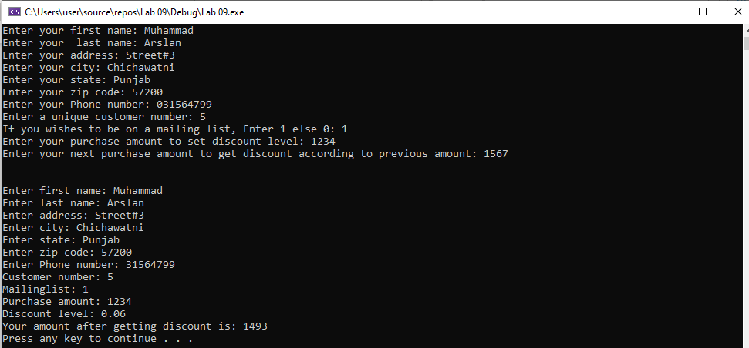

**Program # 3:**

#include<iostream>

using namespace std;

class vehicle

{

float speed;

float distance;

public:

void setspeed(float s)

{

speed = s;

}

float getspeed()

{

return speed;

}

void setdistance(float d)

{

distance = d;

}

float getdistance()

{

return distance;

}

float computeduration()

{

return (distance / speed);

}

vehicle()

{

speed = 0;

distance = 0;

}

vehicle(float a, float b)

{

speed = a;

distance = b;

}

void display()

{

cout << "The speed of vehicle: " << speed << endl;

cout << "The distance covered by vehicle: " << distance << endl;

cout << "Compute duration: " << computeduration() << endl;

}

};

class wheelvehicle :vehicle

{

int wheels;

public:

void setwheels(int w)

{

wheels = w;

}

int getwheels()

{

return wheels;

}

wheelvehicle() :vehicle()

{

wheels = 0;

}

wheelvehicle(float a, float b, int c) :vehicle(a, b)

{

wheels = c;

}

void display()

{

vehicle::display();

cout << "Number of wheel are: " << wheels << endl;

}

};

class wingsvehicle :public vehicle

{

int wings;

public:

void setwings(int w)

{

wings = w;

}

int getwings()

{

return wings;

}

wingsvehicle() :vehicle()

{

wings = 0;

}

wingsvehicle(float a, float b, int d) :vehicle(a, b)

{

wings = d;

}

void display()

{

vehicle::display();

cout << "Number of wings are: " << wings << endl;

}

};

class truck : wheelvehicle, vehicle

{

int load;

public:

void setwings(int x)

{

load = x;

}

int getwings()

{

return load;

}

truck() :wheelvehicle()

{

load = 0;

}

truck(float a, float b, int c, int e) : wheelvehicle(a, b, c)

{

load = e;

}

void display()

{

wheelvehicle::display();

cout << "Load of truck is: " << load << endl;

}

};

int main()

{

int a, b;

float c, d, e;

cout << "Enter speed: ";

cin >> a;

cout << "Enter distance: ";

cin >> b;

cout << "Enter no. of wheels: ";

cin >> c;

cout << "Enter load of truck: ";

cin >> d;

cout << "Enter no. of wings: ";

cin >> e;

cout << endl;

truck s(a, b, c, d);

s.display();

cout << endl;

cout << endl;

wingsvehicle w(a, b, e);

w.display();

system("pause");

return 0;

}

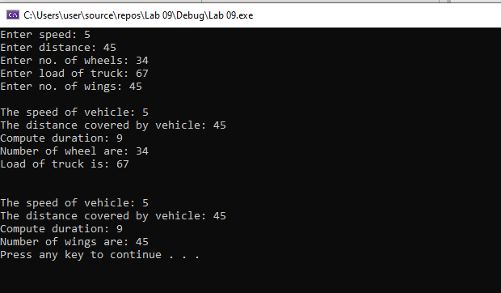

**Program # 4:**

#include<iostream>

using namespace std;

class account

{

protected:

double balance;

public:

account(double b)

{

if (b >= 0.0)

{

balance = b;

}

else

{

balance = 0;

cout << "Your initial balance is invalid!";

}

}

void credit()

{

cout << "Enter the amount to credit: ";

int sum;

cin >> sum;

balance = balance + sum;

}

void debit()

{

cout << "Enter the amount you want to withdraw: ";

int y;

cin >> y;

if (y <= balance)

{

balance = balance - y;

}

else

cout << "Withdraw amount exceeded your balance!";

}

void getbalance()

{

cout << "The current balance is: " << balance << endl;

}

};

class savingsaccount :public account

{

private:

double interestrate;

public:

savingsaccount(double b, double interest) :account(b)

{

interestrate = interest;

}

void calculateinterest()

{

double interestearned = interestrate * balance;

balance = balance + interestearned;

cout << "Interet earned: " << interestearned << endl;

}

void getbalance()

{

account::getbalance();

cout << "The current balance is: " << balance << endl;

}

};

class checkingaccount :public account

{

private:

double fee;

public:

checkingaccount(double f, double b) :account(b)

{

fee = f;

}

void credit()

{

cout << "Enter the amount you want to deposit: " << endl;

int sum;

cin >> sum;

balance = balance + sum;

balance = balance - fee;

cout << "Fee deducted!" << endl;

cout << "After fee deduction balance is: " << balance << endl;

}

void debit()

{

cout << "Enter the amount you want to withdraw: ";

int y;

cin >> y;

if (y <= balance)

{

balance = balance - y;

balance = balance - fee;

cout << "Fee deducted!" << endl;

cout << "After fee deduction balance is: " << balance << endl;

}

else

cout << "Wthdraw amount exceeded your balance!\n";

}

};

int main()

{

cout << "Enter your initial balance: ";

double initial;

cin >> initial;

account a(initial);

a.credit();

a.getbalance();

a.debit();

a.getbalance();

double interest;

cout << "Enter interest rate: ";

cin >> interest;

savingsaccount s(initial, interest);

s.calculateinterest();

cout << "Enter fee chargers per transaction: ";

double fee;

cin >> fee;

checkingaccount c(fee, initial);

c.credit();

c.debit();

system("pause");

return 0;

}

