**M. Ali. Arslan**

**19F-0348**

**Lab # 10**

**Program # 1:**

#include<iostream>

using namespace std;

class A

{

public:

A()

{

cout << "A's constructor called" << endl;

}

};

class B

{

public:

B()

{

cout << "B's constructor called" << endl;

}

};

class C :public B, public A

{

public:

C()

{

cout << "C's constructor called" << endl;

}

};

int main()

{

C obj;

system("pause");

return 0;

}

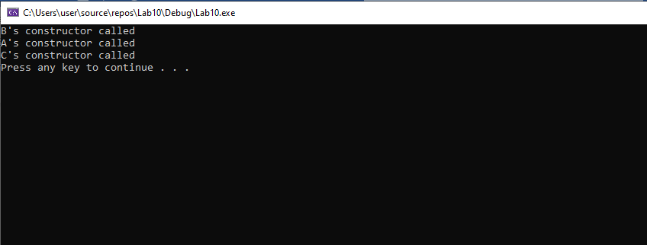

**Program # 2:**

**Main.cpp**

#include"Header.h"

int main()

{

TA ta(30);

}

**Header.h**

class person

{

public:

person(int x);

};

class faculty :public person

{

public:

faculty(int x);

};

class student :public person

{

public:

student(int x);

};

class TA :public faculty, public student

{

public:

TA(int x);

};

**Implementation.cpp**

#include"Header.h"

#include<iostream>

using namespace std;

person::person(int x)

{

cout << "Person::Person(int) is called" << endl;

}

faculty::faculty(int x) :person(x)

{

cout << "Faculty::Faculty(int) is called" << endl;

}

student::student(int x) : person(x)

{

cout << "Student::Student(int) is called" << endl;

}

TA::TA(int x) : student(x), faculty(x)

{

cout << "TA::TA(int) is called" << endl;

}

**Program # 3:**

#include<iostream>

#include<string>

using namespace std;

class person

{

public:

int age;

string gender;

string name;

public:

person()

{

age = 19;

name = "Arslan";

gender = "Male";

}

};

class employed :private person

{

public:

int nic;

public:

employed() :person()

{

nic = 34322;

}

void employ()

{

cout << "Hi, I am Employ from Employed :P" << endl;

}

};

class unemplyed :public person

{

public:

unemplyed() : person() {}

};

class businessman :private employed, private unemplyed

{

public:

businessman() :employed(), unemplyed() {}

void display()

{

cout << "NIC number : " << employed::nic << endl;

cout << "Name : " << unemplyed::name << endl;

employ();

}

};

int main()

{

businessman b;

b.display();

system("pause");

return 0;

}

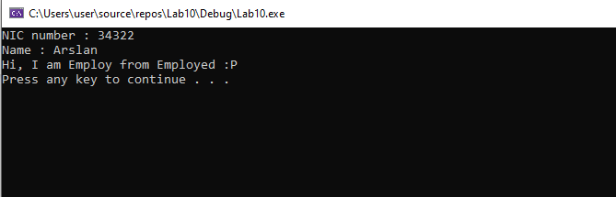

**Program # 5:**

**Main.cpp**

#include<iostream>

#include"Animals.h"

#include<string>

using namespace std;

int main()

{

Animals A;

A.Sound();

cat C;

C.Sound();

dog D;

D.Sound();

Deer DE;

DE.Sound();

Tiger_Family TF;

TF.Sound();

Tiger T;

T.Sound();

Lion L;

L.Sound();

system("pause");

return 0;

}

**Implemenration.cpp**

#include "Animals.h"

#include<iostream>

#include<string>

using namespace std;

void Animals::Sound()

{

cout << "Sound of animals:" << endl;

}

void cat::Sound()

{

cout << "The sound of cat is meow!" << endl;

}

void dog::Sound()

{

cout << "The sound of dog is bark!" << endl;

}

void Deer::Sound()

{

cout << "The sound of Deer is bell!" << endl;

}

void Tiger_Family::Sound()

{

cout << "\nFrom Tiger Family: " << endl;

}

void Tiger::Sound()

{

cout << "The sound of tiger from tiger Family is growl!" << endl;

}

void Lion::Sound()

{

{

cout << "The lion sound from tiger family is roar!" << endl;

}

}

**Animals.h**

#include<iostream>

using namespace std;

class Animals {

public:

void Sound();

};

class cat :public Animals

{

public:

void Sound();

};

class dog :public Animals

{

public:

void Sound();

};

class Deer :public Animals

{

public:

void Sound();

};

class Tiger_Family :public Animals

{

public:

void Sound();

};

class Tiger :public Tiger_Family

{

public:

void Sound();

};

class Lion :public Tiger_Family

{

public:

void Sound();

};

