**M. Ali. Arslan**

**19F-0348**

**OS Assignment # 02**

## **Question # 1:**

This program will have total **16 processes** out of which there will be **15 child processes** and one parent process.

According to the formula 2n , where n is the number of fork system calls we get to know the number of processes and using 2n – 1 we find the child processes.

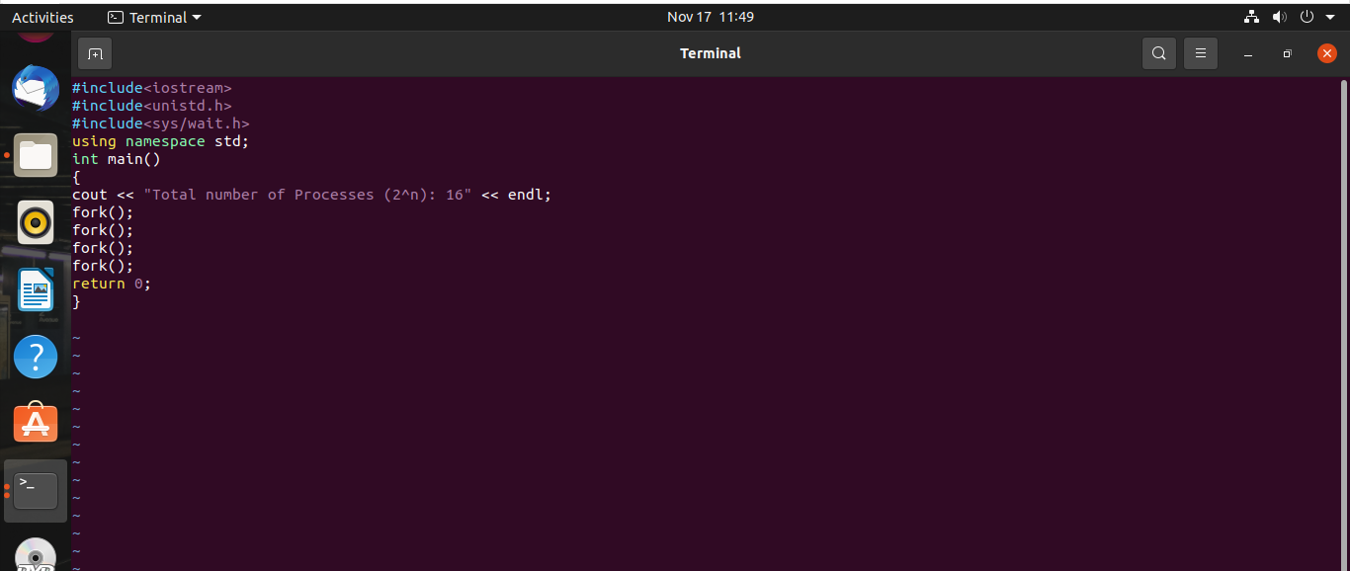

## **Question # 2:**

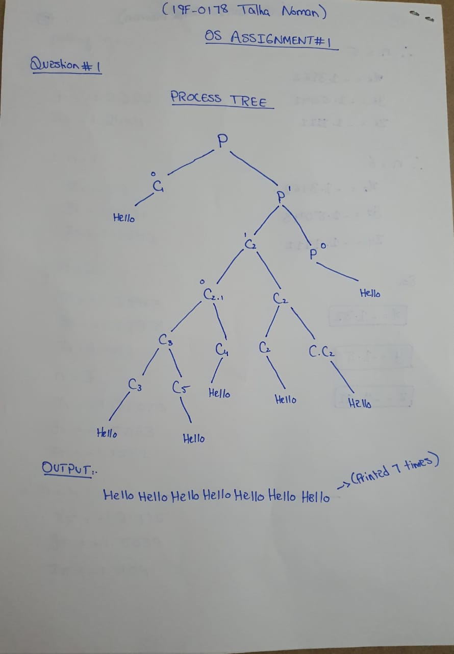

## **Question # 3:**

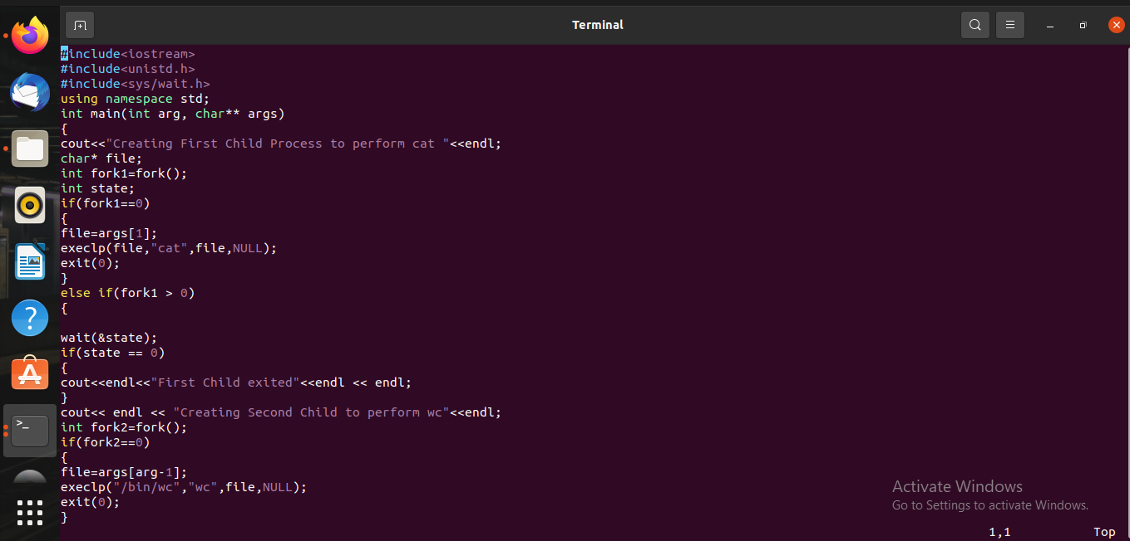

## **Question # 5:**

## **Question # 6:**

**Process # 01**

**Process # 02**

