**M. Ali. Arslan**

**19F-0348**

**OS Assignment # 02**

**Task # 01**

**Commands**

* **cd** is used for change directory
* **head** show first 2 lines in a file
* **tail** shows last 2 lines in a file
* **sort** is used to sort the words in a file

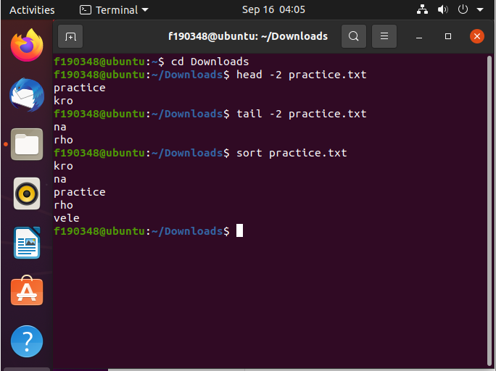

* **cd ..** is used to go back from current directory
* **whatis** is used to print details of a command
* **whoami** print the username
* **pwd** isused to print name of current directory
* **man** is used to print manual of a command
* **less** is used to display less content in a file
* **rmdir** isused to remove directory
* **mkdir** is used to make directory
* **ls** is used to show list of files in directory

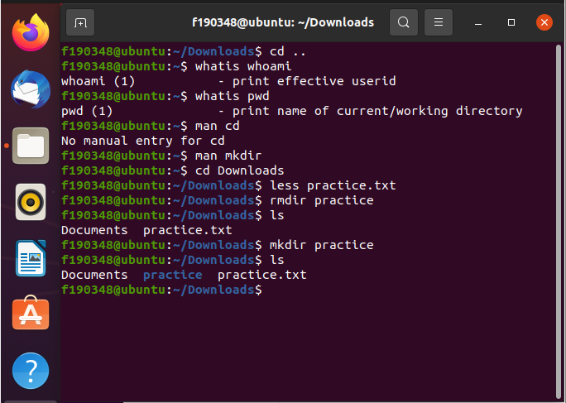

* **sudo** is super user do, give u rights of being an admin
* **sudo who** print user’s details

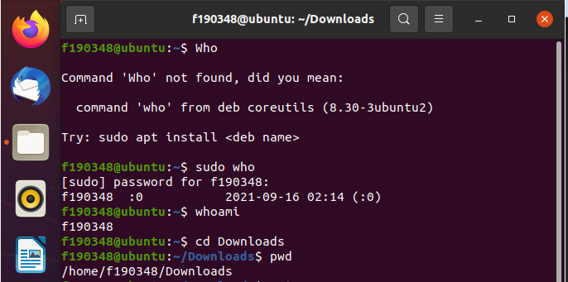

* **date** prints current time & date
* **touch** is used to create a file

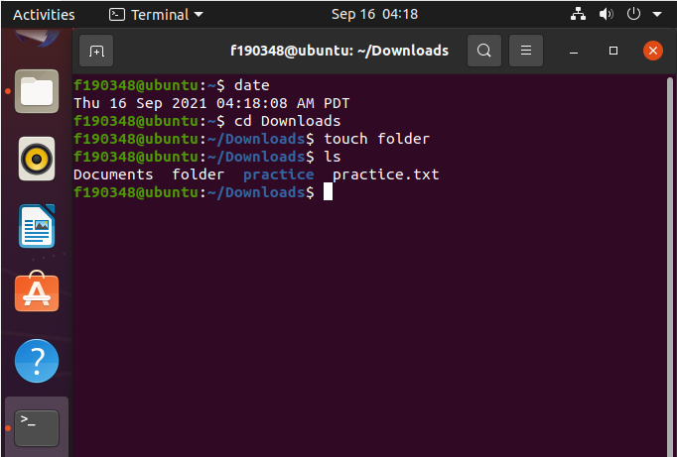

* **Sudo adduser** is used to add a new user to ubuntu

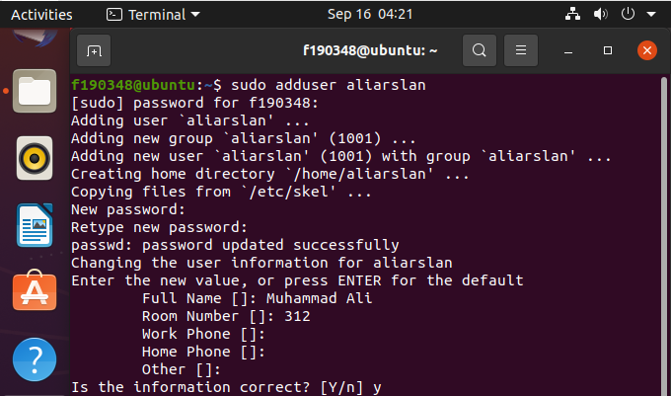

* **cat** is used to display a file’s content
* **cat practice.txt > temp.txt** is moving data from 1 file to other
* **cat temp.txt >> practice.txt** is concatenating data in file

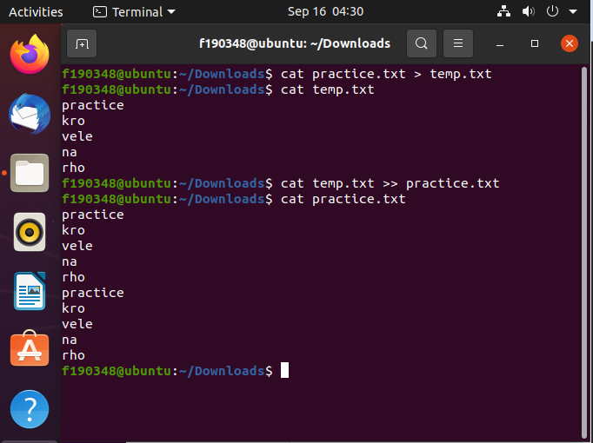

* **ls -l** is used to print list of files with their extra details

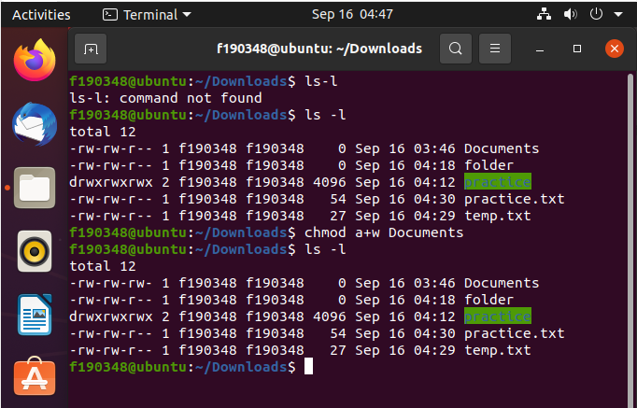

* **g++ <filename>** is used to compile C++ code in a file
* **./a.out** is used to display the output
* **gcc -o obj <filename>** is used to compile a C code in file
* **./obj** is used to display output of C code

