**M. Ali. Arslan**

**19F-0348**

**OS Lab # 05**

**While loop**

**Until Loop**

**For Loop**

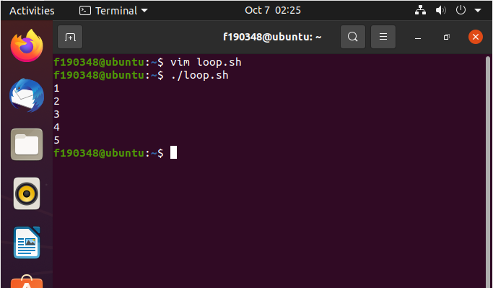

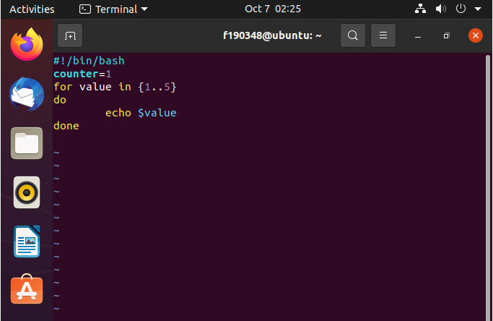

**Function**

**Managing Strings**

**Arrays**

