**M. Ali. Arslan**

**19F-0348**

**OS Lab # 01**

**Task # 01**

1. **Click on link to download VMware**

<https://getintopc.com/softwares/vmware-workstation-pro-2020-free-download/>

1. **Extract the setup and then open setup and click Next**

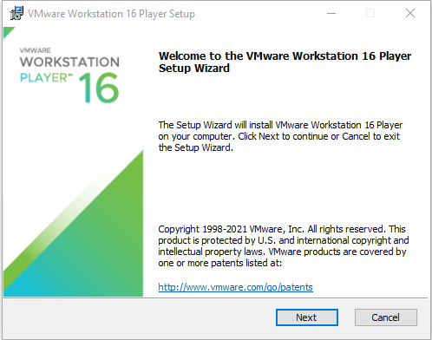

1. **Accept the term of license, then click next**

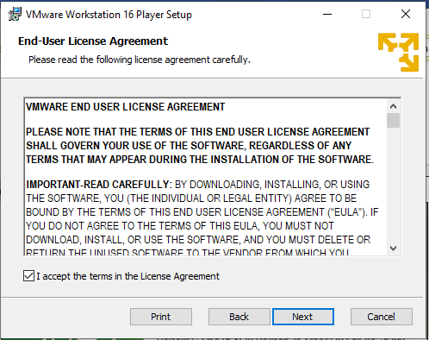

1. **Click Next**

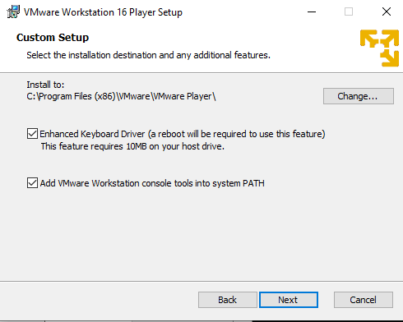

1. **Click Next**

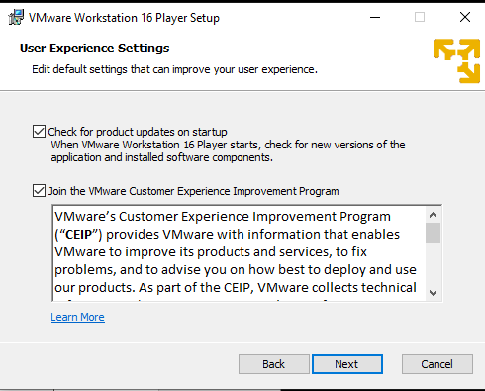

1. **Click Next**

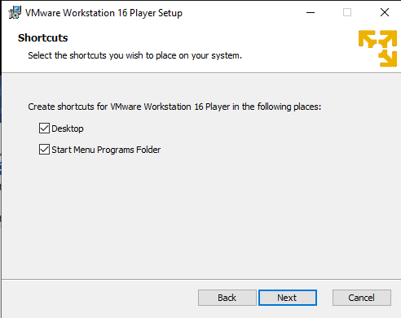

1. **Click Install**

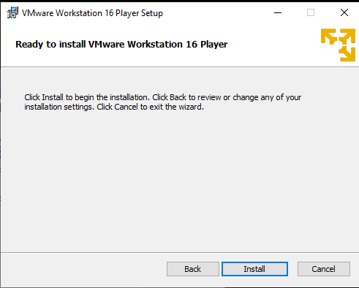

1. **Now Wait**

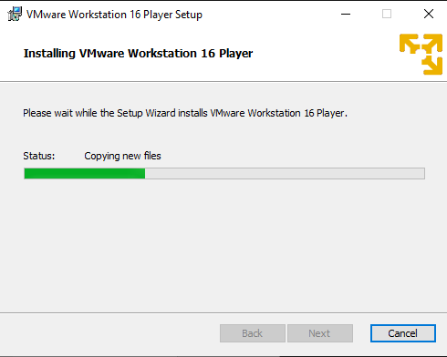

1. **Click Finish**

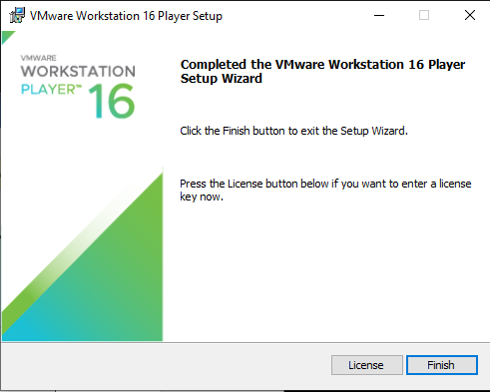

1. **Now Open VMware and click on Create a new Virtual Machine**

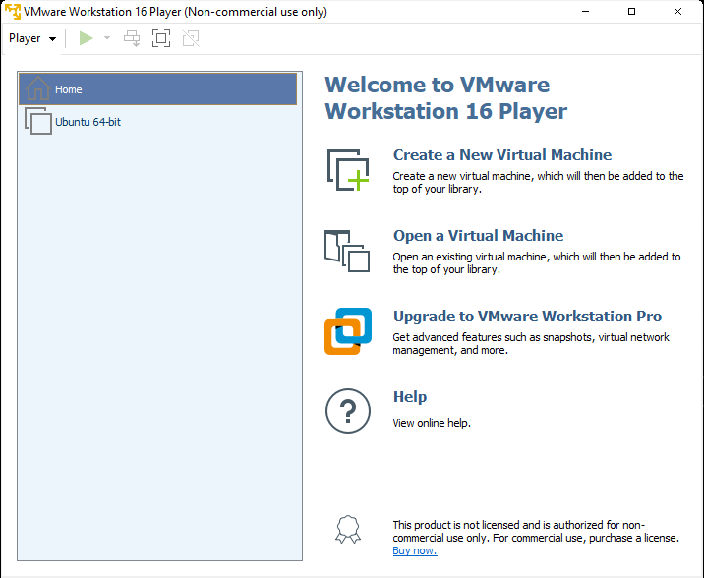

1. **Click on Browse**

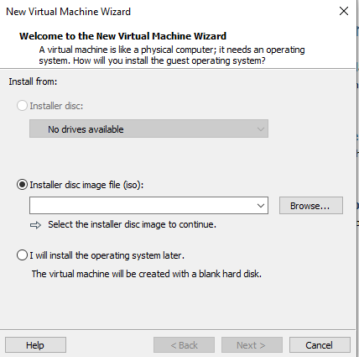

1. **Browse Ubuntu Iso File and click Next**

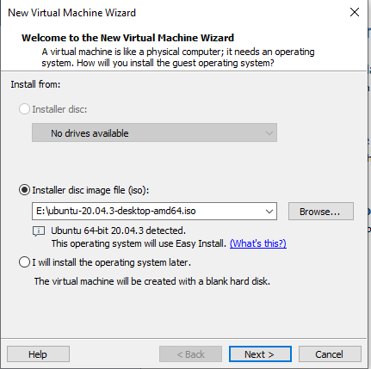

1. **Enter information and click Next**

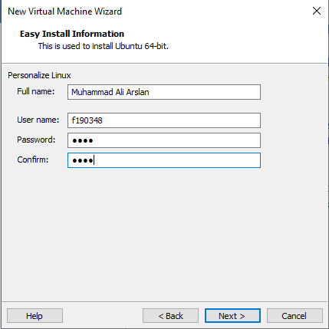

1. **Click Next**

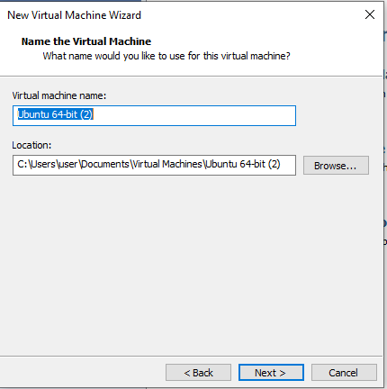

1. **Allocate Memory and click Next**

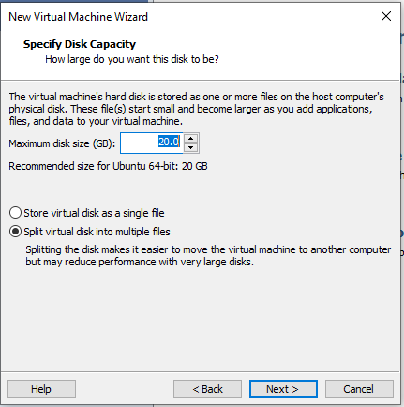

1. **Click Finish**

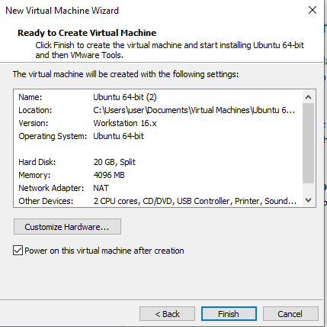

1. **Open VMware and click on Play Virtual Machine**

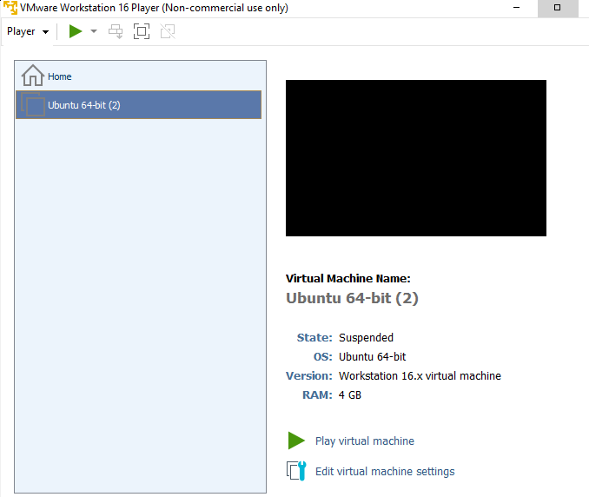

1. **Now Wait**

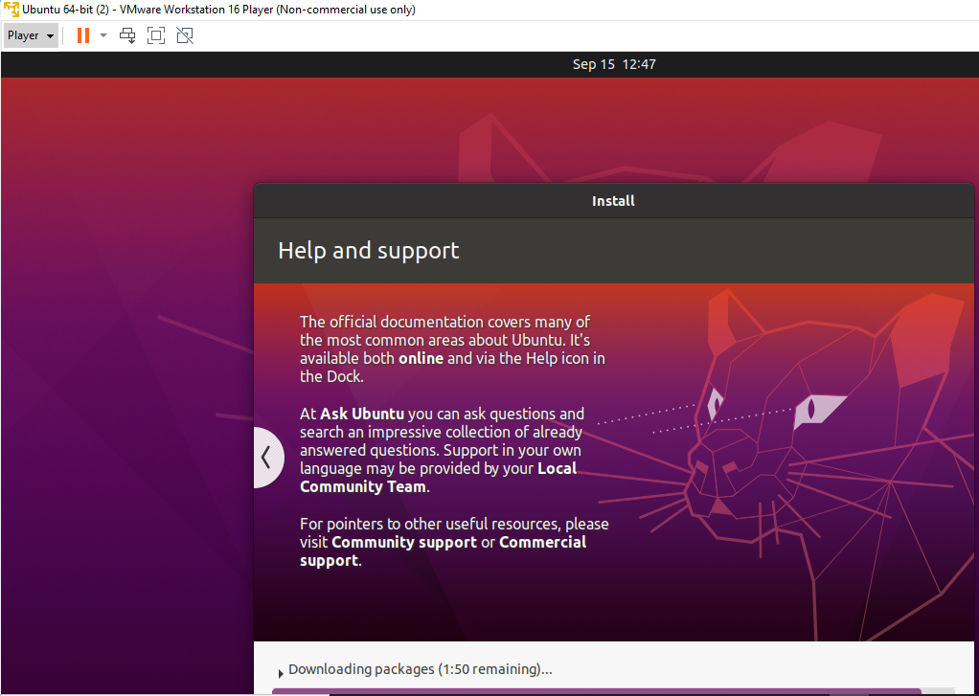

1. **Enter Password and Press Enter**

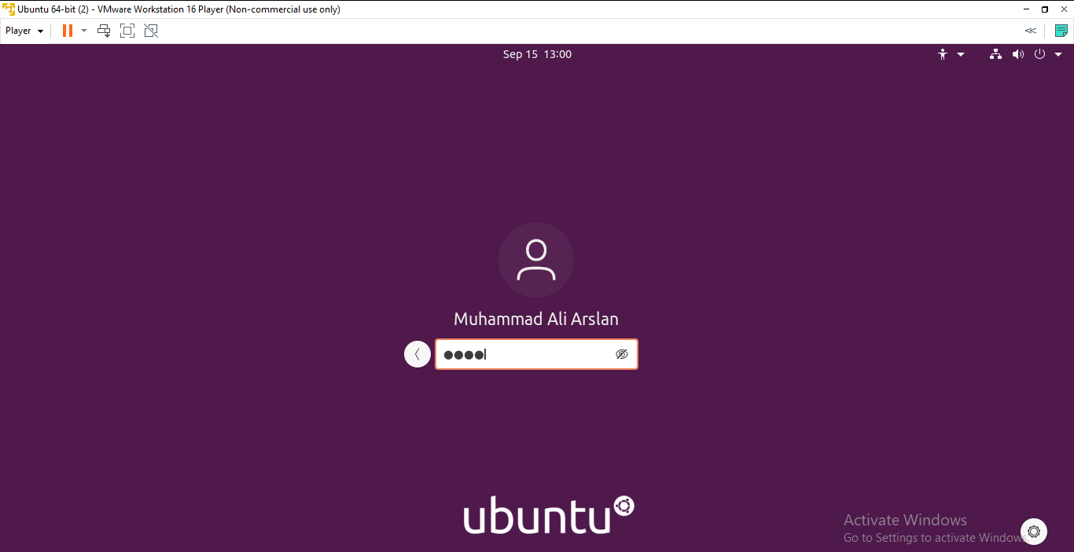

1. **Welcome!**

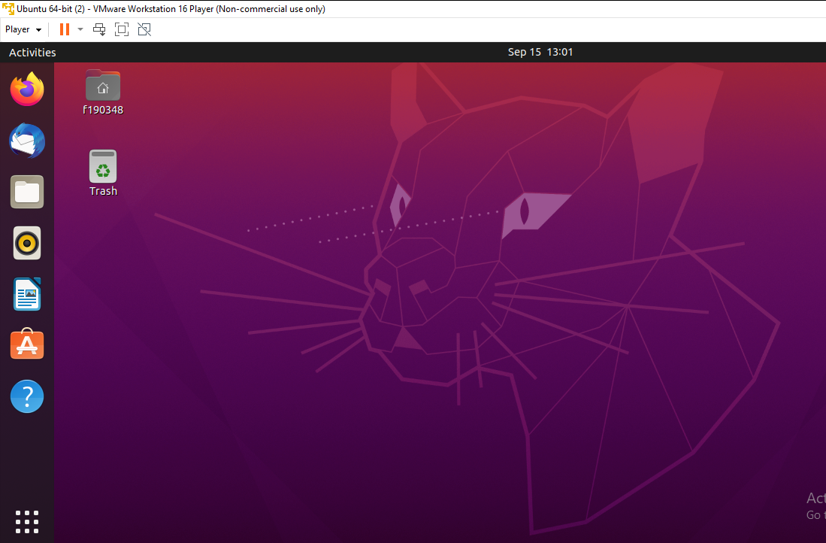

**Task # 02**

**Following Snaps are step by step guide to compile C & C++ Codes in Gcc & G++ Compilers:**

