**M. Ali. Arslan**

**19F-0348**

**OS Lab # 07**

**Task # 01**

1. **After Insert**

create trigger trigger0 on DEPT

after insert

as begin

UPDATE EMP set sal=1000 where DEPTNO = 10

End

insert into DEPT values (80,'Accounting','California')

1. **After Update**

create trigger trigger20

on emp

after update

as

begin

update dept set LOC='LOONAWALA' where DEPTNO=80

End

1. **After Delete**

create trigger trigger23

on dept

after delete

as

begin

UPDATE emp set sal=5000 where DEPTNO = 20

End

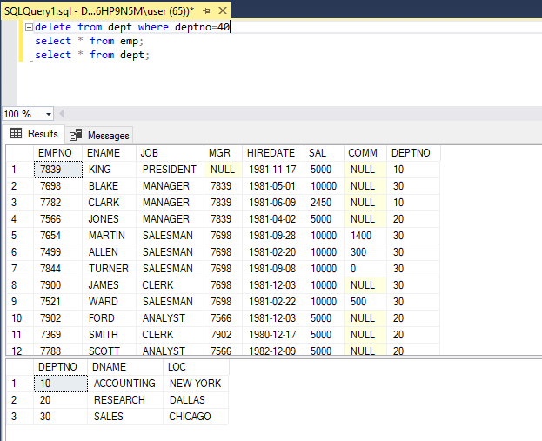

1. **Instead of Insert**

create trigger trigger12

on dept

instead of insert

as

begin

update emp set sal=1000 where EMPNO=7698

End

1. **Instead of update**

create trigger trigger99

on dept

instead of update

as

begin

update emp set sal=90000 where empno=7521

End

1. **Instead of delete**

create trigger trigger3

on dept

instead of delete

as

begin

UPDATE emp set sal=20000 where DEPTNO = 20

End

**Task # 02**

1. **Insert stored procedure with two parameters**

Create procedure proc10(@Depart_Name varchar(50), @Depart_LOC Varchar(15))

AS BEGIN

Insert into Dept values(100,@Depart_Name,@Depart_LOC);

End

Exec proc10 @Depart_name='Sales', @Depart_loc='Sialkot';

1. **Update stored procedure with two parameters**

CREATE PROCEDURE PROC8(@SAL INTEGER, @NAM VARCHAR(35))

AS BEGIN

UPDATE EMP

SET SAL=@SAL, ENAME=@NAM

WHERE EMPNO = 7844;

END

EXEC PROC8 @SAL=35500, @NAM='Ahmed';

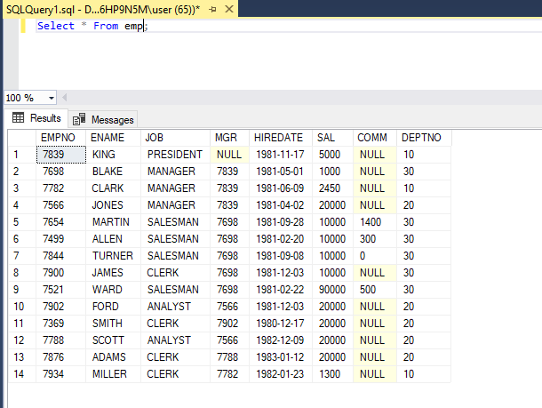

1. **Delete stored procedure with two parameters**

CREATE PROCEDURE PROC_34(@ID INTEGER, @DEP_Sal INTEGER)

AS BEGIN

DELETE FROM EMP WHERE (EMPNO =@ID AND SAL=@DEP_Sal);

END

EXEC PROC_34 @ID=7844, @DEP_Sal=35500;

