M. Ali. Arslan

19F-0348

Lab#05 (Tasks)

1. SELECT v_code, AVG(p_onhand) AS avg from p group by v_code having v_code=21344;

1. SELECT v_code, MIN(p_price) AS min from p group by v_code having v_code is NULL;

1. SELECT MAX(p_price) AS max from p group by v_code having v_code>0;

1. SELECT AVG(p_price) AS avg from p where p_discount=0;

1. 1st query will display number of records in table p which are 16

2nd query will display number of v_code in table p that are not null which are 14

1. The result of both queries are different, as in 1st query, it shows number of records in table p, whereas in 2nd query, it shows number of v_discounts in table p that are not NULL.
2. Products that have discount 0 are **8** & the products that have discount 0.05 are **6**.

SELECT * FROM p WHERE p_discount=0;

SELECT * FROM p WHERE p_discount=0.05;

1. SELECT COUNT(ename) AS Number_Employees,deptno FROM emp GROUP BY deptno;

1. SELECT JOB, avg(SAL) AS Avg_Sal From emp GROUP BY JOB;

1. SELECT DEPTNO, MIN(SAL) AS Min_SAL, MAX(SAL) AS Max_SAL FROM emp GROUP BY DEPTNO;

1. SELECT JOB, SUM(SAL) AS TOTAL_SAL FROM emp GROUP BY JOB HAVING job = 'ANALYST' or job = 'CLERK';

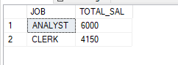

1. SELECT ENAME, YEAR(HIREDATE) AS HIRE_D FROM emp WHERE YEAR(HIREDATE)=1981;

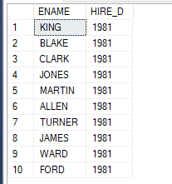

1. SELECT ENAME, YEAR(HIREDATE) AS HIRE_D FROM emp WHERE YEAR(HIREDATE)!=1981;

1. SELECT ENAME, YEAR(HIREDATE) AS HIRE_D FROM emp WHERE YEAR(HIREDATE)>1981

1. SELECT ENAME, MONTH(HIREDATE) AS HIRE_Dec FROM emp WHERE MONTH(HIREDATE)=12;

1. SELECT COUNT(HIREDATE) AS HIRE_D FROM emp WHERE YEAR(HIREDATE)=1981;

1. SELECT ENAME, MONTH(HIREDATE) AS HIRE_FIRST_4Mon FROM emp WHERE MONTH(HIREDATE)<=4;

1. SELECT DATEDIFF(DAY, '1983/12/31', GETDATE()) AS REM_DAYS;

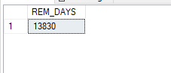

1. SELECT COUNT(HIREDATE) FROM emp WHERE DAY(HIREDATE)=25;

1. SELECT ENAME, HIREDATE, DATEADD(YEAR, 5, HIREDATE) AS D_ADDED FROM emp;

