**Tampere University of Applied Sciences**

19I260E, YEAR 2020

TECHNICAL DOCUMENT

ARDUINO MUSIC LED

HOME PROJECT 1

**Tran Oanh Ngoc Yen**

# **INFORMATION PAGE**

**Date**: 27/06/2020

**Author**: Yen Tran

**Email**: [yen.o.tran@tuni.fi](mailto:yen.o.tran@tuni.fi)

**GitHub**: <https://github.com/notaman958/MUSIC_LED>

**Linkedin**: <https://www.linkedin.com/in/yen-tran-223910110/>

# **INTRODUCTION**

Music has always played a vital role in our lives for many decades. According to Wikipedia, music is a form of art; an expression of emotions through harmonic frequencies. People can feel, hear and sympathize it through the melodies and rhythms. So how about watching it? Back to the old times, people has utilized music book to capture and restore it, however, nowadays the development of technologies help us to visualize music in more vibrant way. In music concert, visualization and effects are quite important besides DJ’s capacities. Additionally, the rise of led technology has lifted audience’s experiences into a new level. So far a simple home project has been come up by utilizing led strip, Arduino and sound sensor (KY-038) in order to make a led strip to sense music vibes as it plays.

The technical document represents the detail installation of this project.

# **PROJECT GOALS**

Bring audiences the best experience of EDM

# **USED TECHNOLOGIES IN GENERAL**

* Circuitry
  + Microcontroller Arduino Uno
  + Sound sensor (KY-038)
  + Resistor, capacitor( recommended)
  + Led strip WS2812
* Libraries
  + Adafruit NeoPixel

# Specification of example in use

* Led strip WS2812 IP30 non-waterproof

|  |  |
| --- | --- |
| SKU: WS2812B5M30LB30  Length: 5 meters  Working voltage: DC5V  Maximum power:45W  30leds/m  *Note:*  *Maximum current through R/G/B is 20mA*  > one node(RGB) maximum 60mA  > 5m total maximum 60mA x 30 x 5= 9A  > should have additional power supply 5V for the strip to keep the color as expected | https://images-na.ssl-images-amazon.com/images/I/61aM0G5YZDL._AC_SL1000_.jpg  Figure 1 Led strip WS2812 – source: internet |

* KY-038 Microphone sound sensor module

|  |  |
| --- | --- |
| A0 > analog signal  G > GND  + > 5V  D0 > digital signal | ky-038.jpg  Figure 2 Sound detector - source internet |

* Arduino UNO

|  |  |
| --- | --- |
| Operating Voltage: 5 Volts  Input Voltage: 7 to 20 Volts  Digital I/O Pins: 14 (of which 6 can provide PWM output)  UART: 1  I2C: 1  SPPI: 1  Analog Input Pins: 6  DC Current per I/O Pin: 20 mA  DC Current for 3.3V Pin: 50 mA  Flash Memory: 32 KB of which 0.5 KB used by bootloader  SRAM: 2 KB  EEPROM: 1 KB  Clock Speed: 16 MHz | Arduino Uno - R3.jpg  Figure 3 Arduino UNO – source internet |

* Resistor and Capacitor (recommended)

|  |  |
| --- | --- |
| Around 330 Ohms to reduce noise on the line | CF1W331JRC: Jameco Valuepro : Resistor Carbon Film 330 Ohm 1 Watt 5% :  Passive Components  Figure 4 resistor - source internet |
| To smooth out the power supply 100uF | Capacitor 100uf 25v - Capacitores [Promoção] no Mercado Livre Brasil  Figure 5 capacitor - source internet |

# **DIAGRAM**

|  |  |  |  |
| --- | --- | --- | --- |
| **Arduino UNO** | **Led Strip** | **5V power supply** | **Sound detector** |
| 5V | +V | +V | +V |
| GND | GND | GND | GND |
| Output digital signal D11 | Din | - | - |
| Input analog signal A1 | - | - | A0 |

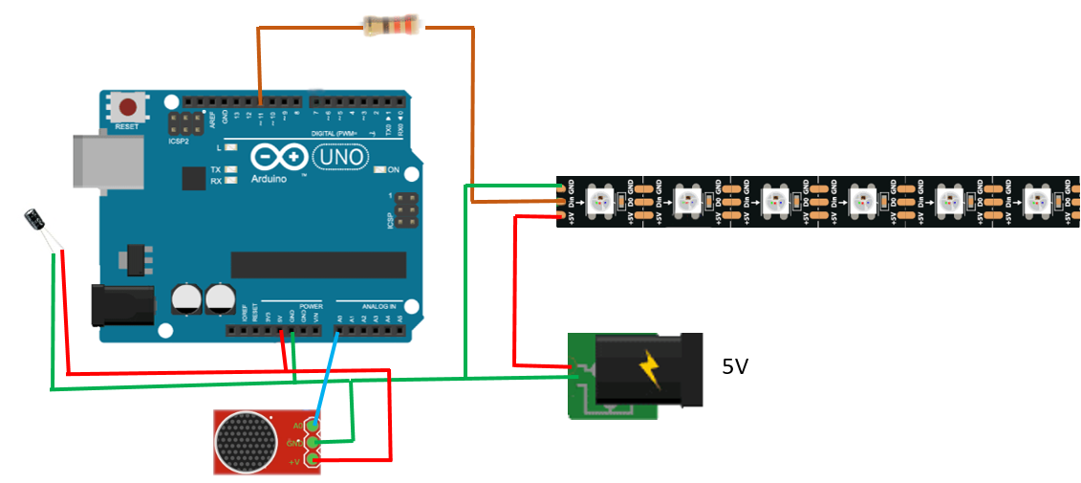

Figure 6 Music led diagram - source: https://create.arduino.cc/projecthub/sairushan/music-reactive-rgb-led-strip-ws1228b-a4c1c3

# **CODE IMPLEMENTATION**

**Libraries in use:**

* Adafruit_NeoPixel.h to control the led strip

**Note:**

* Port Manipulation for analog read instead of AnalogRead() for faster performance
* Delay() is avoid due to stopping program meaninglessly and replaced with millis()

**FlowChart**

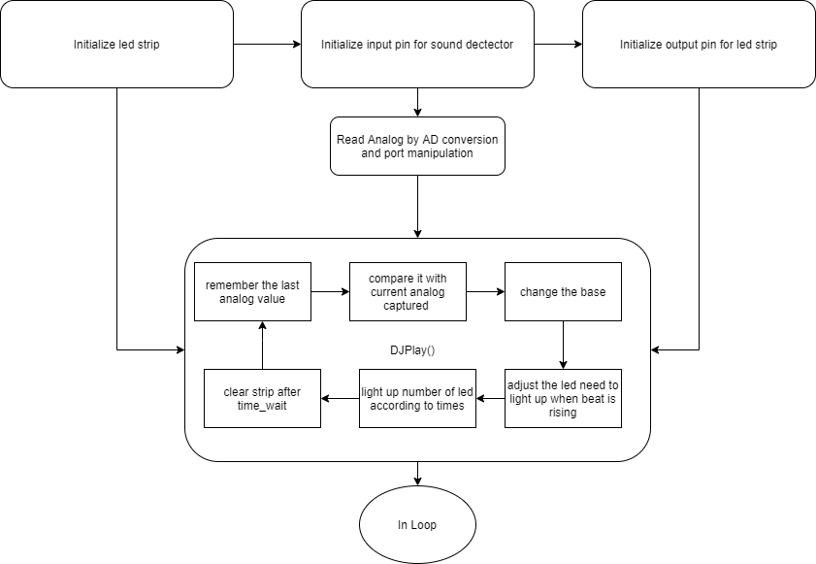

**Detail code: *<folder> music_led***

# Preferences

<https://www.youtube.com/watch?v=5WP2Tjt9o2U>

<https://www.arduino.cc/en/Reference/PortManipulation>

<https://learn.adafruit.com/adafruit-neopixel-uberguide/arduino-library-use>

<http://sensorkit.en.joy-it.net/index.php?title=KY-038_Microphone_sound_sensor_module>