Assignment 1:
Write a C program that includes a user-defined function named isPrime with the signature int isPrime(int num); The function should take an integer as a parameter and return 1 if the number is prime and 0 otherwise.
Source Code:
#include <stdio.h>
#include <math.h>

int isPrime(int);

int main()
{
int n;
printf("\n\nEnter the number: ");
scanf("%d", &n);
if (isPrime(n))
{
printf("\n\nInput %d is a Prime Number.\n", n);
}
else
{
printf("\n\nInput %d is not a Prime Number.\n", n);
}
return 0;
}

int isPrime(int n)
{
if (n <= 1)
return 0;
if (n == 2)
return 1;
if (n % 2 == 0)
return 0;
int temp = (int)sqrt(n);
int i;
for (i = 3; i <= temp; i += 2)
{
if (n % i == 0)
{
return 0;
}
}
return 1;
}
Output:
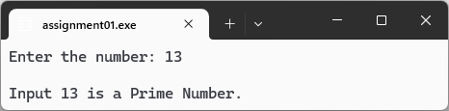
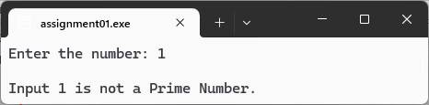
Assignment 2:
Write a C program that includes a user-defined function named isArmstrong with the signature int isArmstrong(int num); . An Armstrong number is a number that is equal to the sum of its own digits each raised to the power of the number of digits. For example, 153 is an Armstrong number because 1^3 + 5^3 + 3^3 = 153
Source Code:
#include <stdio.h>
#include <math.h>

int isArmstrong(int);
int count(int);

int main()
{
int n;
printf("Enter the number: ");
scanf("%d", &n);

if (isArmstrong(n))
{
printf("\nInput %d is a Armstrong Number.", n);
}
else
{
printf("\nInput %d is Not a Armstrong Number.", n);
}

return 0;
}

int count(int n)
{
int count = 0;
while (n > 0)
{
count++;
n = n / 10;
}
return count;
}

int isArmstrong(int n)
{
if (n < 0)
return 0;
if (n == 0)
return 1;

int power = count(n);
int temp = n;
int checker = 0;

while (temp > 0)
{
int digit = temp % 10;
checker = checker + (int)round(pow(digit, power));
temp = temp / 10;
}
return n == checker;
}

Output:
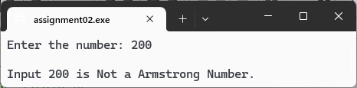
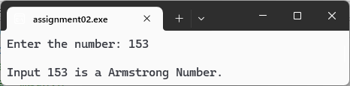
Assignment 3:
Write a C program that includes a user-defined function named isPerfect with the signature int isPerfect(int num); . A perfect number is a positive integer that is equal to the sum of its proper divisors, excluding itself. For example, 28 is a perfect number because the sum of its divisors (1, 2, 4, 7, 14) equals 28.
Source Code:
#include <stdio.h>

int isPerfect(int);

int main()
{
int n;
printf("Enter the number: ");
scanf("%d", &n);
if (isPerfect(n))
{
printf("\nInput %d is a Perfect Number.", n);
}
else
{
printf("\n\nInput %d is not a Perfect Number.", n);
}
return 0;
}

int isPerfect(int n)
{
if (n <= 1)
return 0;
int temp = 1;
int i;
for (i = 2; i <= n / 2; i++)
{
if (n % i == 0)
{
temp += i;
}
}
return temp == n;
}
Output:
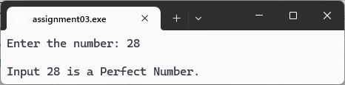
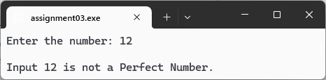

Assignment 4:
Write a C program that takes an integer input representing a month (1 to 12) and a year. Use a switch statement to display the number of days in that month, considering leap years.
Source Code:
#include <stdio.h>
int main()
{
int month, year, days;
printf("Enter the month (1 to 12) and year: ");
scanf("%d %d", &month, &year);
switch (month)
{
case 1: // jan
case 3: // mar
case 5: // may
case 7: // jul
case 8: // aug
case 10: // oct
case 12: // dec
days = 31;
break;
case 4: // apr
case 6: // jun
case 9: // sep
case 11: // nov
days = 30;
break;
case 2: // feb
if ((year % 400 == 0) || ((year % 4 == 0) && (year % 100 != 0)))
{
days = 29;
}
else
{
days = 28;
}
break;
default:
printf("\nYou entered something wrong.");
return 1;
}
printf("\nNumber of days: %d", days);
return 0;
}
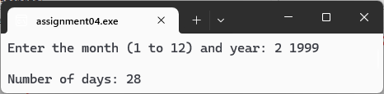
Output:
