Problem Statement:

Write a program to implement a Diagonal Matrix a Lower Triangular Matrix, an Upper Triangular Matrix, and a Symmetric Matrix using a one-dimensional array.

Problem Definition:

Matrix memory optimization means storing special matrices efficiently by avoiding storage of predictable zero or duplicate elements, using compact 1D array instead of full 2D array.

- Diagonal Matrix: Only diagonal elements (i == j) are non-zero. Stored using the formula arr[i].
- Lower Triangular Matrix: All elements above the main diagonal are zero. Non-zero elements mapped using i*(i+1)/2 + j.
- Upper Triangular Matrix: All elements below the main diagonal are zero. Non-zero elements mapped using n*i - i*(i-1)/2 + (j-i).
- Symmetric Matrix: Matrix equal to its transpose (A[i][j] = A[j][i]). Only the lower triangular half is stored, using i*(i+1)/2 + j.

Algorithm:

Diagonal Matrix:

procedure setDiagonal(arr, i, j, x)
begin
if(i == j)
arr[i] <- x;
end if
end procedure

procedure getDiagonal(arr, i, j)
begin
if(i == j)
return arr[i];
else
return 0;
end if
end procedure

Lower Triangular Matrix:

procedure setLower(arr, i, j, x)
begin
if(i >= j)
arr[i*(i+1)/2+j] <- x;
end if
end procedure

procedure getLower(arr, i, j)
begin
if(i >= j)
return arr[i*(i+1)/2+j];
else
return 0;
end if
end procedure

P.T.O.
Upper Triangular Matrix:

Procedure setUpper(arr, n, i, j, x)
begin
if(i <= j)
arr[n*i-i*(i-1)/2+(j-i)] <- x;
end if
end procedure

Procedure getUpper(arr, n, i, j)
begin
if(i <= j)
return arr[n*i-i*(i-1)/2+(j-i)];
else
return 0;
end if
end procedure

Symmetric Matrix:

Procedure setSymmetric(arr, i, j, x)
begin
if(i >= j)
arr[i*(i+1)/2+j] <- x;
else
arr[j*(j+1)/2+i] <- x;
end if
end procedure

Procedure getSymmetric(arr, i, j)
begin
if(i >= j)
return arr[i*(i+1)/2+j];
else
return arr[j*(j+1)/2+i];
end if
end procedure

P.T.O.
Source Code:

#include <iostream>

using namespace std;

class Matrix
{
private:
int n, *arr;

public:
Matrix(int size)
{
n = size;
arr = new int[n * (n + 1) / 2];
}

void setDiagonal(int i, int j, int x)
{
if (i == j)
arr[i] = x;
}
void setLowerTri(int i, int j, int x)
{
if (i >= j)
arr[i * (i + 1) / 2 + j] = x;
}
void setUpperTri(int i, int j, int x)
{
if (i <= j)
arr[n * i - (i * (i - 1) / 2) + (j - i)] = x;
}
void setSymmetric(int i, int j, int x)
{
(i >= j) ? arr[i * (i + 1) / 2 + j] = x : arr[j * (j + 1) / 2 + i] = x;
}

int getDiagonal(int i, int j)
{
return (i == j) ? arr[i] : 0;
}
int getLowerTri(int i, int j)
{
return (i >= j) ? arr[i * (i + 1) / 2 + j] : 0;
}
int getUpperTri(int i, int j)
{
return (i <= j) ? arr[n * i - i * (i - 1) / 2 + (j - i)] : 0;
}
int getSymmetric(int i, int j)
{
return (i >= j) ? arr[i * (i + 1) / 2 + j] : arr[j * (j + 1) / 2 + i];
}

void display(int type)
{
cout << endl
<< "Matrix:" << endl;
for (int i = 0; i < n; i++)
{
for (int j = 0; j < n; j++)
{
if (type == 1)
cout << getDiagonal(i, j) << " ";
else if (type == 2)
cout << getLowerTri(i, j) << " ";
else if (type == 3)
cout << getUpperTri(i, j) << " ";
else if (type == 4)
cout << getSymmetric(i, j) << " ";
}
cout << endl;
}
}

~Matrix()
{
delete[] arr;
}
};

int main()
{
int n, choice, x;
cout << "Enter the order of the matrix : ";
cin >> n;
Matrix M(n);

cout << "\n1. Diagonal Matrix.";
cout << "\n2. Lower Triangular Matrix.";
cout << "\n3. Upper Triangular Matrix.";
cout << "\n4. Symmetric Matrix.";
cout << "\nEnter your choice : ";
cin >> choice;

switch (choice)
{
case 1:
cout << "\nEnter the diagonal elements : ";
for (int i = 0; i < n; i++)
{
cin >> x;
M.setDiagonal(i, i, x);
}
M.display(1);
break;

case 2:
cout << "\nEnter the elements : ";
for (int i = 0; i < n; i++)
{
for (int j = 0; j <= i; j++)
{
cin >> x;
M.setLowerTri(i, j, x);
}
}
M.display(2);
break;

case 3:
cout << "\nEnter the elements : ";
for (int i = 0; i < n; i++)
{
for (int j = i; j < n; j++)
{
cin >> x;
M.setUpperTri(i, j, x);
}
}
M.display(3);
break;

case 4:
cout << "\nEnter the elements : ";
for (int i = 0; i < n; i++)
{
for (int j = 0; j <= i; j++)
{
cin >> x;
M.setSymmetric(i, j, x);
}
}
M.display(4);
break;

default:
cout << "Invalid Choice.";
}
return 0;
}

P.T.O.
Output:
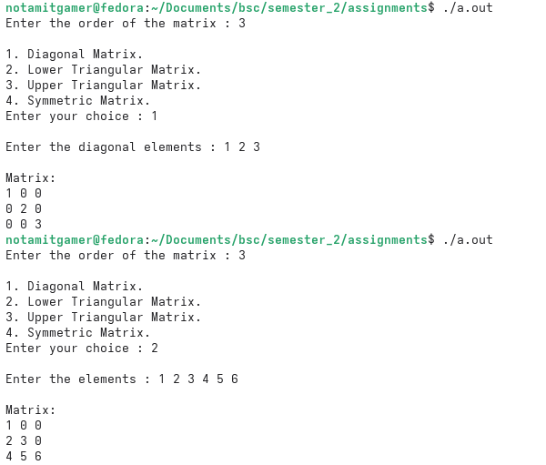
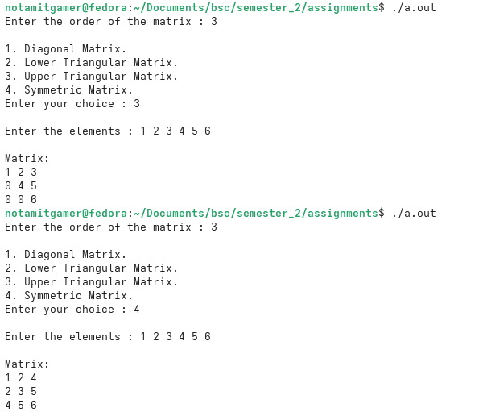

P.T.O.
Discussion:

This program demonstrates how memory can be saved when working with special types of matrices — Diagonal, Lower Triangular, Upper Triangular, and Symmetric — by storing only their essential elements in a single dynamically allocated 1D array, rather than a full 2D array.

A Matrix class is used to bundle together the storage (the array) and the logic needed to interpret it correctly for each matrix type.

Two private members drive the class:

- arr - a dynamically allocated integer pointer that holds the compact array of stored values.
- n - the order (size) of the square matrix.

When a Matrix object is created, the constructor computes the array size as n*(n+1)/2 and allocates it on the heap using new.

The class's functionality is built around these key methods:

- setDiagonal(), setLowerTri(), setUpperTri() and setSymmetric() – Each of these accepts a row index, column index, and a value, then applies a matrix-specific formula to determine exactly where that value should be placed in the 1D array.

- getDiagonal(), getLowerTri(), getUpperTri() and getSymmetric() – These reconstruct values for any (i, j) position by locating them in the array (using ternary conditions), returning 0 for positions that were never stored, and — in the Symmetric case — reflecting values across the diagonal when needed.

- display() – Using two nested loops, this method walks through every position of the conceptual n×n matrix and prints the corresponding value, effectively rebuilding the full matrix view from the compact array.

Finally, the destructor ~Matrix() ensures proper cleanup by releasing the dynamically allocated array with delete[] once the object goes out of scope, preventing memory leaks.

