Assignment 1:
Write a C program that includes a user-defined function named isPrime with the signature int isPrime(int num); The function should take an integer as a parameter and return 1 if the number is prime and 0 otherwise.
Source Code :
#include <stdio.h>

int isPrime(int num)
{
int i;

for (i = 2; i <= num / 2; i++)
{
if (num % i == 0)
return 0;
}
return 1;
}

int main()
{
int n;

printf("Enter a number: ");
scanf("%d", &n);

if (n <= 1)
printf("%d is not a prime number.", n);
else if (isPrime(n))
printf("%d is a prime number.", n);
else
printf("%d is not a prime number.", n);
return 0;
}
Output:
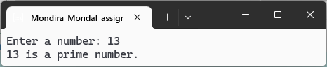
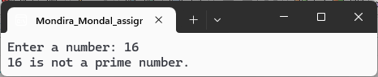
Assignment 2:
Write a C program that includes a user-defined function named isArmstrong with the signature int isArmstrong(int num);. An Armstrong number is a number that is equal to the sum of its own digits each raised to the power of the number of digits. For example, 153 is an Armstrong number because 1^3 + 5^3 + 3^3 = 153
Source Code:
#include <stdio.h>
#include <math.h>

int isArmstrong(int num)
{
int originalNum = num;
int remainder;
int sum = 0;
int numberOfDigits = 0;
int tempNum = num;

while (tempNum != 0)
{
tempNum /= 10;
numberOfDigits++;
}

tempNum = num;
while (tempNum != 0)
{
remainder = tempNum % 10;
sum += pow(remainder, numberOfDigits);
tempNum /= 10;
}

if (sum == originalNum)
{
return 1;
}
else
{
return 0;
}
}

int main()
{
int number;

printf("Enter an integer: ");
scanf("%d", &number);

if (isArmstrong(number))
{
printf("%d is an Armstrong number.\n", number);
}
else
{
printf("%d is not an Armstrong number.\n", number);
}
return 0;
}
Output:
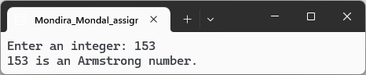
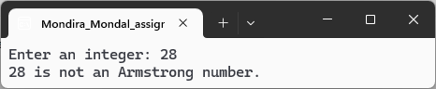

Assignment 3:
Write a C program that includes a user-defined function named isPerfect with the signature int isPerfect(int num);. A perfect number is a positive integer that is equal to the sum of its proper divisors, excluding itself. For example, 28 is a perfect number because the sum of its divisors (1, 2, 4, 7, 14) equals 28.
Source Code:
#include <stdio.h>
int isPerfect(int num)
{
if (num <= 0)
{
return 0;
}
int sum_of_divisors = 0, i;
for (i = 1; i < num; i++)
{
if (num % i == 0)
{
sum_of_divisors += i;
}
}
return (sum_of_divisors == num);
}
int main()
{
int number;
printf("Enter a positive integer: ");
scanf("%d", &number);
if (isPerfect(number))
printf("%d is a perfect number.\n", number);
else
printf("%d is not a perfect number.\n", number);
return 0;
}
Output:
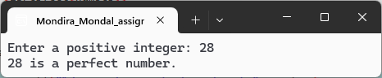

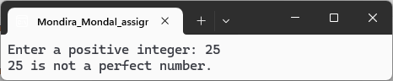

Assignment 4:
Write a C program that takes an integer input representing a month (1 to 12) and a year. Use a switch statement to display the number of days in that month, considering leap years.
Source Code:
#include <stdio.h>
int main()
{
int month, year, numDays;
printf("Enter month (1-12) and year: ");
scanf("%d %d", &month, &year);
if (month < 1 || month > 12)
{
printf("Invalid month entered. Please enter a month between 1 and 12.\n");
return 1;
}
switch (month)
{
case 1: // January
case 3: // March
case 5: // May
case 7: // July
case 8: // August
case 10: // October
case 12: // December
numDays = 31;
break;
case 4: // April
case 6: // June
case 9: // September
case 11: // November
numDays = 30;
break;
case 2: // February
if ((year % 4 == 0 && year % 100 != 0) || (year % 400 == 0))
numDays = 29;
else
numDays = 28;
break;
}
printf("Number of days in month %d of year %d: %d\n", month, year, numDays);
return 0;
}
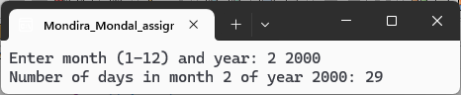
Output:
