

Faculty of Information Technology

Computer Science Department

Free Distribution Resources System

(FDRS)

Graduation Project (1) Report

Prepared by:

|  |  |
| --- | --- |
| **Students Name** | **Student ID** |
| **Wasef jayousi** | **201920074** |
| **Anas asyed** | **202020067** |
| **Saif karborani** | **202020088** |

Supervised by:

Ashraf Odeh

Semester / Academic Year

Copyright © 2022-2023 - All rights reserved

Middle East University

Declaration

We hereby acknowledge that the work presented in this document report and the ideas based upon are the group members own unless stated otherwise and properly cited in text and referenced at the end of the document.

|  |  |  |  |
| --- | --- | --- | --- |
| Date | Signature | Students Name | Student ID |
|  |  |  |  |
|  |  |  |  |
|  |  |  |  |

..

Table of Contents

List of Figures and tables 4

Terminologies 5

Chapter 1: Introduction 7

1.1 Description of the Challenge/Problem/Opportunity 7

1.2 Description of the Solution 8

1.3 Literature Review (related work) 8

1.4 Technology and tools to be used 9

Chapter 2: Project Plan 10

2.1 Project Objectives 10

2.2 Project Scope 11

2.3 Software Process Model 12

2.4 Project Schedule 13

2.5 Project Schedule Chart(s) (Bar/Gantt Chart) 14

Chapter 3: Requirements and Analysis 15

3.1 Functional Requirements 15

3.2 Non-Functional Requirements 15

Chapter 4: Architecture and Design 17

4.1 Architecture 17

4.2 Use Case Diagram 18

4.3 Use Cases Descriptions/Flow of Events 19

4.4 Class Diagram 19

4.5 Entity Relationship Diagram 19

Chapter 5: Conclusion & Future Work 20

5.1 Conclusion 20

5.2 Future work 20

Appendix 21

References 22

# List of Figures and tables

Figure 2.3 Software process model

…………………………………………………………………………………………………...12

Table 2.4 Project Schedule (WBS)

…………………………………………………………………………………………………...13

Table 2.5 Bar / Gantt chart

…………………………………………………………………………………………………...14

# Terminologies

Abstract

One of the biggest issues students suffer from while studying a course in there university is finding enough resources to make them understand the course they are taking. A tool like a resources library for each course and for each major in university will help and support students. The resources main source on the website will be uploaded and categorized from students who previously took the course, they will upload the documents, videos, websites that helped them through taking the course. Students who downloaded any document a history list will track there downloads to help them track there downloads and a favorite list to let them track uploads form their favorite source.

# Chapter 1: Introduction

This chapter is about illustrating the description of the challenge (problem statement) and the solution, related work to be done and the Technology and tools that were going to use later so we can implement our project (website)

## Description of the Challenge/Problem/Opportunity

The challenge facing students and researchers in universities today is the availability of reliable and up-to-date academic references. Many students struggle to find relevant resources for their studies, which can impact their academic performance.

The challenge is to make an E-library that will be experienced and rated from students to make it easier for future students on how to be more productive and keep the library updated.

The problem is that many existing libraries may not have resources that are specific to a particular major or field of study. In addition, many academic resources are expensive and not readily available to students, making it difficult for them to access the latest research and information.

This problem is compounded by the fact that traditional libraries may not have the latest updates or revisions to academic resources, which can negatively impact students' studies.

The opportunity is to create an e-library that caters to different majors and provides a comprehensive collection of academic references. An e-library that has student-generated content can be a valuable tool for students, allowing them to share their resources and experiences with their peers. Additionally, an e-library that is regularly updated with the latest research and information can help students stay up-to-date with their studies and improve their academic performance.

## Description of the Solution

The e-library is a unique digital resource that allows users to upload and share their academic references with other users. This library caters to various majors in universities, including but not limited to Information Technology, Business, Engineering, Medicine, Law, and Social Sciences. The library's collection includes books, videos, research papers, and other relevant resources, which are contributed by other students with experience in the major or subject.

The resource library is designed to facilitate collaboration between users, allowing them to share their academic resources and experiences with other users “Students”. Students can upload their own resources, which they find useful and share them with their peers, ensuring that the resource library collection is always up-to-date and comprehensive, each user can rate, review, and make a favorite list with favorite users that upload frequently, and a history list with every downloaded resources by user will be automatically initiated in the users profile.

The resource library has a user-friendly interface that is easy to navigate, allowing users to search for resources based on their specific needs and interests. The library is organized by majors, with each major having a dedicated section that contains resources specific to their field of study. The library's search feature also allows users to find resources based on keywords or topics.

The resource library encourages users to contribute to the library, ensuring that the library's collection continues to grow and expand. The library's community-driven approach promotes collaboration and knowledge-sharing among users and researchers.

## Literature Review (related work)

In this related work, we are going to see and maybe upgrade on other students project that made this project similar.

Related work:

In this related work their system is mainly about book issues for students, what is meant here by book issues are the librarian (Admin) writes your name and details and gives you the book & tells you the time period of returning the book, so this is in real life library. but in the system it actually does a lot more, the admin can monitor the whole system .It also has facility of an online notice board where teachers and student can put up information about workshops being held in our colleges or nearby colleges and librarian after proper verification from the concerned institution organizing the workshop can add it to the notice board. The students when they log in and have an account they can see list of books issued and its date , their return date and the can request from the librarian which is the admin to add new books by filling a request form the student made.

In their mechanism of search:

Their search of books will be faster, able to search record by using few clicks of mouse and few search keywords thus saving his valuable time.

SEARCH BOOK DESCRIPTION OF FEATURE: We can search book based on book id, book name, and publication or by author name.

Their reference is all at the end of the page.

Their interface is much uglier. We will make ours much easier to navigate and probably more modern. Their system is about a student user and a teacher user and they both have similar features, Our system improvement would be rather than a student that has to log in and a teacher that has also to log in, we can put a guest automatic log in with less features so that with anybody wants to enter the website without logging in he can still do the core thing that the system provides.

## Technology and tools to be used

Using Vscode our route will be a web development app at the end so we will use these two Terms

FRONTEND: HTML, CSS, JAVASCRIPT and maybe other stuff (frameworks, API’s, bootstrap).

BACKEND: still not decided yet.

But what is a frontend and backend? Well Front end and back end are terms used by programmers and computer professionals to describe the layers that make up hardware, a computer program or a website which are delineated based on how accessible they are to a user (Laura Fitzgibbons).

Chapter 2: Project Plan

In this chapter, it illustrates about the project objectives, project scope, and the software process model that we are going to use for us to do the project, also project scheduling.



## Project Objectives

* Provide users in the university with the new up to date academic references.
* Provide users in the university to ability to share and upload their academic resources.
* Provide users to search for resources (Books...Etc.) Based on their specific needs.
* Provide users a user friendly interface that it easy to navigate.
* Provide users the ability to download the required resource if available.
* Provide users with video tutorials.
* Provide users the ability to review the Resource (book…etc.)
* Provide a guest with less features
* An admin login page where admin can add books, videos or page sources.
* Open link for learning websites.

An admin who has a complete control of what he wants to distribute, for the user who wants to sign up

Will have a feature of a history list of what the book that he searched for and viewed or downloaded

, and also can give feedbacks and have some extra features, unlike the guest who only wants to view or download a resource.

Also will give the admin the ability to control the user on what resources he uploads and reviews and the ability to ban or delete the user.

## Project Scope

|  |
| --- |
| **Date:** March 2023 |
| ***General Project Information***  **Project Name:**  Resource library for students  **Sponsor:Middle east university**  **Project Manager: Dr. Ashraf Odeh**  **Prepared by :**   * Anas Alseid * Wasef Jayousi * Saif Karborani | |
| ***Project Objectives :***   * Provide students in the university with the new up to date academic references. * Provide students in the university to ability to share and upload their academic resources. * Provide students to search for resources (Books...Etc.) Based on their specific needs. * Provide students a user friendly interface that it easy to navigate. * Provide students the ability to download the required book if available.   Provide students with video tutorials. | |
| ***Project Description:***  ***One of the biggest issues students suffer from while studying a course in there university is finding enough resources to make them understand the course they are taking. A tool like a resources library for each and for each major in university will help and support students . the resources main source on the website will be uploaded and categorized from students who previously took the course , they will upload the documents , videos , websites that helped them through taking the course . students who downloaded any document a history list will track there downloads to help*** | |
| ***Business Benefits:***   * ***Improving the way students contribute with each other*** * ***Improving how the students study and save time while researching*** * ***Making important resources more easy to access by users*** * ***Easy to search in resources library*** | |
| ***Project Deliverables:***   * ***User friendly interface*** * ***User history of downloads list*** * ***User login page*** * ***User can upload documents under his name*** * ***User can review , rate , different documents that got uploaded to the website*** | |
| ***Estimated Project Duration:***  4 Months | |

## Software Process Model

The Software Development Life Cycle (SDLC) is a structured process that enables the production of high-quality, low-cost software, in the shortest possible production time. The goal of the SDLC is to produce superior software that meets and exceeds all customer expectations and demands. The SDLC defines and outlines a detailed plan with stages, or phases, that each encompass their own process and deliverables. Adherence to the SDLC enhances development speed and minimizes project risks and costs associated with alternative methods of production.

We are going to implement it because it fits our project and because it fits our Problem either the system we are doing or us.

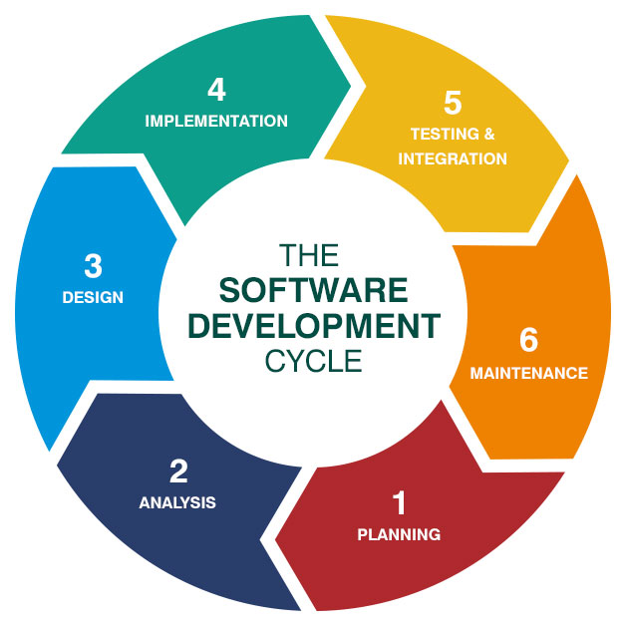

Figure 2.3

## Project Schedule

Our project schedule will depend on Software process model WBS, Our weekend off holidays and on other specific holidays, like Eid al Ftir, Eid al Adha.

Notice: The EID al ftir, Eid al adha holidays will be dependent on the university (MEU) Academic calendar that is published on their website.

(https://www.meu.edu.jo/admission/academic-calendar/)

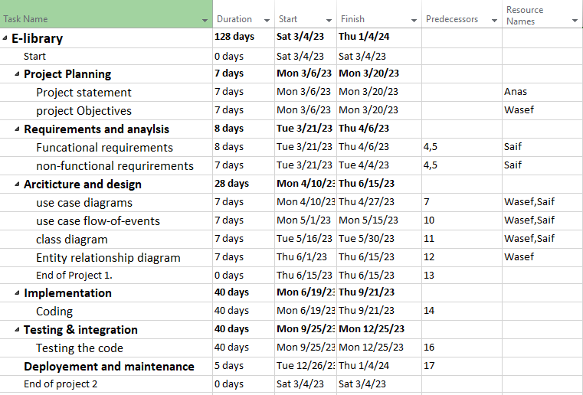

## Project Schedule Chart(s) (Bar/Gantt Chart)

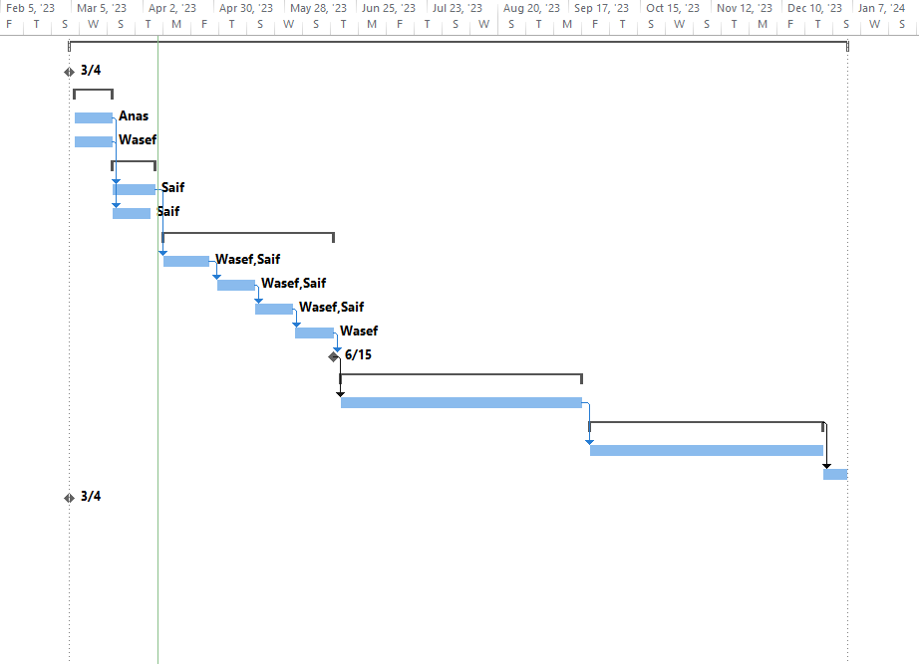

Notice: to open this link you need to first install the project professional App by Microsoft

This is alive link on the project schedule <Project1.mpp>

# Chapter 3: Requirements and Analysis



## Functional Requirements

1. User Authentication and Authorization - Users should be able to create an account, login, and access only the features that they are authorized to use.

2. Recourse Catalog - The system should provide a searchable catalog of all recourse available in the e-library along with their metadata such as title, author, genre, publication year, publisher, and availability status.

3. Recourse Reading - Users should be able to read recourse online or download them for offline reading.

4. Recourse Search - Users should be able to search for recourse by title, author, keyword, or category.

5. User Interaction - Users should be able to rate, review, and comment on recourse, as well as share them on social media.

6. Admin Panel - The system should have an admin panel to manage users, recourse, and system settings.

7. Reporting and Analytics - The system should provide reports and analytics to track the usage of recourse, users, and the system overall.

8. User Profile Management - Users should be able to manage their profile information, update their preferences, and view their reading history.

9. Recourse Recommendation - The system should provide personalized recommendations to users based on their reading history and preferences.

## 

## Non-Functional Requirements

1. Performance - The system should handle many concurrent users and transactions without slowing down or crashing, with fast page load times and smooth scrolling for online reading.
2. Availability - The system should be available 24/7, with minimal downtime for maintenance or upgrades, and with high availability to ensure users can access the system whenever they need it.
3. Reliability - The system should be reliable and provide accurate information, without losing data or causing errors, with frequent backups to ensure that data is not lost.
4. Scalability - The system should be able to scale up or down as needed to accommodate changes in user traffic or library collections, with the ability to add more servers and storage space as required.
5. Security - The system should be secure, with measures in place to protect user data, prevent unauthorized access, and detect and respond to security breaches, with SSL encryption and strong password policies.
6. Usability - The system should be easy to use, with an intuitive user interface and clear instructions for performing tasks, with clear and concise user documentation available.
7. Compatibility - The system should be compatible with different web browsers and operating systems, and support different languages and character sets, with a responsive design to ensure that it works on different devices.
8. Maintainability - The system should be easy to maintain and upgrade, with clear documentation and well-structured code, with change management policies in place to prevent unplanned changes.

# Chapter 4: Architecture and Design



## Architecture

## Use Case Diagram

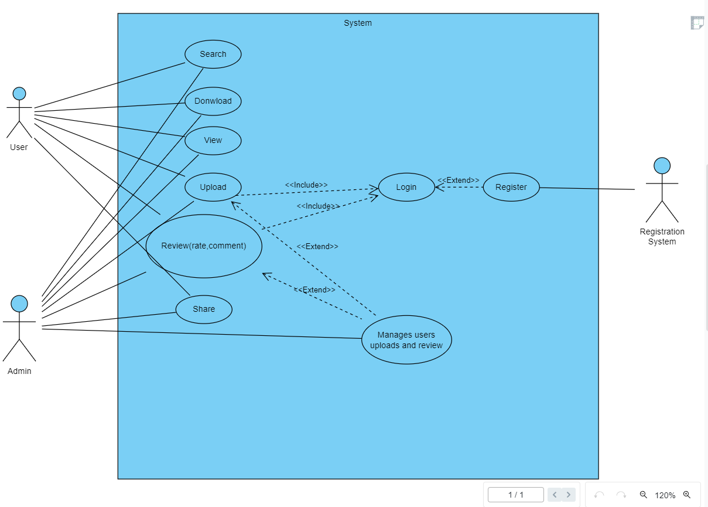

## Use Cases Descriptions/Flow of Events

## Class Diagram

## Entity Relationship Diagram

# Chapter 5: Conclusion & Future Work



## Conclusion

## Future work

# Appendix

# References

1. Bernd Bruegge Allen H.Dutoit (2010) Object-Oriented Software Engineering Using UML, Patterns, and Java 3rd Edition.
2. <https://www.academia.edu/37726542/Library_Management_System_Mini_Project_Report_On_LIBRARY_MANAGEMENT_SYSTEM>
3. Why to use SDLC? <https://www.synopsys.com/glossary/what-is-sdlc.html#:~:text=The%20SDLC%20defines%20and%20outlines,with%20alternative%20methods%20of%20production>.
4. <https://www.techtarget.com/whatis/definition/front-end#:~:text=Front%20end%20and%20back%20end%20are%20terms%20used%20by%20programmers,they%20are%20to%20a%20user>.