

Faculty of Information Technology

Computer Science Department

Library management system

(E-library)

Graduation Project (1) Report

Prepared by:

|  |  |
| --- | --- |
| **Students Name** | **Student ID** |
| **Wasef jayousi** | **201920074** |
| **Anas asyed** | **202020067** |
| **Saif krborani** | **202020088** |

Supervised by:

Supervisor’s Name

Semester / Academic Year

Copyright © 2022-2023 - All rights reserved

Middle East University

Declaration

We hereby acknowledge that the work presented in this document report and the ideas based upon are the group members own unless stated otherwise and properly cited in text and referenced at the end of the document.

|  |  |  |  |
| --- | --- | --- | --- |
| Date | Signature | Students Name | Student ID |
|  |  |  |  |
|  |  |  |  |
|  |  |  |  |

..

Table of Contents

List of Figures 4

List of Tables 5

Terminologies 6

Chapter 1: Introduction 8

1.1 Description of the Challenge/Problem/Opportunity 8

1.2 Description of the Solution 8

1.3 Literature Review (related work) 8

1.4 Technology and tools to be used 8

Chapter 2: Project Plan 9

2.1 Project Objectives 9

2.2 Project Scope 9

2.3 Software Process Model 9

2.4 Project Schedule 9

2.5 Project Schedule Chart(s) (Bar/Gantt Chart) 9

Chapter 3: Requirements and Analysis 10

3.1 Functional Requirements 10

3.2 Non-Functional Requirements 10

Chapter 4: Architecture and Design 11

4.1 Architecture 11

4.2 Use Case Diagram 11

4.3 Use Cases Descriptions/Flow of Events 11

4.4 Activity Diagram 11

4.5 Class Diagram 11

4.6 Entity Relationship Diagram 11

Chapter 5: Conclusion & Future Work 12

5.1 Conclusion 12

5.2 Future work 12

Appendix 13

References 14

# List of Figures

# List of Tables

# Terminologies

What is meant here by terminology, will ask the doc.

Abstract

*In today's digital age, e-libraries have become an essential tool for students and researchers. This e-library aims to provide a comprehensive collection of academic references for various majors in universities. The library is accessible online, making it easy for students to search for and access resources from anywhere and at any time. The collection is updated regularly with new additions and revisions to existing content to ensure that students have access to the latest research and information. The e-library No.1 resource to make bigger will be students from different majors that can upload resources to it. The e-library aims to support the academic pursuits of students and researchers by providing them with a reliable source of information.*

# Chapter 1: Introduction

This chapter is about illustrating the description of the challenge (problem statement) and the solution, related work to be done and the Technology and tools that were going to use later so we can implement our project (website)

## Description of the Challenge/Problem/Opportunity

The challenge facing students and researchers in universities today is the availability of reliable and up-to-date academic references. Many students struggle to find relevant resources for their studies, which can impact their academic performance.

The challenge is to make an E-library that will be experienced and rated from students to make it easier for future students on how to be more productive and keep the library updated.

The problem is that many existing libraries may not have resources that are specific to a particular major or field of study. In addition, many academic resources are expensive and not readily available to students, making it difficult for them to access the latest research and information.

This problem is compounded by the fact that traditional libraries may not have the latest updates or revisions to academic resources, which can negatively impact students' studies.

The opportunity is to create an e-library that caters to different majors and provides a comprehensive collection of academic references. An e-library that has student-generated content can be a valuable tool for students, allowing them to share their resources and experiences with their peers. Additionally, an e-library that is regularly updated with the latest research and information can help students stay up-to-date with their studies and improve their academic performance.

## Description of the Solution

The e-library is a unique digital resource that allows students to upload and share their academic references with their peers. This library caters to various majors in universities, including but not limited to Information Technology, Business, Engineering, Medicine, Law, and Social Sciences. The library's collection includes books, research papers, journal articles, and other relevant resources, which are contributed by students with experience in the major or subject.

The e-library is designed to facilitate collaboration between students, allowing them to share their academic resources and experiences with their peers. Students can upload their own resources, which they find useful and share them with their peers, ensuring that the e-library's collection is always up-to-date and comprehensive.

The e-library has a user-friendly interface that is easy to navigate, allowing students to search for resources based on their specific needs and interests. The library is organized by majors, with each major having a dedicated section that contains resources specific to their field of study. The library's search feature also allows students to find resources based on keywords or topics.

The e-library encourages students to contribute to the library, ensuring that the library's collection continues to grow and expand. The library's community-driven approach promotes collaboration and knowledge-sharing among students and researchers.

The e-library is accessible online, making it convenient for students to access resources from anywhere and at any time. The library's digital format also allows for easy sharing of resources, making it an excellent collaborative tool for students and researchers.

## Literature Review (related work)

In this related work, we are going to see and upgrade on other students project that made this project similar...

Chrome extension://efaidnbmnnnibpcajpcglclefindmkaj/https://www.daitm.org.in/wp-content/uploads/2019/04/Gr.-06library-project-report.pdf

## Technology and tools to be used

Later on.

# Chapter 2: Project Plan

In this chapter, it illustrates about the project objectives, project scope, and the software process model that we are going to use for us to do the project, also project scheduling.



## Project Objectives

* Provide students in the university with the new up to date academic references.
* Provide students in the university to ability to share and upload their academic resources.
* Provide students to search for resources (Books...Etc.) Based on their specific needs.
* Provide students a user friendly interface that it easy to navigate.
* Provide students the ability to download the required book if available.
* Provide students with video tutorials.
  + An admin login page where admin can add books , videos or page sources
  + Open link for learning websites

## Project Scope

1. Provide students in the university with the new up-to-date academic references: The resources library system will provide students with access to the latest academic references, such as books, journals, research papers, and other relevant materials. The system will be updated regularly to ensure that students have access to the most recent academic resources.
2. Provide students in the university the ability to share and upload their academic resources: The resources library system will allow students to share and upload their own academic resources, such as class notes, research papers, and other relevant materials. This will encourage collaboration among students and promote a culture of knowledge-sharing.
3. Provide students to search for resources (books...etc.) based on their specific needs: The resources library system will include a search functionality that will allow students to search for resources based on their specific needs. Students will be able to search by keywords, author, title, and other relevant criteria.
4. Provide students a user-friendly interface that is easy to navigate: The resources library system will be designed with a user-friendly interface that is easy to navigate. The system will be intuitive and user-friendly, ensuring that students can find the resources they need quickly and easily.
5. Provide students the ability to download the required book if available: The resources library system will allow students to download the required book if available. The system will ensure that students have access to the resources they need, even if they are unable to visit the physical library.
6. Provide students with video tutorials: The resources library system will provide students with access to video tutorials that will enhance their learning experiences. The video tutorials will cover a range of topics, including research methodologies, academic writing, and other relevant topics.
7. An admin login page where admin can add books, videos or page sources: The resources library system will include an admin login page that will allow the library administrators to add books, videos or page sources to the system. The admin login page will be password protected and accessible only to authorized personnel.
8. Open link for learning websites: The resources library system will include open links for learning websites that will provide students with access to additional learning resources, such as online courses, tutorials, and other relevant materials.

## Software Process Model

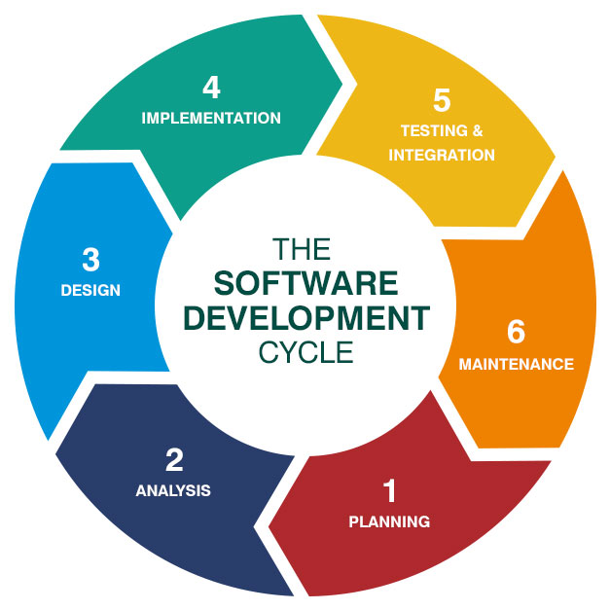

## Project Schedule

## Project Schedule Chart(s) (Bar/Gantt Chart)

# Chapter 3: Requirements and Analysis



## Functional Requirements

## 

## Non-Functional Requirements

# Chapter 4: Architecture and Design



## Architecture

## Use Case Diagram

## Use Cases Descriptions/Flow of Events

## Activity Diagram

## Class Diagram

## Entity Relationship Diagram

# Chapter 5: Conclusion & Future Work



## Conclusion

## Future work

# Appendix

# References