Nama : Muhammad Lubis Notangsi
NIM : 18.11.2594
Kelas : S1-Informatika 11
Mata Kuliah : Statistika (Responsi)

1.
 | Statistics
 |  |  | No | Nilai
N | Valid |  | 30 | 30
 | Missing |  | 0 | 0
Mean |  |  | 15.50 | 76.77
Median |  |  | 15.50 | 78.00
Mode |  |  | ₁a | 78
Std. Deviation |  |  | 8.803 | 10.040
Skewness |  |  | .000 | .081
Std. Error of Skewness |  |  | .427 | .427
Kurtosis |  |  | -1.200 | -1.086
Std. Error of Kurtosis |  |  | .833 | .833
Percentiles | 10 |  | 3.10 | 64.00
 | 25 |  | 7.75 | 66.75
 | 30 |  | 9.30 | 68.90
 | 50 |  | 15.50 | 78.00
 | 60 |  | 18.60 | 79.80
 | 75 |  | 23.25 | 85.00
 | 90 |  | 27.90 | 90.00

a. Multiple modes exist. The smallest value is shown
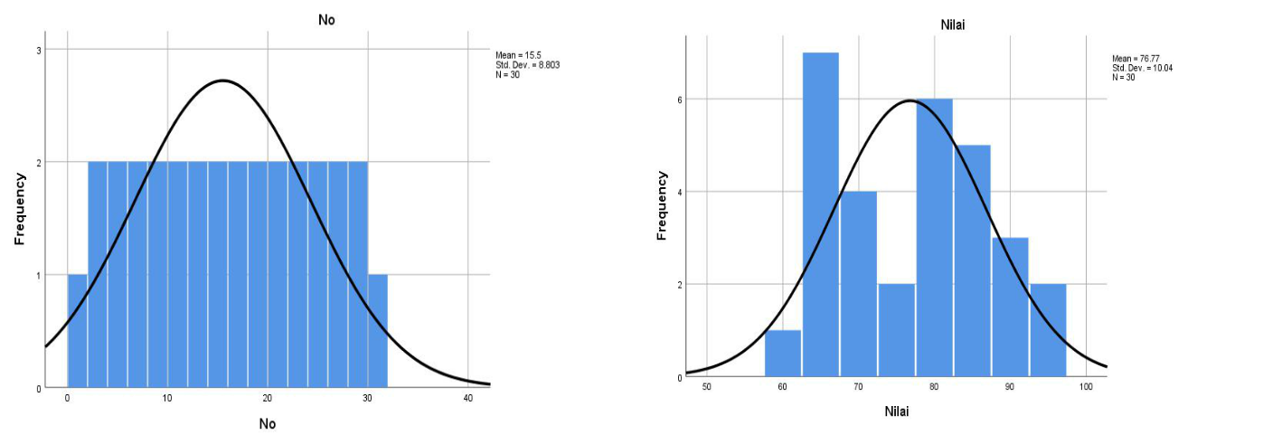
2. a. Bagaimana hubungan antar variabelnya?

 |  | Correlations
 |  |  | X1 | X2 | Y
X1 | Pearson Correlation |  | 1 | .705* | .550
 | Sig. (2-tailed) |  |  | .010 | .064
 | N |  | 12 | 12 | 12
X2 | Pearson Correlation |  | .705* | 1 | .542
 | Sig. (2-tailed) |  | .010 |  | .069
 | N |  | 12 | 12 | 12
Y | Pearson Correlation |  | .550 | .542 | 1
 | Sig. (2-tailed) |  | .064 | .069
 | N |  | 12 | 12 | 12

*. Correlation is significant at the 0.05 level (2-tailed).
Hubungan antara X1 dan X2 didapatkan angka | +.705 | Kuat
Hubungan antara X1 dan Y didapatkan angka | +.550 | Sedang
Hubungan antara X2 dan Y didapatkan angka | +.542 | Sedang

b. Tentukan persamaan regresi ganda!
 |  |  |  | Coefficientsa
 |  |  |  |  |  | Standardized
 |  | Unstandardized Coefficients |  |  |  | Coefficients
Model |  | B |  | Std. Error |  | Beta | t | Sig.
1 | (Constant) | 28.321 |  | 5.294 |  |  | 5.350 | .000
 | X1 | .520 |  | .591 |  | .333 | .879 | .402
 | X2 | .052 |  | .064 |  | .307 | .810 | .439

a. Dependent Variable: Y

Rumus Persamaan Regresi :

Y = 28,321 + 0.520 + 0.052

c. Buktikan apakah ada pengaruh yang signifikan antara makanan ikan dan panjang ikan terhadap berat ikan!

 |  |  | Coefficientsa
 |  |  |  |  | Standardized
 |  | Unstandardized Coefficients |  |  | Coefficients
Model |  | B | Std. Error |  | Beta | t | Sig.
1 | (Constant) | 28.321 | 5.294 |  |  | 5.350 | .000
 | X1 | .520 | .591 |  | .333 | .879 | .402
 | X2 | .052 | .064 |  | .307 | .810 | .439

a. Dependent Variable: Y

- Pengaruh Makanan Ikan(X1) terhadap Berat Ikan(Y)
  - Berdasarkan Nilai Signifikan (Sig.)

Nilai signifikan (Sig.) Variable (X1) sebesar 0,402. Karena nilai Sig. 0.402 > probabilitas 0.05, maka dapat disimpulkan bahwa H1(hipotesis pertama) ditolak. Artinya tidak ada pengaruh Makanan ikan(X1) terhadap Berat Ikan(Y).

- Perbandingan t hitung dengan t tabel

Nilai t hitung var makanan ikan(X1) sebesar 0.879.

Cari t tabel

t tabel = (0.05/2 ; 12-2-1)
t tabel = (0.025 ; 9)
t tabel = 2,262

Karena nilai t hitung 0,879 < t tabel 2,262, maka dapat disimpulkan bahwa H1(hipotesis pertama) ditolak.

- Pengaruh Panjang Ikan terhadap Berat Ikan

  - Berdasarkan Nilai Signifikan (Sig.)

Nilai signifikan (Sig.) Variable (X2) sebesar 0,439. Karena nilai Sig. 0.439 > probabilitas 0.05, maka dapat disimpulkan bahwa H2(hipotesis kedua) ditolak. Artinya tidak ada pengaruh Panjang Ikan(X2) terhadap Berat Ikan(Y).

- Perbandingan t hitung dengan t tabel

Nilai t hitung panjang ikan(X2) sebesar 0.810.

Cari t tabel

t tabel = (0.05/2 ; 12-2-1)
t tabel = (0.025 ; 9)
t tabel = 2,262

Karena nilai t hitung 0,810 < t tabel 2,262, maka dapat disimpulkan bahwa H1(hipotesis pertama) ditolak.
3. Uji Validitas
 |  |  |  | Item-Total Statistics
 |  |  |  |  |  | Corrected | Cronbach's
 |  | Scale Mean if |  | Scale Variance |  | Item-Total | Alpha if Item
 |  | Item Deleted |  | if Item Deleted |  | Correlation | Deleted
L1 |  |  | 51.47 | 65.016 |  | .513 | .906
L2 |  |  | 51.40 | 64.386 |  | .693 | .899
L3 |  |  | 51.33 | 64.713 |  | .701 | .899
E1 |  |  | 51.83 | 65.661 |  | .615 | .902
E2 |  |  | 51.40 | 64.800 |  | .700 | .899
E3 |  |  | 51.30 | 65.390 |  | .666 | .900
M1 |  |  | 51.43 | 65.013 |  | .709 | .899
M2 |  |  | 51.53 | 64.189 |  | .660 | .900
M3 |  |  | 51.30 | 64.907 |  | .755 | .898
EH1 |  |  | 52.00 | 65.655 |  | .514 | .906
EH2 |  |  | 52.03 | 67.895 |  | .433 | .908
EH3 |  |  | 52.33 | 66.851 |  | .407 | .910
S1 |  |  | 51.67 | 65.057 |  | .573 | .903
S2 |  |  | 51.40 | 65.007 |  | .644 | .901
S3 |  |  | 51.77 | 65.220 |  | .555 | .904
R tabel = 0.3610
Dibandingkan dengan r tabel
L1 | .513 > .3610 |  |  | Valid
L2 | .693 > .3610 |  |  | Valid
L3 | .701 > .3610 |  |  | Valid
E1 | .615 > .3610 |  |  | Valid
E2 | .700 > .3610 |  |  | Valid
E3 | .666 > .3610 |  |  | Valid
M1 | .709 > .3610 |  |  | Valid
M2 | .660 > .3610 |  |  | Valid
M3 | .755 > .3610 |  |  | Valid
EH1 | .514 > .3610 |  |  | Valid
EH2 | .433 > .3610 |  |  | Valid
EH3 | .407 > .3610 |  |  | Valid
S1 | .573 > .3610 |  |  | Valid
S2 | .644 > .3610 |  |  | Valid
S3 | .555 > .3610 |  |  | Valid
Uji Reabilitas
Reliability Statistics
Cronbach's
 | Alpha |  | N of Items
 | .908 |  |  | 15

Dari total 15 pertanyaan yang valid dapat disimpulkan bahwa pertanyaan tersebut reliabel

