# **Section 1 – Point of View**

People with special skills (dancing, singing etc.) need a way to get detailed feedback on their skill and can benefit from the crowd

# **Section 2 – Experience Prototypes**

**2.1 App Idea**

An app that lets you creators seek opinion and feedback from the crowd on their creations. I prototyped a chatbot and a web-based UI

**2.2 Prototype 1 – Connection to the point of view**

First prototype was a SMS – based Chabot which enables comedians to seek feedback of their newly created jokes.

**2.3 Prototype 1 – Planning and Execution**

For planning, I opened the jokes sections on reddit and made a list of joke categories available (Math, One liners, AntiJokes etc). Then, I noted down 5 jokes per category.

Execution looked as follows

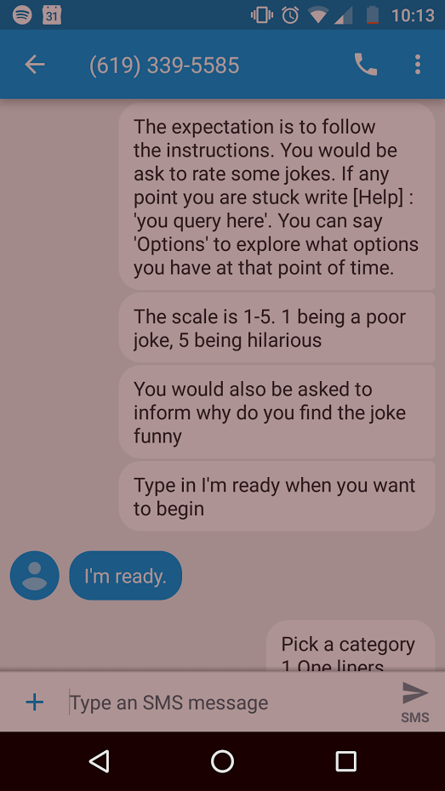 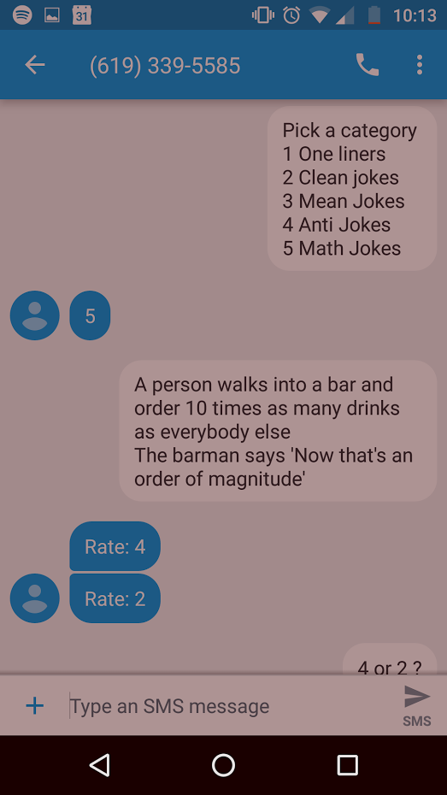

1. **(2)**

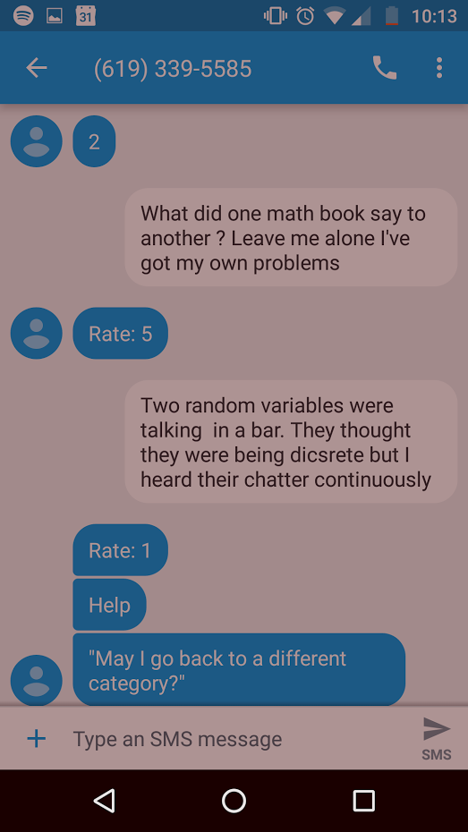 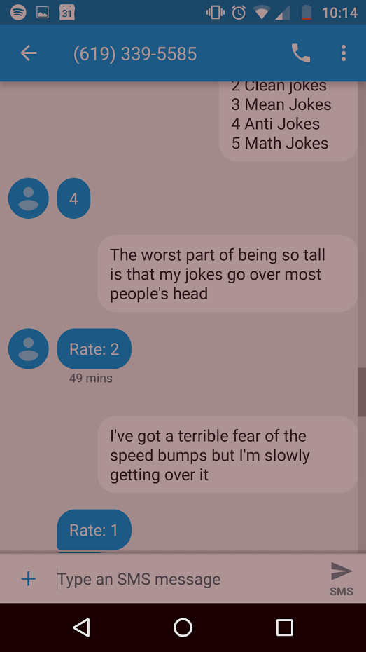

**(3) (4)**

**2.4 Prototype 1 –Feedback**

Humor goes beyond text. There is an aspect of body language, tone, delivery and modality strongly associated to it. Similarly, a simple 1-5 scale is not enough for the creator to judge and fine tune his skill.

The prototype missed an instruction to exit or stop – participant was confused when to end the conversation.

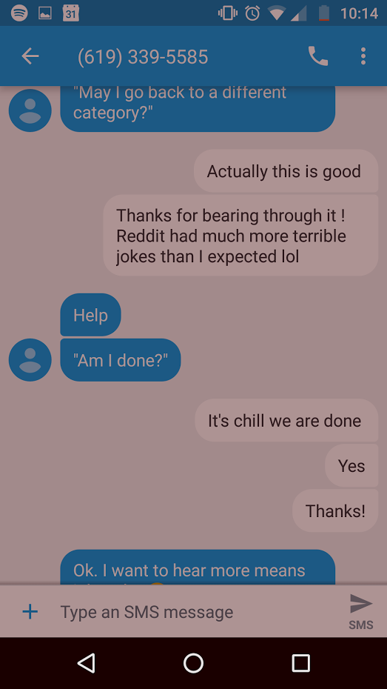

**2.5 Prototype 2 –Connection to Point of View**

Second prototype was an imitation of a online video player with collaborative comments from the cloud.

**2.6 Prototype 2 – Planning and Execution**

I enacted as the computer and had the following conversation –

Interviewer (I) : Hey, what category would you like to comment you choose – Dance / Music  
Participant (P) : Music  
Interviewer (I) : You can search for a video or browse categories  
Participant (P) : I would like to search for Drake  
Interviewer (I) : Here are top drake videos – (1) Topic (2) Used to this (3) Energy (4) Hotline Bl…  
Participant (P) : I would do HOTLINE BLINIK  
Interviewer (I) : You can either make a comment friends only or public  
Participant (P) : Okay  
Interviewer (I) : Let’s go

|  |  |  |  |
| --- | --- | --- | --- |
| Timestamp | Comment | Timestamp | Comment |
| 0:11 | He is turning | 2:30 | LOL, makes me unconformable |
| 0:21 | Looks like he is wearing a costume | 2:50 | Is he holding two iPhones |
| 0:28 | What shoes are those | 3:10 | That is Nicki Minaj |
| 0:44 | Those colors change fast | 3:30 | Did they just tilt it sideways |
| 0:52 | Bad dancer | 3:50 | Sharp haircut |
| 0:56 | Looks like 90s commercial | 4:07 | Oh that is where memes come from! |
| 1:20 | Sweater looks good | 4:10 | Mp3 version does not have it |
| 1:40 | Box changed shape | 4:20 | This is not on Mp3 |
| 1:50 | Is that a lounge | 4:40 | None, not on Mp3 |
| 2:10 | Looks at his outfit |  |  |

**2.7 Prototype 2 – Feedback**

The prototyping session didn’t go as expected. It exposed an untapped need, commenting on video is real-time and tagging those comments with a timestamp.

Participant forgot to mention whether a comment would be friends only or public. There was a limitation in perceiving how a public comment would differ from friends only. Moreover, at such a fast pace, participant was speaking too many comments.

**2.8 Learnings from prototypes**

The method of gather comments and the method of presenting the information would both dictate how the interaction would be designed. In terms of the needs, it seems the second prototype seems to have more potential. A more relevant use case needs to be identified.

# **Section 3 – Observations**

**3.1 POV**

People with special skills (dancing, singing etc.) need a way to get detailed feedback on their skill and can benefit from the crowd

**3.2 Real World**

Imagine you just started to learn to dance. You record a video of yourself dancing to a song. You want to improve your dance skills but do not know any people with those skills around you. You can upload the video to a curated community space to receive critique.

**3.3 Verbal Inspiration**

|  |  |  |  |
| --- | --- | --- | --- |
| Collaborative | Cooperative | Contextual | Fluid |
| Learning | Authentic | Validation |  |

**3.4 Visual Inspiration**

SoundCloud – has a collaborative commenting where people leave comments at specific time instances similar to prototype 2 above. Beautiful UI

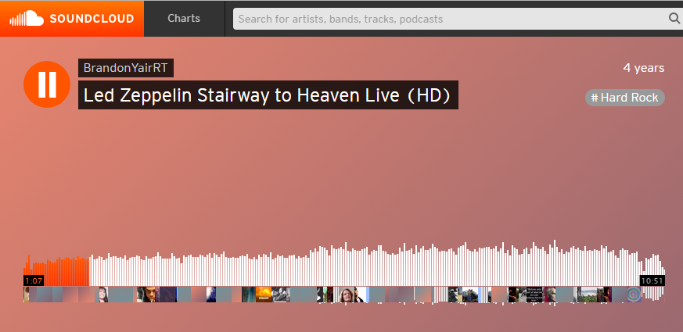

YouTube – The biggest video viewing platform on the internet. It also has a feature adding comments and referencing timestamps

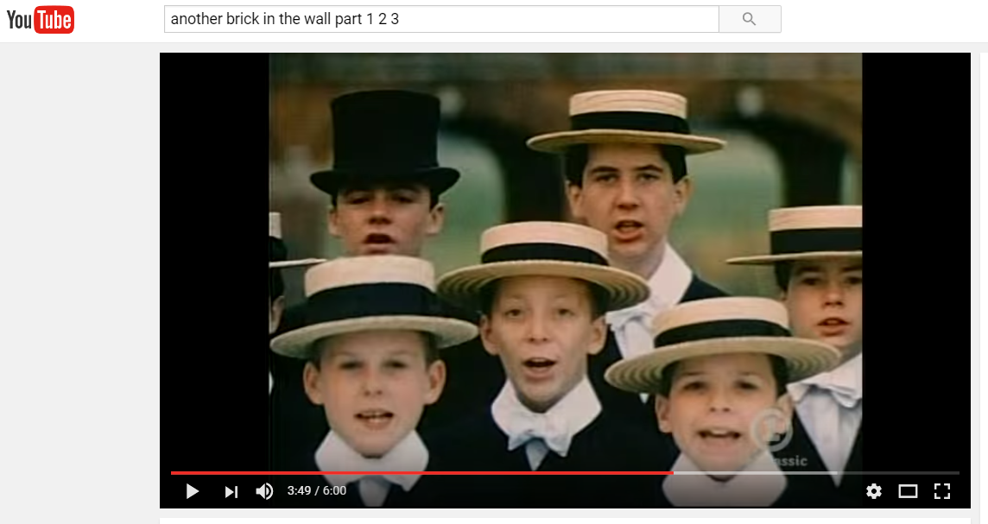

Waze – One of the most successful crowdsourcing platform with a strong community

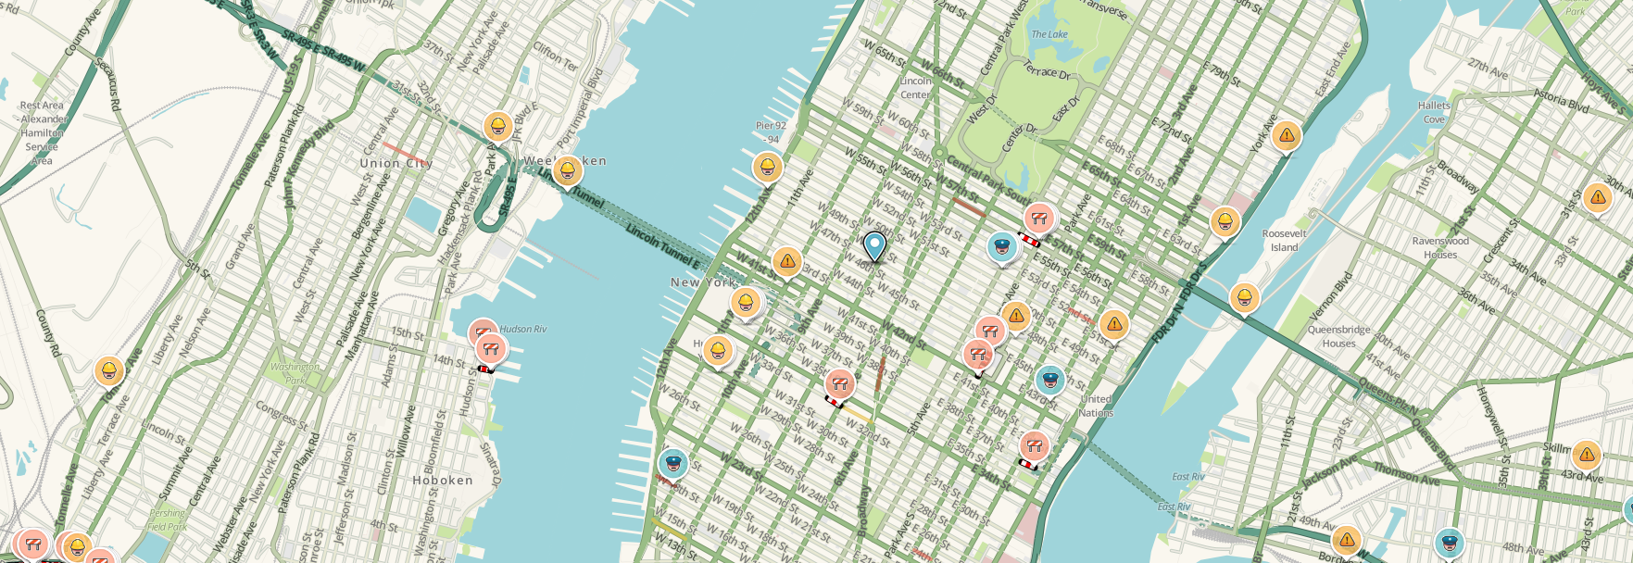

Netflix – Not only it is a video viewing plaform, it is a social conjecture too. Prototype 2 can let you connect you with your friends even if they are not physically present with you



Reddit – Source of jokes. Place to get community feedback

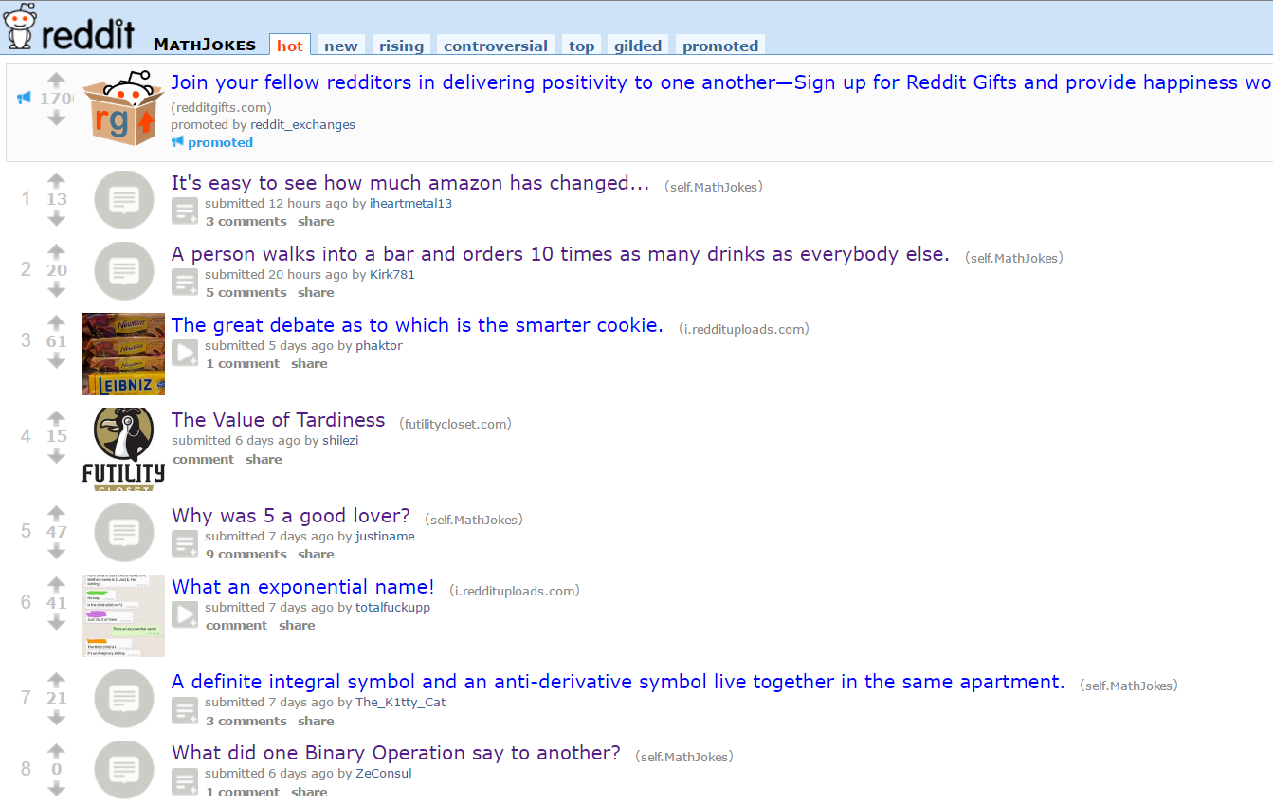

**Section 4 – Open Areas**

|  |  |  |  |  |  |
| --- | --- | --- | --- | --- | --- |
|  | **Reddit** | **YouTube** | **Friends/ Family** | **Professional Teacher** | **Crowd- Speak** |
| **Scalable** | ✓ | ✓ |  |  | ✓ |
| **Availability** | ✓ | ✓ |  |  | ✓ |
| **Collaborative** |  |  | ✓ |  | ✓ |
| **Authentic** |  |  |  | ✓ | ✓ |
| **Affordable** | ✓ | ✓ | ✓ |  | ✓ |