4 Heroes

Game Concept Document

GAm200 Fall 2015

Jesse Lozano

Table of Contents

**High Concept** 3

**Summary** 3

**Look and Feel** 3

**Narrative Arc** 4

Pink Hero 4

Indigo Hero 4

Teal Hero: 4

Orange Hero: 4

The Gralien: 4

**Core Mechanics** 5

Movement 5

Pink 5

Indigo 5

Teal 5

Orange 5

Combat 5

Pink 5

Indigo 5

Teal 5

Orange 5

Combos 5

Customization (stretch) 5

Guarding 5

Drop in – Drop out 5

Character switching 5

Health 6

Health regenerating 6

Civilians 6

**Engagement Types** 7

Challenge: physical 7

Fellowship: cooperation 7

Discovery: Exploration (Stretch) 7

**Controls/interactions** 7

**Example levels/Segments** 7

**Risks** 7

## **High Concept**

A 2D 4 player drop in-drop out multiplayer platform Brawler involving superheroes and themes of uniqueness/ diversity over conformity/ intolerance.

## **Summary**

The goal of the game is to save The City™ from a dangerous alien-robot invasion! 4 super heroes, all as different as can be, must band together to save the people of The City™, and defeat the alien-robots. The player chooses to play as one of 4 heroes, brawling their way through the city to the alien mothership. Each of the 4 heroes has something unique about them. Their unique ability, allows them both to engage in combat in a slightly different way, and allow access to different paths in route to the mothership.

## **Look and Feel**

Aesthetically, I imagine the game to have a semi-pixelated look to it. The art style should have a real comic book inspiration to it, with very vibrant colors, and stylized noir-esque shadowing to it. The 4 heroes will need to look, sound, and feel as aesthetically different as possible, while having all 4 of them conform to the same basic set of mechanics.

## **Narrative Arc**

The games basic narrative is expressing the idea of embracing the uniqueness and beauty of others, against the ideas of fearing the unknown, or the different. The enemies were made into unthinking machines, to facilitate this message, as flesh and blood aliens could lead to unfortunate implications, counter to the games theme. As such, there is only one true alien, controlling the robot horde. When the players reach this alien, it gives a rant on its motivation, one of simple fear of this unknown other species, that it then decided to try and destroy them with its robot horde. Even then, care will need to be taken in setting up the games plot, as to not veer into hypocritical, or hollow in the games message against fearing the unknown/different.

The characters are very important for this to work, and as such, I went and filled the 4 heroes up with as many narrative ensembles as I could think of, and then some more. Some of this information may show up in gameplay, in how each hero holds themselves, or how civilian interact with them, or whatever thing a hero make shout in combat. Other bits of information may only really chow up in reference material and/or character select, but I feel would be good to have for character flare. I also decided for the colors to be slightly off in terms of standard usage of colors (**pink**-red, **indigo**-blue, **teal**- green, and **orange**-yellow), and to include the antagonistic alien in this, dubbing them, the Gralien (I’m sorry, the pun was too tempting).

### Pink Hero

**Temperament**: Sanguine **Philosophy**: Realist **Blood Type**: O **Element:** Fire **Gender**: male **Orientation**: ace

**Super Powers:** Flight

**Victory pose**: a silly dance (ala Kirby or crash bandicoot) before striking a cheesy 80’s freeze frame jump pose

### Indigo Hero

**Temperament**: Melancholic **Philosophy**: Conflicted **Blood Type**: A **Element:** water **Gender**: male **Orientation**: bi

**Super Powers:** Shape-shifting

**Victory pose**: sighing, wiping the sweat off his brow, before moving forward

### Teal Hero:

**Temperament**: Phlegmatic **Philosophy**: Optimist **Blood Type**: AB **Element:** Air **Gender**: female **Orientation**: gay

**Super Powers:** Telekinesis

**Victory pose**: tipping her hat and bowing slightly, before continuing

### Orange Hero:

**Temperament**: Choleric **Philosophy**: Cynic **Blood Type**: B **Element**: Earth **Gender**: female **Orientation**: straight

**Super Powers:** Super strength

**Victory pose**: slamming her hands together in a powerful pose, and then giving a hearty laugh

### The Gralien:

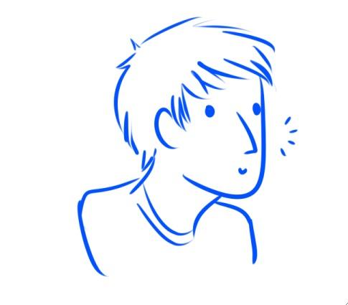

This is the greylien

## **Core Mechanics**

### Movement

The player moves on a 2D axis up and down The City™ at various levels of mobility. This includes running to either side, jumping, at various amounts, climbing, grabbing things, and flight (again character dependent)

#### Pink

Has a triple jump, hovering ability and air dashes. Is fast in the air, slow on the ground. Cannot climb or grab things

#### Indigo

Has a single long jump, and can cling to walls. Fast on the ground, cannot grab.

#### Teal

Slow walker, has a dash and double jump. Can grab things

#### Orange

Naturally fast on ground, but has a low jump. Can climb on certain surfaces, and grab things of massive size.

### Combat

Attacking the various opponents, with a 2 button combat system. I hesitate to say a heavy attack-light attack system, because what attacks are delivered behind the 2 buttons should be customizable. Each character has a different type of combat strength.

#### Pink

Has ranged projectile attacks, fireballs and the like.

#### Indigo

Has breath weapons, or attacks with ranged/splash damage.

#### Teal

Slow hitter. Can pull things in closer to them for massive hits

#### Orange

Close range, heavy hitting punches. High knockback.

### Combos

Each character should have some sort of interesting animation for a string of attacks. These combos can be modified and expanded between levels

#### Customization (stretch)

Between levels we could have the players alter the move listings of the character they are using, allowing them to customize the combos and abilities they can use for the next level.

#### Guarding

Another button for guarding. This button would also be used for dashing and grabbing, if the character is able to perform those actions, and the conditions to do so are met (in air to air dash, moving to dash, etc.)

### Drop in – Drop out

Players can enter and exit the fray at any time, their character teleporting in and out of battle as such.

#### Character switching

When not at the maximum 4 player limit, a team of 3-1 players can also switch their character out, for one of the characters not in use.

### Health

Each player character will have the same amount of health, and displayed all in similar to identical ways. Health is lost if enemy’s successfully hit a player, and can be gained by getting health drops from enemies, or successfully saving a civilian from peril.

#### Health regenerating

Character who are out of combat, have their health slowly regenerate while out of combat

### Civilians

As the City™ is under attack, there will be plenty of instances for our heroes to save the day and protect civilians. Civilians can provide an extra challenge at certain points, such as requiring the heroes to accomplish a platforming challenge within a certain time (civilians caught in a burning building), or a combat challenge (protect civilians from getting hurt from a mob of robots), or some sort of endurance challenge (escorting a group of civilians to a designated safe position, or uniting a separated pair of civilians, like a parent and child, or a pair of lovers etc.).

### Camera

The game would need an expanding camera that can keep all the characters in focus, without having the players worry about controlling it.

## **Engagement Types**

### Challenge: physical

The games basic mode of brawling through aliens

### Fellowship: cooperation

A simple group dynamic between players fighting against a common threat.

### Discovery: Exploration (Stretch)

If time allows, having large open-ended maps that link into multiple pathways to the same end game location (ala Star Fox 64) could create a sense of exploration and freedom for the player to move through.

## **Controls/interactions**

The game primarily uses a controller. The drop-in drop out function would make it very difficult to include a keyboard & mouse function. Here is a basic diagram of controls.

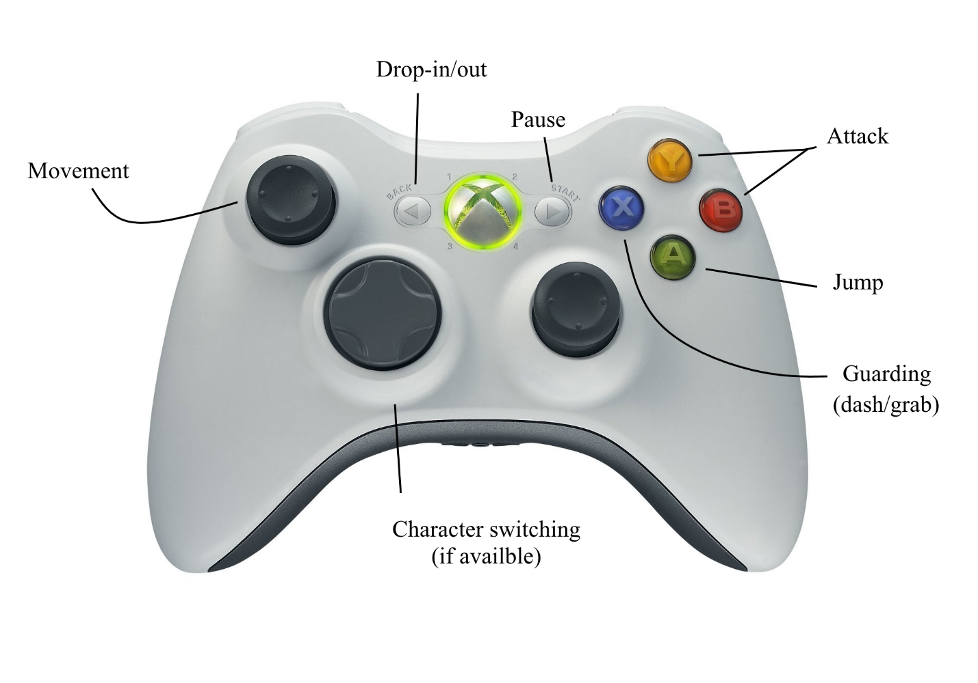

## **Example levels/Segments**

Levels:

(Didn’t get to yet. Sorry! ☹)

## **Risks**

The first most risk is developing 4 unique methods of gameplay, all within the same basic mechanics set, and have all 4 be equally fun and engaging to play with.

The second biggest risk would be art, getting nice looking sprites for 4 different characters.