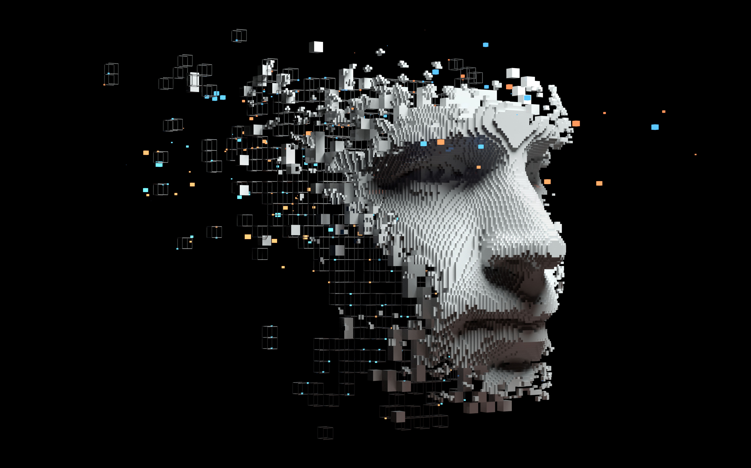

Academic Reflective Journal structure

I will be going over some insights, new skills and some takeaways from this lab as well as the proof of completion of said lab:

Assignment L03: Azure MSLE Lab 3

1. Introduction:  
 • Brief Overview: In this lab I will be learning how and why we need to be able to know why we create language models. We will be creating this service instance in the ResourceGroup1 as per the instructions.

• Purpose: As far as purpose, I will be gaining hands-on experience with how to deploy a system of this sort as well as a basic understanding of how to parse the result that is outputted by the model.

2. Description of Experience or Topic:  
• Background Information: Well for this lab i do have some previous experience as I on my own accord have used Open CV for a different course. In that course we dabbled a bit (3 hours) with it and in doing so we used data sets to analyze what is a face in a video in an image and how they interact with changes. This is kind of like that in the sense that you need a dataset, and the output can be skewed however this way you do not hassle as its automated.

• Specific Details: The main experience of this reflection is to internalize what I have learned through the lab. I hope I can retain most of the information that I went over in the lab.

3. Personal Reflection:  
 • Thoughts and Feelings: Coming into this class with no background in AI ML DL or Neural networks is really starting to hit me now. I’m beginning to realize that I might be a little bit out of my depth because all of this assignment – the whole lab and reflection journal is new to me.

• Analysis and Interpretation: This lab was another small step, and I'm realizing how much I need to study to keep up. The Skillable lab was straightforward, but I overthought things again. I’m adjusting to the workflow even though Azure ai Services are relatively simple to deploy.

* Critical Thinking: While nothing was particularly difficult, I struggled with fully understanding all the capabilities of language services at first. Without prior reading or lectures, I had to piece things together through trial and error. This lab also gave me a better understanding of AI regulations, like the EU AI Act.

4. Discussion of Improvements and Learning:  
 • Personal Growth: The more I do these labs the easier it gets. I am not sure that gpes for all lab-related courses but, that’s the pattern I see and one that I'm not offended by either I think emergent technologies like these are bettered taught this way unencumbered by overwhelming complexity which, to be fair, is a way a lot of AI courses behave nowadays.

• Skills Developed: I learned how to utilize a resource within azure to try out their LLM for detecting the bias of text.

• Future Application: This experience will be valuable for an IT internship or future AI-related projects. I can also apply these tools to personal projects, like processing large text datasets.

5. Conclusion:  
 • Summary: Lastly, the complexity is a bit lacking in these labs and I do wish that they were a little bit more DIY in what we could do irregardless this is the way things are now and i am not upset it's such a good thing that learning has become easier in a way especially now that we have AI. Looking forward to what the last lab of this certification looks like.

## Lab Completion

