Welcome to Sigma Visual
Thank you for choosing Sigma Visual!
Sigma visual UI builder is web based tool for AJAX RIA application UI rapid design and involved scripts programming. Written in pure JavaScript (Sigma Linb), web applications made by Sigma Visual UI builder have great compatibilities with web browsers. With this powerful builder, professional and enterprise developers can developer your web application just like what you do in VB or Delphi. And it also supports source highlight and syntax checking. Through its powerful AJAX components library (Sigma Linb), Sigma visual simplify complex and boring UI design, which artists instead of programmers are good at.

How to

How to install
It is quite simple to install Sigma Visual on your computer.
System requires
- PHP5.0+
- Apache web server 1.31+

Please follow the steps to install Sigma Visual.
- Visit www.sigmawidgets.com to download zip package.
- Unzip package file to apache PHP directory, for example, %install_dir%.
- Make sure that %install_dir%/projects/ directory is writable.
- Open %install_dir%/index.html through browser.

How to create a new project
Simply click on main menu Project | New Project or click on the first toolbar button. A dialog box will pop up, as the following figure shows.

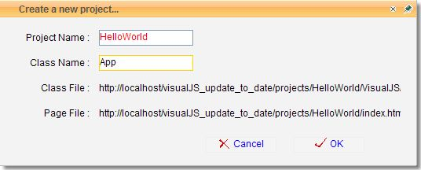
Within that dialog, enter *HelloWorld* as project name and *app* as class name, and then click on OK button.
The new project contains an index.html file, an index.js file (to be loaded by index.html), and language file named en.js. As you develop and build your application, new files will be created and added to the project. The project files are listed in the project manager panel. With the project manager panel, you can easily see how all your project files are related. If you want open a file to see what content is in it, double click on file items and then that file will be open in the workplace.
Double click index.js, this file will appear in an active tab page.
By default, English language will show up on user interface. If you want your web application support other language, you need to provide a new language file under Locale directory.

How to add component to web page
After you open an existing project or create a new project, click UI JavaScript file (generally index.js).
Switch to *Design View*, you will see a web page with dots grid as background.
In *Component Gallery*, open the group your desired component is at by clicking plus icon before group name.
Drag the component item to web page.
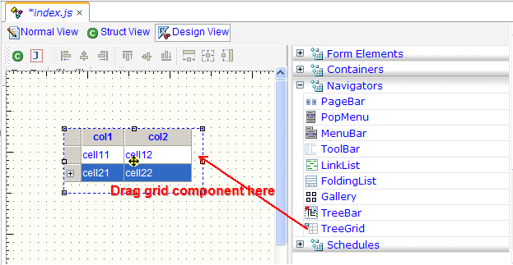

How to set component properties
Select your desired component and that component will be surrounded by dot line box.
Open properties group by clicking plus icon before group name in *Object Inspector*.
If property item is Boolean, you can change its value by checking or un-checking it.
If property item is string, you can input a value by typing.
If property item has some options, there would be a dropdown list for choosing.
If property item is collections, you can click pop-up button to go to input dialog.

How to add new items to a menu
After you add a menu component to your web page by dragging it from *Component Gallery*, that menu will have three menu items. See following figure.
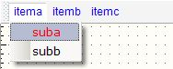
Click the menu to select it.
Click the plus before *properties* in *Object Inspector*, then all the properties for menu will collapse.
Click *properties | items* and then value of *properties | items* will high light, as the following figure shows.
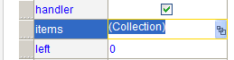
Click *(Collection)* to pop up a dialog like the following figure.
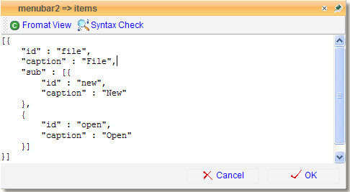
Input the following text.
[{
"id" : "file",
"caption" : "File",
"sub" : [{
"id" : "new",
"caption" : "New"
},
{
"id" : "open",
"caption" : "Open"
}]
}]
You will see a menu like this.
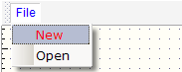

How to copy components
Click the component to select it. If you want to copy more than one component, press shift and then click component(s) one by one.
Click *Clone selected controls* in *Design Tool Bar*.

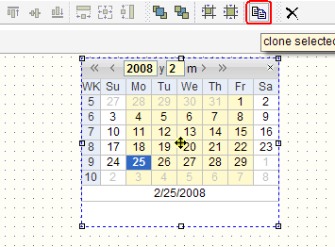
Note that the new component(s) overlay the old one(s), you need to move it/them by mouse or keyboard.
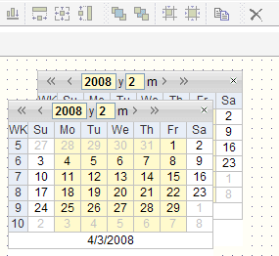

How to select components

鼠标点击选择一个；在container里面用鼠标拉出选择区域可以选择同一个container下的多个components

How to remove components
选中后点击“删除”按钮；选中后用*delete key*

How to move components
Click the component to select it. If you want to copy more than one component, press shift and then click component(s) one by one.
Drop your mouse to anywhere you wish and then release your mouse.
You can also move selected component(s) by *up key*, *down key*, *left key*, *right key*.
*Ctrl* + *up key*, *down key*, *left key*, *right key* => 小步移动

How to resize components
*Shift* + *up key*, *down key*, *left key*, *right key* => 改变大小
*Ctrl* + *Shift* + *up key*, *down key*, *left key*, *right key* => 小步改变大小

How to change components’ container
*Ctrl* + * left mouse down*, and drag it to another container

How to add an event handler
In this section, you will learn how to create a web application with following feature.
- This application has one button with caption *say something*.
- When user clicks that button, an asynchronous message box drops down from top of web page saying *hello, world*.
After you add a button component to your web page by dragging it from *Component Gallery*, a button will appear on your web page. Click the button to select it.
Click the plus before *events* in *Object Inspector*, then all the event for button will collapse.
Click *events | onClick* and then value of *event | onClick* will high light, as the following figure shows.
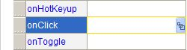
Click the button on the right side to pop up a dialog like the following figure.
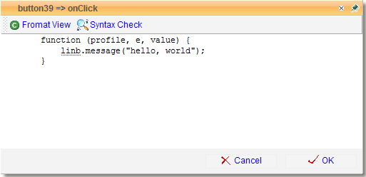
Input the following text.
function (profile, e, value) {
linb.message("hello, world");
}
Press *Save All* tool button to make sure everything changed is saved. Press *Debug* button to preview what happens, as is showed in the following figure.
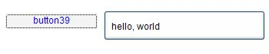

How to add image files to a project
Sigma Visual doesn’t provide a way to upload image files for security reason.
If you want to add some self-made image files to your project, you have to download Sigma Visual and run it on your own computer.
Simply copy image files into %Sigma Visual Path%/projects/%your project%/img/. For example, %Sigma Visual Path%/projects/%your project%/img/img001.gif.
You can access your files by *img/img001.gif* in your JavaScript code.

How to set component appearance
Web page should be colorful and web page could be colorful. If you don’t like the control’s born appearance, Sigma Visual provides several way to change it.
If you are using Sigma Visual on www.sigmawidgets.com, the easy way is to change component’s customer appearance.
Select your desired component and go to *Object Inspector* -> *Customer Appearances*, and then click popup button for input dialog.
Enter CSS style for your component and press OK. For example,
{
"KEY" : "border:solid 1px;"
}
And then you will find your component is surrounded with solid black border.

How to preview & debug UI scripts
Select the *Debug* item from the Project menu or click the *Debug* button on the tool bar to debug current Sigma Visual project.
If some run-time errors (such as to access property of null object) occur or some exceptions are thrown out, error window popup with error information, call stack and context. This information is very useful for developer to diagnose the application.

Reference

Sigma Visual’s Main Page
When you first start Sigma Visual, you are presented with the UI builder without any project open.
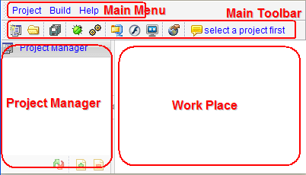

Main Menu

Project Menu
New Project
Select the *New Project* item from the Project menu or click the *New Project* button on the tool bar to start with a new Sigma Visual project.

Open Project
Select the *Open Project* item from the Project menu or click the *Open Project* button on the tool bar to open an existing Sigma Visual project.

Close Project
Select the *Close Project* item from the Project menu or click the *Close Project* button on the tool bar to close current Sigma Visual project.
If you have modified some file but not saved them, a dialog box will pop up saying *Project has been modified. Do you wish to save your changes?*. Press *Yes* to save these changes, or *No* to discard these changes.

Save All
Select the *Save All* item from the Project menu or click the *Save All* button on the tool bar to save all the files that current project contains. Only those ones which have been modified since last saving operation will be saved again. There is a star mark (*) one the tab header in workplace for a modified file.

Build Menu
Debug
Select the *Debug* item from the Project menu or click the *Debug* button on the tool bar to debug current Sigma Visual project.
If some run-time errors (such as to access property of null object) occur or some exceptions are thrown out, error window popup with error information, call stack and context. This information is very useful for developer to diagnose the application.
A diagram goes here.

Release
Select the *Release* item from the Project menu or click the *Release* button on the tool bar to get a zip-formatted package of current project. This menu item is for remote developers. After they get everything well and press the menu item, all files in current project with directory structure will be packed into a zip file and sent to browser client. (Do you remember Sigma Visual itself is also a web based Ajax application? :)

Help Menu
Index
You can get help on how to use Sigma Visual by clicking this item. It will simply open help html files.

Go to forum
Click this item to go to official forum.

Download source code
This is a short link to Sigma Visual application. Yes, you really can use this application on our site remotely. If you complain of your slow network, just download whole application and install it on your own computer.

Flash video show
If you are new to Sigma Visual and don’t know to get started with Sigma Visual to develop Ajax enabled application, watch these flash videos first.

Demos
If you have no ideas of what Sigma Visual can do, you could learn more by clicking this item.

About
A dialog will pop up saying something about Sigma Visual.

Main Toolbar
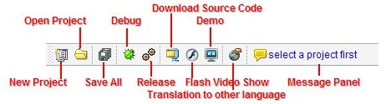
New Project
This button is a short cut for main menu item *Project | New Project*.
Open Project
This button is a short cut for main menu item *Project | Open Project*.
Save All
This button is a short cut for main menu item *Project | Save All*.
Debug
This button is a short cut for main menu item *Build | Debug*.
Release
This button is a short cut for main menu item *Build | Release*.
Download Source Code
This button is a short cut for main menu item *Help | Download Source Code*.
Flash Video Show
This button is a short cut for main menu item *Help | Flash Video Show*.
Demo
This button is a short cut for main menu item *Help | Demo*.
Translation to other language
You can change user interface language by click this button.
Message Panel
Message panel looks like kind of download list. It contains

Project Manager
In the main part of the Sigma Visual is the workspace. The workspace initially displays the Form Designer. It should come as no surprise that the Form Designer enables you to create forms. In Sigma Visual, a form represents a window in your program. The form might be the program's main window, a dialog box, or any other type of window. You use the Form Designer to place, move, and size components as part of the form creation process.
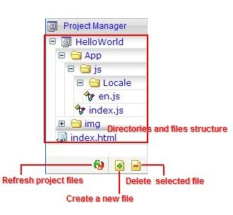
Hiding behind the Form Designer is the Code Editor. The Code Editor is where you type code when writing your programs. The Object Inspector, Form Designer, Code Editor, and Component palette work interactively as you build applications.

Files Viewer
After you creating a new project, the following directory structure is created at once.
ProjectName
ProjectName/App/
ProjectName/App/js/
ProjectName/App/js/index.js
ProjectName/img/
ProjectName/index.html

Refresh Project File
You can refresh directories and files structure by clicking *Refresh project files*. If you know someone else added or updated files in your projects, this is a way to force Sigma Visual to reload files structure on server side.

Create a New File
You can create JavaScript/html/PHP files on server side through Sigma Visual.
To create a new file, click *Create a new file*. A dialog box will pop up, just like the following figure.
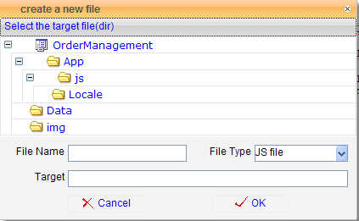
Select a directory where the new file will reside at.
Input a file name in *File Name* input box and choose file type in *File Type* dropdown list. A full path of the new file will show up automatically in *Target* field.
Click on *OK*.

Delete a File
You can delete a file by clicking on *Delete selected file*.
A dialog box with directories and files structure will pop up. Select a file to be deleted and then click on *OK*.
This file will be deleted on server side.

Workplace
Generally, *Workplace* is kind of a tab control. After you open file, a new tab panel appears within workplace standing for that file. You can open any textual files or image files within workplace.
A tab panel could contain three views, normal view, structure view and design view. These three views are all available for an UI JavaScript file, but only normal view is available for other type of files.

Normal View
No matter how powerful and numerous Sigma Linb components are, you still have to write some codes to complete a usable web application. In fact, when you design your web page and lay your components by dragging and drop, Sigma Visual generates lots of codes to tell browsers how to create and initialize components.
When you switch to *Normal View*, you will see it’s really a typical code editor. You can enter and delete text, highlight text with the mouse, cut, copy, paste code within normal view, just the same way as you use some other text editor.
One useful feature is syntax highlighting, which makes keywords, strings, numeric constants, and comments in different colors. Just click *Format View* to syntax highlight your code. The colorful codes look like the following figure.
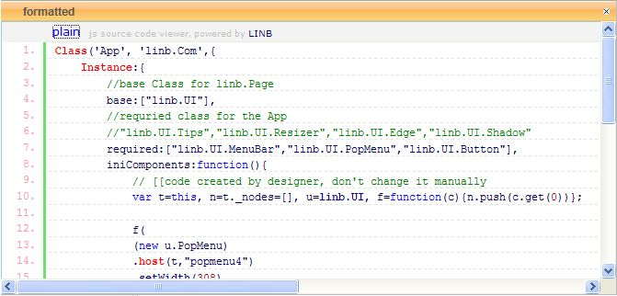

Another feature is that Sigma Visual can help you to figure out whether there are any syntax errors in your code. If you are new to JavaScript, this feature enables you to find out what error you made. After you click *Syntax Check*, a message will drop down saying *Congratulations. No syntax error yet.* or some hints about the errors, for example *missing ) after argument list*.

Structure View
When you switch to structure view, you will notice that a new panel resides on the left side of the editor window. This panel contains a tree with various tree nodes representing various pieces of information about the UI JavaScript currently active in the editor. This panel is called *Code Explorer*.
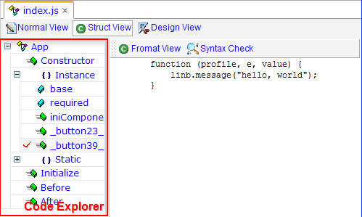
Code Explorer enables you to see to the declaration of event handlers or the implementation of routines just by double-clicking on the functions structure tree node item.

Design View
When you first start Sigma Visual, you are presented with the UI builder without any project open. After you create new project, open index.js then come to *Design View*, similar to the following figure.

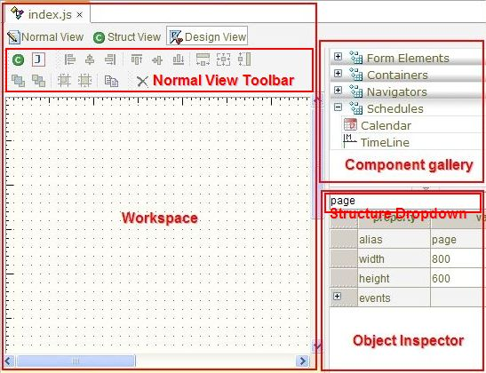

Design Tool Bar
Before you use design view tool buttons, you need to learn more about how to select one or more components on your page.
Select one component
Click on the component to select it. If you click another component, this component will be un-selected.
Select more than one component
Click on the components with *shift* key pressed. If you want select all the components within a rectangle area, just drag your mouse to draw a rectangle.
Move component(s)
You can drag selected component(s) to anywhere. You can move selected component(s) a little by pressing *up*,*down*,*left* and *right* key.

Serialize to JS code
This command enables you to serialize all selected component(s) to JavaScript source code.
Serialize to JSON code
This command enables you to serialize all selected component(s) to JSON code.

Align to left
This command enables you to align the left of all selected components(s).
Align to center
This command enables you to align the center of all selected components(s).
Align to right
This command enables you to align the right of all selected components(s).

Align to top
This command enables you to align the top of all selected components(s).
Align to middle
This command enables you to align the middle of all selected components(s).
Align to bottom
This command enables you to align the bottom of all selected components(s).

Same width
This command enables you to make all selected components(s) in same width.
Same width and height
This command enables you to make all selected components(s) in same size.
Same height
This command enables you to make all selected components(s) in same height.

To top layer
This command enable you to let all selected components(s) go up and no components overlay them.
To bottom layer
This command enable you to let all selected components(s) go down and every components else overlay them.
Set position to grid
If you click this button, all the selected component(s) will be moved a little and snapped at by background grid dots.
Set size to grid
Click this button to enlarge or reduce all the selected component(s) to make

Clone selected controls
Click this button to copy selected component(s). Note that those copies overlay old ones.
Delete
Click this button to remove selected component(s).

Structure Dropdown Tree
A Sigma Visual UI web page could contains several components, such as buttons, tabs, drop down list. Some controls will be child controls to other, for example a button within a panel is a child to this panel . Thus, we have a structure - where any object you work with is in some hierarchical relation to some other object.
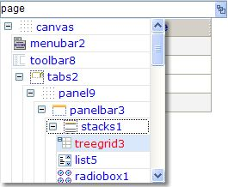
The structure dropdown tree shows the hierarchy of components in web page(within design view).
Structure is shown in a tree-view like display. Try clicking on something in the tree item. Note how various parts on the "form" get selected.

If you have an object on a form and click it, its properties and events are displayed in the Object Inspector. Sometimes, you could not select a component by cliking because that at one point components are crowed. *Structure Dropdown Tree* is another approach to select component. In the figure above, you can get components alias named treegrid3 selected by simply clicking on *treegrid3* item.

Component Gallery
Sigma Visual offered rapid application development (RAD) using something called components. Components are objects that can be dropped on a web page and manipulated via properties, methods, and events. This set of components is called Sigma Linb. Before you use *Component Gallery*, you need to learn some more about Sigma Linb.

Sigma Linb Introduction
Visual Linb is an Ajax RIA framework for building zero footprint Ajax browser applications that feel like desktop GUI applications. It supports all major Ajax browsers.
Sigma Linb includes more than 50 components and useful classes. The components are purely built in XHTML, CSS, JavaScript and XML, which are industry standards compliant and therefore are compatible with all major browsers such as Internet Explorer, Firefox, Opera and Safari, and can be placed anywhere on the page.
Sigma Linb is written in pure JavaScript codes, Seamless Integration with any server side solution, such as j2ee, .net, PHP, Perl.
Sigma Linb is designed by Object-Oriented technology. This makes .Net / Java / PHP programmers feel easier to get started with these components.
Sigma Linb includes several layout components, which can be used to define te various areas in the web pages. The outcomes application could dynamically adjust to accommodate content at run-time with these layout components.

Components Gallery

Component gallery contains a wide array of components that you can drop onto your web page. The components are divided into four groups, which are form elements, containers, navigators, schedules. To place a component on your web page, just click on the component's item in the component gallery and then drag it to your web page.

Form Elements
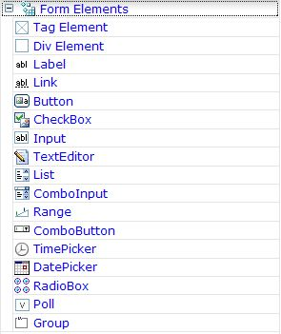
Containers
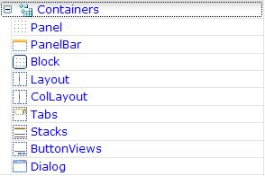
Navigators
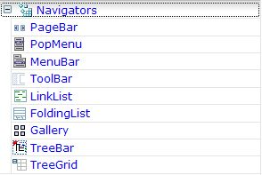
Schedules
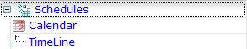

Object Inspector
If you have some experience on MS Visual Basic or Borland Delphi, you could be familiar some words like property and event. If you don’t, you need 5 minutes to know what they mean.
Properties
In Sigma Visual, properties are features of a web component by modifying which developer can change component’s features and behaviors. Many Sigma Linb components have common properties. Most all visual components, for example, have a Height and a Width property. These two properties control how bigger area the component will cover on a web page both at design time and at runtime.
Events
Sigma Visual is aimed to build up an event-driven environment for Ajax developer. Events include mouse movements, mouse clicks, and key presses. Because different components have different feature for different purpose, Sigma Linb components wrap all the movements, clicks and presses. Event will be fired only in some special case, for example, when end-user clicks on a special area within a tree grid component.

Alice Name
In Sigma Visual, all the components have a property named *Alice Name*. This property, *Alice Name*, is very important to any application. It specifies the name of the component as code reference. When you add a component on web page by dragging, Sigma Visual will provide a default *Alice Name* for the component, for example, label1, button1. You are suggested to give your components a meaningful *Alice Name* before writing the code that refers to them. You can do this by changing the value of the*Alice Name* in the *Object Inspector*.

On the left side of the web page is the component inspector. In this inspector, you can modify a component's properties and events. The component inspector has two sections: a dropdown list and a tree grid. Dropdown list contains many items standing for components on the page. Tree grid contains one item saying properties and one item saying events. Click plus in front of properties item, you will see several property entries. Click plus in front of events item, you will see several event entries. The list of properties & events available varies from component to component.
