LINB3.0 Cookbook - Getting Started Guide
linb 2010-7-21 All rights reserved.

Preface 7
Chapter 1. Preparation 8
1.1. Download the package 8
1.2. The package folder 8
1.3. Glance at examples and API 9
Chapter 2. Hello World 10
2.1. The first application 10
2.2. Render onto a html node 11
2.3. Do it in Designer 12
2.4. Application loading process 17
2.5. Code Editor 19
2.5.1. Highlight code from Outline window 20
2.5.2. Code Folding 20
2.5.3. Code Intellisense 20
2.5.3.1. When context doesn’t recognize the input string 21
2.5.3.2. Type dot after a recognizable variable 22
2.5.3.3. When use shortcut [Alt+1 ], or dbclick 23
2.5.4. Find the object definition code 23
2.5.5. Generate event code automatically 24
Chapter 3. Controls Facebook 25
3.1. Script testing environment 25
3.2. “Hello world” in env.html 26
3.3. Control creation and runtime update 27
3.4. Button related 28
3.4.1. onClick event 28
3.4.2. Boolean Controls 29
3.4.3. Link Control 29
3.5. Label related 30
3.6. Input related 30
3.6.1. setValue/setValue/getUIValue/setUIValue 30
3.6.2. Dirty Mark 31
3.6.3. Password Input 31
3.6.4. Multi-lines 32
3.6.5. Input validation 32
3.6.5.1. valueFormat property 32
3.6.5.2. beforeFormatCheck event 33
3.6.6. Dynamic input validation 33
3.6.7. Error Mark 33
3.6.7.1. Default Error Mark 33
3.6.7.2. Validation Tips 34
3.6.7.3. Binding Validation 34
3.6.7.4. Custom Error Mark 34
3.6.8. Mask Input 35
3.6.9. linb.UI.ComboInput 36
3.6.9.1. Pop list for selection 36
3.6.9.2. combobox, listbox and helpinput 36
3.6.9.3. Date Piker 37
3.6.9.4. Time Picker 38
3.6.9.5. Color Picker 38
3.6.9.6. File Picker 39
3.6.9.7. Getter 39
3.6.9.8. Custom Pop Window 40
3.6.9.9. Command Buttons 41
3.6.10. RichEditor 41
3.7. List related 42
3.7.1. A Simple one 42
3.7.2. A little bit complicated 43
3.7.3. RadioBox 44
3.7.4. IconList and Gallery 44
3.7.5. Item selection 45
3.7.6. Container related 45
3.7.7. Pane and Panel 46
3.7.8. Block 47
3.8. Dialog related 47
3.8.1. Normal state 47
3.8.2. Min and Max status 48
3.8.3. Modal Mode 49
3.9. Layout Control 50
3.10. Multi-pages Controls 51
3.10.1. noPanel property 52
3.10.2. ButtonViews types 53
3.10.3. Page selection 53
3.10.4. Pages 54
3.10.4.1. Close and options Button 54
3.10.4.2. Add/Remove Pages 56
3.10.5. Dynamic content loading 57
3.10.5.1. onIniPanelView 57
3.10.5.2. beforeUIValueSet/afterUIValueSet 57
3.11. Menus and toolbars 58
3.11.1. Pop Menu 58
3.11.2. MenuBar 59
3.11.3. Toolbars 60
3.12. TreeBar and TreeView 61
3.12.1. Three selection mode 61
3.12.1.1. No-selection 61
3.12.1.2. Single-selection 62
3.12.1.3. Multi-selection 62
3.12.2. Group Item 63
3.12.3. Expand all nodes by default 63
3.12.4. Mutex Expand 64
3.12.5. Dynamic Destruction 65
3.12.6. Dynamically loading 65
3.13. TreeGrid 66
3.13.1. Header and Rows 66
3.13.1.1. Sets standard format 67
3.13.1.2. Sets simplified format 67
3.13.2. getHeader 67
3.13.3. getRows 68
3.13.4. Active Modes 69
3.13.4.1. non-active appearance 70
3.13.4.2. row-active appearance 70
3.13.4.3. cell-active appearance 71
3.13.5. Selection Mode 71
3.13.5.1. Non-selection 71
3.13.5.2. Single row selection 72
3.13.5.3. Multi-row selection 73
3.13.5.4. Single cell selection 73
3.13.5.5. Multi-cells selection 73
3.13.6. The Tree Grid 74
3.13.7. Column config 75
3.13.7.1. The first column 75
3.13.7.2. Column width 76
3.13.7.3. Drag&Drop to modify column width 76
3.13.7.4. Drag&Drop to modify column position 77
3.13.7.5. Default Sorting 77
3.13.7.6. Custom Sorting 78
3.13.7.7. Hide columns 78
3.13.7.8. Setting Cell Types in column header 79
3.13.7.9. column header style 79
3.13.7.10. column header icon 80
3.13.7.11. Update column header dynamically 81
3.13.8. Row config 81
3.13.8.1. Row height 81
3.13.8.2. Drag&Drop to modify row height 82
3.13.8.3. Setting cell type in row 82
3.13.8.4. Row style 83
3.13.8.5. Row numbers 83
3.13.8.6. Custom row numbers 84
3.13.8.7. Alternate Row Colors 85
3.13.8.8. Group 85
3.13.8.9. Preview and Summary region 86
3.13.8.10. Update row dynamically 87
3.13.9. Cell config 88
3.13.9.1. Cell types 88
3.13.9.2. Cell style 89
3.13.9.3. Update cell dynamically 90
3.13.10. Editable 90
3.13.10.1. Editable TreeGrid 91
3.13.10.2. Editable column 91
3.13.10.3. Editable row 92
3.13.10.4. Editable cell 92
3.13.10.5. The Editor 93
3.13.10.6. Custom the editor 94
3.13.11. Add/Remove rows 95
3.14. Other standard controls 96
3.14.1. ProgressBar 96
3.14.2. Slider 97
3.14.3. Image 98
3.14.4. PageBar 98
Chapter 4. Data exchanging(Ajax) 99
4.1. Fiddler 100
4.2. To get the contents of the file 100
4.3. Synchronous data exchange 100
4.4. Cross-domain 101
4.4.1. To monitor SAjax 101
4.4.2. To monitor IAjax 102
4.5. File Upload 103
4.5.1. Selecting upload file with ComboInput 103
4.5.2. Upload by IAjax 104
4.6. A request wrapper for real application 104
4.7. XML Data 105
4.8. An overall example 106
Chapter 5. Distributed UI 107
5.1. Shows dialog from a remote file 107
5.2. linb.Com and linb.ComFactory 108
5.2.1. linb.ComFactory config 108
5.2.2. linb.Com.Load 109
5.2.3. newCom and getCom 110
5.2.4. linb.UI.Tag 111
5.2.5. Destroy com 111
5.2.6. If com exists in memory 111
Chapter 6. Some fundamental things 112
6.1. Pop-up window 112
6.1.1. alert window 112
6.1.2. confirm window 112
6.1.3. prompt window 113
6.1.4. pop window 113
6.2. Asynchronous execution 113
6.2.1. asyRun 113
6.2.2. resetRun 114
6.3. Skin switcher 114
6.3.1. Switch skin for whole application 114
6.3.2. Change skin for a single control 114
6.4. Locale switcher 115
6.5. DOM Manipulation 115
6.5.1. Node generation and insertion 116
6.5.2. Attributes and CSS 116
6.5.3. className 117
6.5.4. Dom events 117
6.5.5. Node Drag&Drop 118
6.5.5.1. Drag&Drop profile 119
6.5.5.2. Events in Drag&Drop 120
6.6. linb.Template 121
6.6.1. example 1 121
6.6.2. example 2 122
6.6.3. A SButton based on linb.Template 123
6.7. About Debugging 124
6.7.1. The code package for debugging 124
6.7.2. Debugging Tools 124
6.7.3. jsLinb Monitor Tools 125
Chapter 7. Some typical issues 126
7.1. Layout 126
7.1.1. Docking 126
7.1.2. linb.UI.Layout 126
7.1.3. Relative Layout 127
7.2. UI Control’s Drag&Drop 129
7.2.1. Drag&Drop control among containers 129
7.2.2. List sorting 1 129
7.2.3. List sorting 2 130
7.3. Form 131
7.3.1. Form 1 131
7.3.2. DataBinder 132
7.4. Custom UI Styles 133
7.4.1. Custom only one instance only - 1 133
7.4.2. Custom only one instance only - 2 134
7.4.3. Custom only one instance only - 3 134
7.4.4. Custom only one instance only - 4 134
7.4.5. Custom only one instance only - 5 135
7.4.6. Custom only one instance only - 6 135
7.4.7. Custom style for an UI Class 136
7.4.8. Custom style for all UI Class - skin 136
7.4.8.1. First: Copy 136
7.4.8.2. Second: Little by little, modify pictures and CSS 137
The end 138

Preface
"jsLinb" is a Cross-Browser JavaScript framework with cutting-edge functionality for rich web application. And "Visual JS" is a web based tool for AJAX RIA application UI rapid design and involved scripts programming. With this powerful builder, developers can build your web application just like what you do in VB or Delphi.

Features & Resource

- WYSIWYG GUI builder. Do everything by drag & drop. Significant development time reduction.
- Source code editor Integrated (Code Intellisense, Code folding, Syntax Check and Undo/Redo).
- More than 40 common components, including Tabs, Dialog, TreeGrid, TimeLine and many other web GUI components.
- Rich client-side API, works with any backend (php, .Net, Java, python) or static HTML pages. Extremely easily to build php application with php server side wrappers.
- Wide cross-browser compatibility, IE6+, firefox1.5+, opera9+, safari3+ and Google Chrome.
- Detailed Manual and Full API Documentation with tons of samples. Ever increasing code snippets.
- Compatible with jquery, prototype, mootools and other frameworks.
- Dual licenses - Commercial License and LGPL license both available.

Cookbooks are expected to include three parts: Getting Started Guide, Improved Tutorial, and Advanced Tutorial.

This tutorial is the first part: Getting Started Guide.

Go to http://www.linb.net for the latest information.

If you have any good suggestions, you can contact me at linb.net [at] gmail.com.

Preparation
First of all, note that all instances of this tutorial are based on version 3.0. Therefore, our first task is to download the 3.0 release package, and to establish the local environment.

Download the package
3.0 Release package can be downloaded from http://code.google.com/p/linb/downloads/list. It’s the latest stable 3.0 version, but not the latest code. I suggest you get the latest 3.0 code from SVN. For those who are not familiar with SVN, should learn how to use SVN first. After all, a lot of open-source projects use SVN to manage code. SVN requires a client program to connect to what is called a "repository" where the files are stored. On commonly used SVN client is called TortoiseSVN, which is freely available. Other clients exist, but TortoiseSVN is recommended due to its simplicity of use.

3.0 version "repository" URL: http://linb.googlecode.com/svn/trunk/jsLinb3.0/ .

The package folder
If you downloaded package from google group, extract the package to a local folder. If you fetch the code from SVN, does not need to extract.
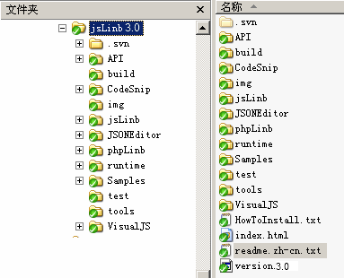
The contents of the package folder

By default, most of the examples in the package can be run in local disk directly, but a small number of examples need php background environment, or mysql database. In this case, you need to prepare Apache server (version 2 and above), php (version 5 and above) and mysql (version 5 and above). At last, copy the package to apache web directory.

Glance at examples and API
If your Apach/php environment works well, after you copied the package folder to Apache’s web directory (this tutorial assumes that your root directory is http://localhost/jsLinb/), you should be able to open the page with your browser: http://localhost/jsLinb/.
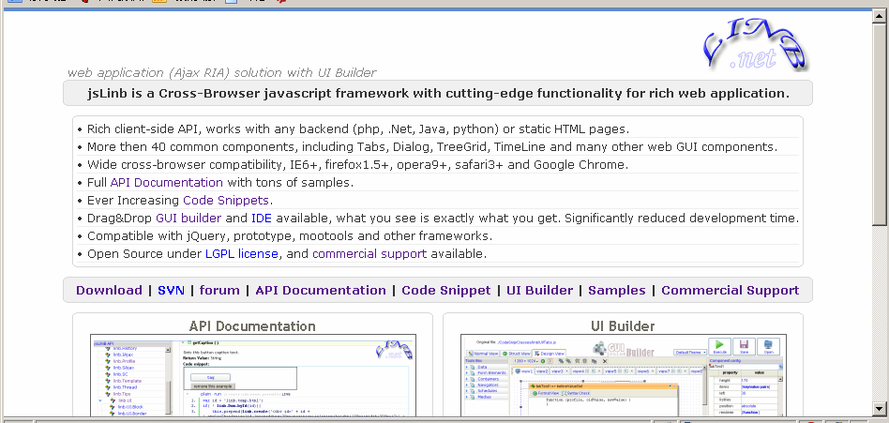

You can browse http://localhost/jsLinb/Examples/ for examples, and http://localhost/jsLinb/API/ for API.
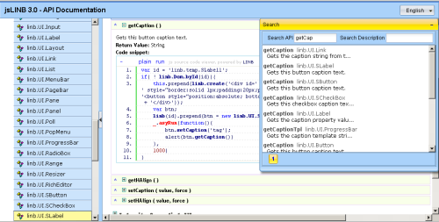
API description
API code examples
API search window

A simple glance at API is strongly recommended. Learn about how to search a specific API, and how to run the inner code examples.

Hello World

The first application
As many would expect or not expect, the first example is "Hello World".

Now, create a new folder “mycases” in the package folder (again, (this tutorial assumes that your root directory is http://localhost/jsLinb/), add a sub folder “chapter1” in it, and create a file named “helloworld.html” in “chapter1”. Enter the following code:
<!DOCTYPE html PUBLIC "-//W3C//DTD XHTML 1.0 Strict//EN" "http://www.w3.org/TR/xhtml1/DTD/xhtml1-strict.dtd">
<html xmlns="http://www.w3.org/1999/xhtml">
<head>
<meta http-equiv="content-type" content="text/html; charset=utf-8" />
<meta http-equiv="Content-Style-Type" content="text/css" />
<meta http-equiv="imagetoolbar" content="no" />
<script type="text/javascript" src="../../runtime/jsLinb/js/linb-all.js"></script>
<title>jsLinb Case</title>
</head>
<body>
<script type="text/javascript">
linb.main(function(){
linb.alert("Hi", "Hello World");
});
</script>
</body>
</html>
strict mode is recommended
Include lib file
main function
cookbook/chapter1/helloworld.html

There is a cookbook folder in the package folder. You can find the source code for each example in this tutorial.

You can double-click the helloworld.htm1 to open the file.
Or open URL http://localhost/jsLinb/cookbook/chapter1/helloworld.html in your browser (firefox or chrome is recommended here). And you can see the following result:
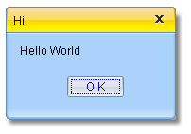
You may have noticed, no lib CSS file was included in the html file. Yes, jsLinb generate CSS automatically, no lib CSS.
File “linb-all.js” contains all codes except several advanced controls (Button, Input, CombInput, Tabs, TreeBar, and TreeGrid etc.). This file can be found in “runtime/js” folder.
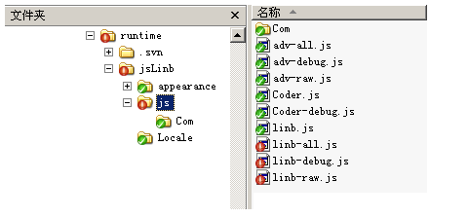

Render onto a html node
“Replace an html node (such as a div) with an advanced control.” A project manager said. "Our web page engineer is responsible to design an html file including a DIV with a unique ID, and JavaScript engineer is responsible to build an advanced UI control, and replace that DIV."

The following example in file chapter1/renderonto.html:
<!DOCTYPE html PUBLIC "-//W3C//DTD XHTML 1.0 Strict//EN" "http://www.w3.org/TR/xhtml1/DTD/xhtml1-strict.dtd">
<html xmlns="http://www.w3.org/1999/xhtml">
<head>
<meta http-equiv="content-type" content="text/html; charset=utf-8" />
<meta http-equiv="Content-Style-Type" content="text/css" />
<meta http-equiv="imagetoolbar" content="no" />
<script type="text/javascript" src="../../runtime/jsLinb/js/linb-debug.js"></script>
<title>jsLinb Case</title>
</head>
<body>
<div id="grid" style="position:absolute;left:100px;top:100px;width:300px;height:200px;"></div>
<script type="text/javascript">
linb.main(function(){
var grid = new linb.UI.TreeGrid();
grid.setGridHandlerCaption('grid')
.setRowNumbered(true)
.setHeader(['col 1','col 2','col 3'])
.setRows([
['a1','a2','a3'],
['b1','b2','b3'],
['c1','c2','c3'],
['d1','d2','d3'],
['e1','e2','e3'],
['f1','f2','f3']
]);
grid.renderOnto('grid');
});
</script>
</body>
</html>

Render onto that DIV
Sets rows
Sets columns
Show line number
Sets grid caption
The DIV with id “grid”
cookbook/chapter1/renderonto.html

The result is:
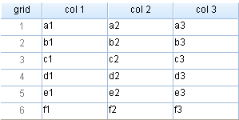
There are two ways to get the same result; codes were in renderonto2.html and renderonto3.html.

renderonto2.html :
linb.main(function(){
(new linb.UI.TreeGrid({
gridHandlerCaption:'grid',
rowNumbered:true,
header:['col 1','col 2','col 3'],
rows:[['a1','a2','a3'],['b1','b2','b3'],['c1','c2','c3'],
['d1','d2','d3'],['e1','e2','e3'],['f1','f2','f3']]
})).renderOnto('grid');
});
Gives properties directly

cookbook/chapter1/renderonto2.html

renderonto3.html :
linb.main(function(){
linb.create('TreeGrid',{
gridHandlerCaption:'grid',
rowNumbered:true,
header:['col 1','col 2','col 3'],
rows:[['a1','a2','a3'],['b1','b2','b3'],['c1','c2','c3'],
['d1','d2','d3'],['e1','e2','e3'],['f1','f2','f3']]
}).renderOnto('grid');
});
Using linb.create
cookbook/chapter1/renderonto3.html
These three approaches generated the same result. You can use any of those in your project according to your habits. But the first approach (using new and setXX) is recommended.

Do it in Designer
There are two types of designer in jsLinb: One is a simplified version, the other one is an advanced version integrated with document management features. The purposes of the two designers are to reduce development time on UI layout. We only use the simplified version in this introduction tutorial.

Go to http://localhost/jsLinb/VisualJS/UIBuilder.html for the simplified one.
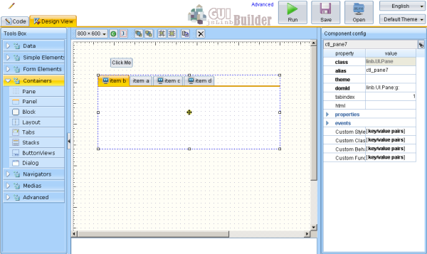
Controls library
Properties and events
Controls tree
Alias
Dblclick for API
Canvas
Run it
Switch views

Now, we are trying to create the previous section’s grid example in Designer.

  - Open the navigators group in “Tools Box”, and drag the “TreeGrid” control to the Canvas area.
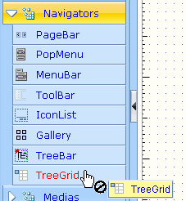
Expand controls group
Drag the control to canvas from here
  - Click to select the “treegrid”
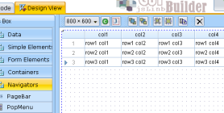
  - Sets this grid’s properties according to the following picture.
- Sets dock to ‘none’;
- Sets rowNumbered to false;
- Sets gridHandlerCapion to ‘gird’.
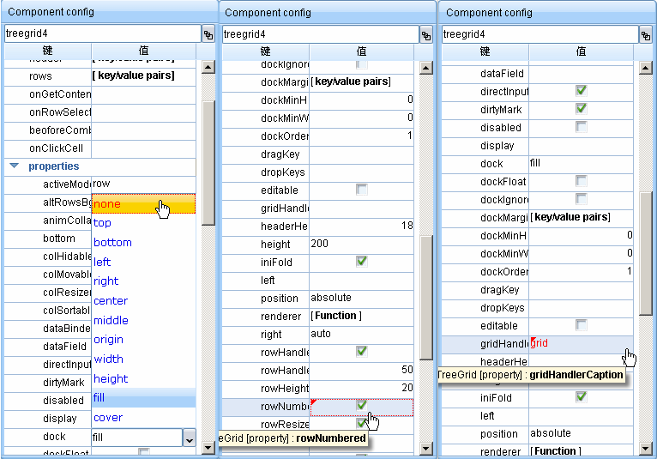
Click to setting dock prop
Click to setting rowNumbered

gridHandlerCaption

  - Sets header and rows
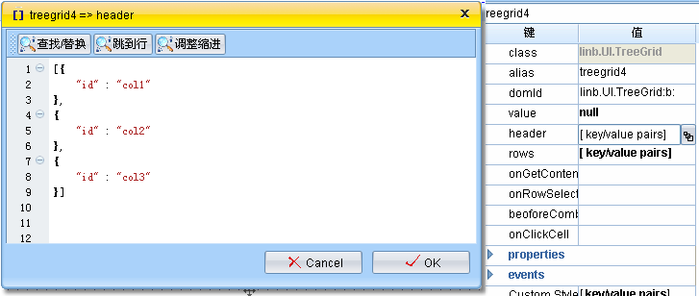
Click here to pop the header setting window
Sets header data
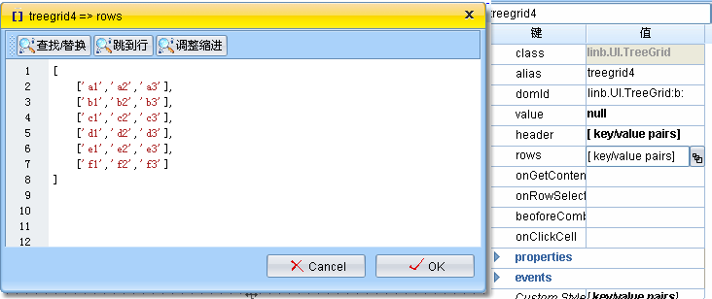
Click here to pop the row setting window

Sets rows data
  - Click to select the grid, adjust its position and size
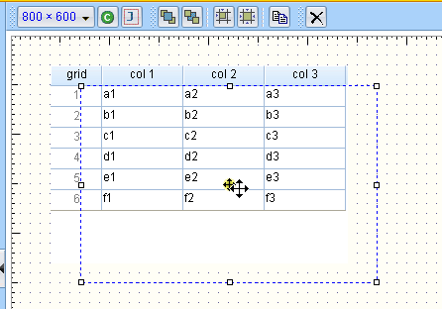
  - Now, switch to “Code” view
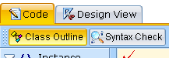
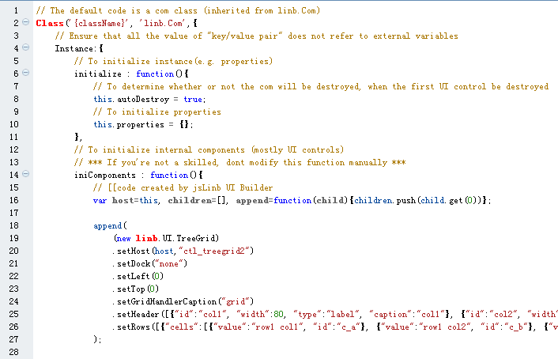
Code created by jsLinb UI Builder
Above code is serialized by Designer. Header data and rows data will not look the same as your setting.
  - Click “Run” Button to open the test window, you will see the same result with section 2.2.
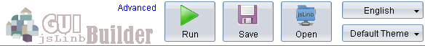

  - Copy the code from this test page, and paste to a new file designer.grid.html.
<!DOCTYPE html PUBLIC "-//W3C//DTD XHTML 1.0 Strict//EN" "http://www.w3.org/TR/xhtml1/DTD/xhtml1-strict.dtd">
<html xmlns="http://www.w3.org/1999/xhtml">
<head>
<meta http-equiv="content-type" content="text/html; charset=utf-8" />
<meta http-equiv="Content-Style-Type" content="text/css" />
<meta http-equiv="imagetoolbar" content="no" />
<title>Web application powered by LINB framework</title>
</head>
<body>
<div id='loading'><img src="../../runtime/loading.gif" alt="Loading..." /></div>
../runtime/loading.gif" alt="Loading..." /></div>
<script type="text/javascript" src="../../runtime/jsLinb/js/linb-all.js"></script>
<script type="text/javascript">
Class('App', 'linb.Com',{
Instance:{
iniComponents:function(){
// [[code created by jsLinb UI Builder
var host=this, children=[], append=function(child){children.push(child.get(0))};

append((new linb.UI.TreeGrid)
.host(host,"treegrid4")
.setDock("none")
.setLeft(60)
.setTop(50)
.setRowNumbered(true)
.setGridHandlerCaption("grid")
.setHeader([{"id":"col 1", "width":80, "type":"label", "caption":"col 1"}, {"id":"col 2", "width":80, "type":"label", "caption":"col 2"}, {"id":"col 3", "width":80, "type":"label", "caption":"col 3"}])
.setRows([{"cells":[{"value":"a1"}, {"value":"a2"}, {"value":"a3"}], "id":"j"}, {"cells":[{"value":"b1"}, {"value":"b2"}, {"value":"b3"}], "id":"k"}, {"cells":[{"value":"c1"}, {"value":"c2"}, {"value":"c3"}], "id":"l"}, {"cells":[{"value":"d1"}, {"value":"d2"}, {"value":"d3"}], "id":"m"}, {"cells":[{"value":"e1"}, {"value":"e2"}, {"value":"e3"}], "id":"n"}, {"cells":[{"value":"f1"}, {"value":"f2"}, {"value":"f3"}], "id":"o"}])
);

return children;
// ]]code created by jsLinb UI Builder
}
}
});
linb.Com.load('App', function(){
linb('loading').remove();
});
</script>
</body>
</html>
Places js lib files in body
Class created in Designer.
You can save this part of code to App/js/index.js
Load UI in asynchronous mode
If no App Class in memory, lib will load the Class from App/js/index.js file first.
Showing a loading picture
cookbook/chapter1/designer.grid.html

Application loading process
In section 2.3, we put all html and JavaScript code in a single file. For a bigger application, it’s not a wise solution. A real application may be include dozens of classes. For a developer, maintaining each class in a separate file is always a must.
OK. Let’s separate “designer.grid.html” into two files → designer.grid.standard.html, and App/js/index.js.

designer.grid.standard.html is:
<!DOCTYPE html PUBLIC "-//W3C//DTD XHTML 1.0 Strict//EN" "http://www.w3.org/TR/xhtml1/DTD/xhtml1-strict.dtd">
<html xmlns="http://www.w3.org/1999/xhtml">
<head>
<meta http-equiv="content-type" content="text/html; charset=utf-8" />
<meta http-equiv="Content-Style-Type" content="text/CSS" />
<meta http-equiv="imagetoolbar" content="no" />
<title>Web application powered by LINB framework</title>
</head>
<body>
<div id='loading'><img src="../runtime/loading.gif" alt="Loading..." /></div>
<script type="text/javascript" src="../../runtime/jsLinb/js/linb-all.js"></script>
<script type="text/javascript">
linb.Com.load('App', function(){
linb('loading').remove();
});
</script>
</body>
</html>
At last, remove loading picture
Load App class from App/js/index.js asynchronously
cookbook/chapter1/designer.grid.standard.html
App/js/index.js is:
Class('App', 'linb.Com',{
Instance:{
iniComponents:function(){
// [[code created by jsLinb UI Builder
var host=this, children=[], append=function(child){children.push(child.get(0))};
append((new linb.UI.TreeGrid)
.host(host,"treegrid4")
.setDock("none")
.setLeft(60)
.setTop(50)
.setRowNumbered(true)
.setGridHandlerCaption("grid")
.setHeader([{"id":"col 1", "width":80, "type":"label", "caption":"col 1"}, {"id":"col 2", "width":80, "type":"label", "caption":"col 2"}, {"id":"col 3", "width":80, "type":"label", "caption":"col 3"}])
.setRows([{"cells":[{"value":"a1"}, {"value":"a2"}, {"value":"a3"}], "id":"j"}, {"cells":[{"value":"b1"}, {"value":"b2"}, {"value":"b3"}], "id":"k"}, {"cells":[{"value":"c1"}, {"value":"c2"}, {"value":"c3"}], "id":"l"}, {"cells":[{"value":"d1"}, {"value":"d2"}, {"value":"d3"}], "id":"m"}, {"cells":[{"value":"e1"}, {"value":"e2"}, {"value":"e3"}], "id":"n"}, {"cells":[{"value":"f1"}, {"value":"f2"}, {"value":"f3"}], "id":"o"}])
);
return children;
// ]]code created by jsLinb UI Builder
}
}
});
cookbook/chapter1/App/js/index.js

When we open designer.grid.standard.html in Browser, the loading process will be:

After DOM is ready, jsLinb lib will handle UI Class → App
Open html/URL in Browser
Browser loading html code (<1k)
Browser load “loading.gif”(small)，and show it (Users will see the loading picture)
Browser load linb-all.js simultaneously
[linb.Com.load] load code from App/js/index.js file asynchronously
[linb.Com.load] new an instance of Class App, and render it into DOM
If Class code is bigger, it’ll take more time. In the meantime, users will see the waiting message (loading.gif picture or other custom showing)

Code Editor
By the way, in order to get better performance, firefox and chrome are recommended here.

There are two views in Builder: “Design view” and “Code” view. The default view is “Design view”. Click “Code” tab to switch to “Code” view.
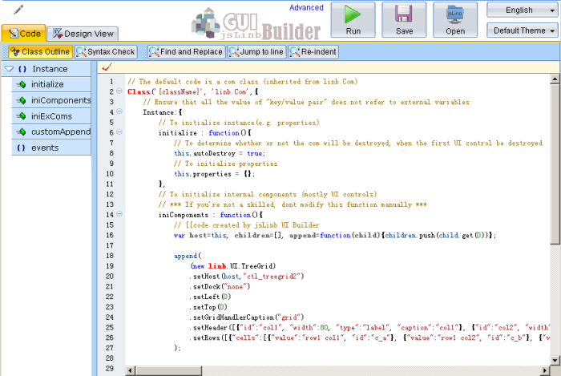
Class outline
Editor window
Commands

Highlight code from Outline window
“Class Outline” is located in the left side of “Code” view. By clicking any member or method name in “Class Outline”, Builder will highlight its code in “Editor window”, and scroll “Editor window” to show the code.
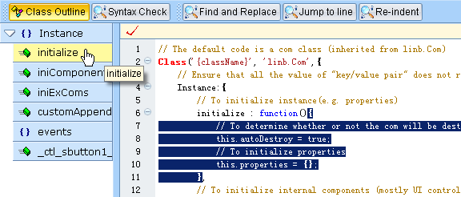

Code Folding
To make your code view more clear to read and understand, jsLinb Builder lets you fold certain parts of it. Click the left side “plus” or “minus” will fold or expand the block code.
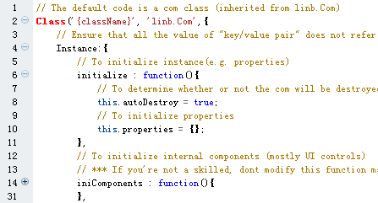
To fold initialize function
To expand iniComponents function
Note: Due to the browser’s poor performance on iframe, please try not to frequent collapse or expand the large body function or object. Chrome’s performance is better than others.

Code Intellisense
Three types Code Intellisense are supported.
- When context does not recognize the input string;
- Type dot after a recognizable variable
- When use shortcut [Alt+1 ], or dbclick a recognizable variable
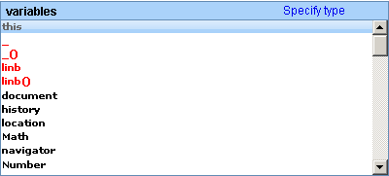

Keyboard actions for Code Intellisense pop Window:
  - “up”: Focus to next item in code list
  - “down”: Focus to previous item in code list
  - “enter”: Select the current focused item, and input to editor window
  - “esc”: Close the pop window
  - Other visible chars: Find and focus the first matched item

When context doesn’t recognize the input string
When you input a string, if editor doesn’t recognize this string, it will pop a list window including local variables, global variables, global functions and JavaScript reserved keywords. In the below picture, type ‘t’ will trigger editor to pop a list window, “this” is the default focused item.
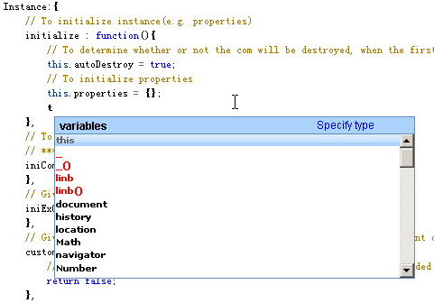

If the input string is “fo”, the “for loop statement” will be the default focused item.
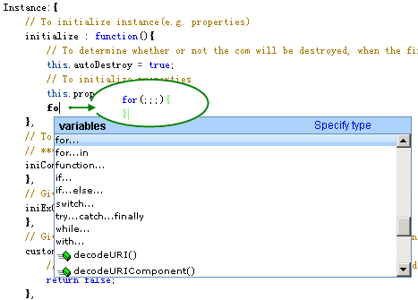
After press "Enter"
In this case, "Enter" keypress will cause “for loop statement” code to be inserted into the editor automatically.

Type dot after a recognizable variable
After an editor recognizable variable, if you type char “.”, editor will pop an available members and functions list for the variable.
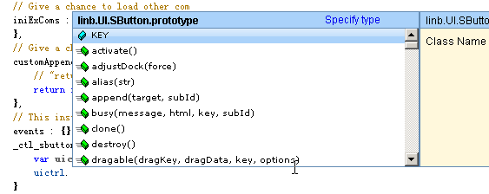
Chainable methods can show Code Intellisense window too.
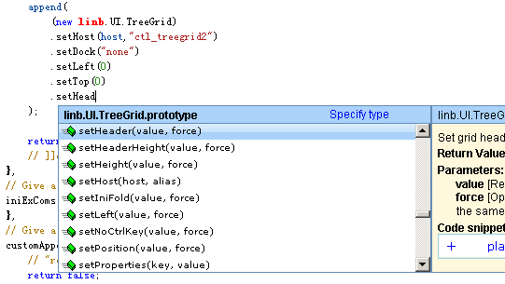
Chainable methods
API document

When use shortcut [Alt+1 ], or dbclick
When a variable was focused, press shortcut [Alt+1] will trigger editor to pop the Code Intellisense window. Double click this variable string will get the same result.
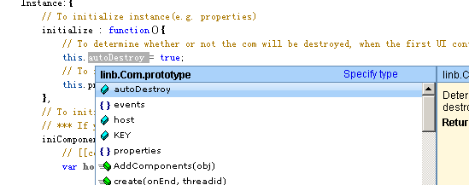
Double click “autoDestroy”

Find the object definition code
In “Design View”, double click a control will cause:
- Switch to “Code” view;
- Highlight the control’s definition code;
- Scroll the definition code to view.
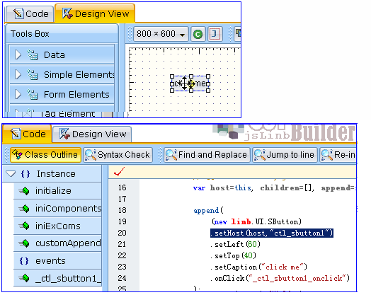
dblclick
Definition code

Generate event code automatically
In the “Design View”, select a control; the right side “Component config” window will be refreshed. Find an event (e.g. onClick event), click its event button will cause:
- Switch to “Code” view;
- Create event code, and insert into the editor;
- Scroll the event code to view.

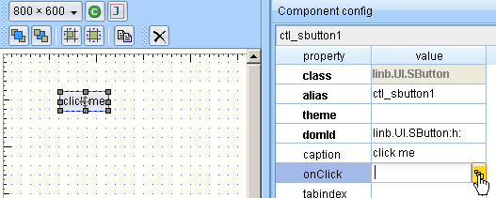
Click

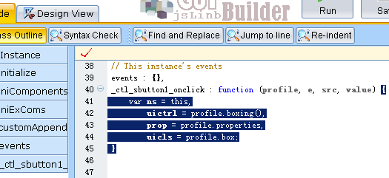
Event code created

Controls Facebook
Many beginners are particularly interested in UI controls. In this chapter we’ll give a rough look at the basic controls. Since each control has a lot of functions, here is a brief introduction, it is impossible to explain all the functions. You can browse API to understand the specific function of each control in detail!

Script testing environment
At first, we have to build a testing environment for executing example codes. About Browsers, firefox is recommended, if firefox is not preferred, ie8 or chrome is ok too.

For firefox:
- You need firefox and firebug;
- Ensure the file “env.html” and all cookbook folders in cookbook dir;
- Open URL cookbook/env.html in firefox;
- Open firebug console, switch to the multi-line mode
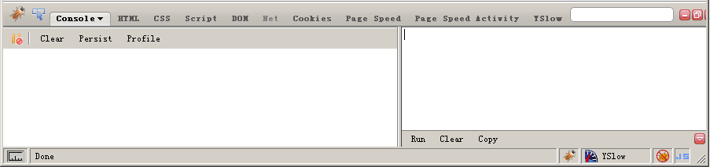
Enter the test code here
Then, click “run”

For IE8:
- You need IE8;
- Open URL cookbook/env.html ;
- Open developer tools, switch to the multi-line mode

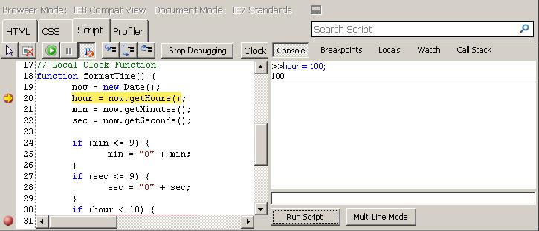
Enter the test code here
Then, click “run”
multi line mode is better

For Chrome:
- You need the latest Chrome;
- Open URL cookbook/env.html ;
- Open developer tools
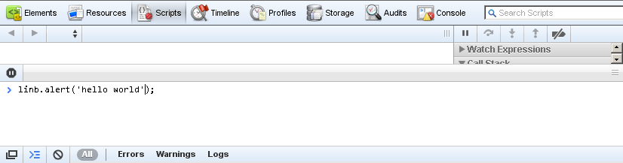
Enter the test code here, press ‘enter’ to run
There’s a “Clear” button in cookbook/env.html, You can click this button to clean up the current page’s DOM. In some cases, you want to clean up both DOM and memory, press ‘F5’ to refresh your browser.
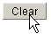

“Hello world” in env.html
Input the following code into script window, and run it.
linb.alert("Hi", "Hello World!");
Output:
Click “Clear” button to clean the DOM.

Control creation and runtime update
There are three approaches to create jsLinb control.
// Approach 1
linb.create("SButton", {
caption: "Using linb.create function",
position: "relative"}
).show();

// Approach 2
(new linb.UI.SButton({
caption: "Using new and key/value pairs",
position: "relative"
})).show();

// Approach 3
(new linb.UI.SButton())
.setCaption("Using new and get/set")
.setPosition("relative")
.show();
We use new/setXX mode in Desinger

The above three approaches will create entirely consistent UI.

You can use setXXX function to update the control after it was rendered into DOM (runtime update).
var dlg=linb.create("Dialog", {caption: "runtime "}).show();
_.asyRun(function(){
dlg.setCaption("updated");
},500);
_.asyRun(function(){
dlg.setMaxBtn(false);
},1000);
_.asyRun(function(){
dlg.setStatus("max");
},1500);
_.asyRun(function(){
dlg.destroy();
},2000);
To modify caption
Create a Dialog
To hide the max button
To modify status
To destroy it

Button related
This section relates to the following controls: linb.UI.Link, linb.UI.SButton, linb.UI.Button, linb.UI.SCheckBox and linb.UI.CheckBox.

onClick event
Input:
var btn=new linb.UI.SButton();
btn.setCaption("Click Me")
.onClick(function(){
linb.alert("Hi","You are great!");
});
btn.show();
Adds onClick evnet
Sets caption
Output:
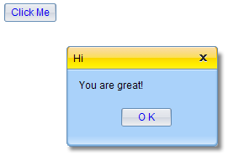
Click it
Input:
var btn=new linb.UI.Button();
btn.setCaption("Click Me")
.onClick(function(){
linb.alert("Hi","You are great!");
});
btn.show();

_.asyRun(function(){
btn.setHeight(80)
.setShadow(true)
.setType("drop")
},1000);
Adds onClick event
Sets caption
Execute code after 1 second
Output:
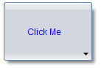
NOTE
linb.UI.SButton / SLabel / SCheckbox are enough for most cases; Only if you need more complex feature, you should use those complex control: linb.UI.Button / Label / Checkbox.

Boolean Controls
There are three controls can represent and modify Boolean value:
Input:
var btn= (new linb.UI.Button({position: "relative", caption:"Button", type:"status"})).show();
var scb= (new linb.UI.SCheckBox({position: "relative", caption:" SCheckBox"})).show();
var cb= (new linb.UI.CheckBox({position: "relative", caption:" CheckBox"})).show();

_.asyRun(function(){
btn.setValue(true,true);
scb.setValue(true,true);
cb.setValue(true,true);
},1000);
Sets position to ‘relative’
Sets values to true after 1 second
Output:
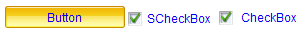

Link Control
You can take linb.UI.Link as a simple button.
Input:
var btn=new linb.UI.Link();
btn.setCaption("Click Me")
.onClick(function(){
linb.alert("Hi","You are great!");
});
btn.show();

// href property
linb.create("Link",{href: "http://www.linb.net"}).show(null,null,100,100)

// href was disabled when return false
linb.create("Link",{href: "http://www.longboo.com"}).show(null,null,200,100)
.onClick(function(){
return false;
});
Adds onClick event
Sets caption
Output:
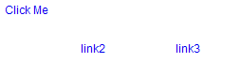
Shows alert window
No action
Goes to linb.net

Label related
This section relates to the following controls: linb.UI.SLabel, linb.UI.Label and linb.UI.Div. These three controls can be used as “label”, linb.UI.SLabel is the simplest one, but it’s enough for most cases; If you need more complex feature like shadow, resizer or border, you should choose linb.UI.Label; Or if you want to input more complex html code in the control, linb.UI.Div is better.
Input:
(new linb.UI.SLabel()).setCaption("SLabel").setPosition("relative").show();
(new linb.UI.Label()).setCaption("Label").setPosition("relative").setShadowText(true).show();
(new linb.UI.Div()).setHtml("It’s a more complicated label in a <br /><b>linb.UI.Div</b>")
.setPosition("relative").show();
Output:
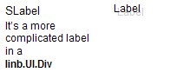
SLabel
Label
Div

Input related
This section relates to the following controls: linb.UI.Input, linb.UI.ComboInput and linb.UI.RichEditor. linb.UI.ComboInput is an enhanced version of linb.UI.Input, it can input/edit value through a pop window; linb.UI.RichEditor is a rich text input/edit control.

setValue/setValue/getUIValue/setUIValue
From the users point of view, value controls (all derived from the linb.absValue control) in jsLinb has two values has two values: the “UI value”(getUIValue/setUIValue) and the “control value”(getValue/setValue).

“UI value” dose not always equal to “control value”. For example, for an empty input control
- Keyboard input “abc”: “UI value” is “abc”, “control value” is empty;
- Calls “updateValue” function: “UI value” is “abc”, “control value” is “abc”;
- Calls “setValue(‘bcd’)”: “UI value” is “bcd”, “control value” is “bcd”;
- Calls “setUIValue(‘efg’)”: “UI value” is “efg’”, “control value” is “bcd”
- Calls “resetValue(‘x’)”: “UI value” is “x”, “control value” is “x”;
var input = (new linb.UI.Input()).show();
linb.message(input.getUIValue()+":"+input.getValue());
_.asyRun(function(){
input.setUIValue('uivalue');
linb.message(input.getUIValue()+":"+input.getValue());
},2000);
_.asyRun(function(){
input.updateValue();
linb.message(input.getUIValue()+":"+input.getValue());
},4000);
A new Input
Sets UI value
Updates UI value to control value

Dirty Mark
If the control’s dirtyMark property is set to true, when “UI value” does not equal to “control value”, a “Dirty Mark” will appear. The “Dirty Mark” will disappear when “UI value” equals to “control value”.
.
Dirty Mark
var input = (new linb.UI.Input()).show();
_.asyRun(function(){
input.setUIValue('uivalue');
},1000);
_.asyRun(function(){
input.updateValue();
input.setDirtyMark (false);
},2000);
_.asyRun(function(){
input.setUIValue('uivalue 2');
},3000);
Dirty Mark appears
Dirty Mark disappears

Nothing happen
If DirtyMark is disabled

Password Input
Sets Input’s type property to “password”.
Input:
var input = (new linb.UI.Input({type: 'password'})).show();

_.asyRun(function(){
input.setUIValue('123456').updateValue();
linb.pop(input.getValue());
},1000);
Sets type

Output:
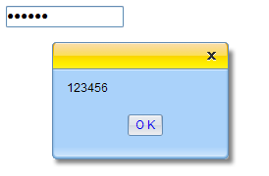

Multi-lines
Sets Input’s multiLine property to true.
Input:

var input = (new linb.UI.Input()).setMultiLines(true).setHeight(100).show();

_.asyRun(function(){
input.setUIValue('123456 \n abc').updateValue();
linb.pop(input.getValue());
},1000);
Sets multiLine to true

Output:
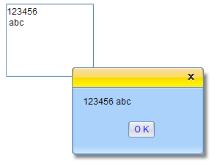

Input validation

valueFormat property
“valueForamt” property represents a regular expression.

Input:
var input = (new linb.UI.Input())
.setValueFormat("^-?\\d\\d*$")
.show();
Number only
Executes the above code, input some charts, and let it lose the mouse focus, the “Error Mark” will appear.

beforeFormatCheck event
Input:
var input = (new linb.UI.Input())
.beforeFormatCheck(function(profile,value){
if(value!=parseFloat(value).toString())
return false;
})
.show();
Number only

In above methods, “beforeFormatCheck” has priority. That means, when "beforeFormatCheck" returns ‘false’, "valueFormat" property will be ignored.

Dynamic input validation
In previous section examples, “Error Mark” appears only when the control loses focus. If you want to a real-time input validation , you need to set dynCheck property to true.

var input = (new linb.UI.Input())
.setDynCheck(true)
.setValueFormat("^-?\\d\\d*$")
.show();
Sets dynCheck

Error Mark

Default Error Mark
The default “Error Mark” is an icon at the right side of Input.
The default Error Icon

Validation Tips
There are three tool tips in linb.UI.Input control:
- tips: the default tool tips
- tipsOK: the valid tool tips
- tipsErr: the invalid tool tips
Input:
var input = (new linb.UI.Input())
.setTips("default tips")
.setTipsErr("invalid tips ")
.setTipsOK("valid tips")
.setValueFormat("^-?\\d\\d*$")
.show();
Sets those tips
Output:
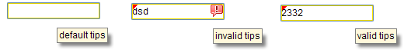

Binding Validation
You can bind the validation tips to a linb.UI.Div, linb.UI.SLabel or linb.UI.Span.
Input:
var slbl= (new linb.UI.SLabel({position:'relative'})).setCustomStyle({KEY:'padding-left:10px'});
var input = (new linb.UI.Input({position:'relative'}))
.setValueFormat("^-?\\d\\d*$")
.setTipsBinder(slbl)
.setDynCheck(true)
.setTips(" default tips")
.setTipsErr(" invalid tips ")
.setTipsOK(" valid tips")

input.show();
slbl.show();
Show SLabel here
Sets tipsBinder
Output:

Custom Error Mark
We can custom “Error Mark” in beforeFormatMark event.
Input:
var input = (new linb.UI.Input())
.setValueFormat("^-?\\d\\d*$")
.beforeFormatMark(function(profile,err){
if(err)
linb.alert("Invalid input!","Only number allowed!",function(){
profile.boxing().activate();
});
return false;
}).show();
Return false to ignore the default action
Customs information and aciton
Output:
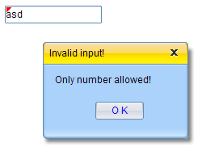

Mask Input
Mask Input examples:
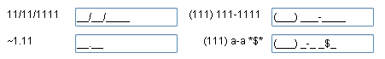
In chapter2\Input\index.html

There is a mask property in linb.UI.Input control. It’s a string. In this string,
- ‘~’ represents [+-]
- ‘1’ represents [0-9]
- ‘a’ represents [A-Za-z]
- ‘u’ represents [A-Z]
- ‘l’ represents [a-z]
- ‘*’ represents [A-Za-z0-9]
- Other visible char represents itself
Input:
var input = (new linb.UI.Input())
.setMask("(1111)11111111-11")
.show();
Output:
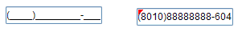
NOTE
chapter2\Input\index.html is an overall example for Input.

linb.UI.ComboInput
linb.UI.ComboInput is an advanced Input.

Pop list for selection
When type property was set to “combobox”, “listbox” or “helpinput”, click the command button will trigger to pop a list window for selection.
listbox
(new linb.UI.ComboInput({items:[ "a","b","c"]})).show();
(new linb.UI.ComboInput({type: "listbox", top:"100", items:[ "a","b","c"]})).show();

combobox
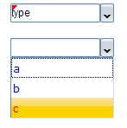
readonly
Keyboard input

combobox, listbox and helpinput
There’s an items property in linb.UI.ComboInput (And all list related controls have this property too). Usually, we set items as an simple single layer array (like "[ia’, ‘ib’, ‘ic’]"). The lib? will convert this simple array to inner format:
[
{
id : "ia",
caption : "ia"
},
{
id : "ib",
caption : "ib"
},
{
id : "ic",
caption : "ic"
}
]

  - combobox: Not readonly. The pop List shows “caption”; Input box shows “caption”; getValue returns “caption”.
  - listbox: Readonly. The pop List shows “caption”; Input box shows “caption”; getValue returns “id.
  - helpinput: Not readonly. The pop List shows “caption”; Input box shows “id”; getValue returns “id”.
Input:
var items=[
{
id : "id1",
caption : "caption1"
},{
id : "id2",
caption : "caption2"
},{
id : "id3",
caption : "caption3"
}
];
linb.create('ComboInput',{position:'relative',items:items}).show();
linb.create('ComboInput',{position:'relative',items:items,type:'listbox'}).show();
linb.create('ComboInput',{position:'relative',items:items,type:'helpinput'}).show();
Output:
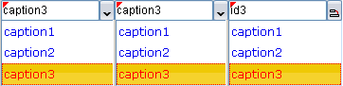

Date Piker
Sets type property to “date”.
Input:
var ctrl=linb.create('ComboInput')
.setType('date')
.setValue(new Date)
.show();

_.asyRun(function(){
alert("The value is a timestamp string:"+ctrl.getValue());
alert("You can convert it to date object:"+new Date(parseInt(ctrl.getValue())));
});
Date object or timestamp string
Output:
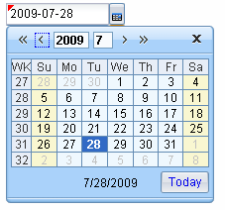

Time Picker
Sets type property to “time”.
Input:
var ctrl=linb.create('ComboInput')
.setType('time')
.setValue('2:15')
.show();

linb.alert("The value is a string : "+ctrl.getValue());
Sets string
Output:
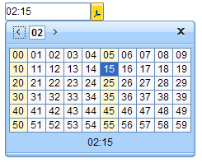

Color Picker
Sets type property to “color”.
Input:
var ctrl=linb.create('ComboInput')
.setType('color')
.setValue('#00ff00')
.show();

linb.alert("The value is a string : "+ctrl.getValue());
Sets string
Output:
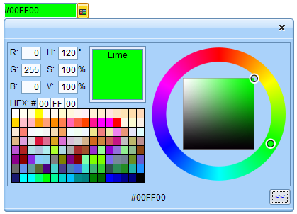

File Picker
Sets type property to “upload”.
Input:
var ctrl=linb.create('ComboInput')
.setType('upload')
.show();
Output:

Note: use getUploadObj function to get the file’s handler
ctrl.getUploadObj)

Getter
Sets type property to “getter”.
Input:
var ctrl=linb.create('ComboInput')
.setType('getter')
.beforeComboPop(function(profile){
profile.boxing().setUIValue(_.id())
})
.show();
Sets value in beforeComboPop event
Output:

Custom Pop Window
Sets type property to “cmdbox”, or “popbox”.
Input:
var ctrl=linb.create('ComboInput')
.setType('popbox')
.beforeComboPop(function(profile){
var dlg=new linb.UI.Dialog, tb;
dlg.append(tb=new linb.UI.TreeBar({items:["a","b",{id:"c",sub:["c1","c2","c3"]}]}));
tb.onItemSelected(function(profile,item){
ctrl.setUIValue(item.id);
dlg.destroy();
});
dlg.show(null,true,100,100)
})
.show();
Shows custom pop window in beforeComboPop event
Output:
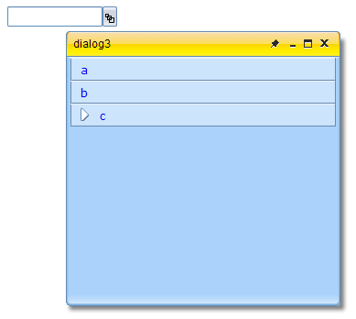
The custom pop window

Command Buttons
You can use commandBtn property to add an command button into ComboInput control. The following types are available for commandBtn property:
- “none”: no command button
- “save”: It’s a save button
- “add” : It’s a add button
- “remove” : It’s a remove button
- “delete” : It’s a delete button
- “custom” : custom button ( sets imageClass or mage,/imagePos to custom it)

Input:
(new linb.UI.ComboInput).setPosition('relative').setCommandBtn('none').show();
(new linb.UI.ComboInput).setPosition('relative').setCommandBtn('save').onCommand(function(){ linb.alert('save event'); }).show();
(new linb.UI.ComboInput).setPosition('relative').setCommandBtn('add').onCommand(function(){ linb.alert('add event'); }).show();
(new linb.UI.ComboInput).setPosition('relative').setCommandBtn('remove').onCommand(function(){ linb.alert('remove event'); }).show();
(new linb.UI.ComboInput).setPosition('relative').setCommandBtn('delete').onCommand(function(){ linb.alert('delete event'); }).show();
(new linb.UI.ComboInput).setPosition('relative').setCommandBtn('save').onCommand(function(){ linb.alert('save event'); }).show();
Output:
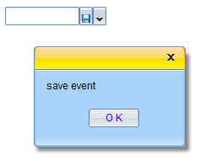

NOTE
chapter2\ComboInput\index.html is an overall example for ComboInput.

RichEditor
Input:
(new linb.UI.RichEditor()).show();
Output:
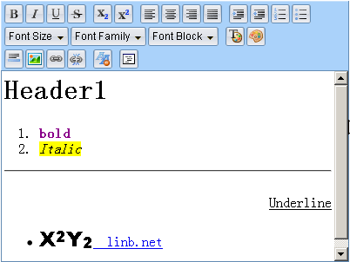

List related
This section relates to the following controls: linb.UI.List, linb.UI.RadioBox and linb.UIIconList and linb.UI.Gallery.

A Simple one
linb.create("List")
.setItems(["Item one","Item two","Item tree"])
.onItemSelected(function(profile,item){
linb.message(item.id);
})
.show();
onItemSelected event
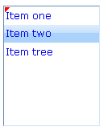

A little bit complicated
var renderer=function(o){
return '<span style="width:40px">'+o.col1+"</span>" + ' <span style="width:60px">'+o.col2+"</span>" + ' <span style="width:40px">'+o.col3+"</span>";
};

linb.create("List")
.setWidth(160)
.setItems([{
id:"a",
col1:'Name',
col2:'Gender ',
col3:'Age',
renderer:renderer,
itemStyle:'border-bottom:solid 1px #C8E1FA;font-weight:bold;'
},
{
id:"b",
col1:'Jack',
col2:'Male',
col3:'23',
renderer:renderer
},
{
id:"c",
col1:' Jenny',
col2:'Female',
col3:'32',
renderer:renderer
}]
)
.beforeUIValueSet(function (profile, ov, nv){
return nv!=="a"
})
.show();
Gives a render function
Extra variables
For the header item
Result:
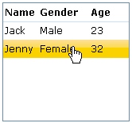
A Grid List
The above special render function applies to any control’s caption property (e.g. linb.UI.Button, linb.UI.Label); and any control’s sub item caption property (e.g. linb.UI.List, linb.UI.TreeBar) .
linb.create("SCheckBox")
.setCaption("caption")
.setRenderer(function(prop){return prop.caption+"+"+this.key})
.show();

RadioBox
linb.UI.RadioBox is derived from linb.UI.List.
Input:
linb.create("RadioBox")
.setItems(["a","b","c"])
.onItemSelected(function(profile,item){
linb.message(item.id);
})
.show();
Output:
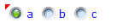

IconList and Gallery
Both are derived from linb.UI.List.
Input:
linb.create("IconList")
.setItems([{id:'a',image:'img/a.gif'},{id:'b',image:'img/b.gif'},{id:'c',image:'img/c.gif'}])
.onItemSelected(function(profile,item){
linb.message(item.id);
})
.show();
Output:
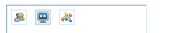

Input:

linb.create("Gallery")
.setItemWidth(64).setItemHeight(64)
.setItems([{id:'a',image:'img/a.gif',caption:'User',comment:'It’s a user'},{id:'b',image:'img/b.gif',caption:'Computer',comment:'It’s a computer'},{id:'c',image:'img/c.gif',caption:'Tree',comment:'It’s a tree'}])
.onItemSelected(function(profile,item){
linb.message(item.id);
})
.show();
Item’s height
Output:
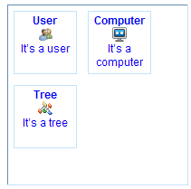

Item selection
You can use “setUIValue” function to select a item in List, or use “fireItemClickEvent” function to get the same result. “fireItemClickEvent” function will trigger “onItemSelected” event, “setUIValue” won’t.
var ctrl=linb.create("List")
.setItems(["Item one","Item two","Item tree"])
.onItemSelected(function(profile,item){
linb.message(item.id);
})
.show();

_.asyRun(function(){
ctrl.fireItemClickEvent("Item two");
},1000);

_.asyRun(function(){
ctrl.setUIValue("Item one");
},2000);
Trigger onItemSelected event

Container related
This section relates to the following controls: linb.UI.Group, linb.UI.Pane , linb.UI.Panel, linb.UI.Block.

linb.UI.Dialog, linb.UI.Layout and linb.UI.Tabs /Stacks/ButtonViews are container controls too, we will give an example? these controls in separate sections.

Container is those controls that can have child controls. In jsLinb Designer, you can drag a child control and drop it into a container control. Just like this,
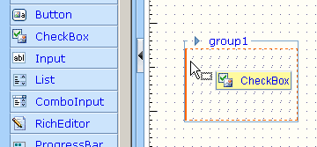

Input 1:
(new linb.UI.Group)
.append(new linb.UI.SButton)
.show();
append
Input 2:
var con = new linb.UI.Group;
con.show();
(new linb.UI.SButton).show(con);
show
Input 3:
linb.create({
key:"linb.UI.Group",
children:[[{key:"linb.UI.SButton"}]]
}).show();
In children object
Output:
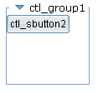

Pane and Panel
linb.UI.Pane is a single node control. It’s derived from linb.UI.Div. linb.UI.Panel has a border and a title bar.
Input:
(new linb.UI.Pane)
.append(new linb.UI.SButton)
.show()
You can’t see output, It’s transparent
Input:
(new linb.UI.Panel)
.setDock("none")
.append(new linb.UI.SButton)
.show()
Sets dock to ‘none’
Output:
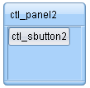

Block
Input:
linb.create("Block",{position:'relative',borderType:'none'}).show()
linb.create("Block",{position:'relative',borderType:'flat'}).show()
linb.create("Block",{position:'relative',borderType:'inset'}).show()
linb.create("Block",{position:'relative',borderType:'outset'}).show()
linb.create("Block",{position:'relative',borderType:'groove'}).show()
linb.create("Block",{position:'relative',borderType:'ridge'}).show()
linb.create("Block",{position:'relative',borderType:'none',border:true,shadow:true,resizer:true}).show()
Output:
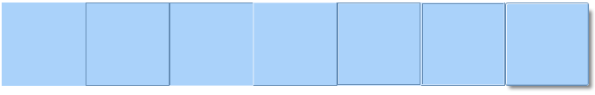

Dialog related

Normal state
Input:
(new linbUI.Dialog).show()
Output:
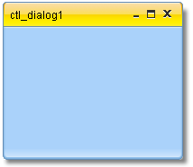
Input:
var dlg = (new linb.UI.Dialog).show();
var panel;
_.asyRun(function(){
dlg.append(panel=new linb.UI.Panel)
},1000);
_.asyRun(function(){
panel.append(new linb.UI.ColorPicker)
},2000);
Output:
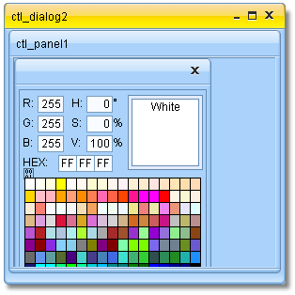

Min and Max status
Input:
var dlg = (new linb.UI.Dialog). setStatus("min").show();
_.asyRun(function(){
dlg.setStatus("normal");
},1000);
_.asyRun(function(){
dlg.setStatus("max");
},2000);
Output:
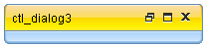

Modal Mode
Input:
var dlg = (new linb.UI.Dialog).show();
dlg.append(panel=new linb.UI.SButton({
caption: "Pop a modal dialog"
},
{onClick:function(){
linb.create("Dialog",{
width:200,
height:100,
html:"The second modal dialog"
}).showModal(dlg);
}}
))

(new linb.UI.Dialog)
.setHtml("The first modal dialog")
.show(null,true);
Parent is html body
Parent is dlg
Sets caption
onClick event
Output:

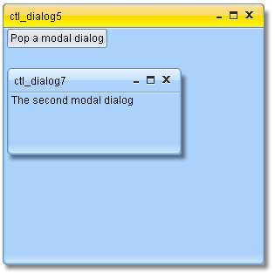

Layout Control
Input:
var block=linb.create("Block").setWidth(300).setHeight(300);
var layout=linb.create("Layout",{items:[
{id:'before',
pos:'before',
size:100,
cmd:true
},{id:'after',pos:'after',size:100}
]});
block.append(layout).show();
Size to 100
Has a command button
Append into a block
Output:
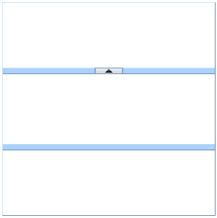
Fold/Expand command button
Before container
After container
Main container
Input:
var block=linb.create("Block").setWidth(400).setHeight(100);
var layout=linb.create("Layout",{items:[
{id:'before',
pos:'before',
size:100,
cmd:true,
folded:true,
max:120,
min:80
},{
id:'after',
pos:'after',
cmd:true,
locked:true,
size:50
},{
id:'after2',
pos:'after',
size:50
}],type: 'horizontal'});
block.append(layout).show();
Max size is120
Min size is 80
horizontal
Default status is fold
Size locked
Output:
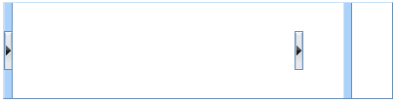
fold
With command button, without split bar
Without command button, with split bar

NOTE
chapter2\Layout\index.html is an overall example for Layout.

Multi-pages Controls
Three multi-pages controls: linb.UI.Tabs, linb.UI.Stacks and linb.UI.ButtonViews.
Input:
var block=linb.create("Block").setWidth(400).setHeight(100);
var pages=linb.create("Tabs",{
items:["page1","page2","page3"],
value:"page2"
});
block.append(pages).show();

_.asyRun(function(){
pages.append(new linb.UI.SButton,"page2")
},1000);
3 pages
The default page
Adds a SButton to 2th page
Append to a block
Output:
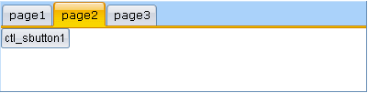

noPanel property
For linb.UI.Tabs and linb.UI.ButtonViews, when “noPanel” property was set to true, they no longer are the container control. So, don’t append any children control to tabs in this case.

Input:
var block=linb.create("Block").setWidth(400).setHeight(300).show();
var items=["page1","page2","page3"];
linb.create("Tabs",{
items:items,
value:"page2",
position:'relative',
width:'auto',
height:'auto',
dock:'none',
noPanel:true
}).show(block);

linb.create("ButtonViews",{
items:items,
value:"page2",
position:'relative',
width:'auto',
height:32,
barSize:30,
dock:'none',
noPanel:true
}).show(block);
Auto width
Set position to ‘relative’
No container
Auto height
No container
Set height to buttonview
Output:
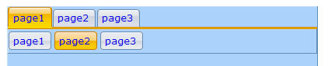

ButtonViews types
There are three properties used to define the ButtonViews’ layout:

- barLocation: Used to set the location of the command button bar.
In ‘top’,’bottom’,’left’,’right’.
- barHAlign: Used to set command buttons horizontal alignment
In ‘left’, ‘right’. Only for barLocation is ‘top’ or ‘bottom’
- barVAlign: Used to set command buttons vertical alignment
In ‘left’, ‘right’. Only for barLocation is ‘left’ or ‘right’

The below picture shows all the eight possible ButtonViews layouts:
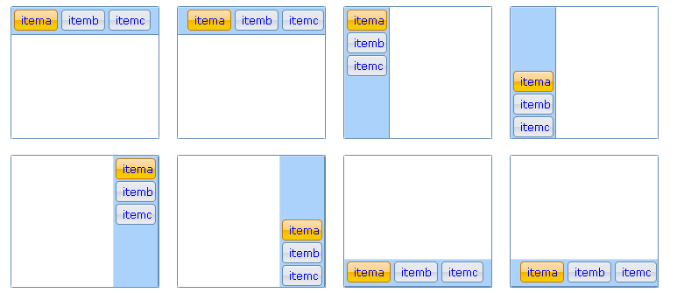
In chapter2\ButtonViews\index.html
NOTE
chapter2\ButtonViews\index.html is an overall example for ButtonViews.

Page selection
You can use “setUIValue” function to select a page, or use “fireItemClickEvent” function to get the same result. “fireItemClickEvent” function will trigger “onItemSelected” event, “setUIValue” won’t.

Input:
var block=linb.create("Block").setWidth(400).setHeight(100).show();
var pages=linb.create("Tabs",{
items:["page1","page2","page3"]
})
.onItemSelected(function(profile,item){
linb.message(item.id);
})
.show(block);

_.asyRun(function(){
pages.fireItemClickEvent("page2");
},1000);

_.asyRun(function(){
pages.setUIValue("page1");
},2000);
Trigger onItemSelected event
Output:
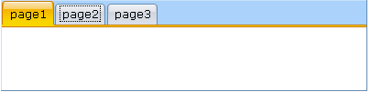

Pages

Close and options Button
Each page can hold a “close” button and a “options” button. Click this button will close the page.
Input:
var block=linb.create("Block").setWidth(200).setHeight(400).show(), stacks;
block.append(stacks=new linb.UI.Stacks({
value:'a',
items:[{
id:'a',
caption:'First Page',
closeBtn:true
},{
id:'b',
caption:'Second Page',
optBtn:true
},{
id:'c',
caption:'Third Page'
},{
id:'d',
caption: 'Fourth Page'
}]
}));
stacks.onShowOptions(function(profile,item){
linb.message(" You clicked "+item.caption)
});
Close button
Options button
Click options to trigger onShowOptions event
Output:
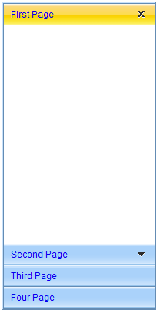
Close button
Options button
Two events can be fired when “close” button was clicked:
- beforePageClose: Fired before user clicked the close button on a page. If returns false, the page won’t be closed.
- afterPageClose: Fired after user clicked the close button on a page.

Add/Remove Pages
Input:
var block=linb.create("Block").setWidth(400).setHeight(100).show(), tabs;
block.append(tabs=new linb.UI.Tabs({
value:'a',
items:[{
id:'a',
caption:'First Page'
},{
id:'b',
caption:'Second Page'
}]
}));
_.asyRun(function(){
tabs.insertItems([{
id:'c',
caption:'Third Page'
},{
id:'d',
caption:'Fourth Page'
}]);
},500);
_.asyRun(function(){
tabs.insertItems('Fifth Page');
},1000);
_.asyRun(function(){
tabs.removeItems('d');
},1500);
_.asyRun(function(){
tabs.removeItems(['b','c']);
},2000);
Close button
Adds two pages
Adds one more
Removes this page
Removes two more

Dynamic content loading

onIniPanelView
var block=linb.create("Block").setWidth(400).setHeight(100).show(),
tabs=new linb.UI.Tabs({
value:'a',
items:[{
id:'a',
caption:'First Page'
},{
id:'b',
caption:'Second PageAgeeablellByRowColtem.caption+lue paires'
},{
id:'c',
caption:'Third Page'
}]
});
tabs.onIniPanelView(function(profile,item){
profile.boxing().getPanel(item.id).append(new linb.UI.SButton)
});
block.append(tabs);

beforeUIValueSet/afterUIValueSet
It’s a fine-grained mechanism.
var block=linb.create("Block").setWidth(400).setHeight(100).show(), tabs;
block.append(tabs=new linb.UI.Tabs({
value:'a',
items:[{
id:'a',
caption:'First Page'
},{
id:'b',
caption:'Second Page'
},{
id:'c',
caption:'Third Page'
}]
}));
tabs.beforeUIValueSet(function(profile,ovalue,value){
if(value=='b')
return false;
});
tabs.afterUIValueSet(function(profile,ovalue,value){
if(value=='c'){
var item=profile.getItemByItemId(value);
if(!item.$ini){
profile.boxing().append(new linb.UI.SButton);
item.$ini=true;
}
}
});
Cancel selection
Checks flag
Sets a flag

Gets item object

Menus and toolbars

Pop Menu
Input:
var pm=linb.create('PopMenu')
.setItems([
{"id":"itema", "caption":"itema", "tips":"item a"},
{"type":"split"},
{"id":"itemb", "type":"checkbox", value:true,"caption":"itemb", "tips":"item b"},
{"id":"itemc", "caption":"itemc", "type":"checkbox", "tips":"item c"},
{"id":"itemd", "caption":"itemd", "tips":"item d",sub:[
{"id":"itemd1", "caption":"itemd1"},
{"id":"itemd2", "caption":"itemd2"}
]},
{"id":"iteme", "caption":"iteme", "tips":"item d", disabled:true}
])
.onMenuSelected(function(profile,item){
linb.message(item.id + (item.type=="checkbox"?" : " + item.value:""))
});

linb.create('SButton')
.onClick(function(profile){
pm.pop(profile.getRoot())
})
.show();
Checkbox type
event
For position

Disabled it
Sub pop menu
Output:
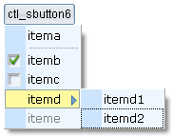

MenuBar
Input:
var pm=linb.create('MenuBar')
.setItems([{
"id" : "file", "caption" : "File",
"sub" : [{
"id" : "newproject",
"caption" : "New Project"
},
{ "id" : "openproject", "caption" : "Open Project",
"add" : "Ctrl+Alt+O",
"image" : "img/b.gif",
"sub":["option 1","option 2"]
},
{ "id" : "closeproject", "caption" : "Close Project"
},
{"type" : "split"},
{ "id" : "save", "caption" : "Save",
"image" : "img/a.gif"
},
{ "id" : "saveall", "caption" : "Save All",
"add" : "Ctrl+Alt+S",
"image" : "img/c.gif"
}]
},
{ "id" : "tools", "caption" : "Tools",
"sub" : [{ "id" : "command", "caption" : "Command Window"
},
{ "id" : "spy", "caption" : "Components Spy"
}]
},
{ "id" : "build", "caption" : "Build",
disabled:true,
"sub" : [{ "id" : "debug",
"caption" : "Debug"
}]
}]).show()
An icon
Sub pop menu
A split

Disabled it
Extra data
Pop menu data
Output:
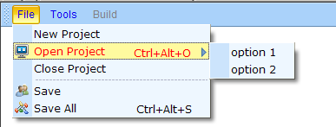

Toolbars
Input:
linb.create('ToolBar',{items:[{
"id" : "align",
"sub" : [
{"id" : "left","caption" : "left"},
{"id" : "center","caption" : "center"},
{type:'split'},
{"id" : "right","caption" : "center"}
]
},{
"id" : "code",
"sub" : [{
"id" : "format","caption" : "format",
label:"label",
image:"img/a.gif",
"dropButton" : true
}]
}]
})
.onClick(function(profile,group,item){
linb.message(group.id + " : " +item.id)
})
.show();
Button group data
With an icon
Group object

A split
Button data
With a label
A drop button
Button object

Output:

TreeBar and TreeView

Three selection mode
All controls derived from linb.UI.absList have three options mode.

No-selection
Input:
var block=new linb.UI.Block({width:200,height:200}).show();
linb.create("TreeBar",{items:[{ id : "itema", sub : ["suba","subb","subc","subd"]},
{id : "itemd", sub : ["sub1","sub2","sub3"]}]})
.setSelMode("none")
.onItemSelected(function(profile,item){
linb.message(item.id);
}).show(block);
Sets to ‘none’
Output:
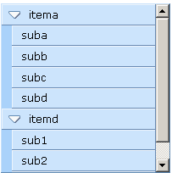

Single-selection
Input:
var block=new linb.UI.Block({width:200,height:200}).show();
linb.create("TreeBar",{items:[{ id : "itema", sub : ["suba","subb","subc","subd"]},
{id : "itemd", sub : ["sub1","sub2","sub3"]}]})
.setSelMode("single")
.onItemSelected(function(profile,item){
linb.message(item.id);
}).show(block);
Sets to single
Output:
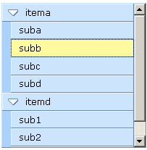

Multi-selection
Input:
var block=new linb.UI.Block({width:200,height:200}).show();
linb.create("TreeBar",{items:[{ id : "itema", sub : ["suba","subb","subc","subd"]},
{id : "itemd", sub : ["sub1","sub2","sub3"]}]})
.setSelMode("multi")
.onItemSelected(function(profile,item){
linb.message(item.id);
}).show(block);
Sets to ‘multi’
Output:
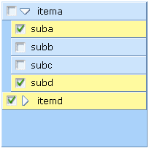

Group Item
Input:
var block=new linb.UI.Block({width:200,height:200}).show();
linb.create("TreeBar",{items:[{
id : "itema",
image : "img/a.gif",
sub : ["suba","subb","subc","subd"]
},
{id : "itemb"},
{
id : "itemd",
group:true,
sub : ["sub1","sub2","sub3"]

}]}).show(block);
With an icon
It’s a group
Sub items
Output:
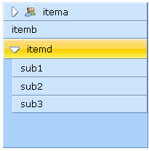
Group item

Expand all nodes by default
Input:
var block=new linb.UI.Block({width:200,height:200}).show();
linb.create("TreeBar",{
iniFold:false,
items:[{
id : "itema",
image : "img/a.gif",
sub : ["suba"]
},
{
id : "itemd",
group:true,
sub : ["sub1","sub2",{
id:"sub3",sub:["a","b"]
}]
}]}).show(block);
Sets iniFold property to false
Output:
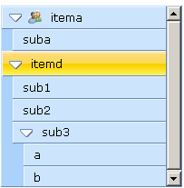

Mutex Expand
var block=new linb.UI.Block({width:200,height:200}).show();
linb.create("TreeBar",{
singleOpen:true,
items:[{
id : "itema",
image : "img/a.gif",
sub : ["suba"]
},
{
id : "itemd",
group:true,
sub : ["sub1","sub2",{
id:"sub3",sub:["a","b"]
}]
}]}).show(block);
Mutex Expand

Dynamic Destruction
var block=new linb.UI.Block({width:200,height:200}).show();
linb.create("TreeBar",{
dynDestory:true,
items:[{
id : "itema",
image : "img/a.gif",
sub : ["suba"]
},
{
id : "itemd",
group:true,
sub : ["sub1","sub2",{
id:"sub3",sub:["a","b"]
}]
}]}).show(block);
Dynamic Destruction

Dynamically loading
Input:
var block=new linb.UI.Block({width:200,height:200}).show();
linb.create("TreeBar",{
singleOpen:true,
dynDestory:true,
items:[{
id : "itema",
sub : true
},
{
id : "itemb",
sub : true
}]})
. onGetContent(function(profile,item,callback){
if(item.id=="itema"){
var rnd=_();
callback([rnd+"-a",rnd+"-b",rnd+"-c"]);
}
if(item.id=="itemb")
return ["itembsub1","itembsub2","itembsub3"];
})
.show(block);
Mutex Expand

Wants to load children dynamically
Asynchronous or synchronous callback
Can also be returned directly
Dynamic Destruction

Takes time stamp as a random string
Output:
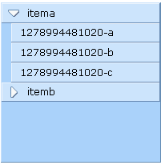
dynamic created and destroyed

TreeGrid

Header and Rows
The header property and rows property in TreeGrid are Array of key/value pairs, like,
[
{id : "xxx1", caption : "xxx1" …,
sub: []
},
{id : "xxx2", caption : "xxx2" …},
…
]
[key/value pairs]
The sub [key/value pairs]
If no id specified, will create one automatically
It can be written as a simplified format,
[
"xx1",
"xx2",
{
id : "xxx3",
sub: ["sub1","sub2"]
}
]
Only id string
Only id string

When call setHeader/setRows, the simplified format can be convert to,
[
{id:"xx1",caption:"xx1"},
{id:"xx2",caption:"xx2"}
{
id : "xxx3", caption : "xxx3",
sub: [
{id:"sub1",caption:"sub1"},
{id:"sub2",caption:"sub2"}
]
}
]

Sets standard format
var block=new linb.UI.Block({width:200,height:200}).show();
var tg=new linb.UI.TreeGrid;
tg.setRowHandler(false)
.setHeader([
{id:"col1", caption:"Name"},
{id:"col2", caption:"Age", width:40}
]).setRows([
{id:"row1",cells:[{
value:'Jack',caption:'Jack'
},{
value:23,caption:'23'
}]},
{id:"row2",cells:[{
value:'John',caption:'John'
},{
value:32,caption:'32'
}]}
]).show(block);
Cells data
Column’s width
No row handler
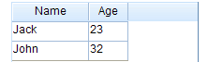

Sets simplified format
var block=new linb.UI.Block({width:200,height:200}).show();
var tg=new linb.UI.TreeGrid;
tg.setRowHandler(false)
.setHeader(["Name", "Age"])
.setRows([['Jack', 23], ['John', 32]])
.show(block);
Only value input
Only id input

getHeader
Calls getHeader function to return the header data. There are three format,
- getHeader(): returns memory data;
- getHeader("data"): returns the standard format data;
- getHeader("min"): returns the simplified format data;
var block=new linb.UI.Block({width:200,height:200}).show();
var tg=new linb.UI.TreeGrid;
tg.setRowHandler(false)
.setHeader(["Name", "Age"])
.setRows([['Jack', 23], ['John', 32]])
.show(block);
linb.log(tg.getHeader());
linb.log(tg.getHeader("data"));
linb.log(tg.getHeader("min"));
Comparing these three formats
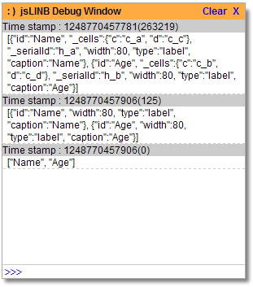

getRows
Calls getRows function to return the rows data. Similarly, there are three format,
- getRows (): returns memory data;
- getRows ("data"): returns the standard format data;
- getRows ("min"): returns the simplified format data;
var block=new linb.UI.Block({width:200,height:200}).show();
var tg=new linb.UI.TreeGrid;
tg.setRowHandler(false)
.setHeader(["Name", "Age"])
.setRows([['Jack', 23], ['John', 32]])
.show(block);
linb.log(tg.getRows("data"));
linb.log(tg.getRows("min"));
//console.log(tg.getRows());
Comparing these three formats

There is circular reference in memory data, can‘t be directly serialized
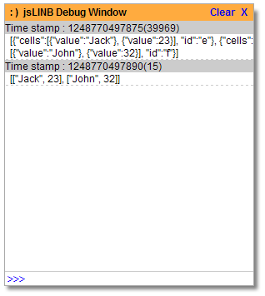
The rows memory data in firebug:
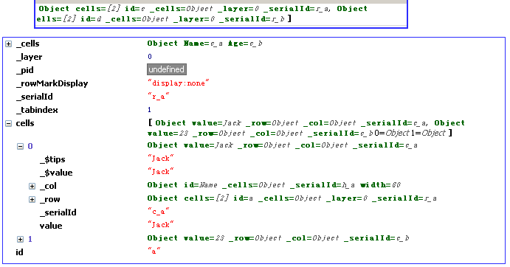

Active Modes
There are three active modes for TreeGrid:
- non-active appearance : activeMode is “none”;
- the row-active appearance: activeMode is “row” ;
- the cell-active appearance: activeMode is “cell”;

non-active appearance
Input:
var block=new linb.UI.Block({width:200,height:200}).show();
var tg=new linb.UI.TreeGrid;
tg.setRowHandler(false)
.setHeader(["Name", "Age"])
.setRows([['Jack', 23], ['John', 32]])
.setActiveMode("none")
.show(block)

. afterRowActive (function(profile,row){
linb.message(row.id);
})
. afterCellActive (function(profile,cell){
linb.message(cell.value);
})
Sets to ‘none’
No row handler
Does not trigger events
Output:
non-active appearence
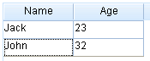

row-active appearance
var block=new linb.UI.Block({width:200,height:200}).show();
var tg=new linb.UI.TreeGrid;
tg.setRowHandler(false)
.setHeader(["Name", "Age"])
.setRows([['Jack', 23], ['John', 32]])
.setActiveMode("row")
.show(block)

.afterRowActive (function(profile,row){
linb.message(row.id);
})
.afterCellActive (function(profile,cell){
linb.message(cell.value);
})
Sets to “row”

No row handler

Will be fired
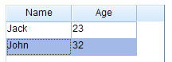
non-active appearence

cell-active appearance
var block=new linb.UI.Block({width:200,height:200}).show();
var tg=new linb.UI.TreeGrid;
tg.setRowHandler(false)
.setHeader(["Name", "Age"])
.setRows([['Jack', 23], ['John', 32]])
.setActiveMode("cell")
.show(block)

.afterRowActive (function(profile,row){
linb.message(row.id);
})
.afterCellActive (function(profile,cell){
linb.message(cell.value);
})
Sets to “row”

No row handler

Will be fired

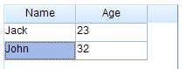
non-active appearance

Selection Mode
There are five selection modes for TreeGrid:
- Non-selection: activeMode is “none”, or selMode is ‘none’
- Single row selection: activeMode is “row”, and selMode is ‘single’
- Multi-rows selection: activeMode is “row”, and selMode is ‘multi’
- Single cell selection: activeMode is “cell”, and selMode is ‘single’
- Multi-cells selection: activeMode is “cell”, and selMode is ‘multi’

Non-selection
Input:
var block=new linb.UI.Block({width:200,height:200}).show();
var tg=new linb.UI.TreeGrid;
tg.setRowHandler(false)
.setHeader(["Name", "Age"])
.setRows([['Jack', 23], ['John', 32]])
.setSelMode("none")
.show(block)

.afterUIValueSet(function(profile,ovalue,value){
linb.message(value);
});
Non-selection
Won’t be fired
Output:
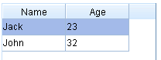
It’s active appearance, not the selection

Input:
var block=new linb.UI.Block({width:200,height:200}).show();
var tg=new linb.UI.TreeGrid;
tg.setRowHandler(false)
.setHeader(["Name", "Age"])
.setRows([['Jack', 23], ['John', 32]])
.setActiveMode("none")
.setSelMode("none")
.show(block)

.afterUIValueSet(function(profile,ovalue,value){
linb.message(value);
});
Non-selection
Won’t be fired
Non-active
Output:
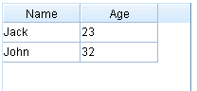
Non-active appearance, non-selection

Single row selection
Input:
var block=new linb.UI.Block({width:200,height:200}).show();
var tg=new linb.UI.TreeGrid;
tg.setRowHandler(false)
.setHeader(["Name", "Age"])
.setRows([['Jack', 23], ['John', 32]])
.setSelMode("single")
.show(block)

.afterUIValueSet(function(profile,ovalue,value){
linb.message(value);
});
Sets to ‘single’ mode
Will be fired
Output:
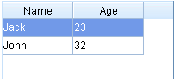
Selection appearance

Multi-row selection
Input:
var block=new linb.UI.Block({width:200,height:200}).show();
var tg=new linb.UI.TreeGrid;
tg.setRowHandlerWidth(24)
.setHeader(["Name", "Age"])
.setRows([['Jack', 23], ['John', 32]])
.setSelMode("multi")
.show(block)

.afterUIValueSet(function(profile,ovalue,value){
linb.message(value);
});
Sets to ‘multi’ mode
Row handler’s width
Will be fired

Output:
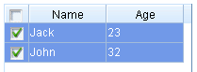

Single cell selection
Input:
var block=new linb.UI.Block({width:200,height:200}).show();
var tg=new linb.UI.TreeGrid;
tg.setRowHandler(false)
.setActiveMode("cell")
.setHeader(["Name", "Age"])
.setRows([['Jack', 23], ['John', 32]])
.setSelMode("single")
.show(block)

.afterUIValueSet(function(profile,ovalue,value){
linb.message(value);
});
Sets to ‘single’ mode
Sets to ‘cell’ mode
Output:
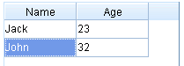

Multi-cells selection
Input:
var block=new linb.UI.Block({width:200,height:200}).show();
var tg=new linb.UI.TreeGrid;
tg.setRowHandler(false)
.setActiveMode("cell")
.setHeader(["Name", "Age"])
.setRows([['Jack', 23], ['John', 32]])
.setSelMode("multi")
.show(block)

.afterUIValueSet(function(profile,ovalue,value){
linb.message(value);
});
Sets to ‘multi’ mode
Output:
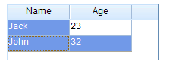

The Tree Grid
Input:
var block=new linb.UI.Block({width:200,height:200}).show();
var tg=new linb.UI.TreeGrid;
tg.setRowHandlerWidth(20)
.setHeader([
{id:"col1", caption:"Name"},
{id:"col2", caption:"Age", width:40}
]).setRows([
{id:"row1",cells:['Jack',23]},
{id:"row2",cells:['John',32],
sub:[{id:"row21",cells:['Tom',24]},
{id:"row22",cells:['Bob',25]}
]}
]).show(block)
A row has sub rows
Row header is a must for tree grid
Output:
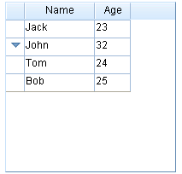
No Indentation here
Input:
var block=new linb.UI.Block({width:200,height:200}).show();
var tg=new linb.UI.TreeGrid;
tg.setRowHandlerWidth(20)
.setGridHandlerCaption("Name")
.setRowHandlerWidth(80)
.setHeader([
{id:"col2", caption:"Age", width:40}
]).setRows([
{id:"row1",caption: 'Jack',cells:[23]},
{id:"row2",caption: 'John',cells:[32],
sub:[{id:"row21",caption: 'Tom',cells:[24]},
{id:"row22", caption: 'Bob',cells:[25]}
]}
]).show(block)
Row’s caption
Grid handler caption
Output:
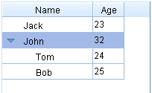
Indentation in row handler

Column config

The first column
In order to show the first column, you have to set rowHandler to [true].
Input:
var block=new linb.UI.Block({width:200,height:200}).show();
var tg=new linb.UI.TreeGrid;
tg.setRowHandlerWidth(80)
.setGridHandlerCaption("Name")
.setHeader([
{id:"col1", caption:"Age", width:40}
]).setRows([
{id:"row1",caption:'Jack',cells:[23]},
{id:"row2",caption:'John',cells:[32],
sub:[{id:"row21",caption:'Tom',cells:[24]},
{id:"row22",caption:'Bob',cells:[25]}
]}
]).show(block)
Sets row handler’s width
Output:
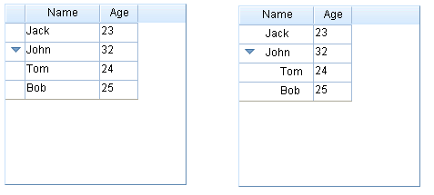
The first column
The first column
上一节中缩进的例子

Column width
Input:
var block=new linb.UI.Block({width:240,height:200}).show();
var tg=new linb.UI.TreeGrid;
tg.setRowHandlerWidth(80)
.setGridHandlerCaption("Name")
.setHeader([
{id:"col1", caption:"Age", width:40},
{id:"col2", caption:"Part-time", width:90}
]).setRows([
{id:"row1",caption:'Jack',cells:[23, true]},
{id:"row2",caption:'John',cells:[32, false]}
]).show(block)
_.asyRun(function(){
tg.updateHeader("col2", {width:70});
},1000);
Column’s width
The first column’s width
Modify column width dynamically
Output:
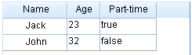

Drag&Drop to modify column width
“colResizer” property in TreeGrid determines whether the column width can be modified with Drag&Drop. Each column can include a “colResizer” property too. The “colResizer” property in column has higher priority than in TreeGrid.
In jsLInb, "fine-grained Setting has higher priority than coarse-grained" is a base rule.

Input:
下拉辑ckboxleizer(false)ion(profile,item){
var block=new linb.UI.Block({width:240,height:200}).show();
var tg=new linb.UI.TreeGrid;
tg.setRowHandlerWidth(80)
.setColResizer(false)
.setGridHandlerCaption("Name")
.setHeader([
{id:"col1", caption:"Age", width:40},
{id:"col2", caption:"Part-time", width:90,colResizer:true}
]).setRows([
{id:"row1",caption:'Jack',cells:[23, true]},
{id:"row2",caption:'John',cells:[32, false]}
]).show(block)
fine-grained setting
coarse-grained setting
Output:
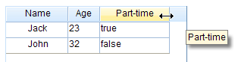
Only this column

Drag&Drop to modify column position
Input:
var block=new linb.UI.Block({width:240,height:200}).show();
var tg=new linb.UI.TreeGrid;
tg.setRowHandlerWidth(80)
.setColMovable(false)
.setGridHandlerCaption("Name")
.setHeader([
{id:"col1", caption:"Age", width:40},
{id:"col2", caption:"Part-time", width:90,colMovable:true}
]).setRows([
{id:"row1",caption:'Jack',cells:[23, true]},
{id:"row2",caption:'John',cells:[32, false]}
]).show(block)
fine-grained setting

coarse-grained setting

Output:
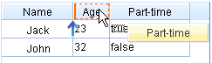

Default Sorting
Input:
var block=new linb.UI.Block({width:240,height:200}).show();
var tg=new linb.UI.TreeGrid;
tg.setRowHandlerWidth(80)
.setColSortable(false)
.setGridHandlerCaption("Name")
.setHeader([
{id:"col1", caption:"Age", width:40},
{id:"col2", caption:"Part-time", width:90,colSortable:true}
]).setRows([
{id:"row1",caption:'Jack',cells:[23, true]},
{id:"row2",caption:'John',cells:[32, false]}
]).show(block)
fine-grained setting

coarse-grained setting

Output:
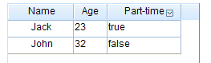
Sorting icon

Custom Sorting
var block=new linb.UI.Block({width:240,height:200}).show();
var tg=new linb.UI.TreeGrid;
tg.setRowHandlerWidth(80)
.setGridHandlerCaption("Name")
.setHeader([
{id:"col1", caption:"Age", width:40},
{id:"col2", caption:"Part-time", width:90,sortby:function(x,y){return -1}}
]).setRows([
{id:"row1",caption:'Jack',cells:[23, true]},
{id:"row2",caption:'John',cells:[32, false]}
]).show(block)
Custom sorting function

Hide columns
Input:
var block=new linb.UI.Block({width:240,height:200}).show();
var tg=new linb.UI.TreeGrid;
tg.setRowHandlerWidth(80)
.setColHidable (false)
.setGridHandlerCaption("Name")
.setHeader([
{id:"col1", caption:"Age", width:40, colHidable:true },
{id:"col2", caption:"Part-time", width:90, colHidable:true}
]).setRows([
{id:"row1",caption:'Jack',cells:[23, true]},
{id:"row2",caption:'John',cells:[32, false]}
]).show(block)
These 2 columns can be hidden
Global setting
Output:
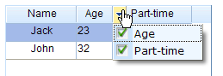

Setting Cell Types in column header
Input:
var block=new linb.UI.Block({width:240,height:200}).show();
var tg=new linb.UI.TreeGrid;
tg.setRowHandlerWidth(80)
.setColSortable(false)
.setGridHandlerCaption("Name")
.setHeader([
{id:"col1", caption:"Age", width:40, type: "number"},
{id:"col2", caption:"Part-time", width:90, type: "checkbox"}
]).setRows([
{id:"row1",caption:'Jack',cells:[23, true]},
{id:"row2",caption:'John',cells:[32, false]}
]).show(block)
Checkbox type
Number type
Output:
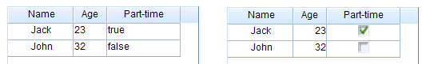

column header style
Input:
var block=new linb.UI.Block({width:240,height:200}).show();
var tg=new linb.UI.TreeGrid;
tg.setRowHandlerWidth(80)
.setColSortable(false)
.setGridHandlerCaption("Name")
.setHeader([
{id:"col1", caption:"Age", width:40, type: "number"},
{id:"col2", caption:"Part-time", width:90, type: "checkbox", headerStyle: "font-weight:bold;"}
]).show(block)
Sets bold
Output:

column header icon
Input:
var block=new linb.UI.Block({width:240,height:200}).show();
var tg=new linb.UI.TreeGrid;
tg.setRowHandlerWidth(80)
.setColSortable(false)
.setGridHandlerCaption("Name")
.setHeader([
{id:"col1", caption:"Age", width:40, type: "number"},
{id:"col2", caption:"Part-time", width:90, type: "checkbox", renderer: function(h){
return "<img style='vertical-align:middle' src='img/a.gif'> "+ h.caption;
}}
]).show(block)
Renderer function
Output:

Update column header dynamically
var block=new linb.UI.Block({width:240,height:200}).show();
var tg=new linb.UI.TreeGrid;
tg.setGridHandlerCaption("Name")
.setHeader([
{id:"col1", caption:"Age", width:40, type: "number"},
{id:"col2", caption:"Part-time", width:90, type: "checkbox"}
]).setRows([
{id:"row1",caption:'Jack',cells:[23, true]},
{id:"row2",caption:'John',cells:[32, false]}
]).show(block)

_.asyRun(function(){
tg.updateHeader('col2','Full-time')
},1000)

_.asyRun(function(){
tg.updateHeader('col2',{caption:'Part-time', width:40, headerStyle:'font-weight:bold', colResizer:false, colSortable:false, colMovable:true, colHidable:true})
},2000)
Updates caption only
Those properties are updatable

Row config

Row height
Input:
var block=new linb.UI.Block({width:240,height:200}).show();
var tg=new linb.UI.TreeGrid;
tg.setGridHandlerCaption("Name")
.setHeader([
{id:"col1", caption:"Age", width:40, type: "number"},
{id:"col2", caption:"Full-time", width:90, type: "checkbox"}
]).setRows([
{id:"row1",caption:'Jack',cells:[23, true], height:120},
{id:"row2",caption:'John',cells:[32, false]}
]).show(block)
Sets row height
Output:
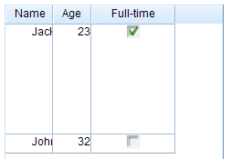

Drag&Drop to modify row height
Input:
下拉辑ckboxleizer(false)ion(profile,item){
var block=new linb.UI.Block({width:240,height:200}).show();
var tg=new linb.UI.TreeGrid;
tg.setRowHandlerWidth(80)
.setRowResizer(false)
.setGridHandlerCaption("Name")
.setHeader([
{id:"col1", caption:"Age", width:40},
{id:"col2", caption:"Full-time", width:90}
]).setRows([
{id:"row1",caption:'Jack',cells:[23, true]},
{id:"row2",caption:'John',cells:[32, false],rowResizer:true}
]).show(block)
This row has rowResizer
Global disabled rowResizer
Output:
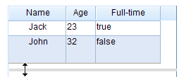

Setting cell type in row
Input:
var block=new linb.UI.Block({width:240,height:200}).show();
var tg=new linb.UI.TreeGrid;
tg.setRowHandlerWidth(80)
.setColSortable(false)
.setGridHandlerCaption("Name")
.setHeader([
{id:"col1", caption:"Age", width:40, type: "number"},
{id:"col2", caption:"Part-time", width:90, type: "checkbox"}
]).setRows([
{id:"row1",caption:'Jack',cells:[23, true]},
{id:"row2",caption:'John',cells:[32, false],type: "label"}
]).show(block)
Sets all cells in this row type to ‘'label'
Output:
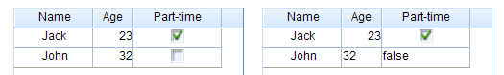

Row style
Input:
var block=new linb.UI.Block({width:240,height:200}).show();
var tg=new linb.UI.TreeGrid;
tg.setRowHandlerWidth(80)
.setGridHandlerCaption("Name")
.setHeader([
{id:"col1", caption:"Age", width:40, type: "number"},
{id:"col2", caption:"Full-time", width:90, type: "checkbox"}
]).setRows([
{id:"row1",caption:'Jack',cells:[23, true]},
{id:"row2",caption:'John',cells:[32, false],rowStyle: "background-color:#00ff00"}
]).show(block)
Sets styles
Output:
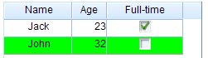

Row numbers
Input:
var block=new linb.UI.Block({width:240,height:200}).show();
var tg=new linb.UI.TreeGrid;
tg.setRowHandlerWidth(80)
.setRowNumbered(true)
.setGridHandlerCaption("Name")
.setHeader([
{id:"col1", caption:"Age", width:40, type: "number"},
{id:"col2", caption:"Full-time", width:90, type: "checkbox"e paires, width:90, type: "checkbox"}
]).setRows([
{id:"row1",caption:'Jack',cells:[23]},
{id:"row2",caption:'John',cells:[32],
sub:[{id:"row21",caption:'Tom',cells:[24]},
{id:"row22",caption:'Bob',cells:[25]}
]}
]).show(block)
To show row numbers
Output:
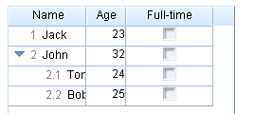
Default format line numbers

Custom row numbers
Input:
var block=new linb.UI.Block({width:240,height:200}).show();
var tg=new linb.UI.TreeGrid;
tg.setRowHandlerWidth(80)
.setRowNumbered(true)
.setGridHandlerCaption("姓名")
.setHeader([
{id:"col1", caption:"Age", width:40, type: "number"},
{id:"col2", caption:"Full-time", width:90, type: "checkbox"e paires, width:90, type: "checkbox"}
]).setRows([
{id:"row1",caption:'Jack',cells:[23]},
{id:"row2",caption:'John',cells:[32],
sub:[{id:"row21",caption:'Tom',cells:[24]},
{id:"row22",caption:'Bob',cells:[25]}
]}
])
.setCustomFunction('getNumberedStr',function(no){
var a=no.split('.');
a[0]={1:'I',2:'II'}[a[0]];
return a.join('-')
})
.show(block)
Custom function
Output:
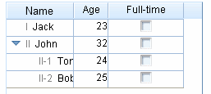

Alternate Row Colors
Input:
var block=new linb.UI.Block({width:240,height:200}).show();
var tg=new linb.UI.TreeGrid;
tg.setRowHandlerWidth(80)
.setAltRowsBg (true)
.setGridHandlerCaption("Name")
.setHeader([
{id:"col1", caption:"Age", width:40, type: "number"},
{id:"col2", caption:"Full-time", width:90, type: "checkbox"}
]).setRows([
{id:"row1",caption:'Jack',cells:[23]},
{id:"row2",caption:'John',cells:[32],
sub:[{id:"row21",caption:'Tom',cells:[24]},
{id:"row22",caption:'Bob',cells:[25]}
]}
]).show(block)
Sets alternate bg color
Output:
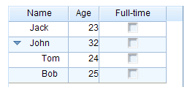

Group
Input:
var block=new linb.UI.Block({width:240,height:200}).show();
var tg=new linb.UI.TreeGrid;
tg.setRowHandlerWidth(80)
.setGridHandlerCaption("Name")
.setHeader([
{id:"col1", caption:"Age", width:40, type: "number"},
{id:"col2", caption:"Full-time", width:90, type: "checkbox"}
]).setRows([
{id:"row1",caption:'Jack',cells:[23]},
{id:"row2",caption:'John',cells:[32],group:true,
sub:[{id:"row21",caption:'Tom',cells:[24]},
{id:"row22",caption:'Bob',cells:[25]}
]}
]).show(block)
It’s a group row
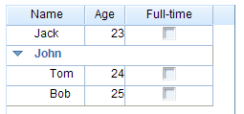
Group row

Preview and Summary region
Input:
var block=new linb.UI.Block({width:240,height:200}).show();
var tg=new linb.UI.TreeGrid;
tg.setRowHandlerWidth(80)
.setGridHandlerCaption("Name")
.setHeader([
{id:"col1", caption:"Age", width:40, type: "number"},
{id:"col2", caption:"Full-time", width:90, type: "checkbox"}
]).setRows([
{id:"row1",caption:'Jack',cells:[23], preview: '<strong>Attention:</strong>',summary: '<em>Jack is athe right one</em>'} ,
{id:"row2",caption:'John',cells:[32], preview: 'John is OK',
sub:[{id:"row21",caption:'Tom',cells:[24]},
{id:"row22",caption:'Bob',cells:[25]}
]}
]).show(block)
preview
summary
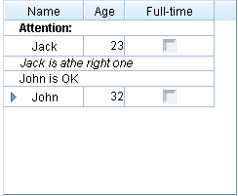
preview
summary

Update row dynamically
Input:
var block=new linb.UI.Block({width:240,height:200}).show();
var tg=new linb.UI.TreeGrid;
tg.setRowHandlerWidth(80).setGridHandlerCaption("Name")
.setHeader([
{id:"col1", caption:"Age", width:40, type: "number"},{id:"col2", caption:"Full-time", width:90, type: "checkbox"}
]).setRows([
{id:"row1",caption:'Jack',cells:[23, true]},
{id:"row2",caption:'John',cells:[32],
sub:[{id:"row21",caption:'Tom',cells:[24]},
{id:"row22",caption:'Box',cells:[25]}
]}
]).show(block)

_.asyRun(function(){
tg.updateRow('row2', 'Jerry')
},1000)

_.asyRun(function(){
tg.updateRow('row2',{caption:'Group', height:30, rowStyle:'background-color:#00ff00;', rowResizer:false, group:true, preview:'preview', summary:'summary'})
},2000)

_.asyRun(function(){
tg.updateRow('row1', {sub:[{value:"Kate",cells:[24,true]}]})
},3000)
Updates row caption only
These properties are updatable
Updates all sub rows
Output:
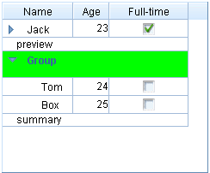

Cell config

Cell types
These types are support:
  - ‘label’: readonly text;
  - ‘button’: the button;
  - ‘input’: single line input;
  - ‘textarea’: multi lines input;
  - ‘number’: number only input;
  - ‘currency’: currency only input;
  - ‘progress’: the progress appearance;
  - ‘combobox’: combo input;
  - ‘listbox’: readonly combo input;
  - ‘getter’: for getting data;
  - ‘helpinput’: help data input;
  - ‘cmdbox’: command box input;
  - ‘popbox’: pop box input;
  - ‘time’: time input;
  - ‘date’: date input;
  - ‘color’: color input;

Input:
var block=new linb.UI.Block({width:240,height:200}).show();
var tg=new linb.UI.TreeGrid;
tg.setRowHandlerWidth(80)
.setColSortable(false)
.setGridHandlerCaption("Name")
.setHeader([
{id:"col1", caption:"Age", width:40, type: "number"},
{id:"col2", caption:"Full-time", width:90, type: "label"}
]).setRows([
{id:"row1",caption:'Jack',cells:[23, true]},
{id:"row2",caption:'John',cells:[32, {value:false, type: "checkbox"}] }
]).show(block)
Setting in cell (has priority)
Setting in column header data
Output:
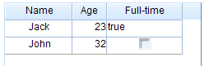

Cell style
Input:
var block=new linb.UI.Block({width:240,height:200}).show();
var tg=new linb.UI.TreeGrid;
tg.setRowHandlerWidth(80)
.setColSortable(false)
.setGridHandlerCaption("Name")
.setHeader([
{id:"col1", caption:"Age", width:40, type: "number"},
{id:"col2", caption:"Full-time", width:90, type: "checkbox", cellStyle: "background-color:#00ff00;"}
]).setRows([
{id:"row1",caption:'Jack', cells:[23, true]},
{id:"row2",caption:'John', cellStyle: "background-color:#0000ff;",cells:[
32,
{value:false, cellStyle: "background-color:#ff0000;"}
] }
]).show(block)
Output:
Setting in row
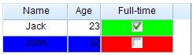
Setting in column header
Setting in cell

Update cell dynamically
Input:
var block=new linb.UI.Block({width:240,height:200}).show();
var tg=new linb.UI.TreeGrid;
tg.setRowHandlerWidth(80).setGridHandlerCaption("Name")
.setHeader([
{id:"col1", caption:"Age", width:40, type: "number"},{id:"col2", caption:"Full-time", width:90, type: "checkbox"}
]).setRows([
{id:"row1",caption:'Jack',cells:[23, true]},
{id:"row2",caption:'John',cells:[32]}
]).show(block)

_.asyRun(function(){
tg.updateCellByRowCol('row2','col1', 18)
},1000)

_.asyRun(function(){
tg.updateCellByRowCol('row2','col1',{value:18,cellStyle:'background-color:#00ff00;'})
},2000)

_.asyRun(function(){
tg.updateCellByRowCol ('row2','col1', {type:"listbox",value:"20", editorListItems:["20","30","40"], editable:true})
},3000)
Updates value only
These properties are updatable
Updates cell type

Editable
“editable” property in TreeGrid determines whether the TreeGrid is editable or not . Each column / row / cell has this property too. Those setting follow “Fine-grained priority principle”.

- TreeGrid’s editable =>false; cell’s editable=>true: only this cell is editable
- TreeGrid’s editable =>false; column header’s editable=>true: only this column is editable
- TreeGrid’s editable =>false; row’s editable=>true: only this row is editable
- TreeGrid’s editable =>true; cell’s editable=>true: only this cell is uneditable
- TreeGrid’s editable =>true; column header’s editable=>false: only this column is uneditable
- TreeGrid’s editable =>true; row’s editable=> false: only this row is uneditable

It should be noted that, cells in Row handler are uneditalbe; cells with ‘label’ or ‘button’ type are uneditable.

Editable TreeGrid
Input:
var block=new linb.UI.Block({width:240,height:200}).show();
var tg=new linb.UI.TreeGrid;
tg.setRowHandler(false)
.setEditable(true)
.setHeader([
{id:"col1", caption:"Name", width:60, type: 'input'},
{id:"col2", caption:"Age", width:40, type: "number"},
{id:"col3", caption:"Gender", width:40, type: "listbox", editorListItems:[{id:'male',caption:'Male'},{id:'female', caption:'Female'}]}
]).setRows([
['Jack',23, {value:'male',caption:'Male'}],
['John',25, {value:'female',caption:'Female'}]
]).show(block)
Value and caption
List for editor
Sets editable
Output:
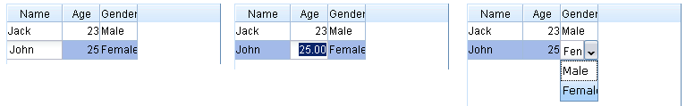

Editable column
Input:
var block=new linb.UI.Block({width:240,height:200}).show();
var tg=new linb.UI.TreeGrid;
tg.setRowHandler(false)
.setEditable(false)
.setHeader([
{id:"col1", caption:"Name", width:60, type: 'input'},
{id:"col2", caption:"Age", width:40, type: "number"},
{id:"col3", caption:"Gender", width:40, type: "listbox", editable:true, editorListItems:[{id:'male',caption:'Male'},{id:'female', caption:'Female'}]}
]).setRows([
['Jack',23, {value:'male',caption:'Male'}],
['John',25, {value:'female',caption:'Female'}]
]).show(block)
This column is editable
Sets uneditable
Output:
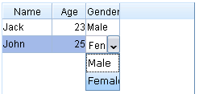

Editable row
Input:
var block=new linb.UI.Block({width:240,height:200}).show();
var tg=new linb.UI.TreeGrid;
tg.setRowHandler(false)
.setEditable(false)
.setHeader([
{id:"col1", caption:"Name", width:60, type: 'input'},
{id:"col2", caption:"Age", width:40, type: "number"},
{id:"col3", caption:"Gender", width:40, type: "listbox", editorListItems:[{id:'male',caption:'Male'},{id:'female', caption:'Female'}]}
]).setRows([
['Jack',23, {value:'male',caption:'Male'}],
{cells:['John',25, {value:'female',caption:'Female'}],editable:true}
]).show(block)
This row is editable
Sets uneditable

Output:
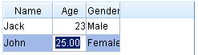

Editable cell
Input:
var block=new linb.UI.Block({width:240,height:200}).show();
var tg=new linb.UI.TreeGrid;
tg.setRowHandler(false)
.setEditable(false)
.setHeader([
{id:"col1", caption:"Name", width:60, type: 'input'},
{id:"col2", caption:"Age", width:40, type: "number"},
{id:"col3", caption:"Gender", width:40, type: "listbox", editorListItems:[{id:'male', caption:'Male'}, {id:'female', caption:'Female'} ]}
]).setRows([
['Jack',23, {value:'male', caption:'Male'}],
['John',25, {value:'female', caption:'Female', editable:true }]
]).show(block)
Only this cell is editable
Sets uneditable
Output:
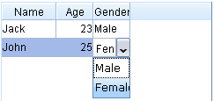

The Editor
When a cell is set to editable, “active this cell” will show a corresponding editor. There are the following editors for different cell types.
  - ‘label’: readonly; no editor
  - ‘button’: readonly; no editor
  - ‘input’: normal linb.UI.Input control
  - ‘textarea’: multi lines linb.UI.Input control
  - ‘number’: number only linb.UI.Input control
  - ‘currency’: currency only linb.UI.Input control
  - ‘progress’: linb.UI.ComboInput control, spin
  - ‘combobox’: linb.UI.ComboInput control, combobox
  - ‘listbox’: linb.UI.ComboInput control, listbox
  - ‘getter’: linb.UI.ComboInput control, getter
  - ‘helpinput’: linb.UI.ComboInput control, helpinput
  - ‘cmdbox’: linb.UI.ComboInput control, cmdbox
  - ‘popbox’: linb.UI.ComboInput control, popbox
  - ‘time’: linb.UI.ComboInput control, time
  - ‘date’: linb.UI.ComboInput control, date
  - ‘color’: linb.UI.ComboInput control, color
Input:
var block=new linb.UI.Block({width:300,height:340}).show();
var tg=new linb.UI.TreeGrid;
tg.setRowHandler(false)
.setEditable(true)
.setHeader(["Type","Cell UI"]).setRows([
{cells:['label',{type:'label',value:'label'}]},
{cells:['button',{type:'button',value:'button'}]},
{cells:['input',{type:'input',value:'input'}]},
{cells:['textarea',{type:'textarea',value:'textarea'}]},
{cells:['number',{type:'number',value:'1.23'}]},
{cells:['currencty',{type:'number',value:'21.23'}]},
{cells:['progress',{type:'progress',value:'0.85'}]},
{cells:['combobox',{type:'combobox',value:'combobox'}]},
{cells:['listbox',{type:'listbox',value:'listbox'}]},
{cells:['getter',{type:'getter',value:'getter'}]},
{cells:['helpinput',{type:'helpinput',value:'helpinput'}]},
{cells:['cmdbox',{type:'cmdbox',value:'cmdbox'}]},
{cells:['popbox',{type:'popbox',value:'popbox'}]},
{cells:['time',{type:'time',value:'12:08'}]},
{cells:['date',{type:'date',value:(new Date).getTime()}]},
{cells:['color',{type:'color',value:'#00ff00'}]}
]).show(block)

Output：
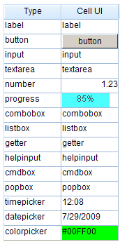

Custom the editor
Input:
var block=new linb.UI.Block({width:300,height:340}).show();
var tg=new linb.UI.TreeGrid;
tg.setRowHandler(false)
.setEditable(true)
.setHeader(["Type","Cell UI "]).setRows([
{cells:['email',{type:'email',value:'a@b.com'}]},
{cells:['popwnd',{type:'popwnd',value:'value'}]}
])
.beforeIniEditor(function(profile, cell, cellNode){
var t=cell.type;
if(t=='email'){
var editor = new linb.UI.Input({valueFormat:"^[\\w\\.=-]+@[\\w\\.-]+\\.[\\w\\.-]{2,4}$"});
return editor;
}

if(t=='popwnd'){
var dlg=linb.prompt('Specify it','Update',cell.value, function(value){
if(cell.value!==value)
profile.boxing().updateCell(cell, value);
});
dlg.getRoot().cssPos(cellNode.offset());
return false;
}
}).show(block);
Return false for advanced custom editor
Return the custom editor
Linb.U.Input or CombInput
Output:
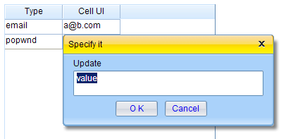
The custom editor

Add/Remove rows
Input:
var block=new linb.UI.Block({width:240,height:200}).show();
var tg=new linb.UI.TreeGrid;
tg.setRowHandler(false)
.setEditable(true)
.setHeader([
{id:"col1", caption:"Name", width:60, type: 'input'},
{id:"col2", caption:"Age", width:40, type: "number"}
]).setRows([
{id:'row1',cells:['Jack',23]},
{id:'row2',cells:['John',25]}
]).show(block);

_.asyRun(function(){
tg.insertRows([[]])
},1000);
_.asyRun(function(){
tg.insertRows(["Tom",30])
},2000);
_.asyRun(function(){
tg.insertRows([{id:'row3',cells:['Jerry',19]},['Mark',31]])
},3000);
_.asyRun(function(){
tg.removeRows('row1')
},4000);
_.asyRun(function(){
tg.removeRows(['row2','row3'])
},5000);
_.asyRun(function(){
tg.insertRows([{id:'row4',cells:['Jack',23]}],null,null,true)
},6000);
_.asyRun(function(){
tg.insertRows([['John',23]],null,'row1',false)
},7000);
Adds a empty row
Adds a new row
Adds two rows
Removes a row by id
Removes two row by ids
Adds a row to the top
Adda a row next to ’row1’

NOTE
chapter2/TGDynamic\index.html is an overall example for ThreeGrid
chapter2/TreeGrid.Paging\index.html is another example for multi pages

Other standard controls

ProgressBar
Input:
linb.create('ProgressBar')
.setCaptionTpl("{value}% finished!")
.setValue(80)
.show();
Sets text display template
percentage
Output:

Slider
Input:
linb.create('Slider')
.setPosition('relative')
.setSteps(100)
.setValue("20:50")
.show()

linb.create('Slider')
.setSteps(10)
.setType("vertical")
.setIsRange(false)
.setValue(2)
.setHeight(200)
.show();
Sets step to 100
A single slider
Sets the locations for the two slider
Sets step to 10
Vertical slider
Output:
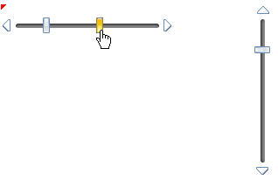
Vertial slider
Drag it to move

Image
linb.create("Image")
.setSrc("img/a.gif")
.afterLoad(function(){
linb.message("The picture is loaded.");
})
.show();

linb.create("Image")
.setSrc("img/b.gif")
.beforeLoad(function(){
return false;
})
.show()
The image was loaded successful
Cancel loading process

PageBar
Input:
var onclick=function(profile,page){
profile.boxing().setPage(page);
};
// a PageBar
linb.create('PageBar')
.setValue("1:5:12")
.onClick(onclick)
.show();
// another PageBar
linb.create('PageBar')
.setValue("1:5:12")
.setTop(100)
.setCaption("")
.setPrevMark("<<")
.setNextMark(">>")
.setTextTpl("[ * ]")
.onClick(onclick)
.show();
Set current page
onClick event
1.Min page; 2.current page; 3.max page
Caption label
Prev command label
Next command label
Page label templates, * is the variable value
Output:
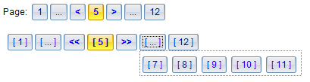

Data exchanging(Ajax)
jsLinb is a client-side solution, it can work with any backend (php, .Net, Java, python) or static HTML pages. Client-side and backend is completely decoupled. Client-side does not need to care what kind of technique is used in the backend. Client-side sends request to, and gets response from a given backend service(e.g. JSON service, REST service) .

There are three IO class in jsLinb:
- linb.Ajax: An AJAX wrapper for xmlHttp object. It’s features:
  - Can only access the same domain by default;
  - Works both synchronous and asynchronous;
  - Works both ‘get’ and ‘post’ methods;
  - Returns string.
- linb.SAjax: An AJAX wrapper for “script tag”. It’s features:
  - Cross domain;
  - Asynchronous only;
  - Can not post data;
  - Returned content is packaged as javascript’s Object
inb.SAjax send request data includes a “callback” parameter (default is “linb.SAjax.$response”), and a “id” parameter ( the uniquely identify).
Server’s return data must be the following format:
linb.SAjax.$response({id: "12483145855311"/*,data*/})

- linb.IAjax: An AJAX wrapper for “iframe”. It’s features:
  - Cross domain;
  - Asynchronous only;
  - Can update file;
  - Works both ‘get’ and ‘post’ methods;
  - Returned content is packaged as javascript’s Object
inb.IAjax send request data includes an “id” parameter ( the uniquely identify).
Server’s return data must be the following format:
<script type='text' id='json'>{"id":"12483161278402"/*,data*/}]}</script>
<script type='text/javascript'>
window.name=document.getElementById('json').innerHTML;
</script>
“linb.request” function can choose an appropriate class from linb.Ajax, linb.SAjax or linb.IAjax automatically, according to requested domain, ‘GET/POST’ method and other information.

NOTE
Examples in this chapter works only as a http url, do not double-click directly to open.

Fiddler
In order to understand the data exchanges process better, you need a tool like Fiddler to monitor network traffic.

Go to http://www.fiddler2.com/fiddler2/ to get Fiddler.

Fiddler can configure IE proxy automatically, but if you are in firefox, chrome or opera, you need to configure the proxy by manual (Fiddler proxy: 127.0.0.1:8888). Of course, you can find some firefox proxy plug-ins to help you.

To get the contents of the file
linb.Ajax can get file contents easily.

linb.Ajax('data/ajax.js', '23233', function(rsp){
linb.message(rsp)

},function(errMsg){
linb.alert(errMsg)
}).start();
Start to send request
Callback function for fail
Callback function for success
File’s uri address
A random string for avoiding browser cache
In Fiddler:
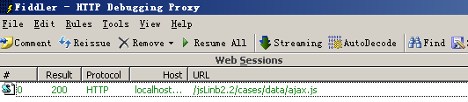

Synchronous data exchange
Only linb.Ajax support synchronous data exchanging.
var url="chapter3/request.php";
linb.Ajax(url, {
key:'test',
para:{p1:'para 1'}
},function(rsp){
linb.log(rsp);
},function(errMsg){
linb.alert(errMsg)
}, null, {
asy:false
}).start();
synchronous
Request data
In fiddler:
The request:
The response:

This is an asynchronous request:
var url="chapter3/request.php";
linb.Ajax(url, {
key:'test',
para:{p1:'para 1'}
},function(rsp){
linb.log(rsp);
},function(errMsg){
linb.alert(errMsg)
}).start();

Cross-domain
linb.SAjax and linb.IAjax can be used for calling Cross Domain Web Services. But only linb.IAjax can post data and upload file.

To monitor SAjax
Code:
var url="chapter3/request.php";
linb.SAjax(url, {
key:'test',
para:{p1:'para 1'}
},function(rsp){
linb.log(rsp);
},function(errMsg){
linb.alert(errMsg)
}).start();
Request data
In Fiddler:
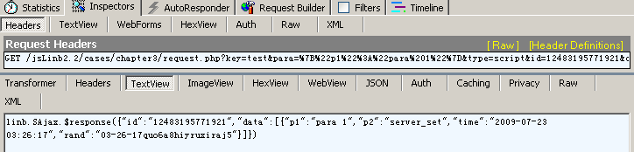
GET method
The response
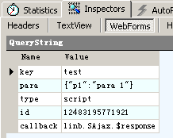
The request data
‘script’ tells backend: this is a SAjax request

To monitor IAjax
Code:
var url="chapter3/request.php";
linb.IAjax(url, {
key:'test',
para:{p1:'para 1'}
},function(rsp){
linb.log(rsp);
},function(errMsg){
linb.alert(errMsg)
}).start();
Request data

In Fiddler:
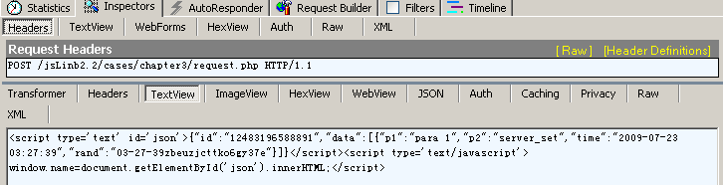
POST method
The response

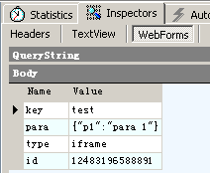
The request data

‘iframe’ tells backend: this is an IAjax request

By default, IAajax use “POST” method, you can specify method in options.
var url="chapter3/request.php";
linb.IAjax(url, {
key:'test',
para:{p1:'para 1'}
},function(rsp){
linb.log(rsp);
},function(errMsg){
linb.alert(errMsg)
},null,{
method: 'get'
}).start();
Switch to GET method

File Upload
Only linb.UI.IAjax can upload file.
This code in this section is in "chapter3/upload/".

Selecting upload file with ComboInput
ComboInput
Sets ComboInput’s type property to “upload”:
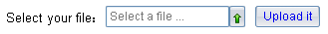
chapter3/upload/index.html

Upload by IAjax
Class('App', 'linb.Com',{
Instance:{
iniComponents:function(){
// [[code created by jsLinb UI Builder
var host=this, children=[], append=function(child){children.push(child.get(0))};

append((new linb.UI.SLabel)
.setHost(host,"slabel1")
.setLeft(40)
.setTop(44)
.setCaption("Select your file: ")
);

append((new linb.UI.ComboInput)
. setHost(host,"upload")
.setLeft(140)
.setTop(40)
.setWidth(140)
.setReadonly(true)
.setType("upload")
.setValue("Select a file ...")
);

append((new linb.UI.SButton)
. setHost(host,"sbutton3")
.setLeft(290)
.setTop(40)
.setCaption("Upload it")
.onClick("_sbutton3_onclick")
);

return children;
// ]]code created by jsLinb UI Builder
},
_sbutton3_onclick:function (profile, e, src, value) {
var file=this.upload.getUploadObj();
if(file){
linb.IAjax('../request.php',{key:'upload',para:{},file:file},function(rsp){
linb.alert(rsp.data.message);
},function(errMsg){
linb.alert(errMsg)
}).start();
}
}
}
});
Created by Designer
Upload control
IAjax upload
Successful return
Getting file content

A request wrapper for real application
In practical applications, you can choose linb.Ajax, linb.SAjax and linb.IAjax according to the actual situation. Usually, we will wrap a common function or class to handle all data interaction with the backend service. This is an example wrapper. Just for your reference.
request=function(service,
requestData,
onOK,
onStart,
onEnd,
file
){
_.tryF(onStart);
linb.observableRun(function(threadid){
var options;
if(file){
requestData.file=file;
options={method:'post'};
}
linb.request(service, requestData, function(rsp){
if(typeof rsp=='string')
rsp=_.unserialize(rsp);

if(rsp){
if(!rsp.error)
_.tryF(onOK, [rsp]);
else
linb.pop(_.serialize(rsp.error));
}else{
linb.pop(_.serialize(rsp));
}
_.tryF(onEnd);
},function(rsp){
linb.pop(_.serialize(rsp));
_.tryF(onEnd);
}, threadid,options)
});
};
Service url address
Request data (key/value pairs)
Callback for successful call
Callback for onStart and onEnd
File to upload
Success
Fail

Fail

Fail
linb.Ajax returns string, not js object

XML Data
If the server returns xml data, we can use linb.XML to convert the XML data into JSON data.
linb.Ajax('data/ajax.xml', '', function(rsp){
alert (rsp)
var obj = linb.XML.xml2json(linb.XML.parseXML(rsp));
linb.pop(obj.message);
},function(errMsg){
linb.alert(errMsg)
}).start();
XML to JSON

An overall example
The following is an overall example for data exchanging.
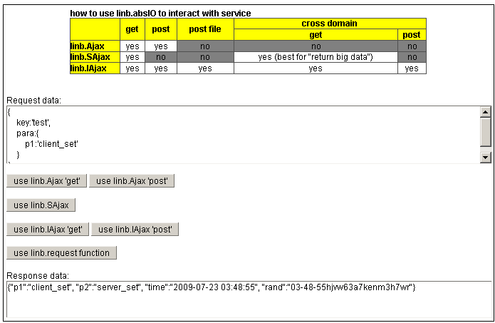
Results window
Request data
Ajax get and post
SAjax
IAjax get and post
linb.request
Chapter3/io/index.html

Distributed UI
Sometimes, especially in larger applications, we maybe save a large “not frequently used” UI Class into a separate file. This file will not be loaded at the beginning.
When the application needs to show the UI, the program will automatically load code from the "separate file". It is so called "distributed UI". This "distributed UI" file can be in your server, or in different domain remote servers.

Shows dialog from a remote file
There’s a file “Module3.js” in folder “cookbook\chapter4\distributed\App\js\”, “Module3.js” includes a Class named “App.Module3”. Let’s try to call it.
Input:
Namespace("App");
linb.include("App.Module3",
linb.getPath("chapter4/distributed/App/js/","Module3.js"),
function(){
var ins=new App.Module3();
ins.show();
},function(){
linb.alert("fail");
}
);
Namespace is “App”
Dynamic asynchronous remote file loading
Create instance and show it
Output:
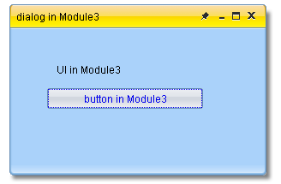
Code in Module3.js

And try to load code and create UI from a difference domain.
Namespace("App");
linb.include("App.Module3",
"http://www.linb.net/Samples/linb/app/distributed/App/js/Module3.js",
function(){
var ins=new App.Module3();
ins.show();
},function(){
linb.alert("fail");
}
);
A difference domain

linb.Com and linb.ComFactory
In fact, most of the actual business applications will not load code from a foreign domain. From another perspective, most of "Distributed UI" files are put in the application directory.
In this case, we can use linb.Com and linb.ComFactory to load those “distributed UI”. In order to use this approach, all those Classes must be derived from the linb.Com, named according to specified rules, and put into the specified directory.

linb.ComFactory implements a management mechanism for the linb.Com. It can follow a specified rule (finding file path from the class name) to load code from a remote file.

There ‘s an overall example in “chapter4/distributed”, we can browse it for detail.
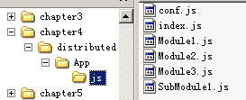
Distributed UI classes
Conf file
This folder

linb.ComFactory config
In conf.js:
CONF={ComFactoryProfile:
{
module1:{
cls:'App.Module1',
children:{
tag_SubModule1:'submodule1'
}
},
submodule1:{
cls:'App.SubModule1'
}
}}
module1 is an “Aoo.Module1” Class
submodule1 is a “Aoo.SubModule1” Class
module1 has a child submodule1
Loading this configuration to linb.ComFactory:
linb.ComFactory.setProfile(CONF.ComFactoryProfile);

linb.Com.Load
In file index.html,
linb.Com.load ('App');
To load and show the firs UI Class

The above code will try to find file named “index.js” from “distributed/App/js/”, create an instance (new App), and show the instance to DOM.
Output:
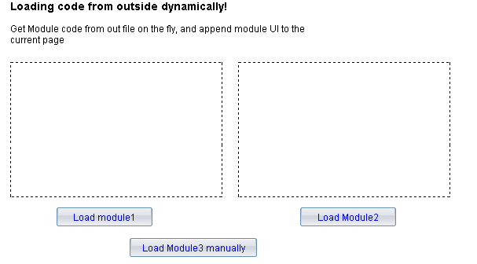

newCom and getCom
In index.js, onClick event for “Load module3 manually” button is:
_button3_onclick:function (profile, e, value) {
var host=this;
linb.ComFactory.newCom('App.Module3' ,function(){
this.show(linb([document.body]));
});
}
newCom
Shows to HTML body
Callback function
Uses Class Name

[linb.ComFactory.newCom(“App.Module3”.. ], will:
- find file “Module3.js” in “distributed/App/js/”
- load code from file “Module3.js” ;
- create new instance,;
- call the callback function.

Note: newCom use “Class Name” to load code.

onClick event for “Load module1” button is:
_button9_onclick:function (profile, e, value) {
var host=this;
linb.ComFactory.getCom('module1',function(){
var ns=this;
host.div16.append(ns.getUIComponents(),false);
});
}
getCom
Shows to the left block
Callback function

From config

[linb.ComFactory.newCom(“module1”.. ], will:
- find config from linb.ComFactory
- find file “Module1.js” in “distributed/App/js/”
- load code from file “Module1.js” ;
- create new instance,;
- call the callback function.

onClick event for “Load module2” button is:
_button10_onclick:function (profile, e, value) {
var host=this;
linb.ComFactory.getCom('App.Module2',function(){
var ns=this;
host.div16.append(ns.getUIComponents(),false);
});
}
getCom
Shows to the right block
Callback function

“Class Name” works too.
No config needed in this case.
By default, the instance created by "getCom" is singleton, and will be cached in inb.ComFactory.

linb.UI.Tag
There’s a linb.UI.Tag object in file Module1.js:
host.panelMain.append((new linb.UI.Tag)
.host(host,"tag2")
.setLeft(20)
.setTop(70)
.setWidth(218)
.setHeight(98)
.setTagKey("tag_SubModule1")
);
Module name in configuration
Here, this Tag object configures size and position properties for module “tag_SubModule1”. When the instance of Module1 was created, according to the Tag object’ info, system will load the “tag_SubModule1” automatically, and set size and position properties to it. Then, system will replace the Tag object with “tag_SubModule1” object, and destroy the Tag object.
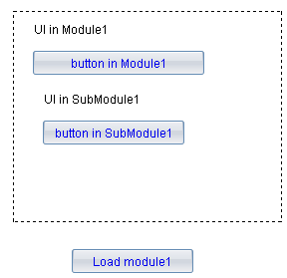
The Tag object was replaced by “tag_SubModule1”

Destroy com
Call com’s destroy() function to destroy the Class instance;
Call Class.destroy(“class name”) to destroy the Class itself.
If you used “getCom(‘module name’)” to create an com instance, you have to call “linb.ComFactory.setCom ( ‘module name’, null )” to clear that cache.

If com exists in memory
If a com exists in memory already, we can call it directly:
linb('body').append(new App.Acom);

Some fundamental things

Pop-up window

alert window
linb.alert('title','message',function(){
linb.message('You close this window!')
}, 'O K', 50, 100);
Fired after user close the window
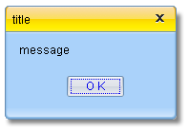a

confirm window
linb.confirm('title','confirm?',function(){
linb.message('You confirmed it')
},
function(type){
linb.message(" You didn’t cofirm it -" + type)
},'YES', 'NO',50,100);
Fired when user click “YES”
Fired when user click “NO” or click close button

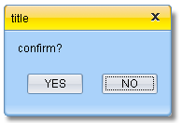

prompt window
linb.prompt('title', 'message','default content',function(msg){
linb.message('You input - ' + msg)
},function(){
linb.message(" You cancel it")
},'YES', 'NO',50,100);

Fired when user click “YES”
Fired when user click “NO” or click close button

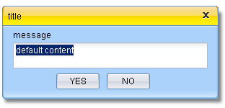

pop window
linb.pop('title', 'message','Button Caption',50,100);
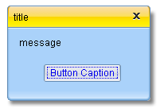

Asynchronous execution

asyRun
_.asyRun is a wrapper for settimeout.
_.asyRun(function(arg1,arg2){
linb.pop("this===linb:"+(this===linb), arg1+":"+arg2)
},
500,
['arg1','arg2'],
linb)
scope
parameters
Delay 500 ms
Function body

resetRun
_.asyRun is a wrapper for set timeout too. But it has an unique id. When you set another function with the same id, the latter will cover the former.

_.resetRun('key1',function(arg){
linb.pop("this===linb:"+(this===linb), arg)
},500,['The previous one'],linb)

_.resetRun('key1',function(arg){
linb.pop("this===linb:"+(this===linb), arg)
},500,['The last one'],linb)
The latter one will be executed
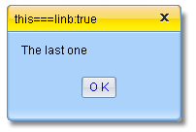

Skin switcher

Switch skin for whole application
There are three system skins in jsLinb3.0: default, vista and aqua. You can use linb.UI.setTheme to switch the skin.
linb.UI.setTheme("vista")

Dynamically (no page refresh)

Change skin for a single control
It’s a fine-grained mechanism.
ctl_button.setTheme("custom")

Only for “ctl_button”
In this case, developer needs to define CSS class for this "custom".

Locale switcher
linb.alert(linb.getLang())
linb.setLang("cn");

Sets locale, switch locale dynamically (no page refresh)

Gets the current locale key

Example “chapter5\lang” loading process:

After DOM is ready, jsLinb lib will handle UI Class → App
Open url in the Browser
Loading html file (<1k)
Browser load “loading.gif”(small)，and show it (Users will see the loading picture)

Browser load linb-all.js simultaneously

[linb.Com.load] load code from App/js/index.js file asynchronously

Loading lib locale file [jsLinb path] / jsLinb / Locale / en.js asynchronously
If Class code is bigger, it’ll take more time. In the meantime, users will see the waiting message (loading.gif picture or other custom showing)

[linb.Com.load] new an instance of Class App, and render it into DOM

File 1
File 2
Loading application locale file Locale/en.js asynchronously
File 3

DOM Manipulation
Class “linb.Dom” is a wrapper for cross-browser DOM Manipulation. It can: create / remove elements; manage elements’ attributes; manage elements’ CSS; manage elements’ events.

Node generation and insertion
Input:
var firstNode;
linb('body').append(firstNode=linb.create('<div style="border:solid 1px">the first div</div>'));
firstNode.append('input')

.last().attr('value','append')

.parent()

.prepend('<button>prepend</button>')

.addPrev('<div style="border:solid 1px">prev div</div>')

.addNext('<div style="border:solid 1px"> div</div>')
Appends to firstNode
It’s the fist node
Returns to firstNode
Prepend a button
Adds to previous sibling

Adds to next sibling

Finds input, and sets
output:
addPrev
addNext
append
prepend
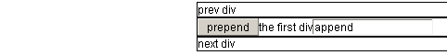

Attributes and CSS
Input:
var node;
linb('body').append(node=linb.create('div'));

node.html('content<input value="ini">');

_.asyRun(function(){
node.css('border','solid 1px');
},1000);

_.asyRun(function(){
linb.message(node.css('fontSize'))
node.css({background:'#00ff00',fontSize:'16px'});
},2000);

_.asyRun(function(){
node.attr('style','border:none;font-size:18px;')
},3000);

_.asyRun(function(){
linb.message(node.last().attr('value'))
node.last().attr('value','updated');
},4000);
Sets contents
Updated input’s value attr
Gets CSS fontSize
Updates all style
Updates fontSize and backgorund
Updates CSS border
Gets input’ value attr

className
There are five function to handle CSS className:
- hasClass: Determines whether a specified class exists or not
- addClass: Adds classes to the current DOM nodes
- removeClass: Removes classes from the current DOM nodes
- replaceClass: Replaces classes for the current DOM nodes
- tagClass: Adds/Removes a tag to all classes of the current DOM nodes
var node;
linb('body').append(node=linb.create('div'));

_.asyRun(function(){
node.addClass("cls1 cls2 cls3");
linb.message(node.hasClass('cls2'));
node.text(node.attr('className'));
},1000);

_.asyRun(function(){
node.removeClass("cls2");
node.text(node.attr('className'));
},2000);

_.asyRun(function(){
node.replaceClass(/cls/g,"class");
node.text(node.attr('className'));
},3000);

_.asyRun(function(){
node.tagClass("-mouseover",true);
node.text(node.attr('className'));
},4000);

_.asyRun(function(){
node.tagClass("-mouseover",false);
node.text(node.attr('className'));
},6000);
Adds classes
Remove tag
Removes
Modifies
Determines whether a class name exists or not
Adds tag

Dom events
There are three groups of event functions are designed for a DOM event in jsLinb: [before-], [on-] and [after-].
- linb(/**/).onClick([function], ‘label’) => adds the [function] to [onclick]group;
- linb(/**/).onClick([function]) => removes all event functions in [onclick] group, and adds the [function] to [onclick] group;
- linb(/**/).onClick(null, ‘label’) => removes the event function labeled with ‘label’ from the [onclick] group;
- linb(/**/).onClick(null) => removes all event functions in [onclick] group;
- linb(/**/).onClick(null,null,true) => removes all event functions in [beforeclick] group, [onclick] group and [afterclick] group;
- linb(/**/).onClick() => fire event, executes all event functions in [onclick] group in order. If any of those functions returns [false], the remaining functions will be ignored;
- linb(/**/).onClick(true) => fire event, executes all event functions in [beforeclick] group, [onclick] group and [afterclick] group in order;
var node;
linb('body').append(node=linb.create("<button>click me</button>"));

node.onClick(function(){
alert('onClick');
return false;
})
.beforeClick(function(){
alert('beforeClick');
})
.afterClick(function(){
alert('afterClick');
});

node.onClick(true);

_.asyRun(function(){
node.onClick(null);
node.onClick(true);
},2000);
Adds a onClick event
Fires all click events. Since onClick returns false, afterClick will not be fired.
Removes onClick event;
Adds a beforeClick event
Adds an afterClick event
Fires all click events. Since onClick was removed, afterClick will be fired this time.

Node Drag&Drop
Input:
var btn,div;
linb('body').append(btn=linb.create("<button>drag me</button>"))
.append(div=linb.create("<div style='position:absolute;left:100px;top:100px;border:solid 1px;width:150px; height:150px;display:block;'> drop here </button>"))

btn.draggable(true,{dragType:'icon'},'dragkey','dragdata');
div.droppable(true,'dragkey')
.onDrop(function(){
linb.alert(linb.DragDrop.getProfile().dragData);
});
Sets draggable
Sets droppable
onDrop event
Output:
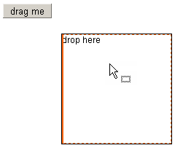

Drag&Drop profile
The “draggable” function’s second parameter is Drag&Drop profile object. It’s a key/value pairs. In dragging process, the Drag&Drop profile object can be got by linb.DragDrop.getProfile(). The profile object:
- dragType: ‘move’,’copy’,’deep_copy’,’shape’,’icon’, ‘blank’ or ‘none’, Default is ‘shape’;
- shadowFrom: DOM element or linb.Dom Object. It’s valid when dragType==‘icon’;
- targetReposition: Boolean, does dd reset the target position, Default is [true];
- dragIcon: String, the drag icon image path, Default is [linb.ini.path+’ondrag.gif’];
- magneticDistance: Number, the magnetic distance, Default is 0;
- xMagneticLines: Array of Number, the magnetic line values in horizontal dir, Default is [];
- yMagneticLines: Array of Number, the magnetic line values in vertical dir, Default is [];
- widthIncrement: Number, the width increment in horizontal dir, Default is 0;
- heightIncrement: Number, the height increment in vertical dir, Default is 0;
- dragDefer: Number, when [linb.DragDrop.startDrag] is called, the real drag action will be triggered after [document.onmousemove] runs [dragDefer] times, Default is 0;
- horizontalOnly:Boolean, drag horizontal dir only, Default is [false];
- verticalOnly: Boolean, drag vertical dir only, Default is [false];
- maxBottomOffset</strong>:Number, the offset between [the restricted bottom] and [the current mouse Y], for mouse restricted region, Default is [null];
- maxLeftOffset</strong>:Number, the offset between [the restricted left] and [the current mouse X], for mouse restricted region, Default is [null];
- maxRightOffset</strong>:Number, the offset between [the restricted right] and [the current mouse X], for mouse restricted region, Default is [null];
- maxTopOffset: Number, the offset between [the restricted top] and [the current mouse Y], for mouse restricted region, Default is [null];
- targetNode: DOM element or linb.Dom Object, the drag target node;
- targetCSS: Number, the drag target node’s CSS key/value Object, Default is [null];
- dragKey: String, the drag key, Default is [null];
- dragData: Object, the drag data, Default is [null];
- targetLeft: Number, the drag target node’s CSS left, Default is [null];
- targetTop: Number, the drag target node’s CSS top, Default is [null];
- targetWidth: Number, the drag target node’s CSS width, Default is [null];
- targetHeight: Number, the drag target node’s CSS height, Default is [null];
- targetOffsetParent: linb.Dom Object, the drag target node offsetParent node, Default is [null];
- dragCursor: ‘none’, ‘move’, ‘link’, or ‘add’, the drag cursor key; [readonly]
- x: Number, current X value of mouse; [readonly]
- y: Number, current Y value of mouse; [readonly]
- ox: Number, original X value of mouse; [readonly]
- oy: Number, original Y value of mouse; [readonly]
- curPos: {left:Number,top:Number}, current CSS pos of the dragging node [readonly]
- offset: {x:Number,y:Number}, offset from now to origin [readonly]
- isWorking: Boolean, is dd working or not? [readonly]
- restrictedLeft: Number, the calculated restricted left value; [readonly]
- restrictedRight: Number, the calculated restricted right value; [readonly]
- restrictedTop: Number, the calculated restricted top value; [readonly]
- restrictedBottom: Number, the calculated restricted bottom value; [readonly]
- proxyNode: linb.Dom Object, the proxy Object; [readonly]
- dropElement: String, the target drop element DOM id. [readonly]

There is an DD overall example in chapter3/dd/ddProfile.html.
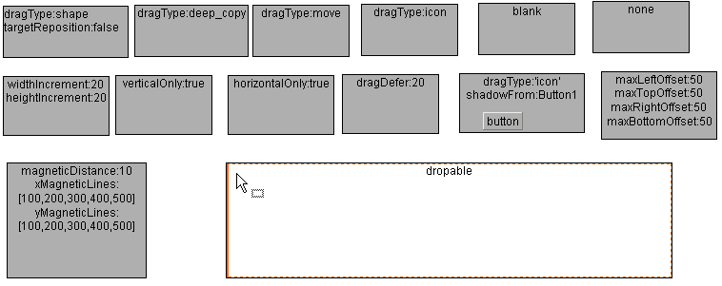

Events in Drag&Drop
For that node in dragging,
- onDragbegin
- onDrag
- onDragstop
For that droppable node,
- onDragenter
- onDragleave
- onDragover
- onDrop

Input:
var btn,div,elist;
linb('body').append(btn=linb.create("<button>drag me</button>"))
.append(div=linb.create("<div style='border:solid 1px;width:100px;height:100px;'>drop here</button>"))

linb('body').append(elist=linb.create('<div style="position:absolute;left:140px;top:40px;width:600px;height:400px;overflow:auto;"></div>'))

btn.dragable(true,{dragType:'icon'},'dragkey','dragdata')
.onDragbegin(function(){
elist.append('<strong>onDragbegin </strong>');
})
.onDrag(function(){
elist.append('<em>onDrag </em>');
})
.onDragstop(function(){
elist.append('<strong>onDragend </strong>');
})

div.dropable(true,'dragkey')
.onDragenter(function(){
elist.append('<strong>onDragenter </strong>');
})
.onDragover(function(){
elist.append('<em>onDragover </em>');
})
.onDragleave(function(){
elist.append('<strong>onDragleave </strong>');
})
.onDrop(function(){
elist.append('<strong>onDrop </strong>');
});
Output:
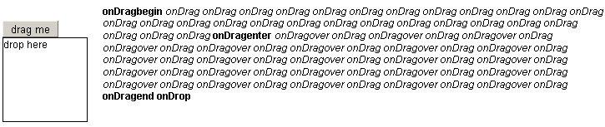

linb.Template
Linb.Template is a completely independent UI wrapper. It doesn’t depend on linb.UI Class and all its derived Classes.

example 1
linb.Template includes three aspects: template, properties and events:
Input:
var tpl=new linb.Template;
tpl.setTemplate("<div [event]>{con}</div>")
//tpl.setTemplate({root:"<div [event]>{con}</div>"})
.setProperties({
con:'click me'
})
.setEvents({
root:{
onClick:function(){
linb.alert('Hi');
}
}
})
.show()
Sets template
Sets properties
Sets events
For event
Output:
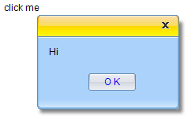

example 2
Input:
(tpl=new linb.Template)
.setTemplate({
root : "<div style='width:200px;border:solid 1px;'><h3>{head}</h3><ul>{items}</ul><div style='clear:both;'></div></div>",
items: "<li [event] style='padding:4px;border-top:dashed 1px;'><div ><div><a href='{href}'><img src='{src}'/><p>{price}</p></a></div></div><div><a href='{href}'><h4>{title}</h4><div>{desc}</div></a></div></li>"
})
.setEvents({
items:{
onMouseover:function(profile,e,src){
linb.use(src).css('backgroundColor','#EEE');
//Tips
var item=profile.getItem(src),
tpl=new linb.Template({"root":"<div style='text-align:center;border:solid 1px;background:#fff;'><h4>{title}</h4></div><p>{desc}</p>"},item),
html=tpl.toHtml();
linb.Tips.show(linb.Event.getPos(e),html);
},
onMouseout:function(profile,e,src){
linb(src).css('backgroundColor','transparent');
linb.Tips.hide();
}
}
})
.setProperties({
head:"On sale products",
items:[{ id:"a", href:"#", price:"$ 18.99", title:"product #0", desc:"product #0 is on sale now!" },
{id:"b", href:"#", price:"$ 23.99", title:"product #1", desc:"product #1 is on sale now!" },
{id:"c", href:"#", price:"$ 23.99", title:"product #2", desc:"product #2 is on sale now!" }]
})
.show()
Sets events in “items”
Sub template exists
Here, “root” key is a must
Sets properties in “root”
Sets properties in “items”

Output:
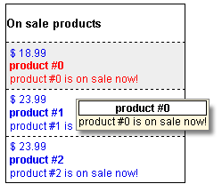

A SButton based on linb.Template
“chapter5\SButton” is an example for creating a linb.UI.SButton like control based on linb.Template.
Output:
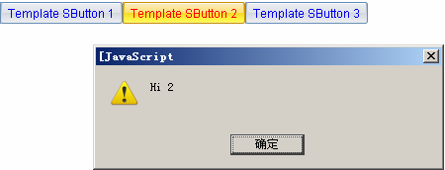

About Debugging

The code package for debugging
In folder “runtime/jsLinb/js/”, All files ending with ”-debug.js” are for debugging purpose.
For debugging

For debugging

Debugging Tools
You can use Firebug in Firefox, developer tool in IE8, chrome or opera10 to debug JavaScript.
FireBug:
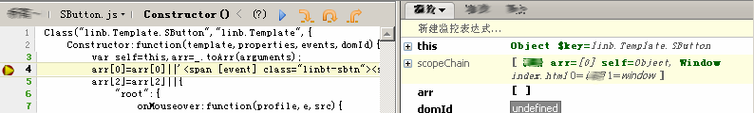
Developer Tools in IE8:
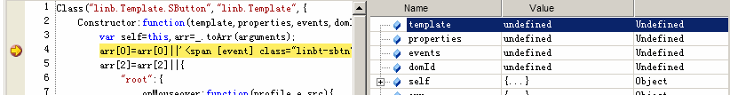

jsLinb Monitor Tools
jsLinb has a variable monitor tools. It’s cross browser. Call linb.log(“xxx”) to show the monitor window:
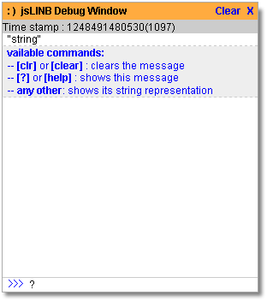

Some typical issues

Layout

Docking
Input:
linb.create('Block',{dock:"top",
height:80,html:'top'
}).show();
linb.create('Block',{dock:"bottom",
height:30,html:'bottom'
}).show();
linb.create('Block',{dock:"left",
width:150,html:'left'
}).show();
linb.create('Block',{dock:"right",
width:150,html:'right'
}).show();
linb.create('Block',{dock:"fill",
html:'main',
dockMargin:{left:10,right:10,top:10,bottom:10}
}).show();
The main area
At top
At bottom
Left side
Right side
Sets docking margin
Output:
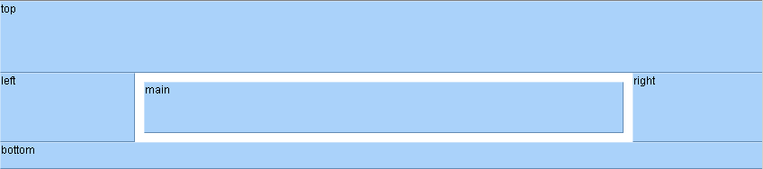

linb.UI.Layout
Input:
var layout1=linb.create('Layout',{type:'vertical',
items:[{
pos:'before',
id:'top',
size:80
},{
pos:'after',
id:'bottom',
size:30
}]
}).show();

linb.create('Layout',{type:'horizontal',
items:[{
pos:'before',
id:'top',
size:150
},{
pos:'after',
id:'bottom',
size:150
}]
}).show(layout1);
Vertial layout
At top
At bottom
Left side
Right side
Horizontal layout
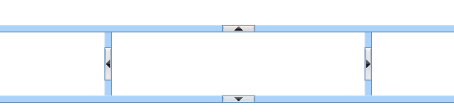
Drag&Drop to resize

Relative Layout
Input:
linb.create('Pane',{position:'relative',
width:"auto",height:80,html:"the top div"
})
.setCustomStyle({"KEY":"border:solid 1px #888"})
.show()

var pane=linb.create('Pane',{position:'relative',
width:"auto",height:"auto",
html:"<strong>auto height</strong>"
})
.setCustomStyle({"KEY":"border:solid 1px #888"})
.show()

linb.create('Pane',{position:'relative',
width:"auto",height:100,
html:"<strong>bottom</strong>"
})
.setCustomStyle({"KEY":"border:solid 1px #888"})
.show()

linb.create("SButton")
.setLeft(140)
.setTop(30)
.setCaption("Add content")
.onClick(function(){
pane.append(linb.create("Pane").setPosition("relative").setHeight(30).append("Input"))
})
.show()
At top
Middle
At bottom
Adds contents
Output:
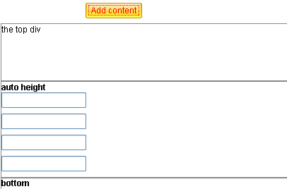
Automatic growth

UI Control’s Drag&Drop

Drag&Drop control among containers
Input:
var panel1=linb.create('Panel',{position:'relative', dock:'none',width:150}).show();
var panel2=linb.create('Panel',{position:'relative', dock:'none',width:150}).show();
var btn=linb.create('Button',{left:10,top:10}).show(panel1);
var onDrop=function (profile, e, node, key, data) {
var dd = linb.DragDrop.getProfile(), data = dd.dragData;
if(data){
var btn=linb.getObject(data);
profile.boxing().append(btn.boxing());
}
};

btn.draggable('iAny',btn.get(0).getId(),null,{shadowFrom:btn.getRoot()});
panel1.setDropKeys('iAny').onDrop(onDrop);
panel2.setDropKeys('iAny').onDrop(onDrop);
Sets onDrop function
Sets draggable
Sets droppable
Output:
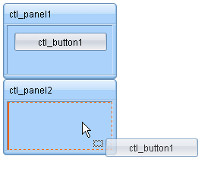

List sorting 1
Input:
linb.create("List",{
items:["item a","item b","item c","item d"]
})
.setDragKey("list")
.setDropKeys("list")
.show()
Sets drag key and drop keys.
Output:
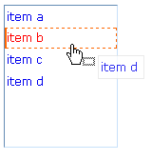

List sorting 2
Input:
linb.create("List",{
items:["item a","item b","item c","item d"]
})
.setDragKey("list")
.setDropKeys("list")
.onDropMarkShow(function(profile,e,src,key,data,item){
if(item){
linb.DragDrop.setDragIcon('move');
linb.DragDrop.setDropFace(null);
profile.getSubNodeByItemId('ITEM',item.id).css('borderTop','dashed 1px');
return false;
}
})
.onDropMarkClear(function(profile,e,src,key,data,item){
if(item){
linb.DragDrop.setDragIcon('none');
profile.getSubNodeByItemId('ITEM',item.id).css('borderTop','');
return false;
}
})
.show()
Custom appearance
Sets drag key and drop keys
Restores appearance
Output:
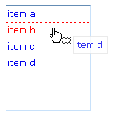

Form

Form 1
Input:
Class.destroy('App');
Class('App', 'linb.Com',{
Instance:{
iniComponents:function(){
// [[code created by jsLinb UI Builder
var host=this, children=[], append=function(child){children.push(child.get(0))};
append((new linb.UI.SLabel)
.setHost(host,"slabel1").setLeft(80).setTop(60).setWidth(44).setCaption("Name:") );
append((new linb.UI.SLabel)
. setHost(host,"slabel2").setLeft(80).setTop(90).setCaption("Age:").setWidth(44));
append((new linb.UI.Input)
.setHost(host,"iName").setLeft(130).setTop(60).setValueFormat("[^.*]").setValue("Jack"));
append((new linb.UI.ComboInput)
.setHost(host,"iAge").setLeft(130).setTop(90).setType("spin").setIncrement(1).setMin(20).setMax(60).setValue("35"));
append((new linb.UI.SCheckBox)
.setHost(host,"cFull").setLeft(130).setTop(130).setCaption("Full time"));
append((new linb.UI.SButton)
.setHost(host,"submit").setLeft(130).setTop(170).setCaption("SUBMIT").onClick("_submit_onclick"));
return children;
// ]]code created by jsLinb UI Builder
},
_submit_onclick:function (profile, e, src, value) {
if(!this.iName.checkValid()){
linb.alert('You must specify Name');
return;
}
var name=this.iName.updateValue().getValue(), age=this.iAge.updateValue().getValue(),
full=this.cFull.updateValue().getValue();
linb.alert(_.serialize({name:name,age:age,full:full}))
}}
});
(new App).show();
Form validation

Code created by Designer
event
Collects data
Output:
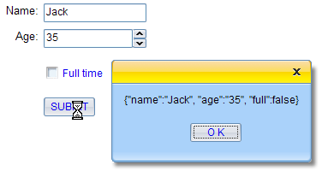

DataBinder
Input:
Class.destroy('App');
Class('App', 'linb.Com',{
Instance:{
iniComponents:function(){
// [[code created by jsLinb UI Builder
var host=this, children=[], append=function(child){children.push(child.get(0))};
append((new linb.DataBinder).setHost(host,"binder").setName("binder"))
append((new linb.UI.SLabel)
.setHost(host,"slabel1").setLeft(80).setTop(60).setWidth(44).setCaption("Name:") );
append((new linb.UI.SLabel)
.setHost(host,"slabel2").setLeft(80).setTop(90).setCaption("Age:").setWidth(44));
append((new linb.UI.Input) .setDataBinder("binder").setDataField("name")
.setHost(host,"iName").setLeft(130).setTop(60).setValueFormat("[^.*]").setValue("Jack"));
append((new linb.UI.ComboInput) .setDataBinder("binder").setDataField("age")
.setHost(host,"iAge").setLeft(130).setTop(90).setType("spin").setIncrement(1).setMin(20).setMax(60).setValue("35"));
append((new linb.UI.SCheckBox) .setDataBinder("binder").setDataField("isfull")
.setHost(host,"cFull").setLeft(130).setTop(130).setCaption("Full time"));
append((new linb.UI.SButton)
.setHost(host,"submit").setLeft(130).setTop(170).setCaption("SUBMIT").onClick("_submit_onclick"));
return children;
// ]]code created by jsLinb UI Builder
},
_submit_onclick:function (profile, e, src, value) {
if(!this.binder.checkValid()){
linb.alert('One or some invalid fields exits!');
return;
}
linb.alert(_.serialize(this.binder.getValue()))
}}
});
(new App).show();
Form validation
Code created by Designer

Sets dataBinder and dataField to each control
Collects data

Adds a DataBinder, sets name property
Output:
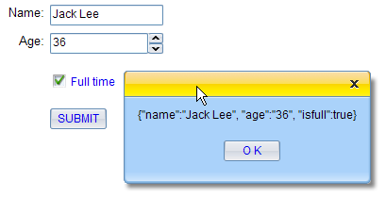
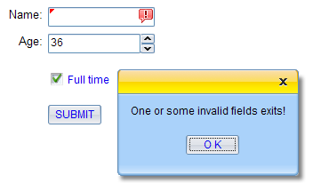

Custom UI Styles

Custom only one instance only - 1
Input:
linb.CSS.remove("id","my_css");
linb.CSS.addStyleSheet(".linb-sbutton-custom-focus{font-weight:bold;color:#ff0000;}", "my_css");

(new linb.UI.SButton)
.setCaption("Use setCustomClass ")
.setTheme ("custom")
.show();
Sets theme to this instance
Adds CSS. You should put those into a CSS file in your real application
Theme key words
Output:

Custom only one instance only - 2
Input:
(new linb.UI.SButton)
.setCaption("Use setCustomStyle")
.setCustomStyle({
FOCUS:"font-weight:bold;color:#ff0000;"
})
.show();
Custom FOCUS node style
Output:

Custom only one instance only - 3
Input:
linb.CSS.remove("id","my_css");
linb.CSS.addStyleSheet(".my-class{font-weight:bold;color:#ff0000;}", "my_css");

(new linb.UI.SButton)
.setCaption("Use setCustomClass ")
.setCustomClass({
FOCUS:"my-class"
})
.show();
Custom FOCUS node className

Adds CSS. You should put those into a CSS file in your real application

Output:

Custom only one instance only - 4
Input:
linb.CSS.remove("id","my_css");
linb.CSS.addStyleSheet("#myctrl1 .linb-sbutton-focus{font-weight:bold;color:#ff0000;}", "my_css");

(new linb.UI.SButton)
.setCaption("Use domId")
.setDomId("myctrl1")
.show();
Gives a domId
Adds CSS. You should put those into a CSS file in your real application

Output:

Custom only one instance only - 5
Input:
(new linb.UI.SButton)
.setCaption("Use getSubNode and css ")
.onRender(function(profile){
profile.getSubNode('FOCUS').css({
fontWeight:'bold',
color:'#ff0000'
});
})
.show()
After it was rendered into DOM
Output:

Custom only one instance only - 6
Input:
linb.CSS.remove("id","my_css");
linb.CSS.addStyleSheet(".my-listitem{font-weight:bold;color:#ff0000;}", "my_css");

linb.create('List',{items:[{
id:"item 1",
itemStyle:"border:dashed 1px #00ff00;margin:2px;"
},{
id:"item 2",
itemStyle:"border:dashed 1px #0000ff;margin:4px;"
},{
id:"item 3",
itemClass:"my-listitem"
}]}).show()
Adds CSS. You should put those into a CSS file in your real application

Output:
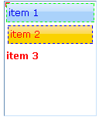

Custom style for an UI Class
Input:
linb.CSS.remove("id","my_css");
linb.CSS.addStyleSheet(".linb-sbutton-focus{font-weight:bold;color:#ff0000;}", "my_css");

(new linb.UI.SButton({position:'relative'})).show();
(new linb.UI.SButton({position:'relative'})).show();
(new linb.UI.SButton({position:'relative'})).show();
(new linb.UI.SButton({position:'relative'})).show();
(new linb.UI.SButton({position:'relative'})).show();
All instances were changed
Adds CSS. You should put those into a CSS file in your real application

Output:

Custom style for all UI Class - skin
There are three system skins in jsLinb3.0: default, vista and aqua. You can use linb.UI.setTheme to switch the skin. You can also add your own custom skin easily. Only two steps:

First: Copy
All skins are in “runtime/jsLinb/appearance”, you can create an new folder (e.g. ‘myskin’), and copy all directories and files in an existing skin folder to it.
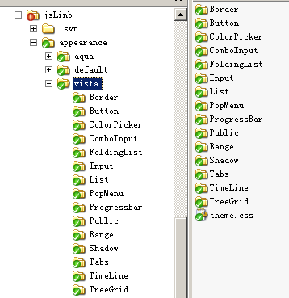
A skin folder
Skin pictures
Skin CSS file
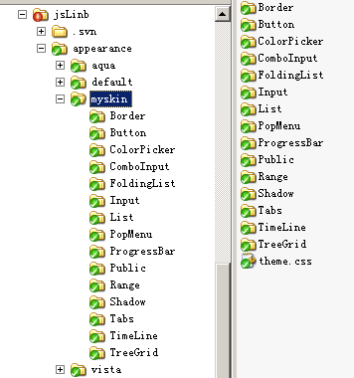
From vista folder

Second: Little by little, modify pictures and CSS
For example, we modifies corner.gif file in Button folder.

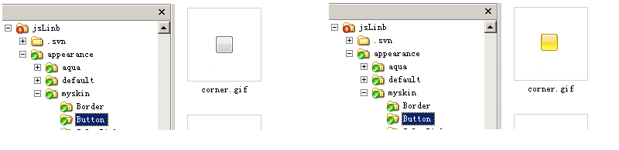
After that,
Input:
linb.create('Button').show();
_.asyRun(function(){
linb.UI.setTheme('myskin')
},2000);
Output:
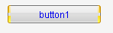

The end
linb
2010-7-21
All rights reserved.

