CT3008 – Programming Principles

Connor Weyman
S4511134
CT3008 – programming principles
Dr Patrick Tobin
09/01/2026

Contents
Introduction 1
Conceptual Overview 1
System Design 2
Testing and Results 3
Evaluation and Limitations 3
References 4
Appendices 4

Introduction
This report contains the design and implementation of a Python-based word game based on Wordle. The program allows users six attempts to guess the randomly selected five-letter word and provides feedback after each attempt. This report discusses the program design, data structures used, implementations of decisions, testing, and limitations.

Conceptual Overview
In Wordle a player’s task is to identify a hidden five-letter word within a fixed number of attempts, using feedback from previous guesses to refine future inputs (New York Times, 2025). The game’s mechanics rely on systematic comparison between a guessed word and a target word, making it well suited to demonstrate core programming principles.
From a programming perspective, the target word and the player’s guesses can be stored in an array or list. The program can determine whether a guessed letter is correct, misplaced, or incorrect by comparing the two words/letters, that allow each character to be compared position by position. Conditional logic controls the feedback given after each guess, while iterative constructs manage the limited number of attempts.

System Design
The Wordle-based game was implemented within Python using a modular, function-based design to improve readability, maintainability, and logical separation of tasks. The program makes use of the ‘random’ module, to support random word selection.
A pre-defined word bank is loaded from an external text file ‘words.txt’ using the ‘load_words()’ function. This function filters the list of words in the text file to include only words that are five letters long and use the Latin alphabet. (appendix 1)
A random word target is selected at the start of each game using the ‘wordle()’ function, which chooses a word from the validated list. Player interaction is handled within the ‘play_game()’ function, which controls the main game loop and enforces the six-guess limit specified in the assignment brief. (appendix 2)
Letter comparison logic is implemented in the ‘letter_hint()’ function. This function uses a two-pass algorithm to correctly apply Wordle rules. The first pass identifies letters in the correct position and marks them as green. The second pass checks for correct letters in incorrect positions, marking them as yellow while ensuring duplicate letters are handled correctly by removing matched letters from a temporary list. Letters not present in the target word are displayed in grey. ANSI escape codes are used to visually distinguish letter states in the terminal. (appendix 3)
Input validation ensures that guesses are exactly five letters long and exist within the word bank. The game terminates when the player either guesses the word correctly or exhausts all attempts, at which point the correct word is revealed. A replay loop allows multiple games to be played without restarting the program. (appendix 4)
The modular structure of the system allows individual components to be developed, tested, and modified independently. Separating responsibilities into functions such as word loading, game control, and letter comparison improves readability and reduces complexity within the codebase. This design choice also supports easier debugging, as faults can be isolated to specific functional areas.
By loading the word bank from an external file it improves flexibility and scalability. Changes to the word list can be made without altering the program logic, demonstrating effective separation of data and functionality. This approach also allows the system to be extended easily in the future, for example increasing the size of the word bank.

Testing and Results
Testing was conducted to verify that the program functions correctly. A manual testing approach was adopted, focusing on function and input validation testing. This method was considered appropriate given the limited scope and interactive nature of the program.
Several test cases were used to test the core features of the program. These included validating correct and incorrect guesses, enforcing the six-attempt limit, and confirming that only valid five-letter words from the predefined word bank were accepted. Testing confirmed that the program correctly rejected invalid inputs, such as words of incorrect length or words that are not present in the word bank, without reducing the number of available attempts to the user.
Additional testing focused on the letter comparison logic, particularly in scenarios involving repeated letters. Results showed that the system correctly identified letters in the correct position and letters that were present but misplaced, while preventing duplicate letters from being highlighted more times than they appear in the target word. This behaviour aligns with the rules of the original Wordle game (New York Times, 2025).
Overall, testing demonstrated that the system consistently produced accurate feedback and behaved as expected across multiple playthroughs. All key functional requirements were met, and the results indicated that the implementation is reliable. Results from testing can be seen in: Appendix 5 and Appendix 6

Evaluation and Limitations
The program meets the core requirements of the assignment by providing a functional Wordle-style game that accurately processes user guesses and provides appropriate feedback. The system demonstrates effective use of fundamental programming concepts, including arrays, iteration, and conditional logic, and maintains consistent behaviour across multiple playthroughs.
One of the strengths of the implementation is its clear and modular structure, which improves readability and simplifies maintenance. Input validation ensures that only valid five-letter words are accepted, improving robustness and preventing runtime errors.
However, several limitations are acknowledged. The word bank is intentionally small which may reduce replayability and does not fully reflect the complexity of a real-world dictionary. The game is also limited to a text-based interface, which restricts visual clarity compared to a graphical user interface implementation. Furthermore, automated testing was not implemented, with reliance placed on manual testing instead.
Despite these limitations, the system fulfils the assignment objectives and provides a solid foundation for future enhancements, such as expanding the word list, introducing automated testing, or implementing a graphical user interface.

References
New York Times (2025) Wordle. Available at: https://www.nytimes.com/games/wordle/index.html (Accessed: 21 December 2025).

Appendices
Appendix 1
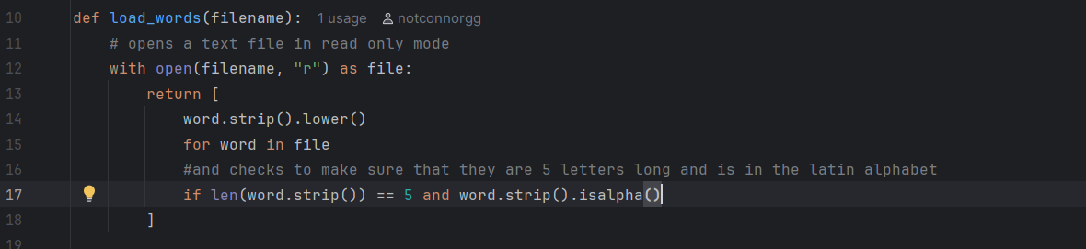
Appendix 2
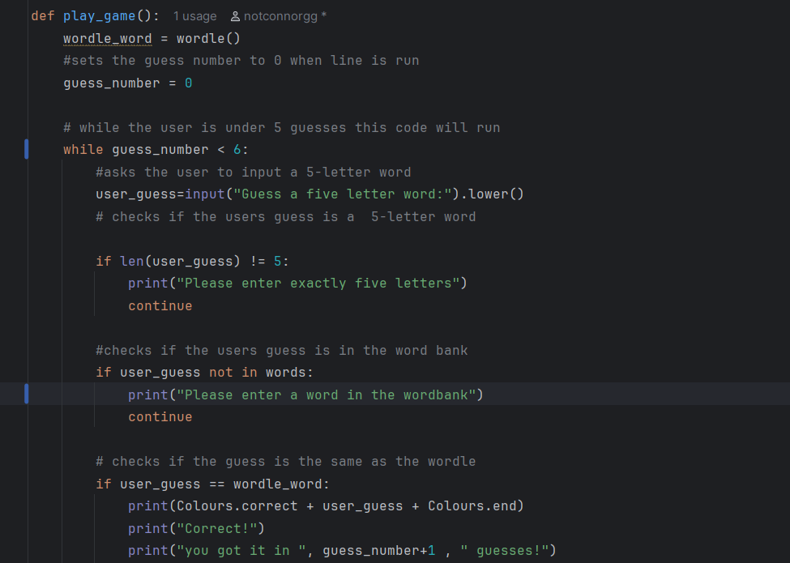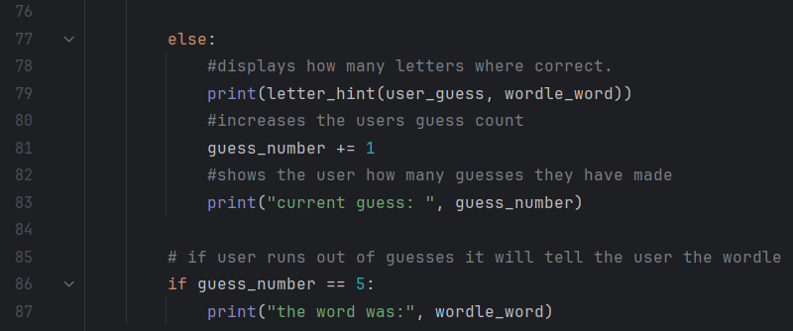
Appendix 3
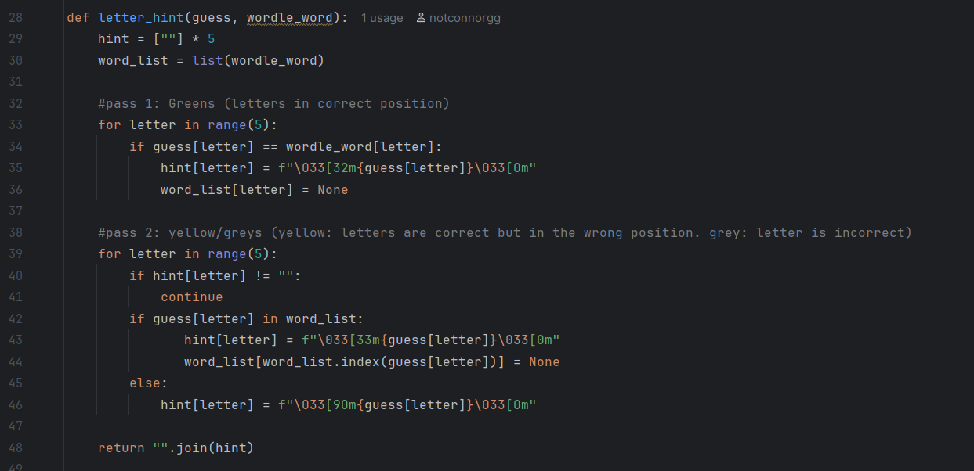
Appendix 4
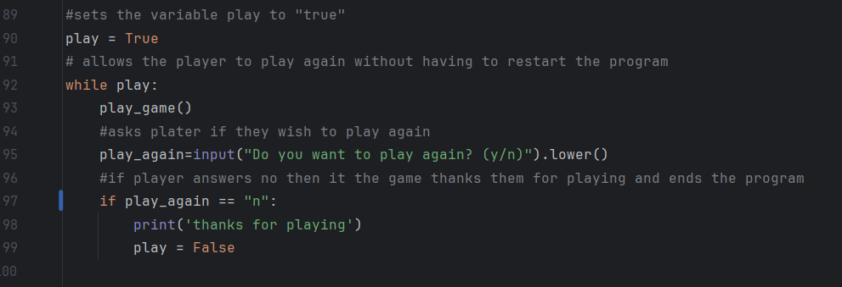
Appendix 5
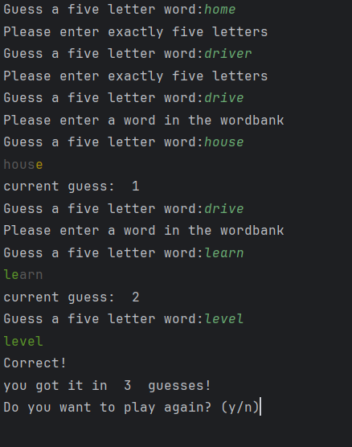
Appendix 6
