**EXPERIMENT NO: 1**

**TITLE:** To analyze the forward and reverse characteristics of P-N junction diode.

**OBJECTIVES:**

* To study V-I characteristics of the P-N junction diode.
* To draw V-I characteristics curve.

**EQUIPMENT REQUIRED:**

* P-N junction diode
* Multimeter as voltmeter
* Multimeter as ammeter
* Connecting wires

**THEORY:**

A PN-junction diode is formed when a p-type semiconductor is fused to an n-type semiconductor creating a potential barrier voltage across the diode junction. The p-side or the positive side of the semiconductor has an excess of holes, and the n-side or the negative side has an excess of electrons. The process of doping is explained in further detail in the next section.

**Forward Bias:**

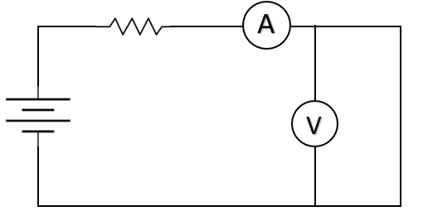The p-n junction is said to be forward-biased when the p-type is connected to the positive terminal of the battery and the n-type to the negative terminal. The built-in electric field at the p-n junction and the applied electric field are in opposing directions when the p-n junction is forward biased.

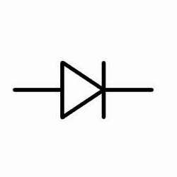

**Reverse Bias:**

The p-n junction is said to be reverse-biased when the p-type is linked to the negative terminal of the battery and the n-type is attached to the positive side. The applied electric D

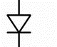

**PROCEDURE:**

* In forward bias, p-type was connected to positive terminal and n-type was connected to negative terminal.
* In reverse bias, p-type was connected to negative terminal and n-type was connected to positive terminal.
* One multimeter as ammeter was connected in series with diode to measure diode current (ID) and another multimeter acting as voltmeter was connected in parallel to diode to measure diode voltage (VD).
* The voltage (Vs) was increased according to the requirement and corresponding readings of the multimeters were noted.
* Graph of VD vs ID was plotted based on the readings taken.

**OBSERVATION TABLE:**

|  |  |  |  |  |  |  |
| --- | --- | --- | --- | --- | --- | --- |
| **S.N.** | **FORWARD BIAS** | | | **REVERSE BIAS** | | |
| **VS** | **VD (V)** | **ID (mA)** | **VS** | **VD (V)** | **ID (µA)** |
| 1. | 0.5 | 0.41 | 0.068 | 5 | 5 | 0 |
| 2. | 1 | 0.50 | 0.454 | 10 | 10 | 0 |
| 3. | 2 | 0.55 | 1.295 | 15 | 15 | 0 |
| 4. | 5 | 0.61 | 3.41 | 20 | 20 | 1 |
| 5. | 8 | 0.65 | 7 | 25 | 25 | 1 |
| 6. | 12 | 0.67 | 10.94 | 30 | 30 | 2 |
| 7. | 18 | 0.70 | 16.78 |  |  |  |
| 8. | 30 | 0.73 | 28.8 |  |  |  |

**GRAPH:**

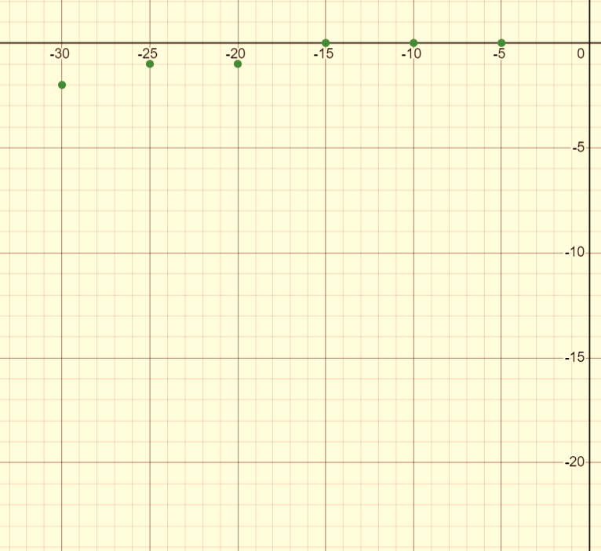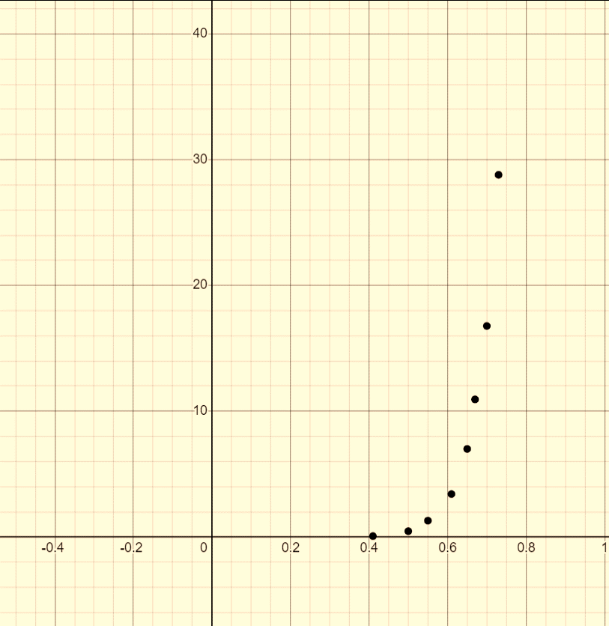

ID (µA)

VD (V)

ID (mA)

VD (V)

**Forward Characteristics Reverse Characteristics**

**RESULT AND CONCLUSION:**

Therefore, the forward bias characteristics and reverse bias characteristics of PN junction diode was studied. In forward bias, as the applied voltage increased gradually, the current also increased slowly until potential barrier overcame. After that, the current increased rapidly. In reverse bias, as the applied voltage increased, the current increased very slowly and then for a particular high value of reverse voltage the junction may breakdown with sudden rise in reverse current.

**PRECAUTIONS:**

* The reading should be noted carefully.
* The connections must be done accordingly.
* The applied voltage shouldn’t be very large.

**EXPERIMENT NO: 2**

**TITLE:** To operate Zener diode as voltage regulator.

**OBJECTIVES:**

* To study voltage regulating characteristics of Zener diode.
* To understand properties of Zener diode.

**EQUIPMENT REQUIRED:**

* Zener diode
* Multimeter as voltmeter
* Multimeter as ammeter
* Connecting wires
* Load Resistor

**THEORY:**

A Zener Diode, also referred to as a breakdown diode, is a specially doped semiconductor device engineered to function in the reverse direction. When the voltage across a Zener diode’s terminals is reversed and reaches the Zener Voltage (also known as the knee voltage), the junction experiences a breakdown, allowing current to flow in the opposite direction.

A Zener diode functions similarly to a regular diode when forward-biased. However, in reverse-biased mode, a small leakage current flows through the diode. As the reverse voltage increases and reaches the predetermined breakdown voltage (Vz), current begins to flow through the diode. This current reaches a maximum level determined by the series resistor, after which it stabilizes and remains constant across a wide range of applied voltages.

**Zener diode as a voltage regulator:**

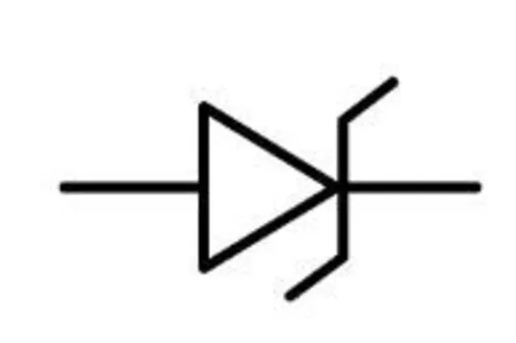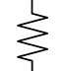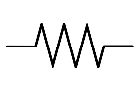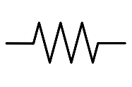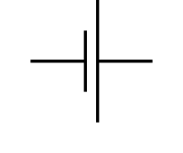The Zener diode is used as a shunt voltage regulator for regulating voltage across small loads. The Zener diode is connected parallel to the load to make it reverse bias, and once the Zener diode exceeds knee voltage, the voltage across the load will become constant. The breakdown voltage of Zener diodes will be constant for a wide range of currents.

IZ

IL

I

30V

RL

Vz

VL

Rs

V

A

A

The total current in the circuit is given by:

**I = IL + IZ**

where,

IL = Current though load

IZ = Current through Zener diode

When the load resistance is varied, current through load resistor also varies accordingly. **IL = V/ RL**

The current through series resistor assuming Zener diode in breakdown region is given as:

**Is = (V- VS) / Rs**

The Zener diode adjusts by increasing/decreasing as required its current to compensate the load current keeping the total current constant.

**IZ = I - IL**

**PROCEDURE:**

* The circuit was connected in reverse bias as shown in the diagram.
* Each ammeter was connected in series with Zener diode and the load to read the current and voltmeter was connected in parallel to Zener diode to measure the voltage.
* The load resistance was slowly decreased as per the requirement and corresponding readings of ammeter and voltmeter was noted, while voltage source was kept constant.

**OBSERVATION TABLE:**

|  |  |  |  |  |  |  |
| --- | --- | --- | --- | --- | --- | --- |
| **S.N.** | **Vs (V)** | **VL (V)** | **IZ (mA)** | **IL (mA)** | **Is (mA)** | **RL (KΩ)** |
| 1. | 30 | 6.38 | 66.3 | 5.8 | 72.1 | 1.1 |
| 2. | 30 | 6.38 | 66.1 | 6.0 | 72.1 | 1 |
| 3. | 30 | 6.38 | 65.6 | 6.5 | 72.1 | 0.9 |
| 4. | 30 | 6.38 | 64.7 | 7.4 | 72.1 | 0.8 |
| 5. | 30 | 6.38 | 63.8 | 8.3 | 72.1 | 0.7 |

**RESULT AND CONCLUSION:**

Hence, when the voltage source is kept fixed and the load resistance was varied for analysis i.e. RL was decreased which increased IL but decreased IZ that makes total current constant. So, the voltage drop across RS was unchanged and hence load voltage was held constant which shows Zener diode as voltage regulator.

**PRECAUTIONS:**

* The reading should be noted carefully.
* The connections must be done accordingly.
* The applied voltage shouldn’t be very large.

**EXPERIMENT NO: 3**

**TITLE:** To analyze the common emitter configuration of BJT.

**OBJECTIVES:**

* To study input and output characteristics of a BJT in CE configuration.
* To draw its characteristics curve.

**EQUIPMENT REQUIRED:**

* Power Supply
* Transistor breadboard
* Connecting wires

**THEORY:**

A Bipolar Junction Transistor (BJT) is a three-terminal semiconductor device that consists of two p-n junctions which are able to amplify or magnify a signal. It is a current controlled device. The three terminals of the BJT are the base, the collector, and the emitter. A signal of a small amplitude applied to the base is available in the amplified form at the collector of the transistor. This is the amplification provided by the BJT.

In common emitter configuration, base is the input terminal, collector is the output terminal and emitter is the common terminal for both input and output. That means the base terminal and common emitter terminal are known as input terminals whereas collector terminal and common emitter terminal are known as output terminals. In CE configuration, the emitter terminal is grounded so the common emitter configuration is also known as grounded emitter configuration.



IC

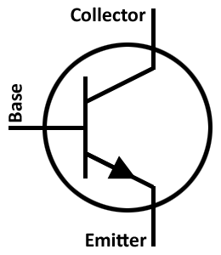

IB

A



V



VCE

F. B

R. B

V

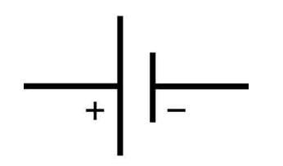

VBE

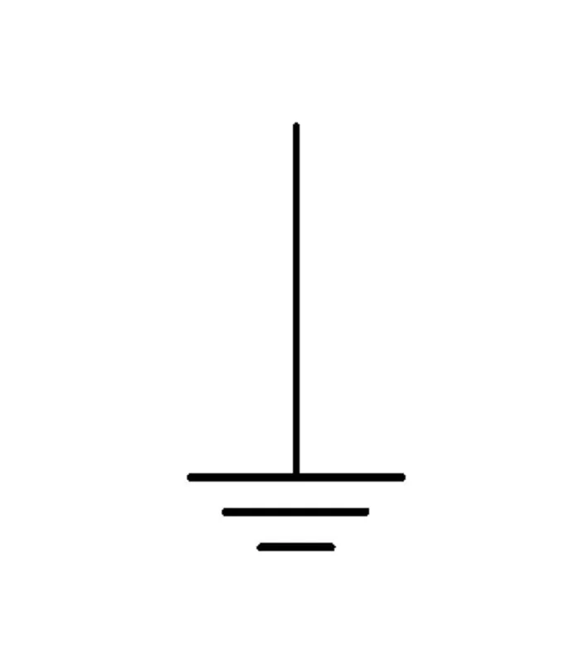

The input signal is applied between the base and emitter terminals while the output signal is taken between the collector and emitter terminals. Thus, the emitter terminal of a transistor is common for both input and output and hence it is named as common emitter configuration.

The supply voltage between base and emitter is denoted by VBE while the supply voltage between collector and emitter is denoted by VCE. Input current or base current is denoted by IB and output current or collector current is denoted by IC.

**Input Characteristics:** The input characteristics describe the relationship between input current or base current (IB) and input voltage or base-emitter voltage (VBE).

**Output Characteristics:** The output characteristics describe the relationship between output current (IC) and output voltage (VCE).

**PROCEDURE:**

* The circuit was connected as shown in the figure.
* To determine the input characteristics, the output voltage VCE was kept constant and the input voltage VBE was increased from 0 V to different voltage levels. For each voltage level of input voltage (VBE), the corresponding input current (IB) was recorded.
* A curve is then drawn between input current IB and input voltage VBE at constant output voltage VCE.
* To determine the output characteristics, the input current or base current IB was kept constant and the output voltage VCE was increased from 0 V to different voltage levels. For each level of output voltage, the corresponding output current (IC) was recorded.
* A curve is then drawn between output current IC and output voltage VCE at constant input current IB.

**OBSERVATION TABLE:**

|  |  |  |  |
| --- | --- | --- | --- |
| **S.N.** | **IB (μA)** | **VCE (V)** | **IC (mA)** |
| 1. | 75 | 0.5 | 4 |
| 1 | 9 |
| 2 | 10 |
| 4 | 10 |
| 2. | 150 | 0.5 | 4 |
| 1 | 10 |
| 2 | 18 |
| 4 | 21 |
| 8 | 21 |

**Input characteristics: Output Characteristics:**

|  |  |  |  |
| --- | --- | --- | --- |
| **S.N.** | **VCE (V)** | **VBE (V)** | **IB (μA)** |
|  | 0 | 0.6 | 80 |
| 0.53 | 45 |
| 0.45 | 25 |
|  | 4 | 0.80 | 160 |
| 0.75 | 125 |
| 0.60 | 30 |
|  | 8 | 0.98 | 220 |
| 0.90 | 145 |
| 0.70 | 35 |

**GRAPH:**

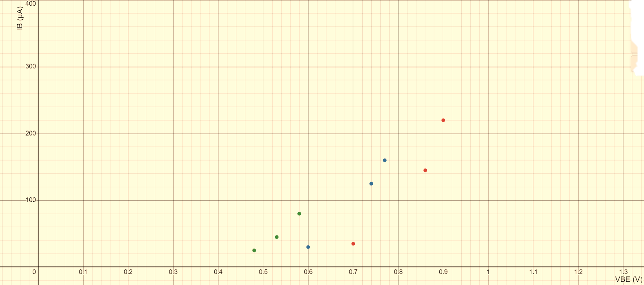

VCE = 8 V

VCE = 0 V

VCE = 4 V

Input characteristics (IB vs VBE)

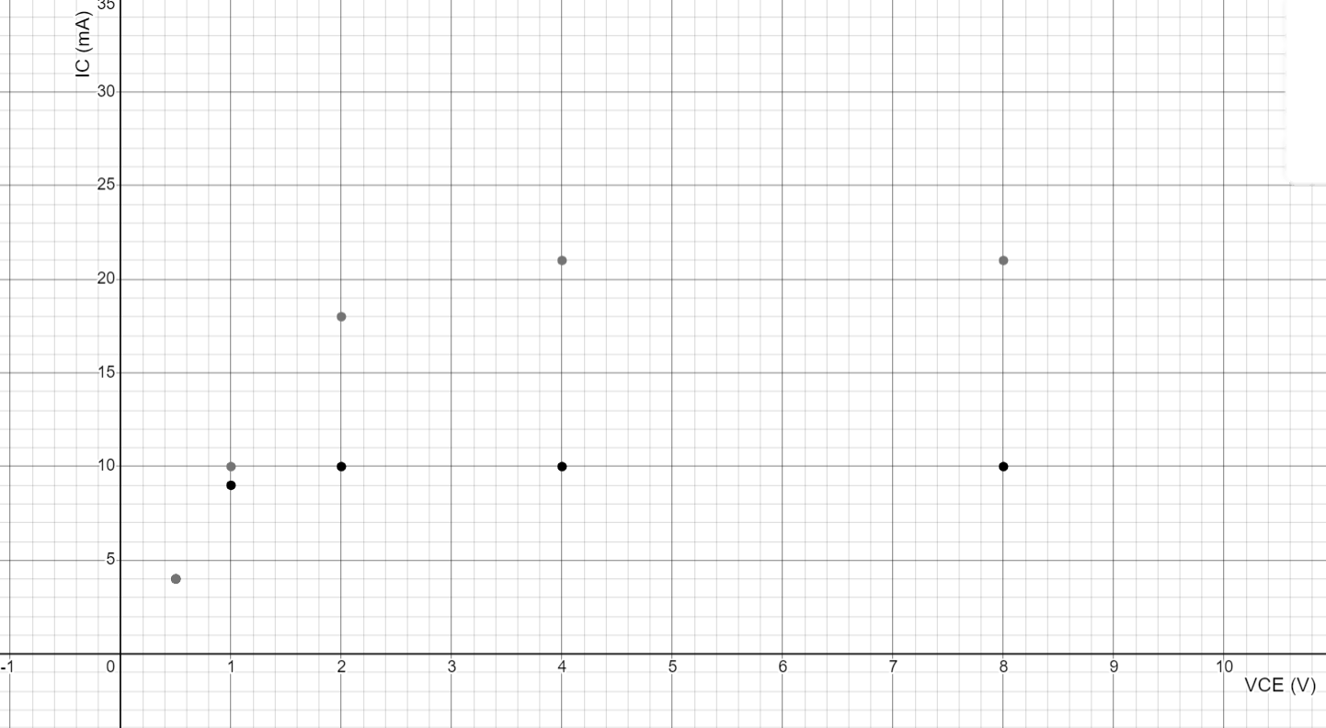

IB = 150 μA

IB = 75 μA

Output Characteristics (IC vs VCE)

**RESULT AND CONCLUSION:**

Hence, for the input characteristics the graph of IB vs VBE was plotted and for the output characteristics the graph of IC vs VCE was plotted. The input and output characteristics of the common emitter configuration of BJT was analyzed.

**PRECAUTIONS:**

* The reading should be noted carefully.
* The connections must be done accordingly.
* The applied voltage shouldn’t be very large.

**EXPERIMENT NO: 4**

**TITLE:** To analyze the common base configuration of BJT.

**OBJECTIVES:**

* To study input and output characteristics of a BJT in CB configuration.
* To draw its characteristics curve.

**EQUIPMENT REQUIRED:**

* Power Supply
* Transistor breadboard
* Connecting wires

**THEORY:**

A Bipolar Junction Transistor (BJT) is a three-terminal semiconductor device that consists of two p-n junctions which are able to amplify or magnify a signal. It is a current controlled device. The three terminals of the BJT are the base, the collector, and the emitter. A signal of a small amplitude applied to the base is available in the amplified form at the collector of the transistor. This is the amplification provided by the BJT.

In common base (CB) configuration, emitter is the input terminal, collector is the output terminal and base terminal is connected as a common terminal for both input and output. That means the emitter terminal and common base terminal are known as input terminals whereas the collector terminal and common base terminal are known as output terminals. In common base configuration, the base terminal is grounded so the common base configuration is also known as grounded base configuration.

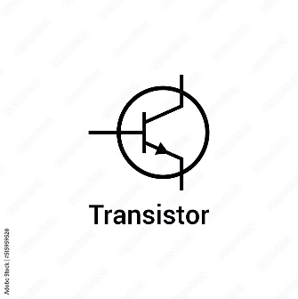

IC

IE

R.B

F.B

V

V

A

A

The input signal is applied between the emitter and base terminals while the corresponding output signal is taken across the collector and base terminals. Thus, the base terminal of a transistor is common for both input and output terminals and hence it is named as common base configuration. The base-emitter junction is forward biased by the supply voltage VBE while the collector-base junction is reverse biased by the supply voltage VCB.

The emitter current is the sum of base current and collector current, i.e. **IE = IB + IC**

**Input Characteristics:** The input characteristics describe the relationship between input current (IE) and the input voltage (VBE).

**Output Characteristics:** The output characteristics describe the relationship between output current (IC) and the output voltage (VCB).

**PROCEDURE:**

* The circuit was connected as shown in the figure.
* To determine the input characteristics, the output voltage VCB (collector-base voltage) was kept constant at 0 V and the input voltage VBE was increased from zero volts to different voltage levels. For each voltage level of the input voltage (VBE), the input current (IE) was recorded.
* A curve was then drawn between input current IE and input voltage VBE at constant output voltage VCB.
* To determine the output characteristics, the input current or emitter current IE was kept constant at zero mA and the output voltage VCB was increased from zero volts to different voltage levels. For each voltage level of the output voltage VCB, the output current (IC) was recorded.
* A curve was then drawn between output current IC and output voltage VCB at constant input current IE.

**OBSERVATION TABLE:**

|  |  |  |  |
| --- | --- | --- | --- |
| **S.N.** | **IE (mA)** | **VCB (V)** | **IC (mA)** |
| 1. | 10 | 0 | 7 |
| 1 | 9 |
| 2 | 10 |
| 2. | 16 | 0 | 8 |
| 1 | 12 |
| 2 | 13 |
| 3. | 20 | 0 | 9 |
| 1 | 17 |
| 2 | 18 |

**Input characteristics: Output Characteristics:**

|  |  |  |  |
| --- | --- | --- | --- |
| **S.N.** | **VCB (V)** | **VBE (V)** | **IE (mA)** |
|  | 0 | 6 | 20 |
| 7 | 28 |
| 8 | 42 |
|  | 2 | 6 | 12 |
| 7 | 19 |
| 8 | 30 |
|  | 4 | 6 | 8 |
| 7 | 12 |
| 8 | 22 |

**GRAPH:**

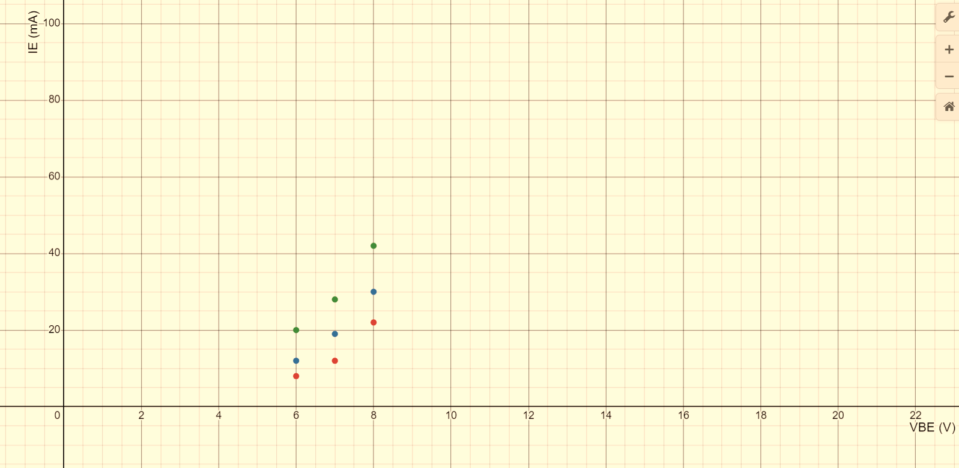

IE (mA)

VCB =2V

VCB =0V

VCB =4V

VBE (V)

Input Characteristics (IE vs VBE)

IC (mA)

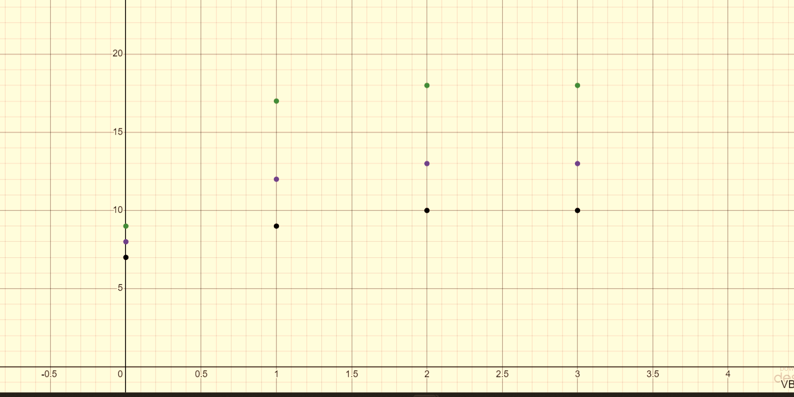

IE = 20 mA

IE = 16 mA

IE = 10 mA

VCB (V)

Output Characteristics (IC vs VCB)

**RESULT AND CONCLUSION:**

Hence, for the input characteristics the graph of IE vs VBE was plotted and for the output characteristics the graph of IC vs VCB was plotted. The input and output characteristics of the common base configuration of BJT was analyzed.

**PRECAUTIONS:**

* The reading should be noted carefully.
* The connections must be done accordingly.
* The applied voltage shouldn’t be very large.

**EXPERIMENT NO: 5**

**TITLE:** To analyze the common collector configuration of BJT.

**OBJECTIVES:**

* To study input and output characteristics of a BJT in CC configuration.
* To draw its characteristics curve.

**EQUIPMENT REQUIRED:**

* Power Supply
* Transistor breadboard
* Connecting wires

**THEORY:**

A Bipolar Junction Transistor (BJT) is a three-terminal semiconductor device that consists of two p-n junctions which are able to amplify or magnify a signal. It is a current controlled device. The three terminals of the BJT are the base, the collector, and the emitter. A signal of a small amplitude applied to the base is available in the amplified form at the collector of the transistor. This is the amplification provided by the BJT.

In this configuration, the base terminal of the [transistor](https://www.physics-and-radio-electronics.com/electronic-devices-and-circuits/transistors/bipolarjunctiontransistor/bipolarjunctiontransistorintroduction.html) serves as the input, the emitter terminal is the output and the collector terminal is common for both input and output. Hence, it is named as common collector configuration. The input is applied between the base and collector while the output is taken from the emitter and collector. In common collector configuration, the collector terminal is grounded so the common collector configuration is also known as grounded collector configuration.

A

IE



IB

A



V



VCE

F. B

R. B

V



VCB

The input supply voltage between base and collector is denoted by VCB while the output voltage between emitter and collector is denoted by VCE. Input [current](https://www.physics-and-radio-electronics.com/electronic-devices-and-circuits/introduction/electriccurrent-howelectriccurrentproduced.html) or base current is denoted by IB and output current or emitter current is denoted by IE. The common collector amplifier has high input impedance and low output impedance. It has low voltage gain and high current gain.

**Input Characteristics:** The input characteristics describe the relationship between input current or base current (IB) and input voltage or base-collector voltage (VCB).

**Output Characteristics:** The output characteristics describe the relationship between output current or emitter current (IE) and output voltage or emitter-collector voltage (VCE).

**PROCEDURE:**

* The circuit was connected as shown in the figure.
* To determine the input characteristics, the output voltage VEC was kept constant and the input voltage VCB was increased from 0V to different voltage levels. For each level of input voltage VCB, the corresponding input current IB was noted.
* A curve was then drawn between input current IB and input voltage VBC at constant output voltage VCE.
* To determine the output characteristics, the input current IB was kept constant at 0 µA and the output voltage VCE was increased from 0 V to different voltage levels. For each level of output voltage VCE, the corresponding output current IE was noted.
* A curve was then drawn between output current IE and output voltage VCE at constant input current IB.

**OBSERVATION TABLE:**

**Input characteristics: Output Characteristics:**

|  |  |  |  |
| --- | --- | --- | --- |
| **S.N.** | **VCE (V)** | **VCB (V)** | **IB (µA)** |
|  | 2 | 0.8 | 28 |
| 0.7 | 116 |
| 0.6 | 220 |
| 0.5 | 330 |
|  | 4 | 1.4 | 35 |
| 1.3 | 146 |
| 1.2 | 274 |
| 1.1 | 367 |
|  | 6 | 1.8 | 44 |
| 1.7 | 158 |
| 1.6 | 256 |
| 1.5 | 349 |

|  |  |  |  |
| --- | --- | --- | --- |
| **S.N.** | **IB (µA)** | **VCE (V)** | **IE (mA)** |
| 1. | 108 | 1 | 1.12 |
| 2 | 1.27 |
| 3 | 1.37 |
| 4 | 1.4 |
| 2. | 160 | 1 | 1.5 |
| 2 | 1.87 |
| 3 | 2.01 |
| 4 | 2.06 |
| 3. | 180 | 1 | 2 |
| 2 | 2.34 |
| 3 | 2.56 |
| 4 | 2.6 |

**GRAPH:**

VCB (V)

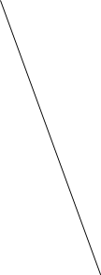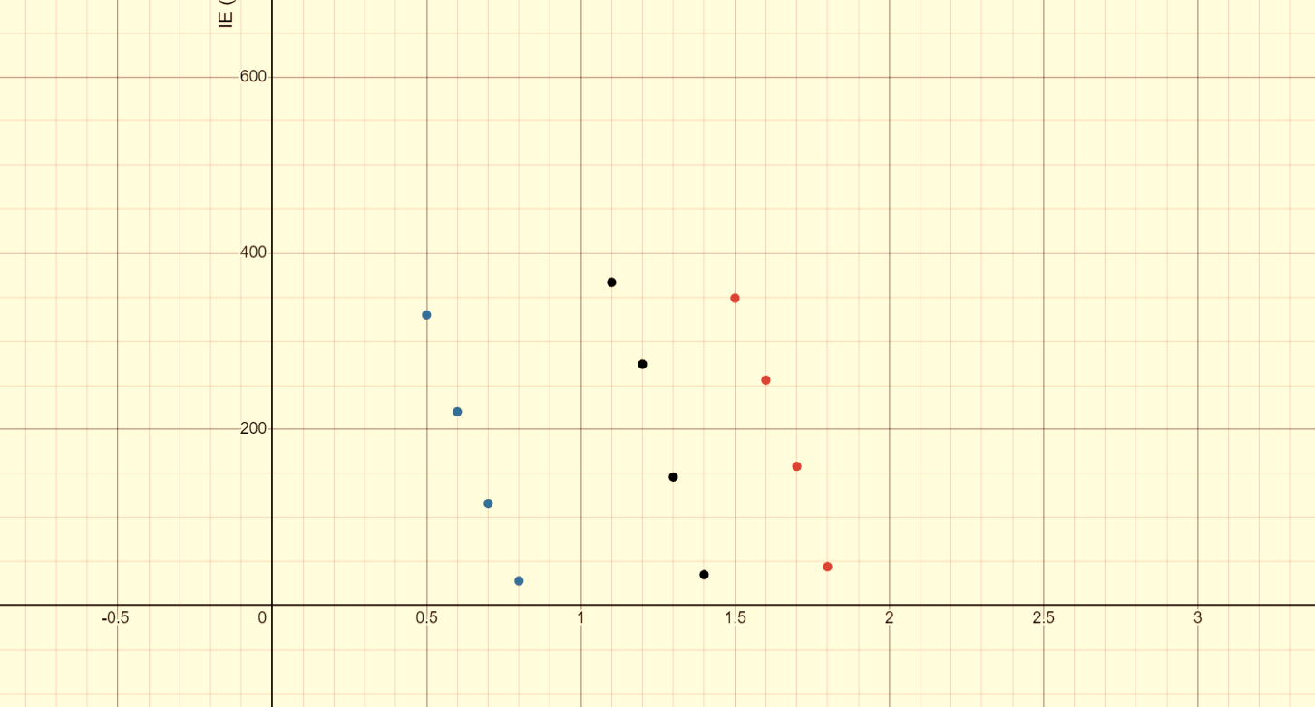

**IB (µA)**

VCE = 2V VCE = 4V VCE = 6V

Input Characteristics (IB vs VCB)

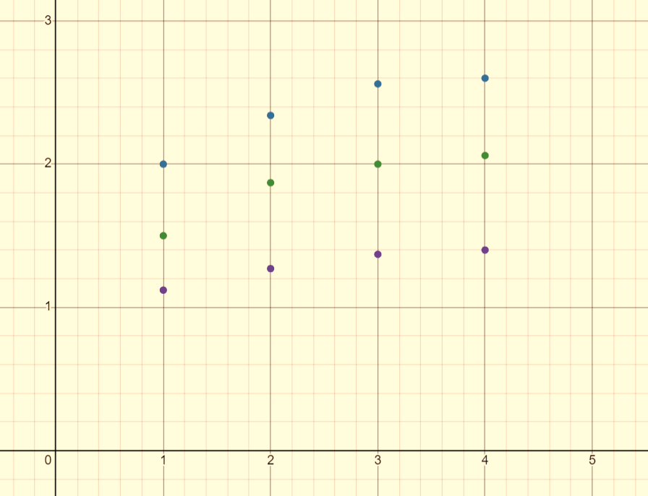

**VCE (V)**

**IB = 180 µA**

**IB = 160 µA**

**IB = 108 µA**

**IE (mA)**

Output Characteristics (IE vs VCE)

**RESULT AND CONCLUSION:**

Hence, for the input characteristics the graph of IB vs VCB was plotted and for the output characteristics the graph of IE vs VCE was plotted. The input and output characteristics of the common collector configuration of BJT was analyzed.

**PRECAUTIONS:**

* The reading should be noted carefully.
* The connections must be done accordingly.
* The applied voltage shouldn’t be very large.