1.
int[] data = {27, 51, 33, -1, 101};

2.
data[0] = 3
data[1] = 3
data[2] = 0
data[3] = 0
data[4] = 6
data[5] = 9
data[6] = 0
data[7] = -18

3.
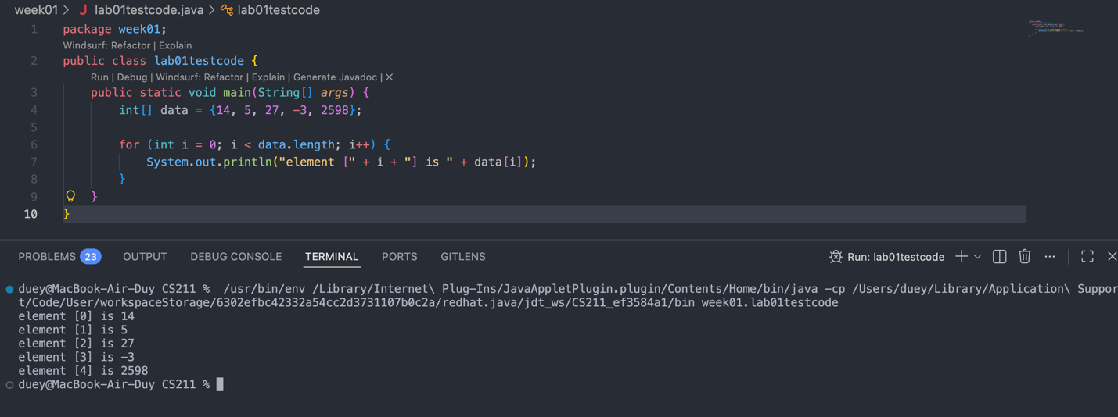
4.
2 [0,0,1,0]
1 [0,0,1,0]
3 [0,0,1,1]
2 [0,0,1,1]

5.
a1[0] = 1
a1[1] = 3
a1[2] = -3
a1[3] = 13
a1[4] = -4
a1[5] = -24
a1[6] = -6
a1[7] = -14

6.
Arrays.sort method:
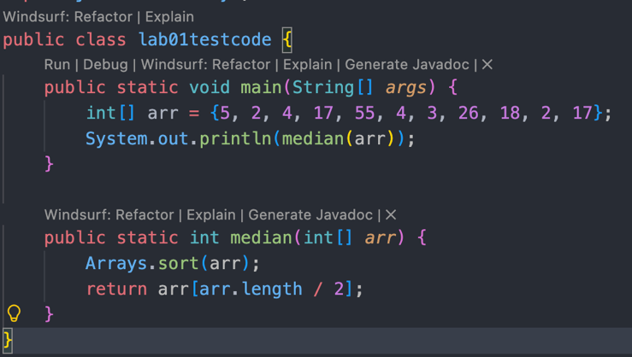
tally technique:
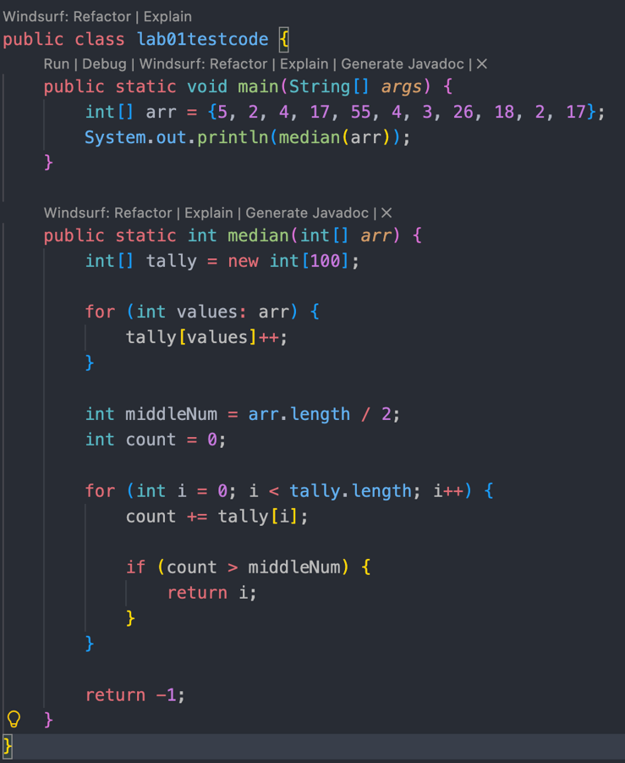

7.

