Visoka škola strukovnih studija za informacione i komunikacione tehnologije

LIVIO

https://livio.netlify.com/

Smer: Internet tehnologije

Predmet: Web programiranje 1 Teodora Nedeljković, 5/18

Beograd, decembar 2019.

SADRŽAJ

1. UVOD 3

1.1. Korišćene tehnologije 3

1.2. Opis funkcionalnosti sajta 3

2. Organizacija 4

2.1. Organizaciona šema 4

2.2. Mapa sajta 4

2.3. Opis stranica sajta 5

3. Kodovi 11

3.1. HTML 11

3.2. SCSS 11

3.3. JavaScript 11

# UVOD

## Korišćene tehnologije

• HTML 5

• CSS 3

• JavaScript

• jQuery

• jQuery Slick plugin

• Sublime Text

## Opis funkcionalnosti sajta

• Klikom na strelicu view se spušta do prvog nadolazećeg diva.

• Dinamička promena širine hamburger menija prilikom prelaska mišem.

• Klikom na hamburger meni pojavljuje se sakrivena navigacija.

• Dinamičko pojavljivanje slika prilikom prelaska mišem preko opcija navigacije.

• Dinamičko pojavljivanje slika u jednom divu prilikom prelaska miša na različita dva naslova.

• Menjanje određenog dela sadržaja klikom na span tagove u obliku tačke.

• Provera unetih podataka u formi korišćenjem regularnih izraza i ozačavanje ne/tačnih polja menjanjem boje bordura.

• Dinamička galerija u vidu slajdera.

• Fade-in efekat na određen sadržaj kada ono postane vidljivo u pregledaču.

### 1.3. Template

Samostalno pisan kod.

# Organizacija

## Organizaciona šema

Multiple page sajt.

## Mapa sajta

<?xml version="1.0" encoding="utf-8"?>

<urlset xmlns="http://www.sitemaps.org/schemas/sitemap/0.9">

<url>

<loc>https://livio.netlify.com/index.html</loc>

<lastmod>2019-12-07</lastmod>

<changefreq>weekly</changefreq>

<priority>1</priority>

</url>

<url>

<loc>https://livio.netlify.com/menu.html</loc>

<lastmod>2019-12-07</lastmod>

<changefreq>weekly</changefreq>

<priority>0.9</priority>

</url>

<url>

<loc>https://livio.netlify.com/restaurant.html</loc>

<lastmod>2019-12-07</lastmod>

<changefreq>monthly</changefreq>

<priority>0.8</priority>

</url>

<url>

<loc>https://livio.netlify.com/contact.html</loc>

<lastmod>2019-12-07</lastmod>

<changefreq>monthly</changefreq>

<priority>0.8</priority>

</url>

</urlset>

## Opis stranica sajta

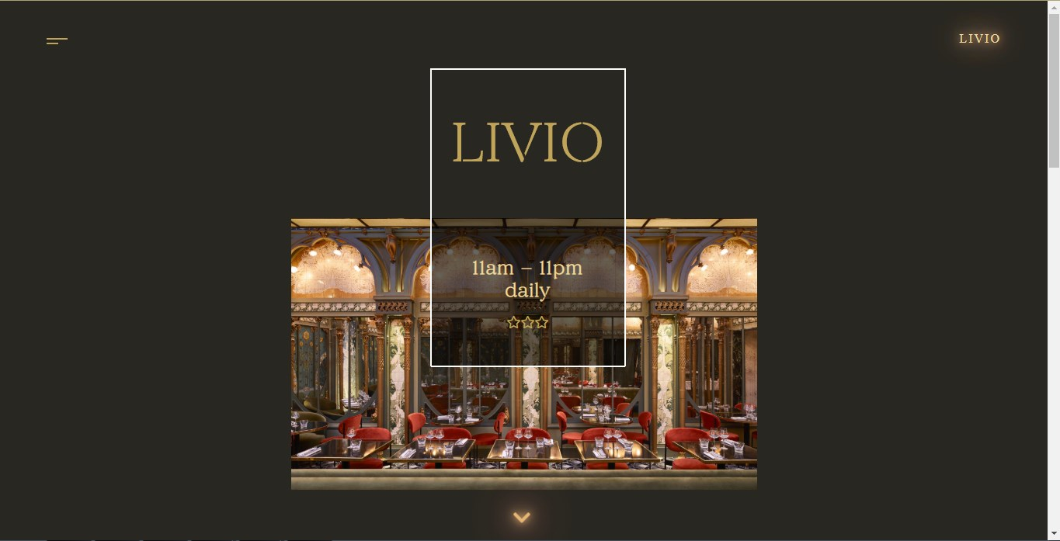Prelaskom miša preko crtica menija one menjaju svoju širinu i izlaskom se vraćaju na prvobitni oblik.

Klik na strelicu pri podnožju vidljivog dela pregledača odvešće nas do opisnog diva nekoliko piksela niže.

Klikom na hamburger navigaciju pojavljuje se sakriveni div sa navigacijom. Prelaskom preko svake opcije dinamički se prikazuje određena slika u zavisnosti od stranice. 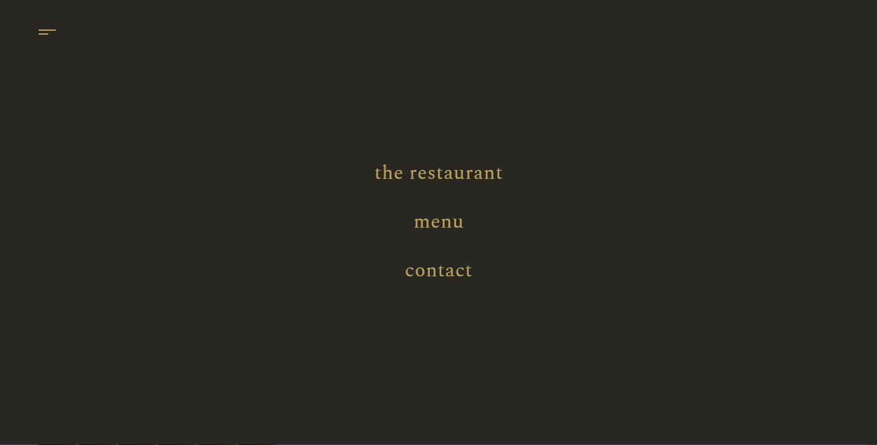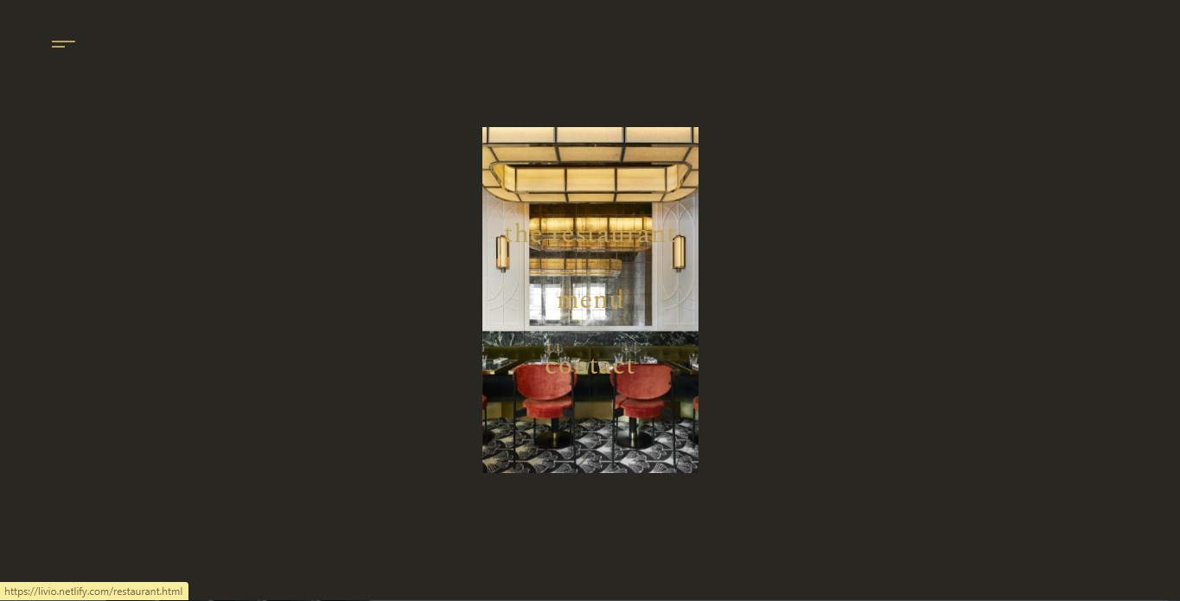

Prelaskom preko jednog od naslova dinamički se prikazuje drugačija slika.

Klikom na jednu od 4 tačkice menja se sadržaj- naslov, tekst i slika. Tačkicama se dodaje i otklanja klasa active. 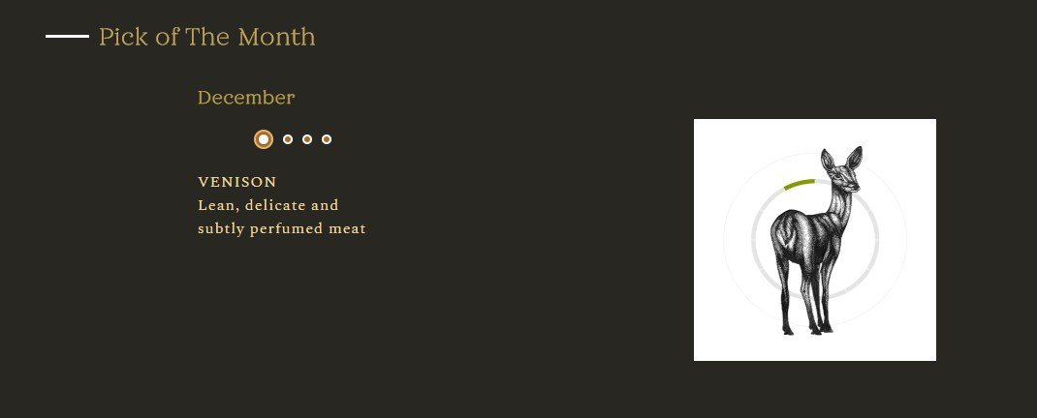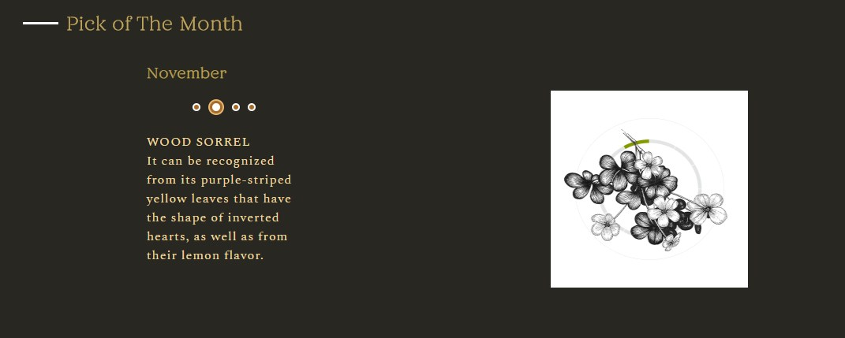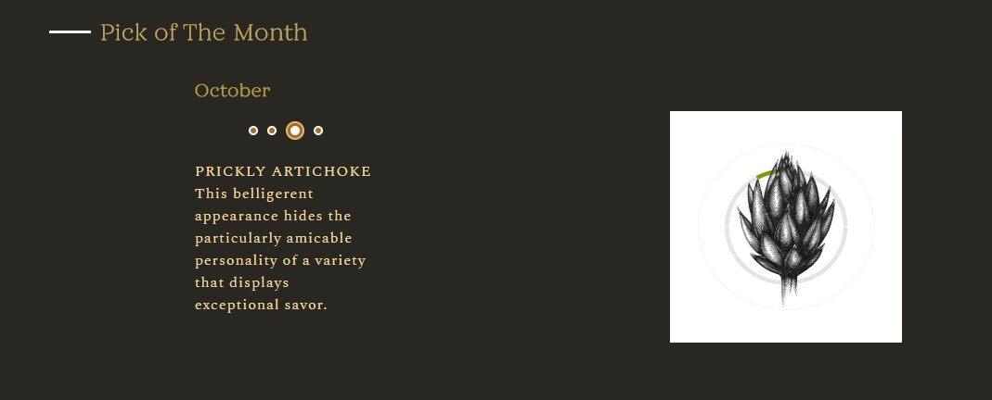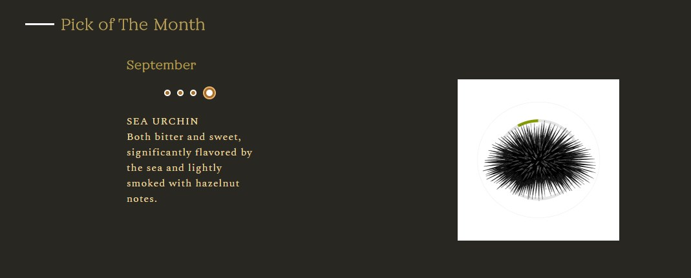

Na stranici restoran je uradjen dinamicki slajder, bez upotrebe plug inova.

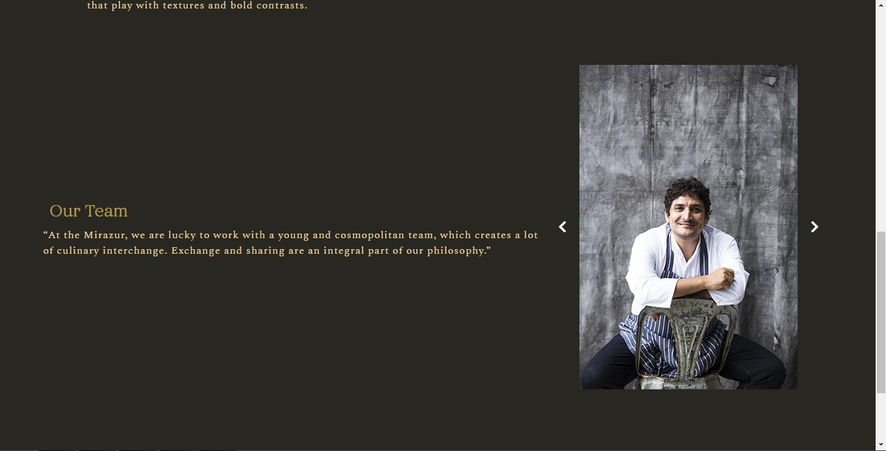

Pri učitavanju strane, deo menija koji je vidljiv u pregledaču će simulirati fade-in efekat od 1 sekunde. 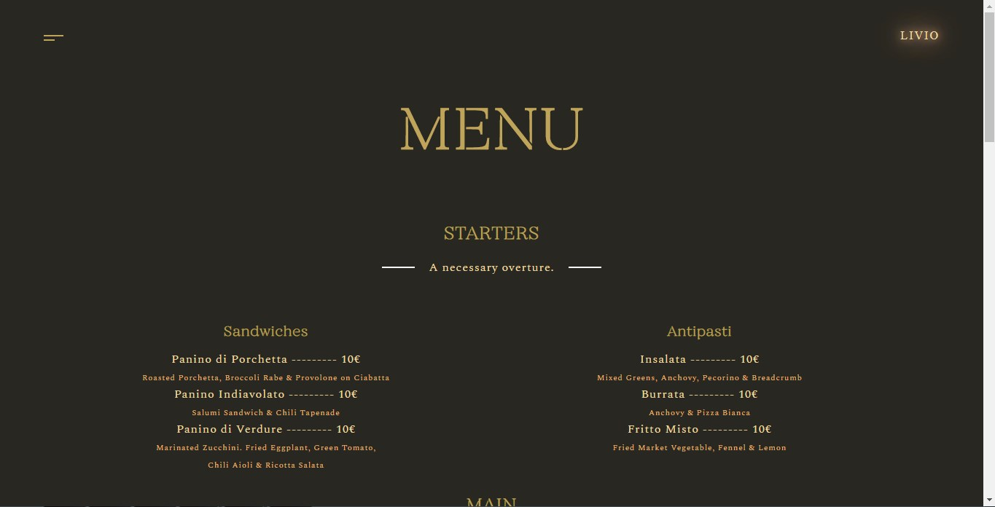

Pri daljem srolovanju, i ostatak menija će se ponašati isto. 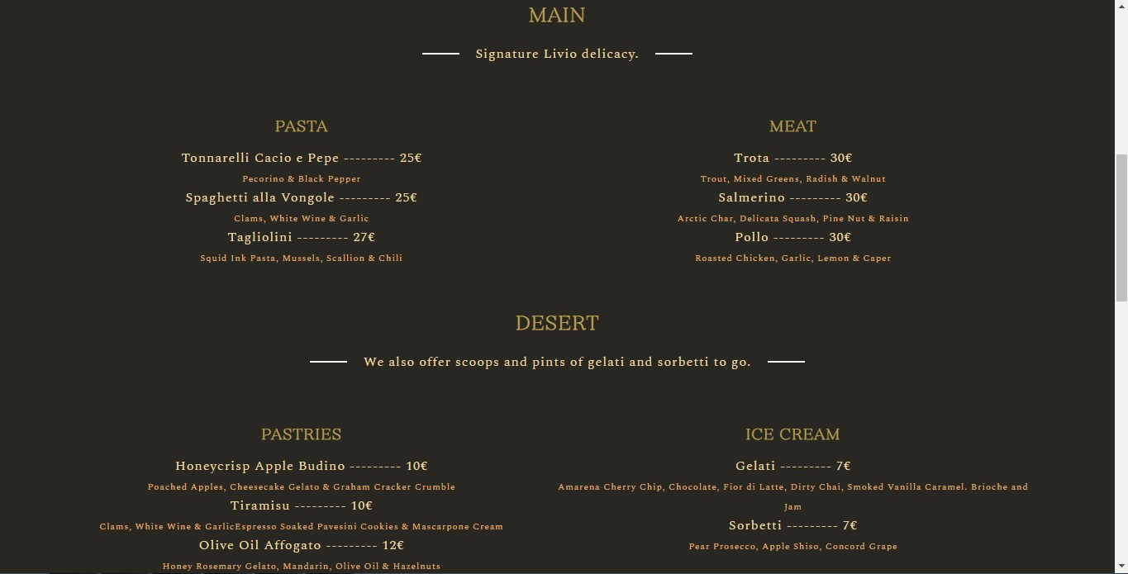

Kroz galeriju u vidu slajdera može se preći klikom na strelice ili povlačenjem slika. Ovo je urađeno jQuery plug-inom. 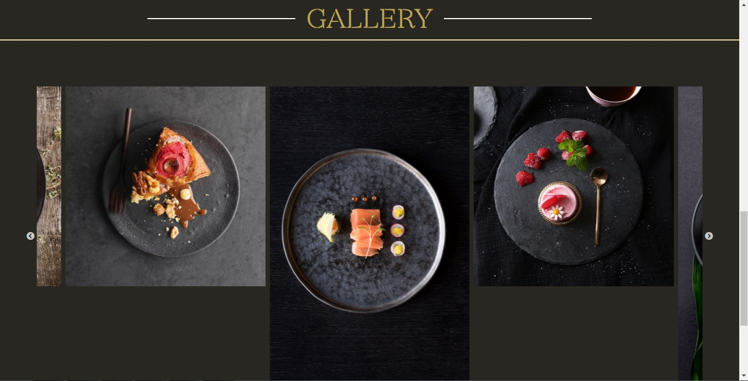

Provera forme se radi klikom na ikonicu. Ukoliko je neki od podataka netačan, donja bordura će se obojiti u crveno, u suprotnom u zeleno. Validacija se radi regularnim izrazima. 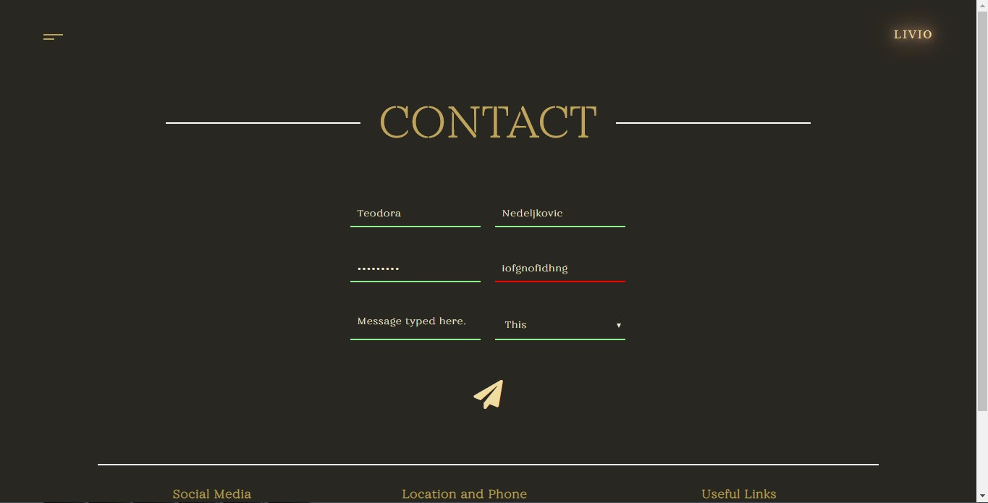

Stranica o autoru i link ka portfoliu.

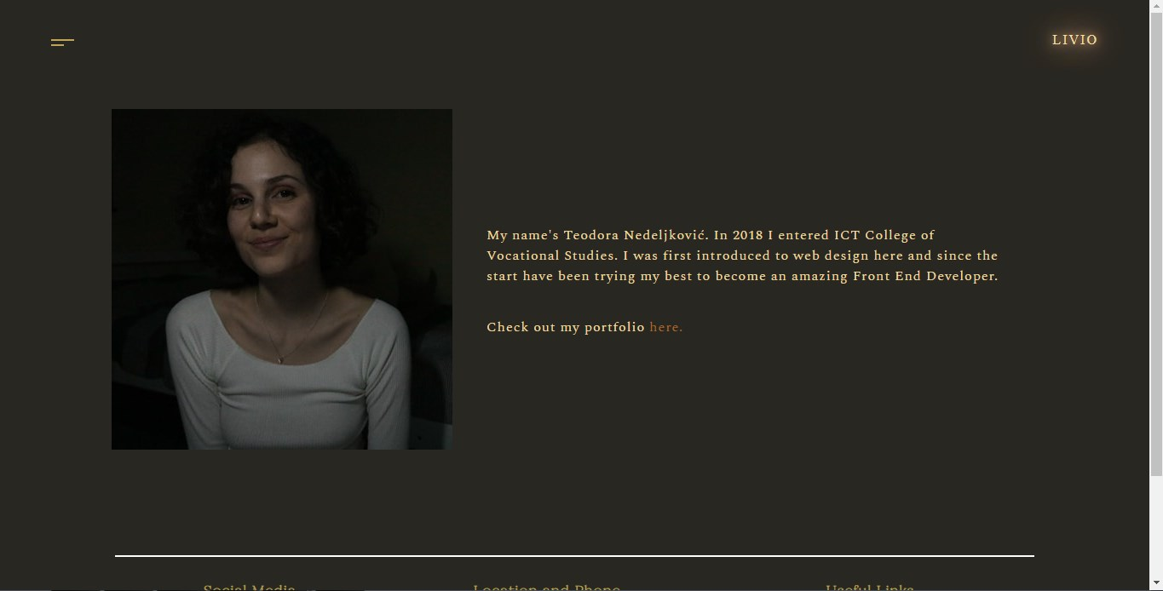

# Kodovi

## HTML

index.html

<!DOCTYPE html>

<html>

<head>

<title>Livio Restaurant</title>

<link rel="stylesheet" type="text/css" href="css/min.style.css"/>

<link rel="stylesheet" href="https://use.fontawesome.com/releases/v5.4.1/css/all.css" integrity="sha384-5sAR7xN1Nv6T6+dT2mhtzEpVJvfS3NScPQTrOxhwjIuvcA67KV2R5Jz6kr4abQsz" crossorigin="anonymous"/>

<meta charset="utf-8"/>

<meta name="description" content=""/>

<meta name="keywords" content=""/>

<meta name="author" content=" Teodora Nedeljković"/>

<meta name="viewport" content="width=device-width, initial-scale=1.0"/>

<link rel="shortcut icon" href="img/favicon.ico"/>

</head>

<body>

<div id="logo">

<a href="index.html">LIVIO</a>

</div>

<div id="white">

<div id="navIcon">

<span></span>

<span></span>

</div>

<div id="slika">

<div id="lineConnect">

<span id="firstLine" class="line"></span>

<span id="secondLine" class="line"></span>

<span id="thirdLine" class="line"></span>

<span id="fourthLine" class="line"></span>

<div class="header">

<h1>LIVIO</h1>

</div>

<div class="header" id="headerBottom">

<h2>11am - 11pm<br>daily</h2><br>

<div>

<i class="far fa-star"></i><i class="far fa-star"></i><i class="far fa-star"></i>

</div>

</div>

</div>

</div>

<div id="arrowDown">

<i class="fas fa-chevron-down"></i>

</div>

<div id="about">

<div class="aboutRow" id="aboutRow1">

<div id="aboutPhoto1">

</div>

<div>

<h2>Livio</h2>

<p>At the foot of the mountains overlooking the sea, a stone’s throw from Italian border post, the 1930s-era rotunda building housing the Mirazur enjoys an idyllic setting. It spreads over three levels on the hillside, surrounded by lush vegetation. The elegant, spacious and light-drenched dining room commands a panoramic view of the sea and the town of Menton through the large windows running all the way around.</p>

</div>

<div id="aboutPhoto2">

</div>

<div>

<p>At the Livio, nothing is immutable; everything changes with the seasons, available produce, and the inspiration of the chef.</p>

</div>

</div>

<div class="aboutRow" id="aboutRow2">

<div id="aboutSide1">

<h2><a href="restaurant.html">Our Team</a></h2>

</div>

<div id="aboutPhoto3">

<img src="" alt="">

</div>

<div id="aboutSide2">

<h2><a href="menu.html">Our Menu</a></h2>

</div>

</div>

</div>

<div id="slider">

<h2>Pick of The Month</h2>

<div id="slideChange">

<div>

<h3 data-number="1" class="activeHeader">December<br></h3>

<h3 data-number="2">November<br></h3>

<h3 data-number="3">October<br></h3>

<h3 data-number="4">September<br></h3>

<div id="dotsHolder">

<span class="dots active" data-number="1"><span></span></span>

<span class="dots" data-number="2"></span>

<span class="dots" data-number="3"></span>

<span class="dots" data-number="4"></span>

</div>

<p data-number="1" class="activeHeader"> VENISON<br>Lean, delicate and subtly perfumed meat</p>

<p data-number="2">WOOD SORREL<br>It can be recognized from its purple-striped yellow leaves that have the shape of inverted hearts, as well as from their lemon flavor.</p>

<p data-number="3">PRICKLY ARTICHOKE <br>This belligerent appearance hides the particularly amicable personality of a variety that displays exceptional savor.</p>

<p data-number="4">SEA URCHIN<br>Both bitter and sweet, significantly flavored by the sea and lightly smoked with hazelnut notes.</p>

</div>

<img src="img/month1.png" alt=""/>

</div>

</div>

<div id="footer">

<ul id="mainList">

<li><h4>Social Media</h4>

<ul>

<a href="https://www.instagram.com" target="_blank"><i class="fab fa-instagram"></i></a>

<a href="https://www.facebook.com" target="_blank"><i class="fab fa-facebook-f"></i></a>

</ul>

</li>

<li><h4>Location and Phone</h4>

<ul>

<li>Piazzale Antonio Cantore<br>

20123 Milano MI, Italy<br>

+377 93 30 22 22</li>

</ul>

</li>

<li><h4>Useful Links</h4>

<ul>

<li><a href="author.html">Author</a></li>

<li><a href="documentation.pdf">Documentation</a></li>

</ul>

</li>

</ul>

</div>

</div>

<div id="nav">

<div id="imageBg">

<img src="img/gallery1.jpg" alt=""/>

<img src="img/food1.jpg" alt=""/>

<img src="img/gallery8.jpg" alt=""/>

</div>

<ul>

<li><a href="restaurant.html" id="restaurant">the restaurant</a></li>

<li><a href="menu.html" id="menu">menu</a></li>

<li><a href="contact.html" id="contact">contact</a></li>

</ul>

</div>

<script src="js/jquery.js" type="text/javascript"></script>

<script type="text/javascript" src="js/min.main.js"></script>

</body>

</html>

menu.html

<!DOCTYPE html>

<html>

<head>

<title>Menu</title>

<link rel="stylesheet" type="text/css" href="css/min.style.css"/>

<link rel="stylesheet" href="https://use.fontawesome.com/releases/v5.4.1/css/all.css" integrity="sha384-5sAR7xN1Nv6T6+dT2mhtzEpVJvfS3NScPQTrOxhwjIuvcA67KV2R5Jz6kr4abQsz" crossorigin="anonymous"/>

<!--slick css-->

<link rel="stylesheet" type="text/css" href="slick/slick.css"/>

<link rel="stylesheet" type="text/css" href="slick/slick-theme.css"/>

<!--slick css-->

<meta charset="utf-8"/>

<meta name="description" content=""/>

<meta name="keywords" content=""/>

<meta name="author" content=" Teodora Nedeljković"/>

<meta name="viewport" content="width=device-width, initial-scale=1.0"/>

<link rel="shortcut icon" href="img/favicon.ico"/>

</head>

<body>

<div id="logo">

<a href="index.html">LIVIO</a>

</div>

<div id="white">

<div id="navIcon">

<span></span>

<span></span>

</div>

<div id="menuBlock">

<h1>MENU</h1>

<div class="menuRow" id="menuRow1">

<h2>STARTERS</h2>

<p id="menuDescription"><span></span>A necessary overture.<span></span></p>

<div class="scroll-to">

<h3>Sandwiches</h3>

<p>Panino di Porchetta --------- 10€<br>

<span id="foodDescription">Roasted Porchetta, Broccoli Rabe & Provolone on Ciabatta</span></p>

<p>Panino Indiavolato --------- 10€<br>

<span id="foodDescription">Salumi Sandwich & Chili Tapenade</span></p>

<p>Panino di Verdure --------- 10€<br>

<span id="foodDescription">Marinated Zucchini. Fried Eggplant, Green Tomato,<br> Chili Aioli & Ricotta Salata</span></p>

</div>

<div class="scroll-to">

<h3>Antipasti</h3>

<p>Insalata --------- 10€<br>

<span id="foodDescription">Mixed Greens, Anchovy, Pecorino & Breadcrumb</span></p>

<p>Burrata --------- 10€<br>

<span id="foodDescription">Anchovy & Pizza Bianca</span></p>

<p>Fritto Misto --------- 10€<br>

<span id="foodDescription">Fried Market Vegetable, Fennel & Lemon</span></p></p>

</div>

</div>

<div class="menuRow" id="menuRow2">

<h2>MAIN</h2>

<p id="menuDescription"><span></span>Signature Livio delicacy.<span></span></p>

<div class="scroll-to">

<h3>PASTA</h3>

<p>Tonnarelli Cacio e Pepe --------- 25€<br>

<span id="foodDescription">Pecorino & Black Pepper</span></p>

<p>Spaghetti alla Vongole --------- 25€<br>

<span id="foodDescription">Clams, White Wine & Garlic</span></p>

<p>Tagliolini --------- 27€<br>

<span id="foodDescription">Squid Ink Pasta, Mussels, Scallion & Chili</span></p>

</div>

<div class="scroll-to">

<h3>MEAT</h3>

<p>Trota --------- 30€<br>

<span id="foodDescription">Trout, Mixed Greens, Radish & Walnut</span></p>

<p>Salmerino --------- 30€<br>

<span id="foodDescription">Arctic Char, Delicata Squash, Pine Nut & Raisin</span></p>

<p>Pollo --------- 30€<br>

<span id="foodDescription">Roasted Chicken, Garlic, Lemon & Caper</span></p>

</div>

</div>

<div class="menuRow" id="menuRow3">

<h2>DESERT</h2>

<p id="menuDescription"><span></span>We also offer scoops and pints of gelati and sorbetti to go.<span></span></p>

<div class="scroll-to">

<h3>PASTRIES</h3>

<p>Honeycrisp Apple Budino --------- 10€<br>

<span id="foodDescription">Poached Apples, Cheesecake Gelato & Graham Cracker Crumble</span></p>

<p>Tiramisu --------- 10€<br>

<span id="foodDescription">Clams, White Wine & GarlicEspresso Soaked Pavesini Cookies & Mascarpone Cream</span></p>

<p>Olive Oil Affogato --------- 12€<br>

<span id="foodDescription">Honey Rosemary Gelato, Mandarin, Olive Oil & Hazelnuts</span></p>

</div>

<div class="scroll-to">

<h3>ICE CREAM</h3>

<p>Gelati --------- 7€<br>

<span id="foodDescription">Amarena Cherry Chip, Chocolate, Fior di Latte, Dirty Chai, Smoked Vanilla Caramel. Brioche and Jam</span></p>

<p>Sorbetti --------- 7€<br>

<span id="foodDescription">Pear Prosecco, Apple Shiso, Concord Grape</span></p>

</div>

</div>

</div>

<div id="menuBorder">

<span></span>

<h2>GALLERY</h2>

<span></span>

</div>

<div id="sliderGallery">

<div class="center">

<img src="img/food1.jpg" alt=""/>

<img src="img/food2.jpg" alt=""/>

<img src="img/food3.jpg" alt=""/>

<img src="img/food4.jpg" alt=""/>

<img src="img/food5.jpg" alt=""/>

<img src="img/food6.jpg" alt=""/>

<img src="img/food7.jpg" alt=""/>

<img src="img/food8.jpg" alt=""/>

</div>

</div>

<div id="footer">

<ul id="mainList">

<li><h4>Social Media</h4>

<ul>

<a href="https://www.instagram.com" target="_blank"><i class="fab fa-instagram"></i></a>

<a href="https://www.facebook.com" target="_blank"><i class="fab fa-facebook-f"></i></a>

</ul>

</li>

<li><h4>Location and Phone</h4>

<ul>

<li>Piazzale Antonio Cantore<br>

20123 Milano MI, Italy<br>

+377 93 30 22 22</li>

</ul>

</li>

<li><h4>Useful Links</h4>

<ul>

<li><a href="author.html">Author</a></li>

<li><a href="documentation.pdf">Documentation</a></li>

</ul>

</li>

</ul>

</div>

</div>

<div id="nav">

<div id="imageBg">

<img src="img/gallery1.jpg" alt=""/>

<img src="img/food1.jpg" alt=""/>

<img src="img/gallery8.jpg" alt=""/>

</div>

<ul>

<li><a href="restaurant.html" id="restaurant">the restaurant</a></li>

<li><a href="menu.html" id="menu">menu</a></li>

<li><a href="contact.html" id="contact">contact</a></li>

</ul>

</div>

<script src="js/jquery.js" type="text/javascript"></script>

<script type="text/javascript" src="js/min.main.js"></script>

<!--slick plugin-->

<script type="text/javascript" src="slick/slick.min.js"></script>

<!--slick plugin-->

</body>

</html>

restaurant.html

<!DOCTYPE html>

<html>

<head>

<title>Restaurant</title>

<link rel="stylesheet" type="text/css" href="css/min.style.css"/>

<link rel="stylesheet" href="https://use.fontawesome.com/releases/v5.4.1/css/all.css" integrity="sha384-5sAR7xN1Nv6T6+dT2mhtzEpVJvfS3NScPQTrOxhwjIuvcA67KV2R5Jz6kr4abQsz" crossorigin="anonymous"/>

<meta charset="utf-8"/>

<meta name="description" content=""/>

<meta name="keywords" content=""/>

<meta name="author" content=" Teodora Nedeljković"/>

<meta name="viewport" content="width=device-width, initial-scale=1.0"/>

<link rel="shortcut icon" href="img/favicon.ico"/>

</head>

<body>

<div id="logo">

<a href="index.html">LIVIO</a>

</div>

<div id="white">

<div id="navIcon">

<span></span>

<span></span>

</div>

<div id="restaurantHeader">

<h1>The World of<br><span>&nbsp;Livio</span></h1>

</div>

<div id="bgRestaurant"></div>

<div id="restaurantDescription">

<h2>A creative, free and respectful cuisine</h2>

<p>Through his personal interpretations of ingredients and flavour combinations, Mauro Colagreco has forged a style of his own.<br/> He has absorbed his Italian-Argentinian cultural heritage and that of the chefs with whom he trained, and now follows his intuition as he draws on the local culture on both sides of the border.<br/> Inspired by the sea, the mountains and the fruit and vegetables grown in his own gardens, Mauro invents colourful, pictorial dishes that play with textures and bold contrasts.</p>

</div>

<div id="restaurantSlider">

<div id="team">

<h2>Our Team</h2>

<p>“At the Mirazur, we are lucky to work with a young and cosmopolitan team, which creates a lot of culinary interchange. Exchange and sharing are an integral part of our philosophy.”</p>

</div>

<div>

<div><a href="javascript:Previous()"><i class="fas fa-chevron-left"></i></a></div>

<div><img src="img/team1.jpg" alt="team photo" id="restaurantPhoto"/></div>

<div><a href="javascript:Next()"><i class="fas fa-chevron-right"></i></a></div>

</div>

</div>

<div id="footer">

<ul id="mainList">

<li><h4>Social Media</h4>

<ul>

<a href="https://www.instagram.com" target="_blank"><i class="fab fa-instagram"></i></a>

<a href="https://www.facebook.com" target="_blank"><i class="fab fa-facebook-f"></i></a>

</ul>

</li>

<li><h4>Location and Phone</h4>

<ul>

<li>Piazzale Antonio Cantore<br>

20123 Milano MI, Italy<br>

+377 93 30 22 22</li>

</ul>

</li>

<li><h4>Useful Links</h4>

<ul>

<li><a href="author.html">Author</a></li>

<li><a href="documentation.pdf">Documentation</a></li>

</ul>

</li>

</ul>

</div>

</div>

<div id="nav">

<div id="imageBg">

<img src="img/gallery1.jpg" alt=""/>

<img src="img/food1.jpg" alt=""/>

<img src="img/gallery8.jpg" alt=""/>

</div>

<ul>

<li><a href="restaurant.html" id="restaurant">the restaurant</a></li>

<li><a href="menu.html" id="menu">menu</a></li>

<li><a href="contact.html" id="contact">contact</a></li>

</ul>

</div>

<script src="js/jquery.js" type="text/javascript"></script>

<script type="text/javascript" src="js/min.main.js"></script>

</body>

</html>

contact.html  
 <!DOCTYPE html>

<html>

<head>

<title>Contact</title>

<link rel="stylesheet" type="text/css" href="css/min.style.css"/>

<link rel="stylesheet" href="https://use.fontawesome.com/releases/v5.4.1/css/all.css" integrity="sha384-5sAR7xN1Nv6T6+dT2mhtzEpVJvfS3NScPQTrOxhwjIuvcA67KV2R5Jz6kr4abQsz" crossorigin="anonymous"/>

<meta charset="utf-8">

<meta name="description" content=""/>

<meta name="keywords" content=""/>

<meta name="author" content=" Teodora Nedeljković"/>

<meta name="viewport" content="width=device-width, initial-scale=1.0"/>

<link rel="shortcut icon" href="img/favicon.ico"/>

</head>

<body>

<div id="logo">

<a href="index.html">LIVIO</a>

</div>

<div id="white">

<div id="contactBorder">

<span></span>

<h2>CONTACT</h2>

<span></span>

</div>

<div id="navIcon">

<span></span>

<span></span>

</div>

<form action="" method="" name="contactForm" id="contactForm">

<div>

<input type="text" name="" id="firstName" placeholder="First Name">

<input type="text" name="" id="lastName" placeholder="Last Name">

</div>

<div>

<input type="password" name="" id="password" placeholder="Password">

<input type="email" name="" id="email" placeholder="Email">

</div>

<div>

<textarea name="" id="yourMessage" placeholder="Your Message"></textarea>

<select id="ddList">

<option value="0">Number of people</option>

<option value="1">1-2</option>

<option value="2">2-5</option>

<option value="3">5-10</option>

</select>

</div>

<i class="fas fa-paper-plane" id="buttonSubmit"></i>

</form>

<div id="footer">

<ul id="mainList">

<li><h4>Social Media</h4>

<ul>

<a href="https://www.instagram.com" target="_blank"><i class="fab fa-instagram"></i></a>

<a href="https://www.facebook.com" target="_blank"><i class="fab fa-facebook-f"></i></a>

</ul>

</li>

<li><h4>Location and Phone</h4>

<ul>

<li>Piazzale Antonio Cantore<br>

20123 Milano MI, Italy<br>

+377 93 30 22 22</li>

</ul>

</li>

<li><h4>Useful Links</h4>

<ul>

<li><a href="author.html">Author</a></li>

<li><a href="documentation.pdf">Documentation</a></li>

</ul>

</li>

</ul>

</div>

</div>

<div id="nav">

<div id="imageBg">

<img src="img/gallery1.jpg" alt=""/>

<img src="img/food1.jpg" alt=""/>

<img src="img/gallery8.jpg" alt=""/>

</div>

<ul>

<li><a href="restaurant.html" id="restaurant">the restaurant</a></li>

<li><a href="menu.html" id="menu">menu</a></li>

<li><a href="contact.html" id="contact">contact</a></li>

</ul>

</div>

<script src="js/jquery.js" type="text/javascript"></script>

<script type="text/javascript" src="js/min.main.js"></script>

</body>

</html>

author.html

<!DOCTYPE html>

<html>

<head>

<title>Author</title>

<link rel="stylesheet" type="text/css" href="css/min.style.css"/>

<link rel="stylesheet" href="https://use.fontawesome.com/releases/v5.4.1/css/all.css" integrity="sha384-5sAR7xN1Nv6T6+dT2mhtzEpVJvfS3NScPQTrOxhwjIuvcA67KV2R5Jz6kr4abQsz" crossorigin="anonymous"/>

<meta charset="utf-8"/>

<meta name="description" content=""/>

<meta name="keywords" content=""/>

<meta name="author" content=" Teodora Nedeljković"/>

<meta name="viewport" content="width=device-width, initial-scale=1.0"/>

<link rel="shortcut icon" href="img/favicon.ico"/>

</head>

<body>

<div id="logo">

<a href="index.html">LIVIO</a>

</div>

<div id="white">

<div id="navIcon">

<span></span>

<span></span>

</div>

<div id="author">

<div>

<img src="img/author.jpg" alt="author" />

</div>

<div id="authorDescription">

<p>My name's Teodora Nedeljković. In 2018 I entered ICT College of Vocational Studies. I was first introduced to web design here and since the start have been trying my best to become an amazing Front End Developer.</p><br><br>

<p>Check out my portfolio <a href="http://teodoranedeljkovic.000webhostapp.com/">here.</a></p>

</div>

</div>

<div id="footer">

<ul id="mainList">

<li><h4>Social Media</h4>

<ul>

<a href="https://www.instagram.com" target="_blank"><i class="fab fa-instagram"></i></a>

<a href="https://www.facebook.com" target="_blank"><i class="fab fa-facebook-f"></i></a>

</ul>

</li>

<li><h4>Location and Phone</h4>

<ul>

<li>Piazzale Antonio Cantore<br>

20123 Milano MI, Italy<br>

+377 93 30 22 22</li>

</ul>

</li>

<li><h4>Useful Links</h4>

<ul>

<li><a href="author.html">Author</a></li>

<li><a href="documentation.pdf">Documentation</a></li>

</ul>

</li>

</ul>

</div>

</div>

<div id="nav">

<div id="imageBg">

<img src="img/gallery1.jpg" alt=""/>

<img src="img/food1.jpg" alt=""/>

<img src="img/gallery8.jpg" alt=""/>

</div>

<ul>

<li><a href="restaurant.html" id="restaurant">the restaurant</a></li>

<li><a href="menu.html" id="menu">menu</a></li>

<li><a href="contact.html" id="contact">contact</a></li>

</ul>

</div>

<script src="js/jquery.js" type="text/javascript"></script></script>

<script type="text/javascript" src="js/min.main.js"></script>

</body>

</html>

## SCSS

@import url('https://fonts.googleapis.com/css?family=Spectral&display=swap');

@font-face{

font-family: 'GabrielaStencil';

src: url(../font/GabrielaStencilUltraLight.otf);

}

*{

margin: 0px;

padding: 0px;

box-sizing: border-box;

}

$siva: #292721;

$tamnozlatna: #A86B28;

$svetlozlatna: #E7B674;

$zlatna: #bfa45a;

$zlatnaAlt: #f0dba1;

@mixin flexCenter{

display: flex;

justify-content: center;

align-items: center;

}

a{

text-decoration: none;

}

ul{

list-style-type: none;

}

h1, h2, h3, h4{

font-family: 'GabrielaStencil';

letter-spacing: 1px;

color: $zlatna;

}

p, li{

font-family: 'Spectral', serif;

letter-spacing: 1px;

color: $zlatnaAlt;

}

.navPhotoAppear{

animation-name: navPhotoRotateOn;

animation-duration: 0.5s;

}

@keyframes navPhotoRotateOn{

from{

transform: rotate(-35deg);

opacity: 0;

}

to{

transform: rotate(0deg);

opacity: 1;

}

}

.navPhotoDisappear{

animation-name: navPhotoRotateOff;

animation-duration: 1s;

}

@keyframes navPhotoRotateOff{

from{

opacity: 1;

}

to{

opacity: 0;

}

}

.aboutPhotoAppear{

animation-name: aboutPhotoAppear;

animation-duration: 1s;

}

@keyframes aboutPhotoAppear{

from{

opacity: 0;

}

to{

opacity: 1;

}

}

.aboutPhotoDisappear{

animation-name: aboutPhotoDisappear;

animation-duration: 1s;

animation-fill-mode: forwards;

}

@keyframes aboutPhotoDisappear{

from{

opacity: 1;

}

to{

opacity: 0;

}

}

body{

background-color: $siva;

#logo{

position: absolute;

top: 40px;

right: 60px;

a{

color: $zlatnaAlt;

letter-spacing: 2px;

}

text-shadow: 0 0 10px $svetlozlatna, 0 0 20px $svetlozlatna, 0 0 30px $svetlozlatna, 0 0 40px #e60073;

}

}

#white{

width: 100%;

@include flexCenter;

flex-direction: column;

margin-top: 130px;

background-color: $siva;

#slika{

width: 600px;

min-height: 350px;

background-image: url('../img/bgRestaurant.jpg');

background-size: cover;

position: relative;

margin-top: 150px;

#lineConnect{

width: 250px;

height: 384px;

flex-direction: column;

position: absolute;

top: -192px;

left: 30%;

.header{

width: 100%;

height: 50%;

@include flexCenter;

flex-direction: column;

h1{

font-size: 70px;

color: $zlatna;

}

}

#headerBottom{

background-color: rgba(0,0,0,0.6);

h2{

text-align: center;

color: $zlatnaAlt;

}

div{

@include flexCenter;

i{

color: $zlatna;

}

}

}

.line{

height: 2px;

position: absolute;

background-color: white;

}

#firstLine{

width: 248px;

position: absolute;

top: -1px;

left: 0px;

background-color: transparent;

animation: line 2s forwards;

animation-delay: 1s;

}

#secondLine{

width: 384px;

top: 190px;

right: -192px;

transform: rotate(90deg);

}

#thirdLine{

width: 251px;

position: absolute;

bottom: 0px;

right: 0px;

background-color: transparent;

animation: line 2s forwards;

animation-delay: 1s;

}

#fourthLine{

width: 384px;

top: 190px;

left: -192px;

transform: rotate(90deg);

}

@keyframes line{

from{

width: 0%;

background-color: transparent;

}

to{

width: 100%;

background-color: white;

}

}

}

}

#arrowDown{

position: absolute;

left: 49%;

bottom: 20px;

font-size: 25px;

color: $svetlozlatna;

animation: upDown 1.7s infinite;

text-shadow: 0 0 10px $svetlozlatna, 0 0 20px $svetlozlatna, 0 0 30px $svetlozlatna, 0 0 40px #e60073, 0 0 50px $svetlozlatna, 0 0 60px $svetlozlatna;

&:hover{

cursor: pointer;

}

}

@keyframes upDown{

0%{

transform: translate(0);

}

50%{

transform: translate(0, 8px);

}

100%{

transform: translate(0);

}

}

#navIcon{

width: 27px;

height: 10px;

position: absolute;

left: 60px;

top: 48px;

z-index: 1000;

&:hover{

cursor: pointer;

}

span{

display: block;

width: 27px;

height: 2px;

background-color: $zlatna;

&:first-child{

margin-bottom: 4px;

}

&:nth-child(2){

width: 15px;

}

}

}

#about{

width: 90%;

margin-top: 100px;

h2{

font-size: 30px;

margin-bottom: 10px;

}

.aboutRow{

width: 100%;

min-height: 400px;

display: flex;

justify-content: space-around;

margin-top: 60px;

}

#aboutRow1{

display: flex;

div{

width: 30%;

}

p::first-letter{

font-size: 30px;

}

div:nth-child(2){

margin: 0px 15px;

max-height: 500px;

}

#aboutPhoto1{

height: 400px;

background-image: url('../img/gallery1.jpg');

background-position: center;

}

#aboutPhoto2{

height: 400px;

background-image: url('../img/gallery2.jpg');

background-position: center;

}

div:nth-child(4){

display: none;

order: 4;

width: 80%;

margin: 30px 15px;

text-align: center;

}

}

#aboutRow2{

align-items: center;

flex-wrap: wrap;

div{

width: 30%;

}

a{

color: $zlatna;

font-size: 0.8em;

}

a:hover{

cursor: pointer;

color: $svetlozlatna;

}

#aboutSide1, #aboutSide2{

@include flexCenter;

}

#aboutPhoto3{

width: 291px;

height: 400px;

background-image: url('../img/gallery3.jpg');

img{

display: none;

width: 100%;

height: inherit;

}

}

}

}

#slider{

width: 80%;

margin-top: 50px;

h2{

margin-bottom: 30px;

margin-left: 60px;

position: relative;

&::before{

content: '';

width: 45px;

height: 3px;

position: absolute;

top: 12px;

left: -55px;

background-color: white;

}

}

#slideChange{

width: 100%;

display: flex;

justify-content: space-around;

flex-wrap: wrap;

margin-bottom: 50px;

img{

width: 250px;

height: 250px;

margin-top: 40px;

}

h3, p{

display: none;

padding: 7px;

}

.activeHeader{

display: block;

}

p{

width: 210px;

}

span:hover{

cursor: pointer;

}

#dotsHolder{

height: 50px;

@include flexCenter;

.dots{

width: 10px;

height: 10px;

margin: 5px;

border-radius: 50%;

border: 2px solid white;

background-color: $tamnozlatna;

}

.active{

border-color: $svetlozlatna;

width:20px;

height: 20px;

@include flexCenter;

span{

width: 10px;

height: 10px;

border-radius: 50%;

background-color: white;

}

}

}

}

}

#footer{

width: 80%;

margin-top: 30px;

margin-bottom: 35px;

#mainList{

display: flex;

justify-content: space-around;

border-top: 2px solid white;

border-bottom: 2px solid white;

li ul{

display: flex;

justify-content: center;

}

li:nth-child(3) ul{

flex-direction: column;

li a{

float: left;

margin: 5px;

}

}

li ul a{

display: flex;

justify-content: center;

margin: 10px;

font-size: 17px;

}

}

#mainList > li{

margin: 10px;

padding-top: 20px;

padding-bottom: 20px;

}

a{

color: $zlatnaAlt;

}

}

}

/******NAVIGACIJA******/

#nav{

@include flexCenter;

width: 10%;

height: 10%;

visibility: hidden;

position: absolute;

top: 0px;

left: 0px;

z-index: 999;

background-color: $siva;

#imageBg{

@include flexCenter;

position: absolute;

width: 100%;

left: 0px;

img{

display: none;

width: 250px;

height: 400px;

z-index: 1;

}

}

ul{

width: 90%;

@include flexCenter;

flex-direction: column;

z-index: 1000;

li{

padding: 15px;

a{

font-size: 30px;

color: $zlatna;

}

}

}

}

/***********KONTAKT************/

#contactBorder{

width: 100%;

@include flexCenter;

span{

display: block;

width: 20%;

height: 2px;

background-color: white;

margin-left: 20px;

margin-right: 20px;

}

h2{

padding: 5px;

font-size: 60px;

text-align: center;

}

}

#contactForm{

width: 70%;

height: 400px;

@include flexCenter;

flex-direction: column;

background-color: transparent;

input, select, textarea{

width: 180px;

margin: 10px;

padding: 9px;

border: none;

border-bottom: 2px solid $svetlozlatna;

outline: none;

background-color: transparent;

color: #f5eedc;

font-family: 'GabrielaStencil';

line-height: 10px;

letter-spacing: 1px;

&::placeholder{

color: #f5eedc;

}

}

option{

border: none;

outline: none;

color: $tamnozlatna;

}

textarea{

resize: none;

}

div{

padding: 10px;

display: flex;

}

#buttonSubmit{

width: 70px;

margin-top: 35px;

color: $zlatnaAlt;

font-size: 40px;

@include flexCenter;

&:hover{

cursor: pointer;

color: white;

transition: color 0.4s;

}

}

}

/***********RESTORAN************/

#restaurantHeader{

h1{

font-size: 60px;

span{

letter-spacing: 30px;

}

}

}

#bgRestaurant{

width: inherit;

height: 50vh;

margin-top: 60px;

background-image: url('../img/bgRestaurant.jpg');

background-position: center;

background-attachment: fixed;

}

#restaurantDescription{

width: 80%;

margin-top: 80px;

h2{

margin: 20px;

}

p::first-letter{

font-size: 30px;

}

}

#restaurantSlider{

@include flexCenter;

width: 90%;

margin-top: 80px;

margin-bottom: 70px;

h2{

margin:10px;

}

div:nth-child(2){

@include flexCenter;

i{

margin: 20px;

font-size: 20px;

color: white;

}

}

}

/***********MENI************/

#menuBlock{

width: 90%;

min-height: 500px;

@include flexCenter;

flex-direction: column;

flex-wrap: wrap;

h1{

width: 100%;

margin-bottom: 80px;

text-align: center;

font-size: 80px;

}

.menuRow{

width: 100%;

display: flex;

flex-wrap: wrap;

h2{

width: 100%;

text-align: center;

}

.scroll-to{

opacity: 0.1;

}

#menuDescription{

width: 100%;

text-align: center;

margin: 20px 20px 50px 20px;

@include flexCenter;

span{

display: block;

width: 45px;

height: 2px;

background-color: white;

margin-left: 20px;

margin-right: 20px;

}

}

#foodDescription{

font-size: 11px;

color: $svetlozlatna;

}

div{

width: 49%;

height: 250px;

text-align: center;

h3{

margin: 15px;

}

}

}

}

#menuBorder{

width: 100%;

height: 100px;

@include flexCenter;

margin-top: 100px;

border-top: 2px solid $zlatnaAlt;

border-bottom: 2px solid $zlatnaAlt;

span{

display: block;

width: 20%;

height: 2px;

background-color: white;

margin-left: 20px;

margin-right: 20px;

}

h2{

padding: 5px;

font-size: 60px;

text-align: center;

}

}

#sliderGallery{

width: 90%;

margin-top: 100px;

margin-bottom: 100px;

img{

margin: 5px;

}

}

.slick-slide.slick-current.slick-center.slick-active{

opacity: 1;

}

.slick-prev.slick-arrow{

color: black;

}

/**********AUTOR************/

#author{

width: 90%;

margin-bottom: 90px;

@include flexCenter;

#authorDescription{

width: 50%;

margin: 40px;

}

a{

color: $tamnozlatna;

}

}

/************************MEDIA**************************/

@media only screen and (max-width: 840px){

body #white #aboutRow1{

flex-wrap: wrap;

div:nth-child(2){

order: 1;

width: 80% !important;

margin: 30px 15px !important;

}

#aboutPhoto1{

order: 2;

}

#aboutPhoto2{

order: 3;

}

div:nth-child(4){

display: block !important;

}

}

body #white #about #aboutRow2 #aboutSide1{

width: 40%;

order: 1;

}

body #white #about #aboutRow2 #aboutSide2{

width: 40%;

order: 2;

}

body #white #about #aboutRow2 #aboutPhoto3{

order: 3;

margin-top: 40px;

margin-bottom: 30px;

}

}

@media only screen and (max-width: 761px){

body #nav #imageBg img{

left: 15em;

}

/*author*/

#author{

width: 90%;

flex-direction: column;

img{

width: 90%;

}

#authorDescription{

width: 80%;

margin: 40px;

}

}

body #aboutRow1 #aboutPhoto1, body #aboutRow1 #aboutPhoto2{

width: 230px !important;

}

}

@media only screen and (max-width: 710px){

body #nav #imageBg img{

display: none !important;

}

body #white #about h2{

font-size: 25px;

}

body #bgRestaurant{

height: 50vh;

}

body #white #slika{

width: 500px;

}

body #white #slika #lineConnect{

left: 25%;

}

body #white #about #aboutRow2 #aboutSide1, body #white #about #aboutRow2 #aboutSide2{

width: 49%;

}

body #white #about #aboutRow2 #aboutSide1{

order: 1;

}

body #white #about #aboutRow2 #aboutSide2{

order: 2;

}

body #white #about #aboutRow2 #aboutPhoto3{

order: 3;

}

body #restaurantSlider{

flex-direction: column;

#team{

order: 2;

margin-top: 40px;

}

}

}

@media only screen and (max-width: 650px){

body #white #footer #mainList{

flex-direction: column;

}

body #white #footer #mainList li{

margin-bottom: 0px;

padding-bottom: 0px;

}

body #white #footer #mainList li:nth-child(3){

margin-bottom: 10px;

padding-bottom: 20px;

}

body #white #footer #mainList li ul{

justify-content: flex-start;

}

}

@media screen and (max-width: 591px){

#white #slider #slideChange .activeHeader{

text-align: center;

}

}

@media screen and (max-width: 550px){

body #white #slika{

width: 320px;

}

body #white #slika #lineConnect{

left: 11%;

}

body #aboutRow1{

flex-wrap: wrap;

}

body #aboutRow1 #aboutPhoto1, body #aboutRow1 #aboutPhoto2{

height: 380px !important;

width: 68% !important;

margin: 15px 0px;

}

body #restaurantHeader h1{

font-size: 45px;

}

body #contactBorder h2{

font-size: 40px;

}

body #contactForm input, body #contactForm select, body #contactForm textarea{

width: 120px;

}

/*restaurant*/

body #contactForm #buttonSubmit i{

font-size: 40px;

}

body #bgRestaurant{

height: 30vh;

}

}

## JavaScript

/*******lokacija******/

var lokacijaCela = window.location.href

var lokacijaSplit = window.location.href.split('/')

for(let i=0; i<lokacijaSplit.length; i++){

if(i==lokacijaSplit.length-1){

var lokacija = lokacijaSplit[i]

}

}

/********NAVIGACIJA********/

window.onload = function(){

document.getElementById("navIcon").addEventListener("click", navSlide)

}

function navSlide(){

if($('#nav').css('visibility')=='hidden'){

$('#nav')

.css({'visibility': 'visible'})

.animate({width: '100%', height: '100%'}, 510)

$('body').css({'overflow': 'hidden'})

}

else {

$('#nav')

.animate({width: '0%', height: '0%'}, 410)

setTimeout(function(){

$('#nav').css('visibility','hidden');

},411);

$('body').css({'overflow': 'visible'})

}

}

$("#navIcon").hover(

function()

{

$("#navIcon span:first-child")

.stop(true, true)

.animate({width: '15px'}, 210)

$("#navIcon span:nth-child(2)")

.stop(true, true)

.animate({width:'27px'}, 210);

},

function()

{

$("#navIcon span:first-child")

.stop(true, true)

.animate({width: '27px'}, 210)

$("#navIcon span:nth-child(2)")

.stop(true, true)

.animate({width: '15px'}, 210)

}

)

$("#nav a").hover(

function()

{

if(this == document.getElementById("restaurant"))

$("#imageBg img:nth-child(1)").show().addClass('navPhotoAppear')

else if(this == document.getElementById("menu"))

$("#imageBg img:nth-child(2)").show().addClass('navPhotoAppear').removeClass('navPhotoDisappear')

else if(this == document.getElementById("contact"))

$("#imageBg img:nth-child(3)").show().addClass('navPhotoAppear').removeClass('navPhotoDisappear')

},

function()

{

if(this == document.getElementById("restaurant"))

$("#imageBg img:nth-child(1)").hide(300)

else if(this == document.getElementById("menu"))

$("#imageBg img:nth-child(2)").hide(300).addClass('navPhotoDisappear').removeClass('navPhotoAppear')

else if(this == document.getElementById("contact"))

$("#imageBg img:nth-child(3)").hide(300).addClass('navPhotoDisappear').removeClass('navPhotoAppear')

}

)

if((lokacija=='index.html')||(lokacijaCela = 'https://livio.netlify.com/')){

/*****ARROW*****/

$("#arrowDown").click(function() {

$('html').animate({

scrollTop: $("#about").offset().top},

1000);

});

/*********DOTS**********/

var dots = $('.dots')

var months = $('#slideChange h3')

var monthsDescription = $('#slideChange p')

$(document).ready(function(){

$('.dots').click(function(){

var dotNumber = $(this).attr("data-number")

for (let i = 0; i < dots.length; i++) {

$(dots[i]).removeClass('active')

$(months[i]).removeClass('activeHeader')

$(monthsDescription[i]).removeClass('activeHeader')

if($(months[i]).attr("data-number")==dotNumber){

$(months[i]).addClass("activeHeader")

$(monthsDescription[i]).addClass("activeHeader")

}

}

$(this)

.addClass('active')

.html("<span></span>")

$("#slideChange img").attr("src", "img/month"+dotNumber+".png")

})

})

/************INDEX MENJANJE SLIKA*************/

$('#aboutSide1 a').hover(

function()

{

$("#aboutPhoto3 img").attr("src", "img/team1.jpg").show().addClass('aboutPhotoAppear').removeClass('aboutPhotoDisappear')

$(this)

.stop(true, true)

.animate({"font-size": "0.87em"}, 300);

},

function()

{

$("#aboutPhoto3 img").removeClass('aboutPhotoAppear').addClass('aboutPhotoDisappear')

$(this)

.stop(true, true)

.animate({"font-size": "0.8em"});

}

)

$('#aboutSide2 a').hover(

function()

{

$("#aboutPhoto3 img").attr("src", "img/food1.jpg").show().addClass('aboutPhotoAppear').removeClass('aboutPhotoDisappear')

stop(true, true)

$(this).animate({"font-size": "0.87em"}, 300);

},

function()

{

$("#aboutPhoto3 img").removeClass('aboutPhotoAppear').addClass('aboutPhotoDisappear')

stop(true, true)

$(this).animate({"font-size": "0.8em"});

}

)

}

if(lokacija=='contact.html'){

/*******forma*******/

$(document).ready(function(){

document.getElementById('buttonSubmit').addEventListener("click", formCheck)

})

var regexIme = /^[A-ZČĆŠĐŽ][a-zčćšđž]{2,20}(\s[A-ZČĆŠĐŽ][a-zčćšđž]{2,25})*$/,

regexPrezime = /^[A-ZČĆŠĐŽ][a-zčćšđž]{2,20}(\s[A-ZČĆŠĐŽ][a-zčćšđž]{2,25})*$/,

regexPassword = /^(?=.*[A-Z])(?=.*[a-z])(?=.*[\d]).{8,30}$/,

/*password mora da ima jedno veliko slovo, jedno malo slov i jedan broj*/

regexEmail = /^(?!\.)[A-z\d!#$%&'*+-/=?^_`{|}~\.]{3,30}@[A-z\d-]{3,10}\.[a-z]{2,5}$/,

regexYourMessage = /^.{5,120}$/;

function formCheck(){

var firstName = document.getElementById("firstName"),

lastName = document.getElementById("lastName"),

password = document.getElementById("password"),

email = document.getElementById("email"),

yourMessage = document.getElementById("yourMessage"),

ddList = document.getElementById("ddList");

var firstNameValue = document.getElementById("firstName").value.trim(),

lastNameValue = document.getElementById("lastName").value.trim(),

passwordValue = document.getElementById("password").value.trim(),

emailValue = document.getElementById("email").value.trim(),

yourMessageValue = document.getElementById("yourMessage").value.trim(),

ddListIndex = document.getElementById("ddList").selectedIndex;

var valid = true;

if(regexIme.test(firstNameValue)){

firstName.style.borderBottom = "2px solid lightgreen"

}

else{

firstName.style.borderBottom = "2px solid red"

valid = false;

}

if(regexPrezime.test(lastNameValue)){

lastName.style.borderBottom = "2px solid lightgreen"

}

else{

lastName.style.borderBottom = "2px solid red"

valid = false;

}

if(regexPassword.test(passwordValue)){

password.style.borderBottom = "2px solid lightgreen"

}

else{

password.style.borderBottom = "2px solid red"

valid = false;

}

if(regexEmail.test(emailValue)){

email.style.borderBottom = "2px solid lightgreen"

}

else{

email.style.borderBottom = "2px solid red"

valid = false;

}

if(regexYourMessage.test(yourMessageValue)){

yourMessage.style.borderBottom = "2px solid lightgreen"

}

else{

yourMessage.style.borderBottom = "2px solid red"

valid = false;

}

if(ddListIndex==0){

ddList.style.borderBottom = "2px solid red"

valid = false;

}

else{

ddList.style.borderBottom = "2px solid lightgreen"

}

if(valid&&(regexIme.test(firstNameValue))&&(regexPrezime.test(lastNameValue))&&(regexPassword.test(passwordValue))&&(regexEmail.test(emailValue))&&(regexYourMessage.test(yourMessageValue))&&(ddListIndex==0)){

firstName.value = '';

lastName.value = '';

password.value = '';

email.value = '';

yourMessage.value = '';

ddList.selectedIndex = 0;

$('#firstName').css({'border-bottom': '2px solid $svetloZlatna'})

lastName.style.borderBottom = "2px solid $svetloZlatna";

password.style.borderBottom = "2px solid $svetloZlatna";

email.style.borderBottom = "2px solid $svetloZlatna";

yourMessage.style.borderBottom = "2px solid $svetloZlatna";

ddList.style.borderBottom = "2px solid $svetloZlatna";

}

}

}

if(lokacija=='restaurant.html'){

/***********RESTAURANT************/

var restaurantPhotos = new Array("img/team1.jpg", "img/team2.jpg","img/team3.jpg","img/team4.jpeg","img/team5.jpg","img/team6.jpg", "img/team7.jpg", "img/team8.jpg", "img/team9.jpg", "img/team10.jpg", "img/team11.jpg","img/team12.jpg","img/team13.jpg")

var photoRestaurantLength = restaurantPhotos.length

var photoNumber = 0

function Previous(){

if(document.images){

photoNumber--

if(photoNumber<0)

photoNumber = photoRestaurantLength - 1

document.getElementById("restaurantPhoto").setAttribute("src", restaurantPhotos[photoNumber])

}

}

function Next(){

if(document.getElementById("restaurantPhoto") && photoNumber < photoRestaurantLength){

photoNumber++

if(photoNumber >= photoRestaurantLength)

photoNumber = 0

document.getElementById("restaurantPhoto").src = restaurantPhotos[photoNumber]

}

}

$.fn.isInView = function() {

var elementTop = $(this).offset().top

var elementBottom = elementTop + $(this).outerHeight()

var viewportTop = $(window).scrollTop()

var viewportBottom = viewportTop + $(window).height()

return elementBottom > viewportTop && elementTop < viewportBottom;

};

var scrollElements = $('.scroll-to')

$(window).on('resize scroll', function() {

for(let i = 0; i<scrollElements.length; i++){

if ($(scrollElements[i]).isInView()) {

$(scrollElements[i]).animate({opacity: '1'}, 690)

}

}

});

}

if(lokacija=='menu.html'){

/************MENU**************/

$(document).ready(function(){

$('.center').slick({

centerMode: true,

centerPadding: '60px',

slidesToShow: 3,

responsive: [

{

breakpoint: 768,

settings: {

dots: true,

centerMode: true,

centerPadding: '40px',

slidesToShow: 3

}

},

{

breakpoint: 480,

settings: {

dots: true,

centerMode: true,

centerPadding: '40px',

slidesToShow: 1

}

}

]

});

})

$.fn.isInView = function() {

var elementTop = $(this).offset().top

var elementBottom = elementTop + $(this).outerHeight()

var viewportTop = $(window).scrollTop()

var viewportBottom = viewportTop + $(window).height()

return elementBottom > viewportTop && elementTop < viewportBottom;

};

var scrollElements = $('.scroll-to')

$(window).on('load scroll resize', function() {

for(let i = 0; i<scrollElements.length; i++){

if ($(scrollElements[i]).isInView()) {

$(scrollElements[i]).animate({opacity: '1'}, 690)

}

}

});

}