**Assignment B-1**

Problem Statement:

Predict the price of the Uber ride from a given pickup point to the agreed drop-off location

Haversine formula:

To calculate distance between two location on earth Haversine formula is used, which is developed to find the arc on sphere.

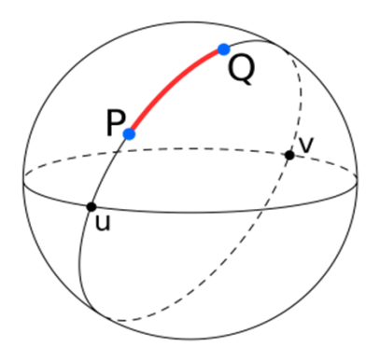

First, convert the latitude and longitude values from decimal degrees to radians. For this divide the values of longitude and latitude of both the points by 180/pi. The value of pi is 22/7. The value of 180/pi is approximately 57.29577951. If we want to calculate the distance between two places in kilometres, use the value 6, 378.8, which is the radius of Earth.

Value of Latitude ( ) in Radians, lat = Latitude / (180/pi) OR

Value of Latitude in Radians, lat = Latitude / 57.29577951

Value of Longitude ( )in Radians, long = Longitude / (180/pi) OR

Value of Longitude in Radians, long = Longitude / 57.29577951

To get the distance between point P and point Q use the following formula:

$$d=2r*\sin^{-1}{\sqrt{\sin{\frac{ϕ2-ϕ1}{2}}+\cos{ϕ2}*\cos{ϕ1}*\sin^{2}{\frac{λ2-λ1}{2}}{}}}$$

Database Used:

<https://www.kaggle.com/datasets/yasserh/uber-fares-dataset>

Python: Colab, spider or similar platform

YT Ref: --------

Code (As attached) & Graphs (wherever applicable): ------

Metrics used for performance measurement: ________

Conclusion: Uber data set gives distances of locations in longitude and latitude. The Haversine distance formula is used to find the distance in KM. the linear regression model developed using distance and fare, is used to predict the next fare if distance is provided.