STUDENT DATA

using System;

using System.Collections.Generic;

using System.Linq;

using System.Text;

using System.Threading.Tasks;

namespace ConsoleApplication3

{

class studentdata

{

struct Student

{

public string studid, name, cname;

public int day, month, year;

}

static void Main(string[] args)

{

{

Student[] s = new Student[2];

int i;

for (i = 0; i < 2; i++)

{

Console.Write("Enter Student Id:");

s[i].studid = Console.ReadLine();

Console.Write("Enter Student name : ");

s[i].name = Console.ReadLine();

Console.Write("Enter Course name : ");

s[i].cname = Console.ReadLine();

Console.Write("Enter date of birth\n Enter day(1-31):");

s[i].day = Convert.ToInt32(Console.ReadLine());

Console.Write("Enter month(1-12):");

s[i].month = Convert.ToInt32(Console.ReadLine());

Console.Write("Enter year:");

s[i].year = Convert.ToInt32(Console.ReadLine());

}

Console.WriteLine("\n\nStudent's List\n");

for (i = 0; i < 2; i++)

{

Console.WriteLine("\nStudent ID : " + s[i].studid);

Console.WriteLine("\nStudent name : " + s[i].name);

Console.WriteLine("\nCourse name : " + s[i].cname);

Console.WriteLine("\nDate of birth(dd-mm-yy) : " + s[i].day + "-" + s[i].month + "-" + s[i].year);

Console.ReadKey();

}

}

}

}

}

DELEGATE

using System;

using System.Collections.Generic;

using System.Linq;

using System.Text;

using System.Threading.Tasks;

namespace ConsoleApplication3

{

public delegate void rectangle(int x,int y);

class rect

{

public void area(int x, int y) {

Console.WriteLine("Area of Rectangle is :" + (x * y));

}

public void perimeter(int x, int y)

{

Console.WriteLine("Area of Rectangle is :" + 2*(x+ y));

}

public static void Main(string[] args) {

rect r = new rect();

rectangle obj = r.area;

obj += r.perimeter;

obj(3, 5);

Console.ReadLine();

}

}

}

INTERFACE

using System;

using System.Collections.Generic;

using System.Linq;

using System.Text;

using System.Threading.Tasks;

namespace ConsoleApplication3

{

interface area

{

void compute(double x);

}

class square : area

{

public void compute(double x)

{

Console.WriteLine("Area of Square " + (x * x));

}

}

class circle : area

{

public void compute(double x)

{

Console.WriteLine("Area of Circle " + (3.14 * x * x));

}

class Program

{

static void Main(string[] args)

{

square s = new square();

circle c = new circle();

area a;

a = s as area;

a.compute(4);

a = c as area;

a.compute(4);

Console.ReadLine();

}

}

}

}

COMPLEX NUMBER(operator overloading)

using System;

using System.Collections.Generic;

using System.Linq;

using System.Text;

using System.Threading.Tasks;

namespace ConsoleApplication3

{

class complex {

int real, img;

public void accept() {

Console.WriteLine("Enter Real part");

real = Convert.ToInt16(Console.ReadLine());

Console.WriteLine("Enter Imaginary part");

img = Convert.ToInt16(Console.ReadLine());

}

public void disp() {

Console.WriteLine(real + "+" + img + "i");

}

public static complex operator -(complex c1, complex c2) {

complex c3 = new complex();

c3.real = c1.real - c2.real;

c3.img = c1.img - c2.img;

return c3;

}

}

class Class2

{

public static void Main(string[] args) {

complex c1 = new complex();

complex c2 = new complex();

complex c3 = new complex();

c1.accept();

c2.accept();

c3 = c1 - c2;

c1.disp();

c2.disp();

Console.WriteLine("Difference Between tow Complex Numver is :");

c3.disp();

Console.ReadLine();

}

}

}

**Calendar Controls**

**Specific Date**

protected void Calendar1_DayRender(object sender, DayRenderEventArgs e)

{

if (e.Day.Date.Day == 18 && e.Day.Date.Month==10) {

e.Cell.Controls.Add(new LiteralControl("<br>Holiday"));

}

**Range of holiday**

protected void Calendar1_DayRender(object sender, DayRenderEventArgs e)

{

if (e.Day.Date >= new DateTime(2022, 10, 17) && e.Day.Date <= new DateTime(2022, 10, 25))

{

e.Cell.BackColor = System.Drawing.Color.AntiqueWhite;

}

}

**Difference between two calendar**

protected void Button1_Click(object sender, EventArgs e)

{

TimeSpan t = Calendar2.SelectedDate - Calendar3.SelectedDate;

Label1.Text="The Difference between tow calender is "+ t.Days.ToString();

}

**Ad Rotator**

<?xml version="1.0" encoding="utf-8" ?>

<Advertisements>

<Ad>

<ImageUrl>1.jpg</ImageUrl>

<NavigateUrl>https://google.com</NavigateUrl>

<Impressions>3</Impressions>

<AlternateText>Koala</AlternateText>

</Ad>

<Ad>

<ImageUrl>2.jpg</ImageUrl>

<NavigateUrl>https://w3schools.com</NavigateUrl>

<Impressions>3</Impressions>

<AlternateText>Penguins</AlternateText>

</Ad>

</Advertisements>

**Viewstate**

using System;

using System.Collections.Generic;

using System.Linq;

using System.Web;

using System.Web.UI;

using System.Web.UI.WebControls;

public partial class _Default : System.Web.UI.Page

{

protected void Page_Load(object sender, EventArgs e)

{

}

protected void Button1_Click(object sender, EventArgs e)

{

ViewState["name"] = TextBox1.Text;

ViewState["password"] = TextBox2.Text;

TextBox1.Text = "";

TextBox2.Text = "";

}

protected void Button2_Click1(object sender, EventArgs e)

{

TextBox3.Text = ViewState["name"].ToString();

TextBox4.Text = ViewState["password"].ToString();

}

}

**Cookies**

using System;

using System.Collections.Generic;

using System.Linq;

using System.Web;

using System.Web.UI;

using System.Web.UI.WebControls;

public partial class _Default : System.Web.UI.Page

{

protected void Page_Load(object sender, EventArgs e)

{

}

protected void Button1_Click(object sender, EventArgs e)

{

Response.Cookies["name"].Value = TextBox1.Text;

Response.Cookies["name"].Expires = DateTime.Now.AddMinutes(1);

Label2.Text = "Cookies created";

}

protected void Button2_Click(object sender, EventArgs e)

{

if (Request.Cookies["name"] == null)

Label2.Text = "No Cookies created";

else

Label2.Text = Request.Cookies["name"].Value;

}

}

**Practical 6(a same as b**

Create a web application bind data in a multiline textbox by querying in another textbox.

using System;

using System.Collections.Generic;

using System.Linq;

using System.Web;

using System.Web.UI;

using System.Web.UI.WebControls;

using System.Data.SqlClient;

public partial class Default2 : System.Web.UI.Page

{

SqlConnection con = new SqlConnection("Data Source=(LocalDB)\\v11.0;AttachDbFilename=C:\\Users\\krish\\OneDrive\\Desktop\\AWP\\insertdelete\\App_Data\\Database.mdf;Integrated Security=True");

protected void Page_Load(object sender, EventArgs e)

{

}

protected void Button1_Click(object sender, EventArgs e)

{

string selquery = "select * from student where name= '"+TextBox1.Text+ "'; ";

SqlCommand cmd = new SqlCommand(selquery, con);

con.Open();

SqlDataReader dr =cmd.ExecuteReader();

while (dr.Read())

{

TextBox2.Text += dr[0].ToString() + "\t" + dr[1].ToString() + "\t" + dr[2].ToString() + "\n";

}

}

}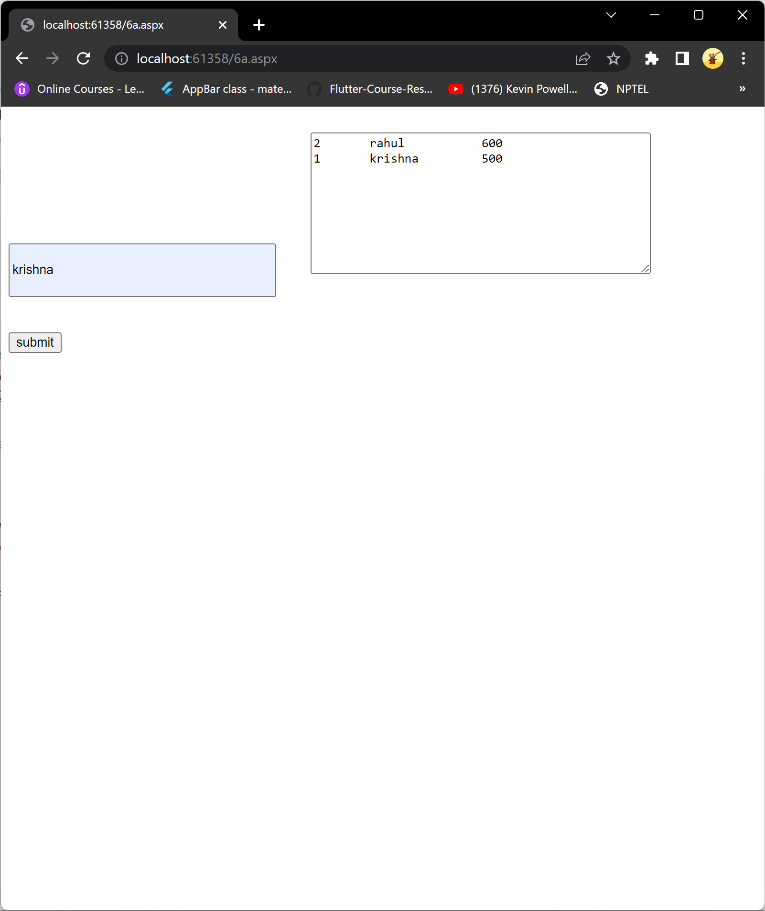

**B)**

Create a web application to display records by using database.

using System;

using System.Collections.Generic;

using System.Linq;

using System.Web;

using System.Web.UI;

using System.Web.UI.WebControls;

using System.Data.SqlClient;

public partial class Default3 : System.Web.UI.Page

{

SqlConnection con = new SqlConnection("Data Source=(LocalDB)\\v11.0;AttachDbFilename=C:\\Users\\krish\\OneDrive\\Desktop\\AWP\\insertdelete\\App_Data\\Database.mdf;Integrated Security=True");

protected void Page_Load(object sender, EventArgs e)

{

}

protected void Button1_Click(object sender, EventArgs e)

{

string selquery = "select * from student where Id='" + TextBox1.Text + "'; ";

SqlCommand cmd = new SqlCommand(selquery, con);

con.Open();

SqlDataReader dr = cmd.ExecuteReader();

while (dr.Read())

{

Label1.Text += dr[1].ToString() + "\n";

}

}

}



**Practical 6(c** ----datalist link;

Demonstrate the use of Datalist link control.

Practical-7(a same as 6-b,7-b

Create a web application to display Databinding using dropdownlist control.

using System;

using System.Collections.Generic;

using System.Linq;

using System.Web;

using System.Web.UI;

using System.Web.UI.WebControls;

using System.Data.SqlClient;

public partial class Default3 : System.Web.UI.Page

{

SqlConnection con = new SqlConnection("Data Source=(LocalDB)\\v11.0;AttachDbFilename=C:\\Users\\krish\\OneDrive\\Desktop\\AWP\\insertdelete\\App_Data\\Database.mdf;Integrated Security=True");

protected void Page_Load(object sender, EventArgs e)

{

}

protected void Button1_Click(object sender, EventArgs e)

{

string selquery = "select * from student";

SqlCommand cmd = new SqlCommand(selquery, con);

con.Open();

SqlDataReader dr = cmd.ExecuteReader();

DropDownList1.DataSource = dr;

DropDownList1.DataTextField = "name";

DropDownList1.DataBind();

}

protected void DropDownList1_SelectedIndexChanged(object sender, EventArgs e)

{

TextBox1.Text = DropDownList1.Text;

}

}

Output

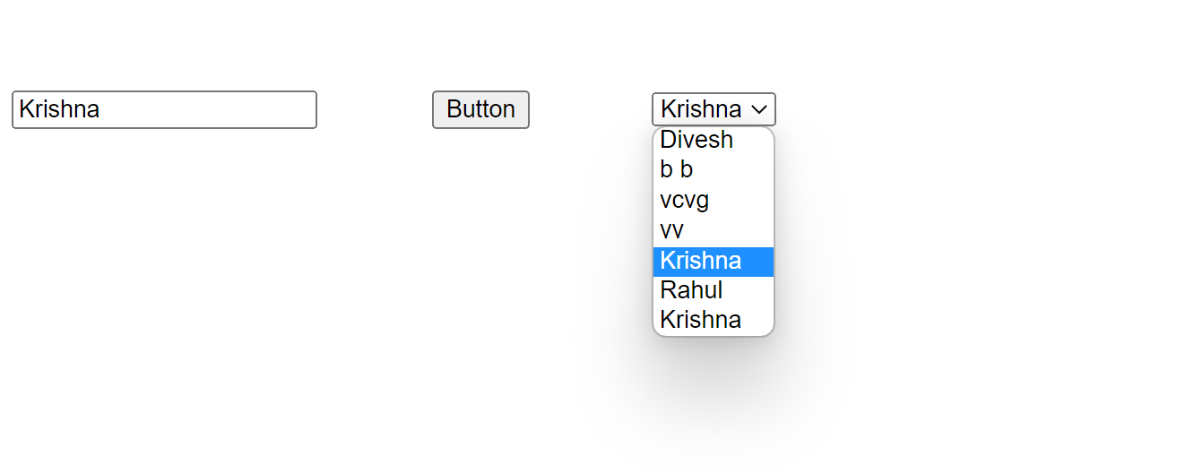

Practical-7(b(same as pract 6b)

Create a web application for to display the phone no of an author using database.

using System;

using System.Collections.Generic;

using System.Linq;

using System.Web;

using System.Web.UI;

using System.Web.UI.WebControls;

using System.Data.SqlClient;

public partial class Default3 : System.Web.UI.Page

{

SqlConnection con = new SqlConnection("Data Source=(LocalDB)\\v11.0;AttachDbFilename=C:\\Users\\krish\\OneDrive\\Desktop\\AWP\\insertdelete\\App_Data\\Database.mdf;Integrated Security=True");

protected void Page_Load(object sender, EventArgs e)

{

}

protected void Button1_Click(object sender, EventArgs e)

{

string selquery = "select * from student where Id='" + TextBox1.Text + "'; ";

SqlCommand cmd = new SqlCommand(selquery, con);

con.Open();

SqlDataReader dr = cmd.ExecuteReader();

while (dr.Read())

{

Label1.Text += dr[3].ToString() + "\n";

}

}

}

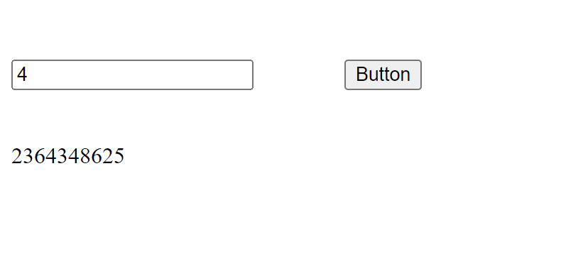

Practical-7(c & pract 8(a

7c)Create a web application for inserting and deleting record from a database. (Using

Execute-Non Query)

8a) Create a web application to demonstrate various uses and properties of SqlDataSource

using System;

using System.Collections.Generic;

using System.Linq;

using System.Web;

using System.Web.UI;

using System.Web.UI.WebControls;

using System.Data.SqlClient;

public partial class _Default : System.Web.UI.Page

{

SqlConnection con = new SqlConnection("Data Source=(LocalDB)\\v11.0;AttachDbFilename=C:\\Users\\krish\\OneDrive\\Desktop\\AWP\\insertdelete\\App_Data\\Database.mdf;Integrated Security=True");

protected void Page_Load(object sender, EventArgs e)

{

}

protected void Button1_Click(object sender, EventArgs e)

{

string insquery = "insert into student values(@id, @name, @city)";

SqlCommand cmd = new SqlCommand(insquery, con);

cmd.Parameters.AddWithValue("@id", TextBox1.Text);

cmd.Parameters.AddWithValue("@name", TextBox2.Text);

cmd.Parameters.AddWithValue("@city", TextBox3.Text);

con.Open();

cmd.ExecuteNonQuery();

Label1.Text = "record inserted successfully";

}

protected void Button2_Click(object sender, EventArgs e)

{

string delquery = "delete from student where id=@id";

SqlCommand cmd = new SqlCommand(delquery, con);

cmd.Parameters.AddWithValue("@id", TextBox1.Text);

con.Open();

cmd.ExecuteNonQuery();

Label1.Text = "record deleted successfully";

}

protected void Button3_Click(object sender, EventArgs e)

{

string delquery = "update student SET name=@name where id=@id;";

SqlCommand cmd = new SqlCommand(delquery, con);

cmd.Parameters.AddWithValue("@id", TextBox1.Text);

cmd.Parameters.AddWithValue("@name", TextBox2.Text);

con.Open();

cmd.ExecuteNonQuery();

Label1.Text = "record Updated successfully";

}

protected void Button4_Click(object sender, EventArgs e)

{

SqlDataSource s = new SqlDataSource();

s.SelectCommand = "select * from students;";

GridView1.DataBind();

}

}

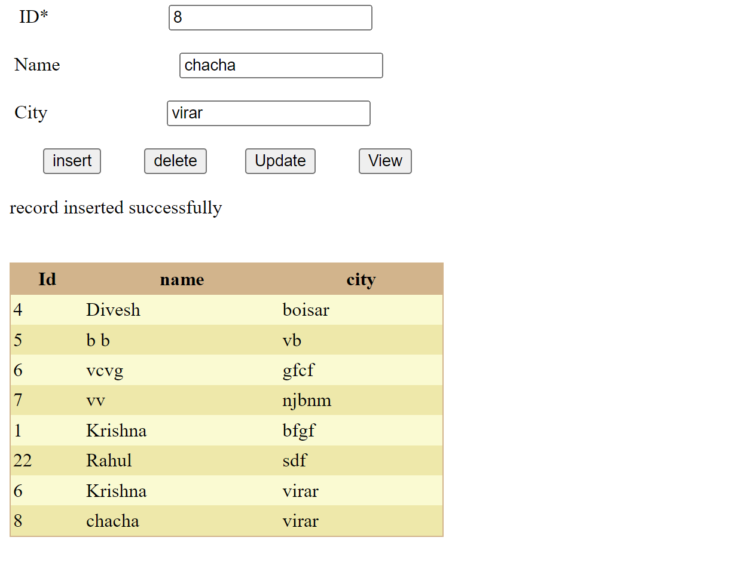 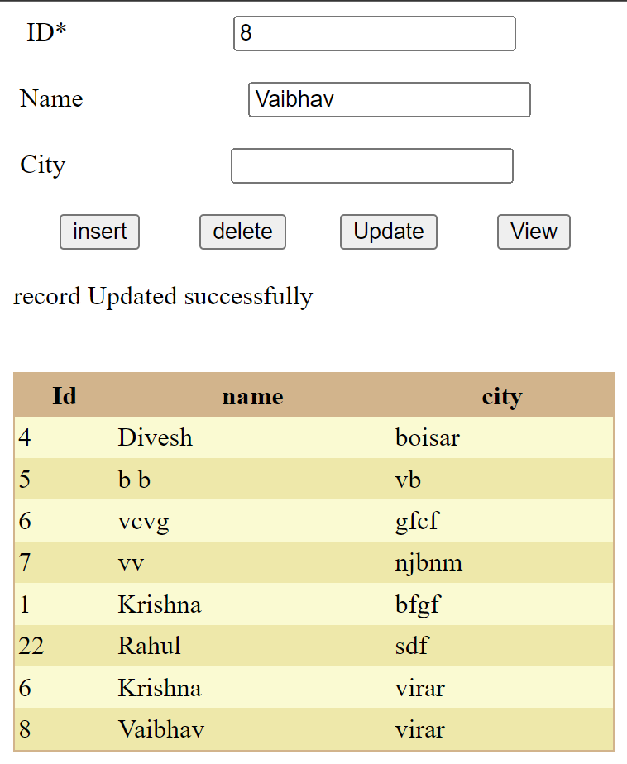

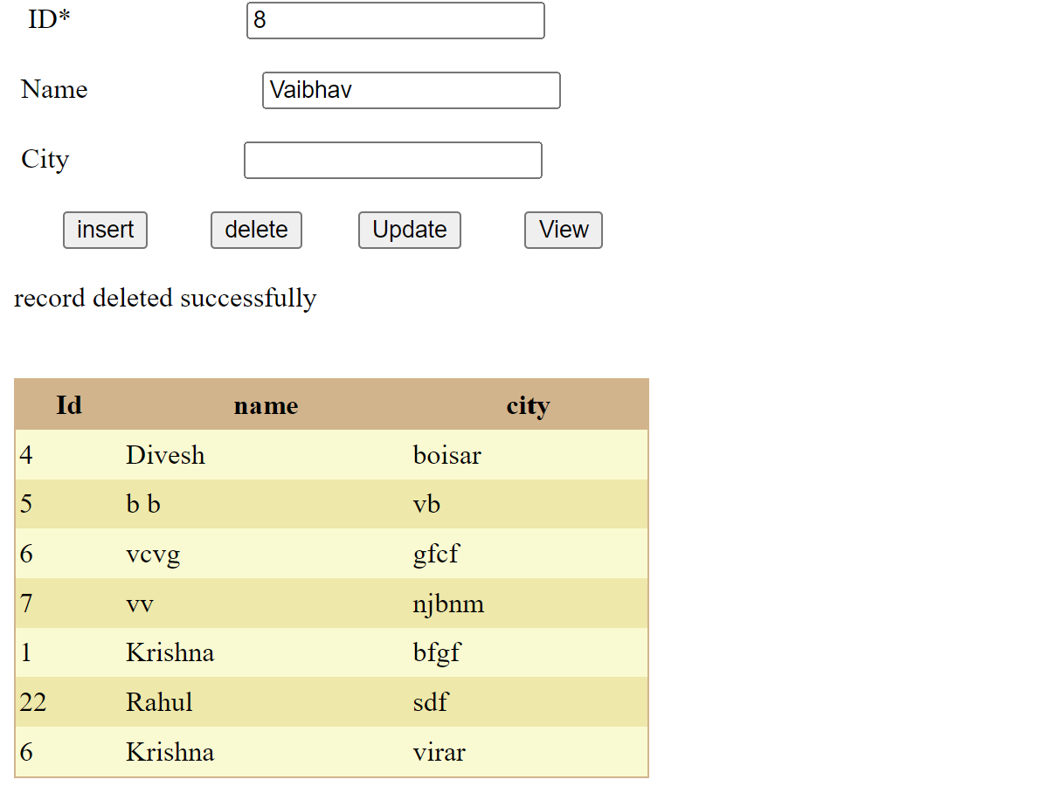

B)

Create a web application to demonstrate data binding using DetailsView and FormView

Control.

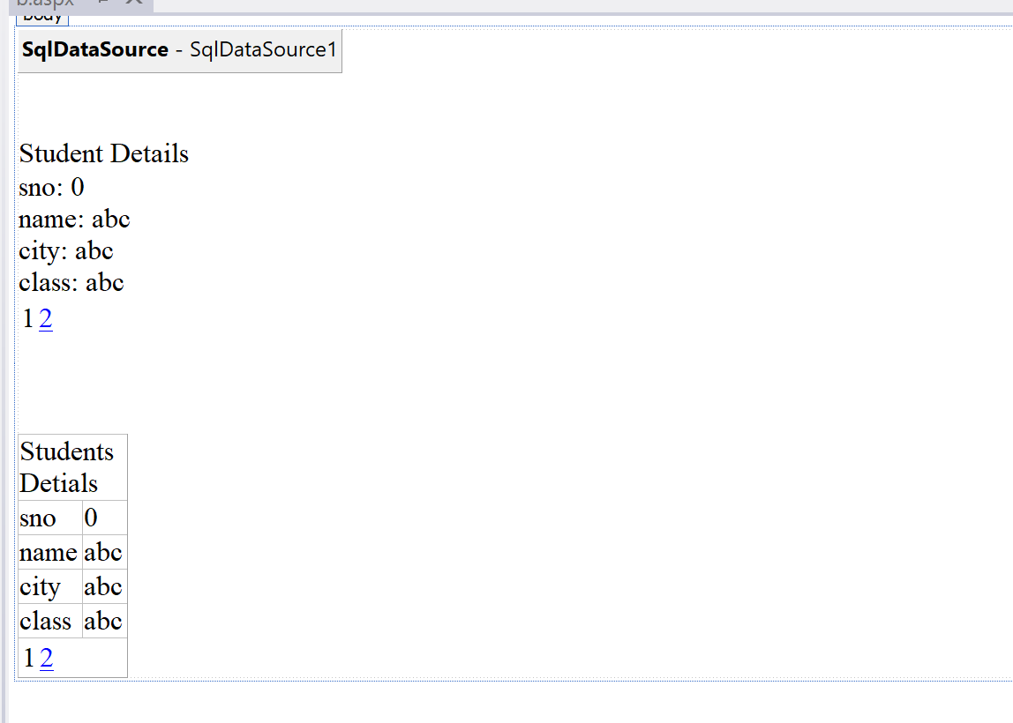

C)Disconnected mode

Create a web application to display Using Disconnected Data Access and Databinding

using GridView.

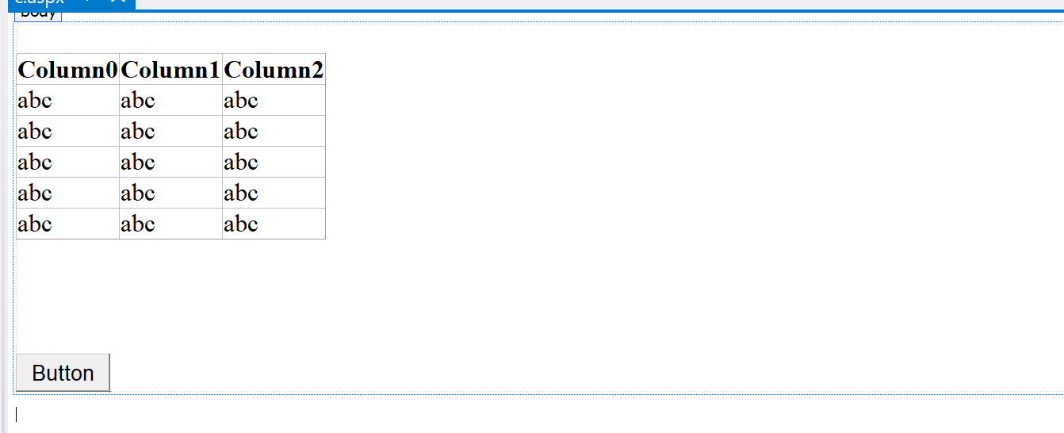

using System;

using System.Collections.Generic;

using System.Linq;

using System.Web;

using System.Web.UI;

using System.Web.UI.WebControls;

using System.Data.SqlClient;

using System.Data;

public partial class c : System.Web.UI.Page

{

SqlConnection con = new SqlConnection("Data Source=(LocalDB)\\v11.0;AttachDbFilename=C:\\Users\\krish\\OneDrive\\Desktop\\AWP\\8\\App_Data\\Database2.mdf;Integrated Security=True");

protected void Page_Load(object sender, EventArgs e)

{

}

protected void Button1_Click(object sender, EventArgs e)

{

SqlDataAdapter da = new SqlDataAdapter("select * from details", con);

DataSet ds = new DataSet();

da.Fill(ds, "details");

GridView1.DataSource = ds;

GridView1.DataBind();

}

}

Output

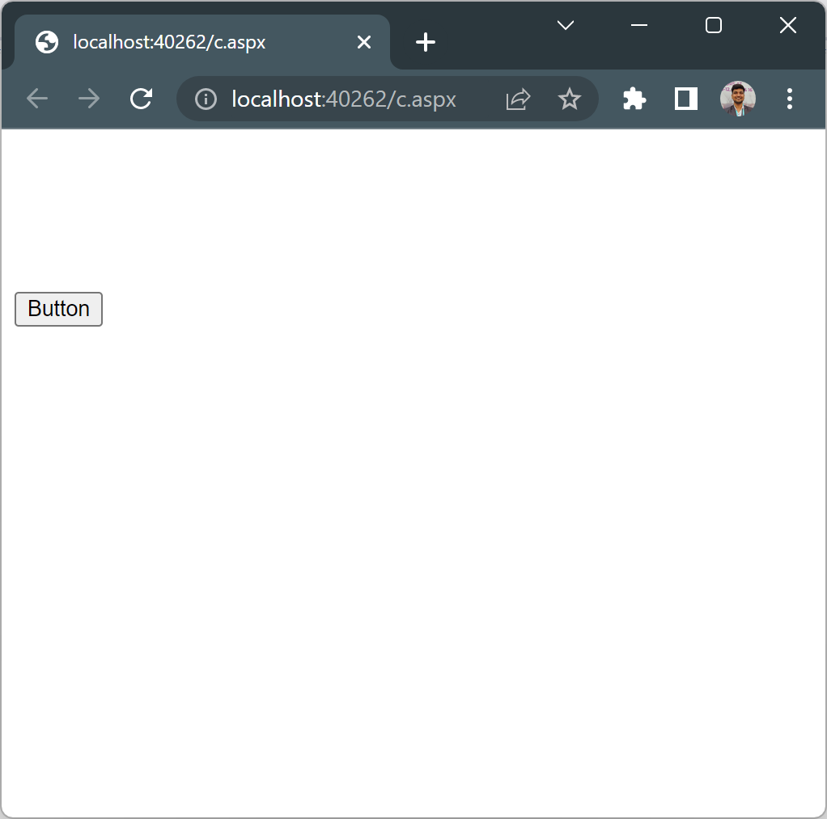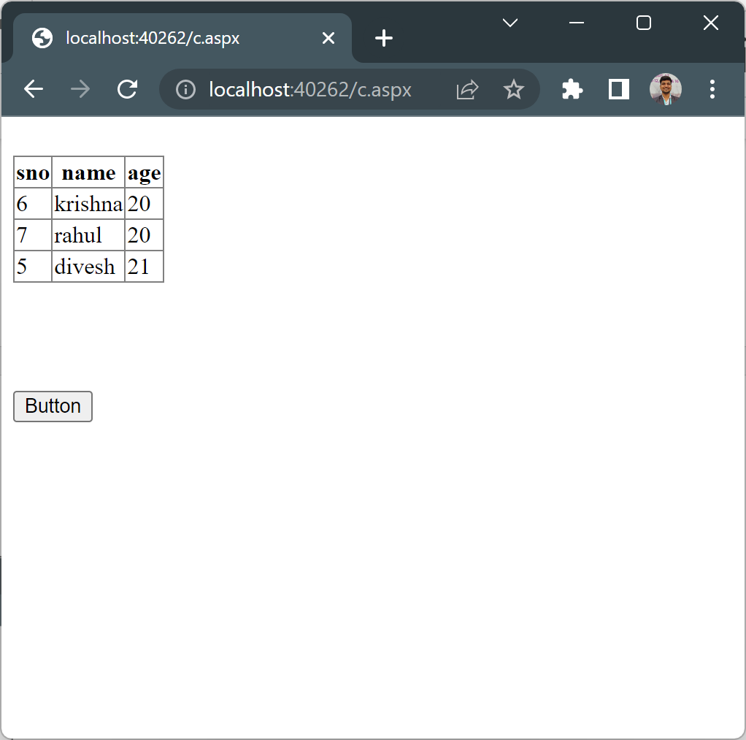

-------------------------or----------------------

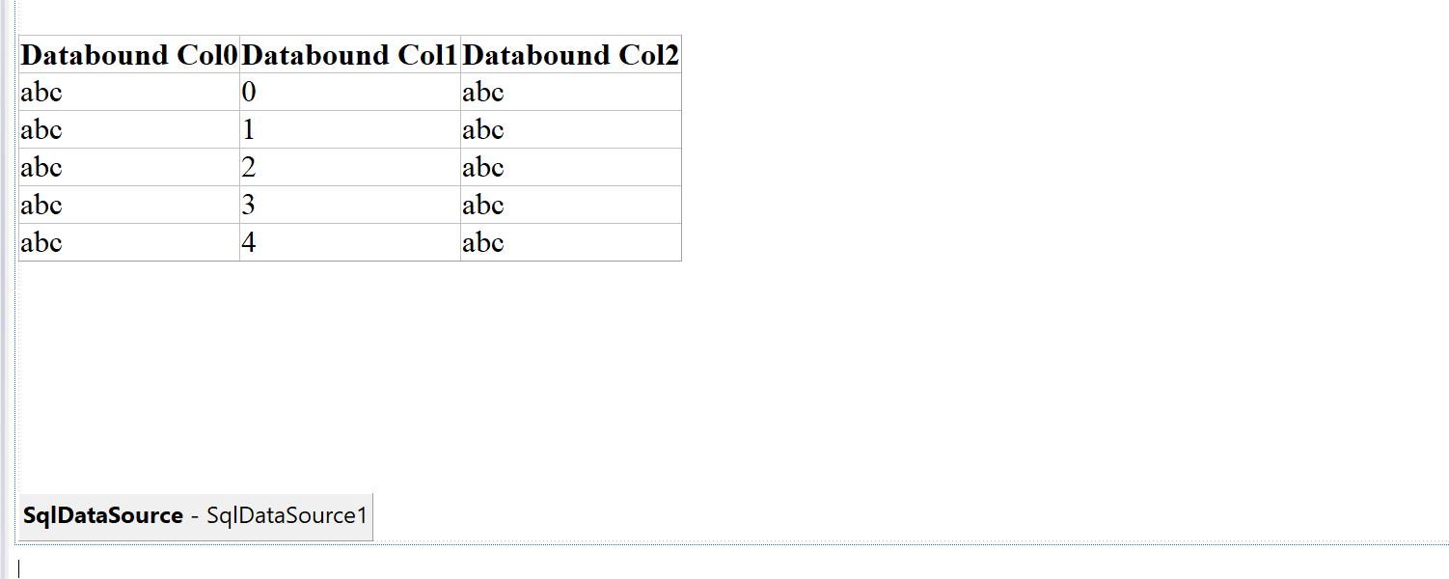

Output

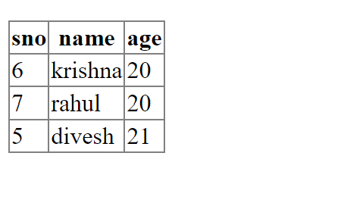

Practical-9

A)-Part 1

Create a web application to demonstrate use of GridView control template and GridView

hyperlink.

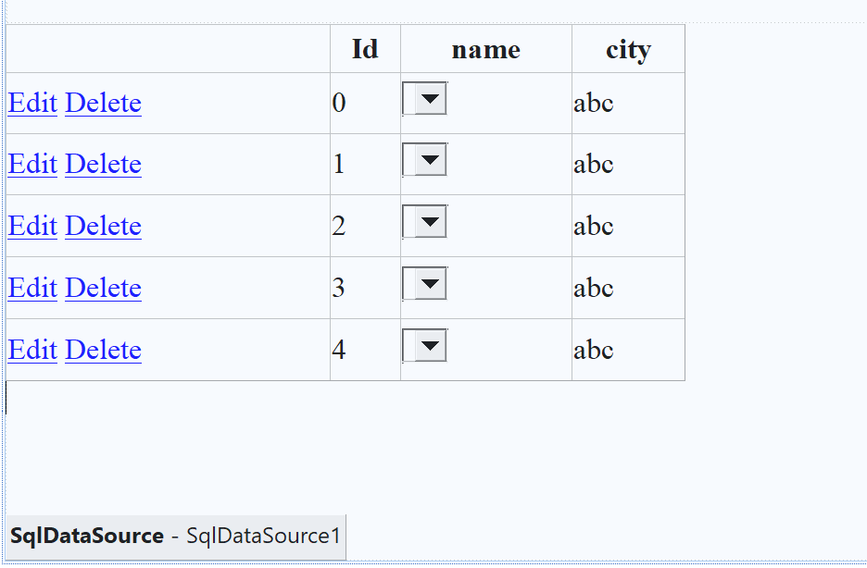

Output

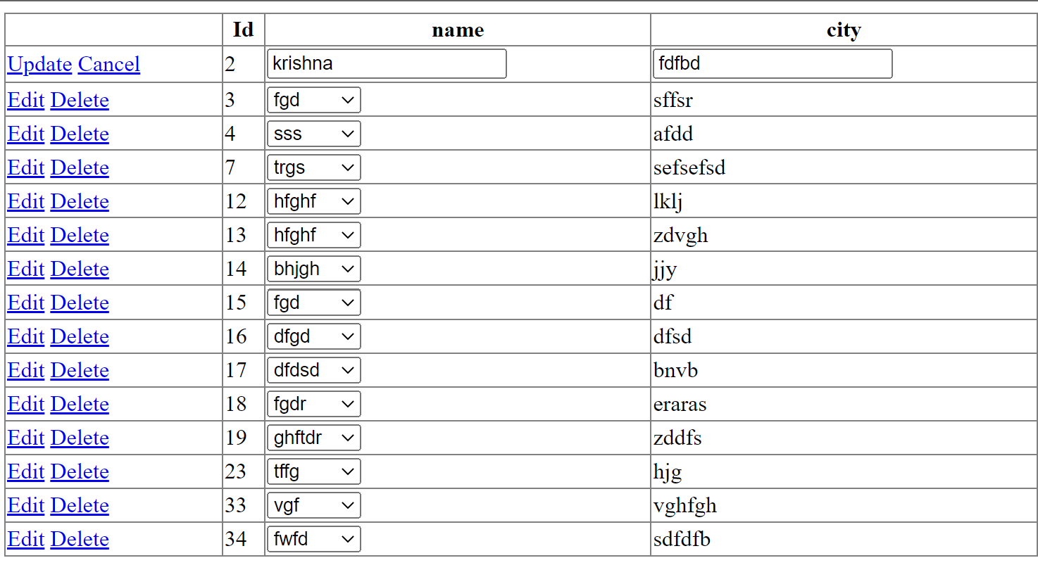

A)-Part 2

Create a web application to demonstrate use of GridView control template and GridView

hyperlink.

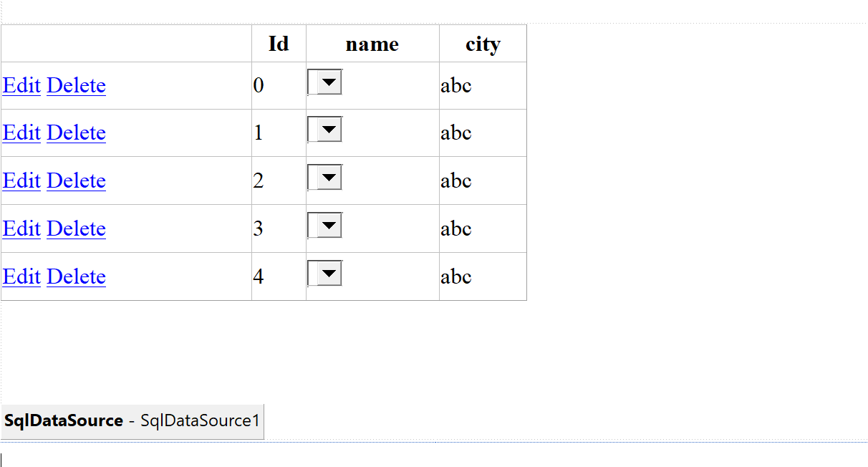 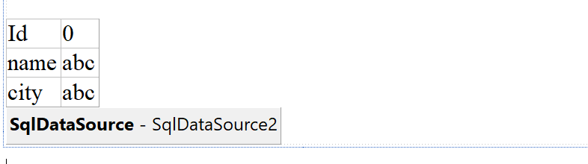

Output

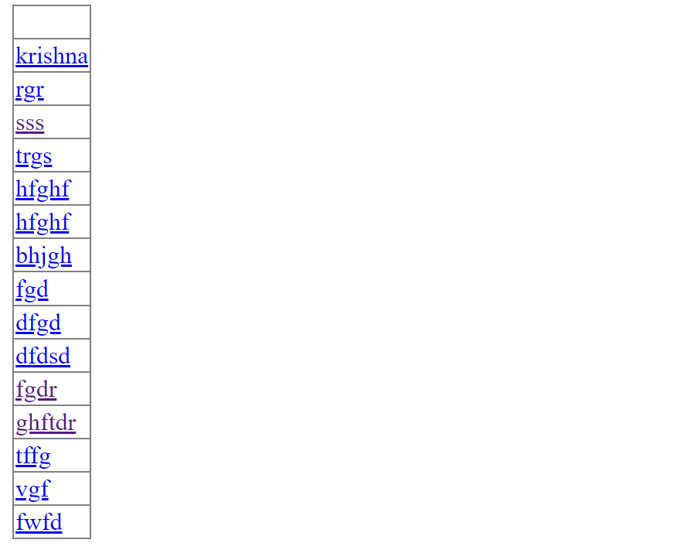

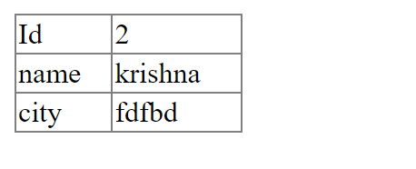

B)

Create a web application to demonstrate use of GridView button column and GridView

events.

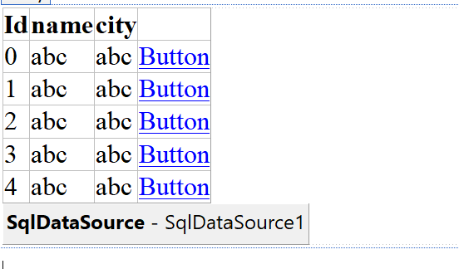

Code

using System;

using System.Collections.Generic;

using System.Linq;

using System.Web;

using System.Web.UI;

using System.Web.UI.WebControls;

public partial class b : System.Web.UI.Page

{

protected void Page_Load(object sender, EventArgs e)

{

}

protected void GridView1_RowCommand(object sender, GridViewCommandEventArgs e)

{

if (e.CommandName == "b1") {

GridView1.Rows[Convert.ToInt32(e.CommandArgument)].BackColor = System.Drawing.Color.Aquamarine;

}

}

}

output

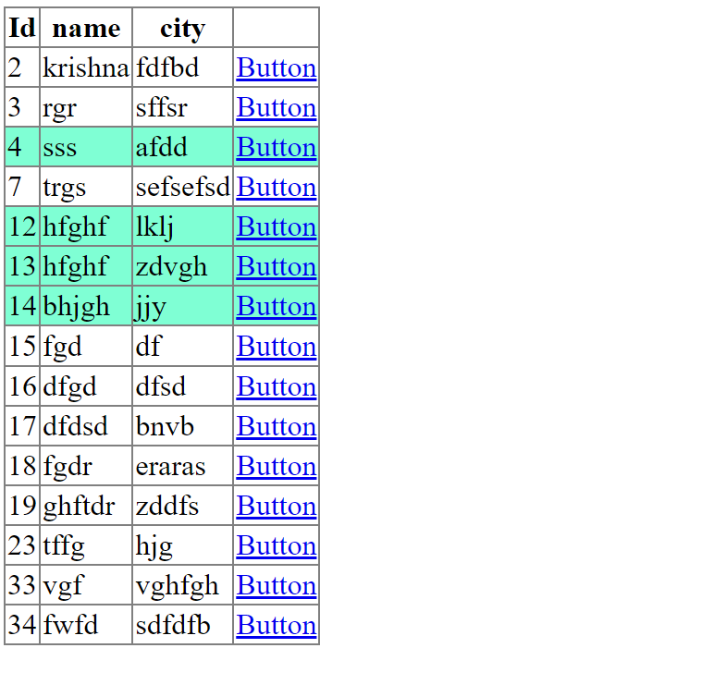

C

Create a web application to demonstrate GridView paging and Creating own table format

using GridView

Output

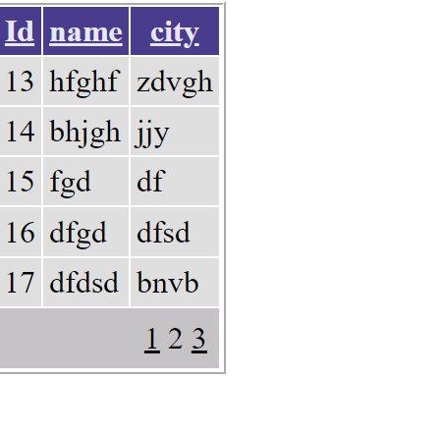

Practical-10

A)XML Read/write

Create a web application to demonstrate reading and writing operation with XML.

using System;

using System.Collections.Generic;

using System.Linq;

using System.Web;

using System.Web.UI;

using System.Web.UI.WebControls;

using System.Xml;

using System.Data;

public partial class xmlwriter : System.Web.UI.Page

{

protected void Page_Load(object sender, EventArgs e)

{

}

protected void Button1_Click(object sender, EventArgs e)

{

XmlTextWriter wr = new XmlTextWriter("C:\\Users\\krish\\OneDrive\\Desktop\\AWP\\kk.xml",null);

wr.WriteStartDocument();

wr.WriteStartElement("Details");

wr.WriteElementString("Firstname","Krishna");

wr.WriteElementString("Lastname", "Chaurasiya");

wr.WriteElementString("Id", "06");

wr.WriteEndElement();

wr.WriteEndDocument();

wr.Close();

Label1.Text = "Successfully data Written";

}

protected void Button3_Click(object sender, EventArgs e)

{

DataSet ds = new DataSet();

string xmlnode = "C:\\Users\\krish\\OneDrive\\Desktop\\AWP\\kk.xml";

ds.ReadXml(xmlnode);

GridView1.DataSource = ds.Tables[0].DefaultView;

GridView1.DataBind();

}

}

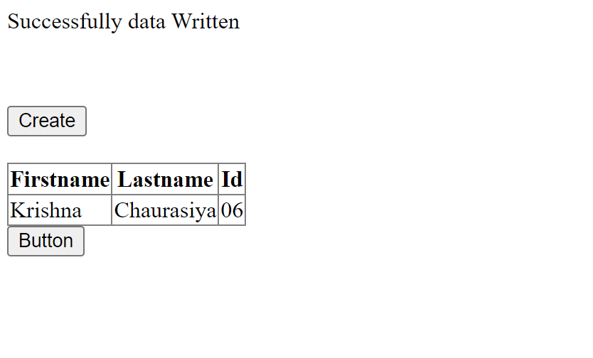

B)AJAX

Create a web application to demonstrate use of various Ajax controls.

using System;

using System.Collections.Generic;

using System.Linq;

using System.Web;

using System.Web.UI;

using System.Web.UI.WebControls;

public partial class _Default : System.Web.UI.Page

{

protected void Page_Load(object sender, EventArgs e)

{

System.Threading.Thread.Sleep(200);

}

protected void Button1_Click(object sender, EventArgs e)

{

Label1.Text = DateTime.Now.ToLongTimeString();

}

}

output

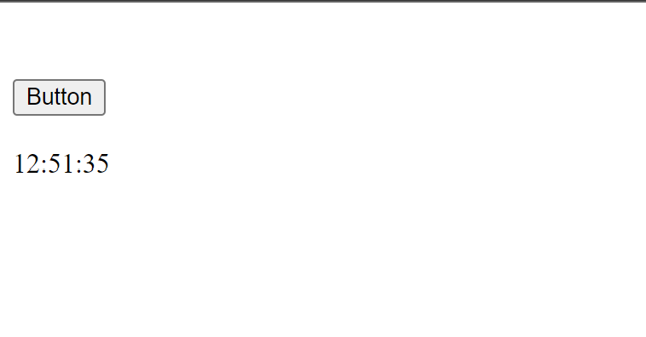

Postback(Viewstate)

using System;

using System.Collections.Generic;

using System.Linq;

using System.Web;

using System.Web.UI;

using System.Web.UI.WebControls;

public partial class viewstate : System.Web.UI.Page

{

protected void Page_Load(object sender, EventArgs e)

{

if (IsPostBack) {

string str = "Krishna Chaurasiya";

if (ViewState["data"] == null) {

ViewState["data"] = str;

}

}

}

protected void Button1_Click(object sender, EventArgs e)

{

Label1.Text = ViewState["data"].ToString();

}

}

