**You don’t need to the build he UI**. You have to build a Spring boot RestController web services for the below mentioned program as microservices

Try implementing the following scenario.

.

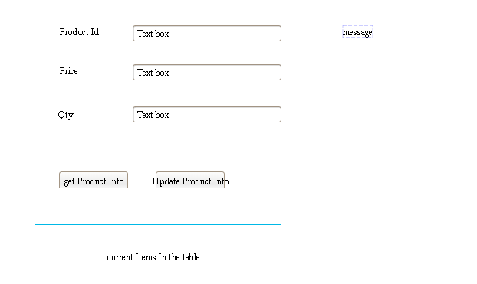

1. Create a product table in the database and insert some rows directly in mysql console itself and start coding.
2. When we give product Id, the product details ie price and qty should come from the product table. Take care of productid found and not found.
3. we give new values for Price and Qty and then we need a function that updates price and qty for the given productid
   1. Only price and qty needs an update and not productid.
   2. The details should be updated in the database.
4. If possible write a function that gives all the current rows in the table.