Build case study using core java service layer and dao layer and add DS to it

If presentation is important, build a react UI or Python serivce , UI need not match the same as mentioned functionality wise it should match.

1. Scenario
   1. Login, Logout Features
   2. import a csv file and push it to the database
      1. do queries
      2. single select
      3. multi select
      4. update
   3. export results to pdf or csv file.
   4. on need basis more logic can be added.
2. some screen shots.
   1. first level of logic is to build service and dao layer for the scenarios
   2. in case required additional logic can be added and also UI changes can be suggested to make the UI look more relevant …

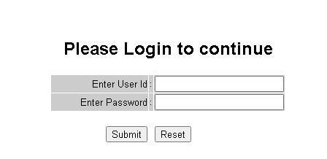

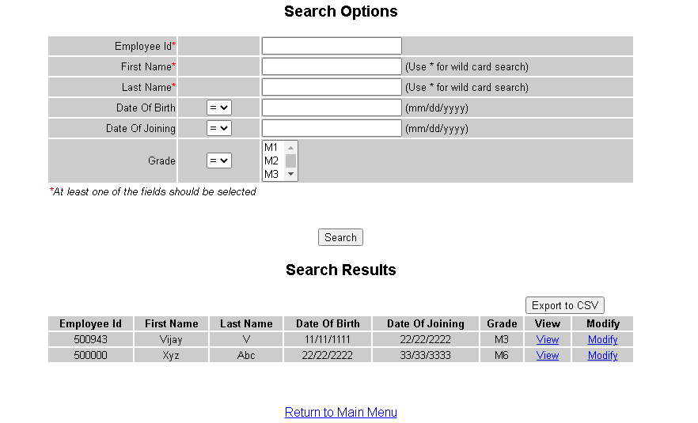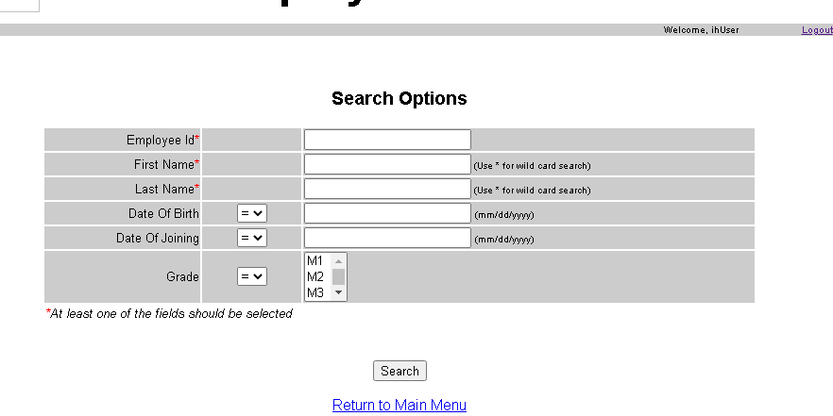

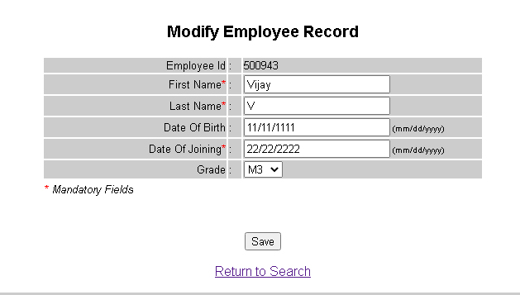

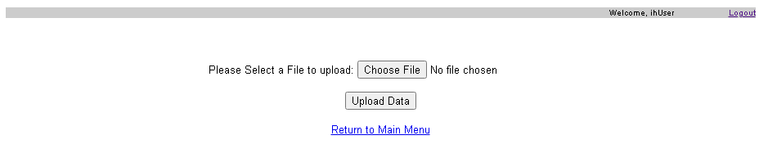

Another domain data.

json

{

"productionData": [

{

"machineId": "M1",

"output": 120,

"efficiency": 85,

"downtime": 5

},

{

"machineId": "M2",

"output": 100,

"efficiency": 90,

"downtime": 15

}

],

"alerts": [

{

"message": "Machine M2 has exceeded 10 minutes of downtime.",

"timestamp": "2024-09-29T10:00:00Z"

}

]

}