

**Project Planning Report**

**CS6003ES – Advance Software Engineering**

**Coursework 2**

Submitted By,

K.Thuvarakan - 18031315

S.Kishanth - 18031315

**Acknowledgement**

We are very thankful to everyone who all supported us, to complete this course work successfully.

Also, we are equally grateful to our coordinator and Lecturer **Mr Mithurshanan and Lectures**. they gave us moral support and guided us in different matters regarding this course work. They had been very kind and patient while suggesting us the outlines of this course work and correcting our doubts. All group members thank him for his overall supports.

We would like to thanks London Metropolitan University and ESOFT Metro Campus for giving us this enormous opportunity to develop our skills in the field to Application Development and helping to improve our knowledge further.

Last but not the least; we would like to thank our parents who supported us a lot in doing course work successfully.

Thank you

**Table of Content**

Table of Contents

**Acknowledgement** 2

1. Introduction 4

1. Generic Plan Information 5

Glossary 5

2. Overview 6

2.1. Purpose 8

2.2. Scope and objectives 8

2.3. Assumptions and constraints 9

2.4. Scope Management 10

2.5. Risk Management 10

2.6. Project deliverables 13

2.7. Schedules 14

2.8. Budget summary 14

3. Description of team users 15

3.1 Description of responsibilities (roles) of each team user for ABC cafeteria online food ordering system 14

4. Project organizational structure 16

4.1 Functional organizational structure 16

4.2 Project based organizational structure 17

4.3 Matrix organizational structure 17

4.4 Project organization structure for “ABC Cafeteria online food ordering” project 18

4.4 Budget Summary 19

5. Work Breakdown Structure 20

5.1. Work Breakdown Structure (WBS) 20

5.2 Schedule of the Project 27

5.3 Gantt chart 29

5.3 Activity on node diagram 36

5.4 Milestones of the project 37

5.4 Rationale for set of milestones 37

References 39

# Introduction

This report is the project plan developed for the ABC Cafeteria management system. It describes the generic plan information, overview of the project with the objectives and the scope. In task two, the scope management, risk management and the summary of the communication plan is given. There are eight people who are engaged in the project including the project manager and brief description of each team user along with their salary information is also provided. As the duration for the project is three months, the work breakdown structure of the project, organizational hierarchy and the project Gantt chart is given at the end of the report.

# 1. Generic Plan Information

Version 1.0

Issuing organization: XYZ Ltd

Date of issue: 17/09/2019

Status: **Ongoing**

## Glossary

The following are the list of conventions and acronyms used in the document:

Document Conventions

Entire document should be justified.

Line spacing for text is 1.5.

The references are written according to the Harvard format.

Convention for Main title

Font face: Times New Roman

Font style: Bold

Font Size: 14

Convention for Sub title

Font face: Times New Roman

Font style: Bold

Font Size: 12

Convention for body

Font face: Times New Roman

Font Size: 12

Acronyms

- IEEE: Institute of Electrical and Electronics Engineers

- GUI: Graphical User Interface

- SRS: Software Requirements Specification

- SQL: Structured Query Language

- CSS: Cascading Style Sheet

- HTML: Hyper Text Markup Language

- WBS: Work Breakdown Structure

- SDLC: System Development Life Cycle

- UML: Unified Modeling Language

- Database: A Collection of information stored in an electronic format that can be searched by a computer

- Web based application: An application use over the internet with a web browser.

# 2. Overview

ABC cafeteria wishes to move with Online ordering and delivering system for the requirement of fast foods delivery. They are selling Chinese foods and Sri Lankan food items. They are taking delivery orders only within 3 km from their shop. The customers can visit the shop and buy the foods also. Dine-in is not permitted. The customers can be Registered customers and the Non-Registered customers. We are required to design a web site to achieve above objectives. High-level system requirement as follows.

* System has two components Web server with the database and Client web Application with the Database Server.
* The users should be able to order the foods based on their preferences either Chinese or Sri Lankan foods.
* Under each category the menu items to be updated based on the availability. The available items should be marked to order, in each day morning.
* For each and every item, The Quantity which could be prepared will be marked and if it is exceeded the item should be automatically removed from the available list.
* The prices are fixed for each item.
* The customer can go to the web and login if he is a loyal customer or else select the menu and choose the type of Item from the menu – Chinese or Sri Lankan.
* The customer can select the main dishes and side dishes with the quantity. After selecting all the items and the quantities the Bill amount can be automatically calculated.
* There are two options to obtain the foods Home Delivery and Take Away. If it is home delivery the mileage will be calculated and the Rs. 50/- per 1km will be charged. If it is take away the customer has to visit the shop and show the confirmation Bill number and buy foods. An 8% of Tax will be charged including the 4% of service charges for the whole bill.
* For the Loyal customers the History of purchase records can be viewed by the customer.
* After the checkout to confirm the order the payment has to be done through PayPal.
* The Bill number and the confirmation number will be issued to the customer in the Confirmation Email.
* The Chef should be able to see the orders come in and the order placement time.
* Once the order is received the Chef will mark the time period which is required to ready the order. Once the food is ready the status of the order will be changed as READY. If it is a home delivery, automatically the available delivery person will be assigned with the Order Number.
* The Customer can cancel the order before the status of the order is shown as “In Preparation”.
* If the order is “In Preparation” status and still customer needs to cancel, 50% of the total bill will be charged.
* If the Order is in READY status it cannot be cancelled.
* After assigning the person, the delivery person’s Contact Number and the name will be sent to the customer Via an Email.
* Once the foods are delivered to the customer the delivery person will update the system as Delivered. If it’s a Home delivery the counter delivery person has to mark the order as “DELIVERED”. The customer has to Confirm the delivery by using a PUSH notification SMS (YES/NO).
* The shop administrator should be able to see the Delivery and the status of the delivery through an online system.

The staff of the ABC Cafeteria has to put lot of effort in making daily, monthly and annual reports where they have to waste lot of time and accuracy of the reports are also less.

The management needs to manage their overall functionalities in an efficient and effective manner and without human processing errors. Therefore, it was decided to implement an automated online food ordering system for ABC Cafeteria.

The proposed system has the following advantages.

• User friendly interface

• Fast access to database

• More Storage Capacity

• Easy search facility of foods and users

• Quick transaction

This document will provide the project’s goals, objectives and other related information with budget plan. Additionally, the Plan will serve as an agreement between the following parties: Project Manager, Project Team, and other personnel associated with and/or affected by the project.

## 2.1. Purpose

This project has comprised on creating a web-based application for ABC Cafeteria on request of them. This project will be started on **1st September 2019** and will be completed on the

**02nd of January 2020**. The system will help to replace the manual procedure and give database storage for all data of the system.

## 2.2. Scope and objectives

**2.2.1. Scope**

The aim of this project was to develop an automated online food ordering system as a solution for the manual processing difficulties faced by “ABC Cafeteria” with the use of programming languages PHP, JavaScript.

**2.2.2. Objectives**

The main objective of the application is to automate the existing system of manually maintain the records of the food ordering, user authentication and order history, stock maintenance, catalog and food search to be computerized. So the online ordering, return and searching will be faster. Other objectives are as follows:

• Enhance the efficiency of the overall functionalities of the ABC Cafeteria.

• Achieve maximum competitive advantages by using the web site and increase the number of users to the online food ordering system.

• Reduce cost and time wasting and increase security for the information of the system by giving database storage to the information.

• Simplify search/ discovery of food items.

• A proper way to handle orders and chefs.

• Evaluation of the developed system

## 2.3. Assumptions and constraints

**2.3.1. Assumptions**

• All project participants will abide by the guidelines identified within this plan.

• Project team users shall adhere to the Communications Plan.

• Failure to identify changes to draft deliverables within the time specified in the project timeline will result in project delays.

• The Project Plan may change as new information and issues are revealed.

• Project manager will ensure that project team users are available as needed to complete project tasks and objectives.

**2.3.2. Constraints**

**Project constraints**

The following represent known project constraints:

* Project funding sources are limited, with no contingency.
* The project must be completed within 3 months of time.
* The development of the system will be constrained by the availability of required software such as database and development tools.

**Critical Project barriers**

Unlike risks, critical project barriers are insurmountable issues that can be destructive to a

project’s initiative. In this project, the following are possible critical barriers:

• Removal of project funding

• Natural disasters or acts of war

The Project Plan would become invalid if any of above project barriers occurred.

## 2.4. Scope Management

• System shall facilitate to keep records of complete information of different kinds of foods and able to classify them according to category wise.

• System shall facilitate to manage users such as user registration, updating, in- activation and authentication friendly.

• System shall facilitate to manage food ordering issues, resource management.

• The system should be able to calculate delivery charges.

• The system shall provide advanced search of foods items for users

• The system shall generate different kinds of reports like total no. of foods, no. of delivered foods, no. of chefs, who preparing the foods etc.

• The System shall provide online access for registered users of the ABC cafeteria to check the status of their order.

## 2.5. Risk Management

Risk management is the process of identifying, assessing and controlling threats to a project. These threats, or risks, could stem from a wide variety of sources, including financial uncertainty, legal liabilities, strategic management errors, accidents and natural disasters.

**2.5.1 Risk assessment**

Risk assessment is the process of identifying the project specific risk involved. Risk identification, risk analysis, risk prioritization and risk resolution are the processes involved. The information controlled within the Project Plan will likely change with the project improvements. It is important to note that any modifications to the Project Plan will impact on following factors.

Time

Available resources

Project Quality

The Initial Risk Assessment tries to identify, characterize, prioritize and document a moderation approach relative to those risks which can be identified prior to the start of the project. The Risk Assessment will be constantly supervised and updated throughout the life of the project, with monthly assessments included in the status report, other reports and open to revision by the Project Manager.

Because mitigation approaches must be agreed upon by project leadership (based on the assessed impact of the risk, the project’s ability to accept the risk, and the feasibility of mitigating the risk), it is necessary to allocate time into each Steering Committee meeting, dedicated to identifying new risks and discussing mitigation strategies.

The Project Manager will convey amendments and recommended contingencies to the Steering

Committee monthly, or more frequently, as conditions may warrant.

**2.5.2. Initial Project Risk Assessment**

|  |  |  |
| --- | --- | --- |
| **Risk** | **Risk Level** | **Mitigation Strategy** |
| Personnel shortfalls | High | Team building, key personnel  agreements |
| Unrealistic schedules and  budgets | High | Detailed multisource cost and  schedule estimation. |
| Team size | High | Wide-ranging plan, frequent  meetings |
| Narrow knowledge of users | Medium | Assigned Project Manager to  evaluate global implications |
| Requirements inflation | High | Constant involvement customers  and developers, frequent meetings |
| Available documentation | Medium | Balance of information to be  gathered by project manager. |

Project scope Low Scope initially defined in project plan, reviewed monthly by Project

and prevent undetected scope.

**2.5.3. Communications Plan**

If project staff does not know what their tasks are, or how to accomplish them, then the entire project will grind to a halt. If project manager does not know what the project staff are doing, then he will be unable to monitor project progress. And if management are uncertain of what the customer expects, then the project will not even get off the ground.

Maintaining open, regular and accurate channels of communication with all levels of project staff and stakeholders is vital to ensuring the smooth flow of instructions from customer to factory floor and sufficient warning of risks and changes to enable early assessment and preparation.

The communication plan provides a framework for notifying, involving, and obtaining buy-in from all users throughout the duration of the project.

**Audience**

This communication plan is for the following audiences:

• Project Manager

• Requirement Engineer

• Database Designer

• User Interface Designer

• Developers

• Testers

• Clients

**2.5.4. Milestones**

The following represent key project milestones, with estimated completion dates:

|  |  |
| --- | --- |
| **Name** | **Finish Date** |
| Project Planning complete | 12/09/2019 |
| Feasibility Study complete | 19/09/2019 |
| Requirement Gathering and Analysis  complete | 03/10/2019 |
| System Design complete | 24/10/2019 |
| System Development complete | 21/11/2019 |
| System Testing complete | 19/12/2019 |
| Deployment of system complete | 26/12/2019 |
| Project Closure complete | 02/01/2020 |

## 2.6. Project deliverables

Deliverables include:

• Web Based online food ordering System for “ABC Cafeteria”

• User manual

• Technical documentation

• Test cases

## 2.7. Schedules

|  |  |
| --- | --- |
| **Name** | **Finish Date** |
| Project Planning complete | 12/09/2019 |
| Feasibility Study complete | 19/09/2019 |
| Requirement Gathering and Analysis  complete | 03/10/2019 |
| System Design complete | 24/10/2019 |
| System Development complete | 21/11/2019 |
| System Testing complete | 19/12/2019 |
| Deployment of system complete | 26/12/2019 |
| Project Closure complete | 02/01/2020 |

## 2.8. Budget summary

|  |  |  |  |
| --- | --- | --- | --- |
| **Project Budget Outline** | **Rate** | **Hours** | **Total (£)** |
| **1 Project Personnel** |  |  |  |
| 1.1 Project Manager - Part Time | £20.00/hr | 200 | 4000.00 |
| 1.2 Requirement Engineer - Part Time | £25.00/hr | 240 | 6000.00 |
| 1.3 Database Designer - Part Time | £30.00/hr | 220 | 6600.00 |
| 1.4 UI Designer - Part Time | £30.00/hr | 240 | 7200.00 |
| 1.5 Developer 1 - Full Time | £25.00/hr | 400 | 10,000.00 |
| 1.6 Developer 2 - Full Time | £25.00/hr | 440 | 11,000.00 |
| 1.7 Developer 3 - Part Time | £30.00/hr | 480 | 14,400.00 |
| 1.8 Tester - Full Time | £30.00/hr | 360 | 10,800.00 |
| **Component Total** |  |  | **70,000.00** |
|  |  |  |  |
| **Grand Total** |  |  | **70,000.00** |

# 3. Description of team users

All support and other processes were covered by using part time employees.

|  |  |  |  |  |
| --- | --- | --- | --- | --- |
| **Position** | **Name** | **Background** | **Specialization** | **Salary** |
| **Project**  **Manager** | K.Thuvarakan | He has 5 years of experience in  managing projects and he has successfully completed more than  20 projects. He knows how to handle the project without exceeding the deadlines and capable of planning the project properly by experience. | Time management  Resource Management | £20.00/hr |
| **Requirement**  **Engineer** | S.Kishanth | He has been working as a  requirement engineer for this organization since 2012 and has ability to gather requirements from the clients well by his long time experience. He has good business knowledge and communication skills. | Requirement  engineering | £25.00/hr |
| **Database**  **Designer** | K.Hasanthanjali | She has 2 years of experience in  database designing and has good knowledge in relational mapping, normalization etc. | Database designing | £30.00/hr |
| **User**  **Interface**  **Designer** | S.Murfi | She has good designing skills and  worked as graphic designer for 3 years. She capable of using software like Adobe Photoshop, Illustrator etc. She always tries her best to make user interfaces very user-friendly to the end user. | HTML5, CSS | £30.00/hr |

|  |  |  |  |  |
| --- | --- | --- | --- | --- |
| **Developer 1** | M.Vijayan | He is the main developer of the  team and has 7 years of experience in software developing. He follows standards of coding and is an expert of PHP and Java. He is well adopted to new technologies. | Java, PHP, SQL, Ajax | £25.00/hr |
| **Developer 2** | G.Lesly | He has 3 years of experience in  web application developing specially using PHP programming language and follows coding standards. He also has experience in making technical documents. | PHP, SQL | £25.00/hr |
| **Developer 3** | T.Thuviyan | He has 2 years of experience in  developing web applications specially client-side scripting. | HTML, JavaScript and  JQuery | £30.00/hr |
| **Tester** | J.Thanushan | He has 3 years of experience in  software testing specially web based applications. He has been working for this organization for  1year and he is well aware of the structure of the testing documents and the standards of the BestSoft organization. | Web application  testing (black box, white box) | £30.00/hr |

ASE Coursework 2 - CS6003ES

13 | P a g e

## 3.1 Description of responsibilities (roles) of each team user for ABC cafeteria online food ordering system

Project Manager: **K.Thuvarakan** (Part time)

The project manager is responsible for the successful initiation, planning, monitoring, controlling and the closure of the project. He should recognize the risks that directly impacts the success of the project and those risks must be formally and informally measured throughout the lifetime of the project. Risks arise from uncertainty therefore project manager should focus on this as his primary concern. He should take steps to lessen the identified risks by adhering to a policy of open communication ensuring every significant participant has an opportunity to express opinions and concerns. Other responsibilities are as follows:

Planning and defining scope

Resource planning

Developing schedules

Time and cost estimating

Developing the budget

Documentation

Managing risks and issues

Monitoring and reporting progress

Requirement Engineer: **S.Kishanth** (Part time)

The requirement engineer has to translate the imprecise, incomplete needs and wishes of the potential users of software (ABC cafeteria online food ordering system) into complete, precise and formal specifications. The specifications act as the contract between the software users and the developers. He has to follow number of requirements gathering techniques to identify the clear requirement of the customer. Therefore, the responsibility of Requirement Engineer is enormous to develop an effective software and in reducing software errors at the early stage of the development of the software.

Database Designer: **K.Hasanthanjali** (Part time)

The database designer should determine the purpose of the database and gather information that will be recorded in the database. Then she has to divide information into tables and then to columns. Other responsibilities of database designer are as follows:

• Specify primary keys.

• Set up table relationships.

• Refine and enhance design.

• Apply normalization rules to ensure tables are structured correctly.

• Coordinate information systems with program objectives.

• Create data migration/conversion techniques for system conversions or upgrades.

User Interface Designer: **S.Murfi** (Part time)

User interface designer of the ABC Cafeteria management system is responsible of designing web pages using HTML 5 and CSS. Color schemes and navigation panels should place in accordance to commercial web standards so as to obtain the optimum user-friendliness of the system. She has to use his maximum skills to design the user interfaces so that many new users will attract to the online food ordering system.

Developer 1: **M.Vijayan** (Full time)

He is the main developer of the team and appoints work for other two developers. He write the code of the functionalities of the application and does unit testing related to the particular unit.

Developer 2: **G.Lesly** (Full time)

Responsible for writing the code for the functionalities (server-side scripting) appointed by main developer and does the unit testing for those functionalities.

Developer 3: **T.Thuviyan** (Part time)

His main responsibility is to do the client-side scripting of the application.

Tester: **J.Thanushan** (Full time)

The tester should make the test plan and test cases for each functionality of the system so as to reduce the errors in the software and to increase the quality. He should categories the functionalities and should test the functionalities where tend to more errors. He should execute and log the tests, evaluate the results and document problems found.

# 4. Project organizational structure

According to (Eric, 2013) Project organizational structure is a structure that facilitates coordination and implementation of project activities. Main reason for creating an organizational structure is to create an environment that promotes interactions among the team users with a minimum amount of disruptions, overlaps and conflict. A well-designed project organizational chart is essential to be success in project. It only shows the hierarchical relationship among the team users. Project manager must create a project organizational structure that will meet the various project needs at different phases of the project. There are three types of project organizational structures. They are,

- Functional organizational structure

- Project based organizational structure

- Matrix organizational structure

## 4.1 Functional organizational structure

This is a most common project organizational structure which is organized into functional divisions based on primary functions such as human resources, IT, marketing, finance, production etc. Each of these functional divisions operates independently. Functional manager allocate and monitor work carry out. In this project organizational structure project manager has limited

authority.

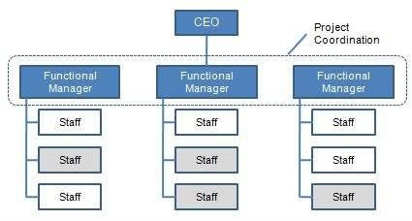

Figure 4.1.1 Functional organizational structur

## 4.2 Project based organizational structure

In this structure project manager has full authority of the project. Project manager set priorities, apply resources and direct the work of team users. All users of the project team report directly to the project manager. Resources will be re-assigned to another project after completion

of the project.

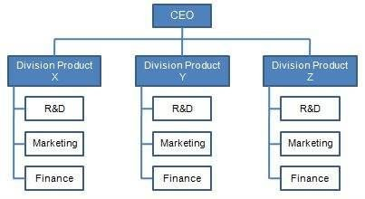

Figure 4.2.1 Project based organizational structure

## 4.3 Matrix organizational structure

Project manager shares responsibility for the project with a number of individual functional managers. Project manager allocate and organize the work for the designated project team. In this structure there is a balance between ongoing operations and projects. It is carrying benefits of both both standard structures. Project managers can get deep expertise and function across varying company programs and good career paths for team users, functional managers and project

managers.

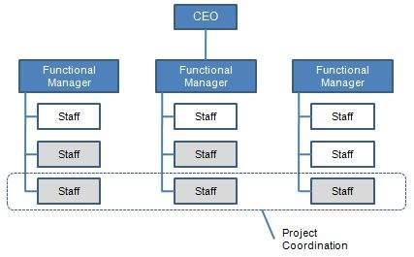

Figure 4.3.1 Matrix organizational structure

## 4.4 Project organization structure for “ABC Cafeteria online food ordering” project

This project uses small number of human resources. But there are people in various fields such as management, designing, developing and testing etc. Under those sectors they have various positions. All the team users directly communicate with project manager. After completing this project all the human resources will allocated for a new project. By considering all factors of three project organizational structures*, the* most suitable project organizational structure for this project is project based organizational structure. Following is the organizational chart for the

project.

**Project Manager**

**Requirement**

**Engineer**

**Database**

**Designer**

**UI Designer**

**Developer 1**

**Developer 2**

**Developer 3**

**Tester**



Figure 4.4.1 Project organizational structure of “ABC Cafeteria” project

## 4.4 Budget Summary

|  |  |  |  |
| --- | --- | --- | --- |
| **Project Budget Outline** | **Rate** | **Hours** | **Total (£)** |
| **1 Project Personnel** |  |  |  |
| 1.1 Project Manager - Part Time | £20.00/hr | 200 | 4000.00 |
| 1.2 Requirement Engineer - Part Time | £25.00/hr | 240 | 6000.00 |
| 1.3 Database Designer - Part Time | £30.00/hr | 220 | 6600.00 |
| 1.4 UI Designer - Part Time | £30.00/hr | 240 | 7200.00 |
| 1.5 Developer 1 - Full Time | £25.00/hr | 400 | 10,000.00 |
| 1.6 Developer 2 - Full Time | £25.00/hr | 440 | 11,000.00 |
| 1.7 Developer 3 - Part Time | £30.00/hr | 480 | 14,400.00 |
| 1.8 Tester - Full Time | £30.00/hr | 360 | 10,800.00 |
| **Component Total** |  |  | **70,000.00** |
|  |  |  |  |
| **Grand Total** |  |  | **70,000.00** |

# 5. Work Breakdown Structure

## 5.1. Work Breakdown Structure (WBS)

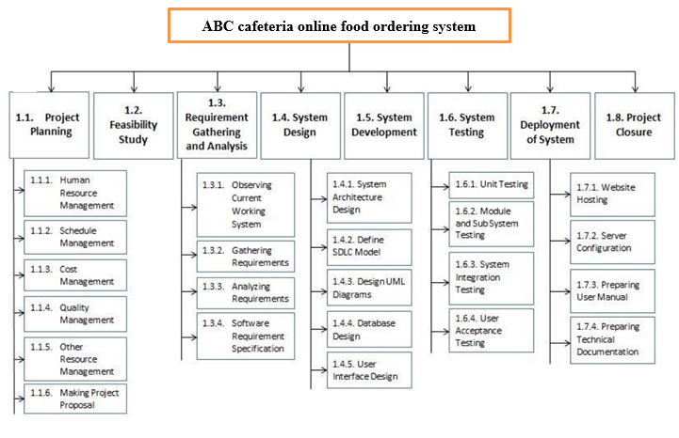5.2. Rationale for Work Breakdown Structure

**1. ABC Cafeteria Project**

This project is to develop and implement a online food ordering system for the ABC Cafeteria. This application will help to keep the complete records of transactions of the foods and users related to the ABC cafeteria. The duration for the project is 12 weeks.

**1.1 Project Planning**

Under project planning there are human resource management, schedule management, cost management, quality management etc. Other activities like setting objectives for the project, identifying deliverables, making supporting plans and project proposal has to done.

**1.1.1 Human resource management**

Human Resource Management includes conducting job analyses, planning personnel needs, recruiting the right people for the job, orienting and training, managing wages and salaries, providing benefits and incentives, evaluating performance, resolving disputes, and communicating with all employees at all levels. The team for this project consisted of eight team users including the project manager and assigned for different roles for the project. The duration for the cost management of the project is 2 days.

**1.1.2 Schedule management**

The project schedule is the tool that communicates what work needs to be performed, which resources of the organization will perform the work and the timeframes in which that work needs to be performed. The project schedule should reflect all of the work associated with delivering the ABC cafeteria project on time. Without a full and complete schedule, the project manager will be unable to communicate the complete effort, in terms of cost and resources, necessary to deliver the project.

**1.1.3 Cost management**

Cost management is the process of planning and controlling the budget of the project. Cost management is a form of management accounting that allows a project to predict impending expenditures to help reduce the chance of going over budget. During the project, all expenses has to be recorded and monitored to make sure they stay in line with the cost management plan. The duration for the cost management of the project is 2 days.

**1.1.4 Quality management**

Software quality management is a management process that aims to develop and manage the quality of software to make sure the product satisfies the user. The goals of SQM (software quality management) is to make sure the product (Online food ordering system) follows regulations and meets the quality standards expected by the ABC Cafeteria. The check lists and other documents related to quality management should be done within one day.

**1.1.5 Other resource management**

This include all the other resources management such as software tools and hardware including computers that will be needed for the development of the project. The other resource management should be done within one day.

**1.1.6 Making project proposal**

The project proposal is a document that a management of the software organization submits to a business customer for acceptance. The proposal describes the problem to be solved and explains the resulting benefits to the customer. The proposal of the ABC Cafeteria project should clearly describe what kind of issues exist in the current practice that the new system would like to address and how the suggested solution will be going to be and what functionalities of the online food ordering system it will perform. The project proposal should be completed within 2 days and handover to the customer.

**1.2 Feasibility study**

An analysis and evaluation of the proposed project to determine if it is technically feasible, is feasible within the estimated cost, and will be profitable. If the proposed system for ABC cafeteria is feasible then the development process of the system will start. The duration for the feasibility study of the project is 5 days.

**1.3 Requirement gathering and analyzing**

The process to gather the software requirements from the client (ABC cafeteria), analyze and document them is known as requirement engineering. The goal of requirement engineering is to gather requirements, analyze them to develop and maintain sophisticated and descriptive ‘System Requirements Specification’ document. The duration that is planned for requirement gathering and analyzing phase for the project is 10 days.

**1.3.1 Observing current working system**

The manual system of the ABC cafeteria has to be observed properly to understand their requirement clearly. The observing current system will help to maintain good relationship with the customer and also to identify their need and what are the problems they faced so that those problems can be addressed from the new system. The duration given for observing the current system is 2 days.

**1.3.2 Gathering requirements**

The other requirements will be gathered by using different requirement gathering techniques like questionnaires, interviews, surveys etc.

**1.3.3Analyzing requirements**

Requirements analysis involves frequent communication with ABC cafeteria staff to determine specific feature expectations, resolution of conflict or ambiguity in requirements that are found in requirement gathering, avoidance of feature creep and documentation of all aspects of the project development process from start to finish. The duration allocated for requirement analysis is 2 days.

**1.3.4 Software Requirement Specification**

A software requirements specification (SRS) is a comprehensive description of the intended purpose and environment for software under development. The SRS fully describes what the software of ABC cafeteria management system will do and how it will be expected to perform. The duration allocated for making SRS is 2 days.

**1.4 System Design**

System design is the process of defining the elements of the online food ordering system such as the architecture, modules and components, the different interfaces of those components and the data that goes through that system. The duration for the system design is 15 days.

**1.4.1 System Architecture Design**

Set of conventions, rules, and standards employed in the computer system's technical framework, plus customer requirements and specifications, that the system's architecture designer follows in designing the system's various components (such as hardware, software and networks) is considered as the system architecture design. The duration for system architecture design is 2 days.

**1.4.2 Define SDLC model**

The software development life cycle, ensures an application meets the needs of its users. Success of this software depends upon utilizing all the steps of the SDLC for as long as the application is in use. To define the system development life cycle model for this project 2 days are allocated.

**1.4.3Design UML Diagrams**

The UML diagrams such as class, activity, use case, sequence, and component diagrams will enhance the understandability of the proposed online food ordering system to the developers. The duration for designing UML diagrams are 6 days.

**1.4.4 Database Design**

Database design is the process of producing a detailed data model for the database of the proposed online food ordering system. The database design contains all the needed logical and physical design choices and physical storage parameters, which can then be used to create a database.

**1.4.5 User Interface Design**

All the necessary interfaces of the proposed online food ordering system will be designing under user interface design and the duration is 15 days.

**1.5 System Development**

The coding of the ABC cafeteria management system will be done in here. As the proposed system is a web-based application the coding will be done in PHP, JavaScript programming languages and database will be MySQL. Difference technologies like Ajax will be used in coding. The duration for system development is 20 days.

**1.6 System Testing**

The testing for the developed system will be carrying out in system testing phase. 20 days are allocated for whole system testing.

**1.6.1 Unit Testing**

Unit testing is a software development process in which the smallest testable parts of the application, called units, are individually and independently scrutinized for proper operation. The tester and the developers will do the unit testing for online food ordering system.

**1.6.2 Module and Sub System Testing**

The sub systems and modules of the application will be testing in this phase and the duration is 5 days.

**1.6.3 System Integration Testing**

System integration testing is the phase in software testing in which individual software modules are combined and tested as a group. The duration is 5 days.

**1.6.4 User Acceptance Testing**

User acceptance testing (UAT) is the last phase of the software testing process. During UAT, actual software users which means the management of the ABC cafeteria test the software to make sure it can handle required tasks of the library, according to specifications. The duration allocated for user acceptance testing is 10 days.

**1.7 Deployment of the system**

System deployment is the delivery, installation and testing of the developed online food ordering system, to put it in a state of operational readiness in the ABC Cafeteria. Five days are allocated to deploy the system.

**1.7.1 Website hosting**

The hosting of the web application of ABC cafeteria management system will be done at this step and duration is 1 day.

**1.7.2 Server configuration**

The server configuration of the online food ordering system will be carried out under system deployment.

**1.7.3 Preparing user manual**

The user manual for the online food ordering system will be documenting in here and the duration for the creating the user manual is 1 day. The user manual will include how to use the system, the resources (hardware, software) that require to run the system with clear description and screen shots of the developed application.

**1.7.4 Preparing technical documentation**

The technical document will describe about the codes used in the system and how to setup the system. To prepare the technical document 1 day is allocated.

**1.8 Project Closure**

Project Closure involves handing over the deliverables to the customer, passing the documentation to the business, cancelling supplier contracts, releasing staff and equipment, and informing stakeholders of the closure of the project. After the project has been closed, a Post Implementation Review is completed to determine the project’s success and identify the lessons learned. The duration for project closure is 5 days.

## **5.2 Schedule of the Project**

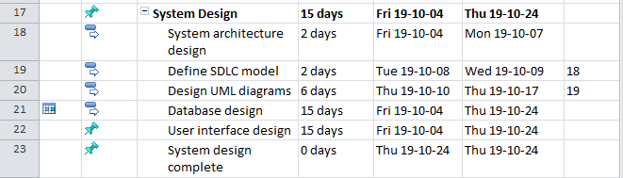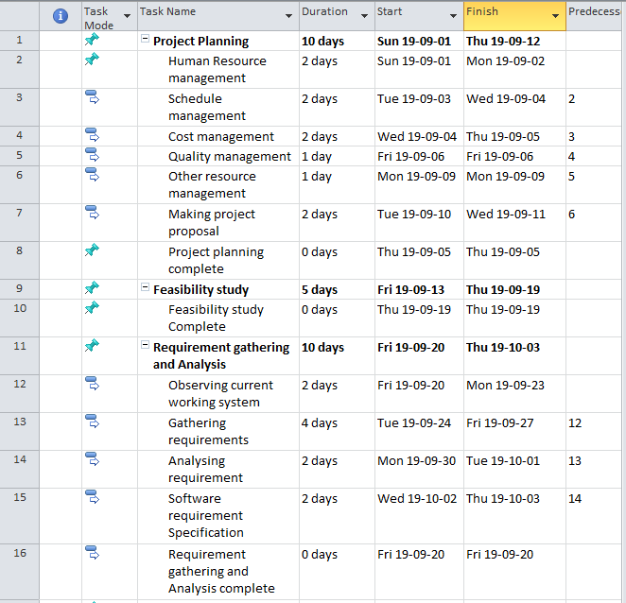

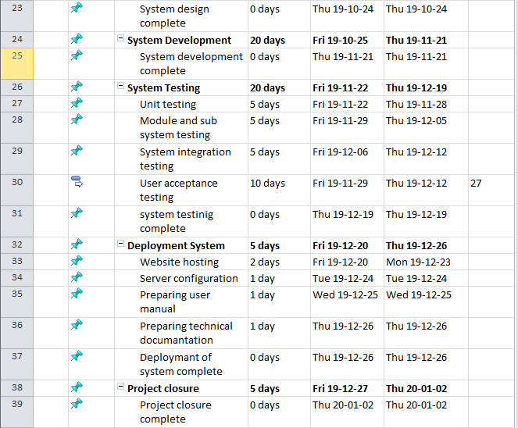

ASE Coursework 2 - CS6003ES

28 | P a g e

## 5.3 Gantt chart

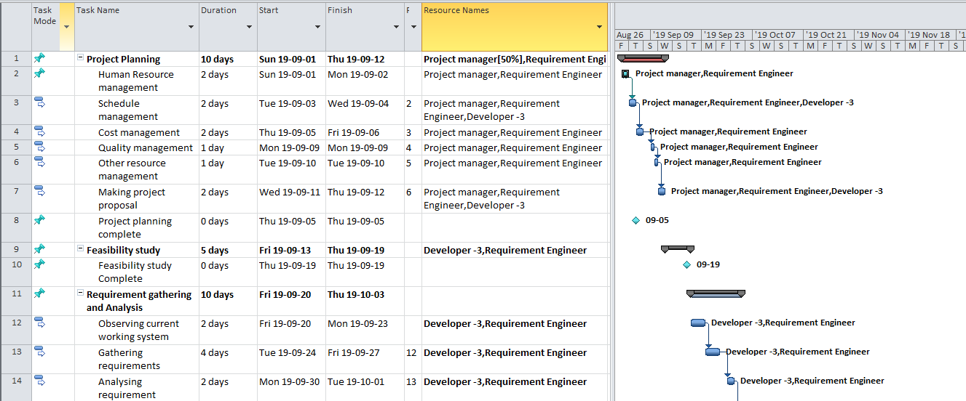

ASE Coursework 2 - CS6003ES

29 | P a g e

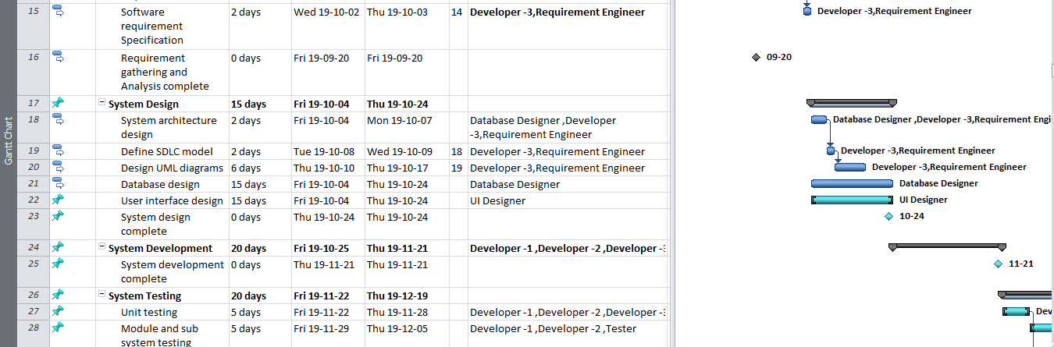

ASE Coursework 2 - CS6003ES

30 | P a g e

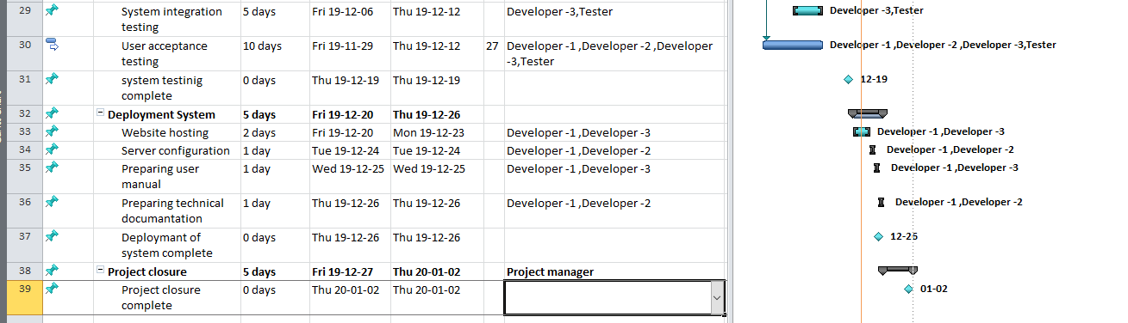

ASE Coursework 2 - CS6003ES

31 | P a g e

A Gantt chart is one of the most standard and beneficial practices used in project management for viewing activities showed against time. The list of the actions will be given along with the proper time scales for each. On the Gantt chart, each activity is denoted by a bar; the position and length of the bar shows the start date, duration and the end date of the activity. It exposes following things.

Number of activities

Beginning and end of each activity

Expected duration of each activity

Whether any activities overlap with another activities, and if so, by how much?

Any available slack times for activities

The start and end date of the entire project

According to ABC cafeteria online food ordering system project there are 8 main tasks. Under main tasks there are several sub tasks. The first main task is project planning and it will be starting on 1st of September 2019. During project planning sub tasks like human resource management, cost management, schedule management etc. has to be covered. The duration for project planning is 10 days. After project planning phase the project proposal has to be delivered to the client.

The second main task is feasibility study and duration are 5 days. It will be starting on 13th

September 2019. During feasibility study, feasibility report for the project has to be developed. The third main task is requirement gathering and analysis. It will be starting on 20th September

2019 and duration is 10 days. Under this task there are several sub tasks like observing current system, gathering requirements, analyzing requirements and making system requirement specification. After completing this phase system requirement specification has to be delivered to the client.

The fourth main task is system design and there are several sub tasks like system architecture design, UML diagraming, database design, user interface design etc. The system design will be starting on 04th of October 2019 and has 15 days to complete this phase. After completing system design, the designed UML diagrams, user interfaces and database design should be delivered to the developers on 24th October 2019.

The fifth main task is system development and has only 20 days to complete the coding of the online food ordering system. The system development will be starting on 25st October 2019. At the end of this phase the completed system should be given for testing.

The sixth main task is testing. Under testing unit testing, sub system testing, integration testing and acceptance testing has to be covered. The duration planned for testing is 20 days and testing phase will be starting on 22nd of November 2019.

The next main task is deployment of the system and it will be starting on 20th of December 2019. The duration given for system deployment is 5 days. After completing of this task, the deliverables such as Online food ordering System, with the user manual and maintenance manual will be given to the client (ABC Cafeteria).

The last task is project closure and it will be starting on 27th December 2019. The project manager is responsible for project closure and duration is 5 days.

**Resource Allocation for the project**

|  |
| --- |
| **Name Resource Names** |
| **Project Planning** |
| Human Resource Management Project Manager [50%], Requirement Engineer [50%] |
| Schedule Management Project Manager [50%], Requirement  Engineer [50%], Developer - 3[50%] |
| Cost Management Project Manager [50%], Requirement Engineer [50%] |
| Quality Management Project Manager [50%], Requirement Engineer [50%] |
| Other Resource Management Project Manager [50%], Requirement Engineer [50%] |
| Making Project Proposal Project Manager [50%], Developer - 3[50%], Requirement  Engineer [50%] |
| **Feasibility Study** |
| Requirement Gathering and Analysis Requirement Engineer [50%], Developer - 3[50%] |
| Observing Current Working System Requirement Engineer [50%], Developer - 3[50%] |
| Gathering Requirements Requirement Engineer [50%], Developer - 3[50%] |
| Analyzing Requirements Requirement Engineer [50%], Developer - 3[50%] |
| Software Requirement Specification Requirement Engineer [50%], Developer - 3[50%] |
| **System Design** |
| System Architecture Design Requirement Engineer [50%], Developer - 3[50%] |
| Define SDLC Model Developer - 3[50%], Requirement Engineer [50%] |

|  |
| --- |
| Design UML Diagrams Developer - 3[50%], Requirement Engineer [50%] |
| Database Design Database Designer [50%], MySQL Server [1] |
| User Interface Design UI Designer [50%], Adobe Dreamweaver CS6[1] |
| System Design Complete |
| **System Development** Developer - 1, Developer - 2, Developer - 3[50%], Adobe Dreamweaver CS6[1], MySQL Server [1], Database Designer [50%], UI Designer [50%], Tester |
| **System Testing** |
| Unit Testing Developer - 1, Developer - 3[50%], Developer - 2, Tester |
| Module and Sub System Testing Tester, Developer - 2, Developer - 1, Developer - 3[50%] |
| System Integration Testing Tester, Developer - 1, Developer - 2 |
| User Acceptance Testing Tester, Developer - 3[50%] |
| **Deployment of System** |
| Website Hosting Developer - 2, Developer - 3[50%], Tester |
| Server Configuration Developer - 3[50%], Developer - 1, Tester |
| Preparing User Manual Developer - 3[50%], Developer - 2 |
| Preparing Technical Documentation Developer - 3[50%], Developer - 2 |
| **Project Closure** Project Manager [50%] |

ASE Coursework 2 - CS6003ES

35 | P a g e

## 5.3 Activity on node diagram

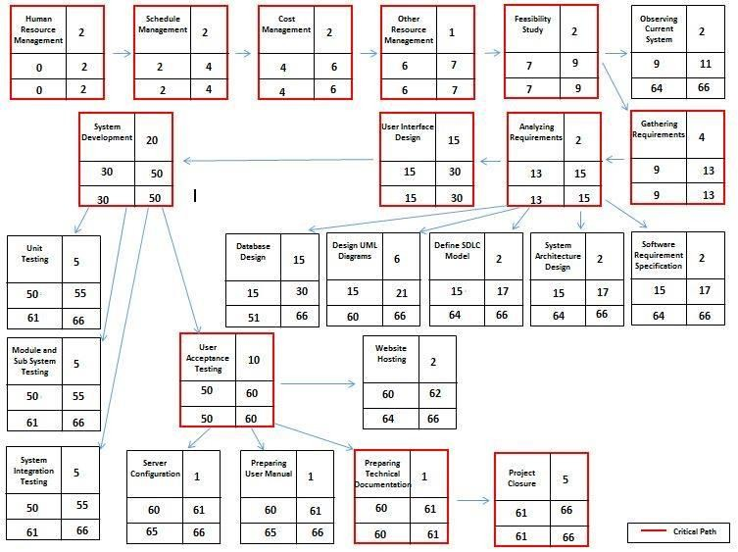

Activity on node is a project management that refers to a precedence diagraming method which uses boxes to donate schedule activities. Those boxes are known as nodes. Nodes are connected from beginning to end with arrows to depict a logical progression of the dependencies between the schedule activities. Each node is coded with a letter or number.

The critical path is the sequence of project network activities which add up to the longest overall duration.

Objective of drawing the activity on node diagram is finding critical path. Following is the critical path of the project:

Human resource Management **>>** Schedule management **>>** Cost Management **>>** Other resource Management **>>** Feasibility study **>>** Gathering requirements **>>** Analyze requirements **>>** User Interface Design **>>** System Development >**>** User Acceptance Testing

>**>** Preparing Technical Documentation >**>** Project Closure

## 5.4 Milestones of the project

|  |  |
| --- | --- |
| Name | Finish Date |
| Project Planning complete | 12/09/2019 |
| Feasibility Study complete | 19/09/2019 |
| Requirement Gathering and Analysis  complete | 03/10/2019 |
| System Design complete | 24/10/2019 |
| System Development complete | 21/11/2019 |
| System Testing complete | 19/12/2019 |
| Deployment of system complete | 26/12/2019 |
| Project Closure complete | 02/01/2020 |

## 5.4 Rationale for set of milestones

Milestone is a special event that requires special attention during project management. Milestones can add significant value to project scheduling. A project milestone is a way to observe, measure and monitor the progress and performance of a project. They help project managers to more accurately determine whether or not the project is on schedule.

In “ABC Cafeteria” project there are eight milestones and those milestones have marked on Gantt chart.

When reach to first milestone, “Project Planning Complete” duration of 10 days has passed from 90 days. It is 11.11% from whole project. Deliverable of this milestone is project plan. When reach to second milestone, “Feasibility Study Complete” duration of 15 days has passed from 90 days. It is

16.66% from whole project. Deliverable of this milestone is feasibility study.

When reach to third milestone, “Requirement Gathering and Analyzing Complete” duration of 40 days has passed from 90 days. It is 27.77% from whole project. Deliverable of this milestone is software requirement specification. When reach to fourth milestone, “System Design Complete” duration of 25 days has passed from 90 days. It is 44.44% from whole project. Deliverables of this milestone are UML diagrams, database and user interfaces.

When reach to fifth milestone, “System Development Complete” duration of 60 days has passed from

90 days. It is 66.66% from whole project. Deliverable of this milestone is completed system. When reach to sixth milestone, “System Testing Complete” duration of 80 days has passed from 90 days. It is 88.88% from whole project. Deliverables of this milestone are test plan, test cases and test results.

When reach to seventh milestone, “Deployment of System Complete” duration of 85 days has passed from 90 days. It is 94.44% from whole project. Deliverables of this milestone are hosted website, user manual and technical documentation. When reach to eighth milestone, “Project Closure Complete” whole duration of 90 days has passed. That means 100% of project has completed. Deliverable of this milestone is project closure report.

# References

* **Eric. Shaw, 2013. *Project organizational structure*.** [Online] Available at: https:/[/www.projectsmart.co.uk/forums/viewtopic.ph](http://www.projectsmart.co.uk/forums/viewtopic.php)p?t=730 [Accessed on 02nd October 2019]
* **CAST.com, 2019. *Risk management in software development projects*.** [Online] Available a[t:http://www.castsoftware.com/research-labs/risk-management-in-software-development-and-](http://www.castsoftware.com/research-labs/risk-management-in-software-development-and-) software-engineering-projects [Accessed on 03rd October 2019]
* **Confluence.com, 2019. *Project Assumptions and Constraints*.** [Online] Available at: https://wikispaces.psu.edu/display/SASPMO/How+to+Define+Project+Assumptions,+Constraints,+Dependencies+and+Critical+Success+Factors [Accessed on 04th October 2019]
* **ISO, 2008. ISO.Org.** [Online] Available at: <http://www.iso.org/iso/catalogue_detail>?csnumber=43447 [Accessed on 07th October 2019].