WERVEXA – VERIFIED HOME-SERVICE WORKERS GIG PLATFORM
24CBP34 - DESIGN STUDIO - I LABORATORY
A MINI PROJECT REPORT
Submitted by
STUDENT NAME - (73152526XXX)
in partial fulfilment for the award of the degree of
BACHELOR OF ENGINEERING
in
COMPUTER SCIENCE AND ENGINEERING
(CYBER SECURITY)
 | K.S.R COLLEGE OF ENGINEERING  (Autonomous)  TIRUCHENGODE 637 215 | 
ANNA UNIVERSITY :: CHENNAI 600 025
November 2026

K.S.R. COLLEGE OF ENGINEERING (AUTONOMOUS)
TIRUCHENGODE 637215
ANNA UNIVERSITY:: CHENNAI 600025
BONAFIDE CERTIFICATE
Certified that this report “WERVEXA – VERIFIED HOME-SERVICE WORKERS GIG PLATFORM” is the bonafide work of STUDENT NAME (73152526XXX) who carried out the project work for Design Studio I under my supervision.

SIGNATURE  Mrs. K.Sudha, M.E, Ph.D  HEAD OF THE DEPARTMENT  Professor & Head,  Department of CSE(Cyber Security)  K.S.R College of Engineering  Tiruchengode - 637 215 | SIGNATURE  Ms. A.Priyadharshini, M.E  SUPERVISOR  Assistant Professor,  Department of CSE(Cyber Security)  K.S.R College of Engineering  Tiruchengode – 637 215

Submitted for the project viva-voce examination held on ………………………

Internal Examiner External Examiner

ACKNOWLEDGEMENT
We feel highly honored to extend our sincere gratitude to our beloved Founder Theivathiru Lion Dr. K. S. Rangasamy, MJF. and our Chairman Mr.R.Srinivasan, B.B.M., M.I.S.T.E., for giving us an opportunity and facilities for the completion of this project.
We express our heartfelt gratitude to our respected Dean Dr. M.Venkatesan, M.E., Ph.D., for the continuous support, valuable guidance, and encouragement extended to us in all our academic endeavors.
We express our deep sense of gratitude to our beloved Principal Dr. P.Meenakshi Devi, M.E., Ph.D., who supported us in all our endeavors and has been responsible for motivating us throughout our career.
We feel highly elated to thank our respectable Head of the Department Mrs. K.Sudha M.E., Ph.D who guided us and was a pillar of support for the successful completion of the project and our guide A.Priyadharshini, M.E., who has guided us by providing fruitful ideas in various stages of our project and helping us in completing this project.
It is a pleasure to express our gratitude to our beloved parents for providing their support and confidence to us for the completion of the project and our heartfelt thanks to our entire department faculty members, non-teaching staff and beloved friends, directly and indirectly who helped us during the tenure of the project.
STUDENT NAME (73152526XXX)

DEPARTMENT OF COMPUTER SCIENCE AND
ENGINEERING (CYBER SECURITY)
K.S.R. COLLEGE OF ENGINEERING (Autonomous)
TIRUCHENGODE 637 215
Nov 2026
DECLARATION
We affirm that the project report titled being “WERVEXA – VERIFIED HOME-SERVICE WORKERS GIG PLATFORM” submitted in partial fulfilment of the requirements for the award of the degree of Bachelor of Engineering is the original work carried out by us. It has not formed the part of any other project report or dissertation since which a degree or award was conferred on an earlier occasion on this or any other candidates.

STUDENT NAME (73152526XXX)

To verify that the declaration made by the above candidates is true to the best of my knowledge.

Date: Name and Signature of the supervisor with seal

ABSTRACT
India has a very large workforce of skilled home-service professionals — electricians, plumbers, carpenters, painters, cleaners and AC and appliance technicians — yet most of them still find work through word of mouth, earn irregular incomes and have no verifiable record of their identity, skills or track record. Households, on the other hand, struggle to find a trustworthy professional quickly, cannot judge pricing in advance and have little protection when a job goes wrong. Wervexa is a verified home-service gig platform designed to close this trust gap on both sides. The platform consists of a Flutter-based Customer App, a Flutter-based Worker App (Wervexa Captain), and a Next.js public website with an operational Admin Panel, all backed by a Supabase PostgreSQL database secured with Row Level Security and Firebase Authentication. Workers are onboarded through identity verification using DigiLocker e-KYC, background checks and trade qualifications, and only eligible workers can publish gigs. A weighted matching engine ranks nearby workers using trade fit, verification status, availability, rating and distance. Customers pay upfront through Razorpay; the money is held until the customer approves the completed work, after which it is credited to the worker’s ledger-based wallet. Every booking follows a database-enforced state machine with server-verified arrival codes, live location tracking, customer-approved material purchases, ratings, support tickets and damage claims. Support for eleven Indian languages makes the system inclusive for workers and customers with varied digital literacy. Through this combination of verification, transparent pricing and secure engineering, Wervexa supports the formalisation of India’s gig workforce and makes home services safer, fairer and more reliable.

TABLE OF CONTENT
CHAPTER NO | TITLE | PAGE NO
 | ABSTRACT | V
 | LIST OF ABBREVIATIONS | VIII
1 | INTRODUCTION | 1
 | 1.1 INTRODUCTION OF THE PROJECT | 1
 | 1.2 NEED OF THE PROJECT | 1
 | 1.3 OBJECTIVE OF THE PROJECT | 3
 | 1.4 THEME OF THE PROJECT | 4
 | 1.5 ORGANIZATION | 5
 | 1.6 SUMMARY | 5
2 | LITERATURE REVIEW | 6
 | 2.1 INTRODUCTION | 6
 | 2.2 EXISTING SYSTEMS AND THEIR LIMITATIONS | 6
 | 2.3 SCOPE OF THE PROJECT | 7
 | 2.4 SUMMARY | 8
3 | SYSTEM DESIGN AND DEVELOPMENT | 9
 | 3.1 FUNDAMENTALS OF ON-DEMAND HOME-SERVICE PLATFORMS | 9
 | 3.2 PROPOSED SYSTEM ARCHITECTURE | 10
 | 3.3 SYSTEM WORKFLOW | 11
 | 3.4 IMPLEMENTATION DETAILS | 13
 | 3.5 SUMMARY | 15
4 | RESULT AND DISCUSSION | 17
 | 4.1 FUNCTIONAL ANALYSIS | 17
 | 4.2 EXPERIMENTAL ANALYSIS | 18
 | 4.3 SUMMARY | 21
5 | CONCLUSIONS | 22
 | 5.1 CONCLUSION | 22
 | 5.2 FUTURE SCOPE | 22
 | 5.3 APPLICATIONS | 23
 | 5.4 SUMMARY | 23
 | REFERENCES | 24

LIST OF ABBREVIATIONS
TERMS | EXPANSION
API | Application Programming Interface
APK | Android Package Kit
CSP | Content Security Policy
CSRF | Cross-Site Request Forgery
DBMS | Database Management System
e-KYC | Electronic Know Your Customer
FCM | Firebase Cloud Messaging
GPS | Global Positioning System
HMAC | Hash-based Message Authentication Code
ITI | Industrial Training Institute
JWT | JSON Web Token
KYC | Know Your Customer
OTP | One-Time Password
RLS | Row Level Security
RPC | Remote Procedure Call
RPL | Recognition of Prior Learning
SDK | Software Development Kit
SQL | Structured Query Language
UI | User Interface
UID | Unique Identifier
UPI | Unified Payments Interface
UX | User Experience
XSS | Cross-Site Scripting

CHAPTER 1 – INTRODUCTION

1.1 INTRODUCTION OF THE PROJECT
Home services are one of the largest and least organised parts of India’s economy. Every household periodically needs an electrician, plumber, carpenter, painter, cleaner or an AC and appliance technician, and millions of skilled workers depend on these jobs for their livelihood. Yet the way the two sides meet has hardly changed: customers ask neighbours for a phone number, workers wait for calls, and neither side has a reliable way to judge the other before the work begins. The result is a market full of uncertainty — unverified people entering homes, unclear pricing, disputes over materials and irregular income for the workers themselves.
To address these challenges, the project Wervexa introduces a verified home-service gig platform. Wervexa connects customers with nearby skilled professionals whose identity, background and — where the trade demands it — qualification have been checked before they are allowed to take any job. The platform is delivered as three applications that share one secure backend: a Customer App for discovering services and booking professionals, a Worker App (Wervexa Captain) through which professionals publish gigs, accept jobs and get paid, and a public website with an Admin Panel that the operations team uses to verify workers, monitor bookings, handle payouts and resolve support tickets and claims.
The purpose of this project is to bring trust, transparency and fairness to every step of a home-service job. A customer sees a quote before the job, pays upfront through a secure payment gateway, approves any material before it is bought, confirms the worker’s arrival with a one-time arrival code and releases payment only after approving the completed work. A worker builds a verified digital profile, receives job offers that match their skills and location, tracks earnings in a wallet and withdraws money to a verified bank account.
In essence, this project acts as a digital bridge between India’s informal skilled workforce and the households that need them. By combining verification, a weighted matching engine, database-enforced business rules and support for eleven Indian languages, Wervexa strives to make home services safer for customers, more dignified and predictable for workers, and auditable for the platform operator.

1.2 NEED OF THE PROJECT
India’s home-service sector faces a range of problems that directly affect the safety of customers and the income of workers. Despite rapid smartphone adoption, a large share of these services is still arranged informally, without verification, written pricing or any record of what happened during the job. This leads to mistrust, overcharging, poor-quality work and, for workers, an unstable livelihood.
The need for this project arises from the following critical gaps in the current system:
1. Lack of Trust and Verification
Customers allow strangers into their homes with no proof of identity, background or skill. A system that verifies identity through e-KYC and checks background and qualifications before a worker becomes eligible is essential for safety.
2. Opaque Pricing and Material Costs
Charges are often decided after the work is done, and material bills are rarely itemised. Customers need to see the price in advance and approve every material purchase before money is spent.
3. Irregular Income for Skilled Workers
Most home-service professionals depend on referrals and have long idle periods. A platform that sends them relevant job offers near their location helps them earn steadily.
4. No Digital Identity or Work History for Workers
Skilled workers without formal certificates have no way to prove their competence. A verified profile with ratings, qualification records and Recognition of Prior Learning (RPL) gives them a portable professional identity.
5. Payment Disputes and Delayed Settlement
Cash payments lead to disputes on both sides — customers fear paying for unfinished work and workers fear not being paid. Holding an upfront payment until the customer approves completion protects both parties.
6. Safety Inside the Home
Customers need to know who is coming, when they will arrive and that the person at the door is the one who was booked. Live location tracking and a server-verified arrival code provide that assurance.
7. Need for Digital Inclusion
Many workers and customers are more comfortable in their own language than in English. A platform that works in eleven Indian languages and uses simple, large touch targets lowers the barrier to adoption.

1.3 OBJECTIVE OF THE PROJECT
The primary objective of the Wervexa project is to develop a secure, verified and multi-lingual gig platform that connects households with skilled home-service professionals, while guaranteeing fair, transparent and auditable handling of every booking and every rupee.
The major objectives of the project are as follows:
1. To Verify Every Worker Before the First Job
To onboard workers through DigiLocker-based identity e-KYC, background checks and trade qualifications (such as ITI certificates), and to allow only eligible workers to go online and publish gigs.
2. To Match Customers with the Most Suitable Worker
To rank nearby workers with a weighted matching engine that considers trade fit, verification status, insurance, availability, rating and distance.
3. To Ensure Transparent Pricing and Secure Payments
To show pricing before booking, collect payment upfront through Razorpay and release it to the worker only after the customer approves the completed work.
4. To Make Every Job Traceable
To drive each booking through a database-enforced state machine, with live tracking, a server-verified arrival code, customer-approved materials and a complete timeline of events.
5. To Provide Fair and Reliable Earnings for Workers
To maintain an append-only wallet ledger for every worker, support payouts to a verified bank account, and keep the platform commission at zero so workers keep the full amount the customer pays.
6. To Give Operators Complete Control
To provide an Admin Panel with role-based permissions for verification, operations, finance and support teams, with every sensitive action recorded in a tamper-proof audit log.
7. To Protect User Data and Platform Integrity
To enforce Row Level Security on every table, keep business rules inside the database, store documents in a private bucket accessed only through short-lived signed URLs, and defend against common web attacks.
8. To Create an Inclusive, User-Friendly Experience
To provide simple mobile interfaces in eleven Indian languages, along with an in-app assistant that helps customers describe their problem and find the right service.

1.4 THEME OF THE PROJECT
The theme of the project Wervexa revolves around using modern cloud, mobile and security technologies to formalise and empower India’s home-service gig workforce. The project addresses the fundamental need for trust between two parties who meet for the first time at the customer’s doorstep.
At its core, the project emphasises Trusted Digital Gig Work, enabling customers to book verified professionals with confidence and enabling workers to build a verified digital identity and a steady income. The platform integrates identity verification, location services, payments and real-time updates to deliver a safe and transparent experience for both sides.
This project aligns with national priorities like:
- Digital India
- Skill India and Recognition of Prior Learning (RPL)
- Social Security for Gig and Platform Workers (Code on Social Security, 2020)
- Digital Public Infrastructure – DigiLocker and UPI
- Women and Home Safety
By combining technology with the practical realities of home-service work, the theme focuses on:
• Empowering Skilled Workers
Giving workers a verified profile, fair job offers, transparent earnings and direct payouts.
• Building Customer Trust
Showing only the checks a worker has actually passed, and keeping the customer in control of who comes, what gets bought and when they pay.
• Security by Design
Enforcing every business rule — booking status, wallet balance, verification outcome — on the server, never on the device.
• Bridging Language Gaps
Delivering the complete experience in eleven Indian languages.
• Supporting Pan-India Scale
Using a cloud-native architecture that can grow from one city to the whole country without redesign.

1.5 ORGANIZATION
This report is organized into five chapters:
- Chapter 1 introduces the project, its need, objectives and theme.
- Chapter 2 reviews existing home-service and gig platforms and identifies their limitations.
- Chapter 3 details the system design, proposed architecture, workflow and implementation.
- Chapter 4 presents the results, functional analysis, testing and discussion.
- Chapter 5 concludes the report and highlights possible future improvements and applications.

1.6 SUMMARY
Chapter 1 presented an overview of Wervexa – Verified Home-Service Workers Gig Platform, highlighting the motivation, relevance and foundational concepts behind the project. The chapter introduced the purpose of the platform and explained why a verified, transparent and secure digital marketplace is essential for both households and skilled workers across India.
The discussion covered the need for the project, emphasising major challenges such as lack of verification, opaque pricing, payment disputes, irregular worker income and safety inside the home. The objectives were clearly defined to show how the system protects customers and empowers workers through verification, matching, secure payments and auditable workflows.
The theme of the project focused on trusted digital gig work supported by modern cloud and security technologies. The organisational structure of the report was also outlined, giving readers a clear understanding of how the subsequent chapters are arranged.

CHAPTER 2 – LITERATURE REVIEW

2.1 INTRODUCTION
A literature review is essential for understanding the existing platforms, research and technologies related to on-demand home services and the gig economy. It shows how digital labour platforms have evolved, what problems they have solved and where they still fall short. This chapter evaluates existing approaches — from informal referrals to large service aggregators — to identify the gaps that Wervexa is designed to fill.
Studies such as NITI Aayog’s report on India’s gig and platform economy and the International Labour Organization’s analysis of digital labour platforms show that platform work is growing rapidly in India, but they also highlight concerns about worker verification, income stability, transparency of algorithms and access to social security. At the same time, customers increasingly expect the convenience of booking services from a mobile phone, with clear pricing and accountability.
This chapter reviews existing systems for finding home-service professionals and establishes the foundation for understanding how Wervexa advances beyond them through verification-first onboarding, transparent pricing, server-enforced workflows and inclusive multi-language design.

2.2 EXISTING SYSTEMS AND THEIR LIMITATIONS
Over the years, several ways of connecting customers with home-service workers have emerged. The key existing systems and their limitations are summarised below:
1. Informal Referrals and Local Contractors
(Word of mouth, neighbourhood shops, visiting cards)
Limitations:
- No verification of identity, background or skill
- Pricing decided after the job, with no written record
- No recourse when work is poor or property is damaged
2. Online Directories and Classifieds
(Business listing and local search websites)
Limitations:
- Provide phone numbers only; booking, tracking and payment happen offline
- Listings are rarely verified and reviews can be unreliable
- No protection for either the customer or the worker
3. Large Home-Service Aggregator Apps
Limitations:
- Often concentrated in large metropolitan cities
- Commission and platform fees reduce the worker’s take-home income
- Workers have limited visibility into how jobs are assigned
- Interfaces are mostly in English, limiting adoption by many workers
4. Government Skilling and Labour Registration Portals
(Skill certification, unorganised-worker registration)
Limitations:
- Create a worker record but do not connect workers to customers
- No booking, payment or job-tracking capability
Key Limitations Across All Existing Systems
- Verification is missing, partial or not visible to the customer
- Payment is not protected until the work is approved
- Material costs are not approved in advance
- Business rules are enforced in the app rather than on the server
- Limited support for regional languages
These limitations justify the need for a verified, transparent and secure home-service platform like Wervexa.

2.3 SCOPE OF THE PROJECT
The scope of Wervexa extends across multiple dimensions of home-service delivery and worker management:
1. Multi-Trade Coverage
Supports electrical, plumbing, AC service, appliance repair, carpentry, painting, cleaning and other home services, with each trade carrying its own verification requirements.
2. Verified Worker Onboarding
Identity e-KYC through DigiLocker, background checks, ITI or diploma certificates, RPL assessment, bank account and insurance records.
3. End-to-End Booking Lifecycle
From service request, matching and payment to travel, arrival, work, materials, completion, ratings, support and damage claims.
4. Three Client Applications on One Backend
Customer App, Worker App and a web Admin Panel that share one database, one identity provider and one set of business rules.
5. Operational and Financial Control
Role-based administration, wallet ledger, payouts, refunds, audit logs and platform settings.
6. Expandable Architecture
Future modules can include subscription plans, insurance products for workers, AI-based price estimation and an iOS release.
The scope ensures that the system is not limited to one trade or one city but can scale to all parts of the country.

2.4 SUMMARY
This chapter reviewed existing ways of finding home-service professionals and identified major limitations that hinder their effectiveness. While current options provide some convenience, they lack verification, payment protection, transparent material handling and server-enforced accountability. The literature highlights the need for a platform that protects both the customer and the worker while remaining easy to use.
The evaluation clearly shows how Wervexa addresses these gaps by combining verification-first onboarding, a weighted matching engine, upfront but protected payments and secure cloud engineering. The insights gained from this chapter provide the foundation for the system design described in the next chapter.

CHAPTER 3 – SYSTEM DESIGN AND DEVELOPMENT

3.1 FUNDAMENTALS OF ON-DEMAND HOME-SERVICE PLATFORMS
On-demand home-service platforms are two-sided digital marketplaces that connect customers who need a job done at home with independent professionals who can do it. Unlike a simple directory, such a platform takes responsibility for the whole transaction: who is eligible to work, how a worker is chosen, how the job progresses and how money moves.
Fundamental characteristics include:
1. Two-Sided User Access
Customers and workers use separate mobile applications designed for their own tasks, while operators use a web-based administration panel. All three are clients of one shared backend.
2. Verification and Eligibility
A worker becomes visible to customers only after passing the checks that their trade requires. Eligibility is computed by the server and cannot be set by the worker.
3. Matching and Dispatch
The platform decides which workers are offered a job using:
- Trade and skill fit
- Verification status
- Availability and distance
- Past ratings
4. Real-Time Updates
Booking status, job offers, wallet balance and the worker’s live location change continuously and must reach the other party instantly through:
- Realtime database subscriptions
- Push notifications
- Live map tracking
5. Trust, Payments and Accountability
A key part of such platforms is protecting both parties:
- Secure payment collection and settlement
- Customer approval of materials and completion
- Ratings, support tickets and damage claims
- A tamper-proof audit trail
Wervexa follows all these fundamentals and strengthens them by enforcing every business rule inside the database rather than inside the apps.

3.2 PROPOSED SYSTEM ARCHITECTURE
The proposed architecture of Wervexa is designed using modular, layered components to ensure security, scalability and real-time behaviour. Figure 3.1 shows the overall architecture. The architecture consists of the following layers:
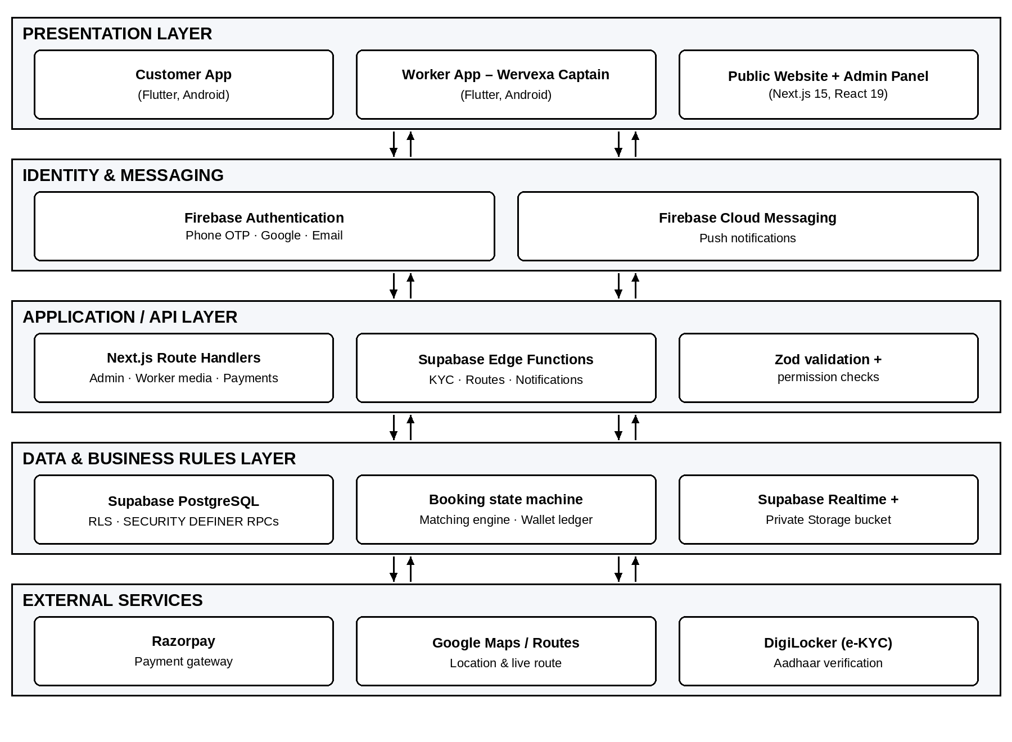
Fig 3.1 System Architecture of Wervexa
1. Presentation Layer
- Customer App (Flutter) – browse services, chat with the assistant, book, pay, track and rate
- Worker App – Wervexa Captain (Flutter) – onboarding, verification, gigs, jobs, wallet and payouts
- Public Website and Admin Panel (Next.js) – information pages, APK downloads and operations console
2. Identity and Messaging Layer
- Firebase Authentication with phone OTP for apps, and Google or email sign-in for administrators
- The Firebase ID token is accepted directly by Supabase (Third-Party Auth), so the Firebase UID identifies every database request
- Firebase Cloud Messaging delivers push notifications
3. Application / API Layer
- Next.js route handlers for admin actions, worker media uploads and payment order creation and verification
- Supabase Edge Functions for DigiLocker e-KYC, route computation and notification delivery
- Input validation with Zod and permission checks before any database call
4. Data and Business Rules Layer
- Supabase PostgreSQL with Row Level Security on every table
- SECURITY DEFINER functions for every state change — booking transitions, verification decisions, payouts, claims
- Booking state machine, matching engine and append-only wallet ledger
- Supabase Realtime for live updates and a private Storage bucket for documents and photos
5. External Services Layer
- Razorpay payment gateway for customer payments
- Google Maps and Routes API for location, distance and live route
- DigiLocker (via an e-KYC provider) for Aadhaar-based identity verification
This architecture ensures that the client applications only request actions and display results, while the server remains the single source of truth.

3.3 SYSTEM WORKFLOW
The workflow of Wervexa follows a sequential, server-controlled process:
Step 1: Sign-in and Onboarding
- Customers and workers sign in with their mobile number and OTP.
- Workers complete their profile, add skills and submit identity, background and qualification documents for verification.
Step 2: Service Request
- The customer chooses a service category or describes the problem to the in-app assistant, which suggests the right service.
- The customer selects the address on the map, adds photos and picks an instant or scheduled time slot.
Step 3: Matching
- The matching engine scores eligible workers within the search radius.
- Each worker’s score is a weighted sum of:
  - Trade, qualification and skill fit
  - KYC and background verification
  - Availability, rating and proximity
  - Insurance status
Step 4: Booking and Payment
- The customer books a worker’s gig and pays upfront through Razorpay.
  - The payment signature is verified on the server and the amount is held.
  - The job is offered to the chosen worker in real time.
Step 5: Job Execution
- The worker accepts the offer and starts travelling; the customer follows the worker on a live map.
- On arrival, the worker enters the customer’s arrival code, which is verified on the server.
- Any material needed is requested by the worker and approved by the customer before purchase.
Step 6: Completion and Settlement
- The customer approves the completed work or sends it back for rework.
- On approval, the held payment is credited to the worker’s wallet and both parties rate each other.
- The worker can request a payout to a verified bank account.
WORK FLOW DIAGRAM:
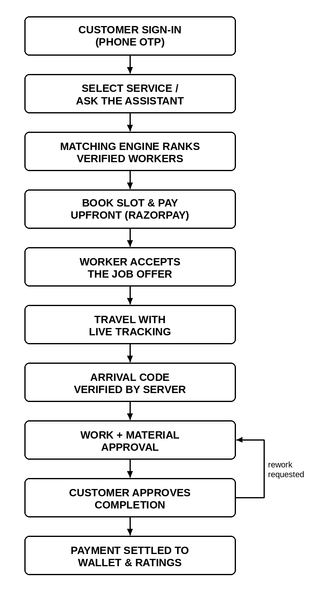
Fig 3.2 Booking Workflow of Wervexa
Internally, every booking moves through the states REQUESTED → ACCEPTED → CONFIRMED → TRAVELING → ARRIVED → IN_PROGRESS → AWAITING_APPROVAL → COMPLETED → PAID → CLOSED, with CANCELLED, DISPUTED and EXPIRED as exit states. The allowed transitions and the actor permitted to make each one (customer, worker, admin or system) are stored in a table, so an invalid transition is rejected by the database itself.

3.4 IMPLEMENTATION DETAILS
This section describes the technologies and tools used to build the Wervexa platform.
Mobile Application Development
- Flutter (Dart) for both the Customer App and the Worker App
- Riverpod for state management and go_router for navigation
- Layered design (presentation → application → domain ← data); screens never call the database directly
- Google Maps, Geolocator and Geocoding for addresses and live tracking
- Localisation in eleven languages: English, Hindi, Tamil, Telugu, Kannada, Malayalam, Marathi, Bengali, Gujarati, Odia and Urdu
Web Development
- Next.js 15 with React 19 and TypeScript for the public website and Admin Panel
- Tailwind CSS for responsive styling
- Admin sessions held in httpOnly cookies, verified on every request with the Firebase Admin SDK
Backend and Database
- Supabase PostgreSQL, built through 61 ordered SQL migrations
- Row Level Security on every table and SECURITY DEFINER RPC functions for every business action
- Supabase Realtime for bookings, offers and wallets; Supabase Storage (private bucket) for media
- Supabase Edge Functions (Deno) for e-KYC, route computation and push notifications
Matching Engine
The matching engine is implemented as a PostgreSQL function. Identity (KYC) and background verification act as hard gates, and the remaining factors are combined as a weighted score. The weights used for each run are stored with the result so that every ranking can be explained later. Table 3.1 lists the factors and their weights.
Table 3.1 Matching Engine Factors and Weights
Factor | What it measures | Weight
Trade | Worker holds an approved skill for the requested service | 0.24
Qualification | Trade qualification (ITI / diploma) verified | 0.16
KYC | Identity verified through e-KYC (hard gate) | 0.12
Skill | Skill verified (RPL or assessment) | 0.10
Background | Background check verified (hard gate) | 0.10
Availability | Worker is online and available | 0.08
Rating | Average customer rating out of 5 | 0.08
Proximity | Distance within the 25 km search radius | 0.08
Insurance | Worker holds active insurance | 0.04

Payments and Wallet
- Razorpay orders are created on the server; the HMAC payment signature is verified before a payment is marked successful
- Wallet balance is derived by a trigger from an append-only transaction ledger
- Payouts require a verified bank account and use idempotency keys to prevent double payment
Security
- Permissions are read only from the database, never from a token or request body
- Audit logs and wallet transactions cannot be updated or deleted by any role
- Strict Content Security Policy, SameSite cookies, input sanitisation and capped page sizes
Testing and Hosting
- Vitest for web unit and security tests; flutter_test for the mobile apps
- Web application deployable on Vercel; Android APKs published for download from the website
This implementation ensures a secure, fast and transparent experience for customers, workers and administrators.

3.5 SUMMARY
This chapter described the system design and development process behind Wervexa. It introduced the fundamentals of on-demand home-service platforms and presented the proposed layered architecture that combines Flutter mobile apps, a Next.js web tier, Firebase identity and a Supabase PostgreSQL backend. The workflow and implementation details explained how a booking is created, matched, paid for, executed and settled, and how the database enforces every business rule.
The next chapter presents the results, outputs and analysis of the system.

CHAPTER 4 – RESULT AND DISCUSSION

4.1 FUNCTIONAL ANALYSIS
The functional analysis focuses on how effectively the Wervexa system performs its intended operations and fulfils the needs of customers, workers and administrators. The system was evaluated on a real Android device for correctness, security, responsiveness and usability across the complete booking lifecycle.
1. Authentication and Onboarding
The system accurately handles:
- Phone number sign-in with OTP for customers and workers
- Profile creation with name validation
- Worker verification submissions that stay PENDING until an administrator decides
A worker cannot mark themselves as verified, because the server alone writes verification outcomes.
2. Service Discovery and Booking
Functional testing showed that the system successfully provides:
- Service categories and sub-issues for each trade
- Location selection using the current GPS position or the map
- A list of verified workers within the search radius with their KYC and background badges
3. Matching and Job Offers
The core function — getting the right worker to the job — was tested for:
- Correct ranking of eligible workers
- Real-time delivery of the offer to the worker
- Clean handling when two workers try to accept the same job
4. Job Execution
- Live tracking of the worker on the customer’s map
- Server-side verification of the arrival code
- Material requests that only the customer can approve
- Completion that the customer approves or sends back for rework
5. Payments and Wallet
- Upfront payment captured through Razorpay and held until approval
- Automatic refund record when a paid booking is cancelled or expires
- Worker wallet credited with the full amount (zero commission)
6. Administration
- Dashboard, workers, customers, bookings with timeline, verification queue, payments, wallets, payouts, claims, support and audit logs
- Every page and action protected by role-based permissions
7. Usability
The system has been verified to work on:
- Android mobile phones (Customer and Worker apps)
- Laptops and desktops (website and Admin Panel)
- Tablets (responsive web layout)
The apps are available in eleven Indian languages and use large touch targets suitable for users with varied digital literacy. Overall, the functional analysis shows that Wervexa performs its core tasks effectively and meets the intended project objectives.

4.2 EXPERIMENTAL ANALYSIS
The complete booking flow was tested end to end on an Android device with a test customer and a test worker, and the automated web test suite was executed. Table 4.1 summarises the results.
Table 4.1 Test Cases and Results
Test Category | Description | Input | Output | Result
Login Test | Phone number sign-in with OTP | Mobile number + OTP | User signed in, profile created | Passed
Location Test | Finding workers near the customer | Current location (Erode) | Worker listed at 700 m within 5 km | Passed
Booking Test | Creating a booking for a gig | Service, address, time slot | Booking created, past slots disabled | Passed
Payment Test | Upfront payment through Razorpay (test mode) | ₹499 test payment | Signature verified, amount held | Passed
Offer Test | Paid job offered to the chosen worker | Paid booking | Offer visible in worker’s New jobs | Passed
Tracking Test | Live location during travel | Worker starts travel | Customer sees worker on map | Passed
Arrival Test | Server check of arrival code | Customer’s arrival code | Booking moves to ARRIVED | Passed
Completion Test | Work finished and approved | Customer approval | Booking settled to PAID | Passed
Security Test | Automated web unit and security tests | 110 test cases (Vitest) | 108 passed, 2 outdated checks | 108/110

During device testing, every defect found was logged with its severity and fixed through a new database migration or app change. For example, a policy that let workers see the jobs offered to them, a missing realtime publication for job offers, and a search-path issue that blocked arrival-code verification were all identified and corrected, after which the full flow — book, pay, offer, accept, travel, arrive, work, approve and settle — completed successfully. The two failing automated checks assert that no Supabase Storage is used; they were written before media files were moved from Firebase Storage to a private Supabase Storage bucket and need to be updated to match the current design.
PROTOTYPE WEB DESKTOP:
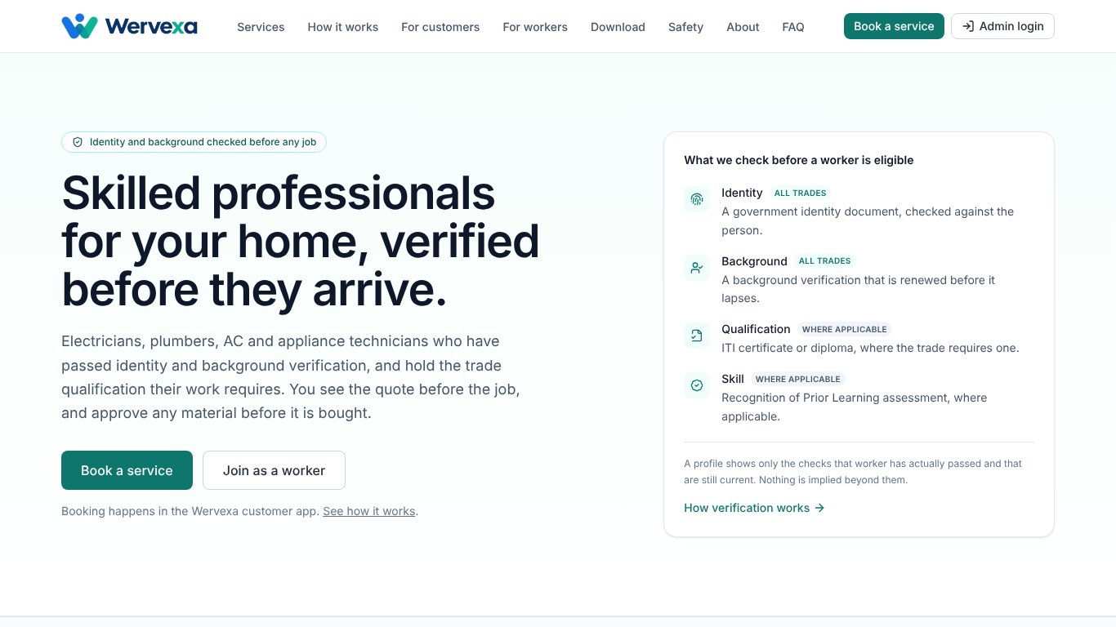
Fig 4.1 Wervexa Public Website – Home Page
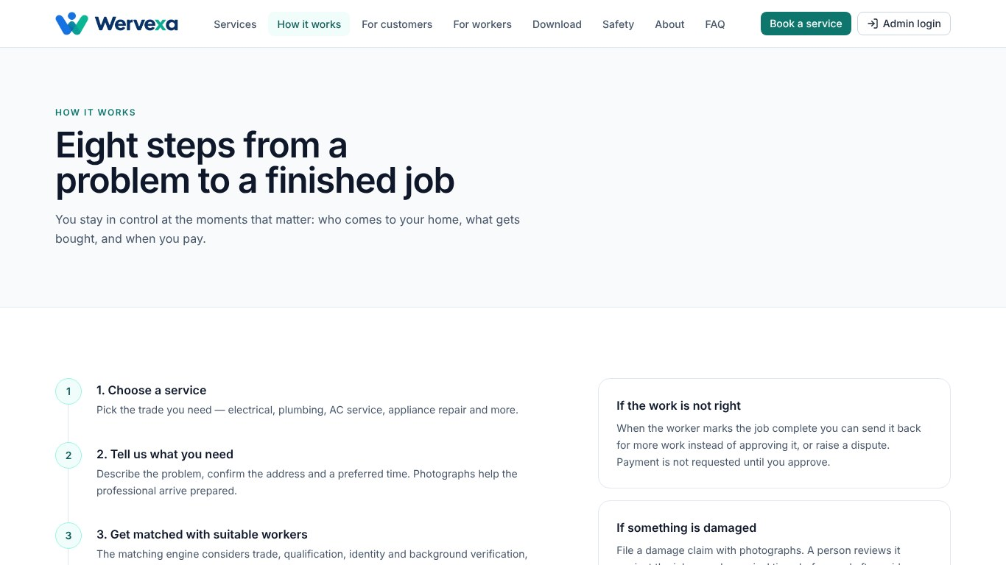
Fig 4.2 Wervexa Public Website – How It Works
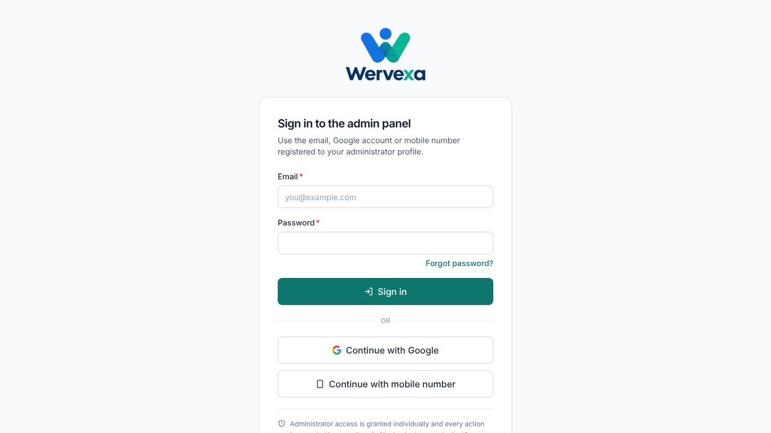
Fig 4.3 Admin Panel Sign-in
PROTOTYPE APP MOBILE:
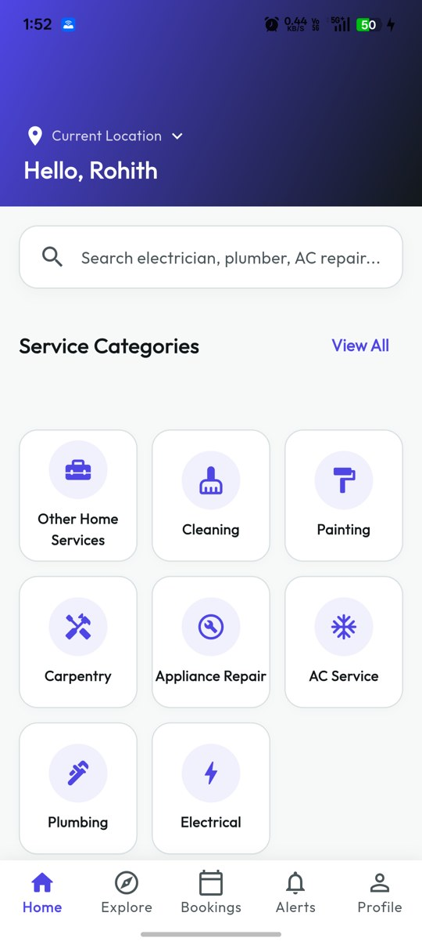 | 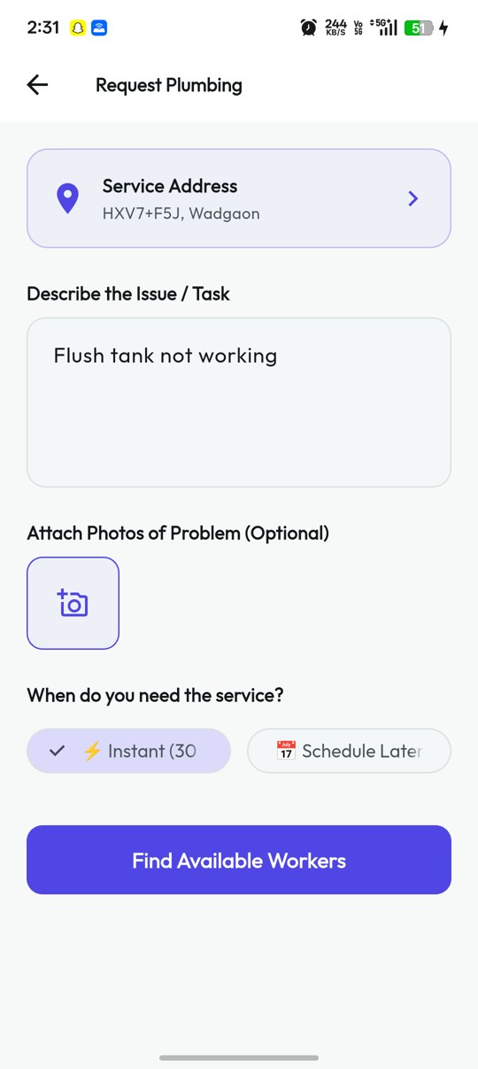 | 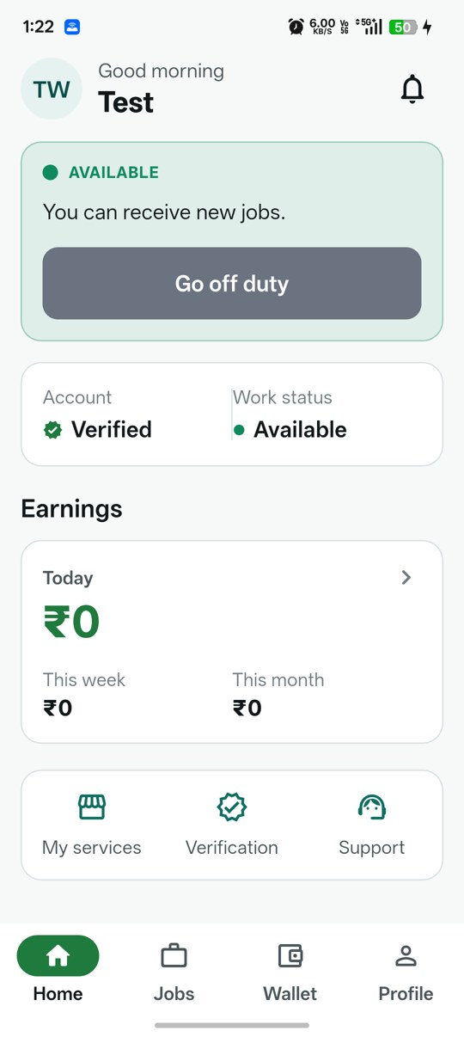
(a) Customer App – Home | (b) Customer App – Request Service | (c) Worker App – Home
Fig 4.4 Wervexa Mobile Applications

4.3 SUMMARY
This chapter presented the results and analysis of the Wervexa system. Functional analysis demonstrated that the platform correctly handles sign-in, onboarding, service discovery, matching, payment, job execution, settlement and administration, with every sensitive decision taken on the server.
The experimental analysis, presented through structured test cases, confirmed that the complete booking lifecycle works end to end on a real device, and that defects discovered during testing were traced to their root cause and fixed. The automated test suite further validated permissions, the booking state machine, input safety and upload rules.
Overall, the results highlight that Wervexa is a dependable and user-friendly platform capable of connecting customers with verified professionals safely and transparently. The outcomes of Chapter 4 provide the foundation for the concluding reflections presented in the next chapter.

CHAPTER 5 – CONCLUSION AND FUTURE SCOPE

5.1 CONCLUSION
Wervexa – Verified Home-Service Workers Gig Platform successfully addresses the major challenges faced by households and skilled home-service workers in India by providing a verified, transparent and secure way to book and deliver home services. Through the integration of Flutter mobile apps, a Next.js web tier, Firebase identity, a Supabase PostgreSQL backend, DigiLocker e-KYC, Razorpay payments and live location tracking, the system protects the customer at every step while giving workers a fair and dignified way to earn.
The project achieves its primary objective of building trust between customers and workers. Verification-first onboarding, a weighted matching engine, upfront but protected payments, customer-approved materials and server-verified arrival codes reduce the risks associated with informal hiring. Because every business rule is enforced in the database, the system remains secure even if a mobile app is modified. Overall, Wervexa is a practical, scalable and impactful solution that contributes to the formalisation of India’s gig workforce.

5.2 FUTURE SCOPE
The system has strong potential for expansion and can be enhanced with several additional features to increase its usefulness for customers and workers nationwide:
- AI-Based Price Estimation – Estimating the job price from the problem description and photos before booking.
- Automated Refund and Payout Processing – Completing gateway refunds and bank payouts automatically through webhooks.
- Worker Insurance and Welfare – Integrating accident and health insurance and linking workers to social-security schemes.
- Skill Upgradation – Connecting workers to RPL assessments and short courses to earn higher-paying gigs.
- iOS Applications – Releasing the Customer and Worker apps on iOS for wider reach.
- Voice-Based Booking – Allowing customers and workers to use the assistant through voice in their own language.
- Subscription and Maintenance Plans – Annual maintenance contracts for appliances and homes.
These enhancements can significantly improve the system’s impact and inclusion across India.

5.3 APPLICATIONS
The Wervexa system can be used in a variety of real-world contexts:
1. Households
To book verified electricians, plumbers, technicians and cleaners safely.
2. Skilled Workers and Freelancers
To find steady work, build a verified profile and receive direct payouts.
3. Apartment Associations and Gated Communities
To provide residents with a trusted pool of service professionals.
4. Facility Management Companies
To dispatch and track field technicians across many sites.
5. Government and NGOs
For skilling, livelihood and social-security programmes for informal workers.
6. Small Businesses and Offices
To handle routine electrical, plumbing and maintenance work with proper records.

5.4 SUMMARY
This chapter summarised the achievements, future potential and real-world applications of the Wervexa system. The project demonstrates how technology can make home services safer, fairer and more transparent for both customers and workers. The conclusion reinforces that the system is secure, scalable and aligned with India’s vision for a digital and inclusive economy. Future enhancements can make Wervexa even more impactful and widely accessible across the nation.

REFERENCES
- NITI Aayog, India’s Booming Gig and Platform Economy: Perspectives and Recommendations on the Future of Work, Government of India, 2022.
- International Labour Organization, World Employment and Social Outlook 2021: The Role of Digital Labour Platforms in Transforming the World of Work, ILO, Geneva, 2021.
- Government of India, The Code on Social Security, 2020, Ministry of Labour and Employment, 2020.
- Government of India, The Digital Personal Data Protection Act, 2023, Ministry of Electronics and Information Technology, 2023.
- Reserve Bank of India, Guidelines on Regulation of Payment Aggregators and Payment Gateways, RBI, 2020.
- Ministry of Skill Development and Entrepreneurship, Recognition of Prior Learning under PMKVY – Guidelines, Government of India, 2021.
- DigiLocker, DigiLocker Partner Documentation, Ministry of Electronics and Information Technology, Government of India, 2024.
- Flutter Team, Flutter Documentation, Google, 2025. Available: https://docs.flutter.dev
- Vercel, Next.js Documentation (App Router), 2025. Available: https://nextjs.org/docs
- Supabase, Row Level Security and Database Functions, Supabase Documentation, 2025.
- The PostgreSQL Global Development Group, PostgreSQL 15 Documentation, 2024.
- Google, Firebase Authentication and Cloud Messaging Documentation, 2025.
- Razorpay, Payment Gateway Integration and Signature Verification Guide, Razorpay Documentation, 2025.
- Google, Routes API and Maps SDK for Android Documentation, Google Maps Platform, 2025.
- OWASP Foundation, OWASP Top 10: 2021 – The Ten Most Critical Web Application Security Risks, 2021.
- Kleppmann, M., Designing Data-Intensive Applications, O’Reilly Media, 2017.
- Martin, R. C., Clean Architecture: A Craftsman’s Guide to Software Structure and Design, Prentice Hall, 2017.
- Fowler, M., Patterns of Enterprise Application Architecture, Addison-Wesley, 2002.
- Sommerville, I., Software Engineering, 10th Edition, Pearson, 2016.
- Riverpod, Riverpod Documentation – State Management for Flutter, 2025.

