**Infrastructure Deployment Report**

**ASSIGNMENT 4**

MUHAMMAD MUSA 2020330

BASIL SHAQEEQ 2020901

# I. Introduction

This report documents the deployment of the infrastructure for the project titled "DevOps Assignment 4". The infrastructure includes the creation of a Virtual Private Cloud (VPC) on AWS using Terraform, the launch of EC2 instances within the VPC, and the setup of a basic web server and database/machine learning instance.

# II. Sequential Deployment Steps

## VPC Creation:

Created a VPC named devops-assignment-4 with a CIDR block of 10.0.0.0/16.

Established two public and private subnets, each in different availability zones, supporting up to 255 virtual machines.

Configured a private route table to restrict internet access for private subnets.

Created an internet gateway to enable access to resources in the VPC.

## Security Groups:

Developed security groups to control inbound and outbound traffic for EC2 instances.

Followed the principle of least privilege to ensure only necessary ports are open.

Configured security groups for web server and database/machine learning instances.

## Key Pair Creation:

Created a secure key pair named cs423-assignment4-key.

Attached the key pair to EC2 instances for secure SSH access.

## EC2 Instances:

Launched two t2.micro EC2 instances using the latest Ubuntu AMI.

Assigned each instance to specific subnets based on their intended purposes.

Configured one instance for hosting a web server (Apache) and the other for a database or machine learning model.

Utilized a user_data.sh script for configuring instances.

# III. Infrastructure Diagram

Internet Gateway

VPC

CIDR BLOCK: 10.0.0.0/16

Public Subnet 2

EC2 DB Instance

Public subnet 1

EC2 Web Instance

Private Subnet 2

Private subnet 1

VPC

**TASK:2**

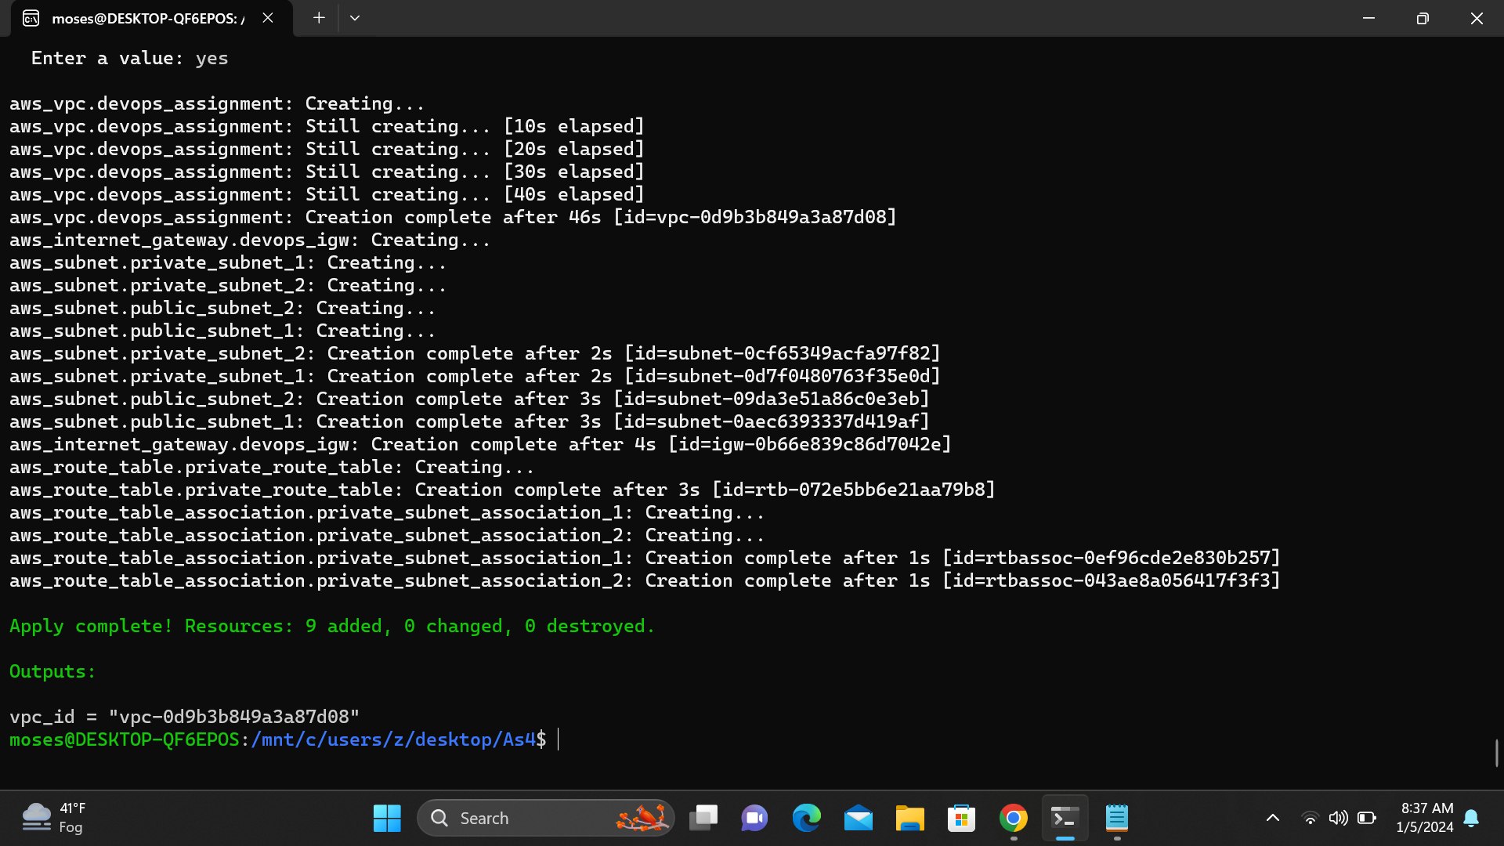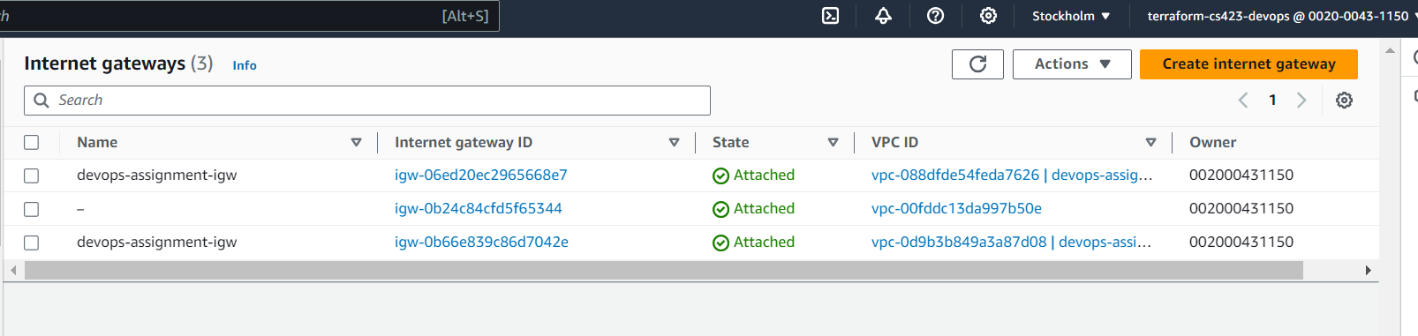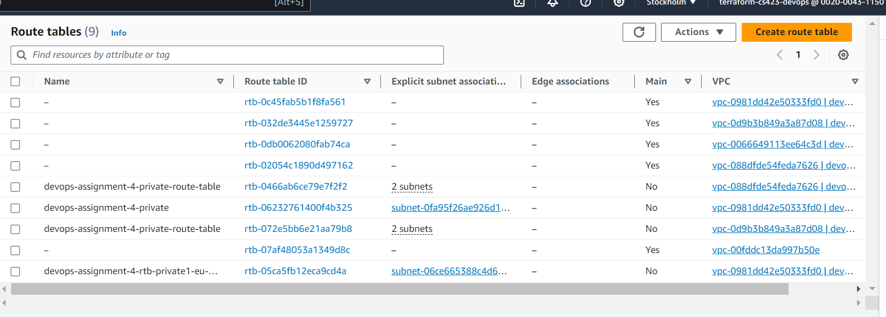

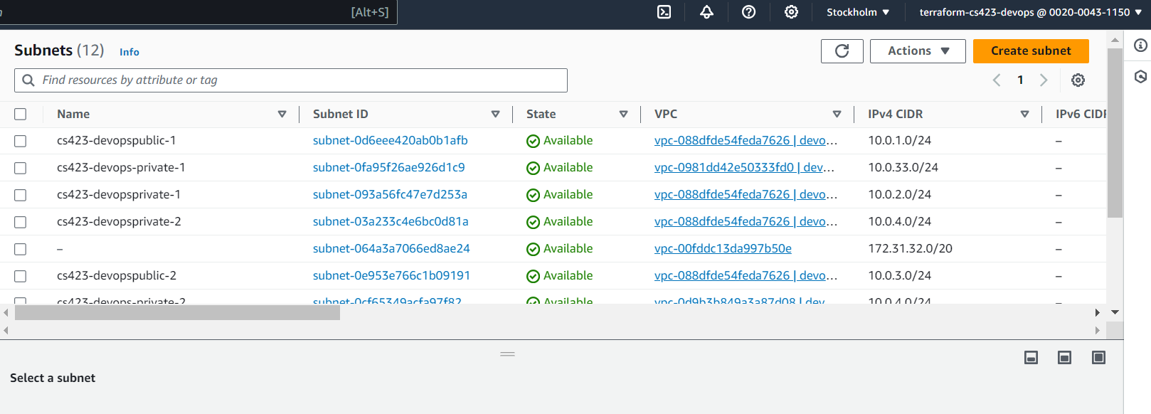

**TASK:3**

