==============================================================>

Open Ubuntu and then the terminal the type the below commands

==============================================================>
Increase max_map_count on your Docker host

sysctl -w vm.max_map_count=262144

==============================================================>
Run the Docker installation script:

curl -sSL https://get.docker.com/ | sh
==============================================================>
Start the Docker service:

systemctl start docker

==============================================================>
Download the Docker Compose binary:

curl -L "https://github.com/docker/compose/releases/download/v2.12.2/docker-compose-$(uname -s)-$(uname -m)" -o /usr/local/bin/docker-compose

==============================================================>
Grant execution permissions:

chmod +x /usr/local/bin/docker-compose

==============================================================>
Test the installation to ensure everything is fine:

docker-compose --version

==============================================================>

Installing Wazuh

git clone https://github.com/wazuh/wazuh-docker.git -b v4.8.1
cd wazuh-docker/single-node
==============================================================>
Get desired certificates

docker-compose -f generate-indexer-certs.yml run --rm generator

==============================================================>
Type the below command

docker-compose up -d

==============================================================>
Then type in ifconfig and check the ip of docker server

Go to browser and type https://ipaddress_of_docker_server

It would open the wazuh dashboard

==============================================================>

==============================================================>

Below are the screenshots

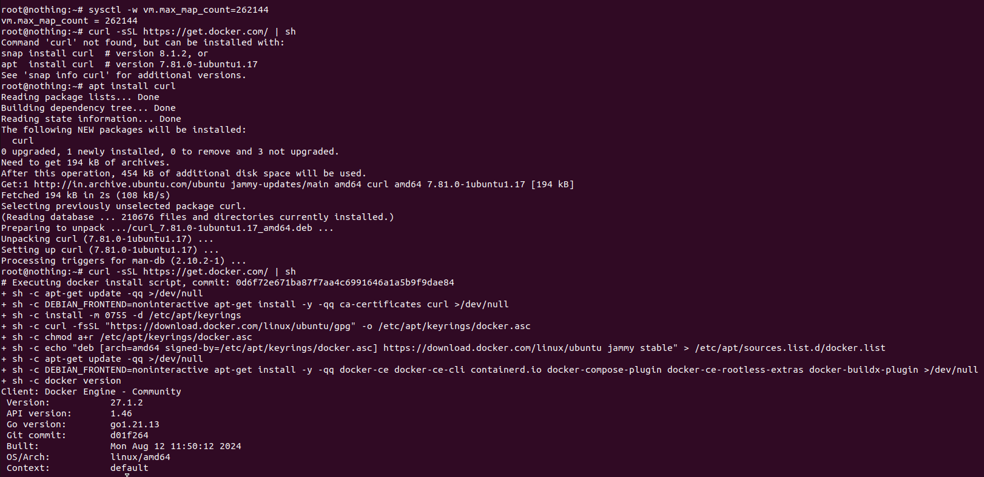

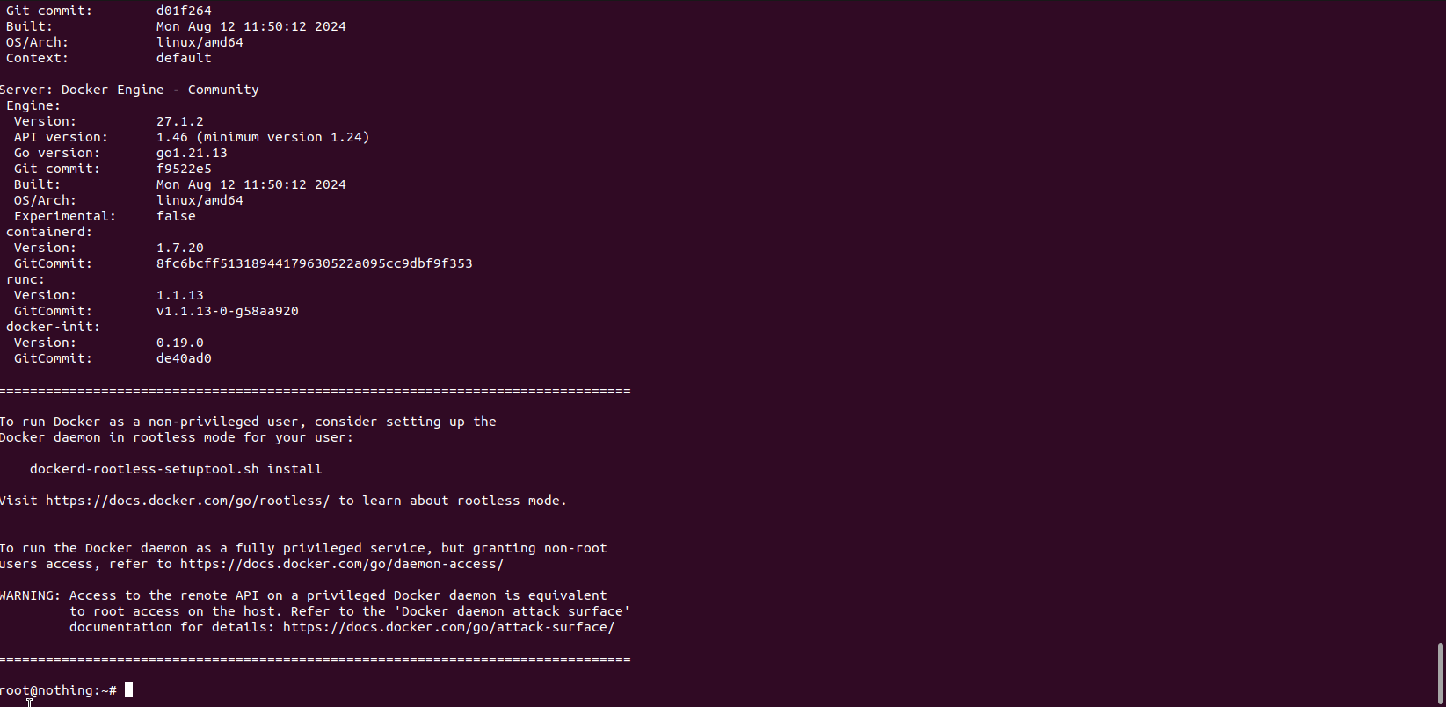

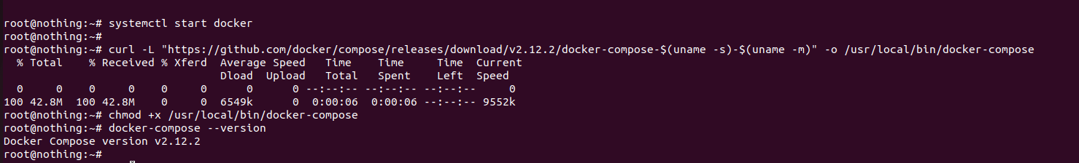

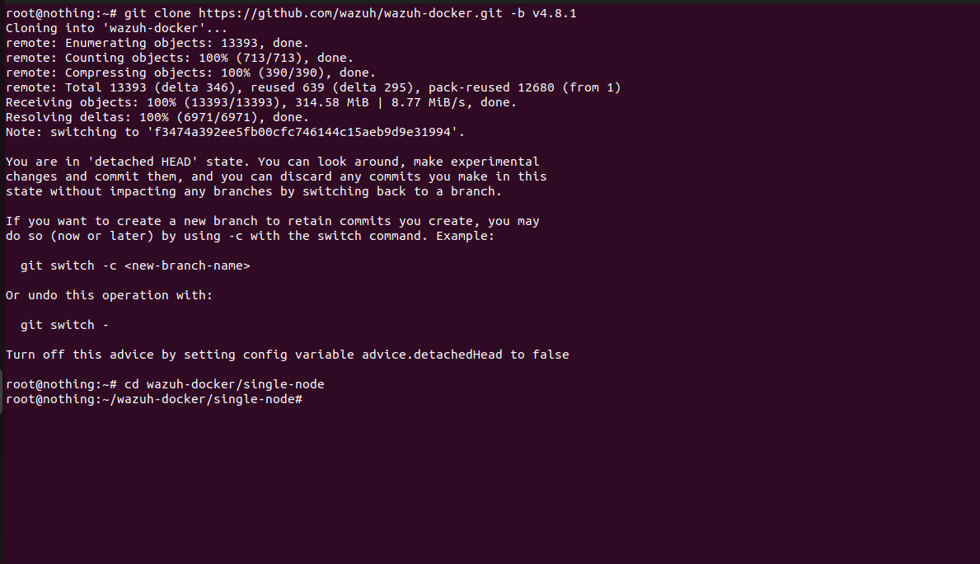

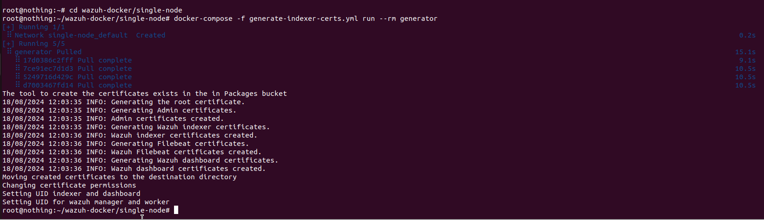

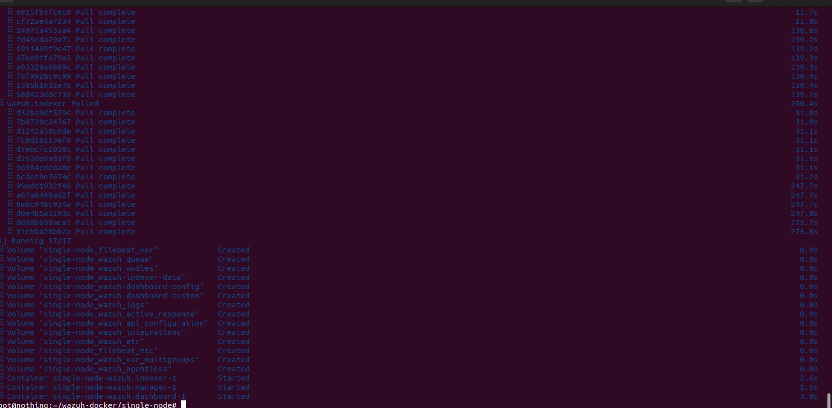

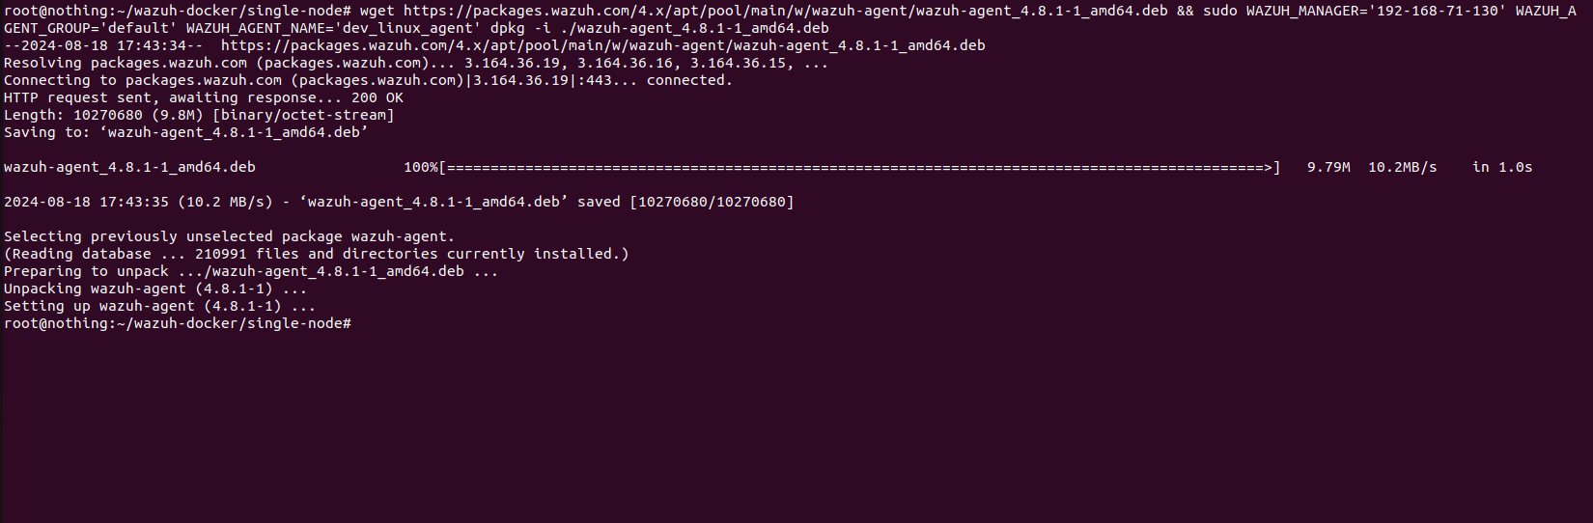

Addition of linux Agent

wget https://packages.wazuh.com/4.x/apt/pool/main/w/wazuh-agent/wazuh-agent_4.8.1-1_amd64.deb && sudo WAZUH_MANAGER='192.168.71.130' WAZUH_AGENT_GROUP='default' WAZUH_AGENT_NAME='dev_linux_agent' dpkg -i ./wazuh-agent_4.8.1-1_amd64.deb

sudo systemctl daemon-reload
sudo systemctl enable wazuh-agent
sudo systemctl start wazuh-agent

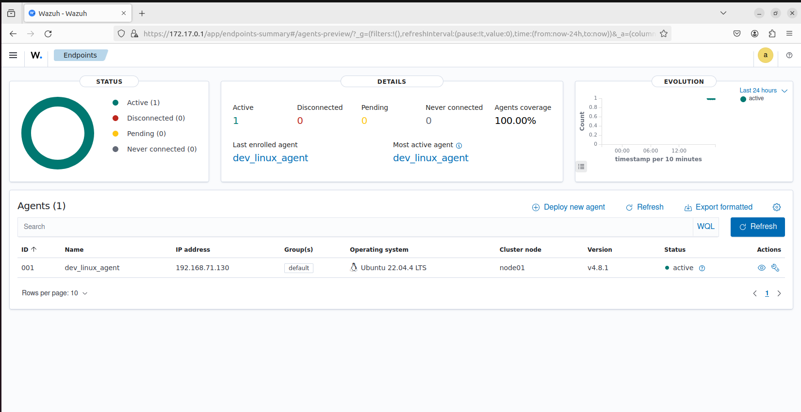

Addition of windows Agent

Invoke-WebRequest -Uri https://packages.wazuh.com/4.x/windows/wazuh-agent-4.8.1-1.msi -OutFile ${env.tmp}\wazuh-agent; msiexec.exe /i ${env.tmp}\wazuh-agent /q WAZUH_MANAGER='192.168.71.130' WAZUH_AGENT_GROUP='default' WAZUH_AGENT_NAME='dev_win_agent'

NET START WazuhSvc

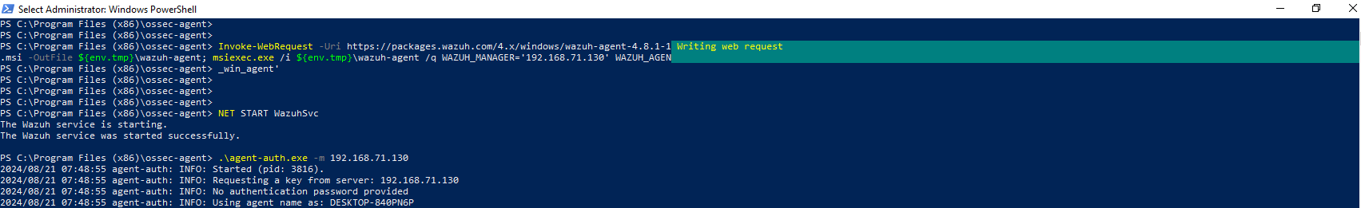

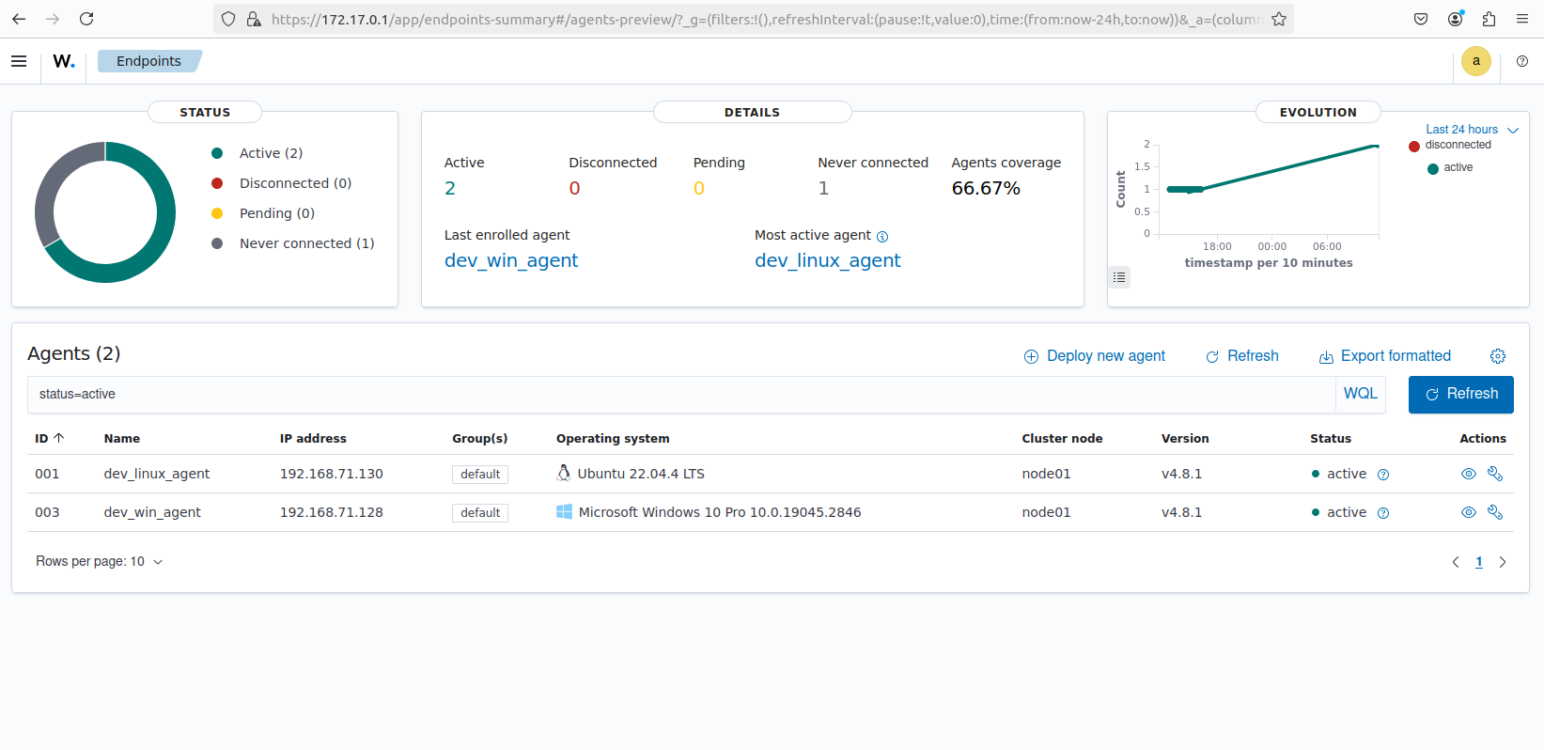
File integrity Test

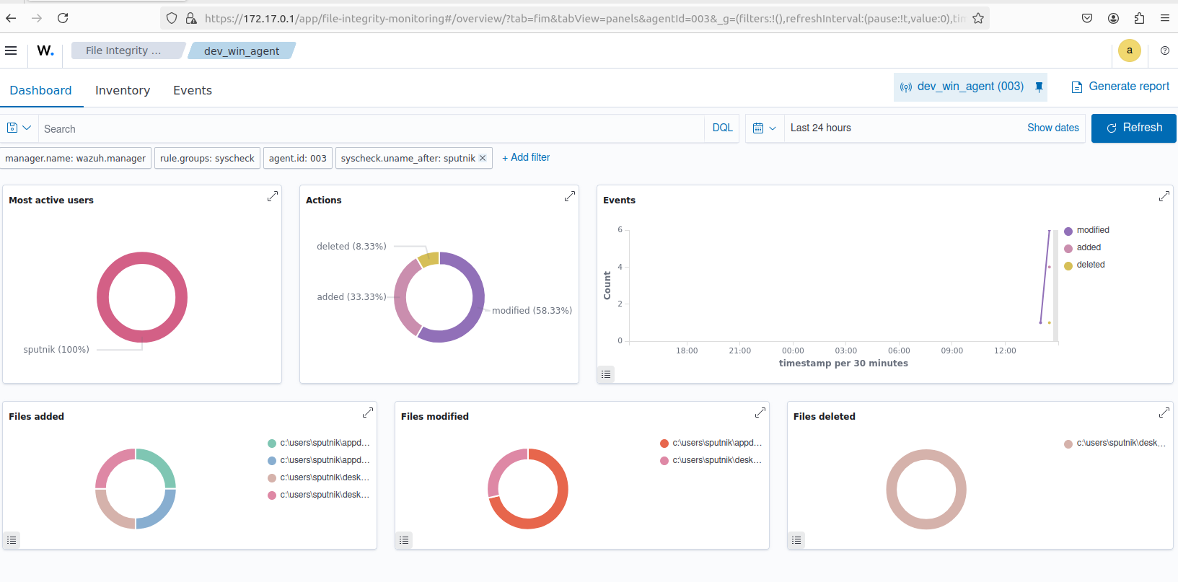
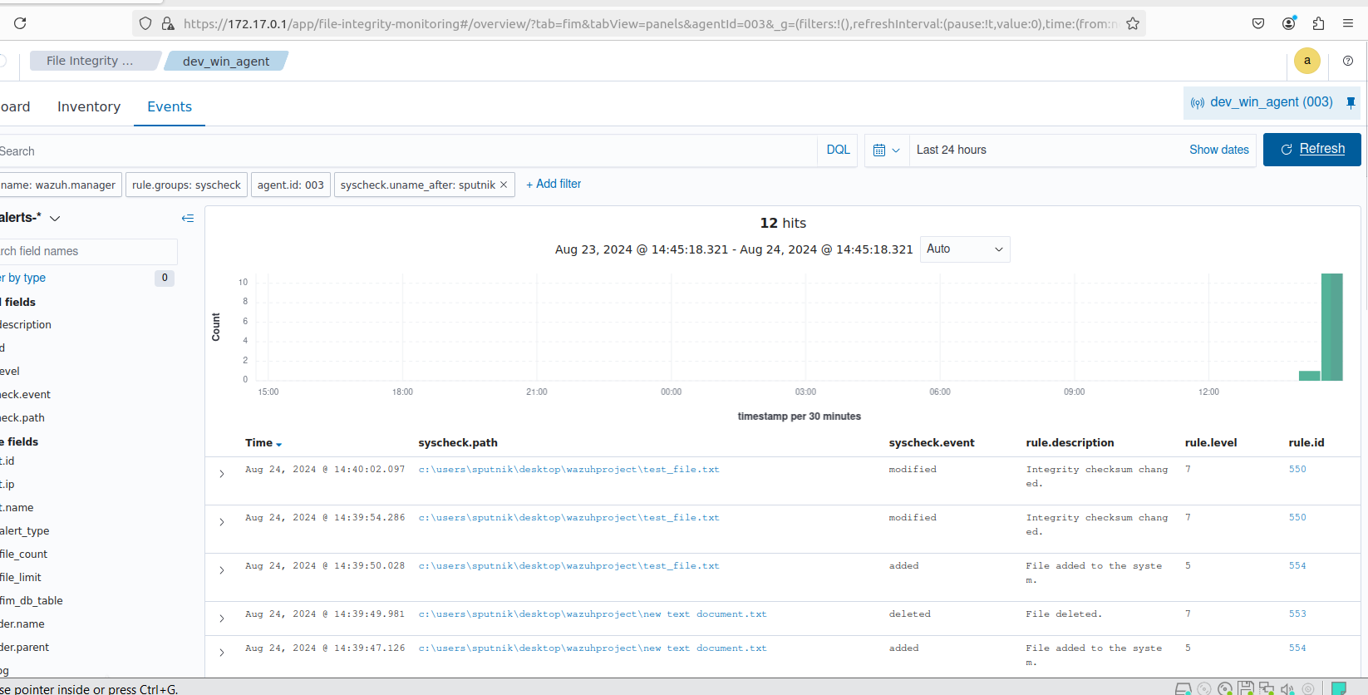

========================================

INSTALLING ELK

Download and install the Public Signing Key:

wget -qO - https://artifacts.elastic.co/GPG-KEY-elasticsearch | sudo gpg --dearmor -o /usr/share/keyrings/elastic-keyring.gpg

You may need to install the apt-transport-https package on Debian before proceeding:

sudo apt-get install apt-transport-https

Save the repository definition to /etc/apt/sources.list.d/elastic-8.x.list:

echo "deb [signed-by=/usr/share/keyrings/elastic-keyring.gpg] https://artifacts.elastic.co/packages/8.x/apt stable main" | sudo tee -a /etc/apt/sources.list.d/elastic-8.x.list

Run sudo apt-get update and the repository is ready for use. You can install it with:

sudo apt-get update && sudo apt-get install logstash

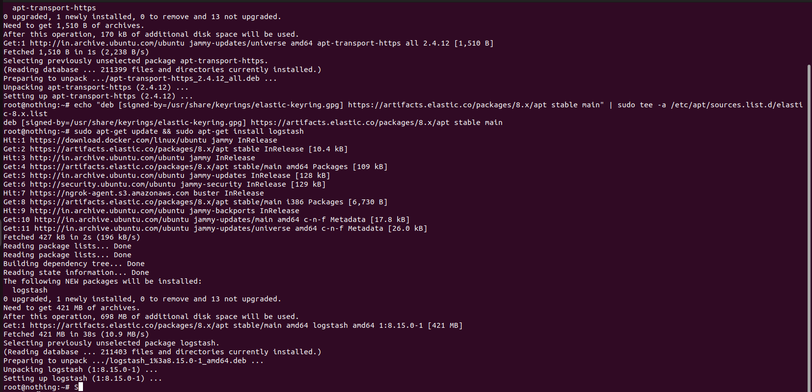

Run the following command to install the logstash-input-opensearch plugin. This plugin reads data from the Wazuh indexer into the Logstash pipeline.

sudo /usr/share/logstash/bin/logstash-plugin install logstash-input-opensearch

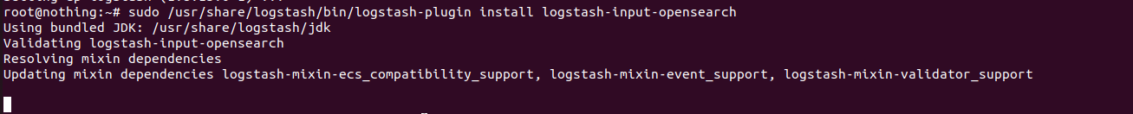

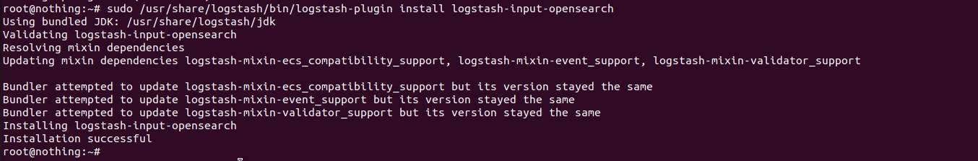

sudo add-apt-repository ppa:openjdk-r/ppa
sudo apt update
sudo apt install openjdk-11-jdk

sudo apt install unzip

sudo chmod -R 755 </PATH/TO/LOCAL/WAZUH_INDEXER/CERTIFICATE>/root-ca.pem
sudo chmod -R 755 </PATH/TO/LOCAL/ELASTICSEARCH/CERTIFICATE>/root-ca.pem

sudo chmod -R 755 /root/wazuh-docker/single-node/config/wazuh_indexer_ssl_certs/root-ca.pem

set +o history
echo 'LOGSTASH_KEYSTORE_PASS="nothingisroot"'| sudo tee /etc/sysconfig/logstash
export LOGSTASH_KEYSTORE_PASS=nothingisroot
set -o history
sudo chown root /etc/sysconfig/logstash
sudo chmod 600 /etc/sysconfig/logstash
sudo systemctl start logstash

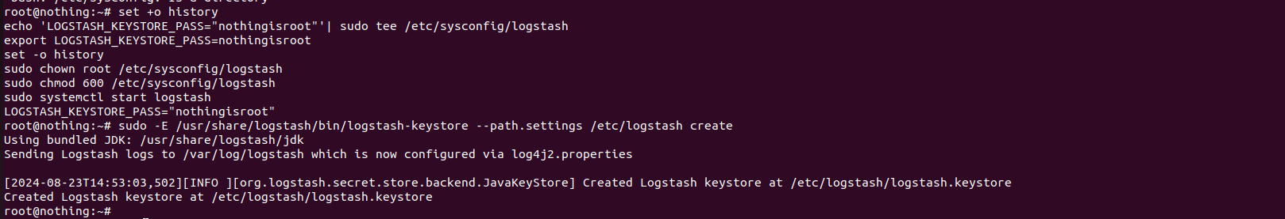

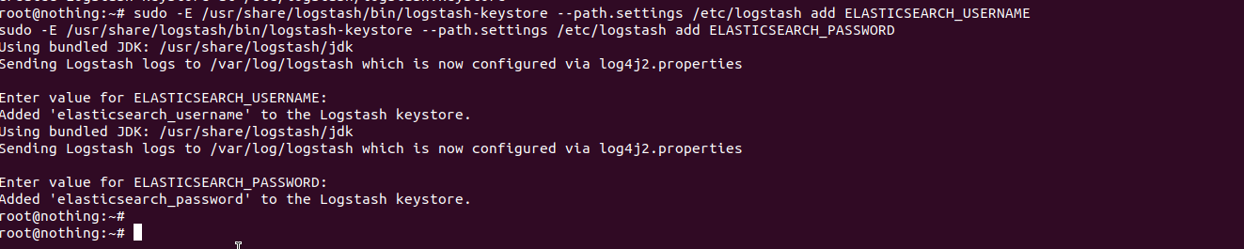

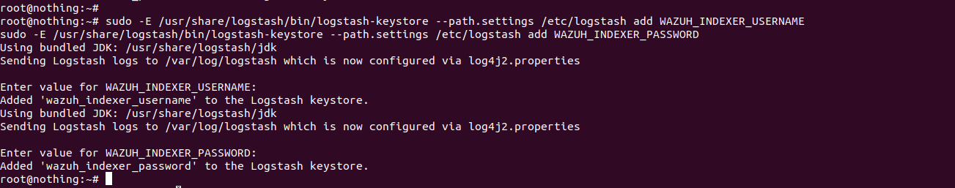

sudo touch /etc/logstash/conf.d/wazuh-elasticsearch.conf

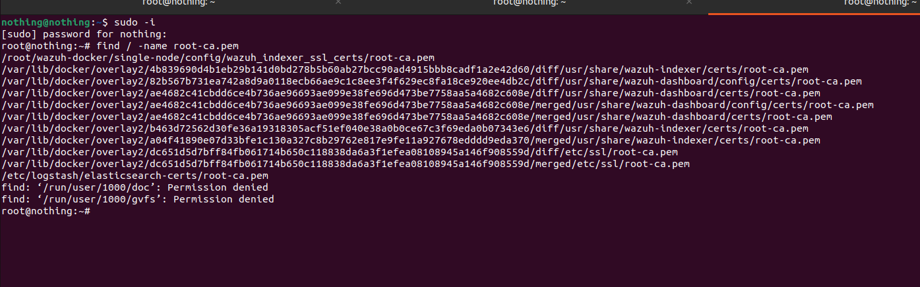
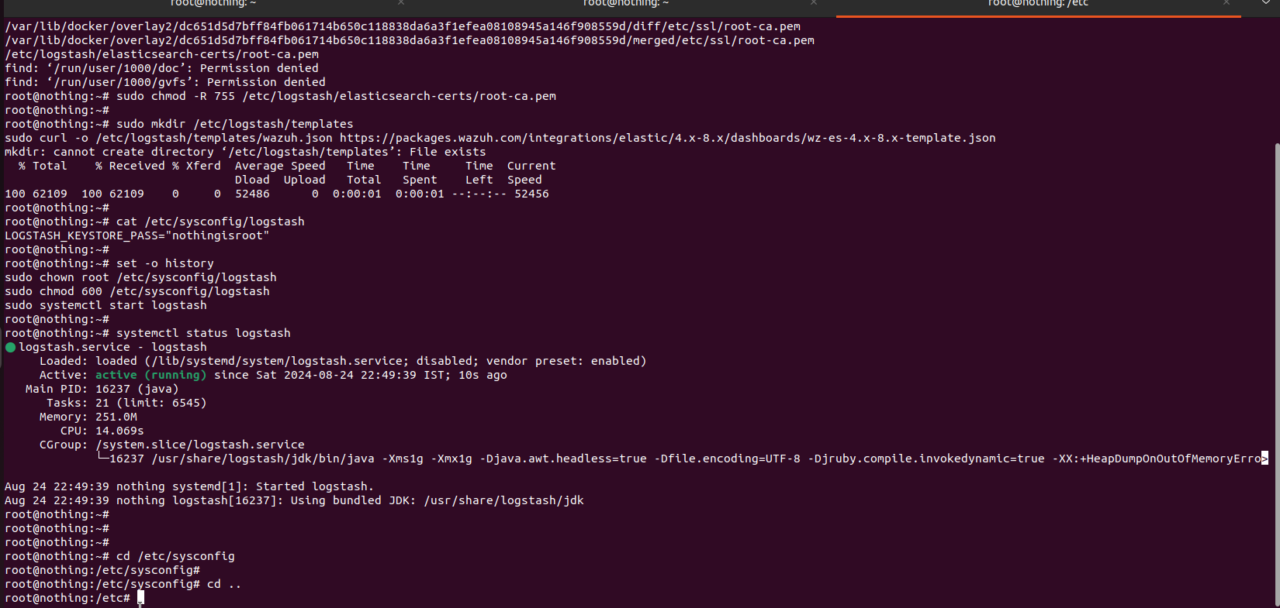

========================================

import pandas as pd
from sklearn.preprocessing import StandardScaler
from sklearn.ensemble import IsolationForest, RandomForestClassifier
from sklearn.neighbors import LocalOutlierFactor

# Load Wazuh log data
log_data = pd.read_csv('wazuh_logs.csv')

# Extract features from the log data
features = ['timestamp', 'event_type', 'source_ip', 'destination_port']

# Preprocess the extracted features
scaler = StandardScaler()
X_scaled = scaler.fit_transform(log_data[features])

# Split the data into training and testing sets
X_train, X_test, y_train, y_test = train_test_split(X_scaled, log_data['anomaly_label'],
test_size=0.2, random_state=42)

# Train an Isolation Forest model on the training set
iforest = IsolationForest(contamination=0.1)
iforest.fit(X_train)

# Predict anomalies using the trained model on the testing set
y_pred_iforest = iforest.predict(X_test)

# Train a LOF model on the training set
lof = LocalOutlierFactor(n_neighbors=20)
lof.fit(X_train)

# Predict anomalies using the trained model on the testing set
y_pred_lof = lof.predict(X_test)

# Create an ensemble method that combines Isolation Forest and LOF models
ensemble_model = RandomForestClassifier()
ensemble_model.fit(X_train, y_train)

# Predict anomalies using the ensemble method on the testing set
y_pred_ensemble = ensemble_model.predict(X_test)
```

import wazuh
from wazuh.core import *

# Load the trained anomaly detection model
model = load_model('anomaly_detection_model.pkl')

# Define a custom plugin to integrate the model with Wazuh
class AnomalyDetectionPlugin(Plugin):
def __init__(self, wazuh_core):
self.wazuh_core = wazuh_core

def process_events(self, events):
for event in events:
# Extract relevant features from the event data
features = extract_features(event)

# Use the trained model to predict whether the event is anomalous
prediction = model.predict(features)

if prediction == 1: # Anomaly detected
# Generate an alert and send it to the Wazuh core
self.wazuh_core.alert('Anomaly detected', {'event': event})

# Register the custom plugin with Wazuh
wazuh.register_plugin(AnomalyDetectionPlugin(wazuh.core))

# Start the Wazuh engine
wazuh.start()

