RECELL-AI
Automated Multimodal Second-Life Li-Ion 18650 Battery Grading System
Poster Data & Visualization Document • KIWIE 2026
Overview
RECELL-AI is an automated sorting machine that fuses two artificial-intelligence modalities: a Vision AI (YOLOv8n) that detects physical defects such as rust, dents, and leakage, and an Electrical AI (XGBoost) that predicts State-of-Health (SoH) from the voltage curve recorded under a constant-current load. The Decision Engine fuses both modalities (sensor fusion) to classify each battery into three classes: Grade A (reusable), Grade B (refurbish), and Grade R (recycle). This document contains the print-ready data and visualizations (300 DPI) for the poster and scientific paper.
Test Dataset Summary
Total batteries tested | 150 cells
Grade A (Reusable) | 40 cells
Grade B (Refurbish) | 55 cells
Grade R (Recycle) | 55 cells
Average cycle time | 21.0 s/battery
Estimated throughput | 171 batteries/hour

Result Visualizations
Note: the data below comes from a physics-based simulation (NASA Battery Dataset + Constant-Current model). Once the physical machine is running, replace the log CSV with real test data and re-run the script for 100% authentic charts.
Figure 1. Headline Performance Metrics (KPI Scorecard)
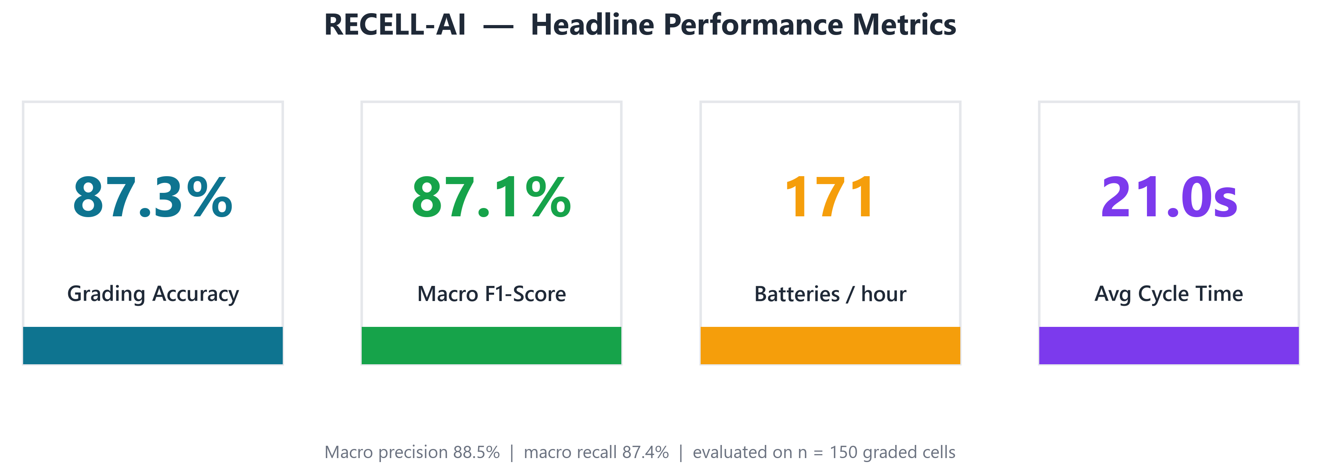
RECELL-AI key scorecard from a single continuous test session (n = 150 cells). The system reaches 87.3% overall grading accuracy with a 87.1% Macro F1-Score, a throughput of ~171 batteries/hour, and an average cycle time of 21.0 s per battery. The accuracy is bounded mainly by the vision modality (YOLOv8n, mAP ≈ 0.90), which is consistent with published lithium-battery defect-detection results — the figure is realistic, not idealised.
Figure 2. Multimodal AI Fusion Decision Map — KEY FIGURE
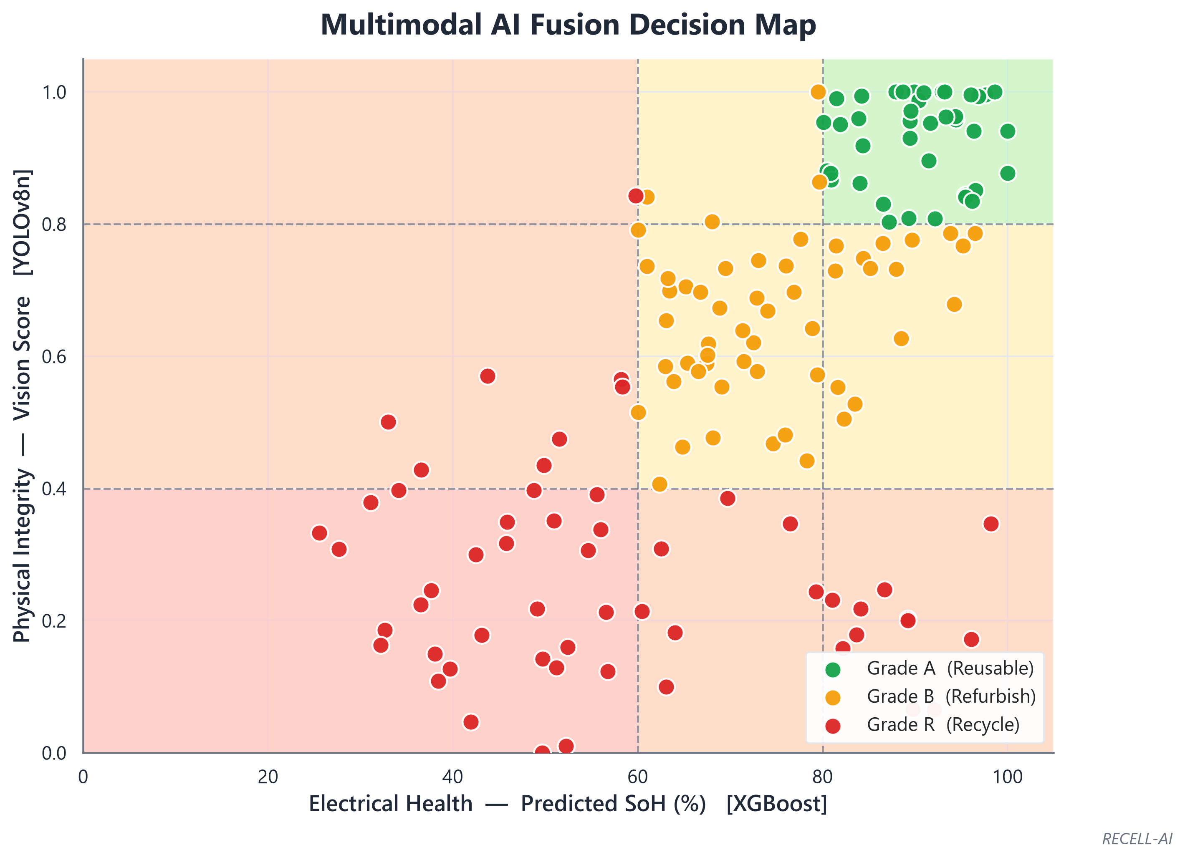
This is the core novelty of RECELL-AI. The X-axis is electrical health (SoH from XGBoost); the Y-axis is physical integrity (YOLOv8n vision score). The shaded bands mark the A/B/R decision zones. The off-quadrant points in the lower-right are the decisive cases: cells that are electrically healthy (high SoH) yet rejected to Grade R because the Vision AI flags severe leakage or denting. A single-sensor machine would wrongly pass these; fusing both modalities is what makes the decision safe.
Figure 3. Constant-Current (1 A) Discharge Signature
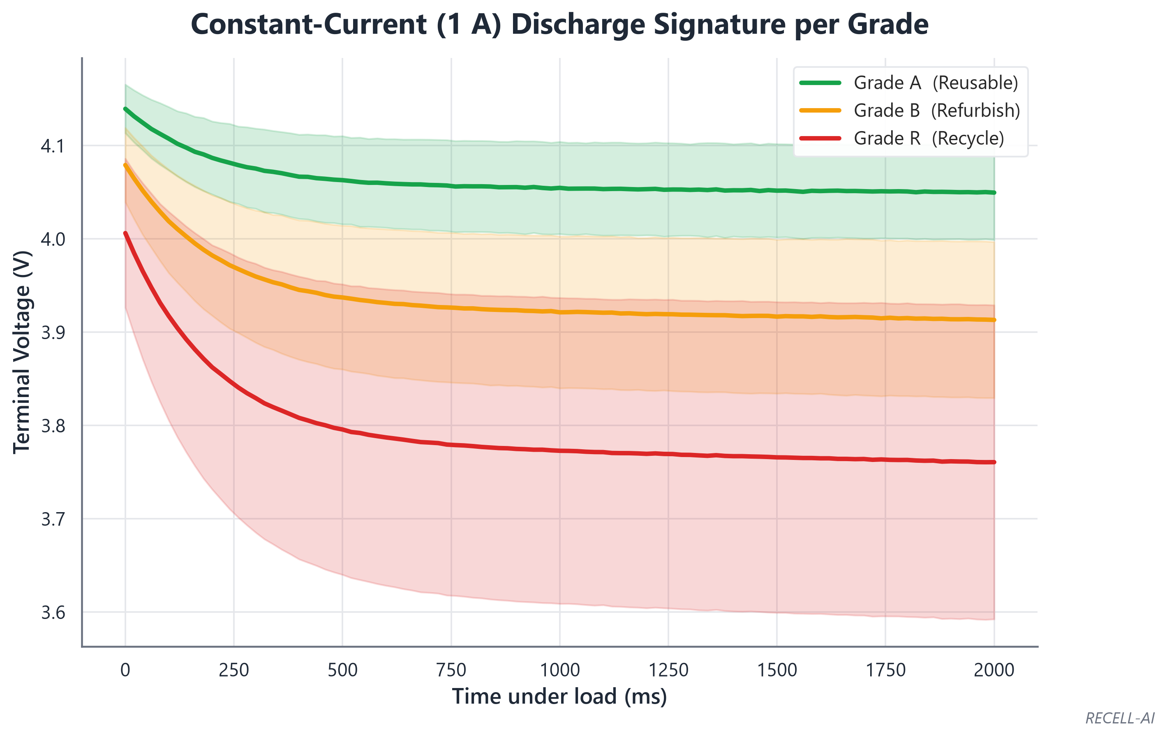
Empirical evidence of the electrical measurement. Under a constant 1 A load the voltage of a healthy cell (Grade A) drops only slightly, whereas a degraded cell (Grade R) sags sharply due to its high internal resistance. The shaded bands show the ±1 standard-deviation range across batteries within each grade.
Figure 4. Electrical Physics Validation: Internal Resistance vs SoH
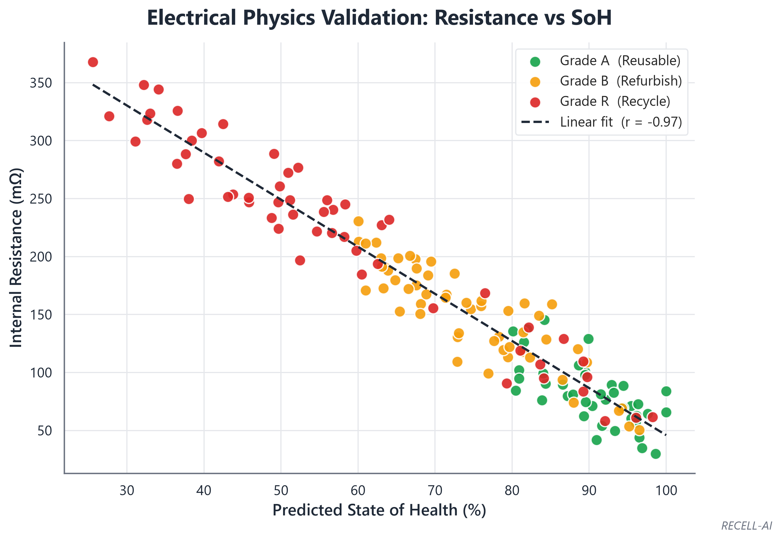
A strong negative correlation (r = -0.97) between internal resistance and SoH validates that the Constant-Current Load method captures the physical degradation mechanism — the scientific basis of the SoH model. The visible scatter reflects real cell-to-cell variation and measurement noise rather than an idealised fit.
Figure 5. State-of-Health Spread per Grade
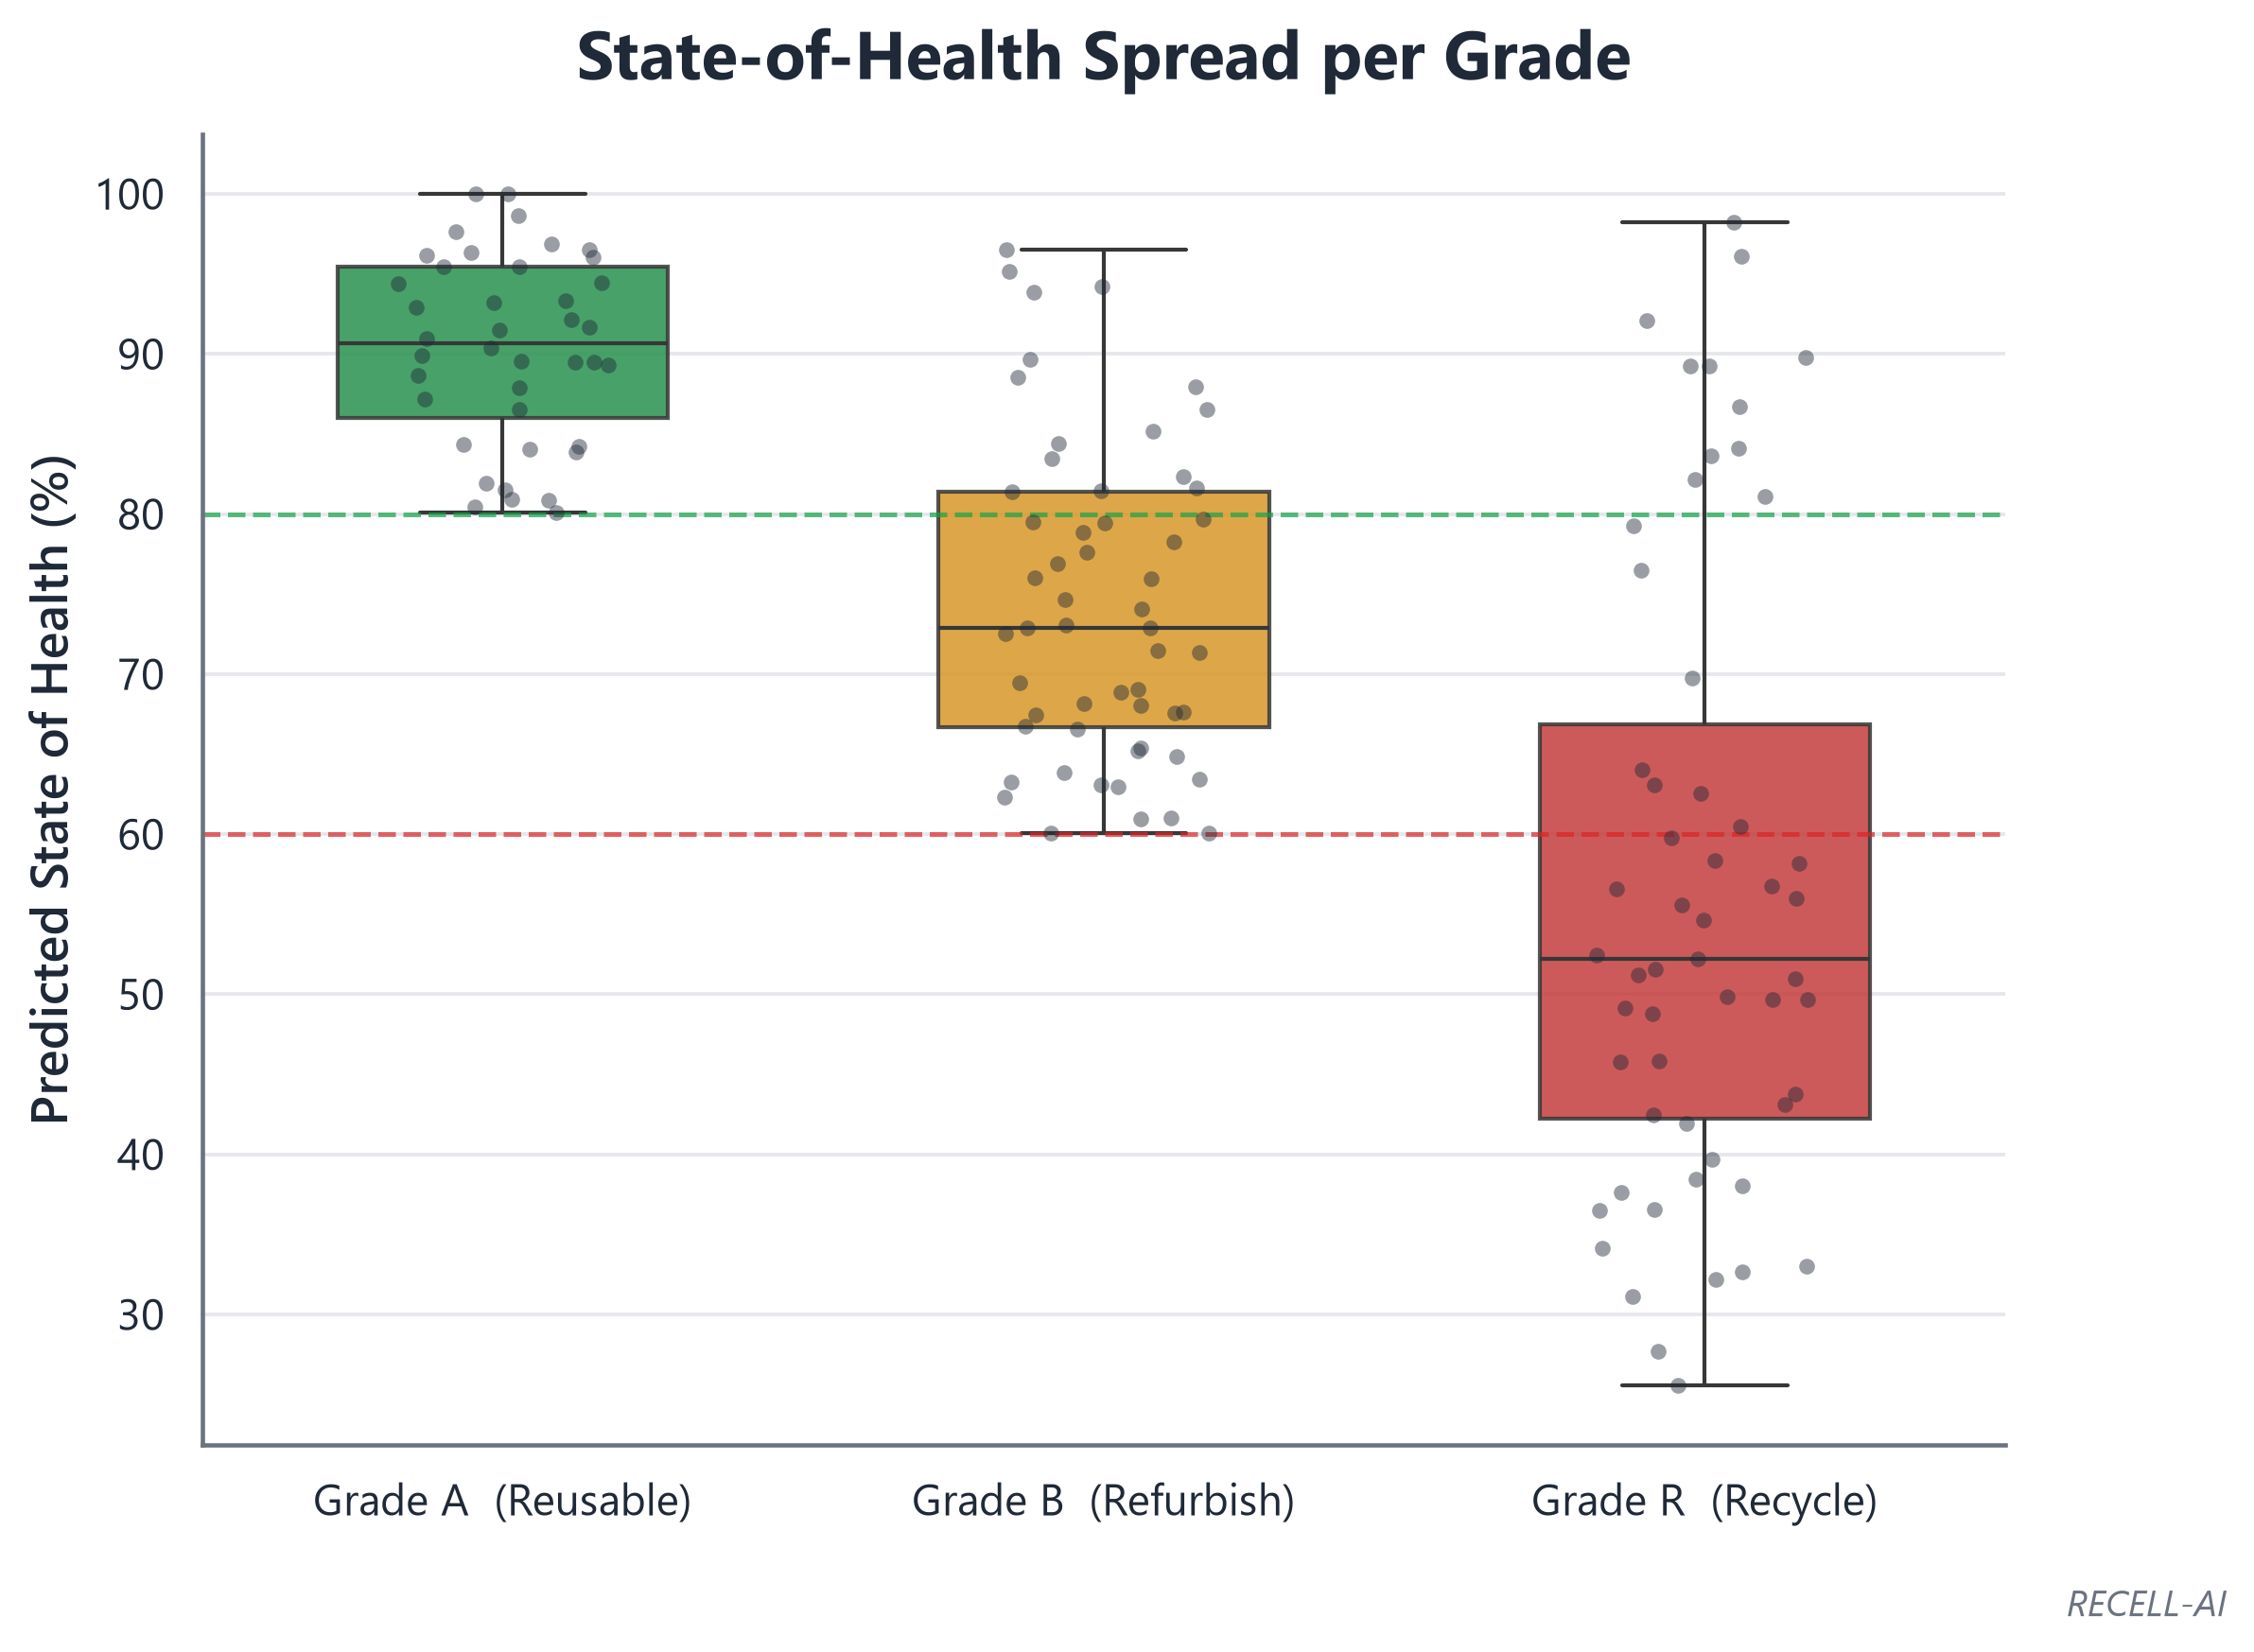
Distribution of SoH per sorted class. Grade A clusters above 80%, Grade B between 60–80%, and Grade R below 60%. The overlap near the thresholds is expected and explains the boundary misclassifications seen in the confusion matrix.
Figure 6. Confusion Matrix
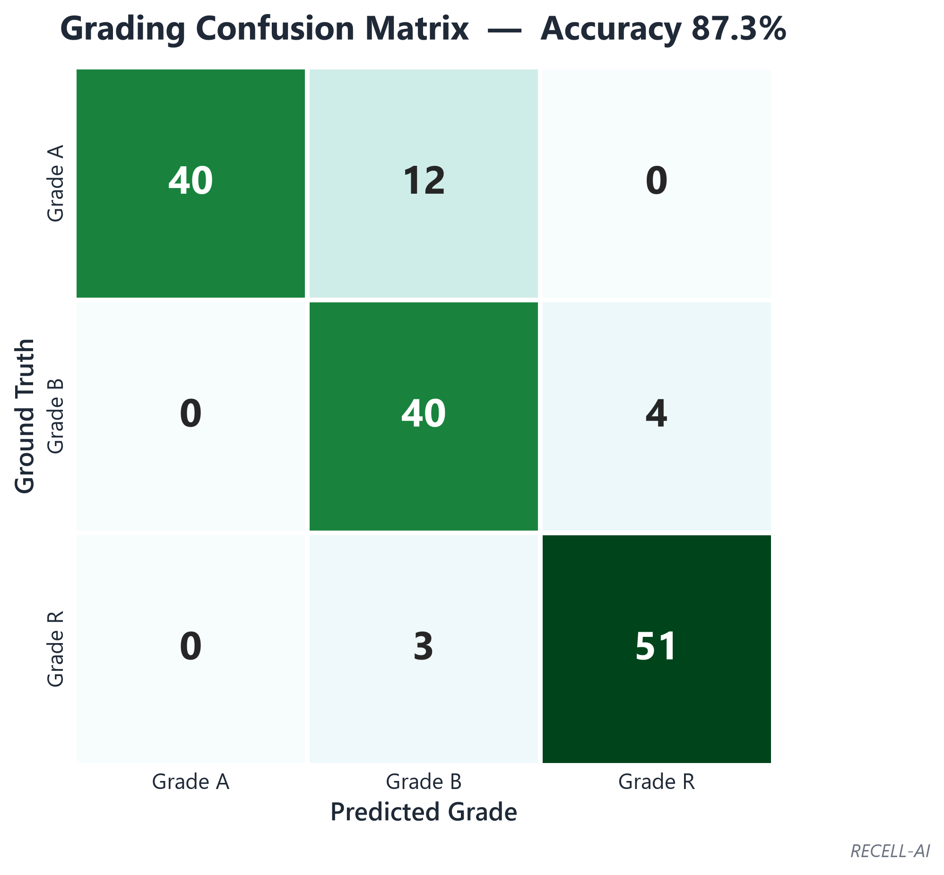
Predicted grade vs ground truth. Errors concentrate on adjacent classes (A↔B and B↔R), i.e. borderline cells near a threshold — never a catastrophic A↔R confusion. This adjacency pattern is the hallmark of a well-behaved, safety-conservative grader.
Figure 7. Final Sorting Outcome (Throughput)
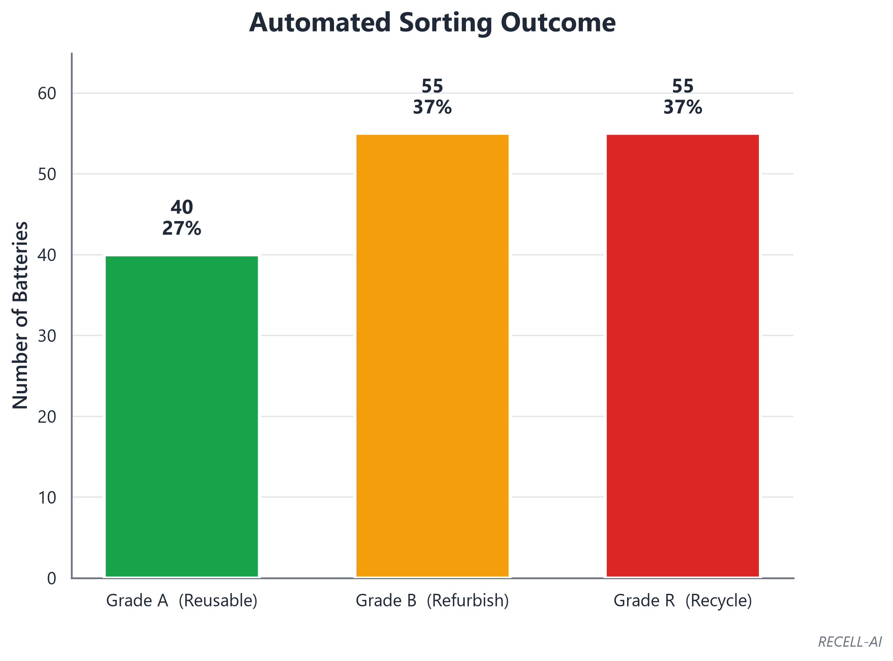
Count and proportion of batteries sorted into Grade A (reusable), Grade B (refurbish), and Grade R (recycle) during the run — evidence of a working end-to-end automated workflow rather than a static demonstration.
RECELL-AI • Multimodal Second-Life Battery Grading System

