# Software Requirements Specification

for

## Student Management System

Version 1.0

Prepared by Ishan Satyanand Thakur

Vedant Agarwal

Priyanshu Sharma

Organization: Manipal Institute of Technology, Manipal

Date: 25-03-2025

# Table of Contents

1. Introduction  
 1.1 Purpose  
 1.2 Document Conventions  
 1.3 Intended Audience and Reading Suggestions  
 1.4 Product Scope  
 1.5 References

2. Overall Description  
 2.1 Product Perspective  
 2.2 Product Functions  
 2.3 User Classes and Characteristics  
 2.4 Operating Environment  
 2.5 Design and Implementation Constraints  
 2.6 User Documentation  
 2.7 Assumptions and Dependencies

3. External Interface Requirements

4. System Features

5. Other Nonfunctional Requirements

6. Other Requirements

Appendices

# 1. Introduction

## 1.1 Purpose

The Student Management System (SMS) is designed to streamline academic processes by managing student records, course enrollments, grades, and attendance tracking. It provides a centralized, digital solution for administrators, teachers, and students.

## 1.2 Document Conventions

This document follows IEEE SRS conventions, using bold headings for sections, bullet points for clarity, and numbered sections for organization.

## 1.3 Intended Audience and Reading Suggestions

The intended audience includes system developers, administrators, teachers, students, and IT staff. Readers should start with the Introduction for an overview, followed by the Overall Description for system context, and finally, the Specific Requirements for implementation details.

## 1.4 Product Scope

SMS aims to replace manual student record-keeping with a web-based platform that enhances efficiency and accuracy. Key features include course enrollment, grading, attendance tracking, and performance monitoring.

## 1.5 References

IEEE Software Engineering Standards, Institutional Academic Policies, Database Management System Manuals.

# 2. Overall Description

## 2.1 Product Perspective

The Student Management System is an independent application that integrates with institutional databases to store and manage academic records.

## 2.2 Product Functions

• Student Information Management  
• Course Enrollment and Management  
• Gradebook and Performance Tracking  
• Attendance Monitoring  
• Notifications and Alerts

## 2.3 User Classes and Characteristics

• **Administrators**: Manage student records and courses.  
• **Teachers**: Enter grades and track attendance.  
• **Students**: Enroll in courses, view grades, and monitor attendance.

## 2.4 Operating Environment

The system will run on a web-based platform, accessible via modern browsers on desktops, laptops, and mobile devices.

## 2.5 Design and Implementation Constraints

Data security must be ensured through authentication and encryption. The system must support multiple concurrent users.

## 2.6 User Documentation

User manuals and online help guides will be provided for students, teachers, and administrators.

## 2.7 Assumptions and Dependencies

The system assumes stable internet access and institutional database integration.

# 3. External Interface Requirements

• **User Interfaces**: Web-based dashboard.  
• **Hardware Interfaces**: Requires standard computers and mobile devices.  
• **Software Interfaces**: Connects with existing academic databases.  
• **Communications Interfaces**: Secure internet-based communication.

# 4. System Features

4.1 Student Records Management  
4.2 Course Enrollment  
4.3 Gradebook Management  
4.4 Attendance Tracking  
4.5 Notifications and Alerts

# 5. Other Nonfunctional Requirements

## 5.1 Performance Requirements

The system must support at least 500 concurrent users without lag.

## 5.2 Safety Requirements

User data should be backed up daily to prevent loss.

## 5.3 Security Requirements

User authentication and data encryption are mandatory.

## 5.4 Software Quality Attributes

The system should be user-friendly, reliable, and scalable.

## 5.5 Business Rules

Only authorized users can modify student records.

# Appendices [Github Link](https://github.com/notishanthakur/StudentManagementSystem)

ER Diagram:

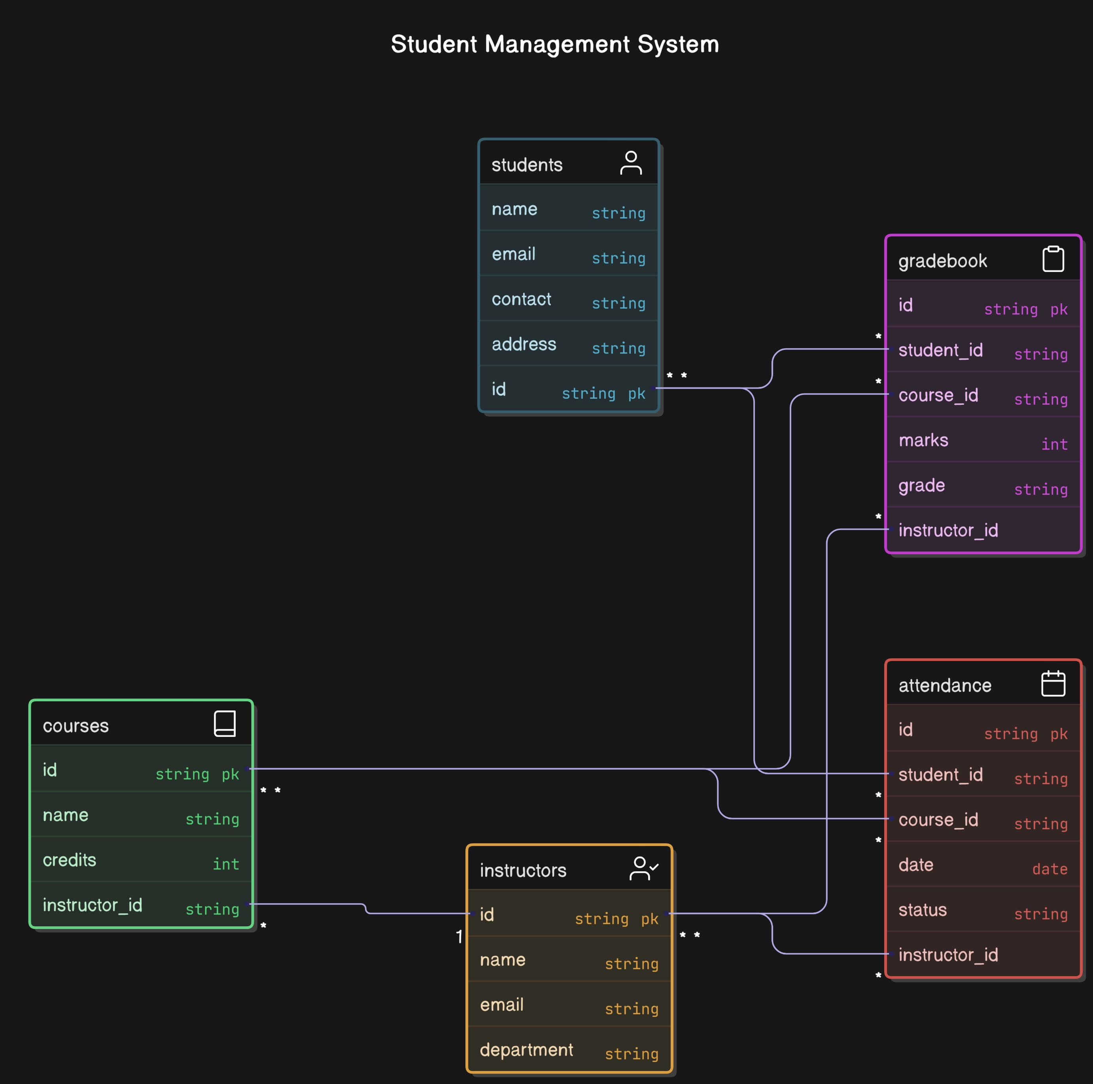

Diagram Normalised:

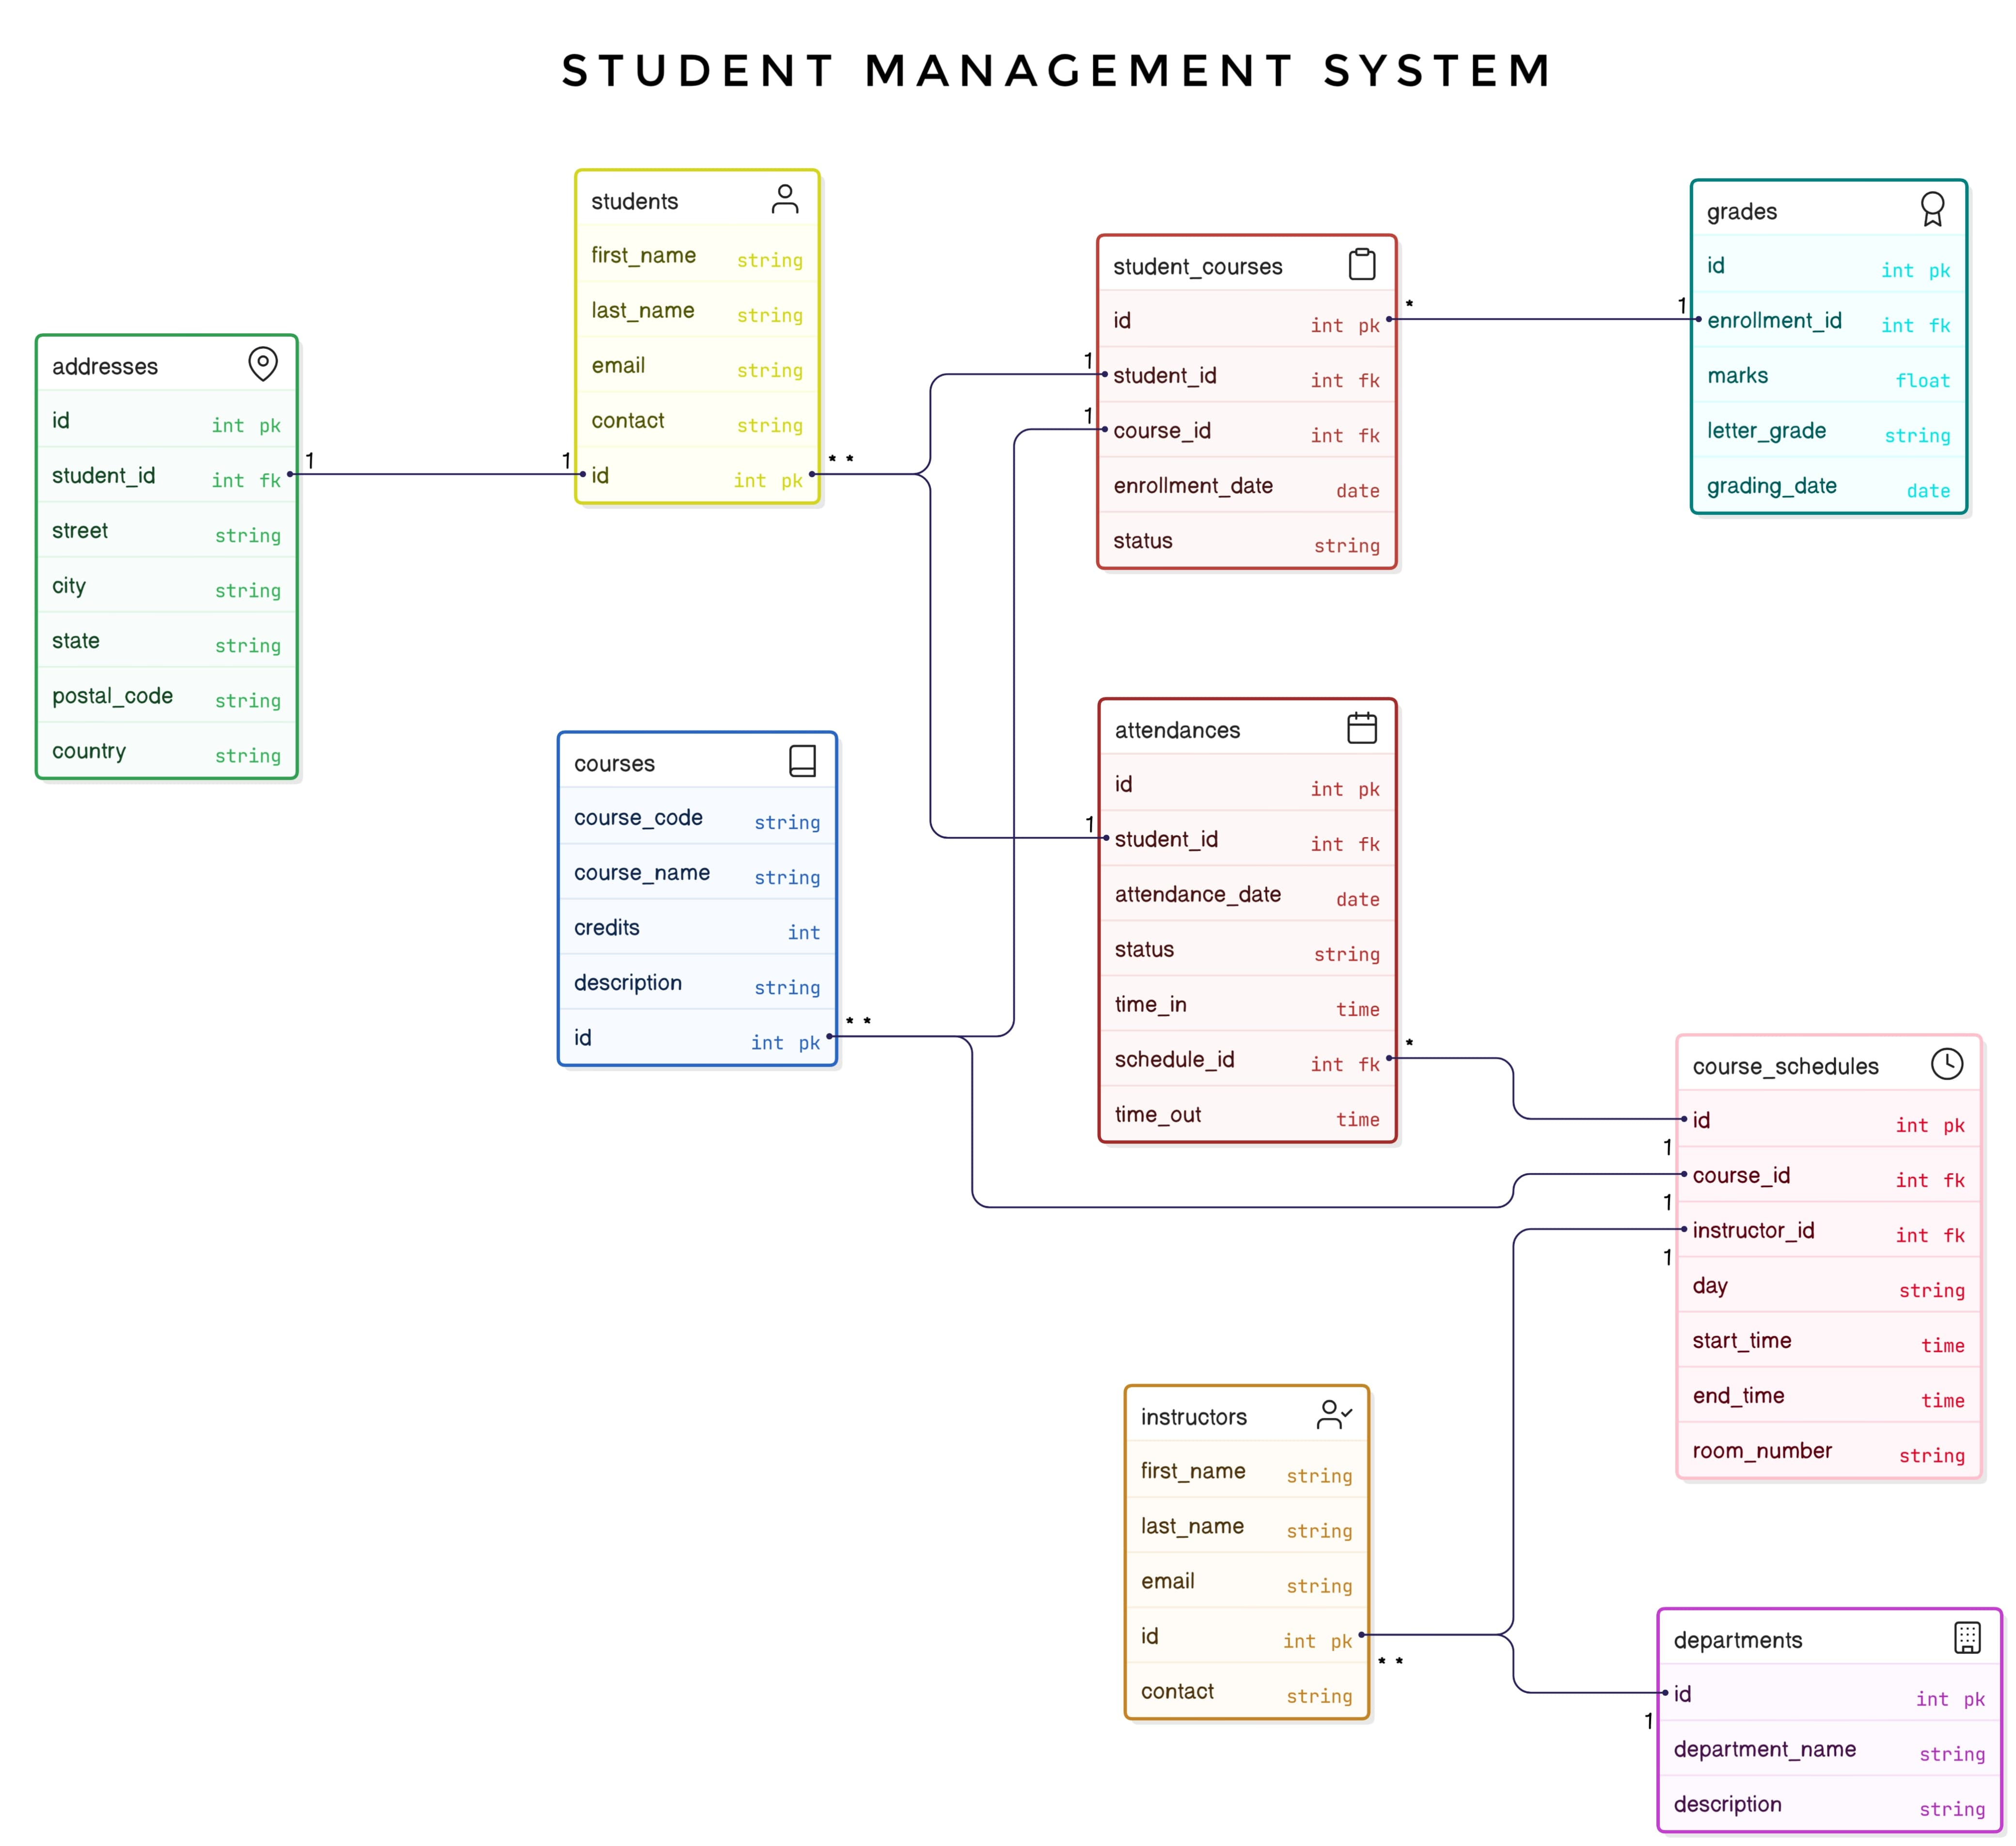

# Prepared by:

Name: Ishan Satyanand Thakur

Reg No.: 230953356

Name: Vedant Agarwal

Reg No.: 230953312

Name: Priyanshu Sharma

Reg No.: 230953520