# **Extended Linear Algebra for Machine Learning and Data Science.**

Why Linear Algebra for Machine Learning?

Linear algebra has a lot of use cases in machine learning.

It can say whether the best fit, worst fit, and all the calculations pertaining to matrices related calculations.

For eg:

Covariance can be used to tell whether the data in the dataset in strongly related or the other way around or all together no relationship between the data.

This in turn can help us to go with the necessary algorithms for the best fit.

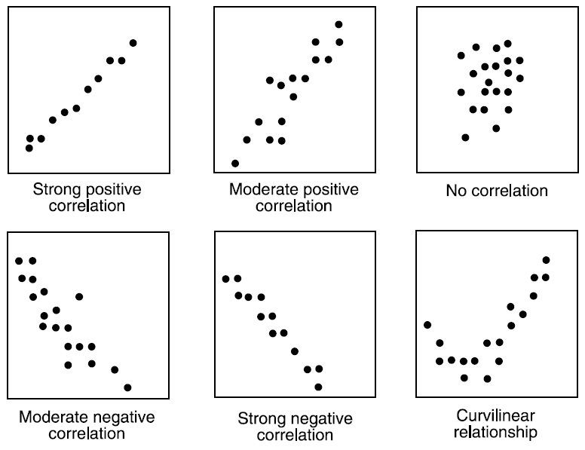

To calculate the covariance, we need to use the matrices logic as:

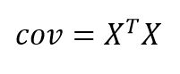

This is one of the examples and in this documentation we will see about various linear algebraic models.

**Linear combination:**

Let v1,v2,v3…vn be any vectors belonging in Rn.

Let c1,c2,c3 be any scalars.

Then the linear combination of these two is:

V = c1v1+c2v2+c3v3….CnVn.

Where c is the weights of the vector.

**Linear dependent and independent:**

When the linear combination ie. V = c1v1+c2v2+c3v3….CnVn. = 0,

Then it is called as linear dependent.

Else it is known as non linear dependent.

Eg: {(1,1),(2,2)} is LD in R2  when c1,c2 = (2,-1).

Executing it we get,

2(1,1) + (-1)(2,2) = (2-2) = **0**

**Hence it is linear dependent.**

Linear Regression:

Linear regression is one of the most commonly used machine learning algorithms used and is one of the easiest algorithms to understand using linear algebra.

Linear regressions shows the relationship between two linear equations.

Linear regression involves fitting a line across two equations whose answer satisfies the maximum of the 2 equations.

Uses of regressions analysis:

* + Determining the strength of the predictors
  + Forecasting an effect
  + Trend forecasting
  + Eg) Age vs income , sales vs profit etc…

Features of Linear Regression:

Modelled using a straight line

Inputs = Continuous variable

Output = Value of the variable

Accuracy calculated by: R squared , Adjusted R squared etc.

The linear regression is explained as:

Y = mx+c

Where m = slope and c = Intercept.