CODE:
class Student{
public String name;
Student(String name){
this.name = name;
}
public String toString(){
return name;
}
}

public class Ex3{
public static void main(String args[]){
Student myStudents[]=new Student[]{new Student("Dharma"),new Student("Sanvi"),new Student("Rupa"),new Student("Ajay")};
for(Student m:myStudents){
System.out.println(m);}

}
}
OUTPUT

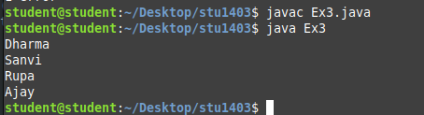

CODE:
public class Ex5{
public static void main(String[] args)
{
int[] arr = new int[4];
arr[0] = 10;
arr[1] = 20;
arr[2] = 30;
arr[3] = 40;
System.out.println("Trying to access element outside the size of array");
System.out.println(arr[5]);
}
}
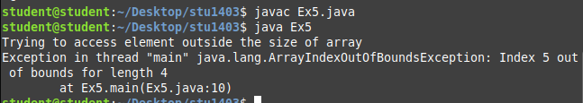
OUTPUT
CODE:
class Ex6{
public static void main(String[] args)
{
int arr[][] = new int[10][20];
arr[0][0] = 1;

System.out.println("arr[0][0]="+arr[0][0]);
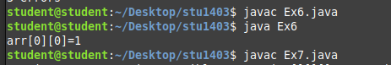
}}

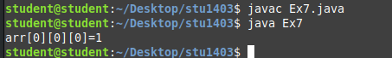
CODE:
class Ex7{
public static void main(String args[]){
int arr[][][] = new int[10][20][30];
arr[0][0][0] =1;
System.out.println("arr[0][0][0]="+arr[0][0][0]);
}}

CODE:
public class Test{
public static void main(String args[]){
int arr[] = {3,1,5,2,4};
sum(arr);
}
public static void sum(int arr[]){
int sum=0;
for(int i=0;i<arr.length;i++){
sum+=arr[i];
System.out.println("sum of the array values:"+sum);
}
}
}
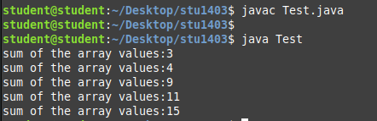

CODE:
public class Ex9{
public static void main(String args[]){
int arr[]=m1();
for(int i=0;i<arr.length;i++){
System.out.println(arr[i]+" "); }}
public static int m1()[]{
return new int[]{1,2,3};
}}
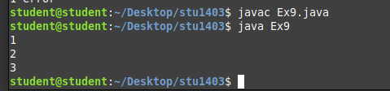

CODE:
class Ex10{
public static void main(String args[]){
int intArray[]= new int[3];
byte byteArray[]= new byte[3];
short shortArray[] = new short[3];
String strArray[]= new String[3];
System.out.println(intArray.getClass());
System.out.println(intArray.getClass().getSuperclass());
System.out.println(byteArray.getClass());
System.out.println(shortArray.getClass());
System.out.println(strArray.getClass());

}}

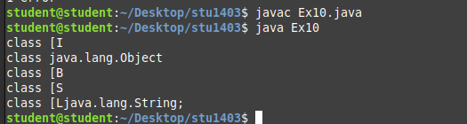

CODE:
class Ex11{
public static void main(String args[])
{
int intArray[]={1,2,3};
int cloneArray[]=intArray.clone();
System.out.println(intArray==cloneArray);

for(int i=0;i<cloneArray.length;i++){
System.out.println(cloneArray[i]+" ");
}
}
}

OUTPUT
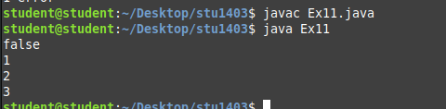

CODE:
class Ex12{
public static void main(String args[])
{
int intArray[][]={{1,2,3},{4,5,6}};
int cloneArray[][]=intArray.clone();
System.out.println(intArray==cloneArray);
System.out.println(intArray[0]==cloneArray[0]);
System.out.println(intArray[1]==cloneArray[1]);
}}

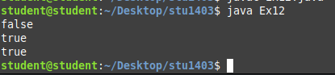
OUTPUT

