Standard Action Cycle:
This cycle applies to any action that a character can select during the Actions phase.

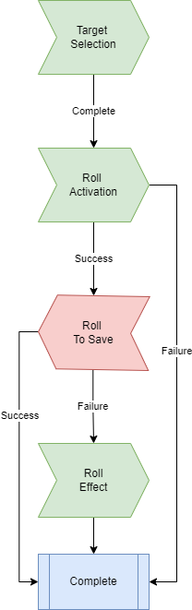

1. Target Selection – The Player selects a target or targets for the action to be carried out on. In many cases this will mean selecting enemies. In some cases this could mean selecting friendly units, or even enemy and friendly units alike. To be selected as a target, a unit must be within the give action’s range. At this point, the player also selects from their available attacks and special abilities.

2. Roll Activation – The Player rolls to see if the action takes effect. For a standard attack action, either Melee or Ranged, a player must roll the ‘To Hit’ value or higher for their selected attack. For special abilities, the player must the activation value or higher for their selected ability.

3. Roll Save – The Target Player must role greater than or equal to the save associated with the specified ability. For most standard attacks this will be their ranged of melee save, and for most special abilities this will be their magic save, but their can be exceptions. This step may not apply to some actions.

4. Roll Effect – The Player rolls the specified effect for their ability. This will be rolling for damage with most standard attacks, and could be rolling for damage or other types of effect. This step may not apply to some actions.

