Microcontroller Prototyping 180
The advent of open source hardware has lead to a wide array of tools and components that have made it easier than ever to design and build your own custom electronic devices. What was possible only to multi million dollar companies just a few short years ago has quickly become accessible to the average garage inventor. Designing new tools and products from scratch is both cost effective and approachable. From mobile devices, to scientific instruments, wearable electronics, and even circuits designed just for fun, you’ll be amazed at what you can do with the open source tools at your disposal. This hands-on course focuses on rapid prototyping using the Arduino microcontroller.
The most pervasive challenge in microcontroller prototyping is learning how to get devices to inter-operate. An Arduino alone doesn’t offer much capability; the power lies in the myriad sensors, input and output devices, actuators, and other components with which it can be connected. As such, this class focuses on the different interfaces through which the Arduino can communicate with other devices. The course is structured into 4 sections, with each section exploring a different interface for microcontroller communication. With these prototyping fundamentals in hand; you’ll be well equipped to tackle an almost unlimited set of possible projects.
Part 1 | Hardware Serial
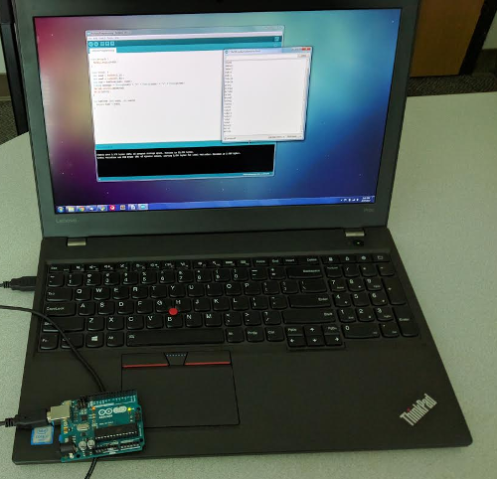 | In this section students will learn about the hardware serial interface through which the Arduino communicates with the computer. We’ll cover some of the basics of programming for the Arduino, getting debug information back from the Arduino as it runs, and an overview of the Arduino build process. The final product of this section will be an Arduino program that listens for user input over the serial port and responds to certain key words with custom logic.

Part 2 | Analog and Parallel
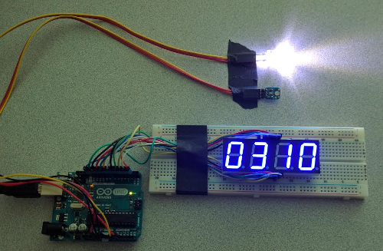 | In this section students will learn about reading data from an analog sensor using the Arduino’s built in analog to digital converters pins. We’ll cover how to feed these readings into logic that makes decisions, like whether to turn an LED or on or off. Finally, we’ll learn how to wire and code a parallel device that lets us show numbers with a digital clock display. Along the way, we’ll learn the basics of working with breadboards, wiring, and how Arduino code libraries are managed. The final product of this section will be a device that displays the value of an analog light sensor, if the value is below some threshold level, it will turn an LED on.

Part 3 | I2C Devices
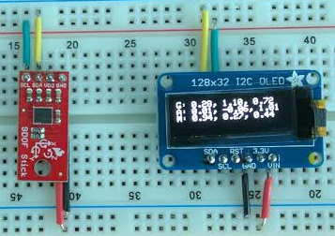 | In this section students will wire and code several I2C devices. We’ll cover how to work with manufacturer provided code libraries. We’ll also write custom logic that uses the devices in concert to achieve some specific goal. The final product of this section will be a device that measures acceleration, gyroscopic header, and magnetic field readings in 3 dimensions, and displays these values on a small organic LED screen.

Part 4 | SPI Devices
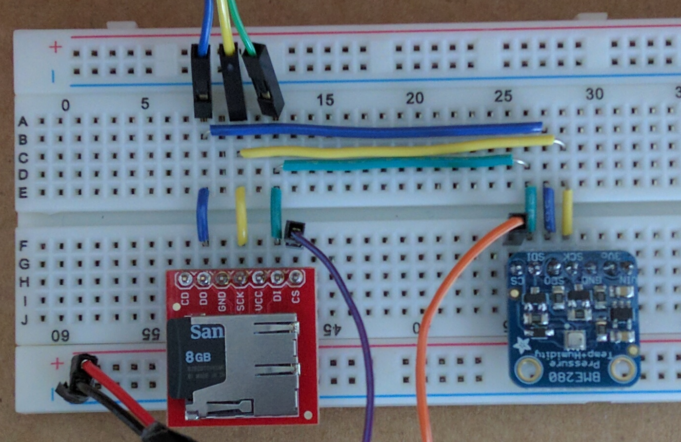 | In this section students will wire and code several SPI devices. We’ll cover how to work with manufacturer provided code libraries. We’ll also write custom logic that uses the devices in concert to achieve some specific goal. We’ll compare the relative advantages between SPI and I2C. The final product of this section will be a device that measures temperature and writes it to an on board SD card for permanent storage.

If you’re new to programming or electronics engineering, don’t panic. Along the way we’ll introduce you to the fundamentals of programming in the Arduino Integrated Development Environment, working with electronic circuits and breadboards, and understanding schematics and diagrams. If you’ve already got a particular project in mind, bring it with you. Your instructor will be available for office hours before and after class to help advise you on projects or to help you with any techniques or concepts you might find challenging. If you’re looking for a hands on, fast paced, and immersive introductions to the world of microcontroller prototyping; this is the class you’ve been waiting for.
Class Fees: $145
Materials Fee: $145
Total: $290

