**Newly Built App Board Testing Procedure**

Written by Hunter Mills on 5/29

Based on Bootload/VM instructions for the now defunct Dev Board

**Bootloader Instructions**

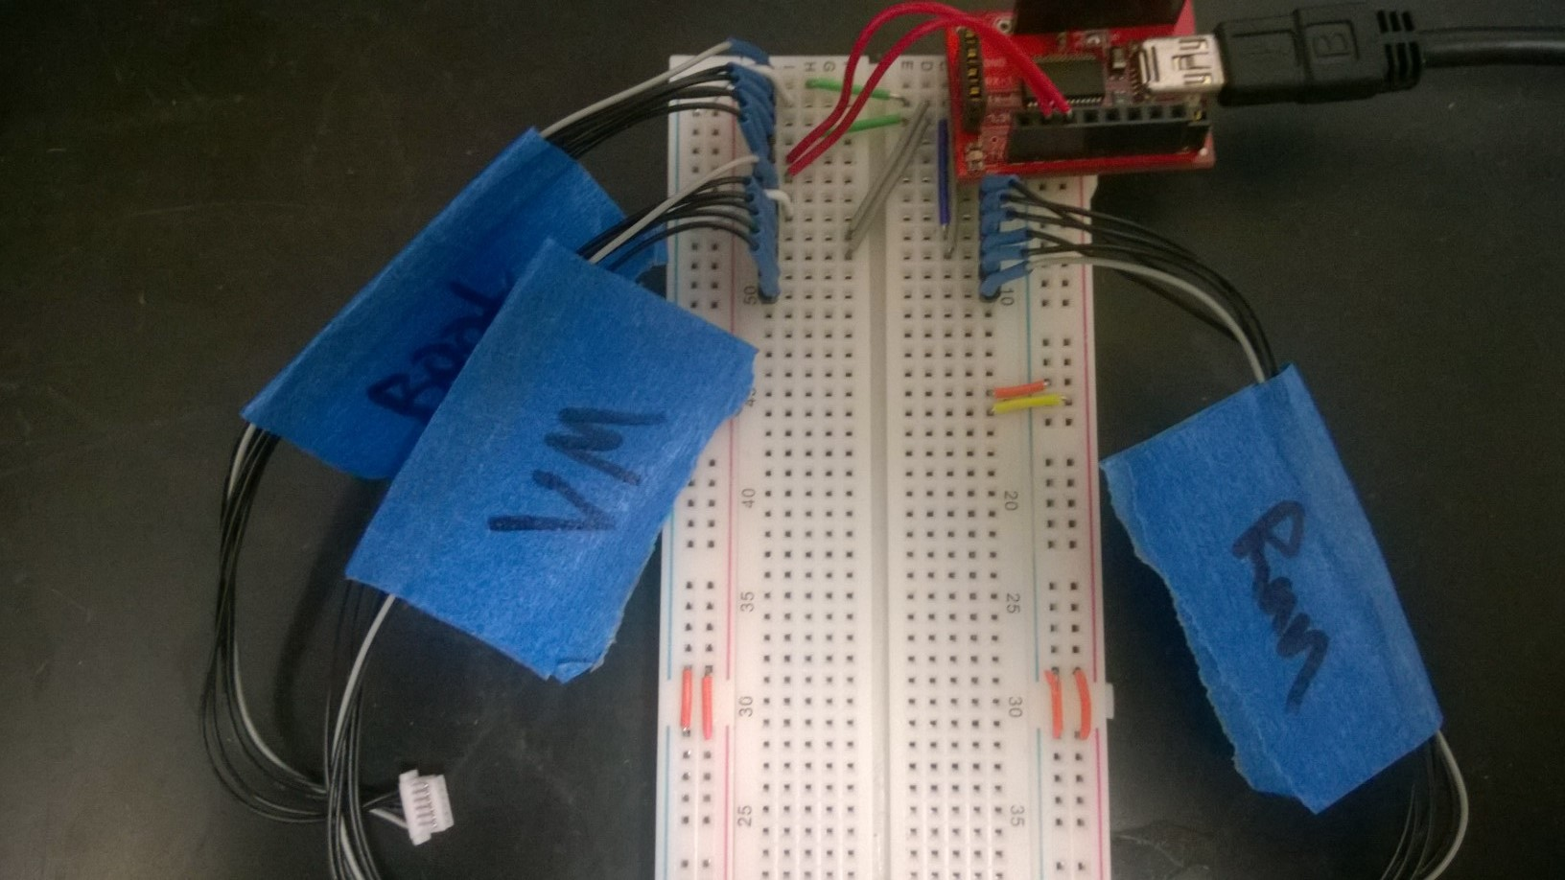

* Disconnect the Jumper, and flip the VM switch toward the 6-pin connector

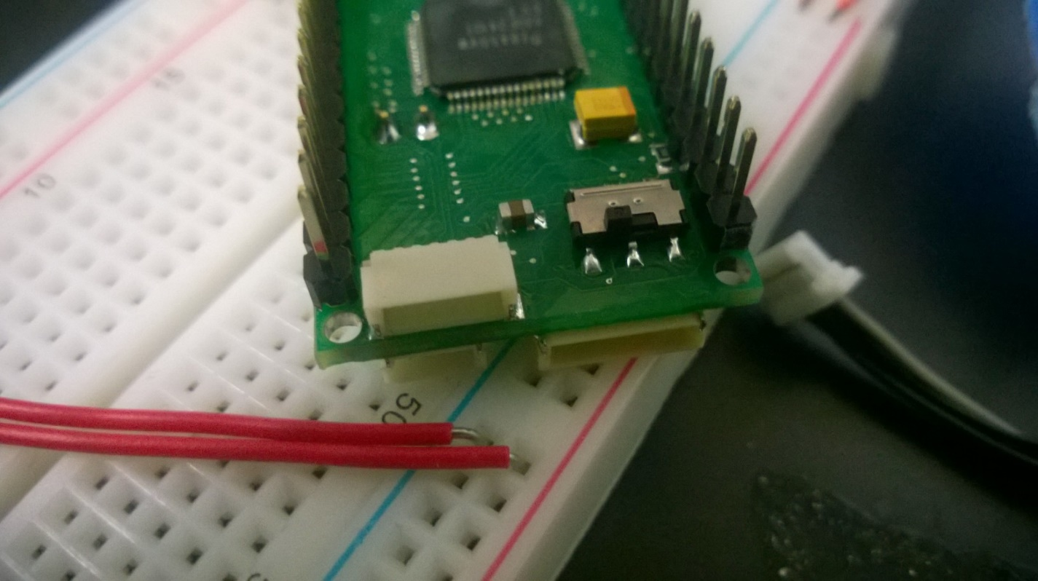

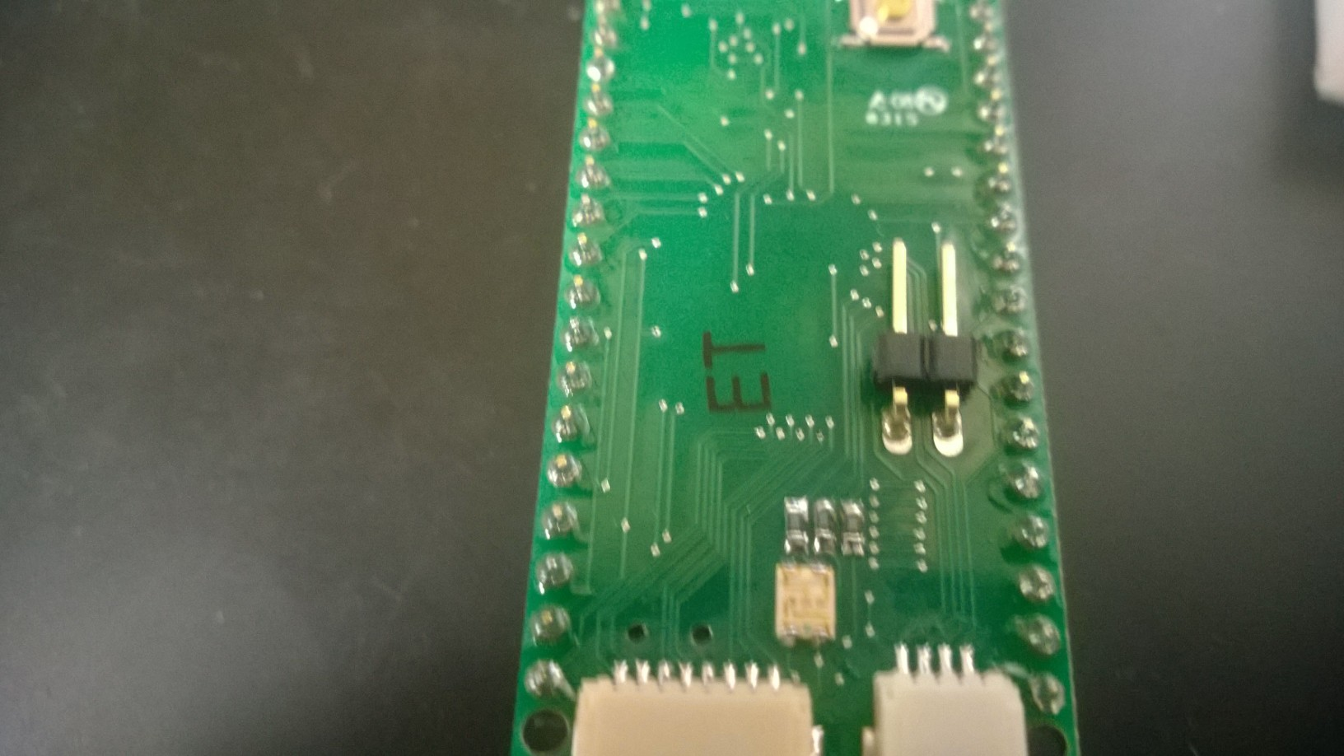

* Plug the App Board into the Bootload/VM Board

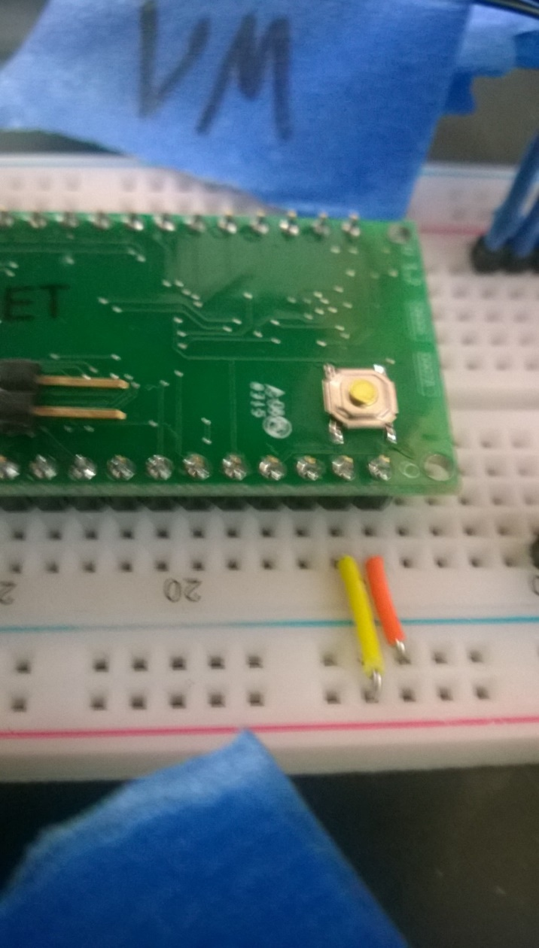

* Plug the Bootload/VM Board ‘s Boot cable into the App Board

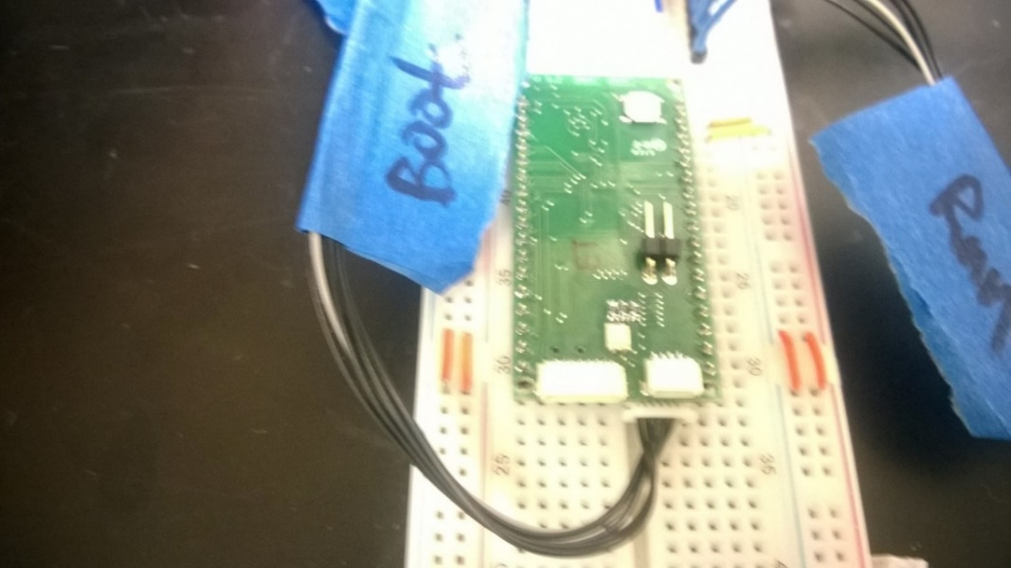

* Plug the Bootload/VM Board’s USB into the computer
* Load assembler.jar in the Bootloading Folder (Should be within Folder AppTest)
  + a java terminal should appear with a text box and two buttons labeled "asm" and "download"
* Type in "new-chip"
* This text should appear
  + enter-bsl
  + passwd v-erase
  + print r1 65502 4288 64
  + se [0 0] v-timints
  + ok
* Within this textbox click in "enter-bsl" and hit enter
  + The system should respond "ok"
* Select "passwd v-erase" and hit and enter
  + If it says "passwd FF", **STOP**, Something is wrong, check power, and swich locations. If you still get FF then stop and check solder connections on Dev-Board
  + if it says "passwd 90", then continue
* Select" print r1 4288 64" and hit enter
  + The system should respond with a bunch of integers between 0 and 255
  + If the system responds with all -1s, do not continue
* Select "w1 65502 se [0 0] v-timints" and hit enter
  + The system should respond "w1 FFDE 90"
* Click the "asm" button
  + The system should respond "368 bytes"
* Click the "download" button
  + The system should respond w1 FFDE 90, w1 FE00 90, w1 FE40 90, w1 FE80 90, w1 FEC0 90, w1 FF00 90, w1 FF40 90
* Unplug the USB and the Bootloading Cable from the App Board
* This Completes the Bootloading Process

**VM Instructions**

* Disconnect the Jumper, and flip the VM switch toward the 6-pin connector

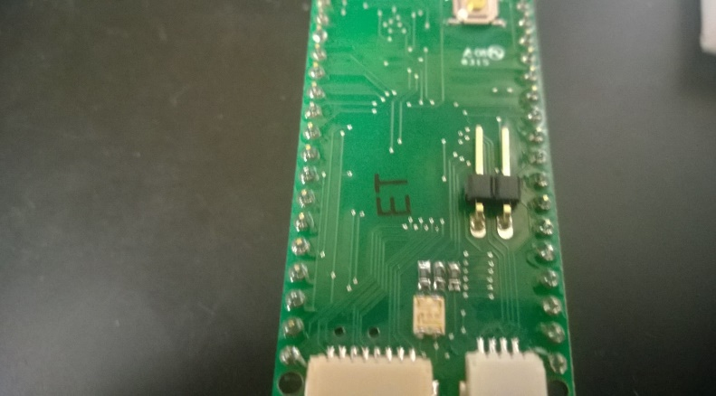 

* Plug the App Board into the Bootload/VM Board



* Plug the Bootload/VM Board ‘s VM cable into the App Board

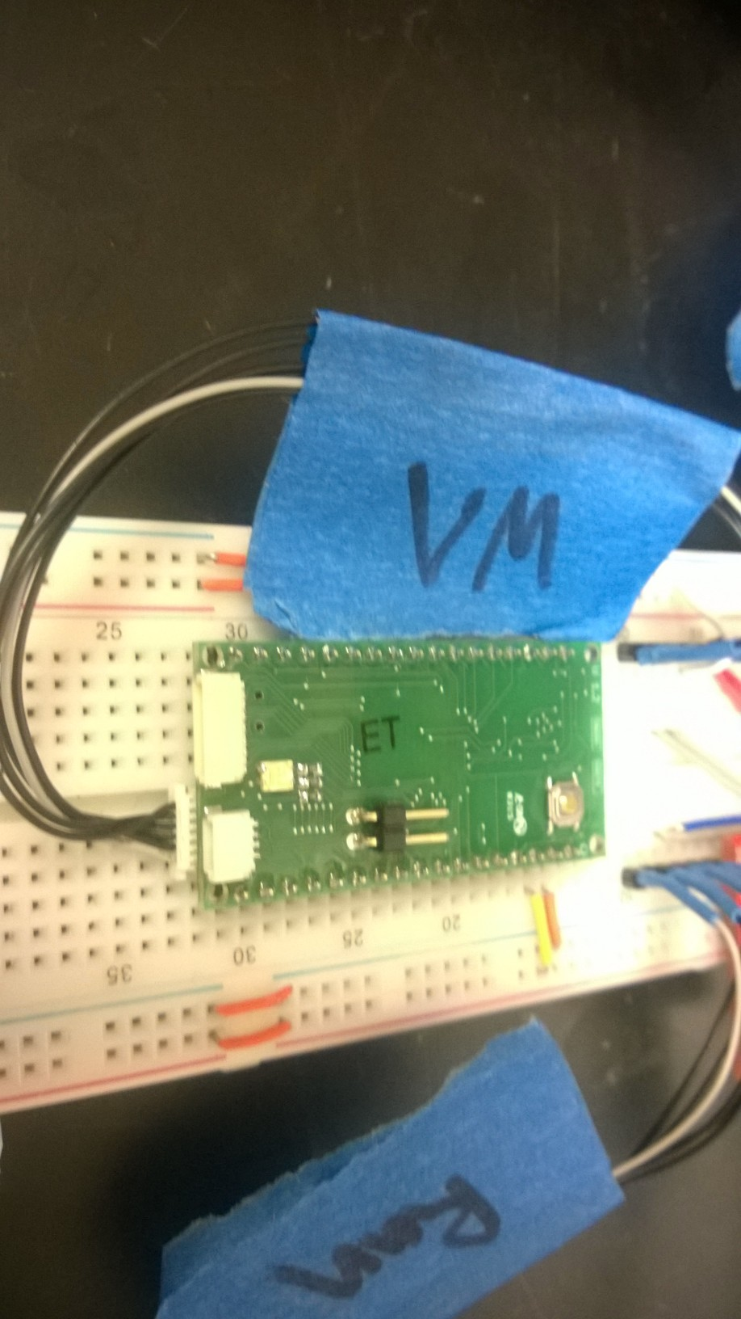

* Plug the Bootload/VM Board’s USB into the computer
* While in terminal execute the following steps
  + Enter the appropriate VM directory (normally the newest)
  + Run jl.sh
  + Type and Return "send $ff print recc"
    - This should be responded with and integer value of 36
  + Type and Return "asm"
  + Type and Return "download"
    - Lights should blink
  + Type and Return "dump $1000 0"
  + Type and Return "erase-seg $1000" -- Be Very Careful on This Step
  + Type and Return "wfl $1000 [ 16 ]"
  + Type and Return "dump $1000 0"
    - This should respond with the first entry as 16 (decimal) or 10 (hex) followed by multiple FFs
  + Hit ctrl + c
* Unplug the Bootload/VM Board’s USB into the computer
* This completes loading the VM

**App Board Function Test**

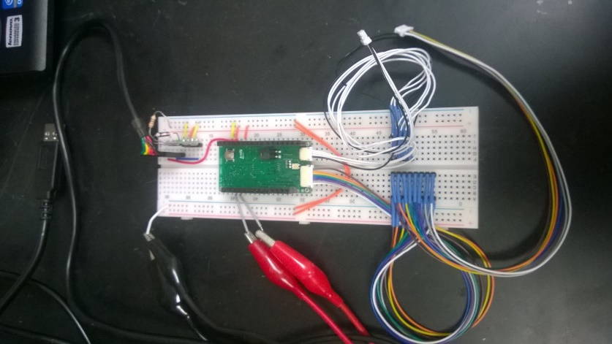

* Connect the Jumper, and flip the VM switch away from the 6-pin connector

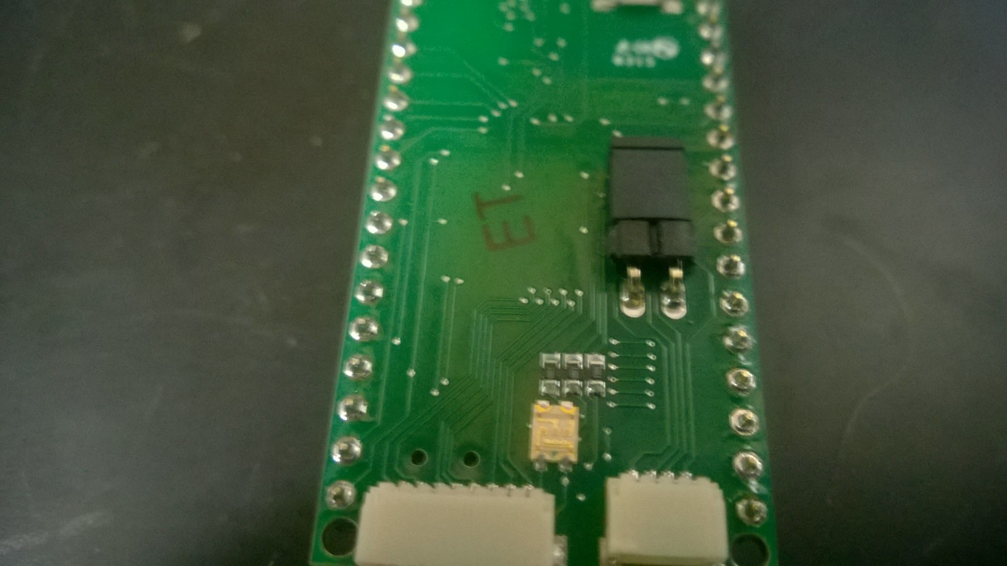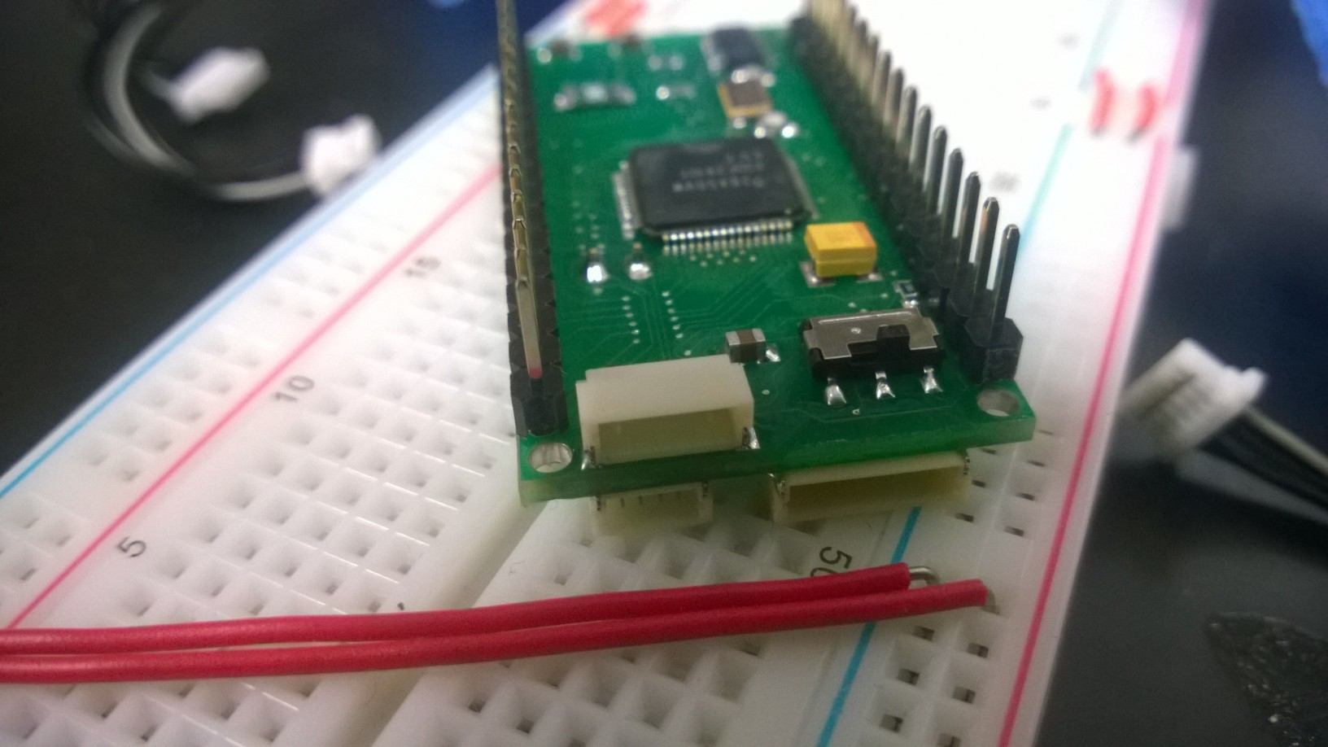

* Connect the new App Board to the Tester Board

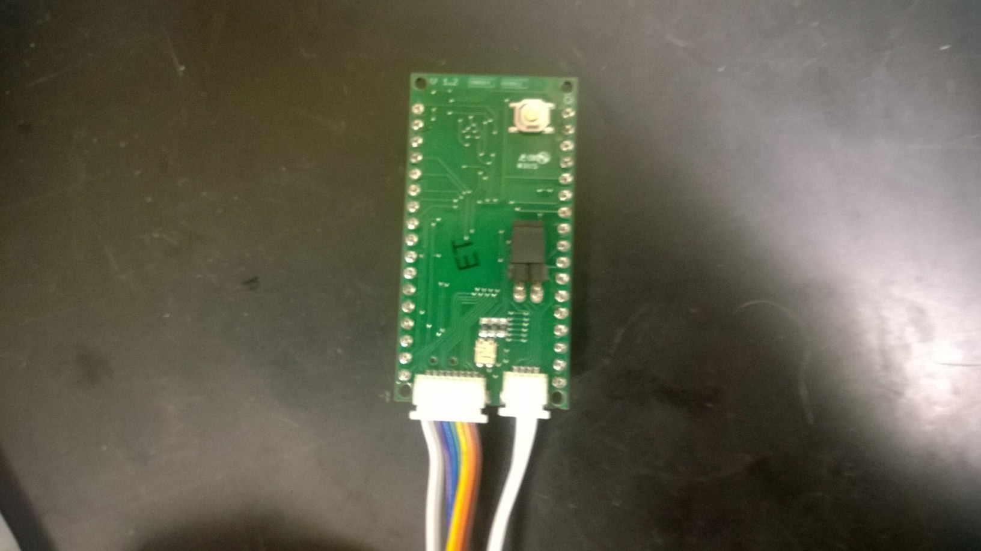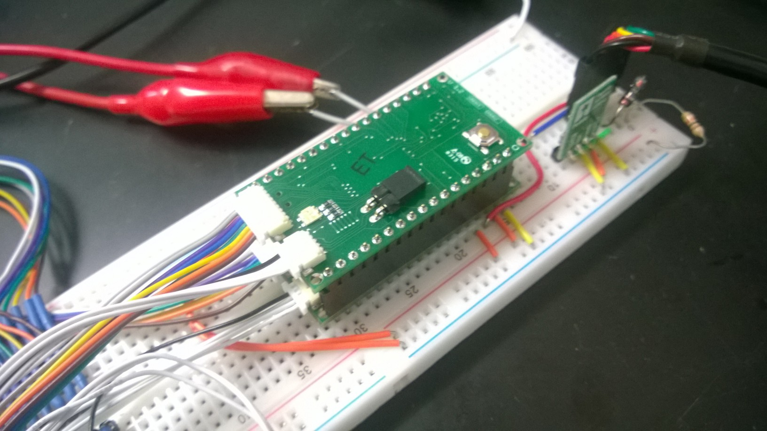

* Enter the “ulogo” folder
  + Run “jl.sh”
  + A terminal should open
  + Run the following command “.init-newboard”
    - This should compile and download the test code to the Board
  + Run the following command “.test-board”
  + Follow the onscreen instructions. This includes:
    - All pins are turned on and read by the tester (should return all 1’s)
    - All pins are turned off and read by the tester (should return all 0’s)
    - The on Board tri-color LED is tested by cycling through red blue and green
    - The DACs are tested by emulating a sine wave routing the signal to an Oscilloscope and test
* If there are any failures in the above procedure, check solder connections and test again.
* This completes testing the App Board. At this point the board is ready to use and should be cataloged.