PHYS3020 – Computational Project Report – Rhys Tyne – s46481894

Comment on chunk size at each temperature, look at initial vs final, explain why.

Why: because as T increases, beta approaches 0, which means e^(-beta\*ΔU) approaches 1, meaning if the dipole switch does not reduce U then it will hardly occur.

Q1b)

Derivations

Q1c) plots

Error bars calculated by running model 10 times and solving using standard procedure for each variable. Temperatures range over 15 evenly spaced values between 0.1 and 3. The simulated values plotted are the average values from all trials at each temperature. REWORD

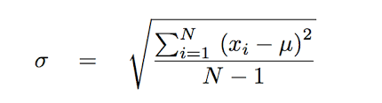

The graph of c against T was the most unpredictable for temperatures between 0 and 1, as can be seen by the error bars present.

F was consistently lower then the value gained by the exact solution. However, the uncertainty is not that large.

Q1d)

Explain what the plots indicate about the finite 1D Ising model at low and high temperatures, compare to exact results and explain differences.

Q1e)

Explain differences in *m* between your simulation and the expected values;  
create histograms of *m* values at 3 different temperatures for 2 different *N* values;  
explain whether the infinite 1D Ising model has a phase transition based on these  
histograms

Q2a)