#### Experiment 10

**Aim:** Install Active Directory Domains Services in Windows 2008: Installing a new forest by using the graphical user interface (GUI)

**Co Attained: CO5:** Identify the role of active directory

**Procedure:**

Install AD DS Graphically

Follow the steps below to install Active Directory Domain Services on Windows Server 2016.

1. Press the Start Menu button and click on the **Server Manager** icon which is the management tool in Windows Server 2016.

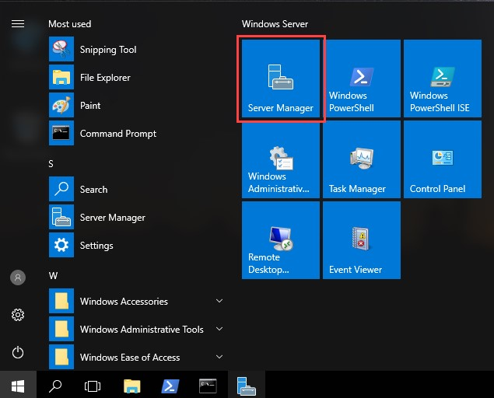

1. Active Directory Domain Services is a Windows Server role. Click on **Add Roles and features** option to install the role.

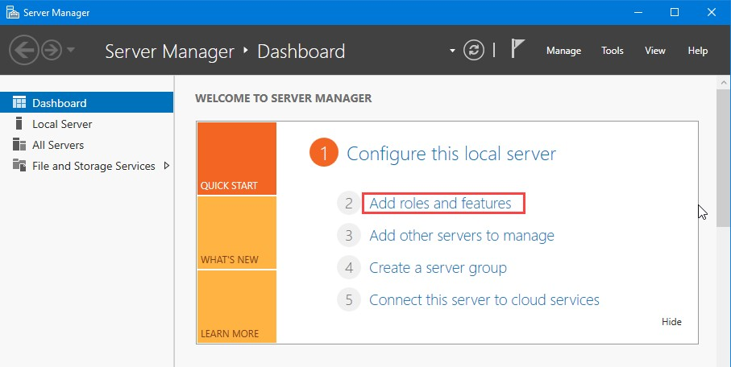

1. In the Before you begin you have nothing to do. Click on **Next** button**.** In the Select Installation Typepage, Select the **Role-based or Feature-based Installation** option. Click **Next** onbutton.

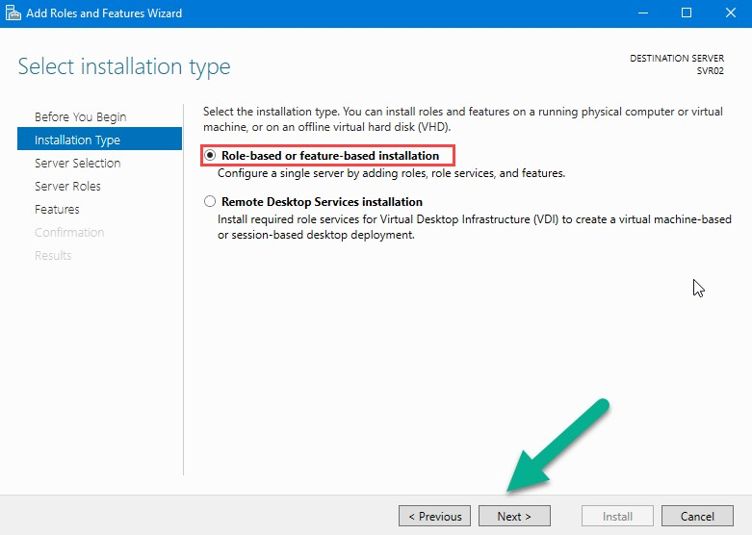

1. Let the **Select a server from the server pool** option selected. Specify the server that you want to install the role on, from the Server Pool. Click on **Next** button.

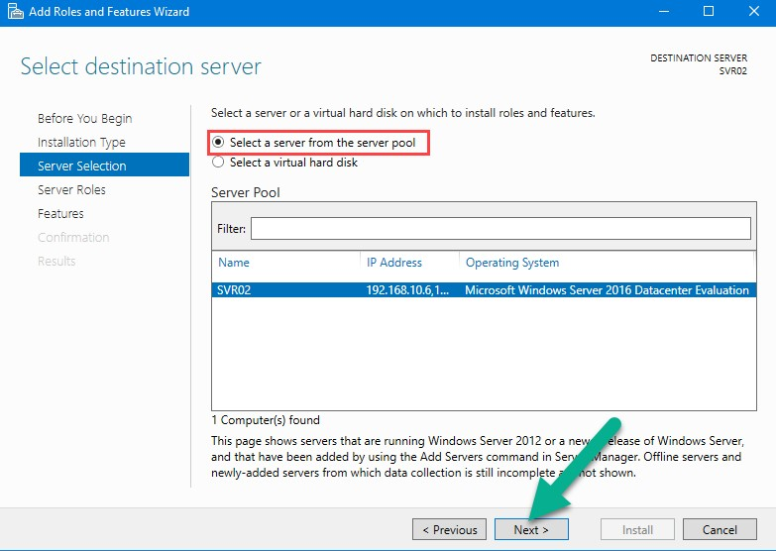

1. Select the **Active Directory Domain Services** role. A new windows opens and ask you to install management tools. Installing AD DS role, you just install the core services. Click on **Add Features** button to install management tools. then click on **Next** button.

Create a forest using GUI In windows Severs

**Step 1**: Open the server Manager and click on Manage and then add roles and features.

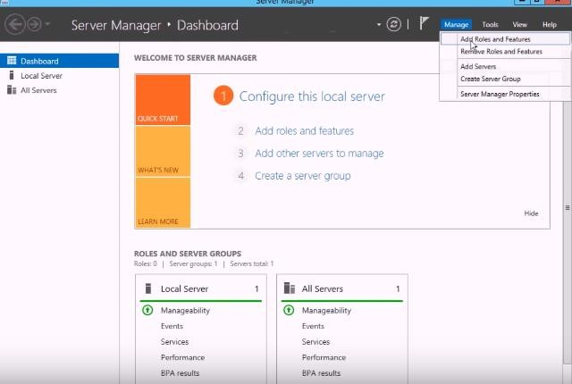

Step 2 : Select the server Roles as (Active directory Domain Services) and click on add features Step 3 : Click Next ,Next and Install

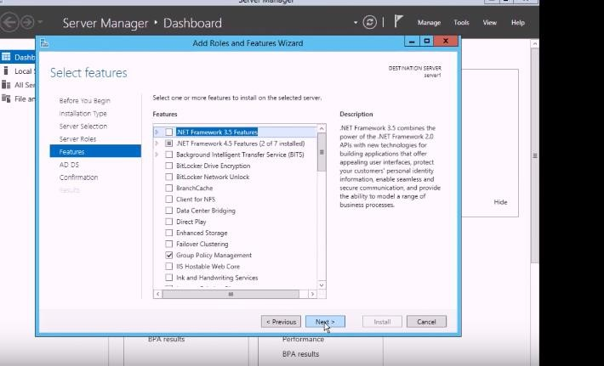

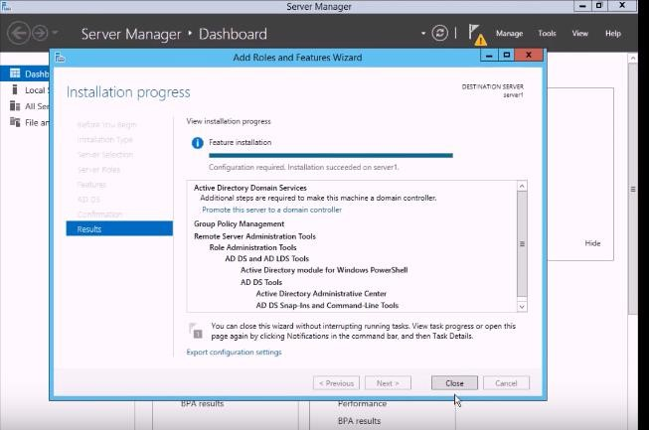

Step 4: After Installation Select Add a new forest in deployment configuration and enter Root domain name as NET.COM and click on next.

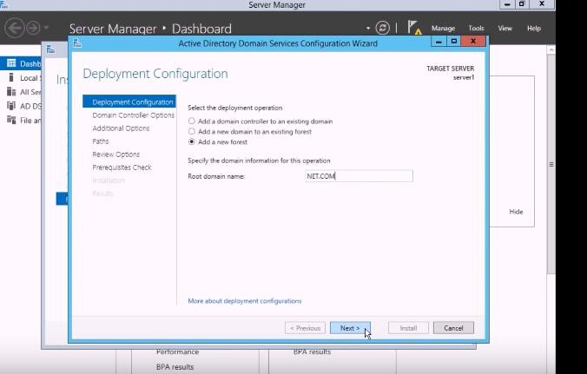

Step 5: Set password and confirm the password and click on next

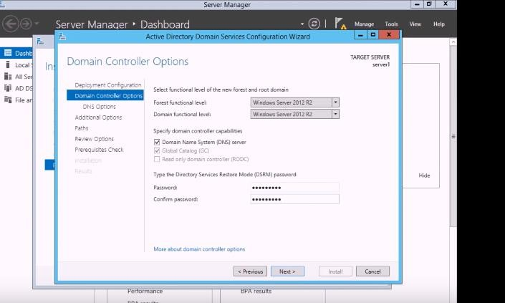

Step 6 : After next installation progress appear and then system restart.