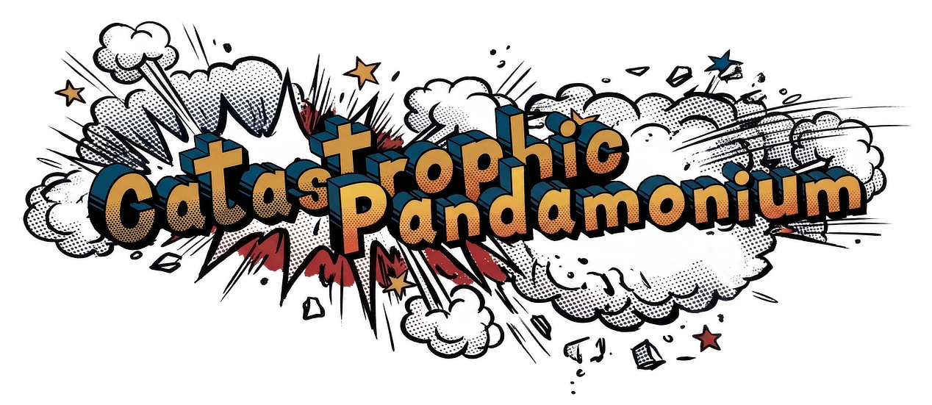

Design Guidelines
Catastrophic Pandamonium (CataPanda)

1. About this guide
This guide describes the visual system for Catastrophic Pandamonium: colors, type, shapes, the stacked-card style, buttons and the core interface components. It is a reference for anyone designing or building the product, including AI build tools.
It deliberately does not cover where things sit on a screen (layout and positioning of the logo, mascots or components), badges, or final font choices. Those are decided during the build.
The product is designed mobile-first: every component is designed for a phone screen first.

2. Brand foundation

Name
- Catastrophic Pandamonium is the official product name. Use it in the logo, the share message and formal mentions.
- CataPanda is the cute, playful nickname used everywhere else in the product.

Pitch
The cool uncle who helps you prep for the worst, with a smile and a plan, in under 3 minutes.

Overall concept
We are a sunny, efficient guide that cuts through disaster-preparedness chaos, making safety feel like a calm, confident choice rather than an overwhelming burden.

Tone
Like a worldly, childless uncle who’s also a sharp travel journalist: warm, casual and equal in conversation, never talking down, always sharing crisp, honest wisdom without overselling.

Emotional promise
We deliver a profound sense of relief and understanding, transforming panic into quiet confidence by handling all the overwhelming details so our customers can breathe easy.

Visuals and UX
Our aesthetic is approachable, bright and colorful. Our UX is a lightning-fast dashboard that gets users their customized checklist in under three minutes. No friction, just action.

Cohesive identity
Every element, from our optimistic color palette to our mentor-like copy to our frictionless interface, makes disaster preparedness feel human, approachable and even a little joyful.

3. Brand assets
Two illustrations are the core brand assets. Use the supplied files as they are: don’t recolor, redraw, crop into the artwork, stretch or add effects.

Logo
File: web-logo.png (1268 × 551, transparent background).
A comic-book explosion: the words “Catastrophic Pandamonium” in chunky, halftone-shaded gold lettering with a deep blue 3D edge, bursting out of white smoke clouds, red spikes and small gold, blue and red stars. It sets the energy for the whole brand: bold, a little chaotic, but cheerful rather than scary.
- Place it on dark or blue backgrounds (Panda Black or Deep Sky Blue), where the white clouds stand out.
- Give it generous space; the burst shape should never feel squeezed by other elements.
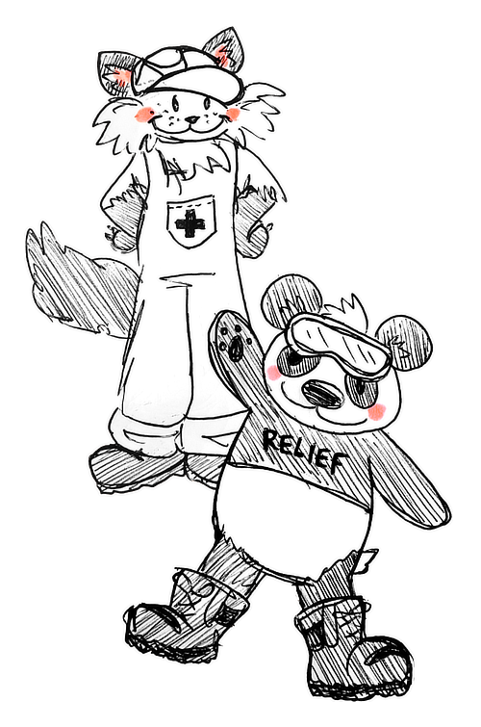

Mascots
File: web-mascots.png (500 × 755, transparent background).
A cat and a panda drawn in a loose, hand-sketched black-and-white ink style with soft pink cheeks. The cat wears a cap and overalls with a first-aid cross; the panda wears goggles, a “RELIEF” shirt and heavy boots and gives a cheerful wave. Together they are the friendly relief crew: capable, warm and a little goofy.
- Use the mascots to add warmth at key moments, such as welcoming the user and keeping them company while lists load.
- Their sketchy monochrome style contrasts with the bold, colorful interface. Keep that contrast: place them on White or Deep Sky Blue, never on busy patterns.
- Any new mascot artwork (for example, the pair digging with shovels for a loading animation) should match this hand-drawn ink style.

4. Color
The brand palette is built on five families: blue, red, gold, grey-black and white. The values below are the official colors. Deep Sky Blue fills the page, stacked cards float on it in White, and black, gold and red create the layered, comic-book energy.
Swatch | Name | Hex | Use
 | Deep Sky Blue | #04508A | Page background. The dominant brand color behind everything.
 | Panda Black | #1C1C1E | Top tab of stacked cards, header band, primary buttons.
 | Sunset Gold | #DB903D | Bottom tab of standard stacked cards. Warm accent.
 | Brick Red | #B6423C | Accent cards (the one card per screen that asks the user to act), secondary buttons.
 | Deep Red | #6B1613 | Hover and pressed states for buttons; outlines on red surfaces.
 | White | #FFFFFF | Card surfaces, option cards, text fields, text on dark or red backgrounds, bottom tab of accent cards. Pure white suits the comic-book style.
 | Bright Blue | #3F7FD1 | Selected states and links.
 | Pale Blue | #EAF4FB | Fill for a selected option card.
 | Ink | #2A2A2E | Main text on light surfaces.
 | Slate Grey | #6B6B70 | Secondary text: short descriptions, the metadata line, helper text.
 | Sand | #E3E0D6 | Borders on option cards and text fields.
 | Linen | #EFECE3 | Thin dividers between checklist items.

Colors to avoid
Avoid these color combinations, which are typically associated with first-aid kits and medical packaging. CataPanda should feel like a friendly guide, not a pharmacy.
Swatch | Name | Hex
 | Healing Green | #4CAF50
 | Emergency Red | #FF5252
 | Bandage Beige | #E6CCB2
 | Pharmacy Blue | #2196F3
 | Auto-Medication Yellow | #FFEB3B

5. Typography
The final typefaces are chosen during the build. Whatever is chosen should meet these criteria:
- Friendly and rounded rather than sharp, clinical or corporate.
- Highly legible at small sizes on a phone, since checklists are read quickly.
- Bold weights with real personality for headings, echoing the chunky comic lettering of the logo, without copying it.
- A calm, clean companion face (or the same family) for body text.
Hierarchy should be obvious at a glance: screen title, then section heading, then item name, then short description, then the metadata line. Use size and weight, not color alone, to separate the levels.

6. Shape, depth and spacing
- Rounded corners everywhere. Cards use large, soft corners; buttons are fully rounded pills; option cards and text fields use a medium radius.
- Soft shadows. Gentle, diffuse shadows lift cards off the blue background. Never harsh or dark.
- Breathing space. Generous padding inside cards and clear gaps between them. When in doubt, add space rather than squeeze content.
- Modular and scannable. Content lives in cards and short sections, each with one clear job.
- Clear visual hierarchy. One primary action per screen should stand out.

7. Components

Layered stacked card
The signature component. Every main content block is a card that appears to sit on top of two colored layers, like a stack of comic panels:
- Card: a White surface with large rounded corners and comfortable padding.
- Top layer: a Panda Black tab peeks out above the card, slightly narrower than the card and inset a little from each side.
- Bottom layer: a Sunset Gold tab peeks out below the card, matching the top tab’s width and inset.
- Both tabs share the card’s rounded corners and show only a thin band (roughly a finger’s width on a phone), so the card always reads as the main surface.
Accent variant. Use this for the one card on a screen that asks the user to do something important, such as describing their household. The card surface is Brick Red, headings and helper text are Panda Black and body text is White; the top tab stays Panda Black and the bottom tab becomes White. Use at most one accent card per screen.

Buttons
- Shape: fully rounded pills with bold labels.
- Primary: Panda Black fill with White text. Hover and pressed: Deep Red fill.
- Secondary: Brick Red fill with a 2-point Deep Red outline and Deep Red text. Hover and pressed: Deep Red fill and outline with White text.
- Disabled: the same shape with reduced opacity. Used, for example, until a disaster is selected and the household description is long enough.
- Labels are short, action-first verbs (“Next”, “Start over”).

Option cards (selectable choices)
Used for choices like disaster types. A small rounded card in White with a thin Sand border, showing a bold name and a short tagline in Slate Grey underneath.
- Selected: Bright Blue border and Pale Blue fill.
- Users can select more than one; each card toggles on and off independently.

Text field
Rounded field in White with a thin Sand border and comfortable padding. Placeholder text in Slate Grey. Show a live character count near the field, since descriptions have a minimum and maximum length.

Checklist item row
Checklists are read, not clicked into. Each item is a simple, text-only row:
- Item name: bold Ink.
- “Why for you” line (Top 10 only): a short reason this item matters for this household, directly under the item name. Ink, regular weight.
- Short description: 50 characters or fewer, regular Slate Grey.
- Metadata line: Category | Priority | Source | Find at [stores], in small Slate Grey text separated by thin vertical bars. “Find at” appears only on the personalized checklist; elsewhere the line ends after Source.
- Source is one of three labels. Link text is Bright Blue:
  - Gov-vetted: Source ↗ (catalog items). “Source ↗” links to the Sources section of the About page.
  - CataPanda Tip (the two always-included team picks). Plain text, no link.
  - AI: Source ↗ (AI-added items). Links to the outside page for items found through web search, or to the About page section explaining the tiered system for all other AI items.
- Stores in “Find at” are listed alphabetically, separated by commas, with full store names.
- Priority is one of three labels: Essential, Important or Nice-to-have.
Example rows (metadata line only):
- Drinking water: Water & Food | Essential | Gov-vetted: Source ↗ | Find at Grocery store
- Grab-and-go bag: Tools & Support Aids | Essential | CataPanda Tip | Find at Hardware store, Specialty store
- Dry shampoo (AI item found through web search): Hygiene & Sanitation | Nice-to-have | AI: Source ↗ | Find at Pharmacy
- Plain text only: no icons, colors, pills or badges in the row.
- Rows are separated by thin Linen dividers.

Section headings and explainer notes
Long lists are split into sections (for example Custom, Combo and Core). Each section has a bold heading and a one-line explainer underneath in Slate Grey, written in the brand voice, that says what the section contains.

Loading moments
Waits are a chance to reassure, not stall. Pair the mascots with short, friendly progress messages and practical preparedness tips. Keep motion gentle and offer a still version for users who have reduced motion turned on in their phone settings.

8. Imagery and icons
- Friendly illustrations, never photography.
- Emoji icons, geometric shapes, infographics and simple process diagrams.
- Cute animal mascots (see section 3).
- Progress visualization and quick wins: show users how far along they are and what they’ve achieved.
- Illustrated examples over long explanations.

9. What to avoid
- Dense text and anything resembling overwhelming government-style documents.
- Fear-based messaging, urgency or anxiety triggers.
- Overly simplistic or kid-focused content. The mascots are cute; the advice is for adults.
- Brutalist design.
- A hyper-clean corporate look.
- Gaming elements.
- First-aid color combinations (see section 4).

